


caGrid Portal Comments on the current portal
31st December 2007

Prepared for:
NCICB

Prepared by:
Usability Engineering Center of Excellence
Persistent Systems Ltd.

Observations:

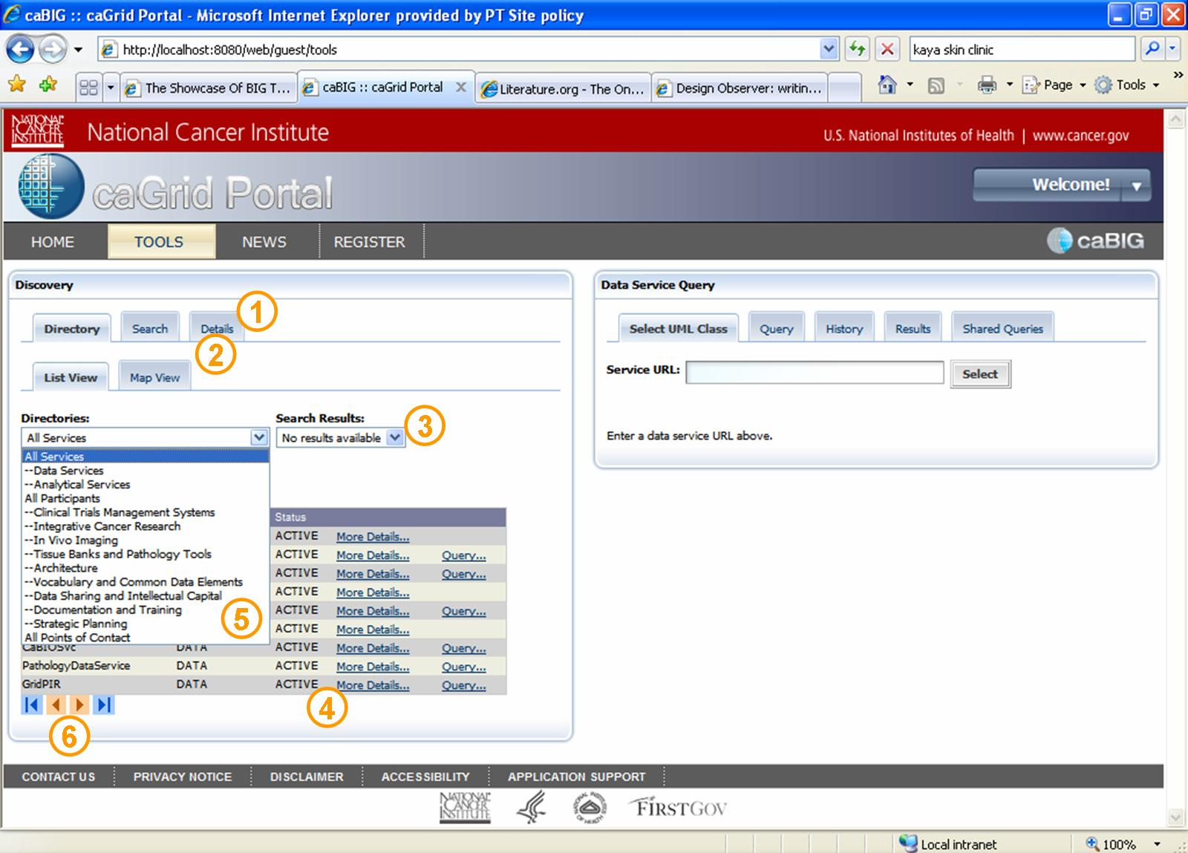

- The user coming to the tools tab might have these motives: View the directory, or search directly go and query if he has the URL. Hence, giving the ‘detail’ at the level of directory and search is not appropriate. User will view detail only when he has searched for some service, participant or POCs.
- The sub tabs do not seem to be linking to the main tabs. All of them seem to be at the same level due to no visual distinction. Once selected any higher level tab for e.g. ‘Directory’, user‘s attention is immediately grabbed by the directories drop down and he intends to neglect the sub tabs (list view and map view), neither do the sub tabs seem to link to the above tabs.
- The placement of the ‘Search Results’ drop down next to directories dropdown is not appropriate. The user might perceive it as some criterion for search, while it actually lists the prior searches performed by the user.
- Once the user opens the list view he is not sure if ‘more detail’ link and ‘detail’ tab are related/one and the same thing/ not related.
- Every time the user has to open the dropdown to know what he has selected, whether it is a service, participant or Poc.
- The pagination is ambiguous giving no information about the total number of pages, pages viewed and pages left to view.

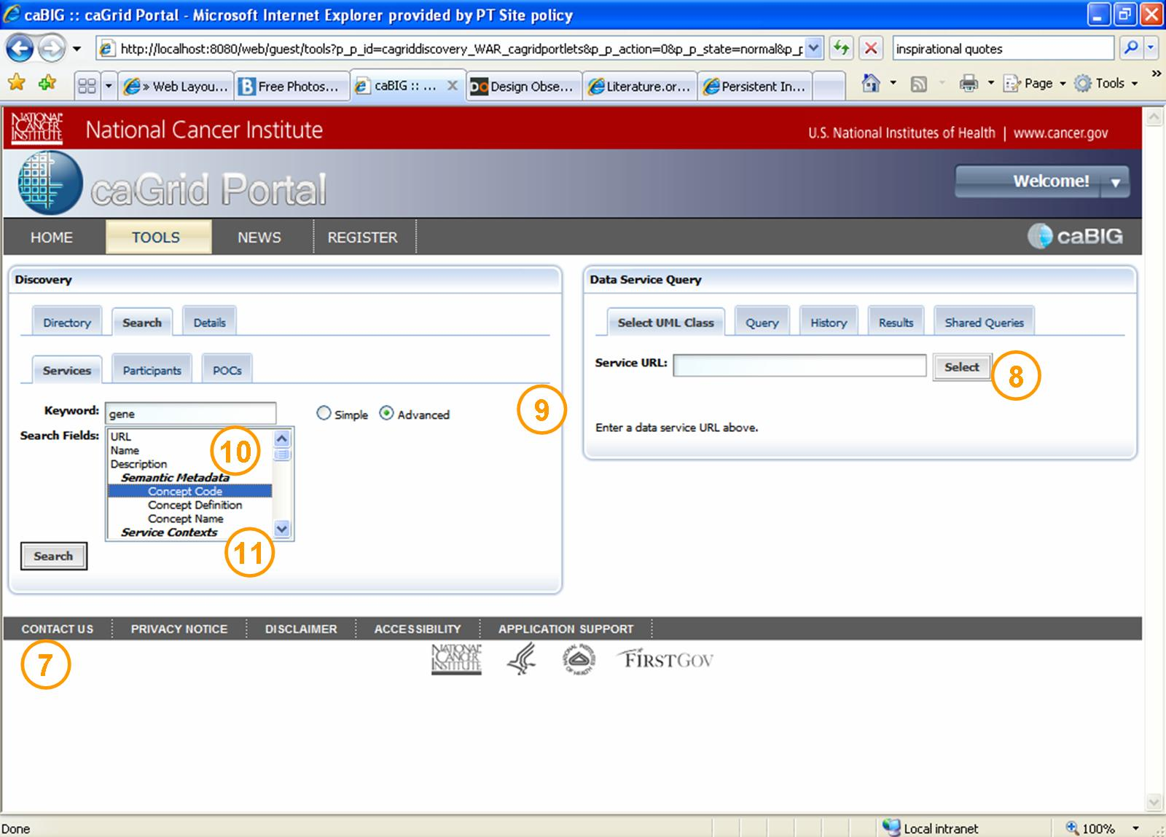

- The footer jumps with the page length, breaking the visual consistency of the portal. It should be fixed at the bottom of the page.
- Use of term ‘Select’ for the button next to the ‘Service URL’ text box is inappropriate, as it does not convey the function the button performs properly. User is not selecting rather firing a command to fetch the list. The button should, hence, read ‘GO’.
- There is no back button for the user who is just exploring the tabs.
- The representation of multiple choice search fields as a list is not correct. The user interface should make user understand the action he can perform intuitively.
- Here, the user does not understand that he can select multiple search fields by pressing ‘Ctrl’ key and clicking on search fields.

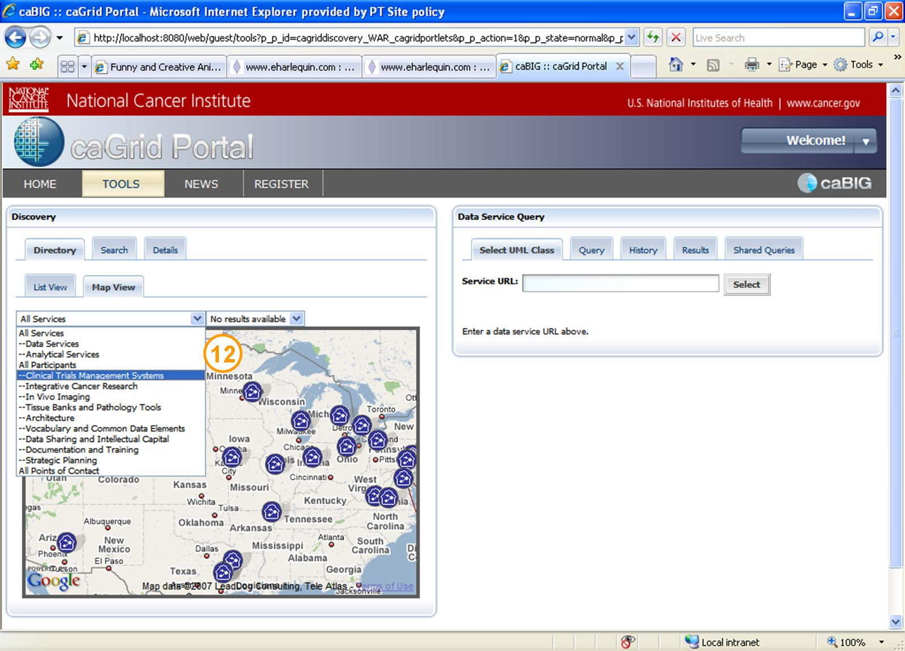

- The map view does not refresh to show data for the filter applied.

For recommendations, kindly refer to the following documents on caGrid CVS.
- caGridportal_design_evaluation_v2.ppt
- Design rationale_ 1.0.doc

