caGrid “Minor” or “Major” Release – Some Thoughts
Author: Avinash Shanbhag, Scott Oster

General
- Need to create official Globus release for what caGrid uses (ws-enum support, updated apache commons, patched cog)
- Each component needs wiki presence.
- Installer needs to be able to use different versions (caGrid, Globus, etc)
  - Ideally we don’t want to have to regenerate the installer when we update the external software or caGrid (maybe have to revisit web start, now that the installer works properly)
  - Need to complete component installers.

Metadata

- Subha had mentioned about needing some kind of higher level business API that will allow her to query for “semantically” aware data (not metadata). What she was talking about was not CDE equivalence, but, more at “synonyms” or partial concepts level. When she talked with me, it seemed that she could do it by calling a “bunch” of EVS APIs. I think it would be useful to determine what her business use case is and then see whether (a) its possible and (b) If so, how to create a higher order business API. Brian Davis may be also aware of it and should be able to facilitate. I think this would need to be driven by caGrid team and then, if there are requirements on EVS (for new APIs or enhancements to EVS Grid APIs), then, Doug Mason is the POC for the EVS Grid APIs.
  - If this is referring to the same thing, it has been discussed previously in the context of “semantic queries.” That is, queries where the instance data itself is concept oriented. In such a scenario, you might like to express a query like: “Give me instances of object Foo, where Foo.code IS_RELATED_TO “lung cancer”. In this case, the value domain of Foo.code could be some concept or enumeration of concepts. The querying user wants to specify a given concept, and find instances where the concepts are related to the given (in the query) concept. This is not currently supported, as the data service query language is structurally and value based.
    - This can basically be implemented two ways:
      - 1) The user makes use of EVS APIs to evaluate the “IS_RELATED_TO” operation locally, translating the “lung cancer” concept in to a set of concepts which satisfy the given relation. Then the data service is queried using a standard value query, that specifies an condition where the Foo.code is any of the values in this expanded set. This could certainly be made available either a client utility, or even a client-side macro language. In this scenario, data services (and the query language they must support) do not change.
      - 2) The query language and data services change to optionally support semantically oriented operations. The user would then send this query directly to the data service. This requires changes to data services.
    - We can follow up with the community to identify the use cases, priority, and impact.

- caDSR team should be planning on adding XSD Namespace information in the caDSR database. This will need to be integrated with GME, Introduce and other caGrid Infrastructure tools.
  - Specifically the caDSR-based “type discovery” of Introduce will be updated to make use of this information instead of assuming the naming conventions.
  - Access to this information will need to be made available in the caDSR grid service.
  - This may also be of significant use in the creation of a workflow GUI, as workflows can be described at the UML/caDSR level, and sufficient information is available to automatically transform it into the XML level (QNames, XPaths, etc) for use in BPEL.

- It would be nice if caGrid could provide a “sandbox” environment for service developers to test their grid services without needing to publish on “production” infrastructure. The sandbox at minimum could contain at a minimum some core services including: Index service, GME, Grid Grouper, etc.

  - Should be addressable using training.cagrid.org (just need to make it easier to use release to target)
    - The caGrid release should have some simple configuration option to allow the user to specify they want to use the sandbox (and later switch back to production).
      - (implementation detail): could move all relevant configuration information to a directory in the top level caGrid area, and have components inherit it as a build artificat. This way a simple property could be set by the user to select among different environments (production, sandbox, cagrid development, etc),
- We need to completely hide XML from the user. We are mostly there, but there are still a few areas we need to improve upon:
  - Need a cagrid metadata editor where people can edit the research center/point of contact/ etc details.
  - Post 1.0 Introduce has added description elements to everything (services, operations, inputs, outputs, etc), so people don’t need to edit XML for that
  - Workflow creation still requires an XML view of the data
  - Generation of XML schemas for non-SDK users
- GME needs to become invisible to the general user/service developer
  - Soup to nuts process needs to have SOP for registering schemas
  - Need to support automatic “staging” of schemas with ability to promote them to “released” by an administrator (just like caDSR).
  - Need to make policy pluggable as opposed to required (need to be able to support cycles, update, and deletion, but have ability to make a policy decision to disallow that if community decides).
  - Above are need to properly support sandboxing as well.

Identifier

- Deploy identifier grid service and underlying handle infrastructure.
- Publish caBIO 3.2 grid service on caGrid ( adopter of caGrid Identifier service)
- Provide a SOP for a client application that can use an Object Id to perform resolution using caGrid identifier service – Resolution service
- Provide a SOP for a service provider such as caBIO on how to obtain unique identifiers for data service – Naming service
- Need simple APIs (in caGrid) for creating identifiers, and resolving them
- Validate that the “Identifier” infrastructure is ready for adoption by an external adopter ( Non NCICB)

Introduce

- Integration with caCORE SDK and CSM enabled SDK (SDK and CSM POC: Charles Griffin and NCICB Product Manager: Avinash)
  - There are two facets to this:
    - 1) Data Service support for newest SDK (with optional CSM)
    - 2) Introduce support for internally using new SDK modifications to automatically generate XML schemas, POJOs, and serialization capabilities
- Technical Support for service developers
- Investigate generation of other language client bindings
- Support for Service Migration (to new caGrid versions)
- Support for Introduce updates (install new extensions and bug fixes, without needing a full caGrid release)
- Increased support for authorization
- Toolkits/Wizards for generating services targeted at TeraGrid or general clusters
- Increased support for handling large data
- Make changes to support “sandbox” environment
  - See above
- Complete the integration of “analytical” service registration in caDSR and provide both a SOP and programmatic controls for analytical service publication on caGrid production infrastructure

Portal
- I would envisage the portal/browser to provide a fairly naïve user as much functionality of caGrid service as possible. As users become more familiar with caBIG, they would move up to using other sophisticated tools such as caTRIP and caB2B. To that extent, the improvements to Portal should target two kinds of naïve user:
  - A senior level “scientific” executive interested in understanding the power of caGrid without too much technical skills and time!
  - A researcher or investigator who is thinking of participating in caBIG but would like to test-drive the system without investing great deal of time and resource

- The current “portal” suffers in two main areas. On one hand, the service “details” information for each grid service (service metadata) is too technical. It would be nice if every service could be hooked up with non-technical information that is currently available on the regular caBIG tool site. Some way of being able to integrate non technical and technical information about services in a common portal will make the portal an attractive user site!
Also the “snapshot view” of the grid is not sufficient. It needs to be easier to identify what is currently running, how long it’s been running, etc (map view needs more overlays for additional information). Ideally I would like this view to be very slick, such that people leave it up and running as a view of “what’s happening with caGrid.”

Take a look at the link for GeneConnect (https://cabig.nci.nih.gov/tools/GeneConnect) on the caBIG site.

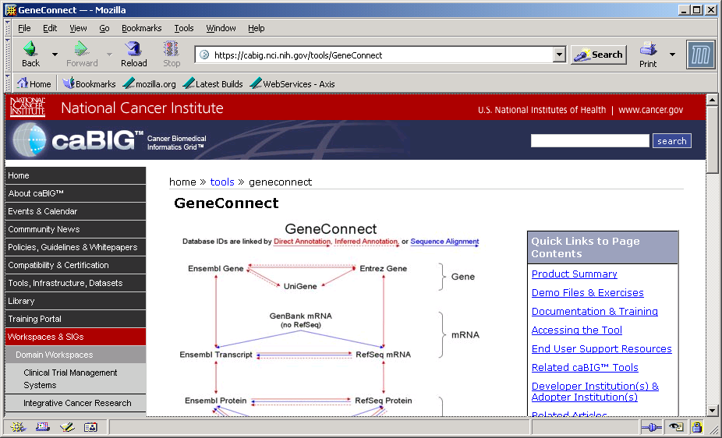

It would be nice if this information is made available on the “portal” for the GeneConnect service interweaved with the “technical” content, see below:

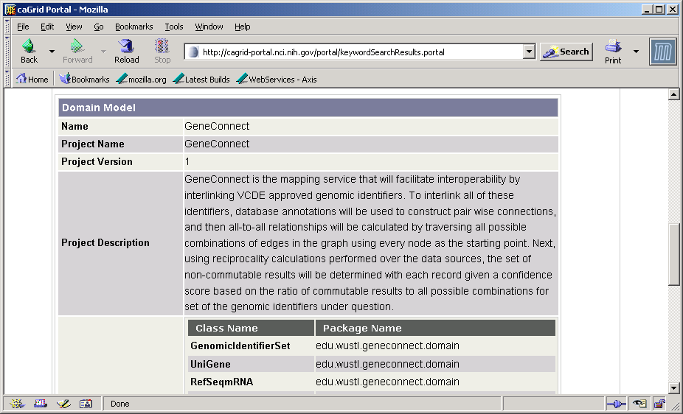

Clint Malone from NCICB can help in getting the pages from the caBIG site, if needed.

On the other hand, the “portal” lacks the basic ability for a user to invoke the services and to create an ad hoc “workflow”. It would be nice, if a user (public user and a logged in user with credential as part of trust structure in Dorian) is able to invoke some APIs ( analytic such as caDSR, EVS, GenePattern, etc), do some queries on data services and perform some basic workflows (e.g. query for some images in NCIA, select them and then run an image CAD algorithm)

Generally, I would like Portal to become the “reference” implementation of new features/enhancements in caGrid. For example, when the Identifier based caBIO service is migrated to caGrid, then, it would be nice to have UI in the portal that allows a query based on the Identifier (testing the resolution service).

One idea is to merge the Portal and Browser into a single “Portal” that is more portal like!

Per other discussions, reusable web application tools for creating web applications that make use of caGrid need to be developed. The “portal” itself could be this more generic infrastructure, or it could use a set of tools which others could also use.

Workflow

- The UI tool selection will most probably be driven by ICR Workspace as part of the working group project. It would be very helpful to get prepared for this integration, including (but not limited to):
  - Replacement of ActiveBPEL workflow engine if necessary (based on Ravi’s thinking)
    - All management operations should be done through the service interface (can’t show status using the behind the scenes engine (e.g. ActiveBPEL web app)).
  - Validate installation and deployment of workflow related services in production and sandbox environment.
  - Rewrite programmers guide and user guide to make it helpful to a “mid-level” programmer implement workflow service.
  - Integrate with caGrid security infrastructure and add documentation for the same. Remove references to grid-map security in workflow doc since it is not recommended
  - Integrate workflow for Bulk Data transport and possibly Identifiers
- Writing BPEL workflows is hard. We need to make it easier for the community to leverage workflow. There are a couple approaches to this, and we should probably do both:
  - 1) Make it easier to write workflows. Part of this can be GUIs, macros, and abstracting BPEL a bit (such as using a UML view as described above).
  - 2) Make it easier to reuse workflows that were already created. An infrastructure for sharing, parameterizing, etc workflows
- Look into simple dynamic invoker tool, often brought up by users
  - Can we use workflow to create an API to execute an arbitrary method on an arbitrary service (without needing service’s stubs). Many “workbench” tools want something like this, so they can discover and invoke arbitrary services. Portal will need this too if it supports invoking an arbitrary service.

Security
- CSM is planning developing a solution for providing instance level security with a reasonable performance and scalability. Integrate with solution in caGrid (Grid Grouper, PDP, etc).
- Work on SWG recommendation as they come!
  - Most importantly is a process for getting trusted credentials for users and services.
- Validate the Trust framework in Dorian by obtaining a few more adopters. The caGrid portal (or browser) access would be the application that is used to engage the adopters.
- Higher level tools for creating (or plugging in) authorization policies to services
- Investigate auditing requirements
- Make performance enhancements for secure data access.
- Engage with caB2B (Rakesh), caTIES (Kevin), caIntegrator (Subha) and CTMS Interop (Patrick) to validate caGrid security infrastructure.
  - Work with portal and application developer to create SOPs for leveraging the security infrastructure in applications

Data Service
- Work with data service developers to determine additional functionality in CQL.
  - Returning/populating associations?
  - Predicates on parent objects (unidirectional associations)?
  - Readdress querying for subclasses (what should be supported)?
  - Need to investigate support for inheritance
  - Limit clause?
- Make performance enhancements in FQP and related DCQL based on identifiers, etc.
  - Notification support (for query status)
  - Service-side delegation/security support
  - Support for query modifiers in DCQL
  - Investigate if FQP could use workflow infrastructure to execute queries
- Integrate with the latest SDK and CSM enabled SDK.
  - Wizard should support both (selection of which to use)
  - Including new changes for “local access” (non http tunneled)
- Explore performance and scalability in grid data service APIs;
  - Capture metrics for various operations; work with application developers to discover real world bottle necks.
- Add any integration with caDSR and GME to improve data service creation and validation
  - Leverage caDSR storing GME namespaces to completely hide selection of XML schemas
- Investigate and develop prototype integration using Identifiers and Bulk data transport (GridFTP) for large scale data access.
- Ability to support update, delete, insert?

