caGrid caDSR Grid Service

Technical Guide

caBIG™ is an initiative of the National Cancer Institute, NIH, DHHS

Copyright and License page

Insert Names of Development Team(s) here
Development | Programmer’s guide |  | Program Management
Names of developers | Names of technical writers and reviewers |  | Names of program managers
Scott Oster | Scott Oster
¹ Footnote contributing companies/ contractors/ divisions |  | ³ company
² department or division

Contacts and Support
Enter training contact | name (email address)
Enter customer support contact | Web hyperlink  Telephone: 111-222-3456  Toll free: 888-234-1234

LISTSERV Facilities Pertinent to software teams
LISTSERV | URL | Name
caGrid_Developers | https://list.nih.gov/archives/cagrid_developers.html | caGrid Developers Discussion

Table of Contents
Chapter 1 Introduction to the Technical Guide 3
Overview of the Guide 3
Document Text Conventions 3
Chapter 2 caDSR Grid Service Overview 5
Introduction 5
Chapter 3 caDSR Component APIs 7
Introduction 7
Component Details 7
caCORE ApplicationService 7
DomainModelBuilder 8
ServiceMetadataAnnotator 9
UML2XMLBinding 9
Chapter 4 caDSR Grid Service Infrastructure 10
Introduction 10
Service Data types 10
Service Details 12
Appendix A References 13
Technical Manuals/Articles 13
Scientific Publications 13
caBIG Material 13
caCORE Material 13
Appendix B Glossary 15
Index 19

List of Figures
Figure 1 Federated Query Infrastructure Overview 5
Figure 2 Federated Query Engine Components 11
Figure 3 Federated Query Services 14

- Introduction to the Technical Guide

Overview of the Guide
Brief overview of this developer’s guide.

Document Text Conventions
The following table shows various typefaces to differentiate between regular text and menu commands, keyboard keys, and text that you type. This illustrates how conventions are represented in this guide.
Convention | Description | Example
Bold & Capitalized Command  Capitalized command > Capitalized command | Indicates a Menu command  Indicates Sequential Menu commands | Admin > Refresh
text in small caps | Keyboard key that you press | Press enter
text in small caps + text in small caps | Keyboard keys that you press simultaneously | Press shift + ctrl and then release both.
Special typestyle | Used for filenames, directory names, commands, file listings, source code examples and anything that would appear in a Java program, such as methods, variables, and classes. | URL_definition ::= url_string
Boldface type | Options that you select in dialog boxes or drop-down menus. Buttons or icons that you click. | In the Open dialog box, select the file and click the Open button.
Italics | Used to reference other documents, sections, figures, and tables. | caCORE Software Development Kit 1.0 Programmer’s Guide
Italic boldface type | Text that you type | In the New Subset text box, enter Proprietary Proteins.
Note: | Highlights a concept of particular interest | Note: This concept is used throughout the installation manual.
Warning! | Highlights information of which you should be particularly aware. | Warning! Deleting an object will permanently delete it from the database.
{} | Curly brackets are used for replaceable items. | Replace {root directory} with its proper value such as c:\cabio
Table 1 Document Conventions

- caDSR Grid Service Overview

Introduction
The caGrid caDSR Grid Service provides access to information in the caDSR that is relevant to caGrid, and has capabilities to generate caGrid standard metadata instances. Specifically, the service provides operations to access UML-like information stored in the caDSR. It also has operations to generate Data Service metadata for a described subset of a given project registered in caDSR. Finally, it has an operation which augments a description of an Analytical Service, via a partially populated service metadata instance, with the necessary UML-like and semantic information, extracted from caDSR, to describe the service and its operations.

The components of the service, shown below in Figure 1, are composed of the actual grid service and the various APIs used to gather the necessary information. These APIs can also be used directly, if necessary, without going through the grid service.
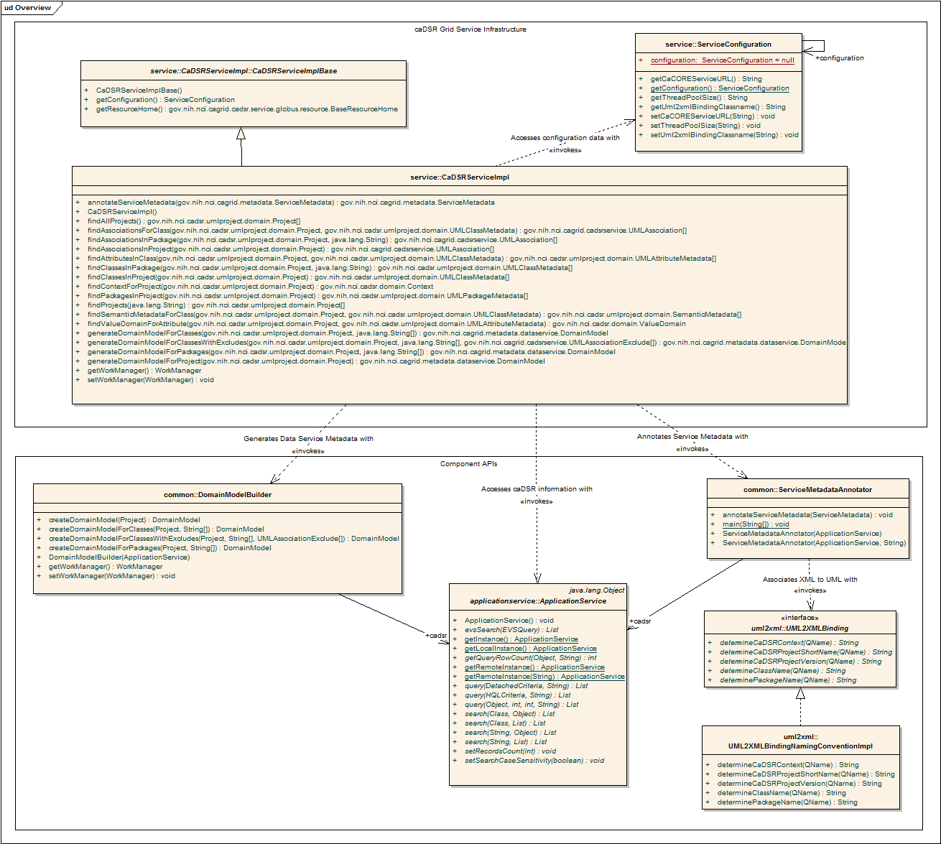
Figure 1 caDSR Grid Service Overview
- caDSR Component APIs

Introduction
This chapter describes the various components, shown below in Figure 2, that make up the business logic of the caDSR grid service. Each component is generally usable outside of the grid service, as a stand alone API.

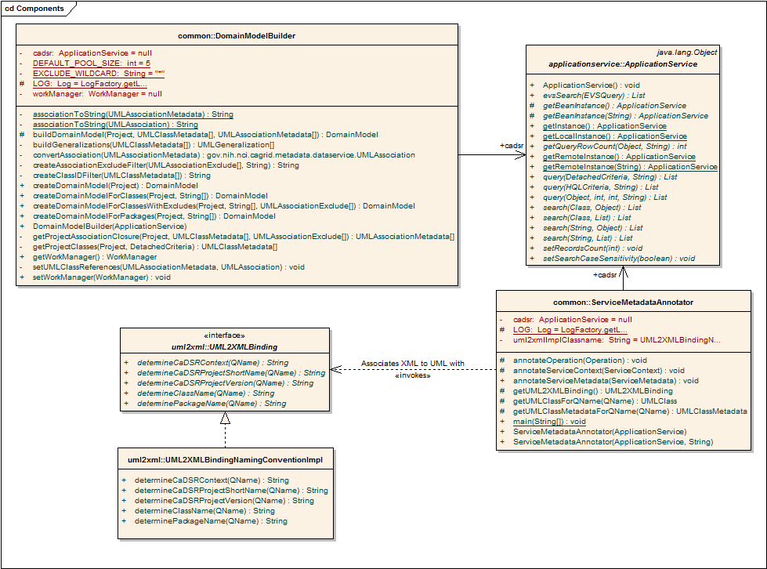
Figure 2 caDSR Components

Component Details

caCORE ApplicationService
The caCORE 3.1 ApplicationService is used be various other components, and by the service logic itself, to access information in the caDSR. It provides a simple query API which is available for remote access. The component APIs that make use of the ApplicationService, generally take in instance of it in their constructor. The service itself, creates an instance by using the ApplicationService.getRemoteInstance(url) call, where the URL used is populated via a configuration parameter.

The ApplicationService is used to issue both HQL (Hibernate Query Language), and simple “query by example” queries. The two caCORE models which are consulted are the gov.nih.nci.cadsr.domain model, which represents the caDSR information and the gov.nih.nci.cadsr.umlproject.domain, which represents a UML-like view of information in the caDSR.

DomainModelBuilder
The DomainModelBuilder provides the ability to generate caGrid standard Data Service metadata instances for project’s registered in the caDSR. The Data Service metadata describes the information model being exposed by a Data Service. For more information on the model, consult the caGrid metadata design document. The DomainModelBuilder uses the ApplicationService to access the necessary information from the caDSR. It mostly uses optimized HQL queries to efficiently access the necessary information, utilizing eager association fetching where appropriate. The majority of work performed by the DomainModelBuilder is simply aggregating and transforming information in the caDSR into the format necessary to describe the DomainModel metadata of Data Services. As much of the necessary extraction and transformation is independent, and the information is located in a remote system where network delays slow down computation, the DomainModelBuilder benefits greatly from parallelism. In order to achieve this parallelism, the builder employs a work/thread pool. The commonj WorkManager, distributed with Globus, is used for this purpose. In this framework, the work to be done is modeled as implementations of the Work interface, and Work items are scheduled with the WorkManager for execution with a configurable pool of threads. This provides a mechanism to manage the amount of system resources consumed by the service for the purposes of scheduling background tasks. Each task concurrently scheduled beyond the maximum number of worker threads is placed in a priority queue for processing once a currently executing task completes, and a thread becomes available. The DomainModelBuilder utilizes the WorkManager by creating Work items for each UML Class and UML Attribute it processes in the model.

The DomainModelBuilder provides four variants of the operation used for creating domain model instances. Each method, takes as input, a representation of the caDSR Project for which the DomainModel should be created. The first, createDomainModelForProject, takes only the project description, and generates a model which describes the entire domain model being exposed for the project. The second, createDomainModelForPackage, additionally takes an array of Strings which represent UML package names in the Project which should be exposed. The method generates a model which describes exposing all UML Classes which are in UML Packages with a name specified in the array. Any associations to UML Classes outside of the specified packages are not exposed. The third method, createDomainModelForClasses, also takes an array of Strings which represent the fully qualified UML Class names which should be exposed in the model. Any association between classes not specified is omitted. The final method, createDomainModelForClassesWithExcludes, also takes an additional array of Strings which represent the fully qualified UML Class names which should be exposed in the model, but also takes an array of UMLAssociationExcludes which can be used to exclude specific associations from the model (in addition to the already excluded associations which reference classes not specified in the array of class names). The UMLAssociationExclude Class allows the client to specify a sourceRoleName, sourceClassName, targetRoleName, and targetClassName. Any UML Association which would otherwise be included in the computed subset of the DomainModel is omitted if it meets the criteria described by any of the UMLAssociationExcludes. The value of any attribute of the UMLAssociationExclude can be the wildcard “*” which indicates it should match anything. As such, specifying an exclude with “*” as the value for all attributes would effectively omit all associations from the DomainModel. By using no wildcards, a single association can be omitted, and by using a combination of some values and some wildcards, groups of associations can be omitted. For example, specifying an exclude instance with a sourceClassName value of “gov.nih.nci.cabio.domain.Gene” and wildcards for all other attributes would effectively omit any associations from the DomainModel where gov.nih.nci.cabio.domain.Gene was the source of the association. Using these methods, in combination with the service provided methods of finding all Projects, Packages, Classes, and Associations a DomainModel exposing any subset of Classes and Associations can be created. The DomainModelBuilder API allows a client to simply identify the items to be exposed in the Project, and it does the work to create the conforming DomainModel instance.

The ServiceMetadataAnnotator is similar to the DomainModelBuilder in that it creates caGrid metadata instances. However, the ServiceMetadataAnnotator produces the standard ServiceMetadata common to all caGrid services, and it requires the client to supply a partially populated model as input. The caGrid common service metadata specifies information about a grid service and its operations. For more information on the model, consult the caGrid metadata design document. The ServiceMetadataAnnotator takes this model and populates the UML and semantically oriented components by querying the caDSR appropriately. Specifically, it populates the semantically annotated UML Class information (similar to the type used in Data Service Domain Model metadata) for each input and output type of every operation the service provides. It does this by examining the XML Qualified Name (QName) of each type used in the signature of the operation and locating its UML equivalent in caDSR. In caGrid every grid service operation is required to use data types which are XML representations of UML Classes registered in the caDSR. The is a one to one mapping of UML Class to XML QNames (XML elements). In order to identify the appropriate UML Class for each QName used by a grid service operation, the ServiceMetadataAnnotator requires an implementation of the UML2XMLBinding interface. This interface, described further in the following section, defines operations for extracting information about the corresponding UML Class of a given QName. The ServiceMetadataAnnotator takes the class name of the implementation of this interface, and uses reelection to dynamically instantiate an instance of it. Once the binding is determined, the annotator uses the ApplicationService to extract the information relevant to populating the ServiceMetadata instance from the caDSR. It follows a similar process to the DomainModelBuilder for such queries, and the two APIs share a common set of low level utilities defined in the caDSRUtils Class.

In addition to annotating operation input’s and output with their caDSR information, the SemanticMetadataAnnotator will be able to augment the service and its operation’s with semantic metadata once services are registered in the caDSR.

UML2XMLBinding
As mentioned above, the UML2XMLBinding interface defines operations for extracting caDSR registered information about XML QNames. As each operations on the grid operate over XML data, caBIG requires that the structure of the XML is defined by XML Schemas registered in the Global Model Exchange. Each data type is uniquely identified by its Qualified Name (QName), which consists of an XML namespace and name. Further, each data type used in the grid, identified by a QName, is the XML materialization of a UML Class registered in the caDSR. As such, there is a one to one mapping between caDSR registered classes, and XML QNames used in the grid as operation inputs and outputs. The UML2XMLBinding defines operations which provide access to this mapping (or binding).

The caDSR is expected to maintain this binding in the future. At which time this occurs, an implementation of this interface could be created which accesses the caDSR in response to method invocations. Until this point, an implementation, UML2XMLBindingNamingConventionImpl, is provided which uses the XML naming conventions defined by caGrid to try to identify the appropriate information in caDSR. For projects which defined their XML Schemas using the recommended naming convention, this implementation should suffice. For information about this recommendation, consult the caGrid Metadata design document. Projects which are using an alternate convention for namespaces, such as an existing XML standard, will not be properly retrieved by this implementation, and an exception, CaDSRGeneralException, will be raised. APIs should only use the interface so they may be updated to pull the information from caDSR for all projects (removing these limitations) at which point the caDSR maintains this information and another implementation is provided. This is the approach the ServiceMetadataAnnotator takes, as its constructor allows the specification of the implementation of the interface it should use. The caDSR grid service also makes this available as a configuration option, so it can be updated without code changes.

- caDSR Grid Service Infrastructure

Introduction

Uses components
Introduce created

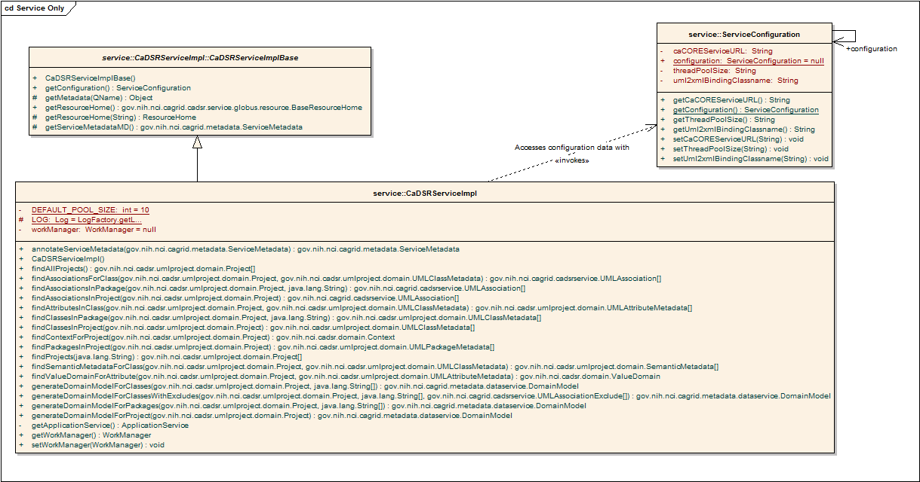
Figure 3 caDSR Grid Service

Service Data types
Asdf
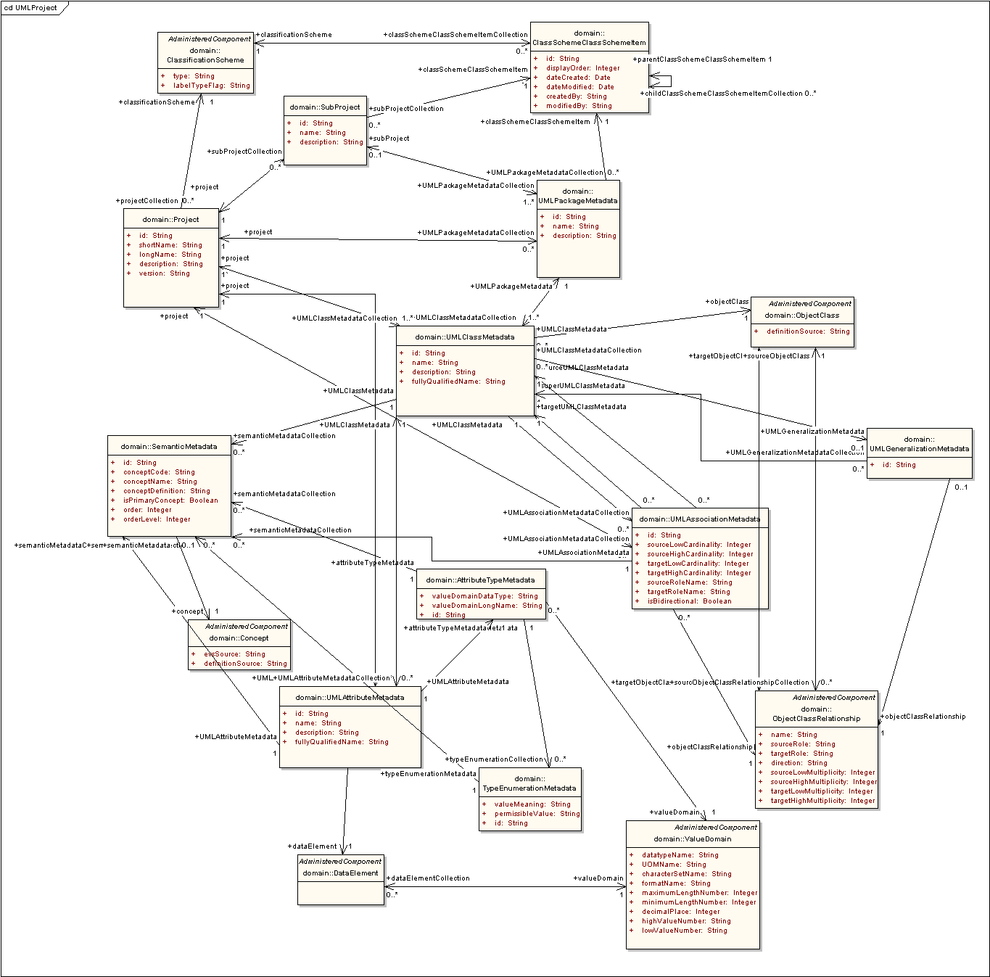
Figure 4 UML Project Model

Asdf

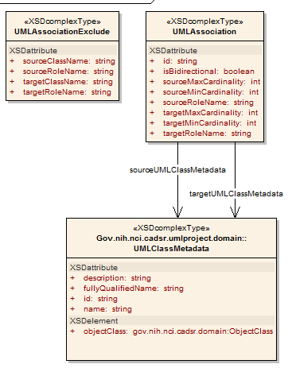
Figure 5 caDSR Grid Service Types

Service Details
Describe api, faults
Describe the impl
Describe service properties

The service contains a single WSRF Resource, which exposes service-level metadata as resource properties. The only resource property currently exposed by the service is the standard caGrid 1.0 ServiceMetadata, which describes the data types and operations of the service.

- References
This appendix could include lists and hypertext links, where appropriate, to technical manuals, articles, scientific publications, etc. Examples are shown:

Technical Manuals/Articles
- National Cancer Institute. "caCORE 2.0 Technical Guide", ftp://ftp1.nci.nih.gov/pub/cacore/caCORE2.0_Tech_Guide.pdf
- Java Bean Specification: http://java.sun.com/products/javabeans/docs/spec.html
- Foundations of Object-Relational Mapping: http://www.chimu.com/publications/objectRelational/
- Object-Relational Mapping articles and products: http://www.service-architecture.com/object-relational-mapping/
- Hibernate Reference Documentation: http://www.hibernate.org/hib_docs/reference/en/html/
- Basic O/R Mapping: http://www.hibernate.org/hib_docs/reference/en/html/mapping.html
- Java Programming: http://java.sun.com/learning/new2java/index.html
- Javadoc tool: http://java.sun.com/j2se/javadoc/
- JUnit: http://junit.sourceforge.net/
- Extensible Markup Language: http://www.w3.org/TR/REC-xml/
- XML Metadata Interchange: http://www.omg.org/technology/documents/formal/xmi.htm

Scientific Publications

caBIG Material
- caBIG: http://cabig.nci.nih.gov/
- caBIG Compatibility Guidelines: http://cabig.nci.nih.gov/guidelines_documentation

caCORE Material
- caCORE: http://ncicb.nci.nih.gov/core
- caBIO: http://ncicb.nci.nih.gov/core/caBIO
- caDSR: http://ncicb.nci.nih.gov/core/caDSR
- EVS: http://ncicb.nci.nih.gov/core/EVS
- CSM: http://ncicb.nci.nih.gov/core/CSM
- Glossary
Following is an example list of terms and their definitions.
Term | Definition
{jboss-home} | The base directory where JBoss is installed on the server
API | Application Programming Interface
caArray | cancer Array Informatics
caBIG | cancer Biomedical Informatics Grid
caBIO | Cancer Bioinformatics Infrastructure Objects
caCORE | cancer Common Ontologic Representation Environment
caDSR | Cancer Data Standards Repository
caMOD | Cancer Models Database
cardinality | Cardinality describes the minimum and maximum number of associated objects within a set
CDE | Common Data Element
CGAP | Cancer Genome Anatomy Project
CMAP | Cancer Molecular Analysis Project
CN | Common Name
CS | Classification Scheme
CSI | Classification Scheme Item
CSM | Common Security Module
CTEP | Cancer Therapy Evaluation Program
CUI | Concept Unique Identifier
CVS | Concurrent Versions System
DAML | DARPA Agent Markup Language
DAO | Data Access Objects
DARPA | Defense Advanced Research Projects Agency
DAS | Distributed Annotation System
DL | Description Logic
EA | Enterprise Architect
EBI | European Bioinformatics Institute
EVS | Enterprise Vocabulary Services
GAI | CGAP Genetic Annotation Initiative
GEDP | Gene Expression Data Portal
HIPPA | Health Insurance Portability and Accountability Act
HLGT | High Level Group Term
HLT | High Level Term
HTTP | Hypertext Transfer Protocol
ISO | International Organization for Standardization
JAAS | Java Authentication and Authorization Service
JAR | Java Archive
Javadoc | Tool for generating API documentation in HTML format from doc comments in source code (http://java.sun.com/j2se/javadoc/)
JDBC | Java Database Connectivity
JET | Java Emitter Templates
JMI | Java Metadata Interface
JSP | JavaServer Pages
JUnit | A simple framework to write repeatable tests (http://junit.sourceforge.net/)
LDAP | Lightweight Directory Access Protocol
LLT | Lowest Level Term
LOINC | Logical Observation Identifier Names and Codes
MAGE | MicroArray and Gene Expression
MAGE-OM | MicroArray Gene Expression - Object Model
MedDRA | Medical Dictionary for Regulatory Activities
metadata | Definitional data that provides information about or documentation of other data.
MGED | Microarray Gene Expression Data
MMHCC | Mouse Models of Human Cancers Consortium
MO | MGED Ontology
multiplicity | Multiplicity of an association end indicates the number of objects of the class on that end may be associated with a single object of the class on the other end
NCI | National Cancer Institute
NCICB | National Cancer Institute Center for Bioinformatics
OIL | Ontology Inference Layer
OilEd | Ontology editor allowing you to build ontologies using DAML+OIL
OLLT | Obsolete Lower Level Terms
OMG | Object Management Group
ORM | Object Relational Mapping
PT | Preferred Term
RDBMS | Relational Database Management System
SDK | Software Development Kit
Semantic connector | A development kit to link model elements to NCICB EVS concepts.
SOC | System Organ Class
SPORE | Specialized Programs of Research
SQL | Structured Query Language
SSC | Special Search Categories
UI | User Interface
UID | User Identification
UML | Unified Modeling Language
UMLS | Unified Medical Language System
UPT | User Provisioning Tool
URL | Uniform Resource Locators
VD | Value Domain
WAR | Web Application Archive
WSDL | Web Services Description Language
XMI | XML Metadata Interchange (http://www.omg.org/technology/documents/formal/xmi.htm) - The main purpose of XMI is to enable easy interchange of metadata between modeling tools (based on the OMG-UML) and metadata repositories (OMG-MOF) in distributed heterogeneous environments
XML | Extensible Markup Language (http://www.w3.org/TR/REC-xml/) - XML is a subset of Standard Generalized Markup Language (SGML). Its goal is to enable generic SGML to be served, received, and processed on the Web in the way that is now possible with HTML. XML has been designed for ease of implementation and for interoperability with both SGML and HTML

Index
It is very easy to generate an index and extremely helpful to the manual user. See the Technical Style Guide located at: https://cabig.nci.nih.gov/working_groups/Training_SLWG/Documents/Technical_Pubs_Style_Guide_021405_jbh.pdf for directions for inserting index markers and generating an index in MS Word (PC).

Document conventions, Supplement, 3
Glossary, 15
References
caBIG materials, 13
caCORE material, 13
scientific publications, 13
technical manuals, guides, 13
Text conventions, Supplement, 3

