Data Service Tutorial

Overview
This tutorial will explain the basic steps required to set up a simple grid service using the Data Service extension in the Introduce toolkit. A Custom CQL query processor for the grid service will be written, the service will be deployed to a Tomcat container, and the service will be invoked in a test.

The following is an outline of the tutorial:
- Create a new grid service with the Data Service Extension
- Configure the Data Service Extension
- Implement the CQL Query Processor and the Data Service Client
- Deploy the Data Service
- Invoke the Data Service

A. Create a new Grid Service with the Data Service Extension
In this section, a new grid service will be set up using the Introduce toolkit. The new service will be created with the Data Service extension allowing the modification of Data Service settings within the Introduce toolkit.

  - Launch the Introduce Grid Service Authoring Toolkit.
  - Select Create Service from the toolbar or select Tools->Create Service from the menu bar. The Create Grid Service screen will appear. See Figure 1 below.
  - Choose a directory in which to place the service. This tutorial will use “C:\DataServiceTutorial”.
  - Type in the Service Name. This tutorial will use “DataServiceTutorial”.
  - Choose a Package. This tutorial will be using “osu.lib.dataservicetutorial”.
  - Choose a Namespace. This tutorial will be using “http://dataservicetutorial.osu.lib/DataServiceTutorial”.
  - In the Service Extensions drop-down, select “Data Service” and click the Add button.
  - Click the Create button at the bottom of the creation screen.
  - In the configuration dialog that appears, select the custom data source radio button and select OK.
  - Be patient while Introduce creates the service. This may take a few minutes.

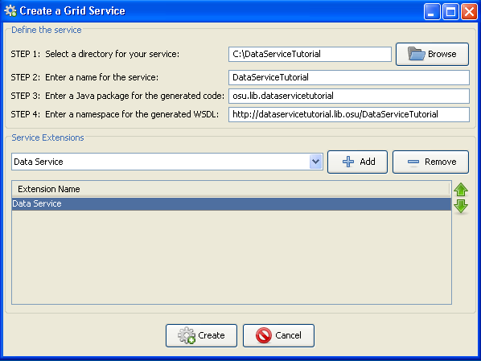
Figure 1: Create Grid Service dialog

B. Configure the Data Service Extension
Next, the parameters and settings specific to the Data Service must be configured. As a result of adding the Data Service Extension when creating the service, a tab is available in the Introduce service modification view where these settings are available.

- When Introduce is finished creating the service, the Modify Service window will appear. Select the Data Service Tab. See Figure 3 below.
- Select caDSR Domain model from Domain Model Source region. ‘Supplied Domain Model’ is for users who have already generated a domain model, and ‘No Domain Model’ is for testing purposes.
- Next, the correct package of data types needs to be added. In the select Data Type region, select the project drop-down and choose “caCOREs (version: 3)” In the Package drop-down, choose “gov.nih.nci.cadsr.domain.” Finally, click Add Package.
- A schema resolution dialog will appear informing you that the default schema for the selected package is not yet in the service. Click the OK button to load it. In the new dialog, select the Global Model Exchange tab. Select from the Namespace drop-down the option: caCORE.caCORE. From the Name field, chooser 3.1/gov.nih.nci.cadsr.domain. Click the Load Schemas button to close the dialog.
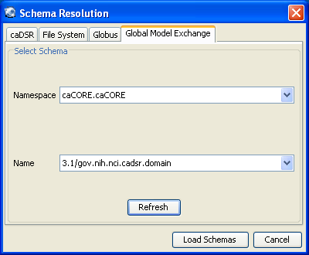
Figure 2: Schema Resolution dialog

- In the UML Class Selection region, a new group should appear. Expand the gov.nih.nci.cadsr.domain group and check the ‘Question’ data type. Doing so specifies that the Question data type may be used in a CQL Query. In the case of this tutorial, it will be the data type the client will request be returned to it.

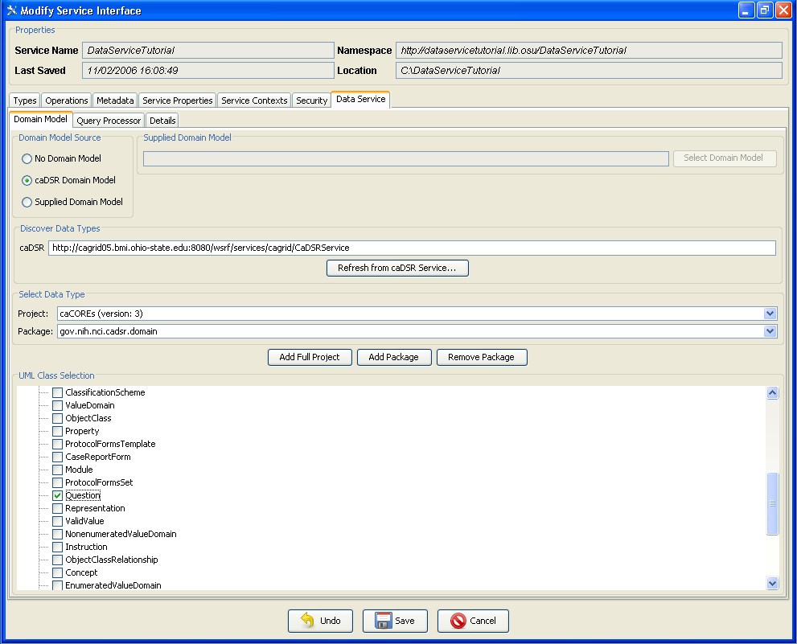
Figure 3: Data Service Domain Model tab

- Now select the Query Processor tab. Notice the Selected Class textbox. This is the class that will serve as your query processor for CQL queries made to the data service. Later in the tutorial, we will fill in a method in this class to implement the processor.
- Select the Details tab. Select the Question data type in the Exposed Class Configuration region. Right click its Serializer column and select the SDK Serialization option. This specifies the proper serialization and deserialization of the Question object for the queries. The same serializer and deserializer should be used for any objects generated by the caCORE SDK.
- Ensure the Targetable option is checked, this will allow queries to return this data type as the result. Data types with this option unselected will be available for use in CQL queries, but cannot be returned.
- Finally, check the Validate CQL Syntax and Validate Domain Model boxes to enable error checking on the CQL queries processed at runtime.

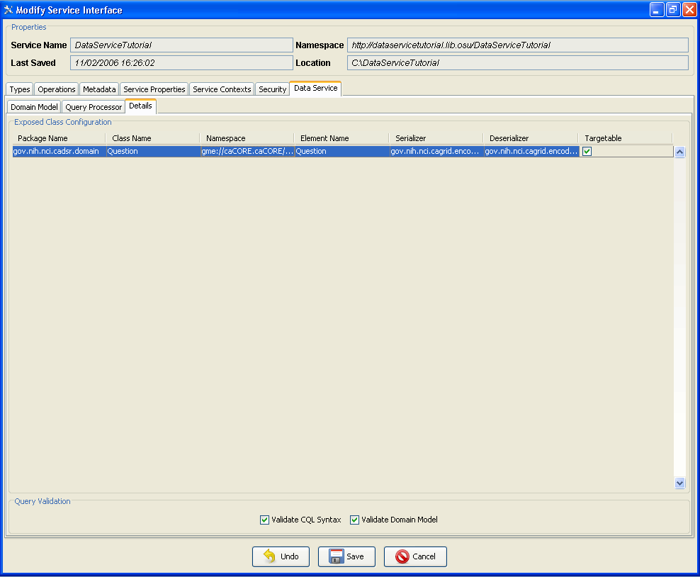
Figure 4: Data Service Details tab.

- Click save at the bottom of the window. Introduce will rebuild the service with the new parameters, and create a Domain Model containing the selected data types. This process can take a few minutes on a slow internet connection.
- Select File->Exit to close the Introduce toolkit completely.

C. Implement the CQL Processor and the Grid Service Client

This part of the tutorial will implement the CQL processor and the data service client. The CQL Processor is responsible for determining what object is requested by the client, finding it in some data storage facility, and returning it to the client. Only one method is required to be implemented for processor. This method takes a CQLQuery object containing the query information and returns a CQLResults object which contains the object or objects to be returned to the client.

- In the folder C:\DataServiceTutorial\src\gov\nih\nci\cagrid\dataservicetutorial\stubs\cql\ open the file StubCQLQueryProcessor.java.
- Replace the contents of the processQuery method with the code below:

CQLQueryResults results;
Mappings mappings = null;
try {
String filename = ServiceConfigUtil.getClassToQnameMappingsFile();
mappings = (Mappings) Utils.deserializeDocument(
filename, Mappings.class);
} catch (Exception ex) {
throw new QueryProcessingException(
"Error getting class to qname mappings: " + ex.getMessage(), ex);
}
String targetName = cqlQuery.getTarget().getName();
ArrayList resultObjects = new ArrayList();
Question question = new Question();
question.setDefaultValue("What is the meaning of life?");
resultObjects.add(question);
try
{
results = CQLResultsCreationUtil.createObjectResults(
resultObjects, targetName, mappings);
} catch(Exception ex) {
throw new QueryProcessingException(
"Error creating object results: " + ex.getMessage(), ex);
}
return results;

- Save StubCQLQueryProcessor.java

- Now open the file DataServiceTutorialClient.java located in the folder C:\DataServiceTutorial\src\gov\nih\nci\cagrid\dataservicetutorial\client\. This code will direct the client’s actions for the grid service. In this tutorial, the client simple sends a CQL Query requesting a Question object in return. It will then print out the defaultValue field of the object returned to it by the CQL Processor. Replace the contents of the method main with the code below:

System.out.println(
"Running the DataServiceTutorial Service Client");
try{
if(!(args.length < 2)){
if(args[0].equals("-url")){
DataServiceTutorial client = new
DataServiceTutorial(args[1]);
CQLQuery query = new CQLQuery();
gov.nih.nci.cagrid.cqlquery.Object target =
new gov.nih.nci.cagrid.cqlquery.Object();
target.setName(Question.class.getName());
query.setTarget(target);
CQLQueryResults results = client.query(query);
Iterator iter = new CQLQueryResultsIterator(results,
DataServiceTutorial.class.getResourceAsStream(
"client-config.wsdd"));
while (iter.hasNext()) {
Object o = iter.next();
System.out.println(
((Question)o).getDefaultValue());
}
System.out.println("Query Complete.");
} else {
usage();
System.exit(1);
}
} else {
usage();
System.exit(1);
}
} catch (Exception e) {
e.printStackTrace();
System.exit(1);

- Save DataServiceTutorialClient.java

D. Deploy the Grid Service
A grid service may be deployed to either a Globus or a Tomcat container. In this tutorial, Tomcat will be used.
- Open a Command prompt and change to the C:\DataServiceTutorial directory.
- Rebuild the data service code with the command: ant all
- Verify that the command resulted in a Build Successful message.
- Deploy the data service with the command: ant deployTomcat

To deploy to a Globus container, replace the command deployTomcat with deployGlobus.

E. Test the Grid Service
Now that the service has been deployed to Tomcat, the service may be tested. An ant script located in the grid service directory will run the client and invoke the service.

- Using a command prompt, change to the Catalina Home directory. Do this by entering cd %CATALINA_HOME%.
- Now enter /bin/startup.bat to start the Tomcat server. Wait for a new Tomcat console window to appear and finish loading Tomcat.
- Now, at the original command prompt, change directories to C:\DataServiceTutorial\ and enter the command ant runClient.
- The result of the run should produce the following output:

C:\DataServiceTutorial>ant runClient
Buildfile: build.xml

setGlobus:

checkGlobus:
[echo] Globus: C:\progs\Globus

defineClasspaths:

runClient:
[echo] Connecting to service: http://localhost:8080/wsrf/services/cagrid/Da
taServiceTutorial
[java] JVM args ignored when same JVM is used.
[java] Running the DataServiceTutorial Service Client
[java] What is the meaning of life?
[java] Query Complete.

BUILD SUCCESSFUL
Total time: 6 seconds

