Overview

Goals
- Determine the process by which a caBIG “gold” compatible service (consider “gold” to mean “grid”) could be hosted on a TeraGrid facility.
  - Technology challenges (authentication framework, etc)
  - Process needs including contacts, paperwork, signoffs, etc

- Publish the TeraGrid-caGrid service on caGrid “stack” and be able to access it using caGrid APIs
  - Users should not need to jump through extra steps to access the TeraGrid service
  - There should be “synchronous” response. i.e the service should be in “running mode” and be able to respond “On Demand” instead of having the user submit a job to the queue and wait for free cycles.
  - User provisioning ease (i.e we don’t want every user to be getting their own user id )

- Determine if there are any constraints placed by caGrid on TeraGrid or vice versa that limits interoperability (both technology, policy wise or simply structurally)

- Determine if caGrid users find this facility usable for future activities
  - E.g. compute intensive workflows, etc

Background (from TeraGrid documentation)

TeraGrid Overview
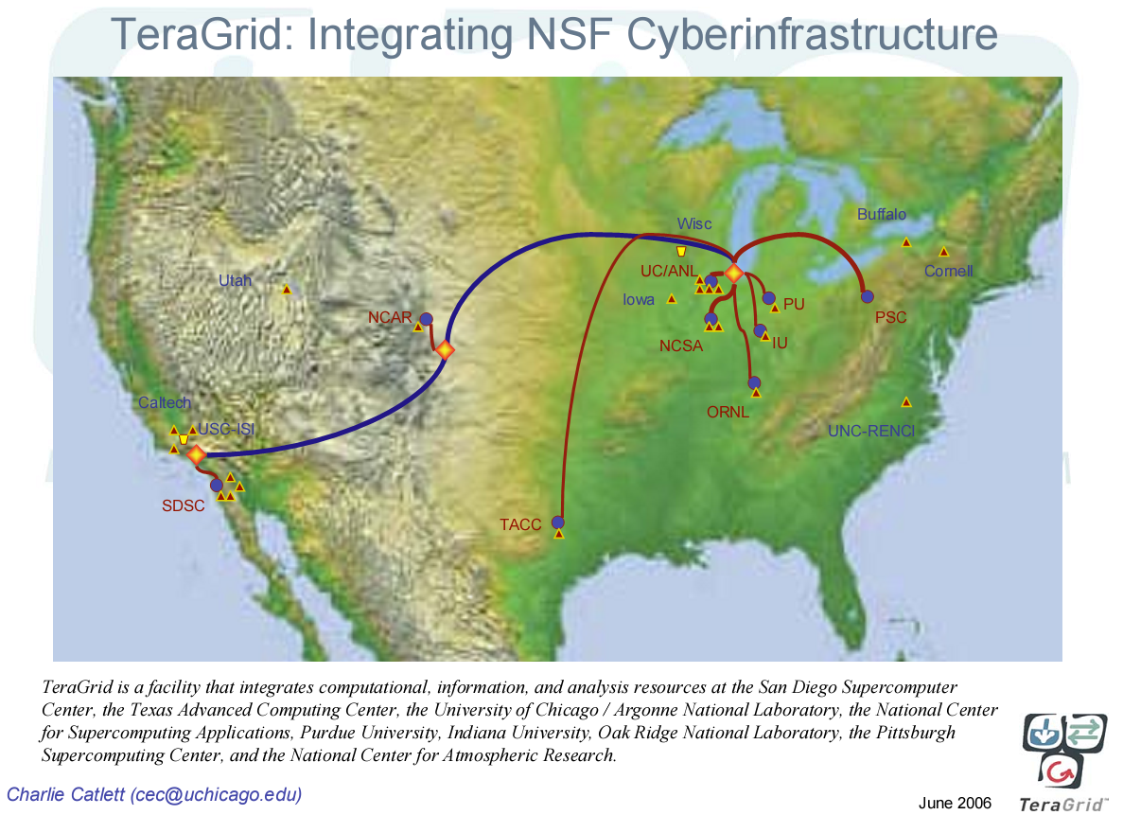
TeraGrid is an open scientific discovery infrastructure combining leadership class resources at nine partner sites to create an integrated, persistent computational resource.
Using high-performance network connections, the TeraGrid integrates high-performance computers, data resources and tools, and high-end experimental facilities around the country. These integrated resources include more than 102 teraflops of computing capability and more than 15 petabytes (quadrillions of bytes) of online and archival data storage with rapid access and retrieval over high-performance networks. Through the TeraGrid, researchers can access over 100 discipline-specific databases. With this combination of resources, the TeraGrid is the world's largest, most comprehensive distributed cyberinfrastructure for open scientific research.
TeraGrid is coordinated through the Grid Infrastructure Group (GIG) at the University of Chicago, working in partnership with the Resource Provider sites: Indiana University, Oak Ridge National Laboratory, National Center for Supercomputing Applications, Pittsburgh Supercomputing Center, Purdue University, San Diego Supercomputer Center, Texas Advanced Computing Center, University of Chicago/Argonne National Laboratory, and the National Center for Atmospheric Research.

Science Gateway
Science Gateways signal a paradigm shift from traditional high performance computing use. Gateways enable entire communities of users associated with a common scientific goal to use national resources through a common interface. Science gateways are enabled by a community allocation whose goal is to delegate account management, accounting, certificates management, and user support to the gateway developers.
Science Gateways take three common forms:
- A gateway that is packaged as a web portal with users in front and TeraGrid services in back.
- Grid-bridging Gateways: often communities run their own Grids devoted to their areas of science. In these cases the Science gateway is a mechanism to extend the reach of the community Grid so it may use the resources of the TeraGrid.
- A gateway that involves application programs running on users' machines (i.e. workstations and desktops) and accesses services in TeraGrid (and elsewhere).
Scientific gateways can have varying goals and implementations. Some expose specific sets of community codes so that anonymous scientists can run them. Others may serve as a "metaportal," a community portal that brings a broad range of new services and applications to the community. A common trait of all three types is their interaction with the TeraGrid through the various service interfaces that TeraGrid provides. Although the gateways may be instantiated on TeraGrid resources, it is expected that many will be instantiated on community resources and be administered by the community itself.

Useful Information:
- TeraGrid Homepage: http://www.teragrid.org/
- TeraGrid Science Gateways: http://www.teragrid.org/programs/sci_gateways/
- TeraGrid Hardware: http://www.teragrid.org/userinfo/hardware/resources.php
- TeraGrid Software: http://www.teragrid.org/userinfo/software/ctss3.php

caGrid/TeraGrid Software Compatibility

caGrid software requirements:
- Java 5
  - TeraGrid CTSS version: Java 1.4.2
- Ant 1.6.5
  - TeraGrid CTSS version: Ant 1.6.4
- Globus ws-core 4.0.3 (with ws-enum patch)
  - TeraGrid CTSS version: Globus 4.0.1
- (optional) MySQL 5 (some services)
  - TeraGrid CTSS version: Not present
- (optional) Tomcat 4.0.28 (optional deployment container)
  - TeraGrid CTSS version: Not present

Summary:
The caGrid science gateway service will most likely require its own local software environment. This should not cause any significant issues, however, as none of the software components it requires need to be installed outside of user space.

Deployment Scenario
Standard caGrid services will (ideally) run as gateways services (Grid-Bridging Gateways) to virtualize the TeraGrid resources (both compute and storage). The caGrid services will not appear “special” in any way to users, but will require capability to ensure they do not abuse the requirements of the gateway nodes (they shouldn’t perform processing directly on the gateway node).

Open Issues:
- User’s will access caGrid service with “caGrid credentials”, but jobs will run with “TeraGrid credentials” need to track usage info on gateway service.
  - Need to look into GRAM audit service
- Gateway services shouldn’t user many resources; needs to just be a front-end.
- Can we run a gateway service with caGrid service credentials?
- TeraGrid is mostly oriented around “batch submission” but its likely caGrid users expect “on demand” performance.
- Most likely will need tools to help compose application logic into GRAM-friendly units, and have caGrid tooling to expose a service which utilizes a GRAM backend (hosted by TeraGrid or elsewhere).

Activities
- Obtain TeraGrid Development Allocation (COMPLETE)
  - TG-MCB060087T
- Initial meeting with TeraGrid members and caGrid members (COMPLETE)
- Add “developers” and participants as users to allocation
  - Long term we probably need to just use a “community account”
- Apply for Science Gateways program
  - http://www.teragrid.org/programs/sci_gateways/apply/
- Request for caGrid (and needed technologies) to be installed
  - http://www.teragrid.org/userinfo/software/request.php
- Install a “Hello World” caGrid service as a Gateway service
  - Verify it properly advertises to caGrid Index Service
  - Verify caGrid user’s can access
- Identify existing community projects that could benefit from either large data storage, or extensive computation
- Prototype gateway service which can make use of backend TeraGrid computational resources
- Create a formal list of requirements for the gateway services.
- Identify community projects to use to develop prototype of “real science” gateway service using TeraGrid resources
- Select one or more community projects to enable as a prototype service using TeraGrid computational and/or storage resources.

