caGRID
Identifier Services Framework

Architecture and Design Guide

caBIG™ is an initiative of the National Cancer Institute, NIH, DHHS

Copyright and License page

This page can include Creative Commons or GNU Free Documentation, software and documentation; may include a summary with a link if licenses are available online. Note: You should have the page you use here approved by your legal advisors.

Example: Copyright 2004 SAIC. This software was developed in conjunction with the National Cancer Institute, and so to the extent government employees are co-authors, any rights in such works shall be subject to Title 17 of the United States Code, section 105.

Redistribution and use in source and binary forms, with or without modification, are permitted provided that the following conditions are met:

1. Redistributions of source code must retain the above copyright notice, this list of conditions and the disclaimer of Article 3, below. Redistributions in binary form must reproduce the above copyright notice, this list of conditions and the following disclaimer in the documentation and/or other materials
provided with the distribution.

2. Affymetrix Pure Java run time library needs to be downloaded from (http://www.affymetrix.com/support/developer/runtime_libraries/index.affx) after agreeing to the licensing terms from the Affymetrix.

3. The end-user documentation included with the redistribution, if any, must include the following acknowledgment:

"This product includes software developed by the Science Applications International Corporation (SAIC) and the National Cancer Institute (NCI).”

If no such end-user documentation is to be included, this acknowledgment shall appear in the software itself, wherever such third-party acknowledgments normally appear.

4. The names "The National Cancer Institute", "NCI", “Science Applications International Corporation”, and "SAIC" must not be used to endorse or promote products derived from this software.

5. This license does not authorize the incorporation of this software into any proprietary programs. This license does not authorize the recipient to use any trademarks owned by either NCI or SAIC.

6. THIS SOFTWARE IS PROVIDED "AS IS," AND ANY EXPRESSED OR IMPLIED WARRANTIES, (INCLUDING, BUT NOT LIMITED TO, THE IMPLIED WARRANTIES OF MERCHANTABILITY AND FITNESS FOR A PARTICULAR PURPOSE) ARE DISCLAIMED. IN NO EVENT SHALL THE NATIONAL CANCER INSTITUTE, SAIC, OR THEIR AFFILIATES BE LIABLE FOR ANY DIRECT, INDIRECT, INCIDENTAL, SPECIAL, EXEMPLARY, OR CONSEQUENTIAL DAMAGES (INCLUDING, BUT NOT LIMITED TO, PROCUREMENT OF SUBSTITUTE GOODS OR SERVICES; LOSS OF USE, DATA, OR PROFITS; OR BUSINESS INTERRUPTION) HOWEVER CAUSED AND ON ANY THEORY OF LIABILITY, WHETHER IN CONTRACT, STRICT LIABILITY, OR TORT (INCLUDING NEGLIGENCE OR OTHERWISE) ARISING IN ANY WAY OUT OF THE USE OF THIS SOFTWARE, EVEN IF ADVISED OF THE POSSIBILITY OF SUCH DAMAGE.

Insert Names of Development Team(s) here
Development | Architecture guide |  | Program Management
Names of developers | Names of technical writers and reviewers |  | Names of program managers
 | Frank Siebenlist
 | Rachana Ananthakrishnan
 | Sam X. Sun
¹ University of Chicago / Argonne National Laboratory (UC/ANL) |  | ³ company
² department or division

Contacts and Support
Enter training contact | name (email address)
Enter customer support contact | Web hyperlink  Telephone: 111-222-3456  Toll free: 888-234-1234

LISTSERV Facilities Pertinent to software teams
LISTSERV | URL | Name
caBIO_Users | https://list.nih.gov/archives/cabio_users.html | caBIO Users Discussion Forum
caBIO_Developers | https://list.nih.gov/archives/cabio_developers.html | caBIO Developers Discussion Forum
caDSR_Users | https://list.nih.gov/archives/cadsr_users.html | Cancer Data Standards Repository
NCIEVS-L Listserv | https://list.nih.gov/archives/ncievs-l.html | NCI Vocabulary Services Information
caArray_Users
Add appropriate listservs and or websites here

Table of Contents

Chapter 1 Introduction to the caGRID Identifier Service Framework - Architecture Guide 5
Chapter Organization and Content 5
Overview of the Guide 6
Organization of the Technical Guide 6
Getting Started with this programmer’s guide 6
Using This Template 6
Viewing Style Headings 7
Examples of Style Headings 7
(Style Heading 2--Second level heading) 7
Style Heading 3--Third level heading (Palatino Linotype 14-point) 7
Installing the Software 7
Headers and Footers 7
Document Text Conventions 8
Chapter 2 Overview of the Software 11
Software Overview 11
System Requirements 11
Design and Architecture 12
Chapter 3 {Product} Requirements 13
Chapter 4 Identifier Services Framework Architecture and Design 15
Introduction 15
Identifier Services Framework 15
Globally Unique Identifiers 15
Identifier and Data-Object Properties 16
Architecture 16
Conceptual Model of Identifier Framework 16
Identifier Services, Naming Authorities and Prefixes 18
Identifiers and Webservice Endpoints 20
Identifier-Endpoint Resolution 21
Identifier Consumers 22
Identifier Producers and Data Service 25
Identifiers and Data Modeling 28
Chapter 5 Security and Security Management 32
Software Authorization 32
Configuring Software Authorizations 32
Chapter 6 {Product} APIs 35
Major Function, Features or API Subset 35
Repeat as appropriate 35
Chapter 7 Information Models 37
Chapter 8 Grid and Web Services 39
Chapter 9 Customized Tools and Features 41
Appendix A References 43
Technical Manuals/Articles 43
Scientific Publications 43
caBIG Material 43
caCORE Material 43
Appendix B Glossary 45
Index 48

List of Illustrations

Figure 1 If captions are inserted automatically, when you update the book, captions also update automatically.. 11
Figure 2. Identifier Services Framework - Conceptual Model 17
Figure 3. Naming Authority Migration and Management 19
Figure 4. The flow of WSEP-related information from an EPR-minter 20
Figure 5. Referral and Resolution Services 21
Figure 6. Resolution through Endpoint Identifier (EPI) 22
Figure 7. Identifier Consumer - Application Layering 23
Figure 8. Initial Identifier/Resolution Functionality on Consumer-side 25
Figure 9. Identifier & Data Service – Application Layering 28
Figure 10. Identifier Integration Mechanisms 30
Figure 11. Example of schema info embedded in bigid's IRI 31

Introduction to the caGRID Identifier Service Framework - Architecture Guide
Before you Begin:
It’s important that you decide early in this process the focus of this programmer’s manual and its target audience and that you write accordingly. This guide can be written to describe software requirements, architecture, and information for programmers writing new APIs and tools that will integrate with your software. Your developers and those of adopter centers will have important input regarding the contents of this technical guide.
Some of the chapters in the technical guide are essential and others are optional. It is up to your writing team and subject matter experts to make the final decision about content and to adapt this template to your specific situation.
- Chapters 1 through 7 are essential. Chapters 8 and 9 are optional and should be included if your application warrants it.
In other cases, chapters can be combined or separated, depending on the nature and length of the material.
- Chapters 3 and 4 on Requirements and Design could be combined into one chapter.
- Chapter 6 could be divided into two chapters about APIs
It is important to remember that the chapters and suggested sections in the guide are to be adapted to your particular context. If you have questions, contact the caBIG™ Training Workspace lead or NCICB Application Support: http://ncicb.nci.nih.gov/NCICB/support

Chapter Organization and Content
Chapter content: For this first chapter, write a very brief paragraph introducing the software for which this manual is written. Then tie that into the purpose of this chapter which is to describe the purpose, objectives, and brief directions for using this manual.
Chapters always begin with an introductory statement and list of topics as shown in this example. List topics in the chapter and cross reference them. If you add automatic cross-references, then the user can use the cross-ref as a hyperlink. (For example, use CTRL + SHIFT on the page number of the last bulleted item in this list.)
For instance, “Topics in this chapter include”: (You could include the following:)
- Overview of the Guide on this page
- Organization of the Guide on page 2
- The {Software} User (background and experience expected to use software)
- Getting Started with the Software on page 6

Overview of the Guide
Brief overview of this developer’s guide.

Organization of the Technical Guide
Summarize each chapter in the table.
Chapter in {name} Technical Guide  Table Title Style | Chapter Contents
Chapter 1
Apply Table Text style
Table 1Include captions for each table and figure in the guide

Getting Started with this programmer’s guide
Bulleted list of sections in this guide to help user get started. You could include statements similar to the following to help programmer’s get started:
- List Bullet Circle Style
- Review Chapter 1 to learn about the manual structure
- Review Chapter 2 for a brief overview of the software
- Review Chapter X to learn system requirements
- Refer to …. To learn about activating your license
- To start the software, refer to …..
If the installation guide is a separate document, be sure and name the document. If it is posted to a website, include a URL.

Using This Template
This template is written using formats defined with Microsoft Word 2003 styles. For more information about using Word while creating your software user’s guides, see Chapter 4 in the Technical Publications Style Guide downloaded from the caBIG website:
https://cabig.nci.nih.gov/working_groups/Training_SLWG/Documents/Technical_Pubs_Style_Guide_021405_jbh.pdf
Style names and brief descriptions appear throughout this guide, and are highlighted in red. This is Body Text Style.

Viewing Style Headings
There are three ways to view the various Style names of the template sample text:
- Style List number style
- Select Format > Styles and Formatting. The style for the selected text shows in the Styles and Formatting task pane, Formatting of selected text, at the top right of the viewer window.
- Click in any paragraph and view the style name on the Formatting toolbar.
- With the document open in Normal view or Outline view (under the View menu), select Tools > Options. Click the View tab. In the Style Area Width box, specify the width and click OK. Each paragraph’s style name displays in the Style area while you work .
To apply styles, select text, then click on the style in the Styles and Formatting task pane, or select the style on the Formatting toolbar, Styles drop-down list. A simple way to apply heading styles is to select the heading text, then press CTRL + ALT + 1 (Heading 1), …+ 2 (Heading 2) , or … + 3 (Heading 3).
Note: If you get frustrated using styles, apply formatting manually. It will override any applied styles.

Examples of Style Headings

(Style Heading 2--Second level heading)

Style Heading 3--Third level heading (Palatino Linotype 14-point)
Style Heading 4—Fourth-level heading (Palatino linotype 12-point bold)
Style Heading 5—Fifth-level heading(Palatino linotype 12-point italic)
Note: To change the name of the manual in the left-facing page headers, select File > Properties. On the Summary tab, change the name of the book title. The header name will change correspondingly.
Text in a note is a 0.5 inch hanging indent. Select Format > Paragraph. On the Indents and Spacing tab, select Hanging in the Special drop-down list, and enter 0.5” in the By section.

Installing the Software
Example of Heading 3.
Downloading Software Files
Example of Heading 4

Headers and Footers
The headers and footers in this template were preconfigured. The header for even-numbered pages is the book title. To change the header, select File > Properties. On the Summary tab, change the name of the title. The header should change automatically. If it does not, double-click on the header and make the change manually. It will change concurrently throughout the guide. The header for odd-numbered pages is the chapter title. As you type in new chapter titles, the associated headers should change automatically. Although they were preconfigured, they sometimes seem buggy, so you can make changes in the header manually, as a last resort.

Document Text Conventions
The following table shows various typefaces to differentiate between regular text and menu commands, keyboard keys, and text that you type. This illustrates how conventions are represented in this guide.
Convention | Description | Example
Bold & Capitalized Command  Capitalized command > Capitalized command | Indicates a Menu command  Indicates Sequential Menu commands | Admin > Refresh
text in small caps | Keyboard key that you press | Press enter
text in small caps + text in small caps | Keyboard keys that you press simultaneously | Press shift + ctrl and then release both.
Special typestyle | Used for filenames, directory names, commands, file listings, source code examples and anything that would appear in a Java program, such as methods, variables, and classes. | URL_definition ::= url_string
Boldface type | Options that you select in dialog boxes or drop-down menus. Buttons or icons that you click. | In the Open dialog box, select the file and click the Open button.
Italics | Used to reference other documents, sections, figures, and tables. | caCORE Software Development Kit 1.0 Programmer’s Guide
Italic boldface type | Text that you type | In the New Subset text box, enter Proprietary Proteins.
Note: | Highlights a concept of particular interest | Note: This concept is used throughout the installation manual.
Warning! | Highlights information of which you should be particularly aware. | Warning! Deleting an object will permanently delete it from the database.
{} | Curly brackets are used for replaceable items. | Replace {root directory} with its proper value such as c:\cabio
Table 1-2 Document Conventions

Overview of the Software
A good rule of thumb is to always start new chapters on odd-numbered (right-facing) pages.
Leave the last page of a chapter blank if it is even-numbered (left-facing).

This chapter provides an overview of the software.
Topics in this chapter include: (bullet list and cross reference to sections in chapter).
- Software Overview on this page
- Component of software and functions on page sss
- Etc.

Software Overview
Background of the software, if appropriate. Include pertinent website links, if appropriate. General description and scope of the system.
caBIG compatibility level
Images can be inserted where appropriate. Figure 1 is an example of an image copied and pasted in metafile format. Note: Each figure in your guide should be referenced in the text.

Figure 1 If captions are inserted automatically, when you update the book, captions also update automatically..

Sections of this chapter could also include:

System Requirements
Define any system requirements that apply to your software. These requirement should fit easily within table format.
(Include a link to system requirements document(s) in GForge http://gforge.nci.nih.gov/)
You might also include in this section brief information about third-party software that the application relies upon, but which has its own documentation. The description should describe whether or not the user must download and install such software or whether it is downloaded and installed by default when you download the caBIG software application.
Do not include information that would appear in the third party application’s own documentation. Do include relevant information about how the third party software integrates with your software, specific configurations for your environment, etc.
The setting of parameters that apply to your software installation and deployment should be included in your {product} Installation Guide.

Design and Architecture
Include only brief descriptions, because more detailed material would be included in the Requirements and Design chapter, or a separate Design chapter, if you so choose.
Include links to relevant architecture documents in GForge http://gforge.nci.nih.gov/).

{Product} Requirements
This chapter can include descriptions of the requirements for your software, or the descriptions of what the user requires in the software.
- It can include information about the nature of the data which is housed and/or managed in the application and how it relates to the requirements
- This chapter can also include information about application security requirements

The requirements chapter can include software design or you may want to include a design chapter (see Chapter 4).

Identifier Services Framework Architecture and Design
This chapter could include the following topics:
- Design is how the requirements of the software are implemented in the product
- Include links to developer design documents such as use case documents and to the latest UML models for the software

Introduction

Identifier Services Framework
The functionality provided by caGrid’s Identifier Services Framework is first related to having “identifiers” for individual data-objects. The identifier is essentially a forever globally unique name for the data-object such that it can be unambiguously used to refer to the data from different application contexts.
In order to create, modify, delete the name-object bindings, facilities and services have to be defined and provided. Furthermore, in order to find the data-object when only the identifier is known, global resolution services have to be defined to resolve the name to the object.
The framework has to provide for the trust fabric that guards the integrity of the name binding. The trust in the name-object binding stands or falls with the trust in the overall framework. An important facet of the trust fabric is fine-grained policy-driven administration of the name bindings and a distinct identification of the responsibilities. This responsibility can be compared with the curator model of caDSR.
Lastly, the identifier services should be fully integrated with caGrid’s architecture and implementation, which implies that all application-facing services have to be exposed as webservices and should follow the same deployment mechanisms.

Globally Unique Identifiers
Once we have standardized data-object identifiers that can be globally resolved to the data-objects themselves, applications can reason about and communicate data-objects by references instead of by value. Applications can benefit from a more efficient lazy-fetching of the data-objects themselves because the data-objects can be many Mbytes in size.
The identifiers also allow applications to test for data-object equality through identifier-string comparison. This property enables applications to bind arbitrary meta-data to the data-objects through the identifiers, and to use identifiers in policy expressions, in audit-log entries, and as primary/foreign keys for (distributed) JOINs. By using the same standardized identifiers, it is also possible to correlate the use of the data-objects in all of the above cases.

Identifier and Data-Object Properties
The identifier is essentially a string and a forever globally unique name for single data-object. Furthermore, identifier can be (globally) resolved to associated data-object.
caBIG’s identifier use cases show that the associated data-objects themselves can be immutable, almost immutable or mutable. Truly immutable implies that the data-object associated with an identifier will never ever change, and if the data-object does change it should be assigned a new identifier. “Almost” immutable is the use case where parts of the data-object is allowed to change without the need for a newly assigned identifier, and a curator will determine when a threshold is passed. Lastly, some data-object are meant to change, their value may be time-dependent, and still a single identifier for such an object makes sense from an application point of view. The current thinking is that the (im-)mutability properties of the data-object should be documented in the associated data-model and accessible through the meta-data, and not through naming conventions.
In order to abstract the identifier’s object properties, the data service implementations and the resolution mechanisms, the identifier’s value must be treated as a “meaningless” opaque string by the consumer applications. Any leaking of design and implementation choices for the identifier framework in the applications, is undesirable from an architecture point of view as it makes the implementations brittle and susceptible to future changes. Of course resolution information will have to be embedded in identifier name, but this should only be meaningful for resolution service related components that are layered below the application.
The implementation choice for the identifier format is the Internationalized Resource Identifier (IRI), which is the recent successor of the Universal Resource Identifier (URI). It is a design principle to make the IRI-schema completely transparent from the identifier producing applications and consumers. To realize that goal, Java interfaces will be defined and provided.

Architecture
This section start with the discussion of the conceptual model of the identifier framework.

Conceptual Model of Identifier Framework
The conceptual model of the identifier services framework is depicted in Figure 2.
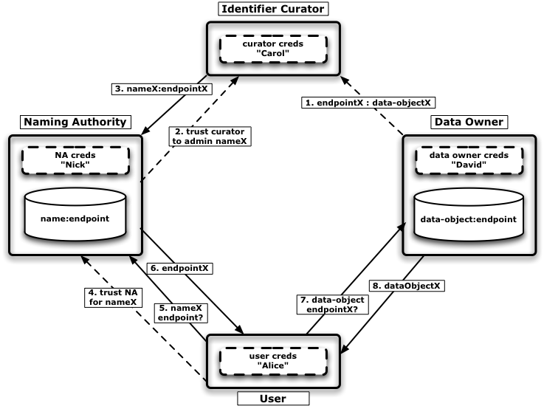
Figure 2. Identifier Services Framework - Conceptual Model

The main actors in the picture are the Naming Authority, the Identifier Curator, the Data Owner and the Identifier User.
The Naming Authority (NA) guards the integrity of identifier namespace & bindings, and maintains the identifier to data-object’s endpoint mapping.
The Identifier Curator/Administrator is expected to understand the semantics of the data-objects and knows “somehow” how to retrieve the data-objects from the data-object’s owner’s data-service. Furthermore, the identifier curator is trusted and authorized by the NA to administer binding for certain identifiers. When the identifier administrator has information about network endpoint associated with a new data-object, it can create a new identifier and bind the data-object’s endpoint information with the naming authority service.
The data-object’s owner makes its data-objects available for retrieval through data-movement services. The detailed information about how such a data-object can be obtained is captured in the so-called data-object’s network endpoint (or endpoint references, i.e. EPRs). Note that in this model, the data-service does not require any knowledge about the identifiers and its use.
Finally, the identifier user or consumer “somehow” has obtained access to the data-object’s identifiers, and is interested to retrieve the data-object itself for further processing. Through the globally resolvable information embedded in the identifier, the user’s identifier-service’s runtime is able to locate the naming authority that maintains the data-object’s endpoint binding. To obtain the data-object through the identifier, the client goes through a 3-step resolution: identifier => NA => endpoint => data-object. First the NA is found that maintains the endpoint info, then that endpoint reference is retrieved, and finally the data-object itself is obtained. Note that the client has to trust the different resolution steps, the resolution services that are consulted, and the binding information, in order to trust the data-object’s integrity.

Identifier Services, Naming Authorities and Prefixes
In order to resolve the identifiers globally, resolution information is embedded in the identifier name. The identifier name consists of a prefix part, which identifies the naming authority. Through the resolution process, the prefix is used to locate the identifier service that hosts the naming authority for all identifiers that share that prefix.
The prefix has a possible hierarchical naming structure, like DNS. The hierarchy can be used to overlay a management and resolution structure over the prefix namespace. There a three main requirements for the management of the prefixes:
- creation of a new prefix.
- migration of prefix’ NA.
- migration of NA’s location records.
One should see the prefix as the unit of administration for the identifiers namespace: all identifiers that share a prefix can be moved between identifier services and even across administrative domains. Different groups of identifiers that share the same prefix cannot be moved independently to a different NA or identifier service.
As a consequence, the applications have to be very conscience of this property, and ensure that the identifiers and associated data-objects are grouped as “manageable units” and mapped to individual prefixes. In other words, one should try to foresee that different groups of identifiers and their associated meta-data have different prefixes when it is undesirable that such identifier groups will always share administrative domains. Note that the traditional conventions where the organizations, divisions and working groups are used to divide the namespace, are not to be used when one anticipates that the management of certain identifiers with their meta-data could potentially move across those organizational boundaries. A more flexible approach would be to associate prefixes with data-object properties or functionality, like data-type, semantically grouping, application, etc., as such abstractions have a better chance to remain valid when moved across organizational boundaries. Such approach will probably result in a more liberate use of unique prefixes.

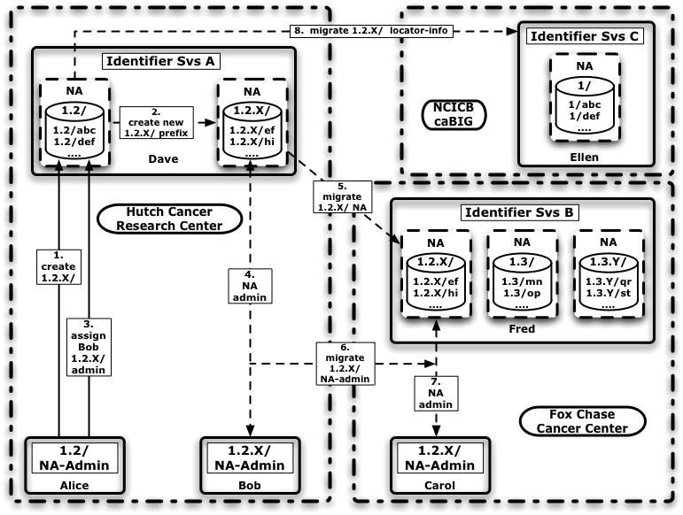
Figure 3. Naming Authority Migration and Management
The issues of naming authority migration is shown in Figure 3, where three administrative domains are shown. Each administrative domain has one identifier service, and each identifier service hosts one or more naming authorities for certain prefixes. Furthermore, each identifier service and actor has subject associated with it.
We can see naming authority’s administrator “Alice” who manages the identifier namespace with the “1.2/” prefix, which is hosted by the identifier service “A” managed by “Dave” within the Hutch’s organization. As the “1.2/” administrator, Alice is allowed to create new child-prefixes, and she uses that privilege to create a new prefix “1.2.X/” in step 1 and 2, after which she empowers “Bob” as a NA-admin for this new prefix in step 3 and 4. After some time, the PI together with his project and the identifiers associated with “1.2.X/” all move to Fox Chase. It is important that the new organization can assume complete control of the identifier administration. In other words, after the identifier database is moved to the identifier server “B” (step 5), the NA-Admin responsibilities have to be assigned to Carol at Fox Chase (step 6 and 7), and none of Hutch’s original administrators should have any privileges to manage the identifiers in the “1.2.X” namespace after that migration. One other important responsibility that has to migrate also is the “1.2.X/” NA-location information that is used for the identifier resolution. A common resolution scheme is one where the location information is maintained in the parent-prefix’ NA, which in this case still resides at the Hutch and which is probably unacceptable as it keeps the Hutch in the resolution trust chain. A possibly more acceptable solution would migrate “1.2.X/” location records to a NA further up the parent-chain that could be used as a trusted third party for this resolution information. Step 8 shows that the “1.2.X” location-record is moved to “1/”, which is our all beloved NCICB.
In summary, the parent-child prefix-relationship of NAs is only important for the creation of the child prefix. After the initial creation, the new NA can be completely severed from the parent-NA from an administrative point of view. Note that in order to remove the parent-NA completely from the trust chain, the location-resolution information also has to be moved up the prefix-hierarchy to a trusted third party NA.
Lastly, when NAs are expected to migrate across organizational boundaries, it makes sense not to include any names associated with the originating entity in the prefix values. As such, number schemes or opaque strings without any obvious semantics are preferred for the prefix values.

Identifiers and Webservice Endpoints
This section discusses some of the equivalent use cases and requirements that are used by GGF’s ws-naming working group for the specification of endpoint identifiers and associated resolution services. The use of data-object identifiers for policy expression, audit entries, and index, discovery, replication and meta-data services, should be able to leverage similar efforts in other Grid communities.

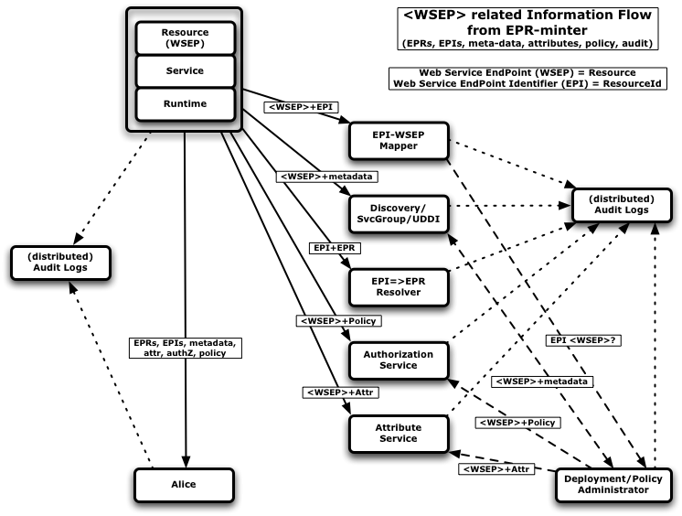
Figure 4. The flow of WSEP-related information from an EPR-minter

Explanation of EPRs, identifying ws-resources, use cases for ws-endpoint-identifiers, ….

Identifier-Endpoint Resolution
In general, the use of identifiers for webservice resources enables the use of endpoint resolution services that can provide resilience in the access of those resources.
GGF’s ws-naming workgroup is in the process to standardize the endpoint resolution service interfaces. The general global resolution scheme is shown in Figure 5, where a client initially fails to interact with a resource but through the endpoint resolution services manages to obtain the updated endpoint information for the resource.

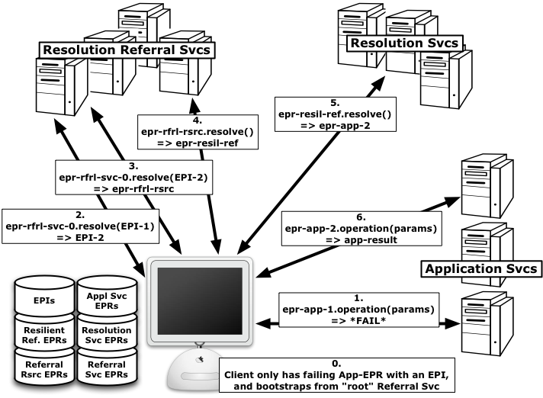
Figure 5. Referral and Resolution Services
It is important to note that the complexity of the resolution functionality is expected to be incorporated in the ws-runtime such that client applications will transparently fail, discover new endpoint references, and retry, through the resolution framework services.
Detailed step-by-step walk-through…

Not all GGF’s use cases are relevant for caBIG’s first deployment, and Figure 6 shows a specific scenario that maps well to most of caBIG’s current requirements.

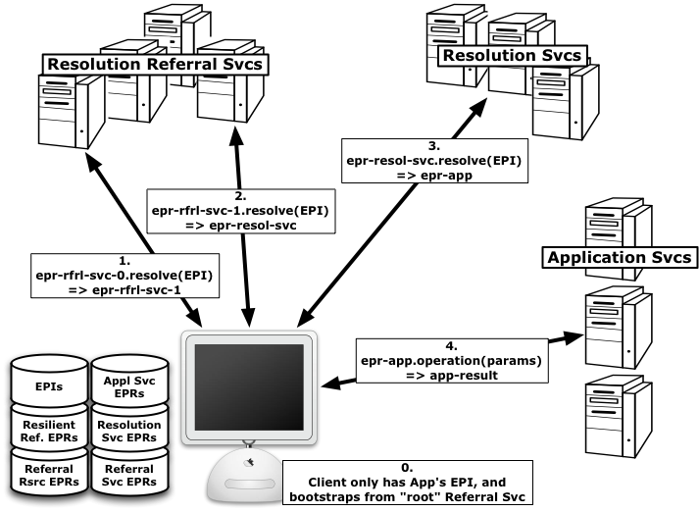
Figure 6. Resolution through Endpoint Identifier (EPI)
The endpoint identifier (EPI) used in step 0 of Figure 6 is essentially equivalent to a data-object identifier. The Resolution Referral Services are used in step 1&2 for the naming authority resolution, i.e. to find the right NA. The subsequent EPI=>EPR resolution step 3 yield the equivalent of an endpoint reference to the data-object, which is subsequently retrieved in step 4.
Note again that it is fully expected that the discussed identifier and endpoint resolution processing will become part of the Globus Toolkit webservice runtime, and that caBIG’s application programmers as identifier users will never be exposed to the associated complexity.

Identifier Consumers
This section discusses the design and layering of the identifier specific interfaces and modules on the client, i.e. the identifier consumer side.
The expectation is that the identifier modules will complement the caCORE functionality, and should probably be integrated on that level.
The overall design is shown in Figure 7, where the highest, application-level layer is expected to deal with data-objects as fully-typed objects and to understand the associated semantics. On this level, the application is also expected to understand the data-object’s identifiers as being part of the data-object’s data-model.
Note that although meta-data is discussed in this section on a high-level, the associated functionality is not part of this specification.

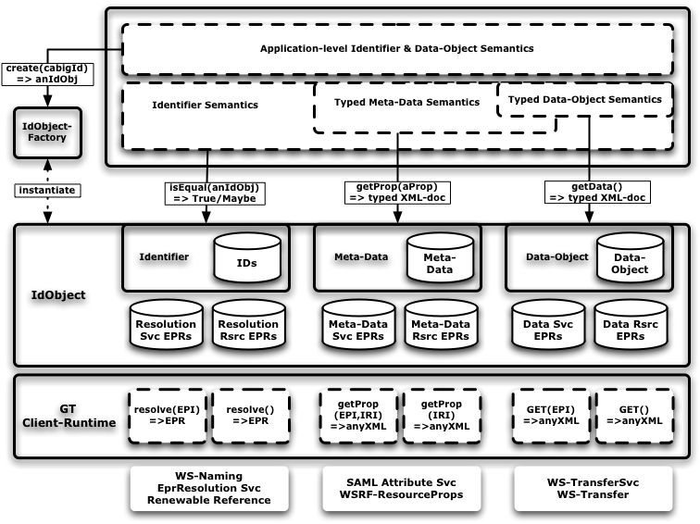
Figure 7. Identifier Consumer - Application Layering

The client applications work with data-objects on different semantic levels: identifier, meta-data and internal data-object level.
Working on the identifier level allows applications to refer to data-objects without the requirement of having the actual data-object locally accessible. Furthermore, the identifiers provide a alternative means for applications to make comparisons for data-object equality, again without the need of having that data-object available. Lastly, through the framework, the identifier can resolve to the associated data-object and the meta-data.
On the meta-data level, the application is able to reason about the data-objects through attributes bound to the data-object’s identifier asserted by the data-object owner or third parties. Applications may make decisions based on a selected few of those attributes without ever needing to access the actual data-object.
The data-object level allows applications to work with the data-object internals, for which the data-object has to be physically present.

IdObject Level
The IdObject in Figure 7 is an abstraction for the data-object and the associated identifiers and meta-data. The IdObject is instantiated through a factory pattern and a data-object identifier. The IdObject instance is subsequently used for the data-object and meta-data resolution. The application level interface exposes methods that cater for the different semantic levels with which the application interacts with data-object: identifier, meta-data and internal data-object. Specifically, an “isEqual” method for data-object equality testing through identifier comparison, as well as separate methods for the passing of meta-data property values and for the actual data-object itself.
The design allows for the actual data retrieval to be done “lazily”, meaning only when explicitly asked for by the calling application. The latter allows optimizations on the time, network and disk storage utilization associated with real data retrieval. Furthermore, by channeling all the data-object related data access through a single module, the caching and sharing of that cache across applications becomes easier to implement.
The IdObject implementation also hides the complexity of the actual 3-step resolution process of the identifiers to data-objects.

The Globus Toolkit Identifier Client Runtime
The GT runtime component will provide implementations of the low-level webservice client code for the resolution services. Furthermore, it incorporates the global resolution functionality and the IRI/URI schema specific code.

The Globus Toolkit Data-Object Retrieval Client Runtime
The GT runtime component will provide a partial implementation of the WS-Transfer specification for the actual data-object retrieval. The functionality provided by the WS-Transfer specification seems to map very well to the generic data movement of data-objects represented as typed but arbitrary xml-documents.
The current client applications only require an implementation of the GET() operation.
Note that the application layer will be provided with a Java interface method to obtain the data-object as an xml-blob, and the specifics of the webservice retrieval mechanism is hidden.

Initially Required Functionality
For the initial implementation of the identifier client, not all functionality depicted in Figure 7 is required. A simplified schema for the initial functionality is shown in Figure 8, which should meet the requirements for the first prototype applications.
As is clear from that picture, less functionality is needed in the GT runtime component.

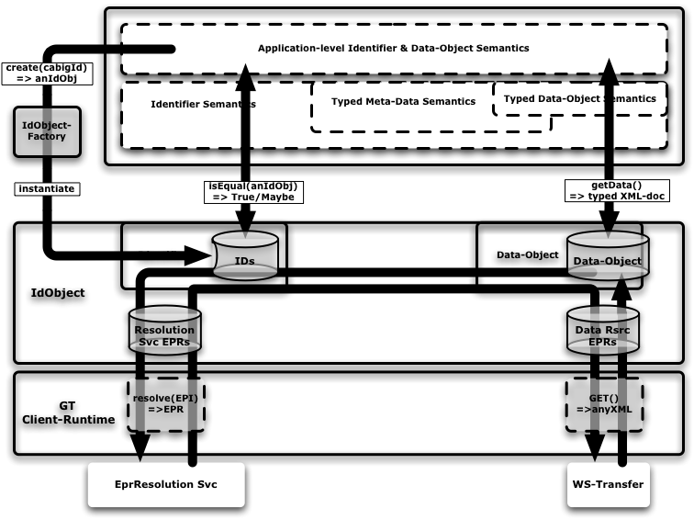
Figure 8. Initial Identifier/Resolution Functionality on Consumer-side

Identifier Producers and Data Service
The conceptual identifier service framework model has three distinct entities on the producer side: the naming authority, the data owner/service, and the identifier administrator/curator. The three entities are depicted as separate and independent actors and services in Figure 2. However, depending on the use case the functionality of two or all three entities can be co-located in practice.

Generic Interface for Identifier Usage
We can distinguish three types of applications:
- Identifiers are not used as key by application. The application only know to identify data-objects by their natural primary key values.
- Identifiers are used as key in multiple types of data-objects. As the identifiers are opaque to the application, it needs guidance from the identifier runtime to find the right data-object set for the look-up.
- Identifiers are used as key for single type of data-object. In that case, the application can locate the data-object through the identifier without help.
The interface between the application and the identifier runtime should support the three different use cases while hiding any identifier-related semantics: the application should remain ignorant of the naming-authority’s prefix as well as any naming convention used for the identifier’s name-value.
The application should be conscience, however, of the potential grouping of the data-object identifiers. As mentioned in section “Identifier Services, Naming Authorities and Prefixes”, the right grouping per prefix keeps the option open to move and migrate the management of the identifiers’ meta-data across administrative domains. To facilitate the mapping of prefixes to data-object groups, the application is required to assign a different “identifier-context” URI to each data-object category. The identifier-context can then be used by the identifier-namespace administrators to map the identifier into an appropriate prefix. Furthermore, the identifier-context can also be used by the application to help with the reverse lookup: to locate the data-object group associated with an identifier.

Identifier Creation
As the identifiers are not natural keys for the data-object, the application must have alternative ways to uniquely identify and locate the data-objects. Those keys will be unique to the data-object type and the way the data-objects are stored: in general only the application can determine what keys and what format are appropriate.
When the application needs to associate an identifier with a data-object, there are two distinct cases:
- An identifier has been assign previously to that data-object. Some applications, like caBIO regenerate their data-objects regularly from scratch, and require that the exact same identifier will be associated with data-objects that are regenerated. When the applications can guarantee that they will always use the exact same identifier-context and data-object identification information, then the identifier framework is able to reassign the same identifiers to the regenerated data-object.
- No identifier has ever been assigned to that data-object. Or at least the application has no way to tell whether the data-object previously had been assigned an identifier here or somewhere else. When it is clear that there is no need that such a data-object will ever be regenerated in the future, then associating identifier-context and data-object identification information with the identifier may not be needed. However, doing so may make it easier to correlate different identifiers that refer to the same data-objects in the future.
The different requirements can be met by providing the application programmers with two interfaces:
- Given an identifier-context and data-object identification information, return a identifier. The application has to understand and standardize on the right context-identifier and has to guarantee that the same identifier-context and data-object identification information is provided for the same data-object in the future.
- Given an identifier, return the initially specified identifier-context and data-object identification information. When the application has received a request about the data-object associated with a provided identifier, it can use this interface to obtain the exact same identifier-context and data-object identification information that was given during the identifier creation, and use this application-specific info to locate data-object. The latter is important if the application does not use the identifiers as alternative lookup keys, or if the application has multiple sets of data-objects to help locate the set where the associated data-object is part off.

Co-located Naming Authority, Identifier Curator and Data Service
An implementation where all three entities are co-located seems to address the requirements of the first prototype applications like caBIO best.
The data-service and identifier-management integration is schematically shown in Figure 9. On the application level, we have data-objects that are conceptually depicted as database table rows. The table is expected to have a bigid column allocated.
The data-objects are expected to be populated through undefined means and initially without any assigned bigid value. When the data-object is first available, the primary key(s) with a data-object type identifier is passed through a createBigId() method and the generated data-object’s bigid value that should be added to the associated database column. The application should treat the returned bigid-value as an opaque string and should be unaware of any naming scheme used by the identifier runtime. This allows the identifier runtime to deploy appropriate naming schemes depending on the data-object type/schema.
The identifier runtime is configured to act as a naming authority in the global naming scheme, which essentially determines the prefix used in the IRI. The intention is to use the data-object type to distinguish the naming convention for the identifier. In some cases, a randomly generated name would be best, in other cases, the passed primary key values will be embedded based on a naming convention. It even allows one to keep the bigid and primary key mapping outside of the data-service application, which could be used in applications where the adding of a bigid column is not possible.
Two other runtime modules are added for the endpoint and data-object resolution. Both are server implementations that listen for client requests.
The endpoint resolution service implements the resolveEPR(EPI) operation of the ws-naming resolution interface. The implementation takes the EPI, which represents the bigid value, and asks the application whether a data-object with such a bigid value is present. If so, the an EPR will be constructed for the co-located ws-transfer service, where the bigid-value will be embedded in that EPR.
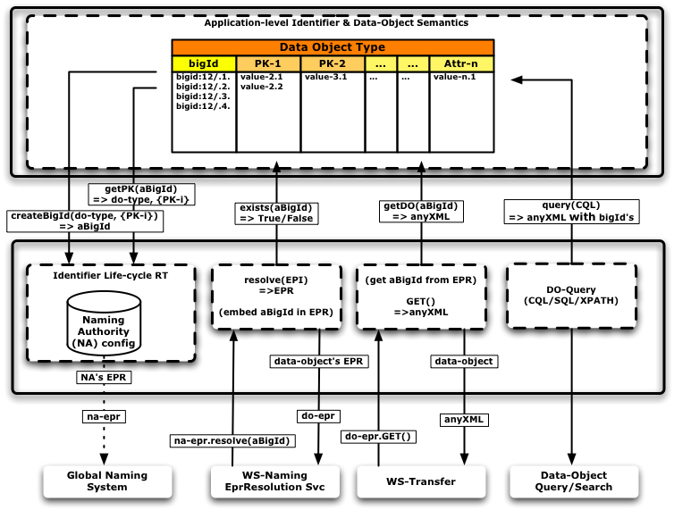
Figure 9. Identifier & Data Service – Application Layering
If the client uses that EPR and comes back with a ws-transfer GET() request, then the associated implementation will retrieve the bigid-value from the ws-transfer EPR’s resource reference properties or wsa:Address. It will then pass that bigid value to the application through the getDO() method call to ask for the data-object as an xml-document. The application can use the bigid-value to lookup the data-object directly. Alternatively. the application can ask the identifier runtime to provide it with the data-object type and pk-values through the getPK() method, such that it can use that information to find the associated data-object.
On right hand side of the picture, the interaction through the existing standard query tools is shown, which should be able to target the identifier values explicitly.

Identifiers and Data Modeling
In order to make use of the “bigID” identifiers, the bigID has to be an integral part of the data-elements and of the way that we reason and work with those elements. In searches and queries, retrieving the element’s bigID value should be as easy as retrieving the element value itself or any of the element’s attributes. Ideally, queries through CQL should be able to make use of the element’s schema to select its bigID for result sets. Furthermore, anyone who has access to the real data-object should be able to easily get the associated bigID such that she can continue to reason about, communicate, bind additional meta-data to, administer policy related to, etc. the data-objects with others.
The data-objects that the identifiers are associated with are very well defined through UML-models and derived XML-schema, Java classes and RDBMS table definitions. The type/schema definitions are maintained in caDSR and guarded through a curator procedures. The attributes are defined by common data elements (CDE).
For each data-type, attributes are identified that uniquely identify the data-objects. There can be one or more of those “primary keys”, that each consist of one or more attributes.
The bigID identifier is an alternative primary key for a data-object. However, it is not a natural key as it is defined outside of the application domain, and can therefore not function as the sole primary key.

bigID attribute
We need a Common Data Element definition for a “bigid” data element as having a “IRI” datatype with a description and properties as being globally unique and identifying the data-objects. Ideally, we would add a bigid-CDE to every single UML-datatype, UML-schema and XDI/XML-schema for data elements that we want to identify in caDSR.
The “bigid” attribute should be added having the same name in each data-element such that one can intuitively and programmatically find the associated identifier in an element.

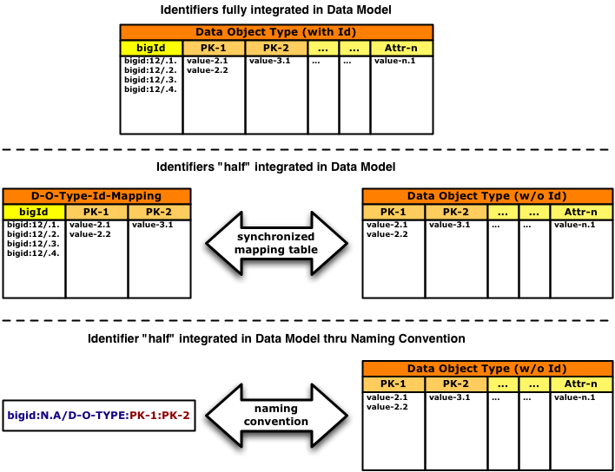
Figure 10. Identifier Integration Mechanisms

For data-elements where we can not change the schema, where we cannot add a bigid attribute, we have to standardize the association in such a way that we again intuitively and programmatically link a data-element with a bigid identifier.
The could possibly be achieved through standard mapping table with tuples like (bigid, data-type, primary-key) – this requires some discussion…
Figure 10 shows the three discussed options where the data-objects is conceptually viewed as a database table. In the ideal case, the bigid would become an additional primary key column in the data-object table such that it can truly be used easily as an alternative lookup key. The second best option would be a separate mapping table where the bigid and the natural keys of the data-object are maintained. In this case the normal query tools can still be used as long as the client is aware of the existing identifier mapping table. The third option shown in the picture depicts an identifier naming convention where the data-object’s primary keys are embedded in the identifier’s name. Figure 11 shows an example of such a naming convention in more detail.
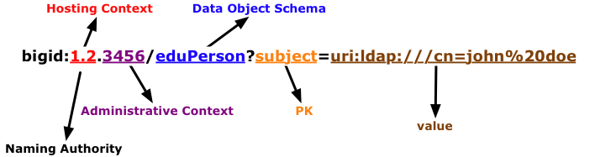
Figure 11. Example of schema info embedded in bigid's IRI
Note that the use of identifier naming conventions for data-object mapping purposes severely limit the ability to deploy the standard query tools to make use of bigid-identifiers and should therefore be seen as the least preferred identifier integration mechanism.

Versioning
Some data objects change over time because of new information, new experimental results, new insights, etc.
The data object’s curator may decide that certain changes in the data object warrant a new identifier to reflect that change.
From a user’s perspective, the versioning of the data object may be important, like knowing whether two identifiers refer to different versions of the same data object, or whether the version associated with one identifier is newer than the version of another, and how to find the identifier associated with the data object’s most recent version.
One of the issues with versioning is the difficulty of standardizing a versioning scheme that would fit all use cases. It becomes more complicated when versioning branching has to be taken into account, and when different data services may decide on different versions of the same data object. In other words, versioning may only be done right when it is completely part of the data model and when the operations and queries related to data object versions have been developed by meeting the requirements that resulted from the relevant use cases.
Some identifier naming schemes attempt to overload the identifier naming convention with versioning information, such that the identifier-user could make assumptions about the “base” identifier, or the versioning number, or construct a new identifier for the most recent one through a naming convention. This approach violates the opaqueness requirement of the identifier for the user, and makes the overall system brittle as it pushes part of the data model in a naming convention. Especially when it doesn’t seem realistic to come up with a single data model that meets all the versioning requirements.
An identifier annotated with version information is essentially an optimization. This same information must be part of the data object’s model, and should therefore also be available through the normal (meta-) data queries and introspections. This optimization comes at the cost of breaking identifier opaqueness, and the use cases and requirements should decide whether this is worthwhile.
The alternative to deal with versioning is to make this truly part of the data model for the objects under consideration. In other words, versioning information should not be deduced by the user from the identifier itself, but through knowledge and understanding of the data model. The user can then find the right versions through queries and possibly versioning-related application and webservice interfaces. By abstracting the versioning specifics of a data object through an interface, the actual implementation of the data object’s versioning is hidden.

Digest value attribute
The integrity of the identifier and data-retrieval framework relies on the ability to safeguard the integrity. We need the means to ensure that received data-object is an exact copy of the original data-object that the curator/administrator associated with the identifier.
We need to add a data-digest-CDE to every single UML-datatype, UML-schema and XDI/XML-schema for data elements that we want to identify in caDSR.
The added “data-digest” attribute should be added having the same name and the same position in each data-element such that one can intuitively and programmatically find the associated identifier in an element.
The data-digest value should hold a base64-encoded SHA-1 value of the XML-serialized and canonicalized data-object as defined in XML-Signature.

Security and Security Management
This chapter could include sections describing:

Software Authorization

Describe permissions and structure

Configuring Software Authorizations

Descriptions of how to add administrators/supervisors/groups/users.
.

{Product} APIs
The purpose of this chapter is to describe the APIs and how to use them. This chapter should not repeat material in the Javadocs, if they are complete, but should reference important sources such as Javadocs for API information not included in the chapter.
It is important to remember that the chapters and suggested section in the guide are to be adapted to your particular context. If you have questions, contact the Training Workspace lead or NCICB Application Support: http://ncicb.nci.nih.gov/NCICB/support

Major Function, Features or API Subset
- Purpose
- Input: commands/functions, data/parameters, format/ option selection
- Step-by-step instruction for use (if appropriate)
- Expected Results and exception handling
- Related function (cross-references, if appropriate)

Repeat as appropriate

This chapter could include comprehensive examples of how to use the APIs and how to extend them. Where appropriate, include example of the code. An API example, for instance, might describe chaining three or four APIs for a useful extension of the software’s functions.
You could create a separate chapter for the API examples, if the length of the material warrants it.
You might include a link to downloadable code.

Information Models
This chapter contains necessary information about the different types of object models and other artifacts of the object-oriented programming language (such as Unified Modeling Language or UML) used to generate your software.
- This presents objects in a data model type view, as opposed to text descriptions that might be included in previous chapters.
- You could include links to the latest UML models: use case diagrams, class diagrams, sequence diagrams, etc.
For example, you might include a paragraph about how your application models biospecimens and their tracking attributes: “…with a total of 60 classes and 150 attributes. A detailed model can be found at {url for the model}.”

Grid and Web Services
This chapter, essential only if your application includes grid (or web) services, could include the necessary information about how to use the services unique to your application. It could include the following topics:
- Usage of web or grid service
- Web service description language
- Links to appropriate documents
- Examples of usage
It may make sense with your application to roll this information in with the API chapter. This is another example of the wisdom of adapting this technical guide to the context of your own application.
Of course, if your application is caBIG™ Gold Compliant, this chapter covering your integration with caGrid is essential.

Customized Tools and Features
This optional chapter would be written only if your application includes customized tools. The chapter could include material describing:
- Descriptions of customized tools and features.
- How to extend the software tools
- How to integrate the software with other applications
- How to add data sources

- References
This appendix could include lists and hypertext links, where appropriate, to technical manuals, articles, scientific publications, etc. Examples are shown:

Technical Manuals/Articles
- National Cancer Institute. "caCORE 2.0 Technical Guide", ftp://ftp1.nci.nih.gov/pub/cacore/caCORE2.0_Tech_Guide.pdf
- Java Bean Specification: http://java.sun.com/products/javabeans/docs/spec.html
- Foundations of Object-Relational Mapping: http://www.chimu.com/publications/objectRelational/
- Object-Relational Mapping articles and products: http://www.service-architecture.com/object-relational-mapping/
- Hibernate Reference Documentation: http://www.hibernate.org/hib_docs/reference/en/html/
- Basic O/R Mapping: http://www.hibernate.org/hib_docs/reference/en/html/mapping.html
- Java Programming: http://java.sun.com/learning/new2java/index.html
- Javadoc tool: http://java.sun.com/j2se/javadoc/
- JUnit: http://junit.sourceforge.net/
- Extensible Markup Language: http://www.w3.org/TR/REC-xml/
- XML Metadata Interchange: http://www.omg.org/technology/documents/formal/xmi.htm

Scientific Publications

caBIG Material
- caBIG: http://cabig.nci.nih.gov/
- caBIG Compatibility Guidelines: http://cabig.nci.nih.gov/guidelines_documentation

caCORE Material
- caCORE: http://ncicb.nci.nih.gov/core
- caBIO: http://ncicb.nci.nih.gov/core/caBIO
- caDSR: http://ncicb.nci.nih.gov/core/caDSR
- EVS: http://ncicb.nci.nih.gov/core/EVS
- CSM: http://ncicb.nci.nih.gov/core/CSM

- Glossary
Following is an example list of terms and their definitions.
Term | Definition
{jboss-home} | The base directory where JBoss is installed on the server
API | Application Programming Interface
caArray | cancer Array Informatics
caBIG | cancer Biomedical Informatics Grid
caBIO | Cancer Bioinformatics Infrastructure Objects
caCORE | cancer Common Ontologic Representation Environment
caDSR | Cancer Data Standards Repository
caMOD | Cancer Models Database
cardinality | Cardinality describes the minimum and maximum number of associated objects within a set
CDE | Common Data Element
CGAP | Cancer Genome Anatomy Project
CMAP | Cancer Molecular Analysis Project
CN | Common Name
CS | Classification Scheme
CSI | Classification Scheme Item
CSM | Common Security Module
CTEP | Cancer Therapy Evaluation Program
CUI | Concept Unique Identifier
CVS | Concurrent Versions System
DAML | DARPA Agent Markup Language
DAO | Data Access Objects
DARPA | Defense Advanced Research Projects Agency
DAS | Distributed Annotation System
DL | Description Logic
EA | Enterprise Architect
EBI | European Bioinformatics Institute
EVS | Enterprise Vocabulary Services
GAI | CGAP Genetic Annotation Initiative
GEDP | Gene Expression Data Portal
HIPPA | Health Insurance Portability and Accountability Act
HLGT | High Level Group Term
HLT | High Level Term
HTTP | Hypertext Transfer Protocol
ISO | International Organization for Standardization
JAAS | Java Authentication and Authorization Service
JAR | Java Archive
Javadoc | Tool for generating API documentation in HTML format from doc comments in source code (http://java.sun.com/j2se/javadoc/)
JDBC | Java Database Connectivity
JET | Java Emitter Templates
JMI | Java Metadata Interface
JSP | JavaServer Pages
JUnit | A simple framework to write repeatable tests (http://junit.sourceforge.net/)
LDAP | Lightweight Directory Access Protocol
LLT | Lowest Level Term
LOINC | Logical Observation Identifier Names and Codes
MAGE | MicroArray and Gene Expression
MAGE-OM | MicroArray Gene Expression - Object Model
MedDRA | Medical Dictionary for Regulatory Activities
metadata | Definitional data that provides information about or documentation of other data.
MGED | Microarray Gene Expression Data
MMHCC | Mouse Models of Human Cancers Consortium
MO | MGED Ontology
multiplicity | Multiplicity of an association end indicates the number of objects of the class on that end may be associated with a single object of the class on the other end
NCI | National Cancer Institute
NCICB | National Cancer Institute Center for Bioinformatics
OIL | Ontology Inference Layer
OilEd | Ontology editor allowing you to build ontologies using DAML+OIL
OLLT | Obsolete Lower Level Terms
OMG | Object Management Group
ORM | Object Relational Mapping
PT | Preferred Term
RDBMS | Relational Database Management System
SDK | Software Development Kit
Semantic connector | A development kit to link model elements to NCICB EVS concepts.
SOC | System Organ Class
SPORE | Specialized Programs of Research
SQL | Structured Query Language
SSC | Special Search Categories
UI | User Interface
UID | User Identification
UML | Unified Modeling Language
UMLS | Unified Medical Language System
UPT | User Provisioning Tool
URL | Uniform Resource Locators
VD | Value Domain
WAR | Web Application Archive
WSDL | Web Services Description Language
XMI | XML Metadata Interchange (http://www.omg.org/technology/documents/formal/xmi.htm) - The main purpose of XMI is to enable easy interchange of metadata between modeling tools (based on the OMG-UML) and metadata repositories (OMG-MOF) in distributed heterogeneous environments
XML | Extensible Markup Language (http://www.w3.org/TR/REC-xml/) - XML is a subset of Standard Generalized Markup Language (SGML). Its goal is to enable generic SGML to be served, received, and processed on the Web in the way that is now possible with HTML. XML has been designed for ease of implementation and for interoperability with both SGML and HTML

Index
It is very easy to generate an index and extremely helpful to the manual user. See the Technical Style Guide located at: https://cabig.nci.nih.gov/working_groups/Training_SLWG/Documents/Technical_Pubs_Style_Guide_021405_jbh.pdf for directions for inserting index markers and generating an index in MS Word (PC).

Document conventions, Supplement, 8
Glossary, 29
References
caBIG materials, 27
caCORE material, 27
scientific publications, 27
technical manuals, guides, 27
Text conventions, Supplement, 8

