caGrid 1.0
Programmer’s Guide






Center for Bioinformatics

caGrid Development and Management Teams
Development | Technical Guide | Reference Implementation |  | Program Management
David W. Ervin | David W. Ervin |  |  | Shannon Hastings
Shannon Hastings | Frank Siebenlist¹¹ |  |  | Scott Oster
Scott Oster | Rachana Ananthakrishnan¹¹ |  |  | Chad LaJoie
Stephen Langella | Sam X. Sun¹¹ |  |  | Arumani Manisundaram
David Ervin | Shannon Hastings
Tahsin Kurc | Scott Oster
 | Stephen Langella
 | Tahsin Kurc
Paul A. Kennedy | Paul A. Kennedy
Manav Kher | Manav Kher
 | Systems Support
¹Science Application International Corporation (SAIC) |  | ²National Cancer Institute Center for Bioinformatics (NCICB)
³Oracle Corporation | ⁴Ohio State University | ⁵ Praxeon Partners | ⁶ Booz Allen Hamilton (BAH)
⁷Terrapin Systems | ⁸Georgetown University | ⁹Duke University | ¹⁰Univ. of Pittsburgh Medical Center
¹¹University of Chicago / Argonne National Laboratory (UC/ANL)

Contacts and Support
NCICB Application Support | http://ncicbsupport.nci.nih.gov/sw/  Telephone: 301-451-4384  Toll free: 888-478-4423

LISTSERV Facilities Pertinent to caGrid
LISTSERV | URL | Name
caGrid_Users | https://list.nih.gov/archives/cagrid_users-l.html | caGrid Users Discussion Forum
caGrid_Developers | https://list.nih.gov/archives/cagrid_developers.html | caGrid Developers Discussion

Table of Contents
Chapter 1 About This Guide 1
Purpose 1
Release Schedule 1
Audience 1
Getting Help 1
How to Use This Guide 2
Additional caGrid Documentation 2
Document Text Conventions 2
Chapter 2 Overview of caGrid 5
Standards Compliant 6
Model Driven 6
Semantically Discoverable 7
Secure and Manageable 8
Chapter 3 caGrid Metadata Infrastructure 11
Technical Architecture 11
APIs 11
Chapter 4 Security 13
Technical Architecture 13
APIs 13
Chapter 5 caGrid Data Services 15
Technical Architecture 15
APIs 15
Chapter 6 Identifier Services Framework 17
Technical Architecture 17
APIs 17
Chapter 7 Introduce 19
Technical Architecture 19
APIs 19
Chapter 8 caGrid Monitoring and Discovery Portal 21
Technical Architecture 21
APIs 21
Chapter 9 caGrid Browser 23
Technical Architecture 23
APIs 23
Chapter 10 Reference Implementations 25
Overview of Reference Implementations 25
Objective 26
Goals 26
Assumptions 26
High-level Process 26
Deliverables 27
Test Bed 27
caArray 28
PIR 29
RProteomics 29
caBIO 30
Chapter 11 caGrid Installer 31
Technical Architecture 31
APIs 31
Chapter 12 WS-Enumeration 33
Technical Architecture 33
APIs 33
Chapter 13 Workflow Management Service 35
Technical Architecture 35
APIs 35
Chapter 14 Migrating/Adapting Services 37
Appendix A References 39
Technical Manuals/Articles 42
Scientific Publications 43
caBIG Material 43
caCORE Material 43
Appendix B Troubleshooting 45
Appendix C Limitations/Out of Scope Items 47
Glossary 49

About This Guide

Purpose
The cancer Biomedical Informatics Grid, or caBIG™, is a voluntary virtual informatics infrastructure that connects data, research tools, scientists, and organizations to leverage their combined strengths and expertise in an open environment with common standards and shared tools. The current test bed architecture of caBIG™, is dubbed caGrid. The software embodiment and corresponding documentation of this architecture constitute the caGrid 1.0 release.
This guide describes:
- Enumerate
- etc

Release Schedule
This guide has been updated for the caGrid 1.0 release. It may be updated between releases if errors or omissions are found. The current document refers to the 1.0 version of caGrid, released in December 2006 by caBIG.

Audience
The primary audience of this guide is the intermediate level programmer who wants to learn about the architecture and technical details of caGrid and/or requires access to one or more caGrid APIs. For additional information about installing and using caGrid, see the caGrid User’s Guide.

This guide assumes that you are familiar with the XX programming language and/or other programming languages, database concepts, and the Internet. If you intend to use caGrid resources in software applications, it assumes that you have experience with building and using complex data systems.

Getting Help
NCICB Application Support
http://ncicbsupport.nci.nih.gov/sw/
Telephone: 301-451-4384
Toll free: 888-478-4423

How to Use This Guide
If you have worked with the preceding versions of caGrid, see <x-ref>, which describes what has been changed for this new version - in the documentation and in caGrid.
If you are new to caGrid, please read this brief overview which explains what you will find in each section of this guide.
Elaborate on description/x-ref each to chpt
- Chapter 1 provides an overview of caGrid
- Chapter # describes Data Services
- Chapter # describes Identifiers
- Chapter # describes Introduce
- Chapter # describes Metadata
- Chapter # describes the caGrid Portal and Browser
- Chapter # describes the caGrid Security module including GTS and Dorian
- Chapter # describes the Installer
- Chapter # describes WS-Enumation
- Chapter # describes Workflow
- Chapter # describes Examples
- Chapter # describes Migration/Adapting Services
- Chapter # describes
- Appendices

Additional caGrid Documentation
- caGrid 1.0 User’s Guide
- caGrid 1.0 Design Documents
- User-specific Tools
- caGrid 1.0 Release Notes?
- Other

Document Text Conventions
The following table shows how text conventions are represented in this guide. The various typefaces differentiate between regular text and menu commands, keyboard keys, and text that you type.
Convention | Description | Example
Bold & Capitalized Command  Capitalized command > Capitalized command | Indicates a Menu command  Indicates Sequential Menu commands | Admin > Refresh
text in small caps | Keyboard key that you press | Press enter
text in small caps + text in small caps | Keyboard keys that you press simultaneously | Press shift + ctrl and then release both.
Special typestyle | Used for filenames, directory names, commands, file listings, source code examples and anything that would appear in a Java program, such as methods, variables, and classes. | URL_definition ::= url_string
Boldface type | Options that you select in dialog boxes or drop-down menus. Buttons or icons that you click. | In the Open dialog box, select the file and click the Open button.
Italics | Used to reference other documents, sections, figures, and tables. | caCORE Software Development Kit 1.0 Programmer’s Guide
Italic boldface type | Text that you type | In the New Subset text box, enter Proprietary Proteins.
Note: | Highlights a concept of particular interest | Note: This concept is used throughout the installation manual.
Warning! | Highlights information of which you should be particularly aware. | Warning! Deleting an object will permanently delete it from the database.
{} | Curly brackets are used for replaceable items. | Replace {root directory} with its proper value such as c:\cabio
Table 1-1 Document Conventions

Overview of caGrid
[Update for 1.0]
The cancer Biomedical Informatics Grid, or caBIG™, is a voluntary virtual informatics infrastructure that connects data, research tools, scientists, and organizations to leverage their combined strengths and expertise in an open environment with common standards and shared tools. The current test bed architecture of caBIG, officially named caGrid, is described in this document with respect to its technical architecture. The software embodiment and corresponding documentation of this architecture constitute the caGrid 0.5 release.
Driven primarily from the scientific use cases identified from the domain workspaces of caBIG, caGrid provides the core enabling infrastructure necessary to compose the Grid of caBIG. caGrid is a service-oriented architecture and provides the implementation of the required core services, toolkits and wizards for the development and deployment of community provided services, APIs for building client applications, and some sample client applications for interacting with the current test bed installation. A conceptual overview of these components is shown below in Figure 2-1.

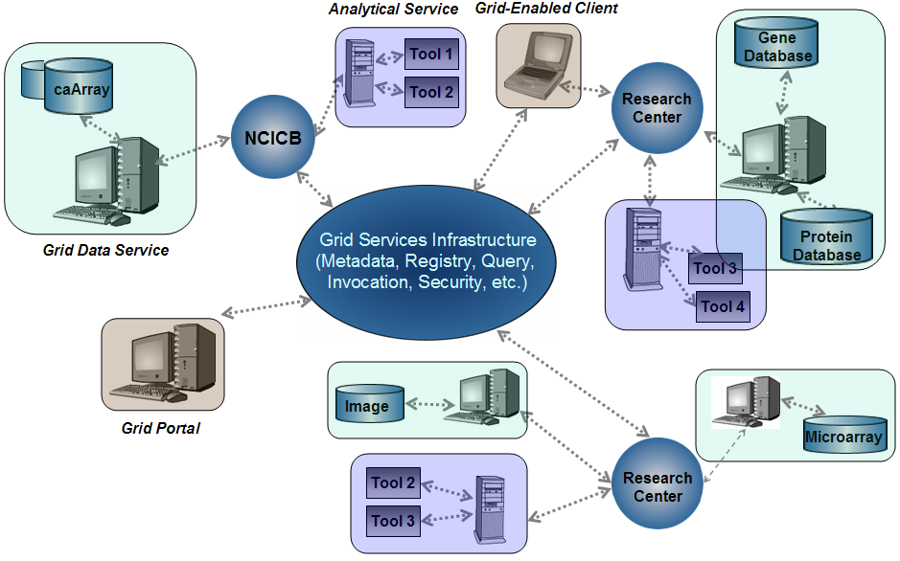
Figure 2- Overview of caGrid

Standards Compliant
As a primary principle of caBIG is open standards, caGrid is built upon the community-driven standards of Open Grid Services Architecture (OGSA). OGSA is the current specification for grid infrastructure and has been developed over the past several years in the Global Grid Forum (GGF), the community of users, developers, and vendors leading the global standardization effort for grid computing. The current release of caGrid is built using the Globus Toolkit 3.2 (GT3.2) and the OGSA Data Access Integration (OGSA-DAI) framework version 5.0. GT3.2 is a reference implementation of the OGSA standards specification for service creation, deployment, and invocation and provides core services such as the Index Service for service registration and discovery and Globus Security Infrastructure (GSI) for security. The OGSA-DAI framework is an implementation of the OGSA-DAIS standards specification for data services. It provides a set of interfaces and runtime support for implementing and deploying data sources as Grid services.

Model Driven
Extending beyond the basic grid infrastructure, caBIG specializes these technologies to better support the needs of the cancer research community. A primary distinction between basic grid infrastructure and the requirements identified in caBIG and implemented in caGrid is the attention given to data modeling and semantics. caBIG adopts a model-driven architecture best practice and requires that all data types used on the grid are formally described, curated, and semantically harmonized. These efforts result in the identification of common data elements, controlled vocabularies, and object-based abstractions for all cancer research domains. caGrid leverages existing NCI data modeling infrastructure to manage, curate, and employ these data models. Data types are defined in caCORE UML and converted into ISO/IEC 11179 Administered Components, which are in turn registered in the Cancer Data Standards Repository (caDSR). The definitions draw from vocabulary registered in the Enterprise Vocabulary Services (EVS), and their relationships are thus semantically described.
In caGrid, both the client and service APIs are object oriented, and operate over well-defined and curated data types. Clients and services communicate through the grid using respectively Globus grid clients and service infrastructure. The grid communication protocol is XML, and thus the client and service APIs must transform the transferred objects to and from XML. This XML serialization of caGrid objects is restricted in that each object that travels on the grid must do so as XML which adheres to an XML schema registered in the Global Model Exchange (GME). As the caDSR and EVS define the properties, relationships, and semantics of caBIG data types, the GME defines the syntax of the XML serialization of them. Furthermore, Globus services are defined by the Web Service Description Language (WSDL). The WSDL describes the various operations the service provides to the grid. The inputs and outputs of the operations, among other things, in WSDL are defined by XML schemas. As caBIG requires that the inputs and outputs of service operations use only registered objects, these input and output data types are defined by the XSDs which are registered in GME. In this way, the XSDs are used both to describe the contract of the service and to validate the XML serialization of the objects which it uses. Figure 2-2 details the various services and artifacts related to the description of and process for the transfer of data objects between client and service.

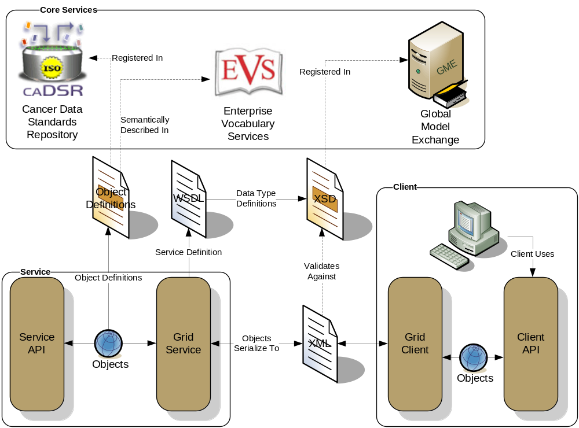
Figure 2- Data Description Infrastructure

Semantically Discoverable
As caBIG aims to connect data and tools from 50+ disparate cancer centers, a critical requirement of its infrastructure is that it supports the ability of researchers to discover these resources. caGrid enables this ability by taking advantage of the rich structural and semantic descriptions of data models and services that are available. Each service is required to describe itself using caGrid standard service metadata. When a grid service is connected to the caBIG grid, it registers its availability and service metadata with a central indexing registry service (Index Service). This service can be thought of as the “yellow pages” and “white pages” of caBIG. A researcher can then discover services of interest by looking them up in this registry. caGrid 0.5 provides a series of high-level APIs and user applications for performing this lookup which greatly facilitate the process.
As the Index Service contains the service metadata (or service data) of all the currently advertised and available services in caBIG, the expressivity of service discovery scenarios is limited only by the expressivity of the service metadata. For this reason, caGrid provides standards for service metadata to which all services must adhere. At the base is the Common Service Metadata standard that every service in caBIG is required to provide. This metadata contains information about the service-providing cancer center, such as the point of contact and the institution’s name. Extending beyond this generic metadata are two standards that are specialized for the two types of community-provided services: Data Services and Analytical Services. Both of these standards leverage the data models registered in caDSR and link them to the underlying semantic concepts registered in EVS. The Data Service Metadata details the domain model from which the Objects being exposed by the service are drawn. Additionally, the definitions of the Objects themselves are described in terms of their underlying concepts, attributes, and associations to other Objects being exposed. Similarly, the Analytical Service Metadata details the Objects using the same format as the Data Service Metadata. In addition to detailing the Objects definitions, the Analytical Service Metadata defines the operations or methods the service provides. The input parameters and output of the operations are defined by referencing the appropriate Object definition. In this way, both the data and analytical services fully define the domain objects they expose by referencing the data model registered in caDSR, and identify their underlying semantic concepts by referencing the information in EVS.

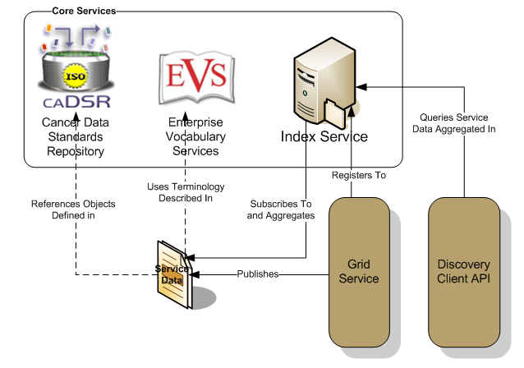
Figure 2- Discovery Overview
As shown in Figure 2-3, the caGrid discovery API and tools allow researchers to query the Index Service for services satisfying a query over the service metadata. That is, researchers can lookup services in the registry using any of the information used to describe the services. For instance, all services from a given cancer center can be located, data services exposing a certain domain model or objects based on a given semantic concept can be discovered, as can analytical services that provide operations that take a given concept as input.

Secure and Manageable
Security is an especially important component of caBIG both for protecting intellectual property and ensuring protection and privacy of patient related and sensitive information. When security is implemented in a multi-institutional environment, such as caBIG, a challenging problem is to facilitate the management of users and user attributes. Furthermore, it is important to be able to leverage existing systems for authenticating and authorizing requests to the corresponding data sources.
The caGrid security architecture, shown in Figure 2-4, is compromised of several components. Components can be classified as core components and external components. Core components are required by the architecture and are essential for meeting the security requirements for caBIG. External components are those that are considered extensions of the core security architecture. The caGrid security architecture is composed of five core components:
- Grid Security Infrastructure (GSI): Globus provided security infrastructure.
- Authorization Manager: Authorization callback mechanism.
- Grid User Management Service (GUMS): Grid Service for the management and creation of grid users and grid user credentials.
- Grid Virtual Organization Service (GVOS) [not implemented in caGrid 0.5]: Grid Service for the management of virtual organizations.
- caGrid Attribute Management Service (CAMS): Grid Service for the management of user/virtual organization attributes.

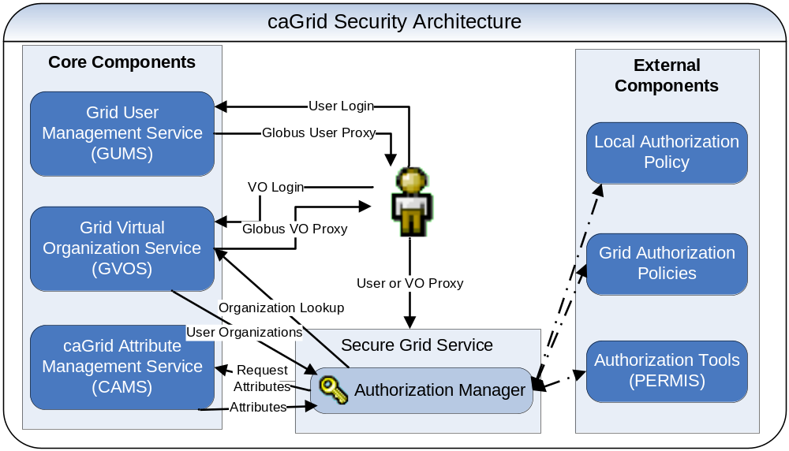
Figure 2- caGrid Security Architecture

caGrid Metadata Infrastructure
This chapter describes the caGrid metadata infrastructure…
Topics in this chapter include:

Technical Architecture
Brief summary
Reference to the technical design document(s):
caGrid Metadata Infrastructure Technical Guide
http://gforge.nci.nih.gov/plugins/scmcvs/cvsweb.php/~checkout~/cagrid-1-0/Documentation/docs/metadata/caGrid-metadata-infrastructure-design.doc?rev=1.9;content-type=application%2Foctet-stream;cvsroot=cagrid-1-0

APIs
(Possible Headings)

Installation and Configuration

Service Methods

Syntax

Examples of Use

Limitations

API-specific Considerations

Security
This chapter describes caGrid security…
Topics in this chapter include:

Technical Architecture
Brief summary
Reference to the technical design document(s):

APIs
(Possible Headings)

Installation and Configuration

Service Methods

Syntax

Examples of Use

Limitations

API-specific Considerations

caGrid Data Services
This chapter is the architecture specification for the …
Topics in this chapter include:

Technical Architecture
Brief summary
Reference to the technical design document(s):

APIs
(Possible Headings)

Installation and Configuration

Service Methods

Syntax

Examples of Use

Limitations

API-specific Considerations

Identifier Services Framework
This chapter describes caGrid Identifier Services Framework …
Topics in this chapter include:

Technical Architecture
Brief summary
Reference to the technical design document(s):

APIs
(Possible Headings)

Installation and Configuration

Service Methods

Syntax

Examples of Use

Limitations

API-specific Considerations

Introduce
This chapter describes Introduce …
Topics in this chapter include:

Technical Architecture
Brief summary
Reference to the technical design document(s):
Introduce User’s Guide
http://gforge.nci.nih.gov/plugins/scmcvs/cvsweb.php/~checkout~/cagrid-1-0/Documentation/docs/introduce/Introduce_Users_Guide.doc?rev=1.3;content-type=application%2Foctet-stream;cvsroot=cagrid-1-0

Introduce Architecture Guide
http://gforge.nci.nih.gov/plugins/scmcvs/cvsweb.php/~checkout~/cagrid-1-0/Documentation/docs/introduce/Introduce_Architecture_Guide.doc?rev=1.3;content-type=application%2Foctet-stream;cvsroot=cagrid-1-0

APIs
(Possible Headings)

Installation and Configuration

Service Methods

Syntax

Examples of Use

Limitations

API-specific Considerations

caGrid Monitoring and Discovery Portal
This chapter describes the caGrid Monitoring and Discovery Portal …
Introduce User’s Guide

Technical Architecture
Brief summary
Reference to the technical design document(s):

APIs
(Possible Headings)

Installation and Configuration

Service Methods

Syntax

Examples of Use

Limitations

API-specific Considerations

caGrid Browser
This chapter describes the caGrid Browser …
Topics in this chapter include:

Technical Architecture
Brief summary
Reference to the technical design document(s):

APIs
(Possible Headings)

Installation and Configuration

Service Methods

Syntax

Examples of Use

Limitations

API-specific Considerations

Reference Implementations
This chapter describes Reference Implementations …
Topics in this chapter include:
- Overview of Reference Implementations
- Objectives
- Goals
- Assumptions
- High Level Process
- Deliverables
- Test Bed
- Implementation 1
- …
- Implementation N

Overview of Reference Implementations
Taken from 0.5 Technical Guide
The primary goal of caGrid is to provide a middleware to share applications and data in the Cancer Research community.
Based on the use cases collected in the inception phase, the caGrid team implemented an automated process to virtualize caBIG resources like data and analytical tools. The implementation includes advertisement, discovery, query, and invocation with secure or without secure services. Current grid technologies are very rich in functionality but, because of the complexity, are difficult to use; caGrid project is using grid and service oriented concepts to leverage Globus as the core infrastructure to virtualize caBIG resources.
The reference implementations are projects within caBIG that have reached silver compliant maturity. The caGrid team developed the grid infrastructure and defined the process to virtualize caGrid resources. Then, caGrid took those silver projects and made them available in the grid environment.
This chapter describes the goals, process, objectives and description of each reference implementation.
These reference implementation projects help to validate the use cases and the implementation of caGrid. As a result, and based on the lessons learned, the caGrid team will adjust the implemented process and will provide recommendations to the compatibility documents.
Reference implementation projects are listed in Table 11-1:
Project Institution
PIR Georgetown University
RProteomics Duke
caArray Georgetown University
caBIO NCICB
caArray NCICB
Table 11- Reference implementation projects

Objective
Virtualize caBIG reference implementations by using the process implemented in the caGrid project.

Goals
- To have at least 6 caBIG applications virtualized with caGrid infrastructure.
- Test and update the virtualization process to expose caBIG resources available to caBIG community.
- To validate compatibility document and provide recommendations.

Assumptions
- Reference implementations are silver compliant.
- The caGrid team has reference implementation schedules to plan the testing.
- Access to computational resources in the research center where we are testing reference implementations.
- Alpha version of caGrid.

High-level Process
For each site/Research Center that provides the reference implementations, the caGrid team and Research center team will perform the following tasks:
- Install Globus 3.2.1
- Test Globus installation
- Install OGSA-DAI 5.0
- Test OGSA-DAI installation
- Test connectivity with NCICB
- Install caGrid
- Test caGrid
- Plug-in API into caGrid infrastructure.
- Test and document

Deliverables
- caBIG computational resources virtualized by caGrid infrastructure. Based on assumption number 1.
- Compatibility document validation.
- Recommendations to compatibility document.
- Recommendations (where appropriate) to modify/update reference implementations architecture based on grid / SOA (service oriented architecture patterns and principles.
- caGrid virtualization process updates and improved based on lessons learned from testing caBIG resource virtualization.

Test Bed

The following deployment diagram represents the infrastructure for the reference implementation. The diagram shows core services and Cancer research services. Core services are security, schema management (GME), and registry (Index services). Cancer research services are caBIO, caArray, PIR and rProteomics. Cancer research services are vistualized using the caGrid infrastructure. caDSR and EVS systems can be accessed with the caBIO/caCORE service and with the caCORE client in a cancer research infrastructure. caDSR and EVS systems can be accessed by the Cancer research services either directly by using caCORE API’s or indirectly by using respective business service layers.

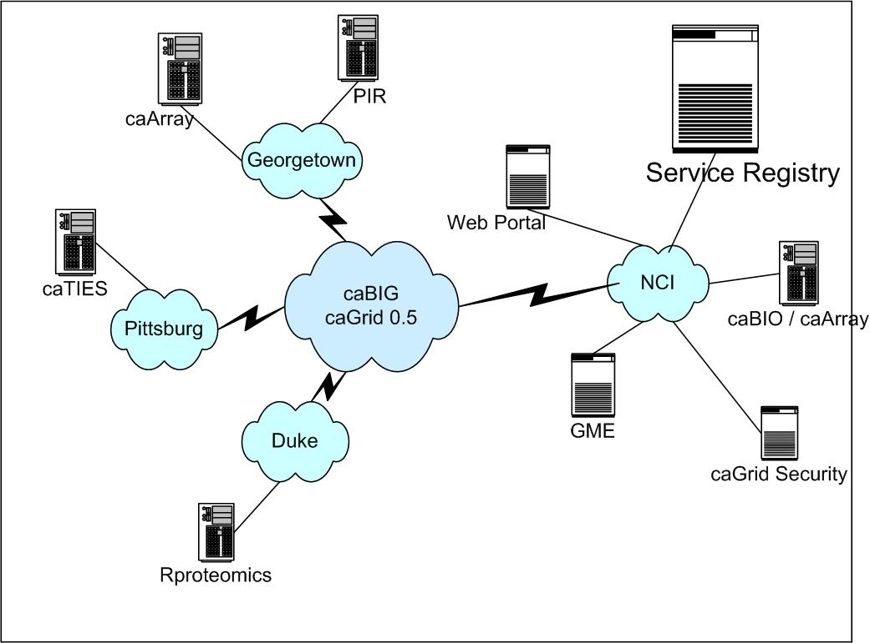
Figure 11- - caGrid 0.5 Test bed Infrastructure

caArray
NCICB's caArray project is a microarray database with open interfaces, strong security, and a user interface that is designed to make MIAME 1.1 level annotations as easy as possible. It’s N-tier architecture will allow integration with other NCICB data sources: clinical data, animal models, genomic data, ontologies and controlled vocabularies. The caArray database can be deployed locally at the NCI designated cancer centers and other affiliated organizations. The system will allow day to day management and analysis of microarray data, and facilitates data exchange between research centers. The data can be easily migrated to the central caArray database at the NCI when the data is published.
caArray consists of a microarray database, web-portal and API for accessing microarray data. It is a standards based data repository of microarray experiment data using MIAME standard. The MIAME standard describes the Minimum Information About a Microarray Experiment that is needed to enable the interpretation of the experiment results unambiguously and, potentially, to reproduce the experiment.

Functionality Exposed to the Grid
caArray is a data service. All objects within the MAGE-OM which are exposed by the API are accessible. caArray service requires login and password, however public data from caArray nodes does not require login and password..

PIR

Introduction
The Protein Information Resource (PIR), located at Georgetown University Medical Center (GUMC - http://gumc.georgetown.edu ), is an integrated public bioinformatics resource to support genomic and proteomic research and scientific studies.

Today, PIR offers a wide variety of resources mainly oriented to assist the propagation and standarization of protein annotation. Among these are: PIRSF, which provides curated protein families with rules for functional site and protein name; iProLink, that supports text mining in
the area of literature-based database curation, named entity recognition, and protein ontology development; and iProClass, which contains value-added annotation reports for UniProt proteins.

Grid-enablement of PIR project will provide a data source containing accurate, consistent, rich sequence and functional annotation on proteins using UniProt Knowledgebase (UniProtKB).

Functionality Exposed to the Grid
PIR is deployed to the grid as a data service. All the objects in the model are exposed to the grid. Since the PIR and UniProt databases are public, no security layers were implemented.

RProteomics

Introduction
RProteomics is a development project in the Proteomics SIG of the ICR Workspace. It implements data, translation, and analysis grid services for proteomics mass spectrometry. The two primary goals of proteomics are (1) to identify proteins responsible for disease state, and (2) determine protein expression profiles to predict disease state. RProteomics provides data services for proteomics experiments, each of which can be gigabytes in size. It leverages an XML database, binary files, and Life Science Identifiers (LSIDs), to solve this problem. The grid services are written in Java; however, the statistical analysis routines themselves are written in the R statistical language. Thus, to gridify the analytical services, an Open Statistical Services package was developed to bridge the languages using XML and web services. Finally, to make the project open to many different sources of data, data translation services were implemented on the grid. The system can be demonstrated using a customized and pluggable graphical user interface based on the caWorkbench system.

Functionality Exposed to the Grid
Rproteomics is deployed as an analytical service to the grid. It contains several analytical routines that could be used for denoising, background removal, peak identification, spectral alignment, normalization and peptide quantitation. All the analytical routines are publicly accessible. The graphical user interface leverages caGrid client APIs for analytical services and service discovery.

caBIO

Introduction
The cancer Bioinformatics Infrastructure Objects (caBIO), Cancer Models Database(caMOD), Cancer Data Standards Repostiory (caDSR), and Enterprise Vocabulary Services (EVS) packages and architecture are the primary programmatic interface to caCORE. The heart of these packages are its domain objects, each of which represents an entity found in biomedical research, vocabulary systems, or in metadata standards. These domain objects are related to each other, and examining these relationships can bring to the surface knowledge that was previously buried in the various primary data sources.
The caCORE Data Access Objects allow for platform-independent persistence of the caCORE objects. The objects provide object relational mapping that is optimized for the data warehouse queries presented by the domain objects. The implementation of the data access layer allows the domain objects to act independently of the actual storage of the data. This allows the data layer to migrate as necessary -- to increase performance or to access new data stores -- without impact to the programs that use the domain objects.
caBIO (Cancer Bioinformatics Infrastructure Objects) is one component of the NCICB caCORE research management system. The caBio API contains implementations of various biomedical objects to facilitate consistent data representation and data integration.

Functionality Exposed to the Grid
caBIO is deployed as a data service to the grid. All the objects in caBIO domain model are accessible in the grid environment, therefore queries could be devised based on any of them. caBIO API’s are publicly accessible and hence do not require any security.

caGrid Installer
This chapter describes the caGrid Installer…
Topics in this chapter include:

Technical Architecture
Brief summary
Reference to the technical design document(s):
caGrid Installer and Deployer Design Document

http://gforge.nci.nih.gov/plugins/scmcvs/cvsweb.php/~checkout~/cagrid-1-0/Documentation/docs/installer/Installer_Design.doc?rev=1.1;content-type=application%2Foctet-stream;cvsroot=cagrid-1-0

APIs
(Possible Headings)

Installation and Configuration

Service Methods

Syntax

Examples of Use

Limitations

API-specific Considerations

WS-Enumeration
This chapter describes WS-Enumeration…
Topics in this chapter include:

Technical Architecture
Brief summary
Reference to the technical design document(s):
Java W Core WS-Enumeration Design Document
http://gforge.nci.nih.gov/plugins/scmcvs/cvsweb.php/~checkout~/cagrid-1-0/Documentation/docs/ws-enum/WSEnumDesign.doc?rev=1.2;content-type=application%2Foctet-stream;cvsroot=cagrid-1-0

APIs
(Possible Headings)

Installation and Configuration

Service Methods

Syntax

Examples of Use

Limitations

API-specific Considerations

Workflow Management Service
This chapter describes the caGrid Workflow Management Service…
Topics in this chapter include:

Technical Architecture
Brief summary
Reference to the technical design document(s):
Workflow Management Service Design Document
http://gforge.nci.nih.gov/plugins/scmcvs/cvsweb.php/~checkout~/cagrid-1-0/Documentation/docs/workflow/WMSDesignV2.doc?rev=1.2;content-type=application%2Foctet-stream;cvsroot=cagrid-1-0

APIs
(Possible Headings)

Installation and Configuration

Service Methods

Syntax

Examples of Use

Limitations

API-specific Considerations

Migrating/Adapting Services
This chapter describes issues around migrating and adapting services from caGrid 0.5 to 1.0…
Topics in this chapter include:
- TBD

- References
From Introduce:

Technical Manuals/Articles
National Cancer Institute. "caCORE 3.2 Technical Guide", ftp://ftp1.nci.nih.gov/pub/cacore/caCORE3.2_Tech_Guide.pdf
Java Bean Specification: http://java.sun.com/products/javabeans/docs/spec.html
Foundations of Object-Relational Mapping: http://www.chimu.com/publications/objectRelational/
Object-Relational Mapping articles and products:
http://www.service-architecture.com/object-relational-mapping/
Hibernate Reference Documentation: http://www.hibernate.org/hib_docs/reference/en/html/
Basic O/R Mapping: http://www.hibernate.org/hib_docs/reference/en/html/mapping.html
Java Programming: http://java.sun.com/learning/new2java/index.html
Javadoc tool: http://java.sun.com/j2se/javadoc/
JUnit: http://junit.sourceforge.net/
Extensible Markup Language: http://www.w3.org/TR/REC-xml/
XML Metadata Interchange: http://www.omg.org/technology/documents/formal/xmi.htm
Global Grid Forum: http://www.gridforum.org
Globus: http://www.globus.org
Mobius: http://www.projectmobius.org
W3C: http://www.w3c.org
OGSA-DAI: http://www.ogsadai.org
Apache: http://www.apache.org
Globus Toolkit 3 Programmer's Tutorial:
http://gdp.globus.org/gt3-tutorial/singlehtml/progtutorial_0.4.3.html
XPath tutorial: http://www.w3schools.com/xpath/xpath_syntax.asp
Globus Security Overview:
http://www.ogsadai.org.uk/docs/OtherDocs/SECURITY-FOR-DUMMIES.pdf
High level Overview of Grid:
http://gridcafe.web.cern.ch/gridcafe/index.html
Overview of Globus Toolkit 3 and the OGSI architecture :
http://www-128.ibm.com/developerworks/grid/library/gr-gt3/

Scientific Publications

caBIG Material
caBIG: http://cabig.nci.nih.gov/
caBIG Compatibility Guidelines: http://cabig.nci.nih.gov/guidelines_documentation

caCORE Material
caCORE: http://ncicb.nci.nih.gov/core
caBIO: http://ncicb.nci.nih.gov/core/caBIO
caDSR: http://ncicb.nci.nih.gov/core/caDSR
EVS: http://ncicb.nci.nih.gov/core/EVS
CSM: http://ncicb.nci.nih.gov/core/CSM
- Troubleshooting

- Limitations/Out of Scope Items

Glossary
Following is a list of terms and their definitions.
Term | Definition
{jboss-home} | The base directory where JBoss is installed on the server
API | Application Programming Interface
caArray | cancer Array Informatics
caBIG | cancer Biomedical Informatics Grid
caBIO | Cancer Bioinformatics Infrastructure Objects
caCORE | cancer Common Ontologic Representation Environment
caDSR | Cancer Data Standards Repository
caMOD | Cancer Models Database
cardinality | Cardinality describes the minimum and maximum number of associated objects within a set
CDE | Common Data Element
CGAP | Cancer Genome Anatomy Project
CMAP | Cancer Molecular Analysis Project
CN | Common Name
CS | Classification Scheme
CSI | Classification Scheme Item
CSM | Common Security Module
CTEP | Cancer Therapy Evaluation Program
CUI | Concept Unique Identifier
CVS | Concurrent Versions System
DAML | DARPA Agent Markup Language
DAO | Data Access Objects
DARPA | Defense Advanced Research Projects Agency
DAS | Distributed Annotation System
DAIS | Data Access and Integration Services
DL | Description Logic
EA | Enterprise Architect
EBI | European Bioinformatics Institute
EVS | Enterprise Vocabulary Services
GAI | CGAP Genetic Annotation Initiative
GEDP | Gene Expression Data Portal
GGF | Global Grid Forum
GME | Mobius Global Model Exchange - DNS-like service for the universal creation, versioning, and sharing of data descriptions
Grid Service | Basically a Web Services with improved characteristics and standard services like stateful and potentially transient services, Service Data, Notifications, Service Groups, portType extension, and Lifecycle management.
GSH | Grid Service Handle
GSI | Grid Security Infrastructure - represents the latest evolution of the Grid Security Infrastructure. GSI in GT3 builds off of the functionality present in early GT2 toolkit releases - X.509 certificates, TLS/SSL for authentication and message protection, X.509 Proxy Certificates for delegation and single sign-on.
GT3 | Globus tool kit - Reference implementation of OGSI. GT3 is the latest toolkit distribution from the Globus Project, which produces open source middleware used in building grids around the world.
HIPPA | Health Insurance Portability and Accountability Act
HLGT | High Level Group Term
HLT | High Level Term
HTTP | Hypertext Transfer Protocol
ISO | International Organization for Standardization
JAAS | Java Authentication and Authorization Service
JAR | Java Archive
Javadoc | Tool for generating API documentation in HTML format from doc comments in source code (http://java.sun.com/j2se/javadoc/)
JDBC | Java Database Connectivity
JET | Java Emitter Templates
JMI | Java Metadata Interface
JSP | JavaServer Pages
JUnit | A simple framework to write repeatable tests (http://junit.sourceforge.net/)
LDAP | Lightweight Directory Access Protocol
LLT | Lowest Level Term
LOINC | Logical Observation Identifier Names and Codes
MAGE | MicroArray and Gene Expression
MAGE-OM | MicroArray Gene Expression - Object Model
MedDRA | Medical Dictionary for Regulatory Activities
metadata | Definitional data that provides information about or documentation of other data.
MGED | Microarray Gene Expression Data
MMHCC | Mouse Models of Human Cancers Consortium
MO | MGED Ontology
Mobius | An array of tools and middleware components to coherently share and manage data and metadata in a Grid and/or distributed computing environment.
multiplicity | Multiplicity of an association end indicates the number of objects of the class on that end may be associated with a single object of the class on the other end
NCI | National Cancer Institute
NCICB | National Cancer Institute Center for Bioinformatics
OGSA | Open Grid Services Architecture - developed by the Global Grid Forum, aims to define a common, standard, and open architecture for grid-based applications.
OGSI | Open Grid Services Infrastructure -gives a formal and technical specification of what a Grid Service is. In other words, for a high-level architectural view of what Grid Services are, and how they fit into the next generation of grid applications
OIL | Ontology Inference Layer
OilEd | Ontology editor allowing you to build ontologies using DAML+OIL
OLLT | Obsolete Lower Level Terms
OMG | Object Management Group
ORM | Object Relational Mapping
PT | Preferred Term
RDBMS | Relational Database Management System
SDE | Service Data Element
SDK | Software Development Kit
Semantic connector | A development kit to link model elements to NCICB EVS concepts.
SOA | Service Oriented Architecture: A discipline for building reliable distributed systems that deliver application functionality as services with the additional emphasis on loose coupling between interacting services.
SOAP | Simple Object Access Protocol
SOC | System Organ Class
SPORE | Specialized Programs of Research
SQL | Structured Query Language
SSC | Special Search Categories
UI | User Interface
UID | User Identification
UML | Unified Modeling Language
UMLS | Unified Medical Language System
UPT | User Provisioning Tool
URL | Uniform Resource Locators
VD | Value Domain
Virtualization | Make a computational or data resource available to caBIG community - some people call "Gridification"
VO | Virtual Organization
WAR | Web Application Archive
WSDL | Web Services Description Language
Web Service | Application to application communication using web based service interfaces as describe by the Web Services 1.0 or 2.0 specification.
XMI | XML Metadata Interchange (http://www.omg.org/technology/documents/formal/xmi.htm) - The main purpose of XMI is to enable easy interchange of metadata between modeling tools (based on the OMG-UML) and metadata repositories (OMG-MOF) in distributed heterogeneous environments
XML | Extensible Markup Language (http://www.w3.org/TR/REC-xml/) - XML is a subset of Standard Generalized Markup Language (SGML). Its goal is to enable generic SGML to be served, received, and processed on the Web in the way that is now possible with HTML. XML has been designed for ease of implementation and for interoperability with both SGML and HTML
XPath | XML query/traversal language adhering to the XPath specification set forth by the W3C.
XQuery | XML query/transformation language adhering to the XQuery specification set forth by the W3C.

Index

caArray
exposure to Grid, 28
caBIO
exposure to Grid, 30
caGrid
manageability, 9
model-driven, 6
overview, 5
reference implementation, 25
reference implementation test bed, 27
security, 8
semantically-discoverable, 7
standard compliance, 6
Document conventions, technical guide, 2
Glossary, 49
PIR
exposure to Grid, 29
References
caBIG materials, 43
caCORE material, 43
scientific publications, 42
technical manuals, guides, 42
RProteomics
exposure to Grid, 29
Text conventions, technical guide, 2

