Conceptual Functional Service Specification

caGrid Identifiers Framework

1.0

03/17/2010

Architecture Inception Team | Scott Oster
Editor | Calixto Melean
Authors | Calixto Melean

Document Version | Date | Author | Changes
1 | 03/17/2010 | Calixto Melean | Release

Table of Contents
1 Overview and Business Case 5
1.1 Service Description and Purpose 5
1.2 Scope 5
1.3 Assumptions 5
2 Business Storyboards 6
2.1 Storyboards Overview 6
2.2 Primary Actors 6
2.2.1 The Data Owner 6
2.2.2 The Naming Authority 6
2.2.3 The Identifier Curator 6
2.2.4 The User 6
2.2.5 The Prefix Authority 6
2.3 Story Boards 7
2.3.1 NA-SB1 Conceptual deployment with a prefix authority 7
2.3.2 NA-SB2 Conceptual deployment without a prefix authority 8
3 Detailed Functional Model 10
3.1 Structure of the Service 10
3.2 Detail of the Capabilities 10
4 Profiles 13
4.1 Functional Profiles 13
4.2 Semantic Profiles 13
4.3 Conformance Profiles 14
5 System Implementation Details 15
5.1 System Runtime Interaction Details 15
5.2 Implementation/Deployment Considerations 18
6 Conformance and Compliance 19
6.1 Compliance and Conformance Statements 19
7 Appendix A - Relevant Standards 20
8 Appendix B – References 21
9 Appendix C - Glossary 22
10 Appendix D – Cross Reference Tables 23
10.1 List of Storyboards 23
10.2 Storyboards to Capabilities Mapping 23
10.3 Actors 23

Overview and Business Case
Provide a grid infrastructure service to uniquely identify data objects, and aid in their retrieval process.

Service Description and Purpose
The functionality provided by caGrid’s Identifier Services Framework is related to having “identifiers” for individual data-objects. The identifier is essentially a forever globally unique name for the data-object such that it can be unambiguously used to refer to the data from different application contexts.
In order to create, modify, delete the name-object bindings, facilities and services have to be defined and provided. Furthermore, in order to find the data-object when only the identifier is known, global resolution services have to be defined to resolve the name to the object.

Scope
- Support for creating identifiers
- Support for maintaining identifiers (updates)
- Support for identifier resolution
- Support for data object retrieval
- Support for secure operations

Assumptions

Business Storyboards

Storyboards Overview
Storyboards present two variations of the framework conceptual model. It’s also shown how the two main related processes (Resolution, and Data Retrieval) can function under those variations.

Primary Actors

The Data Owner
This is the system or domain where the target data objects reside. These are the objects being identified (pointed at). Data Owners specify how data objects are accessed. The identifier framework uses this information to build tools that automate the retrieval of the corresponding data objects.

The Naming Authority
The Naming Authority (NA) is the entity that issues and manages identifiers and their metadata. This is the mapping between identifiers and data objects. A naming authority is identified by a prefix URI, which is part of the identifier as explained later. It is the authority for identifiers created within its prefix.

The Identifier Curator
This Identifier Curator is responsible for creating identifiers on behalf of the Data Owner. It could be the data owner itself. The curator is expected to understand the semantics of the data objects and knows how to retrieve data objects from the Data Owner. This information is sent to the Naming Authority represented as metadata. In this way, the Identifier Curator is responsible for creating the binding between data object and identifier, using a Naming Authority to store the binding.

The User
The user or consumer “somehow” has obtained access to the data-object’s identifier, and is interested in resolving the identifier and retrieving the data object.

The Prefix Authority
The Prefix Authority binds an identifier domain/prefix to a Naming Authority. The Prefix Authority could maintain prefix binding for multiple naming authorities (e.g. a “foo” domain could be mapped to a naming authority running at http://foo.osumc.edu, and a “bar” domain could be mapped to a naming authority running at http://bar.osumc.edu).
The identifiers framework does not require a prefix authority. However, for reasons discussed later, it is highly recommended.

Story Boards

NA-SB1 Conceptual deployment with a prefix authority

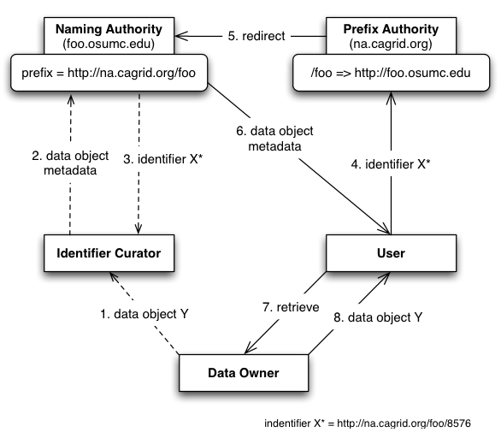
The Identifier Curator actor wants to globally identify a new data object Y contained within the Data Owner. The curator builds the metadata required to help retrieve data object Y later, via the mechanisms supported by the Data Owner, and gives it to the Naming Authority as part of the “create identifier” request. The Naming Authority generates an identifier, stores the metadata associated with it, and returns the identifier to the Identifier Curator. This completes the creation process.
Later, a User is given the identifier and wishes to retrieve the corresponding data object. Since the identifier is a URI that points to the prefix authority, it is simply “followed” (via http) to retrieve the associated metadata. The Prefix Authority notices the URL specifies the foo domain, and redirects the User to the correct Naming Authority. The Naming Authority responds to the request with the identifier’s metadata. At this point, the metadata can be used to retrieve the data object from the Data Owner.

NA-SB2 Conceptual deployment without a prefix authority

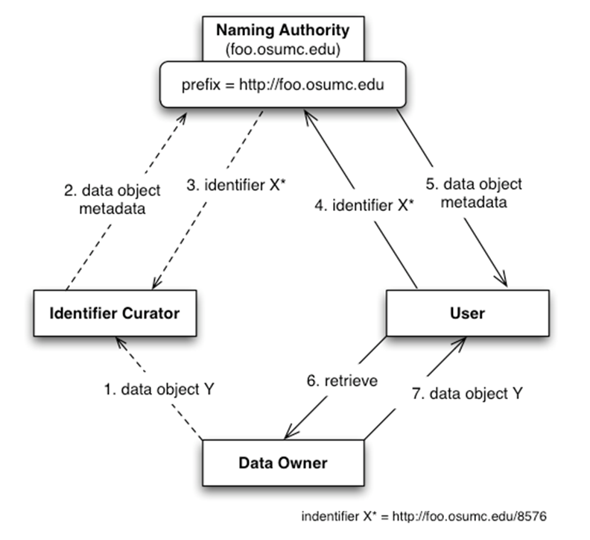
In this model, identifiers created by the naming authority carry a prefix that matches the naming authority server location, which is inconvenient if the naming authority is relocated.

Detailed Functional Model

Structure of the Service

Name | Description
Resolve an identifier | Given an identifier, determine the object metadata associated with it.
Create an identifier | Given object metadata, create an identifier that maps to the given metadata.
Update an identifier | Given an identifier, provide operations to update the corresponding metadata.

Detail of the Capabilities

Name [M] | Resolve an Identifier
Description [M] | Allows an authorized user to retrieve the metadata associated with a given identifier.
Pre-Conditions [M] | Identifier exists.  A naming authority hosting the identifier exists and it’s functional.
Security Pre-Conditions [M] | User must be authorized to read at least some of the identifier metadata. Otherwise, a security error should be produced.
Inputs [M] | Identifier
Outputs [M] | Identifier Metadata
Post-Conditions [O]
Exception Conditions [M] | Invalid Identifier Exception  Naming Authority Configuration Exception  Naming Authority Security Exception
Aspects left for Technical Bindings [O]
Notes [O]

Name [M] | Create an Identifier
Description [M] | Allows an authorized user to create a new identifier and associate metadata to it.
Pre-Conditions [M] | A naming authority has been identified to create the new identifier.
Security Pre-Conditions [M] | User must be authorized to create identifiers in the target naming authority.
Inputs [M] | Identifier Metadata
Outputs [M] | Identifier
Post-Conditions [O]
Exception Conditions [M] | Invalid Identifier Metadata Exception  Naming Authority Configuration Exception  Naming Authority Security Exception
Aspects left for Technical Bindings [O]
Notes [O]

Name [M] | Update an Identifier
Description [M] | Allows an authorized user to update the metadata associated with a given identifier.
Pre-Conditions [M] | Identifier exists.  A naming authority hosting the identifier exists and it’s functional.
Security Pre-Conditions [M] | User must be authorized to update the metadata desired.
Inputs [M] | Identifier  Identifier Metadata
Outputs [M] | None
Post-Conditions [O]
Exception Conditions [M] | Invalid Identifier Exception  Invalid Identifier Metadata Exception  Naming Authority Configuration Exception  Naming Authority Security Exception
Aspects left for Technical Bindings [O]
Notes [O]

Profiles

Functional Profiles

Functional Profile No. | Functional Profile Name | Functional Profile Description | Capability Name
NA-FP1 | NA Resolution | Naming Authority component offering read operations via HTTP (identifier resolution) | - Read (Resolution Interface)  - Web Application
NA-FP2 | NA Administration | Naming Authority component offering all update operations | - Create Identifiers  - Resolve Identifiers  - Update Identifiers

Semantic Profiles

Semantic Profile No. | Semantic Profile Name | Constrained Information Model | Semantic Profile Description
NA-SP1 | NA V1.0 Resolution | NA 1.0 NamingAuthority Interface
NA-SP2 | NA V1.0 Administration | NA 1.0 MaintainerNamingAuthority Interface

Conformance Profiles

Conformance No | NA-CP1
Conformance Name | Naming Authority Resolution Conformance Profile
Description | This conformance profile covers the required resolution interface for the naming authority
Usage Context | Humans or programs resolve identifiers to metadata using this profile
Mandatory | Yes
Functional Profile(s) | NA-FP1 : NA Resolution
Semantic Profile(s) | NA-SP1 : NA V1.0 Resolution

Conformance No | NA-CP2
Conformance Name | Naming Authority Full Administration Profile
Description | This conformance profile covers the management interface for the naming authority
Usage Context | Client programs administer identifiers (creates/updates) using this profile
Mandatory | No
Functional Profile(s) | NA-FP2 : NA Administration
Semantic Profile(s) | NA-SP2 : NA V.1 Administration

System Implementation Details

System Runtime Interaction Details

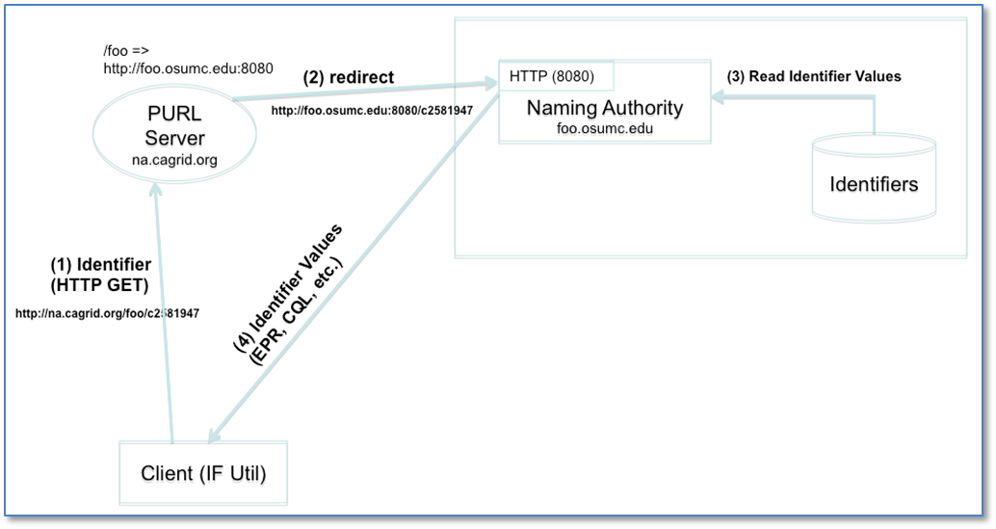
Resolution refers to discovering the identifier values (metadata) given a known identifier. As explained previously, an identifier can be resolved by “following it”, due to its HTTP-URI nature. The figure above depicts a resolution scenario using HTTP GET. When the identifier (URL) is followed, the prefix authority server (PURL) redirects the request to the location (NA) that has been mapped. The NA extracts the local identifier name from the URL (c2581947), looks up the values from the identifiers table, and returns them to the client. As previously explained, the output of the response could be HTML or XML.

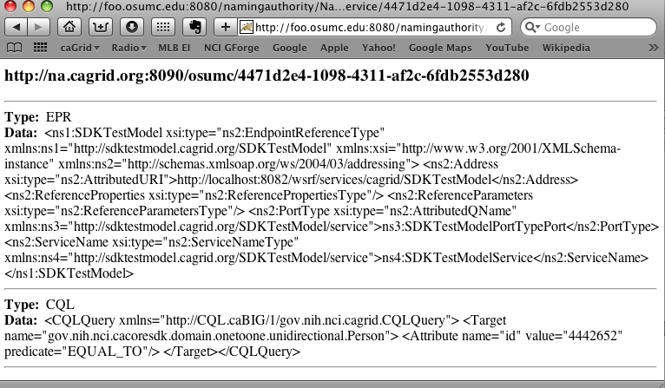

The figure above shows a sample HTML response as presented by a web browser.
A client could also use the framework’s grid service to resolve an identifier. Next figure depicts this scenario.
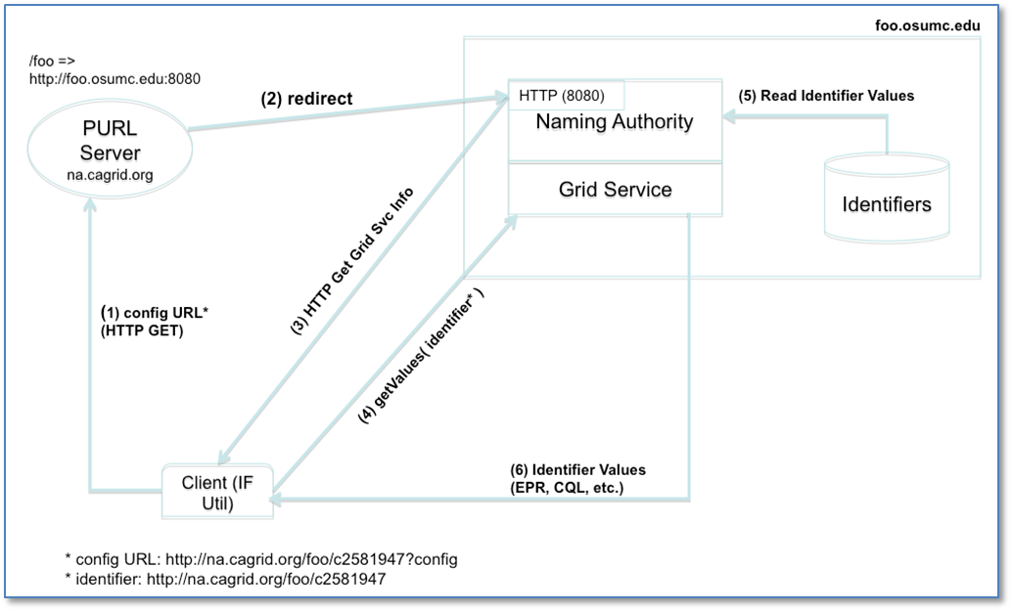
The framework’s client subsystem retrieves the naming authority configuration by adding “?config” to the identifier URL and following it. The NA configuration is needed in this case in order to determine the grid service end point.
For example:
- A user wishes to resolve identifier http://na.cagrid.org/foo/c2581947 using the grid service.

- Client toolkit appends an extra parameter (?config) to the query string, and issues an HTTP GET on http://na.cagrid.org/foo/c2581947?config

- PURL servers redirects to http://foo.osumc.edu:8080/c2581947?config

- NA recognizes that configuration is being requested and returns the information as XML. The response contains the location where the naming authority grid service is running, for example, http://foo.osumc.edu/wsrf/services/cagrid/IdentifiersNAService

- Client now acts as a grid service client and executes the getValues operation on the grid service located at the URL retrieved in the previous step.
In this way, the web (HTTP) is used resolve the identifier to its naming authority, and after the naming authority provides the information about its grid service, the grid is used to actually retrieve the identifier’s metadata.
In addition to resolution, the grid service interface is also used for full naming authority administration (i.e. creating and updating identifiers).

Implementation/Deployment Considerations

Implementation Considerations | Impacts
The identifiers framework is conceptually composed of the following components:  - A Naming Authority.  - A Prefix Authority.  - A Management Interface. | The only required component in any deployment is the naming authority.  Deployments with no prefix authority are impacted by losing federated capabilities.

Conformance and Compliance

Compliance and Conformance Statements
The identifiers framework conceptual model conforms with existing web standards and protocols, providing a natural approach to identifier adoption and resolution.

Appendix A - Relevant Standards

- Uniform Resource Identifier (URI)
- Hypertext Transfer Protocol (HTTP)
- W3C Extensible Markup Language (XML)

Appendix B – References

Name | Description | Location
IDENT  DESIGN 1.0 | caGrid Identifiers Framework Design Document  Scott Oster  Calixto Melean | https://ncisvn.nci.nih.gov/svn/cagrid/trunk/cagrid/Documentation/core/Identifiers/caBIG_IdentifierSvcFramework_Design.docx

Appendix C - Glossary

Term | Description
NA | Identifiers Naming Authority
PURL | Persistent Uniform Resource Locator

Appendix D – Cross Reference Tables

List of Storyboards

# | Name | Description | Source
NA-SB1 | Federated Deployment | The identifiers framework is deployed with the optional Prefix Authority. | IDENT DESIGN 1.0
NA-SB2 | Non-Federated Deployment | The identifiers framework is deployed without a prefix authority. | IDENT  DESIGN 1.0

Storyboards to Capabilities Mapping

# | Storyboard | Capabilities | Functional Profiles
NA-SB1 | Federated Deployment | Management | NA-FP2
NA-SB1 | Federated Deployment | Resolution | NA-FP1
NA-SB1 | Federated Deployment | A prefix authority is present to map multiple prefixes to multiple naming authorities.
NA-SB2 | Non-Federated Deployment | Management | NA-FP2
NA-SB2 | Non-Federated Deployment | Resolution | NA-FP1
NA-SB2 | Non-Federated Deployment | No prefix authority

Actors

Actors | Functional Profile | Type | Operations used
User | NA Resolution  NA Administration | Client | Resolution  Creation  Updates
User | NA Resolution | Person | Resolution
Prefix Authority | NA Resolution | Service | Resolution
Curator | NA Administration | Client | Creation  Updates
Naming Authority | NA Resolution  NA Administration | Service | Resolution  Creation  Updates

