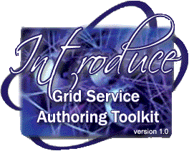

Shannon Hastings
Scott Oster
Stephen Langella
David Ervin

(hastings,oster,langella,ervin)@bmi.osu.edu

Overview
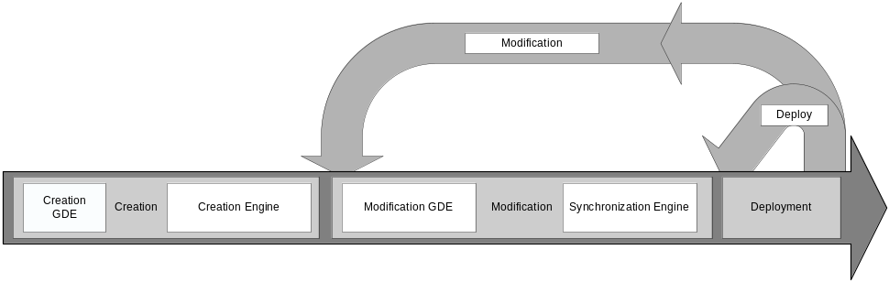
Figure 1. Overall service development process.

The Introduce toolkit is designed to support the three main steps of service development: 1) Creation of Basic Service Structure. The service developer describes at the highest level some basic attributes about the service such as service name and service namespace. Once the user has set these basic service configuration properties, Introduce will create the basic service implementation, to which the developer can then add application-specific methods and security options through the service modification steps. 2) Service Modification. The modification step allows the developer to add, remove, and modify service methods, properties, resources, service contexts, and service/method level security. In this step, the developer creates strongly-typed service interfaces using well-defined, published schemas, which are registered in a system like the Mobius GME, as the type definitions of the input and output parameters of the service methods. 3) Deployment. The developer can deploy the service which has been created with Introduce to a Grid service container (e.g., a Globus or Tomcat service container).
A service developer can access the functions required to execute these three steps through the Graphical Development Environment (GDE) of Introduce. The runtime support behind the GDE functionality is provided by the Introduce engine, which consists of the Service Creator, Service Synchronizer, and Service Deployer components. The toolkit provides an extension framework that allows Introduce to be customized and extended for custom service types and discovery of custom data types. In the following sections, we describe the software prerequisites, the Introduce Graphical Development Environment, the Introduce Engine, and the Introduce Extension Framework in greater detail.

Mailing Lists

- Archive of developer discussion: introduce-dev@globus.org
- Archive of user discussion: introduce-user@globus.org
- Archive of announcements: introduce-announce@globus.org
- Archive of commit notifications: introduce-commit@globus.org

Software Prerequisites

- Java 1.4.2 or greater (www.java.sun.com)
- Apache Ant 1.5.6 (www.ant.apache.org)
- The Globus Toolkit Version 4.0.3 (www.globus.org)

Introduce Graphical Development Environment

The Introduce Graphical Development Environment (GDE) is the graphical user interface that can be used to create, modify, and deploy a grid service (see Figure 2). It is designed to be very simple to use, enable using community excepted data types, and provide easy configuration of service metadata, operations, resources, and security. It also allows customized plug-ins to be added for such things as discovering data types from grid repositories and for creating custom or common service types.

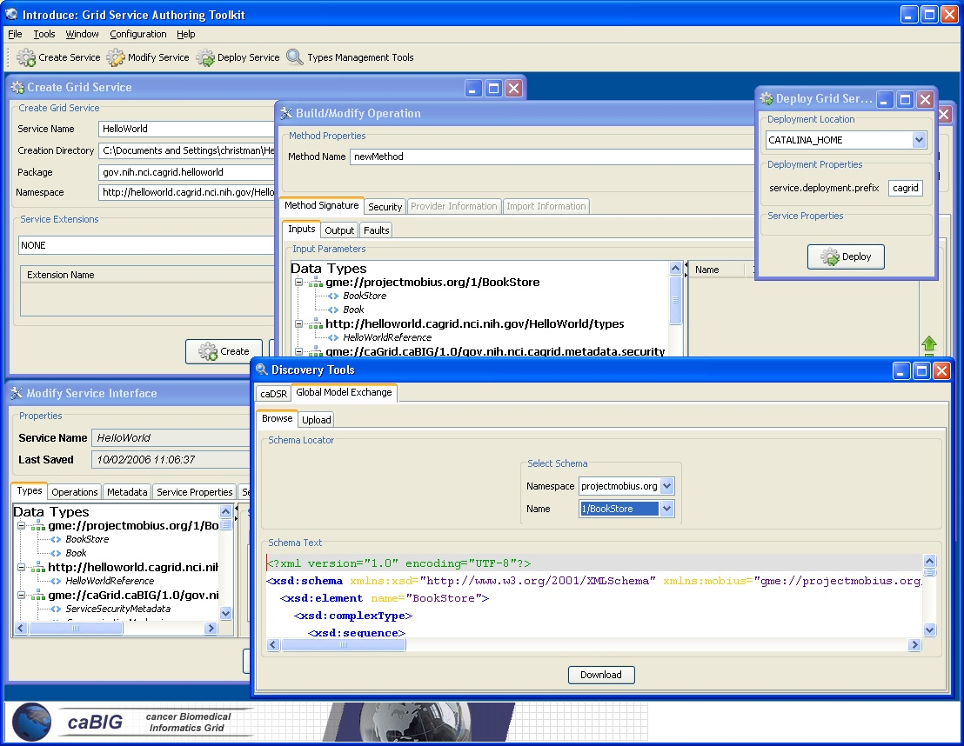
Figure 2. The Introduce Graphical Development Environment (GDE)

The interface contains several screens and options for the service developer to 1) create a new service, 2) modify an existing service, 3) discover and use published data types in order to create strongly-typed service methods, and 4) configure service metadata and deploy the service.

Service Creation

The service creation component, shown in Figure 3, enables the developer to create a new grid service. Using the creation interface, the service developer can provide basic information about the service such as:
- Creation Directory
  - The creation directory is the location of which the grid service will be generated.
- Service Name
  - Service name is the name that will be used to generate the service. The service name must be a valid java identifier.
- Package Name
  - The package name is the base package to be used when generated the grid service source code.
- Namespace
  - The namespace is the namespace to be used when defining the WSDL of the service.

The developer also has the ability to add service extensions. A service extension is an Introduce plug-in (see Service Extensions), which is designed to add customizations to the service. For example, service extensions might add pre-defined operations, resources/resource properties, or security settings. They enable the development of custom service types with predefined methods, which must be implemented. They also enable Introduce to run the custom code implemented in the plug-in, which makes modifications to the underlying service being created. This capability allows the specialization of Introduce to support domain specific common scenarios, further abstracting the individual service developer from responsibilities related to the deployment of grid technologies in a production environment. Once the information has been entered and extensions, if any, have been selected, the user will select the create button. Once the creation button is selected the Introduce creation engine will begin generating the service. After the service is generated is will be compiled and the Modification component will be displayed.
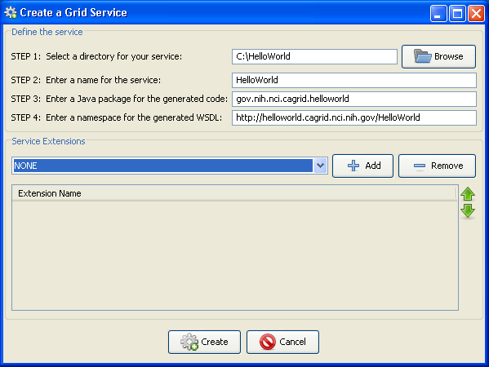
Figure 3. Introduce GDE Service Creation Component.

Service Modification

Service modification can be performed on any new or previously modified Introduce generated service. The service developer can perform a series of operations in order to begin to customize the grid service or modify the existing grid service. The overall flow in the modification of a grid service is to first use the namespaces tab to be sure that all the data types that are desired to be used I the grid service have been selected and added to the service. Next the service can choose to either add/remove or modify operations, metadata in the form of resource properties, service properties, security setting, and service contexts. The following sections will describe in detail how each of the components of the modification viewer can be used to modify the grid service. By selecting the “Modify Service” button on the main menu a prompt will be enabled to enable choosing the service to be modified. Once the desired directory containing the service to be modified is selected the modification viewer component will be launched. The modification viewer contains 6 main areas where modifications can occur on the service:

Types

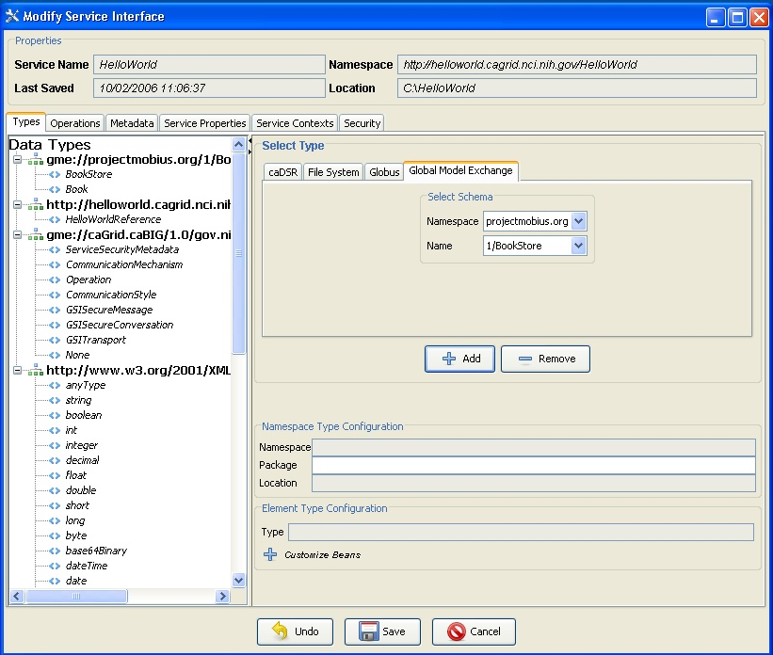

The first task in the modification of a grid service is to discover the data types that are desired to be used as the input and output types of methods of the service and the data types for describing the resource properties of the service. Adding a data types to the service is equivalent to copying schemas into the schema location of the service and importing the schemas into the WSDL file so that the types can be referenced by the service. This is done via the “Types” tab of the Graphical Service Modification Environment. This tab shows the current types the service is using, and provides access to the data type discovery components (such as the Mobius GME), for selecting and configuring additional types. The “Select Type” frame enables several types of ways to locate data types and bring them into the service. Currently there are three main discovery mechanisms (GME, Globus, and File System) that come with introduce, however, this is extensible via the Discovery Extension described in the Extensions section.
Once a set of data types from a namespace are brought into the service the user has the ability to describe how these data types will be mapped into there respective java classes. This can, by default, be done automatically by Introduce via Axis. By default, Axis will create new java beans for each data type and also provide a serializer and deserializer for those objects. If for example, a set of objects already exist for this particular data types then a user can decide to provide there own classes and serialization/deserialization factories.

Operations

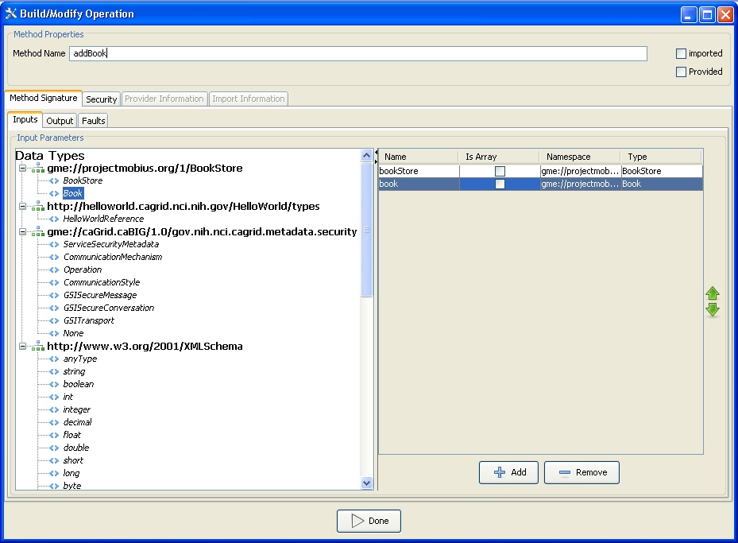

The developer can add, remove, or modify operations on the service, using the “Operations” tab of the GDE Service Modification interface. For each operation, the developer needs to set the input parameters, return type, and any fault types that can be thrown from each service method. The security configuration of the operation should also be set if desired. The input and output types can be selected from the types tree on the left. This tree represents the available data types which can be used by this service. If any input parameter or output type is to be an array the array checkbox must be checked in the table on the right. Also, once an input parameter is added the name of the parameter is defaulted. This name can be edited by the developer by selected the cell in the name column and editing the text. There are two ways to add faults, either choose a type from the types tree which extends WSRF BaseFaultType or create a new fault which will tell Introduce to create you a new fault type which extends the BaseFaultType.
The implementation of a described operation may already exist in another class which is provided by a jar file. You can tell Introduce not to stub this methods server side implementation but instead call this provided method implementation directly in the class provided. In order to use this functionality the “Provided” checkbox must be selected and the Class name attribute must be filled out in the “Provider” tab. The jar file that contains the provided Class which implements this operation must also me copied into the lib directory of the service. This will ensure that the operation will be located at the time the operation is called on the service.
Operations can also be imported from other services. Importing an operation enables the service to implement the exact same operation signature. This enables the service to have an operation which has the exact same WSDL signature of the operation which is being imported. This would enable either client to call this operation on either service. Importing can be done in two ways: (1) from an Introduce generated service, or (2) from a WSDL file. For case 1, importing from an Introduce service, the developer would browse and select the Introduce generated service which contains the operation to be imported. Once the Introduce service is selected a list of services which contain this method will be available to select from. Select the service from which you want to import the operation. The methods signature will be imported and the developer will be prompted to make sure to copy over the WSDL and XSD files needed to import the method into the schema<servicename> directory of the service. For case 2, if a method is described in another WSDL but the developer wants to implement this exact method from this WSDL. The developer must have the WSDL and corresponding XSD’s in the schema/<servicename> directory of the service. Then the developer will be able to browse those WSDL files and select the port type they wish to import the operation from. The importing of a method across services will assure not only that each service has completely protocol compatible methods but also that each service’s method can be invoked by the same base client. This enables the notion of basic inheritance in grid services and is discussed further in Operation Importing.

Resource Properties

Service state information and metadata in the form of resource properties can be added, removed and configured via the “Metadata” tab of the GDE Service Modification interface. The metadata elements which are added to the service can be populated by a file statically or managed dynamically within the service. Also, these metadata entities can be registered with an index service so that users can use the metadata to locate the service.

Service Properties

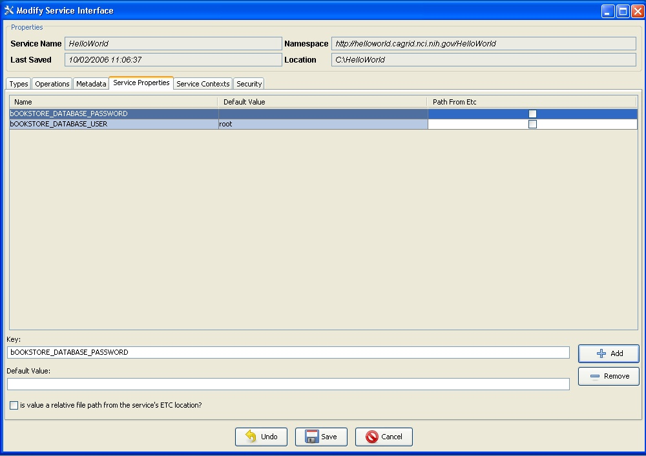
,
Service properties are key value pairs which can be set at deployment time and are available to the server side implementation of the service. This enables passing in configuration variables to the server side of the service at deployment. These key value pair properties can be declared in “Service Properties” tab of the GDE Service Modification interface, and a default value can be given there as well. The properties will be confirmed and/or can be changed at deployment time. The variables can then be accessed inside the user’s implementation of the operations.

Service Level Security

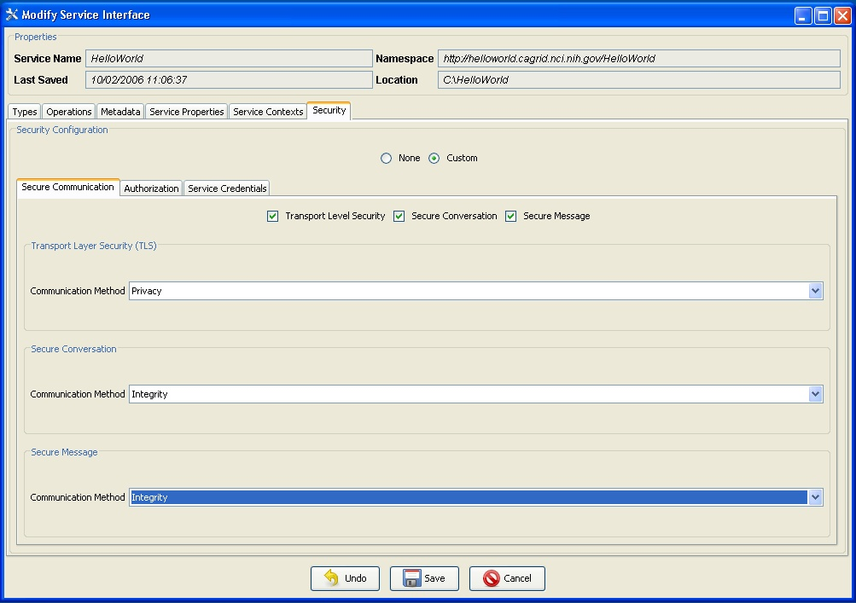

Service level security configuration can be set at this time as well via the “Security” tab of the GDE Service Modification interface. The service level security can be superseded by method level security. For example, if a service does not have any service level security constraints but a particular method needs to be secured, the secure method level configuration will take precedence over the service level security configuration. For detailed knowledge of what the configuration options for Secure Conversation or Secure Credentials please refer to documentation for the GSI framework.

Service Contexts

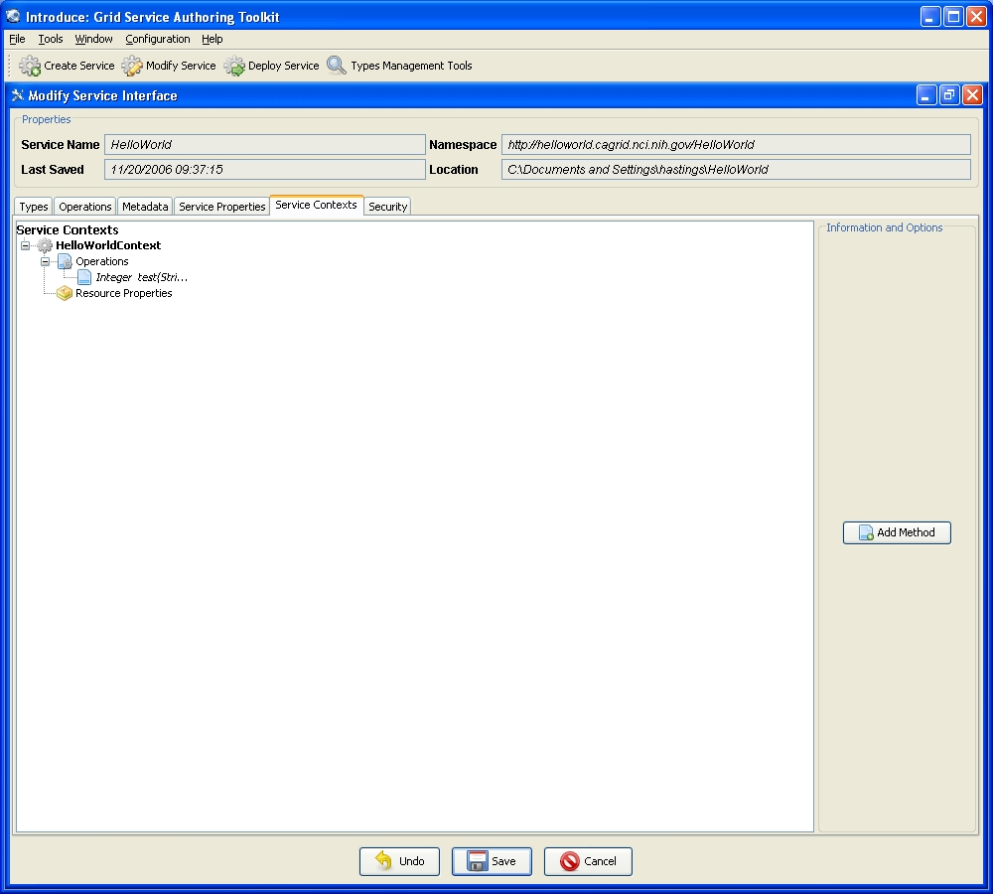

A power user feature which can be enabled at modification time is the addition or removal of service contexts. Contexts can be added via the “Service Contexts” tab of the GDE Service Modification interface Service contexts define additional conceptual contexts of operations needed to support the desired service functionality. This is enabled by using WSRF capabilities of the Globus Toolkit. As an example, if an operation on the main service enables the user to query a database, that operation might create a resource in another context and return the handle to that context to the user as opposed to the full query result set. This secondary context can then enable the user to iterate through the query results. This is accomplished by operations or resource properties to this secondary service context which will be responsible for iteratively giving results to the user. It should be noted that multiple instances of these contexts can be created and executed concurrently; one for each query that comes in, for example. This style of grid service is supported by the WSRF specifications. Though the details of the WSRF-implementation of these concepts are abstracted away from developers its worth noting how they are realized, and this is described in detail in other sections. Introduce makes it easier for service developers to create such complex services, via the GDE, without having to fully understand the underlying service implementations.

Discovery Tools: Support for Strongly-Typed Service Methods

Using the GDE, developers can obtain the types that they want to use for the service parameters and return types from any data type discovery plug-in. Utilizing common and standard data types, which are defined outside of any application-specific service, enables the creation of strongly typed grid service interfaces. This increases service-to-service interoperability. Once a data type is chosen through the GDE, the data type is retrieved, written into the schema area of the service, and imported for use in the service WSDL description so that Java beans can be generated and the data types can be programmatically used.
The Introduce toolkit comes with a set of pre-installed discovery plug-ins, such as the Mobius GME and a basic file system browser which can be used to locate local schemas. The GME plug-in enables developers to browse, upload, and download schemas published in a GME. These schemas represent the valid data types which can be used during service creation. Using the GME plug-in, a developer can take a schema, create an editable view of the schema, and then submit the schema to the GME. If the namespace of the schema is not managed by the GME, to which the schema is submitted, the plug-in will attempt to add the namespace to the GME before submitting the schema. Once the schema has been uploaded, it can be used by anyone in the Grid through the Introduce toolkit. The GME plug-in browser window enables browsing through all the GME published types by namespace and schema name. It presents the user a quick view of the schema and the option to download the schema bundle. The schema bundle contains the schema and all other schemas which are referenced by that schema.

Deployment

The deployment option of the GDE (Figure 4) allows the service developer to deploy the implemented grid service, which has been created with Introduce, to a Grid service container. The toolkit currently supports deploying a service to either a Globus or Tomcat Grid service container; however, support for other deployment options can easily be added to the GDE. The deployment window allows the service deployer to populate service configuration properties, which the service will have access to at runtime. Then the service is deployed to the selected container.
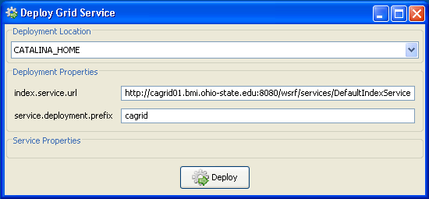
Figure 4. Introduce GDE service deployment component.

Introduce Engine

The runtime support to enable service creation, modification, and deployment is provided by the Introduce engine. In this section, we describe the main components of this engine.

Service Creator

The service creator is composed by a series of templates using the Java Emitter Templates (JET) component, which is part of the Eclipse Modeling Framework (http://www.eclipse.org/emf/), for generating source code and configuration files, and a skeleton set of directories which is used to generate a Grid service that can be built, registered, and deployed in the Grid environment.
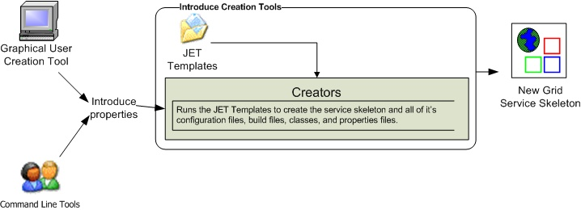Figure 5. Service creation tools and use of JET templates for service creation.

Templates for source code and configuration files are used to create all the custom Java source code for the service and the client APIs, and to generate the files required by the GT in order to build and deploy a Grid service (Figure 5). Deployment configuration files are used for resource and resource property configuration in the form of Java Naming and Directory Interface (JNDI), resource property registration configuration, service deployment descriptor in the form of Web Service Deployment Descriptor (WSDD), and security configuration. The basic service created by Introduce has the following components:
- Ant processes for build, deploy, and test operations,
- custom configuration files for IDE integration, e.g., Eclipse project files for editing of the service using the Eclipse platform (www.eclipse.org),
- standard interface for both client and service to implement,
- fully implemented client APIs,
- stub implemented service,
- configuration to support service metadata and resource properties and the registration of metadata and properties,
- configuration for secure service deployment and authorization.

Service Synchronizer

Service resynchronization is the process by which the source code and configuration generation tools of the Introduce toolkit will analyze the service’s current implementation with that of the desired service description. This process will add, remove, and modify any service methods, resource properties, and service settings which have been added, removed, or modified from the service description. The descriptions and configurations for methods, metadata, and security are those that are generated from the GDE, programmatically or by hand, and that can be validated by the Introduce service schema (Figure 10 and Figure 11). The service description is the basis by which the code generation tools add, remove and modify operations, metadata, and change the security configuration of the service by editing the source code, configuration files, and metadata files. This is similar to the way that Axis will use the WSDL to generate the grid stubs of the service. The overall high level process of service resynchronization is illustrated in Figure 6.
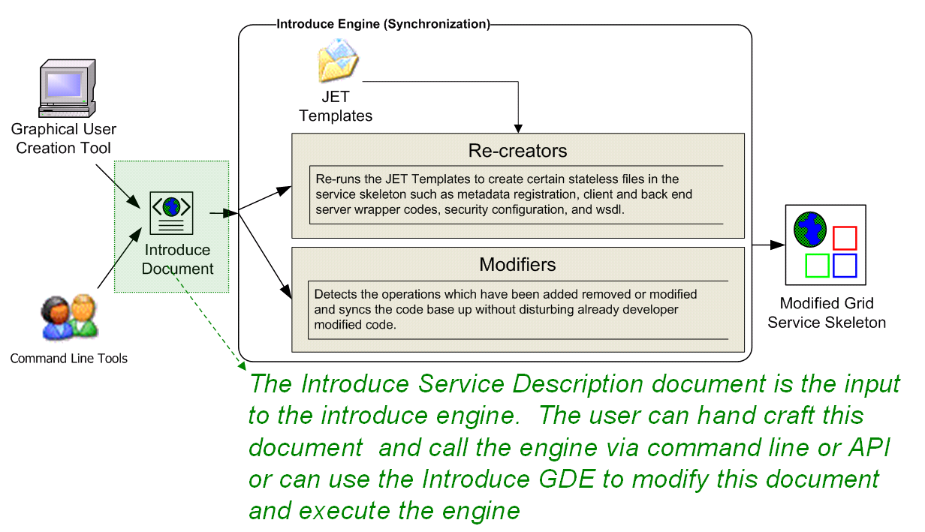
Figure 6. Service resynchronization process.

In this process, modified documents created by the GDE are processed using JET templates to create the modified service skeleton. The service synchronizer component manages the service WSDL description. If a service or method has been added or removed, the respective WSDL files must be updated to reflect the changes. Updating the files requires many auto generated code segments. External XML schemas, which describe published data types, must be imported into the respective WSDL files so that the data types can be located and used to generate the required Java beans and SOAP bindings. The WSDL description is basically the Grid layer representation of the Java based service interface. Both the message types, which represent the data types of the input parameters and the return type of a service method, and the complete operation, which reflects the Java based signature of the method being exposed, have to be described in the WSDL file. The synchronization operation automatically keeps this file in sync during the development of services so that the service implementation and the Grid service description represented by the WSDL match up. This ensures that the methods implemented in the Grid service can actually be invoked.
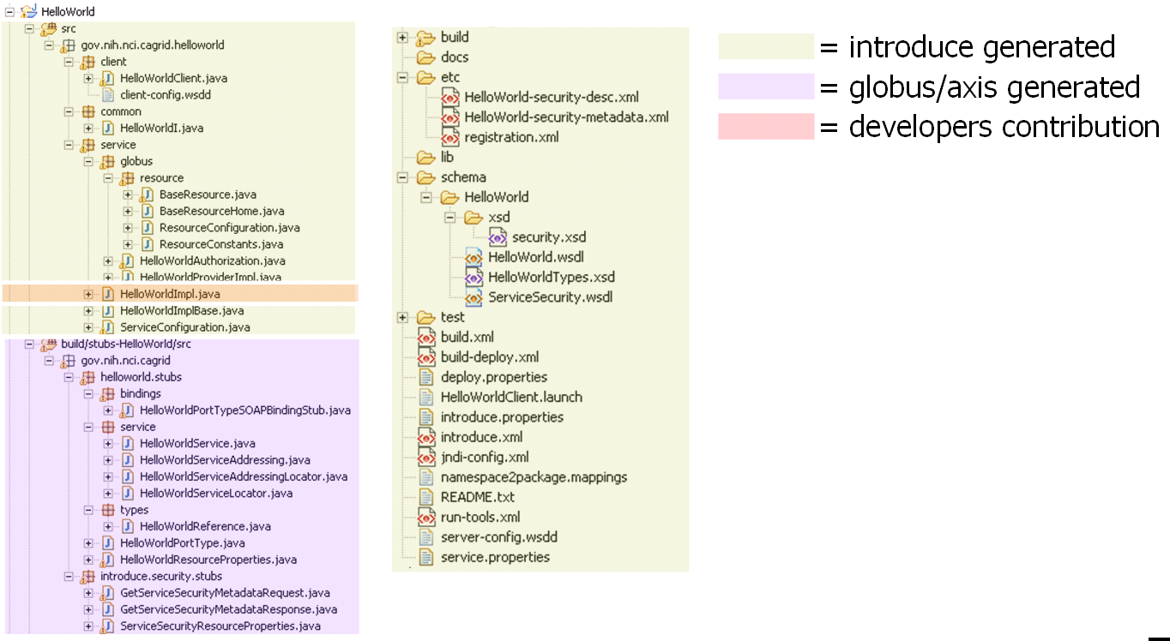
Figure 7. Basic service layout of an example service created by Introduce .

Figure 7 shows a basic service layout as created by the Introduce Service Creator component. It shows which pieces of this example service are generated by the code generation tools, which pieces are built by the underlying Globus/Axis tools, and which pieces are to be implemented by the service developer.
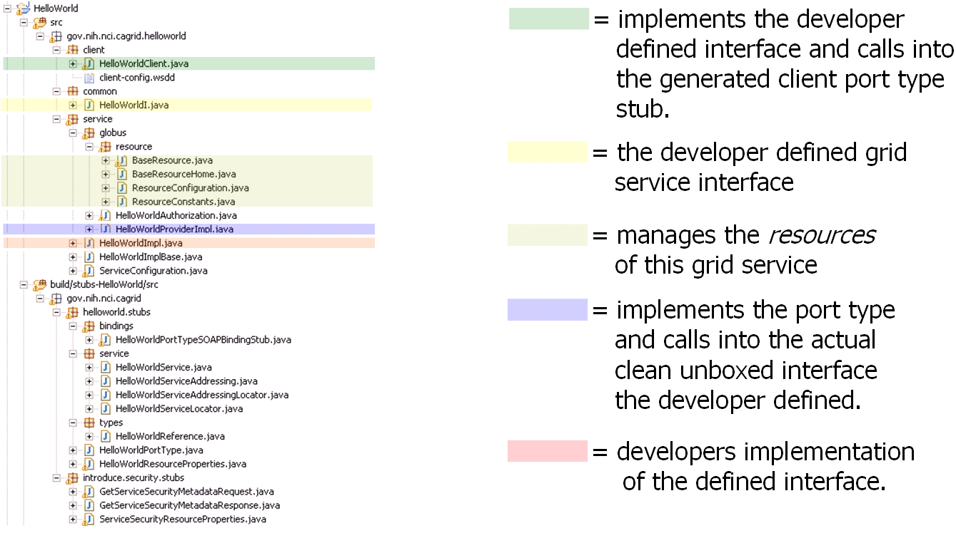
Figure 8. Source files used in an example service created by Introduce.

Figure 8 describes what some particularly critical source files are generated for in an example service created by the Introduce engine. When a WSDL file is parsed by the Axis engine a PortType interface is created which is the Java representation of the API of the grid service. The Axis generated PortType interface must then be implemented on the service to provide the services implementation. In order to enable the service developer to implement a cleaner, non-documument literal interface, Introduce will automatically create the implementation of this PortType interface (HelloWorldProviderImpl). The Introduced generated implementation of this interface will unbox the document literal calls ot the service and pass them on to the unboxed/clean interface (HelloWorldI) which the user defined. Introduce will generate a stubbed implementation of this interface (HelloWorldImpl) which the user will be responsible for implementing. This class will maintain the services implementation of the methods. This enables the service designer to be shielded from the details of the Axis document literal grid service interface and enable them to implement an interface which is as then originally described. The figure also illustrates the example service’s resource and resource home, which are generated to manage the service resource and the service resource properties, respectively.

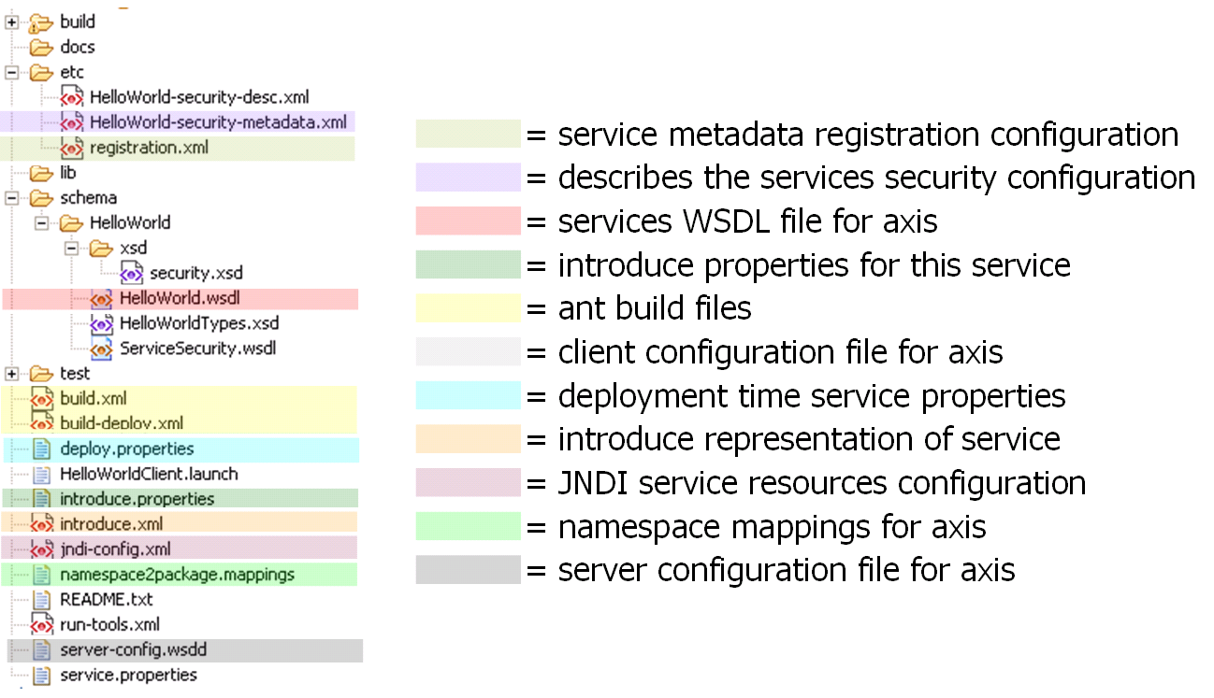
Figure 9. Example common/configuration files on an example service created by Introduce.

Figure 9 shows the use of the different common files of an example Introduce created service. It shows the files used for configuring registration and security for the grid service, as well as those used by Introduce for synchronization, and those used for build and deployment. This example service created by Introduce also contains Eclipse project files so that the service can easily be edited using the Eclipse platform (www.eclipse.org).
The service can have an inheritance model by adding methods from another service; possibly along with the implementations of those methods (see Section ). If a method were imported from another Grid service, the service synchronizer component would also pull in the WSDL description of the method and copy it into the portType of the new service. This enables the service to have a completely protocol compatible implementation of the method.

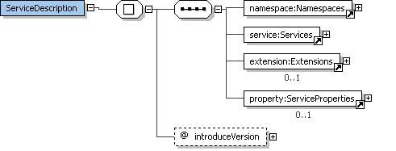
Figure 10. Base Introduce Service Description Schema
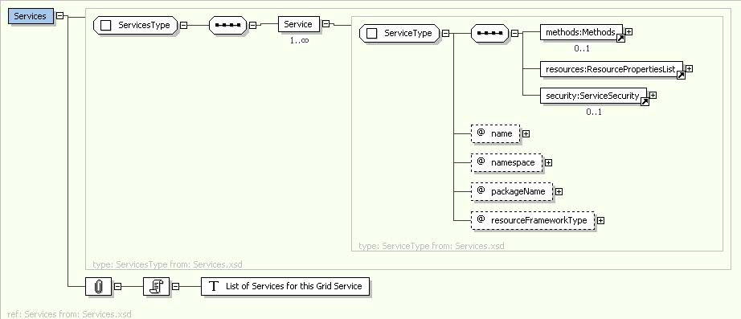
Figure 11. Schema for Introduce Services.

Service Deployer

The service deployment features of Introduce currently support deploying Grid services to a Globus or Tomcat container. The deployment framework can easily be extended to provide deployment capability to other Web Service containers. It utilizes the layout of the Grid Archive (GAR) structure to organize and package a deployable service. Once the GAR for a service is generated by the deployment framework, the GAR can be utilized to deploy the service to the appropriate container. The deployment framework also allows for deployment time service properties to be acquired from the application developer or the user deploying the service. These custom service properties allow a service creator to define configurable options that make sense for a particular deployment of the service to have control over. When the service is deployed, the deployer prompts for the desired values, presenting service developer provided defaults. The supplied values are then made available to the service at runtime. For example, if a service implementation accesses a local database, the username and password of the database can be specified as service properties. This allows a very convenient way for those deploying the service to configure it appropriately for their environment, without requiring knowledge of how the grid service implements these configuration points.
The deployment process first populates files required in deployment (e.g., the WSDD and JNDI of the service) to specify such values as service deployment path or security configuration file locations. It then gathers the library files required for the service as well as those library files which contain the actual runtime code of the service. All configuration files and service resources are also collected. Finally, a GAR file is generated for this service. Once the GAR file has been generated, it can be handed off to the particular deployment handler for the required container to be used for this deployment.

Other Features of Introduce Engine

Auto-boxing/Unboxing of Service Operations

Grid service code generation and synchronization is one of the most complicated code generation operations in the toolkit. This component has to re-write the basic source code of the service so that the client and the server both agree on the newly modified interface as designed by the service creator. It also has to deal with associating the server side implementation of the service designer’s interface to the actual port type generated by Globus via Axis. The overall process is complicated due to fact that GT/Axis[14] use document literal bindings to create the services portType and bindings to SOAP. For example, if a user describes a new method as shown below:
int foo(int bar1, int bar2);

The port type method that will be created for the corresponding Java interface call will look like the one below:
FooReturn foo(FooParameters params);

This style is known as document literal binding. This boxing or wrapping of the parameters and the return type of the service method can be confusing to the service user and service developer to deal with, especially since this document literal style is exposed directly through the client API or the service implementation API. Every client using the service will have to box up the parameters to call the operations of the service and un-box the results. Not only will this task be cumbersome for service users, but the document literal interface is not the interface that the service designer intended to be provided to its users. The Introduce toolkit will hide the boxing and un-boxing of methods by providing an interface to the service, which looks exactly as described by the service developer and not as interpreted by Globus via Axis.
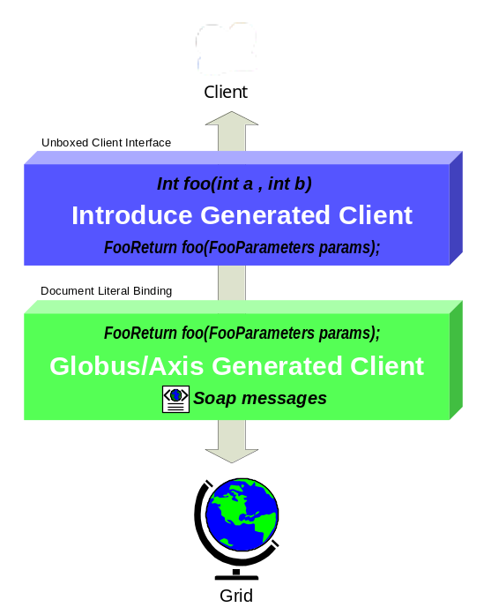
In order to do this, the toolkit creates a wrapping layer in the client and service which both implement the clean interface (non document literal) (see Figure 12: Client Side Unboxing Layers). These wrapper layers auto-box and un-box and map the calls from the clean client to the document literal port type client generated by Globus/Axis and visa versa for the service. It is worth noting that the move to document literal binding was made in the GT for interoperability reasons, as the more developer-friendly APIs provided by Introduce, and previously provided by GT, are not standardized and that Introduce created services can still be accessed via the standard document literal interfaces.
Figure 12: Client Side Unboxing Layers

Resource Framework

Introduce provides support for exposing service state and metadata by abstracting away the details of common patterns of use of the WSRF. The WSRF specifications and the GT implementation of these specifications allow the creation of stateful Grid services, whilst remaining compatible with existing Web Service standards. A Grid service’s state (and metadata) is maintained in Resources in the WSRF specification, and is exposed to clients by way of Resource Properties. Introduce allows its users to expose state or metadata of their services by managing the definition, creation, and population of the Resources and Resource Properties of a service.
Upon creating a service, a service developer is able to simply select from a list of common resource usage patterns, and Introduce manages the complete generation of the necessary backend code and configuration to implement that pattern. Once the resource pattern is defined, a service developer can then use the existing data type discovery tools (as used to specify operation inputs and outputs) in order to expose state or metadata of its resources by way of Resource Properties. Developers need only select a data type they wish to expose, and Introduce makes it available as WSRF standard Resource Property. Developers are able to either programmatically control the values of the property at runtime (as is common for exposed resource state), or supply the value from a file at service startup (as is common for exposed metadata). Another powerful feature of Resource Properties is that they can be advertised to, and aggregated at, a remote indexing service – an indexing service can be used by clients and other services to discover services in the Grid environment. GT provides such a service in the form of the Index Service. It acts as the white and yellow pages of the grid, providing resource and service discovery.
Introduce allows a service developer to maintain soft-state registration of its resource properties simply by selecting a check box on each property they wish to register. For each such property, It creates all of the necessary source code and configuration necessary to periodically register the property with an Index Service, and ensure the most recent value of the property is made available in the Index Service and associated with the service. The combination of these two simple-to-use, yet powerful features, allows a service provider to, for instance, automatically provide and register a description of its service to a central repository when the service is running.

Compositional Inheritance

Introduce enables the service developer to import methods from other services (i.e., from other portTypes). This notion is called compositional inheritance. Services under the new WSDL 2.0 specification cannot extend portType definitions. In order to simulate portType extension Introduce implements the ability to copy operation descriptions from other portTypes and put them in the service’s own description. When using this feature, there are various configuration option the engine must know such as the namespaces of the operations, and whether or not an implementation of the operations are already provided or should be generated stubbed just as any other Introduce defined operation.
In order to be sure that the operation can be correctly imported and copied into the new portType, the WSDL of this operation and any referenced schemas must be brought into this new service and imported. If the operation implementation is not being provided, the synchronization engine must add this operation to the services base interface, and the un-boxing Globus wrapper for this operation must be generated. If the implementation of this operation is being provided, the extra code in the interface, its implementation, and the wrapper do not need to be added. However, the implementation code, in the form of a JAR file, must be brought into the new service, and the operation class must be added to the WSDD of this service.

Multi Service / Multi Resource

In grid services architecture it is sometimes required that a service not only maintain some extra information about the service but also maintain information (state) which is of particular interest to one particular user. These styles of grid service use cases have driven the requirements for specifying a mechanism for stateful Grid services. Each WSRF service manages its state by creating and manipulating Resources. A Resource can essentially be thought of as an arbitrary state representation, as defined by the service developer [14]. The main restriction is that a given service can only manage a single given resource type. As previously stated in section , Introduce supports this mechanism through the Service Context concept. For example, a Data Service may want to define two contexts: the main “Query“ context which provides the ability to query into a backend database, and the secondary “Results Delivery” context which provides the ability to iteratively access query results (similar to a remote cursor). Introduce implements these Service Contexts by creating a WSRF service for each context, and a corresponding Resource type. In this example, the Query Service will have a Resource type that represents the backend database(s), and the Results Delivery Service would have a Resource type that represents query results. In this design, when a client invokes the query operation on the Query Service, the service can query the database and then create an instance of the Results Delivery Service’s Resource. The query operation then returns a pointer, or EndPointReference (EPR), to this Resource. The client is then able to interact with the query results by using the Results Delivery Service’s client, passing in the returned EPR to its constructor. Through its support for multiple Service Contexts, Introduce enables this and other such Resource patterns for stateful grid services.
This support is managed by the synchronization component of the Introduce engine. The service description model, created via the GDE or programmatically/hand generated, enables the description of multiple Service Contexts in an Introduce service. Each Introduce service has at least one Service Context (the main service), and can create an arbitrary number of additional Service Contexts to support more complex resource usage patterns, as described above. Each created context has a corresponding source directory containing its own server, client, common, resource, etc. This enables resource properties, operations, and security configurations to be added, removed, and modified for each additional context. Each additional context’s corresponding service and resource are modified, compiled, and deployed with the main service.

Security

Introduce facilitates the creation and configuration of secure Grid services using the Grid Security Infrastructure (GSI) and allows security to be configured at both the service level and the service method level. Moreover, Security can be enforced on both the client and service sides. Introduce allows service developers to specify the secure communication mechanism(s), in which clients are allowed to communicate with the service. An Introduce generated client can automatically be configured to communicate over the secure communication mechanism specified by the service. In the case where multiple secure communication mechanisms are supported by the service, Introduce will allow the service developer to choose which mechanism the client will use.

Introduce Extension Framework

The Introduce Extension framework currently consists of two styles of extensions; service and data type discovery. These extensions are implemented by service or data type discovery components which add custom functionality to the Introduce framework. Extensions are added to the toolkit in the form of extension plug-ins, which the toolkit will then be able to expose to the user. To provide an extension to Introduce, the extension provider must implement or extend the appropriate classes for the style of extension they wish to provide, and must fill out the extension XML configuration document. Once this extension is implemented and configured it can be placed in the extensions directory of Introduce. This directory has a common library (lib) area which enables it to avoid using custom class loaders for each extension.

Service Extensions

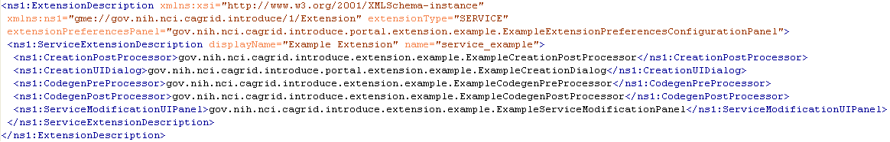
Figure 13. Sample Service Extension Description.

A service extension is one which enables customization of the service creation and modification processes. These extensions can add required operations, service resources or resource properties, or security settings, for example. The service extension allows the user to provide custom code that will be executed at different times throughout the creation and modification processes of service development. A service extension consists of 5 main extension components that can be implemented and provided by the developer: CreationPostProcess, CreationUIDialog, CodegenPreProcess, CodegenPostProcess, and ServiceModificationUIPanel. Each of these extension components have a predefined class and interface that must be extended or implemented. Two of the service extension components, CreationUIDialog and ServiceModificationUIPanel, are graphical components provided to the Introduce GDE, and the other three are Introduce engine plug-ins.
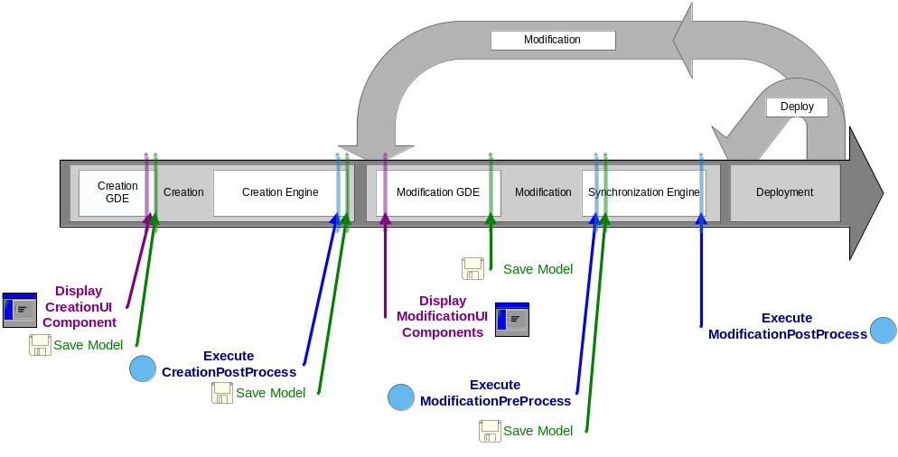
Figure 14. Execution of Introduce Extension Components.

Each service extension component is invoked at a specific point in the creation or modification steps (Figure 14). These different time points for each component execution are critical for making certain changes. For example, when the CreationUIDialog component for a particular extension is executed, the service has been created as a blank service and no modification or synchronization has been done on the service. At this point the CreationUIDialog might prompt the user for particular information about the creation processes. The CreationUI component would only be executed/displayed once for any given service and its non graphical component, the CreationPostProcess, will also only be ran one time after the service has been created and before it will ever be modified.
The modification components are ran every time a service is saved and synchronized. The graphical modification component is always available in the Introduce GDE during modification time. The two service modification engine components, ModificationPreProcess and ModificationPostProcess are executed respectively, before and after the synchronization process is executed. This enables ModificationPreProcess to do such things as modify the ServiceDesription, represented by the Introduce service description file, or the WSDL files of the services. The ModificationPostProcess, on the other hand, might move in required files, or populated stubbed methods, etc.

Data Type Discovery Extensions

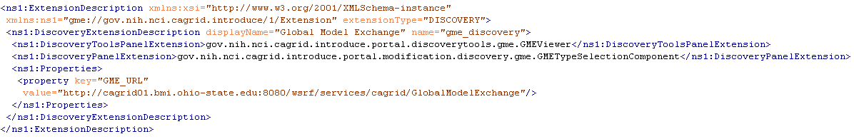
Figure 15. Sample Discovery Tools Extension.

These extensions are Introduce GDE components that will be available at the service modification step. These components are intended to be able to provide custom data type discovery for the service developer. The custom data type discovery component must allow the developer to browse types and chose to use those types in the developed service. This means that the data type discovery extension will have to be able to copy the schemas which represent the data types down to the service’s schema directory and produce a NamespaceType object for the namespace of each separate data type. This enables the grid service to utilize the schemas for describing the data types which are used in the WSDL messages traveling in and out of the created service.
In addition to default plug-ins, domain specific plug-ins can be installed in Introduce. For example, in the caBIG environment, a caDSR discovery plug-in is provided with Introduce. This plug-in allows service developers to locate and use data types registered in the cancer Data Standards Repository (caDSR), which is a curated repository of common data elements used in caBIG.

Introduce Tutorial

Overview
This section will give a tutorial outlining the steps to build an example book store grid service using the Introduce Grid Service Authoring Toolkit. Further steps will illustrate more advanced tools that configure metadata, set grid level and method level security and deployment options.
IMPORTANT: Add info here on how to download the tutorial and all the associated files!
The following is an outline of the tutorial:
- Create a Base Service
- Create or Locate Data Types
- Add Methods to the Service
- Implement the Methods
- Deploy the Service
- Implement a Simple Client
- Start the Globus Container and Run the Client
- Add Metadata
- Add Security Properties

Create a Base Service

The following will give detailed instructions on how to create a service, add data types, add a method and implement that method.

  - Launch the Introduce Grid Service Authoring Toolkit: invoke ant introduce from the top level of the introduce release.
  - Select Create Service from the toolbar or select Tools->Create Service from the toolbar. The Create Grid Service screen will appear. See Figure 1 below.
  - Choose a Creation directory to place the service. The tutorial will use “C:\BookStore”.
  - Type in the Service Name. Use “BookStore” for this tutorial.
  - Choose a Package. The tutorial will be using “osu.lib.bookstore”.
  - Choose a Namespace. The tutorial will be using “http://bookstore.osu.lib/BookStore”.
  - Click the Create button located at the bottom of the creation screen.
  - Be patient while Introduce creates the service. May take minutes.

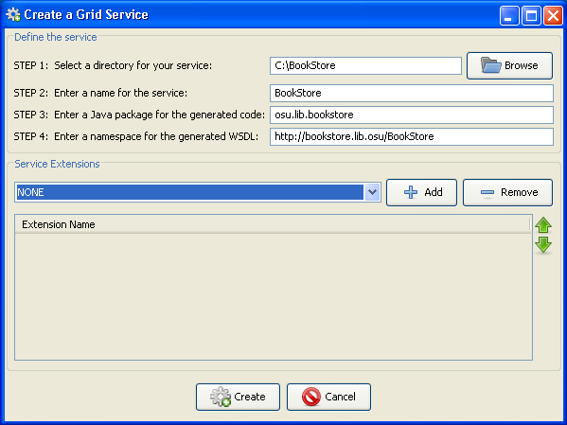
Figure 1. Create Grid Service
This section of the tutorial is complete.

Create or Locate Data Types

The following will give detailed instructions on how to create or locate data types that will be added to the existing base grid service. Complete the Create a Base Service step of the tutorial before proceeding.

From the modification viewer, there are three choices from where to obtain data types if the data types are not listed in the “Data Types” section. The three choices are to create a data type and upload it from the file system, downloading from the GME or importing from Globus. In this tutorial, the data types being used will be found in the GME. Before one can obtain a data type from the GME, the data type has to be uploaded by a user. The following steps will outline the process on how to upload a data type to the GME and obtain it for the current service being built with Introduce.

- Select the Types Management Tools from the menu or select Tools->Types Management Tools from the toolbar. This will launch the Discovery Tools window. Select the Global Model Exchange tab, and then select the Upload tab located within. Click on the Browse button and locate “1_BookStore.xsd” inside the installation directory of the tutorial. Click Open. Click Upload from the Discovery Tools window. A success message will appear and the upload is complete.

The schema will now be accessible from the GME. The following steps will outline how to contact the GME and import the data type into the current service.

- Select Modify Service from the toolbar or select Tools->Modify Service to launch the Select Directory screen. Note: The modification screen will automatically launch after the initial creation of a grid service. In that case, go to step 4.
- Select the root directory where the book store grid service is located. The directory for this tutorial is “C:\BookStore”. This will launch the modification viewer for the book store service. Refer to Figure 2 below.

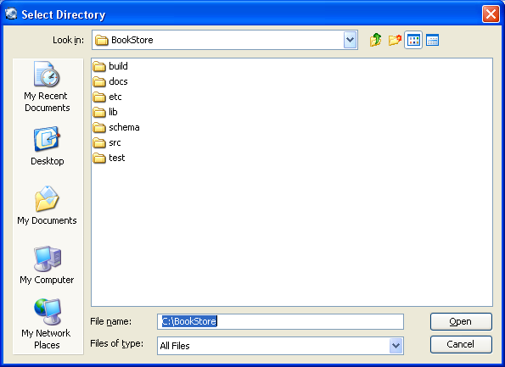
Figure 2. Select Directory

Now that the Modify Service Interface screen is visible, the next step is to import the 1_BookStore schema into the service.

- From the Modify Service Interface, verify the Types tab is active, and then browse to the Select Type section located on the right side of the window. Inside the Select Type window, select the Global Model Exchange tab. From the Namespace drop down menu, select “projectmobius.org” and from the Name drop down menu, select “1/BookStore”. Click the Add button below. Refer to Figure 3.
Note: The types BookStore and Book should be present in the Data Types section on the left hand side of the window.

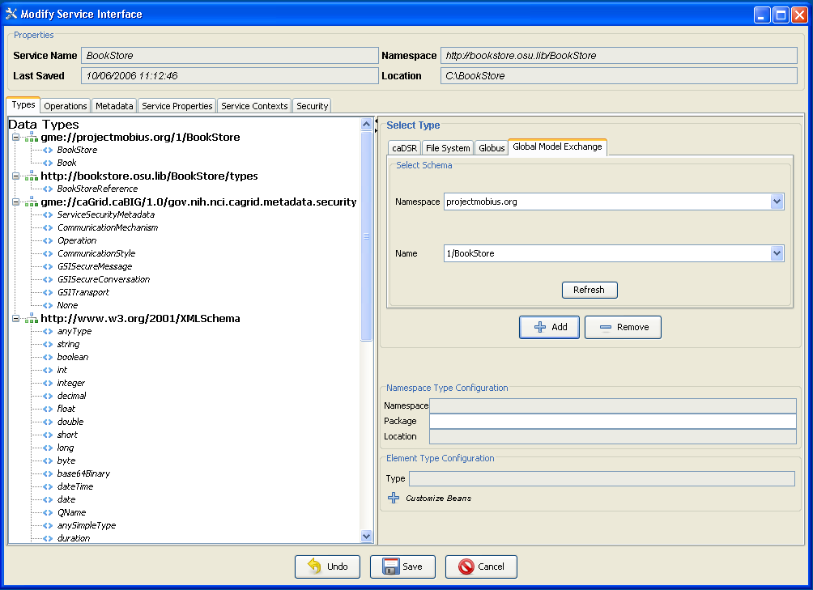
Figure 3. Modify Service Interface

- Click the Save button at the bottom of the Modify Service Interface window.

This section of the tutorial is complete.

Add Methods to the Service

This section of the tutorial will focus on adding two methods, addBook and getBook, to the service. This process includes opening the BookStore service to be modified, browsing to the Operations tab in the Modify Service Interface window, and then adding the methods. The methods to be added will have an input parameter, an output parameter and will throw exceptions. The following will give a detailed outline of how to add the addBook method to the service:

- Open the BookStore service to be modified. Note: Refer to steps 2 and 3 of the Create or Locate Data Types section of the tutorial for help with this.
- Click on the Operations tab in the Modify Service Interface window. Refer to Figure 4.

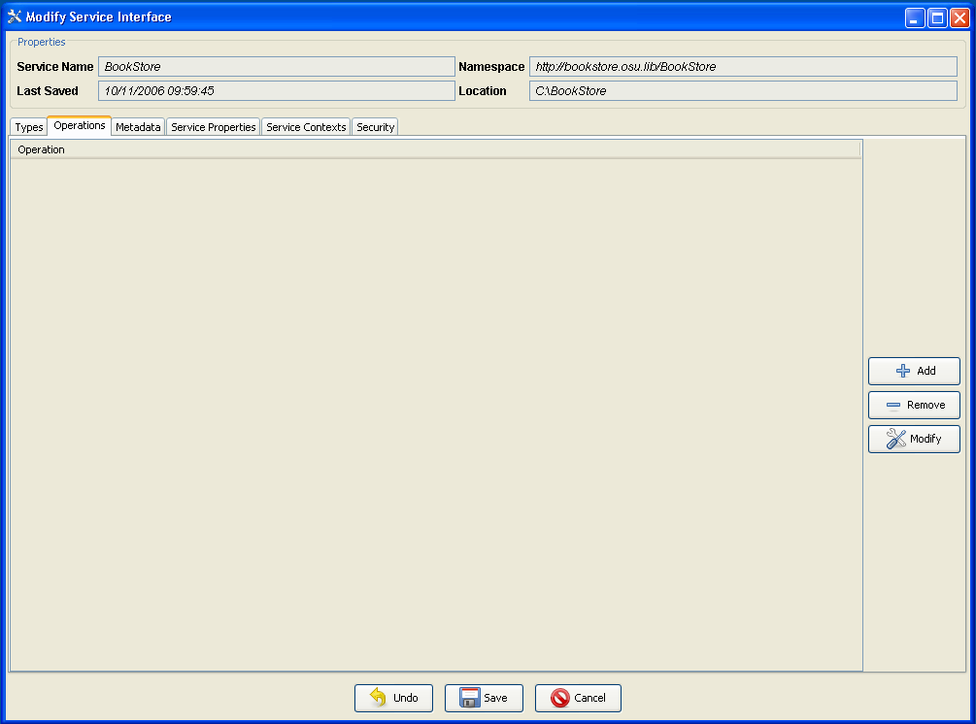
Figure 4. Operations Menu
- From the Operations menu, click Add on the right hand side of the window. Refer to Figure 4. The Build/Modify Operations window will appear.
- From the Build/Modify Operations window, type in “addBook” in place of “newMethod” in the Method Name field. Highlight the Inputs tab (if it is not already) and select Book from the Data Types tree. Click Add from the lower right hand portion of the window. Refer to Figure 5. Note: For the getBook method, the input will be of type string.
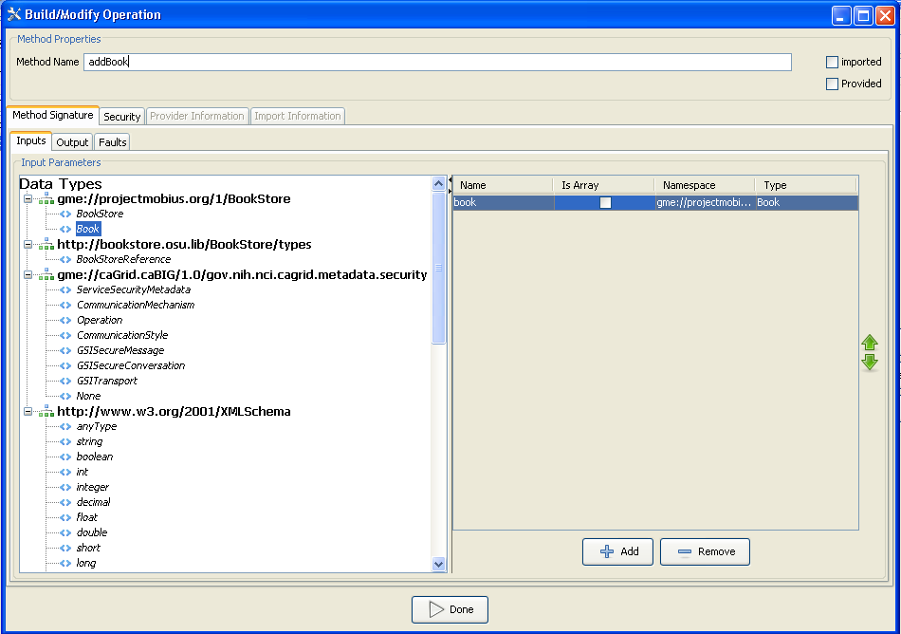
Figure 5. Add Input Parameter
- Next, select the Output tab in the Build/Modify Operation window. By default, the output type is void. For the addBook method there will be no need to specify an output different than void. Refer to Figure 6. Note: For the getBook method, the output type will be of type Book. Double click the data type to set the output type.
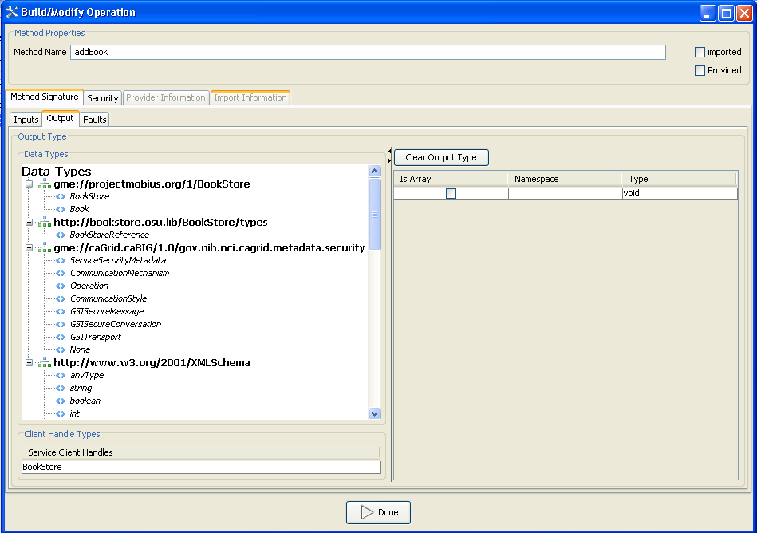
Figure 6. Add Output Parameter
- Finally, select the Faults tab from the Build/Modify Operations window.
- At the bottom of the Faults window, enter “BookAlreadyExists” in the Fault Type Name text box. Click Add New Fault. The fault will populate values for Namespace and Name in the Faults window. Refer to Figure 7.
- Click Done. The Modify Service Interface screen will appear.
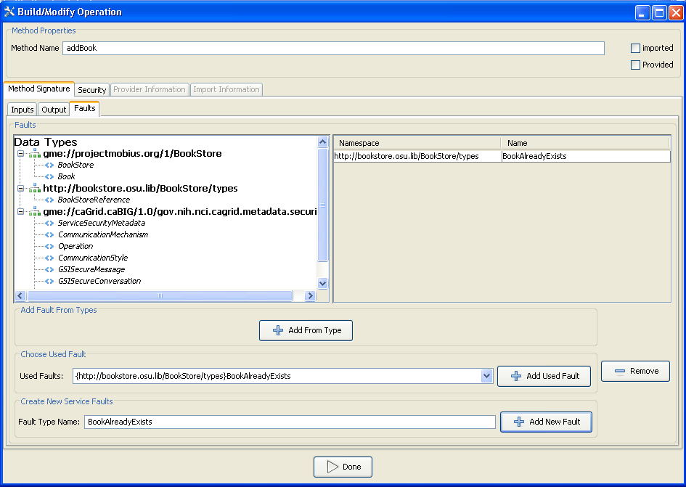
Figure 7. Add Fault

- On your own, add the method getBook with string as the input parameter, Book as the output parameter and “BookDoesNotExist” as the fault. Steps 1-8 should be sufficient to guide you through this.
- Refer to Figure 8 to verify the methods have been added properly.
- Click Save when finished.
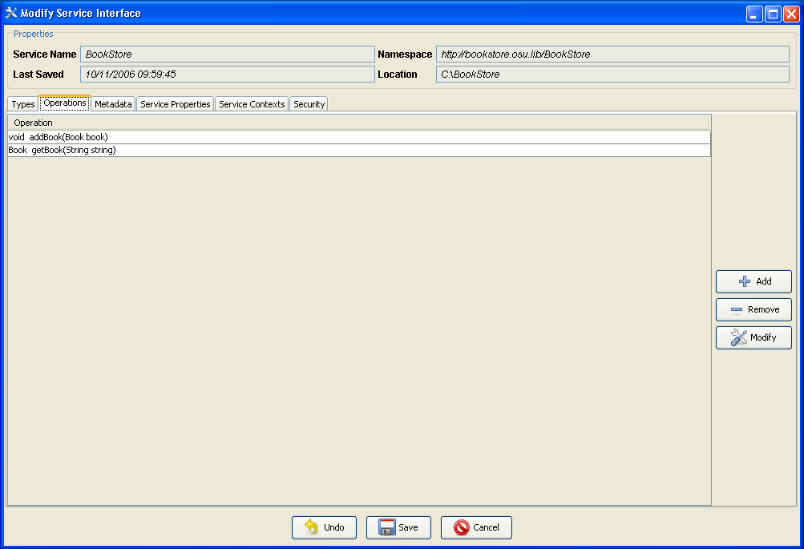
Figure 8. Added Methods

This section of the tutorial is complete.

Implement the Methods

The lone aspect of creating a grid service that Introduce does not automatically generate for the user is the actual implementation for the created methods. This section of the tutorial will provide trivial implementations to the methods created in the previous section. addBook is a method that takes in type Book and is of return type void. getBook is a method that takes in type String and returns type Book. The implementations here will have no functional purpose, but they will demonstrate the process.

- Begin by browsing to the location of the Bookstore service. The tutorial assumes Bookstore is at location “C:\BookStore”. Go to the following location inside the BookStore location: C:\BookStore\src\osu\lib\bookstore\service. This folder contains the file “BookStoreImpl.java” which was automatically generated by Introduce.
- The two methods, addBook and getBook, are located in this file and will need to be implemented. Open “BookStoreImpl.java” with a Java editor or text editor. Copy and paste the following code in for the implementation of the addBook operation:
if(book.getISBN().equals("1234")){
throw new osu.lib.bookstore.stubs.types.BookAlreadyExistsType();
}
else if(book.getISBN().equals(""))
{
throw new RemoteException("Invalid ISBN.");
}

- Copy and paste the following code in for getBook:
bookstore.Book book = null;
book.setAuthor("Shannon Hastings");
book.setDuey("1.1.1.1");
book.setISBN("1234");
book.setPDate("01-06-1999");
book.setPublisher("Generic Publisher");
book.setSection("1");
book.setTitle("Programming Grid Services for Dummies");

if(string.equals(book.getISBN())){
return book;
}
else
throw new osu.lib.bookstore.stubs.types.BookDoesNotExistType();

- Refer to Figure 9 below to validate the previous steps.

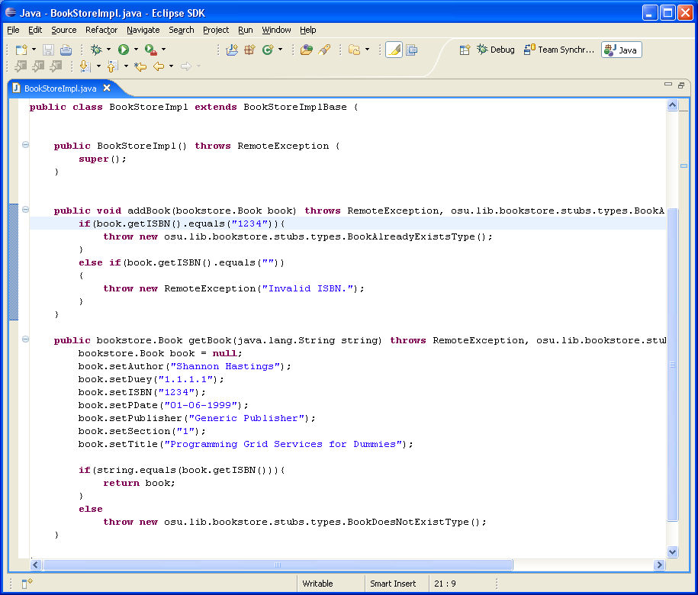
Figure 9. BookStoreImpl.java

- Save the changes.

This section of the tutorial is complete.

Deploy the Service

Deploying a service will create a Gar file and then extract it into a container. Introduce allows a service to be deployed to either Tomcat or Globus. The tutorial will focus on deploying to Globus. For more information, refer to the technical guide. Note!: Environmental variables need to be set for Globus (GLOBUS_LOCATION) and Tomcat(CATALINA_HOME) in order to use Introduce to deploy a service.

- Click Deploy Service or select Tools->Deploy Service from the menu from the main window of Introduce. The Select Directory screen will appear. Select the directory where the BookStore service resides (C:/BookStore for the tutorial). Refer to Figure 10.
Figure 10. Select Directory
- Click Open. The Deploy Grid Servce screen will appear.
- Select GLOBUS_LOCATION under the Deployment Location section.
- Type in “osu” for the service.deployment.prefix under Deployment Properties.
- Click Deploy.
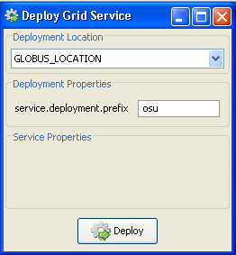
Figure 11. Deploy Grid Service

This section of the tutorial is complete.

Implement a Simple Client

In order to test the service created in this tutorial, a simple client can be created to make remote calls to the deployed service. Introduce creates a template that can easily be filled in to accomplish this task. The following steps will help fill in the template:

- From the BookStore directory (C:/BookStore for the tutorial), open this file with either a java editor or text editor:
C:\BookStore\src\osu\lib\bookstore\client\BookStoreClient.java
- Copy and paste the following code into the main method of the bookstore client as shown in Figure 12:

//Setup the call to addBook
bookstore.Book book = null;
book.setAuthor("Shannon Hastings");
book.setDuey("1.1.1.1");
book.setISBN("1234");
book.setPDate("01-06-1999");
book.setPublisher("Generic Publisher");
book.setSection("1");
book.setTitle("Programming Grid Services for Dummies");
try{
client.addBook(book);
} catch(osu.lib.bookstore.stubs.types.BookAlreadyExistsType b) {
System.out.println("The Book Store already has that book.");
} catch (Exception e){
System.out.println("An unexpected error has occurred in the call for addBook.");
}

//setup the call to getBook
book = null;
String isbn = ("1234");
try{
book = client.getBook(isbn);
} catch (osu.lib.bookstore.stubs.types.BookDoesNotExistType f) {
System.out.println("The book requested does not exist.");
} catch (Exception g) {
System.out.println("An unexpected error has occurred in the call for getBook.");
}
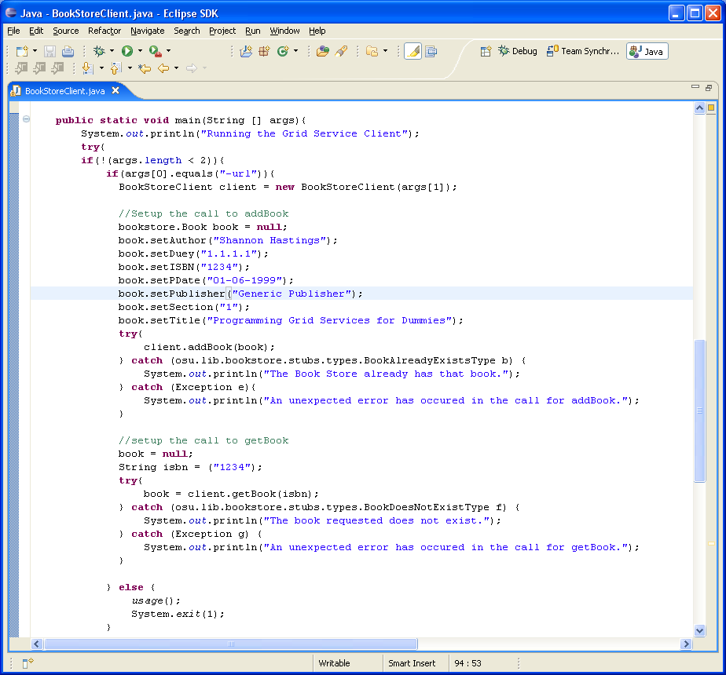
Figure 12. BookStoreClient.java

- Save changes.
- Run ‘ant all’ from the location of the BookStore service. This will rebuild your code. The location for the tutorial is C:\BookStore.

This section of the tutorial is complete.

Start the Globus Container and Run the Client

The tutorial has progressed to a point where something can be run and tested for correctness. As a summary, the tutorial has guided the way through creating a service with two implemented methods, deploying that service to Globus and implementing a client to make remote calls into the BookStore service. Before the client can be run, the Globus container needs to be started up to expose its deployed services. From the Globus location’s bin directory type ‘globus-start-container.bat –nosec’. The container will come up and the BookStore service is ready to receive remote calls from the client. The client can be ran by executing “ant runClient” from the top level of the Introduce created service directory.

