Data Service Tutorial using caCORE SDK

Overview
This tutorial will explain the basic steps required to set up a simple grid service using the Data Service extension and the caCORE SDK in Introduce. The data service will set up a grid service using the help of the caCORE SDK wizard, deploy it to a Tomcat container and perform a test on the service. The sample service will use the query processor created automatically by the wizard to request all Gene data types of a certain type. These values once returned will be output to the user.

The following is an outline of the tutorial:
- Create a new grid service with the Data Service Extension
- Use the caCORE SDK Wizard
- Implement the Grid Service Client
- Deploy the Grid Service
- Test the Grid Service

A. Create a new Grid Service with the Data Service Extension
In this section, a new grid service will be set up using the Introduce toolkit. The new service will be created with the Data Service extension using the caCORE SDK Wizard.

  - Launch the Introduce Grid Service Authoring Toolkit.
  - Select Create Service from the toolbar or select Tools->Create Service from the toolbar. The Create Grid Service screen will appear. See Figure 1 below.
  - Choose a Creation directory to place the service. This tutorial will use “C:\DataServiceSDKTutorial”.
  - Type in the Service Name. This tutorial will use “DataServiceSDKTutorial”.
  - Choose a Package. This tutorial will be using “osu.lib.datadervicesdktutorial”.
  - Choose a Namespace. This tutorial will be using “http://dataservicetutorial.osu.lib/DataServiceTutorial”.
  - In the Service Extensions drop-down, select “Data Service” and click the Add button.
  - Click the Create button located at the bottom of the creation screen.
  - In the configuration dialog that appears, select the caCORE SDK Data Source radio button and select OK.
  - Be patient while Introduce creates the service. This may take a few minutes.

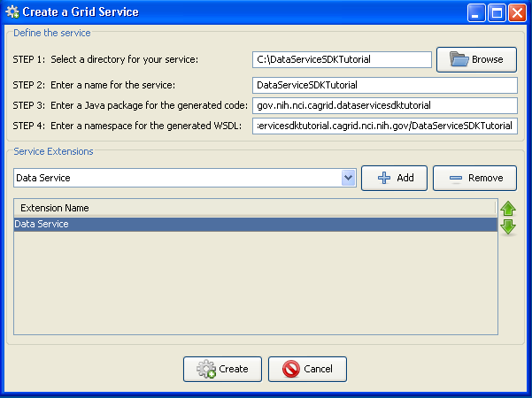
Figure 1: Create Grid Service dialog

B. Using the caCORE SDK Wizard
The caCORE wizard will step through a five pages to enter information about the grid service. Once complete, the service will be ready to be implemented, built and tested. After selecting the caCORE SDK Wizard, the dialog will appear explaining the five steps of the wizard. See Figure 2 below.
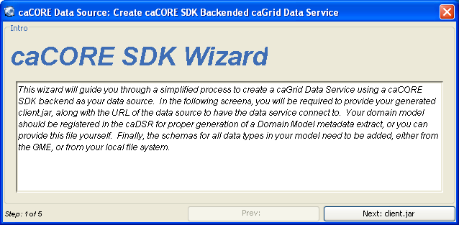
Figure 2: caCORE SDK Wizard, step 1
- Click the Next: client.jar button to continue to the next step of the wizard.
- The second step of the wizard is where jar files are added to the grid service. Click the Add Jars button to open a file dialog. Find the client.jar file for the service and click open to add it to the list. See Figure 3. 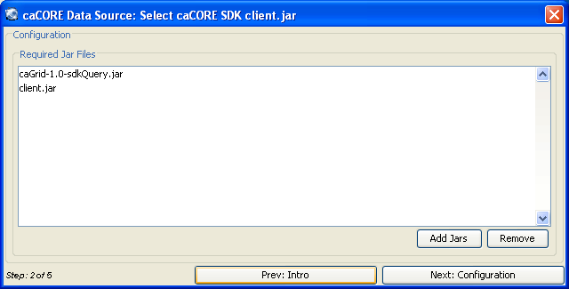
Figure 3: caCORE SDK Wizard, step 2

- The third page of the wizard specifies the service URL for the data service. For this tutorial enter http://cabio.nci.nih.gov/cacore31/http/remoteService in the Service URL textbox. The Case Insensitive Queries option is for data services which have a backend that might require queries to be performed without regard to case. Leave this option off for now. This page also allows CSM Security to be set and the CSM Context Name if necessary. This tutorial will not be using CSM Security. See Figure 4.
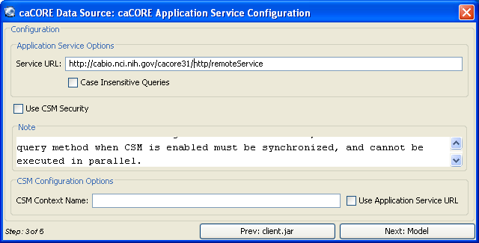
Figure 4: caCORE Wizard, step 3

- The fourth page of the wizard is used to select the Domain Model. In this tutorial, the domain model will be read from a file. Select the “Domain Model from File” radio button and click the browse button on the right to navigate to the domain model file. Click “Next: Schemas” to proceed. See figure 5.
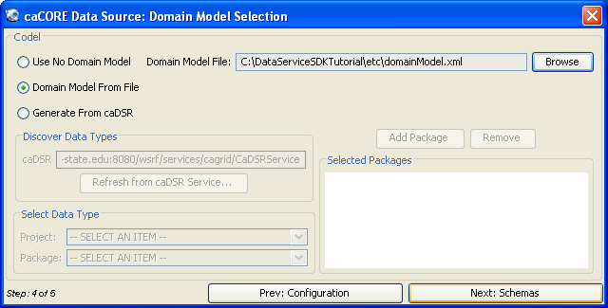
Figure 5: caCORE Wizard, step 4
- In the fifth step, the cabio schema needs to be resolved manually to the file provided with the tutorial. Click the “Resolve” button for the cabio package to open the Schema Resolution Dialog. In the dialog select the “browse” button under the File System tab and select the cabio schema file provided with the tutorial. Then click Load Schemas to close the dialog, and click Done to finish the wizard. See figures 6 & 7.
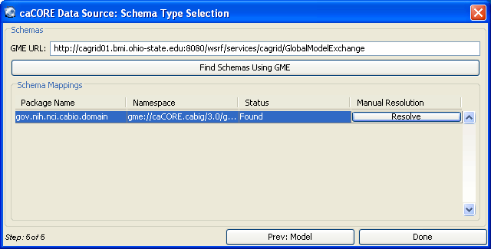
Figure 6: caCORE Wizard, step 5

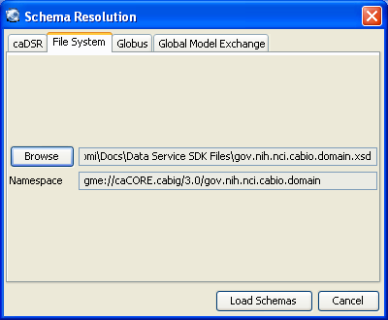
Figure 7: Schema Resolution Dialog

C. Implement the Grid Service Client

This part of the tutorial will implement the actions of the client to test the Data Service we created within our grid service. To do this some code will be added to the DataServiceSDKTutorialClient.java file to query the data service and to output the results for verification.

- Open the file DataServiceSDKTutorialClient.java located in the folder C:\DataServiceSDKTutorial\src\gov\nih\nci\cagrid\dataservicesdktutorial\client\. This code will direct the client’s actions for the grid service. Replace the contents of the method main with the code below:
System.out.println("Running the Grid Service Client");
try{
if(!(args.length < 2)){
if(args[0].equals("-url")){
DataServiceSDKTutorialClient client =
new DataServiceSDKTutorialClient(args[1]);
gov.nih.nci.cagrid.cqlquery.CQLQuery query =
new gov.nih.nci.cagrid.cqlquery.CQLQuery();
gov.nih.nci.cagrid.cqlquery.Object target =
new gov.nih.nci.cagrid.cqlquery.Object();
target.setName(gov.nih.nci.cabio.domain.Gene.class.getName());
gov.nih.nci.cagrid.cqlquery.Attribute att =
new gov.nih.nci.cagrid.cqlquery.Attribute();
att.setName("symbol");
att.setValue("BRCA%");
att.setPredicate(gov.nih.nci.cagrid.cqlquery.Predicate.LIKE);
target.setAttribute(att);
query.setTarget(target);
gov.nih.nci.cagrid.cqlresultset.CQLQueryResults results =
client.query(query);
java.util.Iterator iter = new
gov.nih.nci.cagrid.data.utilities.CQLQueryResultsIterator(
results,
DataServiceSDKTutorialClient.class.getResourceAsStream(
"client-config.wsdd"));
while (iter.hasNext()) {
Object o = iter.next();
System.out.println(
((gov.nih.nci.cabio.domain.Gene) o).getFullName());
}
System.out.println("Query Complete.");

} else {
usage();
System.exit(1);
}
} else {
usage();
System.exit(1);
}
} catch (Exception e) {
e.printStackTrace();
System.exit(1);
}
- Save DataServiceSDKTutorialClient.java

D. Deploy the Grid Service
A grid service may be deployed to either a Globus or a Tomcat container. In this tutorial, Tomcat will be used.
- Open a Command prompt and set the directory to C:\DataServiceSDKTutorial
- Enter the command: ant all
- Verify that the command resulted in a Build Successful message.
- Now enter the command: ant deployTomcat

Note: To deploy to a Globus container, simply replace the command deployTomcat with deployGlobus.

E. Test the Grid Service
Now that the service has been deployed to the Tomcat directory, the service may be tested. An ant script located in the grid service directory will run the client and invoke the service.

- Using a command prompt, change to the Catalina Home directory. Do this by entering cd %CATALINA_HOME%.
- Now enter bin/startup.bat to start the Tomcat server. Wait for a new Tomcat console window to appear and finish loading Tomcat.
- Now, at the original command prompt, change directories to C:\DataServiceSDKTutorial\ and enter the command ant runClient.
- The result of the run should produce the following output:

C:\DataServiceSDKTutorial>ant runClient
Buildfile: build.xml

setGlobus:

checkGlobus:
[echo] Globus: C:\progs\Globus

defineClasspaths:

runClient:
[echo] Connecting to service: http://localhost:8080/wsrf/services/cagrid/Da
taServiceSDKTutorial
[java] JVM args ignored when same JVM is used.
[java] Running the Grid Service Client
[java] Breast cancer 2, early onset
[java] Breast cancer 1, early onset
[java] Query Complete.

BUILD SUCCESSFUL

