Architectural Review Checklist

caGrid 1.4
July 20, 2010

Revision Document History
Date | Version | Description | Author
09/10/03 | 1.0 | First draft | NCICB Dedicated Support
11/07/03 | 1.0 | Final version 1.0. | NCICB Dedicated Support
05/12/04 | 2.0 | Redesign to incorporate developer answer phase followed by a systems interview phase. | NCICB Dedicated Support
2/2/10 | 3.0 | Populated Template for caGrid 1.4 | John Eisenschmidt
7/20/10 | 3.1 | Updated for revised caGrid 1.4 Release Schedule | John Eisenschmidt

Table of Contents

1. Introduction 6
Purpose 6
Guidelines for Completing the ARC 6
2. Project Details (To be answered by development team) 6
General Information 6
Project Description 6
Contact Information 6
Major Deployment Milestones 6
Architectural Details 7
High level architectural description: 7
High Level Design Diagram (If available): 7
Implementation language(s) used? 7
Will connections/requests to the application be session based (i.e. statefull versus stateless)? If so, is there any reason why application would not support “sticky session” load balancing? 7
Will the application be caching data? If so, what is being cached and how much data will be cached? 7
What data files will be created (if any)? How much data will be saved on an on going basis? 7
Will this application need a database schema(s) created on the NCICB infrastructure? If so, what is the maximum number of objects to be stored? 7
Are there any external/non-NCICB data sources that will be accessed by the application? 7
If this is a web-based application, what are the preferred virtual hosts names to be registered? 7
Any additional architectural details that may be of significance to the needed deployment environment. 7
Performance Requirements 8
Total number of users for this application? 8
Peak number of concurrent users? 8
Peak number of requests/minute? 8
Up time requirements? 8
Acceptable down time when recovering from major systems disaster? 8
NCICB Project Dependencies 8
Configuration Management Details 8
Version Control 8
Change Control 8
Migration to CVS 8
Users 8
Build Process 8
Other CM Needs 8
Additional Notes 8
3. System Requirements (To be answered by both development & systems team) 9
Operating System 9
<<Solaris/LINUX/Windows 2000/…>> 9
Software (Technology Stack) 9
Web Server: <<Apache/Tomcat/ZOPE/…>> 9
App Server: <<Tomcat/JBoss/Oracle 9iAS/…>> 9
Database Server: <<Oracle[with JVM component]/MySQL/PostgreSQL/…>> 9
Other software components: <<PERL x.x, Python x.x, …>> 9
Server Hardware 9
Server: <<type, model, …>> 9
Minimum processor speed: 9
Minimum memory: 9
Minimum local drive space: 9
Storage 9
Expected file server disk storage (in MB): 9
Expected database storage (in MB): 9
Expected ftp storage (in MB): 9
Expected media/image storage (in MB): 9
Load Balancing/Fault Tolerance 9
Does the application support load balancing? 9
Implement load balancing – YES/NO 9
Networking 9
Any application specific port assignments? 9
Any additional configuration? 9
Additional Notes 9
4. Proposed NCICB Deployment Environment (To be answered by systems team) 9
Hardware 9
Technology Stack 10
File Server 10
Database 10
Networking 10
Other Resources 10
5. Impact Assessment (To be answered by systems team) 10
Overview 10
Cost 10
Timeline to implement 10
Additional Notes 10
6. Acceptance 10
7. Appendix 1 - Future Systems Requirements 11
New Architecture Diagram 11
Notes on the design change 11
Hardware 11
Servers 11
Processor speed 11
Memory 11
Drive Space 11
Software (Technology Stack) 11
Web Server 11
App Server 11
Other components 11
Fault Tolerance (Redundancy) 11
Does the application support load balancing? 11
Implement load balancing – YES/NO 11
Load balancing requirements 11
Fault tolerance solution suggested 11
Additional requirements (if any) 11
Performance Enhancements 11
Processing Power 11
Memory 11
I/O 11
Other needs 11

Introduction

Purpose
The purpose of the Architectural Review Checklist (ARC) is to help identify the deployment environment (both hardware and software components) necessary for an application to execute optimally within the NCICB IT infrastructure. The ARC is considered to be a dynamic artifact for any NCICB project and should be maintained in the configuration library (i.e. CVS) for each project. For new projects, this document template will be automatically checked into the projects repository by the SCM team upon project initiation. The ARC should be reviewed on at least a quarterly basis to capture any application design changes that may effect the deployment environment necessary for optimal performance.

Guidelines for Completing the ARC
The ARC is divided into 4 main sections. The first section (Project Details) is meant to capture general information about the project. The project development team should fill out the Project Details section and return it to the systems team. The second section (Systems Requirements) is meant to capture details of specific system requirements for the project. Both the development and system teams will preferably answer the Systems Requirement section jointly. However, depending on the development teams familiarity with the NCICB infrastructure, they may choose to answer either all or parts of this section on their own. The third section (Planned Deployment Environment) specifies the proposed deployment environment for the application and is to be answered by the systems team based on the response to section 1 & 2. Finally, the last section (Impact Assessment) describes the impact (additional hardware/software costs, staffing resources…) to the existing NCICB IT infrastructure in order to support this application. Upon completion of the Deployment Environment and Impact Assessment sections, the systems team will return the ARC to the development team for final review and comments.

Project Details (To be answered by development team)

General Information

Project Description
The underlying service oriented infrastructure that supports caBIG is referred to as caGrid. Driven primarily by scientific use cases from the cancer research community, caGrid provides the core enabling infrastructure necessary to compose the Grid of caBIG.

Contact Information
Title | Name | Phone | Email
Project Manager | John Eisenschmidt | 301-443-5314 | eisenschmidtjw@mail.nih.gov
Technical Lead | Justin Permar | 401-743-0130 | justin.permar@osumc.edu
SCM Coordinator | John Eisenschmidt | 301-443-5314 | eisenschmidtjw@mail.nih.gov

Major Deployment Milestones
Milestone | Date
Planned Release to QA | 8/16/2010
Planned Release to Staging | 8/30/2010
Planned Release to Production | 9/7/2010

Architectural Details

High level architectural description:

Full redeployment of existing caGrid Services:
- Authentication Service
- Credential Delegation Service
- Dorian
- Federated Query Processor
- Global Model Exchange
- Grid Grouper
- GTS Master
- GTS Slave
- Index Service
- Metadata Model Service
- Workflow Service (Taverna)

Deployment of new caGrid Services
- Identifiers Naming Authority (identifiers-na.nci.nih.gov)
- Identifiers Prefix Authority (identifiers-pa.nci.nih.gov)

Deprecation of existing caGrid Services
- Workflow Service (BPEL) -- leave as-is

High Level Design Diagram (If available):

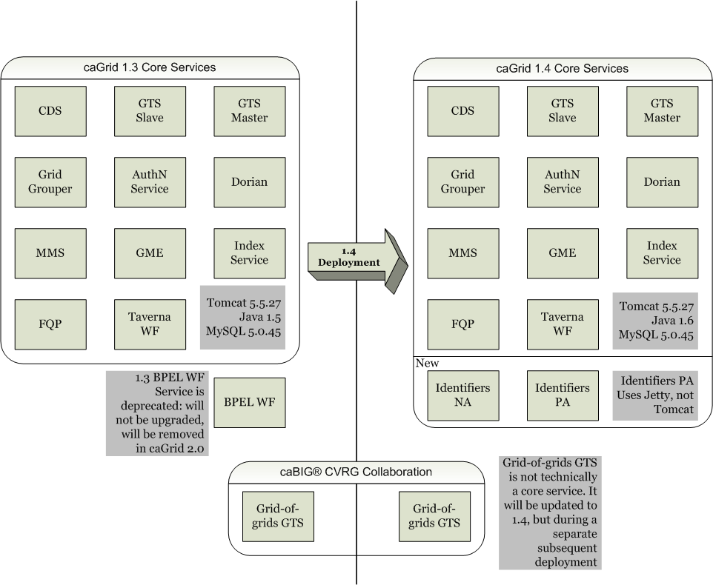

Implementation language(s) used?

Java

Will connections/requests to the application be session based (i.e. statefull versus stateless)? If so, is there any reason why application would not support “sticky session” load balancing?

This is a grid service.

Will the application be caching data? If so, what is being cached and how much data will be cached?

FQP has the ability to store/stage query results using the Transfer Service for later pickup (within 1 hour).

What data files will be created (if any)? How much data will be saved on an on going basis?

None

Will this application need a database schema(s) created on the NCICB infrastructure? If so, what is the maximum number of objects to be stored?

All services will reuse existing databases.

Are there any external/non-NCICB data sources that will be accessed by the application?

No

If this is a web-based application, what are the preferred virtual hosts names to be registered?

The new Identifier Prefix Authority is a web application (see name request above), but runs in it’s own Jetty container.

Any additional architectural details that may be of significance to the needed deployment environment.

Performance Requirements

Total number of users for this application?
Index Service max 500 grid services

Peak number of concurrent users?

Peak number of requests/minute?

Up time requirements?
24 x 7

Acceptable down time when recovering from major systems disaster?
Authentication Service – 1 hour
Credential Delegation Service – 1 hour
Dorian – 1 hour
Federated Query Processor – 4 hours
Global Model Exchange (replaces GME 1.0 grid service) – 4 hours
Grid Grouper – 1 hour
GTS Master – 1 hour
GTS Slave – 1 hour
Identifiers Naming Authority - 4 hours
Identifiers Prefix Authority - 1 hour
Index Service – 15 minutes
Metadata Model Service (replaces caDSR1.2 grid service) – 4 hours
Workflow (Taverna) – 4 hours

NCICB Project Dependencies
Metadata Model Service depends on caDSR

Configuration Management Details
Continuous Integration using svn and Hudson

Version Control
svn

Change Control
What are your current change control practices? What procedures are in place to determine whether to implement a change request?
caGrid follows CBIIT SCM policies

Migration to CVS
Indicate whether you will require SCM support migrating your source code to the NCICB CVS repository.
No

Users
Provide a list of all developers who require access to your repository modules.
N/A

Build Process
Describe your build process here. For example, are you using Ant, Make, or something else?
Ant + IVY

Other CM Needs
Describe any other CM needs?
N/A

Additional Notes

System Requirements (To be answered by both development & systems team)

Operating System

Linux

Software (Technology Stack)

Web Server: n/a

App Server: Tomcat and Jetty

Database Server: MySQL, Apache Xindice (for Index Service)

Other software components: JDK 1.6.0_14 (CBIIT Tech Stack)

Server Hardware

Server: <<type, model, …>>

Minimum processor speed: 2 GHz

Minimum memory: 1024 mb

Minimum local drive space:

Storage

Expected file server disk storage (in MB):

Expected database storage (in MB):

Expected ftp storage (in MB):

Expected media/image storage (in MB):

Load Balancing/Fault Tolerance

Does the application support load balancing? No

Implement load balancing – No

Networking

Any application specific port assignments?

Any additional configuration?
Creation of identifiers-pa and identifiers-na CNAMES in DNS for all tiers:
- QA: identifiers-na-qa, identifiers-pa-qa
- Stage: identifiers-na-stage, identifiers-pa-stage
- Prod: identifiers-na-prod, identifiers-pa-prod (also identifers-na points to identifiers-na-prod and identifiers-pa points to identifiers-pa-prod)

Additional Notes
If we do not change the deployment pattern, we anticipate 2 new VMs needed, and 1 deprecated.

Proposed NCICB Deployment Environment (To be answered by systems team)

Hardware
<<dev, qa, staging, production servers to be used>>

Technology Stack
<<specific technology stack to be used>>

File Server
<<space allocation on big IP, NFS mount points, initial size allocation…>>

Database
<<database server to used, schema names to be created, initial size, maximum size…>>

Networking
<<e.g. any BigIP configuration necessary, …>>

Other Resources
<<e.g. ftp server access, media server access, …>>

Impact Assessment (To be answered by systems team)

Overview

Cost

Timeline to implement

Additional Notes

Acceptance
Project Lead ( ) | Project Coordinator – NCICB ( )
Systems Team | SCM Administrator

Appendix 1 - Future Systems Requirements
In this section, describe any projected future anticipated requirements for your system.

New Architecture Diagram

Notes on the design change

Hardware

Servers

Processor speed

Memory

Drive Space

Software (Technology Stack)

Web Server

App Server

Other components

Fault Tolerance (Redundancy)

Does the application support load balancing?

Implement load balancing – YES/NO

Load balancing requirements

Fault tolerance solution suggested

Additional requirements (if any)

Performance Enhancements

Processing Power

Memory

I/O

Other needs

