caBIG aims to bring together disparate data and analytic resources into a “World Wide Web of cancer research.” This will be achieved through common standards and software frameworks for the federation of these resources into “grid” services. Many of the tasks in the collection and analysis of cancer-related data on the grid involve the use of workflow. Here, we define workflow as the connecting of services to solve a problem that each individual service could not solve. In bioinformatics, this is sometimes referred to as a pipeline. This will be implemented as a grid Workflow Management Service, which will provide caGrid users a convenient scripting language to manage the execution of caBIG application services at large scale for research, data preparation, and data analysis, and to enable users to compose existing services into new, higher level services.

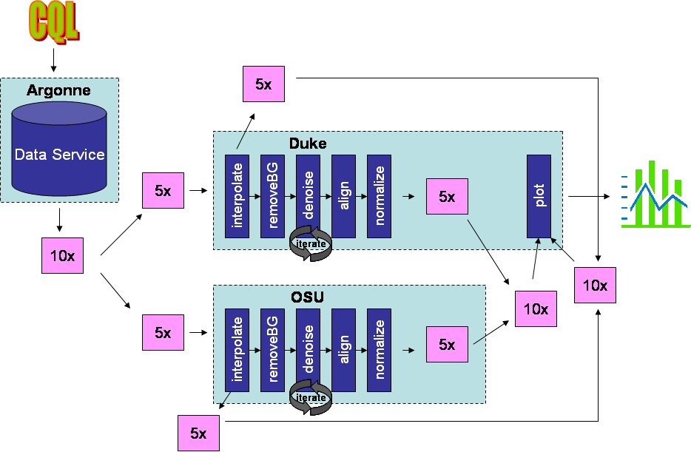

The above diagram describes a demonstration of the workflow engine using the RProteomics data service and analytical service. The data service is deployed by Argonne National Labs at the University of Chicago, and the analytical service is deployed both at Duke and OSU. The first step is a query to the data service, which returns 10 mass spectrometry spectra. These data objects are divided into two sets and run through each of the analytical services where a number of analytical methods (interpolate, background removal, denoising, alignment, and normalization) are invoked. This demonstrates the ability for workflows to perform work in parallel. The results of the pipelines are joined, and the pre- and post-analyzed data are plotted with another grid call. The resulting JPEG image is returned to the user.

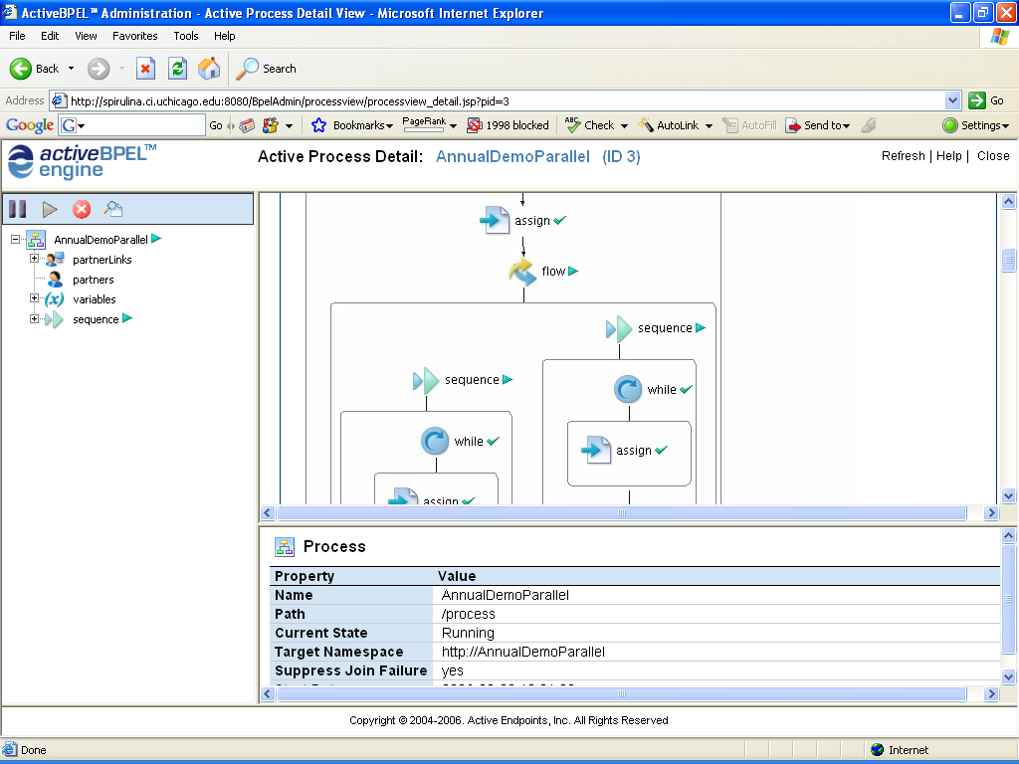

The caGrid workflow service is implemented using the Active BPEL workflow engine developed by Active Endpoints. By integrating the Active BPEL engine with the caGrid infrastructure, the caGrid team is able to leverage existing standards and technologies such as XML, SOAP, WSDL, and BPEL. The screenshot above is from the Active BPEL management interface, which can be used to interrogate running workflows.

