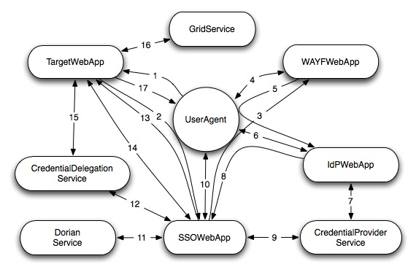
Figure 1: Web SSO Interactions

In the following scenario, an unauthenticated user requests a resource from TargetWebApp. In order to fulfill the request, TargetWebApp must interact with GridService on the user’s behalf.

- UserAgent makes an arbitrary request.
- TargetWebApp determines that UserAgent is not authenticated (probably by checking for the existence of a session cookie). It redirects UserAgent to SSOWebApp.
- SSOWebApp determines that UserAgent has not established a single sign-on session (by checking for the existence of a session cookie). It redirects UserAgent to WAYFWebApp.
- UserAgent interacts with WAYFWebApp to select the user’s institution’s IdPWebApp.
- WAYFWebApp redirects UserAgent to the selected IdPWebApp.
- UserAgent interacts with IdPWebApp to provide the user’s institutional credentials.
- IdPWebApp validates the user’s credentials with CredentialProviderService. If the user’s credentials are valid, CredentialProviderService will create a SAML AuthenticationStatement for the user. This assertion will be retrieved by SSOWebApp.
- Upon successful validation of the user’s credentials, IdPWebApp redirects UserAgent to SSOWebApp, passing a SAML artifact.
- SSOWebApp uses the SAML artifact to retrieve the AuthenticationStatement from CredentialProviderService. SSOWebApp validates the assertion.
- UserAgent interacts with SSOWebApp to specify the appropriate credential delegation policy.
- SSOWebApp generates a key pair for the user ant then requests DorianService to sign the public certificate, passing the AthenticationStatement assertion in the request. Dorian validates the assertion before signing the public certificate.
- SSOWebApp communicates the delegation policy to CredentialDelegationService, using the user’s credentials that were obtained in step 11. SSOWebApp creates an AuthenticationStatement, which asserts the user’s grid identity.
- SSOWebApp redirects UserAgent to TargetWebApp, passing a SAML artifact.
- TargetWebApp uses the SAML artifact to retrieve the AuthenticationStatement from SSOWebApp. TargetWebApp validates the assertion.
- TargetWebApp generates a key pair for the user and then requests CredentialDelegationService to sign the public certificate. CredentialDelegationService verifies the identity of TargetWebApp and validates that the request is authorized according to the previously specified delegation policy. It signs and returns the public certificate.
- TargetWebApp interacts with GridService on behalf of the user.
- TargetWebApp returns to UserAgent the resource that was requested in step 1.

General Remarks:
- CredentialProviderService and SSOWebApp are the only SAML asserting parties.
- The only SAML protocol interactions are in steps 8, 9, 13, and 14.
- TargetWebApp needs to know only how to resolve a SAML artifact and validate the assertion in order to authenticate a user.
- The URL and identity of TargetWebApp must be included as parameters with steps 2, 3, 5, and 8.
- Steps 7, 9, 11, 12, 14, and 15 use secure channel communication and require mutual PKI authentication.

Step 2:
- If SSOWebApp had determined that UserAgent had already established a single sign-on session (i.e. it had found a session cookie), SSOWebApp would have skipped to step 13, which would redirect UserAgent to TargetWebApp.
Step 13
- Once TargetWebApp has retrieved and validated the assertion of the user’s grid identity, the user is considered by TargetWebApp to be authenticated. If the user’s request did not required interaction with a grid service, then TargetWebApp would simply return the requested resource.

