Base Requirements
- (Optional – some Java-based installer frameworks support) – platform specific native installer to bootstrap first installing Java
- Platform-neutral Java-based installer framework (Wizard-like)
  - Some options: http://java-source.net/open-source/installer-generators
- Must be extensible with respect to:
  - Control-flow (ability to add conditional steps based on user input)
  - Panels (custom user interfaces)
- Actual installer should be driven/generated from a descriptor (XML file, etc) that describes the components and control flow
- Would be nice if it supported non-interactive installation
- Should support on-demand download of necessary components
  - Installer should bootstrapped from a single (executable) jar file and download necessary components as needed.
    - For example, if the user already has some prerequisites installed (such as Globus), those shouldn’t be downloaded.
  - Should support a fully bundled “offline” version as well

Basic Functionality
- Install/Configure caGrid prerequisites (if necessary)
  - Current Prerequisites:
    - (Installation support optional – see above) Java
    - Ant
    - Globus (ws-core)
    - Tomcat
  - Should support “pointing to” existing installed components
- Install caGrid
- May require some security configuration (to be determine)
- Deployment of caGrid Services
  - Should be able to specify prerequisites (all will caGrid and its prerequisites)
    - Deploying a service should install any missing perquisites and skip those steps if they are already present
    - Some services may require additional prerequisites (such as a database)
      - To the extent possible, should determine their existence, support installing them, or at least providing a link to where to get them, and exiting until they are present.
  - Need to support deployment of Introduce-created services (See section below)
  - Need to support deployment of caGrid core services
  - Configuration during deployment
    - Need to support custom configuration on a per service basis (should be able to be plugged in (provided by the service developer))
    - Need to support configuration of Introduce-created services (See section below)
    - Need to support configuration of caGrid core services (custom configuration for those that aren’t Introduce-created)

Introduce integration/compatibility
- Installer would have generic (could be specialized as above)Z support to understand how to deploy and configure an Introduce-created service
- Read introduce.xml to determine metadata to be populated
  - for each metadata type to be populated from file:
    - optionally take in existing instance XML document to set existing values
    - prompt user to populate values
    - save XML instance (and cache to be passed in as existing values during next deployment)
    - have ability to plugin renderers for a qname to prompt for values
      - if no plugin exists, have some generic XML/XSD -based editor
      - should be common component shared by installer and introduce
- Read introduce.xml to determine service properties to populate (See Figure 1; caCOREServiceURL is a service property, as defined in Figure 2)
  - introduce already does this (as shown below); just share the functionality

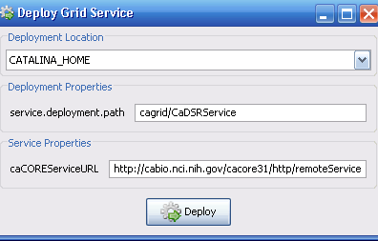
Figure 1 - Introduce Deployment with Service Properties

Figure 2 – Snippet from introduce.xml with Service Properties (corresponding to Figure 1)

- Invoke standard Introduce ant targets to deploy (once configured)

Preferences and Settings:
Preference location (files in directory):
gov.nih.nci.cagrid.common.Utils.getCaGridUserHome() + File.separator + "installer"

Should save settings (such as what has been installed) and previous user choices to cache items in this location. For example, when is prompted to make a choice or decision, their choice should be saved such that the next time they are running the installer, their previous choice should be the default setting.

Service-specific settings should be saved under a service-specific file.

