caGrid 1.0: A Grid Enterprise Architecture for Cancer Research
Scott Oster¹, MS, Stephen Langella¹, MS, Shannon Hastings¹, MS, David Ervin¹, BS, Ravi Madduri², MS, Tahsin Kurc¹, PhD, Frank Siebenlist², PhD, Ian Foster², PhD, Krishnakant Shanbhag³, PhD, Peter Covitz³, PhD, and Joel Saltz¹, PhD
¹Biomedical Informatics Department, Ohio State University, Columbus, OH; ²Mathematics and Computer Science Division, Argonne National Laboratory, Argonne, IL, ³National Cancer Institute Center for Bioinformatics, Rockville, MD

Abstract
caGrid is the core Grid architecture of the NCI-sponsored cancer Biomedical Informatics Grid (caBIGTM) program. It has been developed and released in two main versions. caGrid version 0.5, released in 2005, provided an initial set of tools and services as a test bed infrastructure. The current release, caGrid version 1.0, is developed as the production Grid software infrastructure of caBIGTM. Based on feedback from adopters of caGrid 0.5, it has been significantly enhanced with new features and improvements to existing components. This paper presents an overview of caGrid 1.0, its main components, and enhancements over caGrid 0.5.

Introduction
The National Cancer Institute (NCI) initiated in 2004 a program, called cancer Biomedical Informatics Grid (caBIG™), to address the increasingly complex information management, integration, and analysis requirements of cancer research. The primary objectives of this program are to provide solutions for more effective sharing of data and tools in an open, voluntary network of cancer centers, investigator laboratories, and research institutions and to enable researchers to leverage combined expertise, knowledge, and resources at multiple organizations. To achieve these goals, the caBIG™ community has been developing standards, applications, data and analytical resources, and a common middleware infrastructure, called caGrid¹.
caGrid is a services oriented Grid software infrastructure, building on the Grid Services architecture². It is designed to provide the technology (services, tools, and runtime support) that will link the applications and resources within the guidelines and policies accepted by the caBIGTM community and allow individual researchers or groups to easily contribute to and leverage the resources in a multi-institutional environment. The first public release of caGrid was version 0.5, which was made available as a test bed infrastructure in September 2005. It provided the design and a reference implementation of the basic Grid architecture of the caBIG™ program. It was intended as a test bed infrastructure, with an initial suite of tools and runtime environment, for the caBIG™ community to evaluate the architecture and provide feedback and additional requirements through implementation of several reference applications. Additional information about the caGrid 0.5 effort, and a good overview of the motivation of the Grid approach of caBIG™, can be found in an earlier paper¹. The current release of caGrid is version 1.0³ (caGrid 1.0), which was released to the caBIG™ participants and the research community in large in December 2006. It is a significant improvement over caGrid 0.5 with new features and enhancements to components inherited from caGrid 0.5. It is being used as the production Grid environment in caBIGTM. caGrid is not only built on open source, it is itself made publicly and freely available under a liberal open source license for use both in and outside of caBIGTM. Additional information and downloads of the software can be found at the project web site³. This paper presents an overview of caGrid 1.0, its main components, and enhancements over caGrid 0.5.

caGrid Framework
Objectives of caGrid. The design of caGrid is mainly driven by the requirements and use cases from the cancer research community. While numerous complex use cases are possible, they can be grouped into three main categories: 1) discovery, 2) integrated and large-scale data analysis, and 3) coordinated research. The first use case represents the need to support precisely targeted searches that return precisely defined attributes and data values from heterogeneous information sources. The second use case reflects the need to support integration of different data types and analysis of large volumes of data. This use case stems from the fact that with the help of high throughput and high resolution instruments, cancer related research projects increasingly collect and reference different types of molecular, specimen, and image data and involve correlation of these data types with clinical information and pathology annotations. The third use case is recognition of the fact that many types of basic and clinical cancer research involve coordinated access to and analysis of information across multiple institutions. Examples are cooperative groups and multi-institutional clinical trials. These use cases require support for representation of information as semantically annotated common data elements, for rich metadata associated with resources, for query and retrieval of metadata and information, and for analysis of information using one or more analytical methods. In order to support the use cases, caGrid aims to create an infrastructure wherein the structure and semantics of data can be programmatically determined and to provide a powerful means by which distributed data and analytical resources can be programmatically discovered and accessed.
caGrid leverages Grid Services technologies and makes innovative use of several Grid systems, including the Globus Toolkit (http://www.globus.org) and Mobius⁴, and tools developed by the NCI such as the caCORE infrastructure⁵ to accomplish its goals. In recent years, a service-oriented architecture of the Grid and community accepted standards, namely Open Grid Services Architecture⁶ (OGSA) and Web Services Resource Framework⁷ (WSRF), have been developed to enable better interoperability across Grid middleware systems and applications. As a primary principle of caBIG™ is open standards, caGrid is built upon the Grid Services standards as a services oriented architecture. Each data and analytical resource in caGrid is implemented as a Grid Service, which interacts with other resources and clients using Grid Service protocols. The caGrid infrastructure also consists of coordination services, runtime environment to support the deployment, execution, and invocation of data and analytical services, and tools for easier development of services, management of security, and composition of services into workflows. The coordination services provide support for common Grid-wide operations required by clients and other services. These operations include metadata management; advertisement and discovery; federated query; workflow management; and security. The coordination services can be replicated and distributed to achieve better performance and scalability to large numbers of clients. Figure 1 shows the production deployment of the caGrid infrastructure with coordination services (e.g., metadata services, security services, workflow service) and data and analytical services provided by the community. Users can access these services via web portals or application specific client programs.
While the caGrid 1.0 infrastructure is built upon Globus Toolkit 4.0 (GT4), which is the most commonly deployed reference implementation of the WSRF, it aims to be programming language and toolkit agnostic. Specifically, caGrid services are standard WSRF v1.2 services and can be accessed by any specification-compliant client.

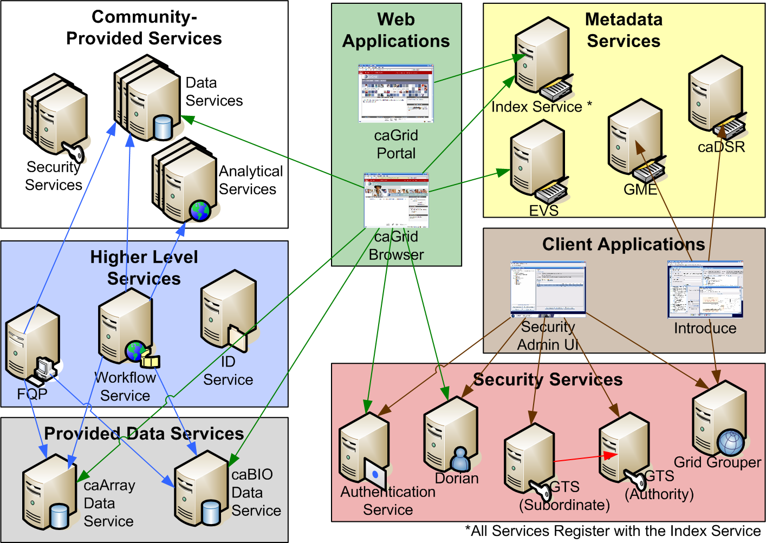
Figure 1. caGrid infrastructure and environment.

caGrid implements several important functions on top of the basic Grid Services architecture to better address the informatics needs of cancer research. In the rest of this section we present an overview of these key features of the caGrid framework.

Interoperability and Model Driven Architecture. A primary distinction of the requirements implemented in caGrid is the attention given to syntactic and semantic interoperability. A major complication in the medical domain arises from the fact that there are a variety of representations of data sets and semantics associated with data elements and values. Controlled vocabularies, common data elements (CDEs), information models (or domain models), and well-defined application programming interfaces (APIs) play a critical role in achieving syntactic and semantic interoperability among resources and to ensure correct interpretation of information in such an environment⁸. To enable syntactic and semantic interoperability, the caBIG community has developed guidelines and a set of requirements to represent the interoperability level of an application in terms of vocabularies, data elements, information/domain models, and APIs. These levels (Legacy, Bronze, Silver, and Gold) and guidelines are outlined in the caBIG compatibility guidelines document⁸. Silver level indicates that a resource has well defined APIs, which provide object-oriented access to backend resources, employs approved terminologies and common data elements based on these terminologies for its data models, and exposes a published information model. caGrid represents the “Gold” level interoperability and adds to Silver level requirements 1) service interfaces in the form of Grid services and XML for data exchange and 2) a common framework across the caBIG federation for the representation, advertisement, discovery, and invocation of distributed data and analytic resources.
caGrid adopts a model-driven architecture best practice. Client and service APIs in caGrid represent an object-oriented view of data and analytical resources. These APIs operate on registered data models, expressed as object classes and relationships between the classes in UML. caGrid leverages existing NCI data modeling infrastructure to manage, curate, and employ the data models. Data models are defined in UML and converted into common data elements, which are in turn registered in the Cancer Data Standards Repository⁵ (caDSR). The definitions of these data elements draw from vocabulary registered in the Enterprise Vocabulary Services⁵ (EVS). The concepts of data elements and the relationships among the data elements thus are semantically described. Clients and services communicate through the Grid using messages encoded in XML. In caGrid, when an objects is transferred over the Grid between clients and services, it is serialized into a XML document that adheres to a XML schema registered in the Mobius Global Model Exchange⁴ (GME) service. As the caDSR and EVS define the properties, relationships, and semantics of caBIG™ data types, the GME defines the syntax of their XML materialization.

Semantic Discovery of Resources. A critical requirement of the caGrid framework is that it supports the ability of researchers to discover distributed resources. This ability is enabled by taking advantage of rich structural and semantic descriptions of data models and services. Each caGrid service is required to describe itself using service metadata. When a service is deployed, its service metadata is registered with an indexing registry service, called the Index Service, provided by the Globus Toolkit, and used in the caGrid infrastructure. The Index Service can be thought of the repository of information about all advertised and available services in the environment. A researcher can discover services of interest by looking them up in this registry.
The expressivity of resource discovery scenarios is limited only by the expressivity of the service metadata. For this reason, caGrid provides support for rich service metadata. At the base is the common service metadata standard to which every service is required to adhere. This metadata contains information about the service-providing cancer center, such as the point of contact and the institution’s name providing the service. It also describes the objects used as input and output of the service’s operations. The definitions of the objects themselves are described in terms of their underlying concepts, attributes, attribute value domains, and associations to other objects being exposed as extracted from the caDSR. In addition, the service metadata specifies the operations or methods the service provides, and allows semantic concepts, extracted from the EVS, to be applied to them. This base metadata is extended for different types of services. Data Services, for example, provide an additional “domain model” metadata standard. This metadata details the domain model, including associations and inheritance information, from which the objects being exposed by the service are drawn. In this way, all services fully define the objects they expose by referencing the corresponding data models registered in caDSR, and identify their underlying semantic concepts from EVS.
caGrid 1.0 provides a series of high-level APIs for performing searches on these metadata standards, thus facilitating discovery of resources based on data models and semantic information associated with them. For instance, all services from a given cancer center can be located, data services exposing a certain domain model or objects based on a given semantic concept can be discovered, as can analytical services that provide operations that take a data type representing a given concept as input. The caGrid metadata infrastructure, APIs, and toolkits are defined with extensibility in mind, allowing domain or application specific extensions to the advertisement and discovery process.

Security. Security is a required component both for protecting intellectual property and to ensure protection and privacy of patient related information. When security is to be implemented in a multi-institutional environment, users and user attributes should be managed in a standard framework. The underlying system should also make it possible for data owners to set their policies in collaboration with others or autonomously, and enforce access control based on these policies. caGrid provides a comprehensive set of services for security. These services enable Grid-wide management of user credentials, support for grouping of users into virtual organizations for role based access control, and management of trust fabric in the Grid.

caGrid Version 1.0 Components and Enhancements
Based on lessons learned from caGrid 0.5 and feedback from the community, caGrid 1.0 has been enhanced in the areas of coordination services, runtime environment, and tooling support to satisfy the additional requirements and comply with current standards. In this section, we describe the improvements and additional features of caGrid 1.0.

Enhanced Metadata Support. The metadata support in caGrid leverages the caDSR⁵, EVS⁵, and Mobius GME⁴ technologies for curation, management, and retrieval of common data elements, vocabularies, and XML schemas. Several components of caGrid make use of the wealth of information in these systems. In caGrid 0.5, caDSR and EVS were accessible only through their own APIs and proprietary communication protocols. This limited their use by client applications, other caGrid tools, and caGrid services. caGrid 1.0 has implemented Grid service access to both the EVS and caDSR. Also, the new service metadata standards include additions of information extracted from the caDSR and EVS, providing richer metadata and better support for semantic discovery.

Enhanced Support for Service Development and Deployment. One of the barriers to adoption of Grid technologies in application domains is that Grid middleware toolkits like GT4 require a good understanding of the Grid and low-level details of the toolkit to develop and deploy Grid services. Since caGrid is envisioned to be used by developers with different levels of knowledge of the Grid, one of the priorities has been to provide high-level tools to facilitate easier development of services. To this end, we have developed the Introduce toolkit⁹. Initially implemented as a tool for analytical services in caGrid 0.5, Introduce has become a unified Grid service authoring toolkit in caGrid 1.0, implemented as an extensible framework and graphical workbench. The toolkit reduces the service developer’s responsibilities, by abstracting away the need to manage the low level details of the WSRF specification and integration with the GT4, allowing them to focus on implementing their business logic. Developers with existing caBIG™ Silver compatible systems need only follow simple a wizard-like process for creating the “adapter” between the Grid and their system.

Support for Grid Workflows. One significant feature provided by caGrid 1.0, which lacked in caGrid 0.5, is the addition of service support for orchestration of Grid services using the industry standard Business Process Execution Language¹⁰ (BPEL). The caBIGTM environment is expected to provide an increasing number of analytical and data services developed and deployed by different institutions. Powerful applications can be created by composing workflows that access multiple services, thus harnessing data and analytical methods exposed as services more effectively. In such applications, information can be queried and extracted from one or more data sources and processed through a network of analytical services. caGrid 1.0 provides a workflow management service, enabling the execution and monitoring of BPEL-defined workflows in a secure Grid environment.

Federated Query Support. Another higher-level support service made available in caGrid 1.0 is the Federated Query Infrastructure. It provides a mechanism to perform basic distributed aggregations and joins of queries over multiple data services. An extension to the standard Data Service query language, implemented in caGrid 0.5, has been developed to describe distributed query scenarios, as well as various enhancements to the Data Service query language itself. The Federated Query Infrastructure contains three main client-facing components: an API implementing the business logic of federated query support, a Grid service providing remote access to that engine, and a Grid service for managing status and results of queries that were invoked asynchronously using the query service.

Support for Large Dataset Retrieval. Numerous improvements to the handling of large data sets and distributed information processing have been made. Support for the implantation of the WS-Enumeration standard has been implemented and added to the Globus Toolkit. This standard and its corresponding implementation provide the capability for a Grid client to enumerate over results provided by a Grid service (much like a Grid-enabled cursor). This provides the framework necessary for clients to access large results from a service. This support is integrated into the caGrid Data Service tools, providing a mechanism for iterating on query results. Additionally, the initial effort to standardize a “bulk data transport” interface for large data has been started in caGrid 1.0, which is intended to provide uniform mechanism by which clients may access data sets form arbitrary services. This work currently supports access via WS-Enumeration, WS-Transfer, and GridFTP¹¹. The bulk data transport effort was mainly motivated by the caBIG in-vivo imaging middleware effort¹², which builds on caGrid, and is being employed in that middleware system.

Security. caGrid 1.0 provides a complete overhaul of federated security infrastructure of caGrid 0.5 to satisfy caBIG™ security needs, incorporating many of the recommendations made in the caBIG™ Security White Paper, culminating in the creation of the Grid Authentication and Authorization with Reliably Distributed Services (GAARDS) infrastructure³. GAARDS provides services and tools for the administration and enforcement of security policy in an enterprise Grid. These services and tools provide support for Grid user management, identity federation, trust management, group/VO management, access control policy management and enforcement, and integration between existing security domains and the Grid security domain. The GAARDS infrastructure consists of three main components. Dorian¹³ provides support for provisioning and federation of Grid user identities and credentials. Users and system administrators can create Grid user accounts directly with Dorian or link existing user accounts registered in trusted local credential providers. Part of the authentication process in the Grid is to verify that the client credentials were issued by a trusted Grid credential provider (e.g., Dorian). To support this requirement, the Grid Trust Service (GTS) of GAARDS maintains a federated trust fabric of all the trusted credential providers in the Grid. Authorization is another important requirement. The Grid Grouper service of GAARDS provides a group-based authorization solution for the Grid, wherein Grid services and applications enforce local authorization policy based on membership to groups defined and managed at the Grid level. Services can use Grid Grouper directly to enforce their internal access control policies.

Conclusions
caGrid 1.0 release represents a major milestone in caBIG™ towards achieving the program goals. It is developed to be used as a production infrastructure. It provides a comprehensive set of core services, toolkits for the development and deployment of community provided services, and APIs for building client applications. It already has been employed in application development in caBIGTM. Information on some of the applications and services, developed using caGrid 1.0, is available at the caGrid web site³.

Acknowledgements. The authors would like to acknowledge the contributions of the entire caGrid technical team³, the members of the Architecture Workspace, the NCICB caCORE team, and the caBIG™ community.
References

