caGrid Federated Query
Infrastructure

Technical Guide

caBIG™ is an initiative of the National Cancer Institute, NIH, DHHS

Copyright and License page

Insert Names of Development Team(s) here
Development | Programmer’s guide |  | Program Management
Names of developers | Names of technical writers and reviewers |  | Names of program managers
Scott Oster | Scott Oster
¹ Footnote contributing companies/ contractors/ divisions |  | ³ company
² department or division

Contacts and Support
Enter training contact | name (email address)
Enter customer support contact | Web hyperlink  Telephone: 111-222-3456  Toll free: 888-234-1234

LISTSERV Facilities Pertinent to software teams
LISTSERV | URL | Name
caGrid_Developers | https://list.nih.gov/archives/cagrid_developers.html | caGrid Developers Discussion

Table of Contents
Chapter 1 Introduction to the Technical Guide 3
Overview of the Guide 3
Document Text Conventions 3
Chapter 2 caGrid Federated Query Overview 5
Introduction 5
Chapter 3 DCQL Overview 6
Introduction 6
Details 6
DCQLQuery 6
Object 6
Attribute 7
Association 7
ForeignAssociation 8
JoinCondition 8
Group 8
An Example Query 9
Chapter 4 Federated Query Engine 10
Introduction 10
Component Details 11
Federated Query Engine 11
Federated Query Processor 12
Data Service Query Executor 13
Chapter 5 Federated Query Service Infrastructure 14
Introduction 14
Federated Query Processor Service 15
Federated Query Results Service 16
Service Security 17
Appendix A References 18
Technical Manuals/Articles 18
Scientific Publications 18
caBIG Material 18
caCORE Material 18
Appendix B Glossary 21
Appendix C DCQL/CQL Reference 25
Index 42

List of Figures
Figure 1 Federated Query Infrastructure Overview 5
Figure 1 Example DCQL Query 9
Figure 2 Federated Query Engine Components 11
Figure 3 Federated Query Services 14

- Introduction to the Technical Guide

Overview of the Guide
Brief overview of this developer’s guide.

Document Text Conventions
The following table shows various typefaces to differentiate between regular text and menu commands, keyboard keys, and text that you type. This illustrates how conventions are represented in this guide.
Convention | Description | Example
Bold & Capitalized Command  Capitalized command > Capitalized command | Indicates a Menu command  Indicates Sequential Menu commands | Admin > Refresh
text in small caps | Keyboard key that you press | Press enter
text in small caps + text in small caps | Keyboard keys that you press simultaneously | Press shift + ctrl and then release both.
Special typestyle | Used for filenames, directory names, commands, file listings, source code examples and anything that would appear in a Java program, such as methods, variables, and classes. | URL_definition ::= url_string
Boldface type | Options that you select in dialog boxes or drop-down menus. Buttons or icons that you click. | In the Open dialog box, select the file and click the Open button.
Italics | Used to reference other documents, sections, figures, and tables. | caCORE Software Development Kit 1.0 Programmer’s Guide
Italic boldface type | Text that you type | In the New Subset text box, enter Proprietary Proteins.
Note: | Highlights a concept of particular interest | Note: This concept is used throughout the installation manual.
Warning! | Highlights information of which you should be particularly aware. | Warning! Deleting an object will permanently delete it from the database.
{} | Curly brackets are used for replaceable items. | Replace {root directory} with its proper value such as c:\cabio
Table 1 Document Conventions

- caGrid Federated Query Overview

Introduction
The caGrid Federated Query Infrastructure provides a mechanism to perform basic distributed aggregations and joins of queries over multiple data services. As caGrid data services all use a uniform query language, CQL, the Federated Query Infrastructure can be used to express queries over any combination of caGrid data services. Federated queries are expressed with a query language, DCQL, which is an extension to CQL to express such concepts as joins, aggregations, and target services. The infrastructure, shown below in Figure 1, is composed of a core engine and grid services which provide access to and management of the use of the core engine.

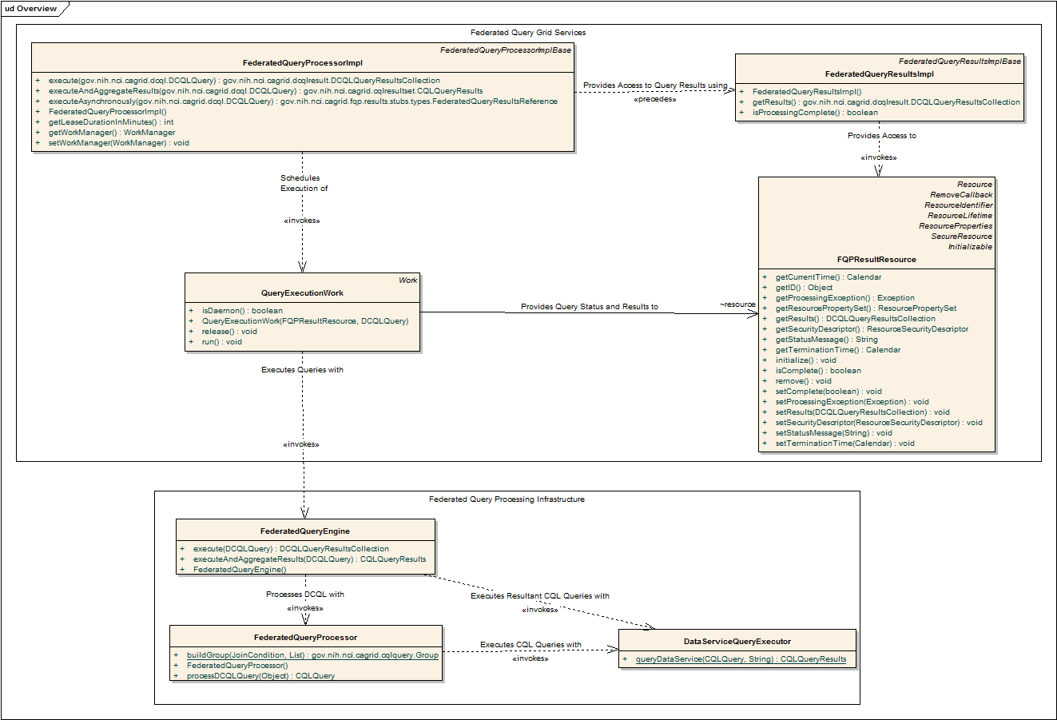
Figure 1 Federated Query Infrastructure Overview
- DCQL Overview

Introduction
DCQL, the language used to express federated queries, is an extension to CQL, the language used to express single data service queries. Both CQL and DCQL use a declarative approach to describe the desired data by identifying the nature of the instance data with respect to its containing UML information model. That is, a query can be seen as identifying a class in a UML model, and restricting its instances to those which meet criteria defined over that class’s UML attributes and UML associations.
The primary additions to CQL, which DCQL provides, are the introduction of the ability to specify multiple target services (aggregations), and the ability to specify object restrictions through relationships to Objects on remote data services (joins). The other primary difference between the languages is that CQL is context dependent, meaning the language must be interpreted against the service receiving the query, and DCQL itself specifies the context of the queries (by identifying the target services). As such, services accepting DCQL (such as the FQP service), generally don’t expose any local data.

Details
As DCQL is modeled as an extension to CQL, it mirrors the general structure wherein a target object Class is identified, and instances are specified by restrictions over its attributes and associated objects. The specifics of each component of a DCQL query are described below.

DCQLQuery
The root of a DCQL Query is the DCQLQuery object. It contains a collection of data service URLs which identify the services that should be queried for instances of data matching the Objects described by the TargetObject. This mechanism provides the basic support for simple aggregation queries, as each identified service will queried for the identified data, and the results will be aggregated and returned to the client. DCQL is a recursively defined language, as queries are ultimately descriptions of instance objects and relationships between associated objects can be described using the same mechanism. That is, just as the target object is described by restrictions of its attributes and associations to other objects, the associated objects are defined using the same syntax. These restrictions are defined below by the Object type, as the DCQLQuery’s TargetObject is just an instance of this type.

Object
The Object type is the core component to CQL and therefore DCQL. Firstly it identifies the Class of targeted instances. That is, all data instances matching the description will be of the class type identified by the “name” of the Object. When used as the TargetObject of a DCQL query, it describes the return type of the results of the query. In addition to specifying the class of objects, the Object type provides the basic recursive structure of DCQL and CQL queries. That is, an object is described through a restriction over one of its attributes with the Attribute type, an association to another object with the Association type, a relationship to another object on a remote data service with the ForeignAssociation type, or a logical grouping of two or more of those types using the Group type. For example, a Group of several restrictions over attributes and associations can be specified. Each of these types are described below.

Attribute
The Attribute type is the simplest of restriction types, and the terminator of query recursion (as it allows no children). DCQL simply makes use of the CQL Attribute type; its syntax and semantics are the same. The type allows basic restriction of a single attribute of an object. The restriction is expressed as name, value, and predicate. The name component defines the name of the attribute. The value component defines the expected value of the attribute, with respect to the predicate. The predicate is the operator that should be used to evaluate whether or not a given attribute instance matches the specified value. For example, an Attribute with name=”size”, value=”5”, and predicate=”LESS_THEN” would restrict the results to contain data instances which had an attribute called “size” with a value of less than 5. The predicate values are generally self-descriptive: “EQUAL_TO", “NOT_EQUAL_TO", “LIKE", "LESS_THAN", "LESS_THAN_EQUAL_TO", “GREATER_THAN", and “GREATER_THAN_EQUAL_TO." Two additional predicates, "IS_NULL", and “IS_NOT_NULL" check only for the presence or absence, respectively, of an attribute, and do not restrict its value at all. Therefore, any value attribute will be ignored when using these predicates. “EQUAL_TO” is the default predicate and so an Attribute need not explicitly specify predicate=”EQUAL_TO” to define equivalence restrictions.

Association
The Association type is used to describe a relationship, or association, between the containing object and the object identified by the Association type. The type is an extension of the Object type, in that it too describes an object (the associated object). The Association type is always used in the context of a containing Object type. The containing object is the source of the UML association, and the object described by the Association type is the target. Beyond everything it inherits from the Object type, the Association type introduces an additional attribute called roleName. The roleName attribute is optional, and can be used to name the role the target object plays in the UML association. The roleName can be omitted if the UML information model only describes a single association between the source and target Classes. If more than one association between the two classes is present in the model, then the roleName must be used to disambiguate the relationship. The query is considered invalid if the roleName is omitted and multiple associations between the two classes exist in the model.

ForeignAssociation
The primary distinction between DCQL and CQL is the addition of the ability to identify data of interest through relationships with data on remote services. The ForeignAssociation type provides this means. Similar to the Assocaition type, this type is only used within the context of a containing Object type, and contains a description of another Object type; in this case the ForeignObject. The type describes a relationship between the containing object and object on another data service. The objects in the other data service are identified by both the targetServiceURL attribute of the ForeignAssociation, which identifies the remote data service, and the ForeignObject which is just an Object type that defines the desired instances just as “local” queries do. Conceptually, the ForeignAssociation results in a new CQL query being sent to the data service running at targetServiceURL with the Target of the query being the ForeignObject. This again shows how DCQL just makes use of minor extensions to CQL to express the notions of aggregation and joins. In addition to the notion of describing a query to a remote service, the way in which the “results” should relate to the containing object must also be defined. For this purpose, DCQL uses a JoinCondition type, which is described below. In this way, the ForeignAssociation type describes a query to a remote data service, and defines that the containing objects which should be kept are those that meet the requirements of the JoinCondition when compared against the results of the remote query. In terms of database query languages, the ForeignAssociation type is roughly equivalent to an SQL subselect.

JoinCondition
Used only as a part of a ForeginAssociation, the JoinCondition type specifies the desired relationship between the ForeignObject and the containing Object type. It currently supports only single simple attribute comparisons. The type is similar to the Attribute type, in that a predicate is used to identify the relationship between the entities, but differs slightly in that rather than a value being specified as one entity, both entities are attribute names. That is, while an Attribute type compares an attribute of its containing Object to a specified value, the JoinCondition type compares the containing Object to another Object (that which is identified by the ForeignAssociation’s ForeignObject). The syntax of the JoinCondition is such that the containing Object’s attribute is named by the required localAttributeName attribute, the ForeignObject’s attribute is named by the required foreignAttributeName, and the predicate is named by the optional predicate attribute. Just like the Attribute type, the predicate is optional, and “EQUAL_TO” is the default value when omitted. The set of allowable predicate values is the same as for the Attribute type, with the exception of the “IS_NULL” and “IS_NOT_NULL” values being disallowed, as they are only applicable against a single attribute.

Group
The Group type provides the capability to express two or more constraints. Whenever a single constraint (Object, Association, ForeignAssociation, or Attribute) needs to be combined with one or more additional contrants, a Group must be used to express their relationship with eachother. This relationship is described by the logicalRelation attribute of the Group. The logicalRelation attribute can assume the value of either “OR” or “AND”. If the value is “AND” all of the contained constraints must be met for the Group constraint to be met. If the value is “OR” only one constraint must be met for the Group constraint to be met. In addition to grouping other constraints, the Group type can also contain nested Groups. This simple construct allows for arbitrarily complex constraints to be modeled.

An Example Query
An example DCQL query, represented in XML, is shown below in Figure 2. In this fictitious example, a PersonRegistry Data Service is joined with a StudyRegistry Data Service. The query specifies Persons in the PersonRegistry should be returned which have an “ssn” that is equal to that of a Participant’s “patientSSN” and the Participant should have an “age” greater than 18. The specification of the target service can be seen on line 18 in the example (in this case only one service is targeted, though may could have been listed). Additionally, the “join” is specified starting on line 6, wherein the second target service is identified, and the join condition is defined. The join condition creates a link between the containing Object (in this case, Person), and an Object (in this case Participant, as defined on line 10) in the second target service. The condition specifies a predicate to be evaluated against an attribute in each of the two linked Objects (in this case Person.ssn and Participant.patientSSN). It is worth noting that as DCQL is a recursive language, the ForeignObject defined on line 10 could have also specified a join to a third Data Service, or other more complex criteria.

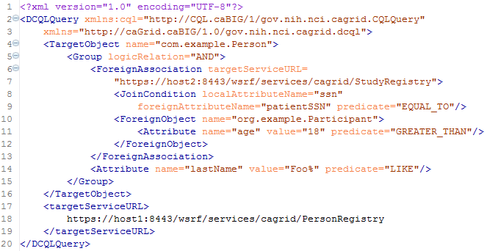
Figure 2 Example DCQL Query
- Federated Query Engine

Introduction
The Federated Query Engine is a simple but powerful design. The main functionality of the engine is to process a DCQL query by converting it into regular CQL queries to the targeted data services, appropriately aggregating results. As such, all of the actual “joining” of data is offloaded to the remote data services. This allows the engine to be reused as a client API as no databases or complex service infrastructure is needed; its simply a client-side querying tool. The trade off of this simplicity is efficiency, as more optimized approaches to federated joins exist. Future versions may adopt a more optimized, but less portable, approach.

The engine requires no special support from data services. Each service which is contacted to satisfy the distributed query is only sent one or more standard, but potentially complex, CQL queries. It is possible to construct a DCQL query which is essentially a standard CQL query, with the addition of specifying one or more target data services. In this case, the engine simply “forwards” that query on to the targeted services, and aggregates their results. In fact, this is always the final step of processing a DCQL query. The primary addition DCQL adds to CQL is the capability to express relationships between objects on multiple data services. The processing of these relationships yield “value conditions” against the source data service, which are expressed in standard CQL, and ultimately sent to the target data service. Take for example, a query that asked for all the Genes in service A that shared a symbol with Genes in service B which had an id greater that 50. In this case, first service B would be asked for all the symbols of the Genes which had an id greater that 50. Then service A would be asked for all the Genes which had a symbol that matched on from the list returned from service B. These results would then be returned as the results of the distributed query. Note the final step is just a standard “value condition” CQL query sent to a data service. While the queries can become quite complex, this basic process of converting cross-data service relationships into single data service value comparisons, and appropriately aggregating results, is the core functionality of the federated query engine.

The engine is composed of three core components, shown below in Figure 3. The first is the FederatedQueryEngine itself, which is the client-facing entry point to using the engine. The FederatedQueryEngine’s main responsibility is accepting the DCQL query, orchestrating the use of the other two components, and returning the appropriate results to the client. The second component is the FederatedQueryProcessor, and performs the bulk of the work of the engine in that it is responsible for traversing the query, executing the logic of the engine, and processing intermediate aggregations. Both of the first two components make use of the third component, the DataServiceQueryExecutor to invoke standard CQL queries on remote data services. Each of these components is described in greater detail in the following section.
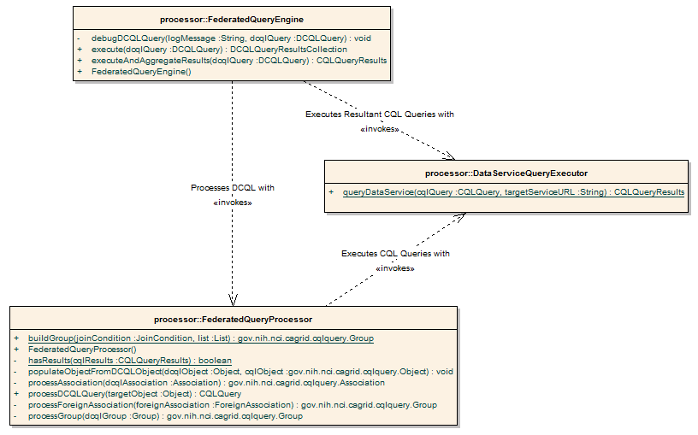
Figure 3 Federated Query Engine Components

Component Details

Federated Query Engine
The FederatedQueryEngine is the client-facing entry point to the engine. Its sole responsibility is to use the FederatedQueryProcessor to convert the specified DCQL query into a CQL query, and then query each specified target data service with that query using the DataServiceQueryExecutor. The results are then appropriately aggregated according to the method that was invoked.

It provides two methods which accept DCQL queries, and return the results. Each of the two methods provides a different variant on how results are represented. The first method is the executeAndAggregateResults method, which returns the standard CQLQueryResults (the same result type returned by data services’ query method). Each CQLResult obtained from each targeted data service is merged into an aggregate list, and a master CQLQueryResults object is constructed which contains them all. The information about which result came from which data service is lost in this scenario, but this provides the ability to reuse existing data service tooling and APIs when that information is not relevant.

In cases where it is important to know from which data service a given result came, the second query method called execute can be used. This method returns a new type called DCQLQueryResultsCollection. The DCQLQueryResultsCollection contains a list of DCQLResult, wherein each DCQLResult specifies a CQLQueryResults object, and the data service URL from which it came. That is, the result type is a collection of tuples containing the standard data service results, and that service’s URL.

Both query methods will throw a RemoteDataServiceException in the event a queried data service returns invalid results (such as the wrong target class type), or if a data service itself throws an exception when being queried, or if there is any problem querying the data service. Additionally, a FederatedQueryProcessingException, which is the parent class of RemoteDataServiceException, may be thrown if there is a problem processing the query itself.

Federated Query Processor
The heart of the engine is the FederatedQueryProcessor. It contains all the logic to convert a DCQL query into a CQL query. The basic process flow is to create a new CQL query, and recursively walk the DCQL query, depth first, until a terminating leaf is reached. These query leafs are either Attribute types, or Association or Object types with no children (class only criteria). Such criteria are converted to their CQL counterparts, and added to the CQL query as the recursion unrolls. The main special processing, described below, occurs when a ForeignAssociation type is encountered. The processing of a ForeignAssociation yields a CQL Group type, which is added to the converted type previously containing the ForeignAssociation. The end result is a standard CQL query, which is returned to the caller.

ForeignAssociations are processed by converting the foreign relationship to a standard CQL query to the specified data service, and converting the results of that query into attribute value comparisons (Attribute type) against the containing Object type. The ForeignObject, a DCQL Object type, in the ForeignAssociation is converted to a standard CQL Object just as the main DCQL Object is. That is, the same depth first recursion logic is used, and the Object may very well contain a nested ForeignAssociation. Once the conversion of the ForeignObject is complete, the resulting CQL Object is used as the target in a new CQL Query. The processor then apply a CQL QueryModifier to the CQL query which specifies that only distinct attribute values should be retrieved from the data service. The attribute requested is the one named in the JoinCondition as the foreignAttributeName. This optimization ensures that only the information necessary to execute the value join is transmitted from the remote data service. It also alleviates the processor from the need to understand the structure of the resulting objects, as attribute only CQL queries always yield a common name-value result format. Given the results of the query, a CQL Group is constructed which represents the value comparisons that are necessary to join these results with the containing object. If the remote query returned no results, then this criteria would never yield any results (as the client requested a join that contains an empty set). In order to maintain the semantics of the query, this criteria must yield no results, but cannot be simply omitted (as it would be inappropriately inclusive), nor should the query be aborted, as other criteria may yield results. The most appropriate replacement for such a query would be a “false” criteria, but CQL has no such construct. In order to replicate this behavior, a Group is constructed which will always be evaluated as false as it contains two mutually exclusive criteria ANDed together. Namely, two Attribute types using the localAttributeName as the name and “IS_NULL” and “IS_NOT_NULL” respectively as the predicates. If results are actually returned from the remote data service query, each is converted into an Attribute type with localAttributeName as the name, a query result value as the value, and the JoinCondition’s predicate as the predicate. In this way the cross-data service joins are executed by first extracting the join values from the remote service, and then converting them into local value queries to the “local” data service.

The net result of this processing is the DCQL query is converted into a standard CQL query, wherein all cross data service joins are evaluated by converting them to local attribute value restrictions. Notice that this processing flow dictates that the joins specified in nested ForeignAssociations are processed by the immediately containing data service. This is also true for joins executed across multiple data services (using a Group of ForeignAssociations). As such, the amount of processing required by the “outer most data service” does not increase with the complexity of the query, but only with the number of results returned by the outermost ForeignAssociation. As such, clients creating federated joins using DCQL, who are interested in performance, should take care to avoid, when possible, unrestricted joins. That is, joins which don’t restrict the return set of the join predicate. For example, joining Gene symbols across data services without attaching criteria to the ForeignObject would require one data service to execute a query with all Gene symbols from the other data service listed as possible values.

Data Service Query Executor
The DataServiceQueryExecutor is a simple wrapper around the standard data service client that ensures uniform exception handling and logging while communicating with remote data services.

- Federated Query Service Infrastructure

Introduction
The federated query service infrastructure provides remote access to the federated query engine through the use of two grid services, shown below in Figure 4. The first, the Federated Query Processor service, is the “entry point” service, and provides the means to execute DCQL queries. Queries can either be executed by a blocking call, and the results returned directly in the response to the query request, or they can be executed asynchronously. If a query is executed asynchronously, the service returns an End Point Reference (EPR, basically a service address), to the second service, the Federated Query Results service. The results service provides information about the current status of the query processing, and provides access to the results once the query processing is complete. These services are implemented using a standard WSRF factory pattern. That is, clients may access the Federated Query Processor service directly, and are given a resource-specified EPR with which the Federated Query Results service can be contacted. The services must be deployed together, in the same container, and can operate in both secure and insecure deployment scenarios. These services were developed using the Introduce grid service authoring tool, and can be viewed or edited using it.

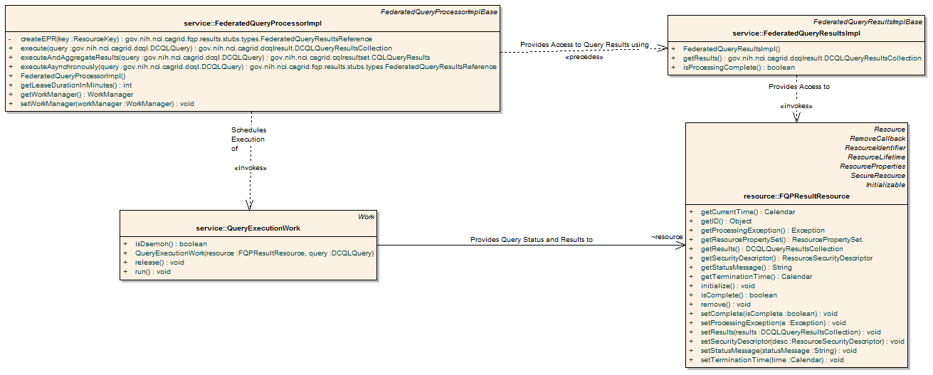
Figure 4 Federated Query Services

Federated Query Processor Service
The Federated Query Processor service is main service interface to the federated query engine. It provides three query execution operations. The first two are execute which takes a DCQL query and returns a DCQLQueryResultsCollection, and executeAndAggregateResults which returns a CQLQueryResults. These are both simple grid service wrappers for the corresponding methods in the FederatedQueryEngine API. The third operation, executeAsynchronously, provides asynchronous, non-blocking, access to the execute method, and returns a FederatedQueryResultsReference. The FederatedQueryResultsReference is a typed container for an EPR to the Federated Query Results service. The Federated Query Results service client API can be used to subsequently retrieve the DCQLQueryResultsCollection.

In order to process the asynchronous query requests (via the executeAsynchronously operation), the service employs a work/thread pool. The commonj WorkManager, distributed with Globus, is used for this purpose. In this framework, the work to be done is modeled as implementations of the Work interface, and Work items are scheduled with the WorkManager for execution with a configurable pool of threads. This provides a mechanism to manage the amount of system resources consumed by the service for the purposes of scheduling background tasks. Each task concurrently scheduled beyond the maximum number of worker threads is placed in a priority queue for processing once a currently executing task completes, and a thread becomes available. The service creates a new Work implementation (QueryExecutionWork) for each invocation of executeAsynchronously operation. This item is given a FQPResultResource, which is used to represent the status of processing and the results, and the DCQL query which needs to be executed. Once given priority to process, the worker uses the federated query engine to execute the query, and stores the results in the resource. Any exceptions that occur during processing are also captured and stored in the resource. After initializing a FQPResultResource and scheduling the QueryExecutionWork to operate on it, the service constructs an EPR to the resource and returns it to the caller.

The service makes a few aspects of its implementation configurable through deploy-time options. This feature, provided by Introduce, allows the service to access configuration options through the ServiceConfiguration class, where the values can be set by deployers of the service. The values can be set in the Introduce GUI when deploying the service using Introduce, or Ant properties when deploying using Ant; the defaults are set in the service.properties file. One configurable aspect is the number of threads used by the thread pool of the WorkManager. This option, named threadPoolSize, defaults to 10. The second option, initialResultLeaseInMinutes, defaults to 30, and defines the number of minutes asynchronous query result will live, unless renewed, before they are discarded. The specifics of how result lifetime is managed is described below in the description of the results service.

The service operations signal errors through the use of service faults. A base fault, FederatedQueryProcessingFault, acts as the main service-specific fault which clients can handle. It extends from BaseFault and represents a problem satisfying the request. All engine exceptions are wrapped with this fault. Additionally, an InternalErrorFault, which extends from FederatedQueryProcessingFault, can be thrown if there is some internal problem with the service. For example, an unrecoverable configuration issue or unexpected logic error in the service would yield such a fault. It is not expected the client could recover from such an issue.

The service contains a single WSRF Resource, which exposes service-level metadata as resource properties. The only resource property currently exposed by the service is the standard caGrid 1.0 ServiceMetadata, which describes the datatypes and operations of the service.

Federated Query Results Service
The Federated Query Results service is the service responsible for providing access to query results and processing status for asynchronously executed queries. The service can only be contacted with a resource-qualified EPR, provided by the Federated Query Processor service. As described above, whenever the query processor service is requested to execute an asynchronous query, a FQPResultsResource is created and an EPR, which identifies that resource in the results service, is returned. The Federated Query Results service’s only purpose is to expose information about, and management of, the FQPResultsResource instances. As such, the only business logic in the service is to call through to the resources. The Globus toolkit provides all the necessary logic for the service to operate in the context of the appropriate resource.

The FQPResultsResource is a WSRF Resource, and its instances act as the managers of the state of asynchronous queries. It is exposed to clients through the results service. It contains the current status of the query it corresponds to, any exceptions which occurred during processing, and eventually the results of the query. It supports standard WSRF Resource Lifetime behavior. As such, it exposes, as Resource Properties, the current time (as believed by the local system), and the termination time of the resource. Once created, the resource will be terminated/destroyed by the service once its termination time is past. This lifetime is initially controlled by the setting in the processor service. The client can also immediately destroy the resource with the Destroy operation, or change its termination time with the SetTerminationTime operation. Both of these operations are standardized operations for resources supporting Resource Lifetime and their implementations are plugged into the service via the provider framework, with the DestoryProvider and SetTerminationTimeProvider.

In addition to the operations and resource properties necessary to support Resource Lifetime on the resource, the service also provides the getResults and isProcessingComplete operations. The isProcessingComplete operation returns a simple Boolean value, indicating whether or not the query processing has completed. Once the query processing has completed, the results can be accessed via the getResults operation, which returns a DCQLQueryResultsCollection. If the operation is invoked prior to the processing being complete, a ProcessingNotCompleteFault fault will be thrown. If the processing is complete, but an exception occurred, a FederatedQueryProcessingFault will be thrown, and its cause will be the exception that occurred during query processing.

Service Security
The services support two deployment scenarios. The first is an insecure deployment, wherein no security (authentication or authorization) is enforced by the container. In this scenario, no encryption is used and no protection of query results is enforced. That is, anonymous communication is used over an open channel, and it is possible for one client to manipulate the query resources of another, given it knows the EPR.

The second scenario is when the services are deployed securely, such as with transport level security (https). In this scenario, no authorization is performed by the processor service, but any resources created via asynchronous queries are created with resource-level security descriptors that enforce that only the creator of the resource can call any operations on it. To accomplish this, the processor service which creates the resource applies Grid Map authorization on the resource, and adds the creator’s identity as the sole entry in the Grid Map.

As previously mentioned, the services are Introduce-created, and as such, the security settings can be modified in Introduce to support additional security enforcement. The only security enforced in the actual source code, is the programmatic application of the Grid Map authorization to the resources.

The services do not make use of delegated credentials, and as such, remote data services are accessed either or anonymously, or with the Federated Query Processor’s credentials (depending on the deployment scenario and the settings of the remote data services). While future work may enable this feature, clients needing this capability (credentialed access of data services) now may leverage the federated query engine directly using the API.

- References
This appendix could include lists and hypertext links, where appropriate, to technical manuals, articles, scientific publications, etc. Examples are shown:

Technical Manuals/Articles
- National Cancer Institute. "caCORE 2.0 Technical Guide", ftp://ftp1.nci.nih.gov/pub/cacore/caCORE2.0_Tech_Guide.pdf
- Java Bean Specification: http://java.sun.com/products/javabeans/docs/spec.html
- Foundations of Object-Relational Mapping: http://www.chimu.com/publications/objectRelational/
- Object-Relational Mapping articles and products: http://www.service-architecture.com/object-relational-mapping/
- Hibernate Reference Documentation: http://www.hibernate.org/hib_docs/reference/en/html/
- Basic O/R Mapping: http://www.hibernate.org/hib_docs/reference/en/html/mapping.html
- Java Programming: http://java.sun.com/learning/new2java/index.html
- Javadoc tool: http://java.sun.com/j2se/javadoc/
- JUnit: http://junit.sourceforge.net/
- Extensible Markup Language: http://www.w3.org/TR/REC-xml/
- XML Metadata Interchange: http://www.omg.org/technology/documents/formal/xmi.htm

Scientific Publications

caBIG Material
- caBIG: http://cabig.nci.nih.gov/
- caBIG Compatibility Guidelines: http://cabig.nci.nih.gov/guidelines_documentation

caCORE Material
- caCORE: http://ncicb.nci.nih.gov/core
- caBIO: http://ncicb.nci.nih.gov/core/caBIO
- caDSR: http://ncicb.nci.nih.gov/core/caDSR
- EVS: http://ncicb.nci.nih.gov/core/EVS
- CSM: http://ncicb.nci.nih.gov/core/CSM
- Glossary
Following is an example list of terms and their definitions.
Term | Definition
{jboss-home} | The base directory where JBoss is installed on the server
API | Application Programming Interface
caArray | cancer Array Informatics
caBIG | cancer Biomedical Informatics Grid
caBIO | Cancer Bioinformatics Infrastructure Objects
caCORE | cancer Common Ontologic Representation Environment
caDSR | Cancer Data Standards Repository
caMOD | Cancer Models Database
cardinality | Cardinality describes the minimum and maximum number of associated objects within a set
CDE | Common Data Element
CGAP | Cancer Genome Anatomy Project
CMAP | Cancer Molecular Analysis Project
CN | Common Name
CS | Classification Scheme
CSI | Classification Scheme Item
CSM | Common Security Module
CTEP | Cancer Therapy Evaluation Program
CUI | Concept Unique Identifier
CVS | Concurrent Versions System
DAML | DARPA Agent Markup Language
DAO | Data Access Objects
DARPA | Defense Advanced Research Projects Agency
DAS | Distributed Annotation System
DL | Description Logic
EA | Enterprise Architect
EBI | European Bioinformatics Institute
EVS | Enterprise Vocabulary Services
GAI | CGAP Genetic Annotation Initiative
GEDP | Gene Expression Data Portal
HIPPA | Health Insurance Portability and Accountability Act
HLGT | High Level Group Term
HLT | High Level Term
HTTP | Hypertext Transfer Protocol
ISO | International Organization for Standardization
JAAS | Java Authentication and Authorization Service
JAR | Java Archive
Javadoc | Tool for generating API documentation in HTML format from doc comments in source code (http://java.sun.com/j2se/javadoc/)
JDBC | Java Database Connectivity
JET | Java Emitter Templates
JMI | Java Metadata Interface
JSP | JavaServer Pages
JUnit | A simple framework to write repeatable tests (http://junit.sourceforge.net/)
LDAP | Lightweight Directory Access Protocol
LLT | Lowest Level Term
LOINC | Logical Observation Identifier Names and Codes
MAGE | MicroArray and Gene Expression
MAGE-OM | MicroArray Gene Expression - Object Model
MedDRA | Medical Dictionary for Regulatory Activities
metadata | Definitional data that provides information about or documentation of other data.
MGED | Microarray Gene Expression Data
MMHCC | Mouse Models of Human Cancers Consortium
MO | MGED Ontology
multiplicity | Multiplicity of an association end indicates the number of objects of the class on that end may be associated with a single object of the class on the other end
NCI | National Cancer Institute
NCICB | National Cancer Institute Center for Bioinformatics
OIL | Ontology Inference Layer
OilEd | Ontology editor allowing you to build ontologies using DAML+OIL
OLLT | Obsolete Lower Level Terms
OMG | Object Management Group
ORM | Object Relational Mapping
PT | Preferred Term
RDBMS | Relational Database Management System
SDK | Software Development Kit
Semantic connector | A development kit to link model elements to NCICB EVS concepts.
SOC | System Organ Class
SPORE | Specialized Programs of Research
SQL | Structured Query Language
SSC | Special Search Categories
UI | User Interface
UID | User Identification
UML | Unified Modeling Language
UMLS | Unified Medical Language System
UPT | User Provisioning Tool
URL | Uniform Resource Locators
VD | Value Domain
WAR | Web Application Archive
WSDL | Web Services Description Language
XMI | XML Metadata Interchange (http://www.omg.org/technology/documents/formal/xmi.htm) - The main purpose of XMI is to enable easy interchange of metadata between modeling tools (based on the OMG-UML) and metadata repositories (OMG-MOF) in distributed heterogeneous environments
XML | Extensible Markup Language (http://www.w3.org/TR/REC-xml/) - XML is a subset of Standard Generalized Markup Language (SGML). Its goal is to enable generic SGML to be served, received, and processed on the Web in the way that is now possible with HTML. XML has been designed for ease of implementation and for interoperability with both SGML and HTML

- DCQL/CQL Reference
element DCQLQuery
diagram | 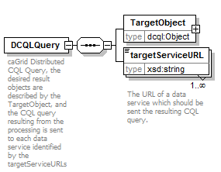
namespace | http://caGrid.caBIG/1.0/gov.nih.nci.cagrid.dcql
children | TargetObject targetServiceURL

element DCQLQuery/TargetObject
diagram | 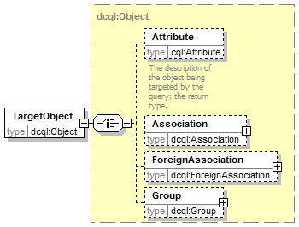
namespace | http://caGrid.caBIG/1.0/gov.nih.nci.cagrid.dcql
type | dcql:Object
children | Attribute Association ForeignAssociation Group
attributes
  Name | Type | Use | Default | Fixed
  name | xsd:string | required

element DCQLQuery/targetServiceURL
diagram | 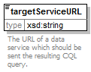
namespace | http://caGrid.caBIG/1.0/gov.nih.nci.cagrid.dcql
type | xsd:string

complexType Association
diagram | 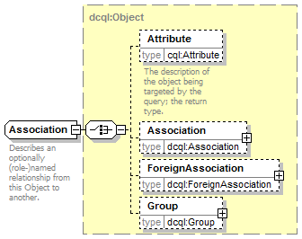
namespace | http://caGrid.caBIG/1.0/gov.nih.nci.cagrid.dcql
type | extension of dcql:Object
children | Attribute Association ForeignAssociation Group
used by
  elements | Object/Association Group/Association
attributes
  Name | Type | Use | Default | Fixed
  name | xsd:string | required
  roleName | xsd:string | optional

complexType ForeignAssociation
diagram | 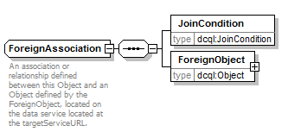
namespace | http://caGrid.caBIG/1.0/gov.nih.nci.cagrid.dcql
children | JoinCondition ForeignObject
used by
  elements | Object/ForeignAssociation Group/ForeignAssociation
attributes
  Name | Type | Use | Default | Fixed
  targetServiceURL | xsd:string | required

element ForeignAssociation/JoinCondition
diagram | 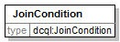
namespace | http://caGrid.caBIG/1.0/gov.nih.nci.cagrid.dcql
type | dcql:JoinCondition
attributes
  Name | Type | Use | Default | Fixed
  predicate | dcql:ForeignPredicate | optional | EQUAL_TO
  localAttributeName | xsd:string | required
  foreignAttributeName | xsd:string | required

element ForeignAssociation/ForeignObject
diagram | 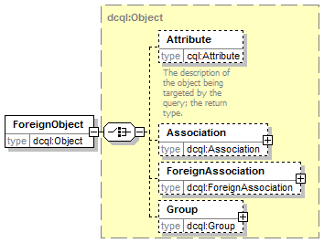
namespace | http://caGrid.caBIG/1.0/gov.nih.nci.cagrid.dcql
type | dcql:Object
children | Attribute Association ForeignAssociation Group
attributes
  Name | Type | Use | Default | Fixed
  name | xsd:string | required

complexType Group
diagram | 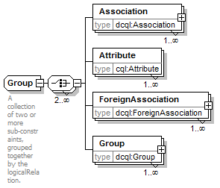
namespace | http://caGrid.caBIG/1.0/gov.nih.nci.cagrid.dcql
children | Association Attribute ForeignAssociation Group
used by
  elements | Object/Group Group/Group
attributes
  Name | Type | Use | Default | Fixed
  logicRelation | cql:LogicalOperator | required

element Group/Association
diagram | 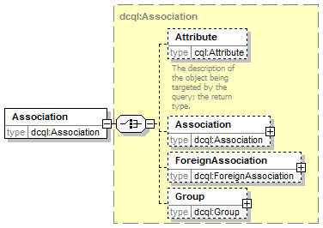
namespace | http://caGrid.caBIG/1.0/gov.nih.nci.cagrid.dcql
type | dcql:Association
children | Attribute Association ForeignAssociation Group
attributes
  Name | Type | Use | Default | Fixed
  name | xsd:string | required
  roleName | xsd:string | optional

element Group/Attribute
diagram | 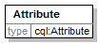
namespace | http://caGrid.caBIG/1.0/gov.nih.nci.cagrid.dcql
type | cql:Attribute
attributes
  Name | Type | Use | Default | Fixed
  name | xsd:string | required
  predicate | cql:Predicate | optional | EQUAL_TO
  value | xsd:string | required

element Group/ForeignAssociation
diagram | 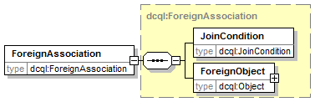
namespace | http://caGrid.caBIG/1.0/gov.nih.nci.cagrid.dcql
type | dcql:ForeignAssociation
children | JoinCondition ForeignObject
attributes
  Name | Type | Use | Default | Fixed
  targetServiceURL | xsd:string | required

element Group/Group
diagram | 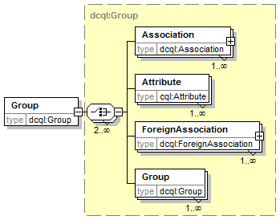
namespace | http://caGrid.caBIG/1.0/gov.nih.nci.cagrid.dcql
type | dcql:Group
children | Association Attribute ForeignAssociation Group
attributes
  Name | Type | Use | Default | Fixed
  logicRelation | cql:LogicalOperator | required

complexType JoinCondition
diagram | 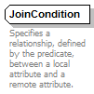
namespace | http://caGrid.caBIG/1.0/gov.nih.nci.cagrid.dcql
used by
  element | ForeignAssociation/JoinCondition
attributes
  Name | Type | Use | Default | Fixed
  predicate | dcql:ForeignPredicate | optional | EQUAL_TO
  localAttributeName | xsd:string | required
  foreignAttributeName | xsd:string | required

complexType Object
diagram | 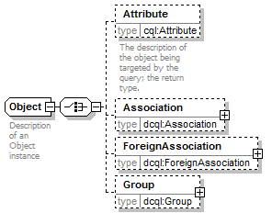
namespace | http://caGrid.caBIG/1.0/gov.nih.nci.cagrid.dcql
children | Attribute Association ForeignAssociation Group
used by
  elements | ForeignAssociation/ForeignObject DCQLQuery/TargetObject
  complexType | Association
attributes
  Name | Type | Use | Default | Fixed
  name | xsd:string | required

element Object/Attribute
diagram | 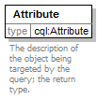
namespace | http://caGrid.caBIG/1.0/gov.nih.nci.cagrid.dcql
type | cql:Attribute
attributes
  Name | Type | Use | Default | Fixed
  name | xsd:string | required
  predicate | cql:Predicate | optional | EQUAL_TO
  value | xsd:string | required

element Object/Association
diagram | 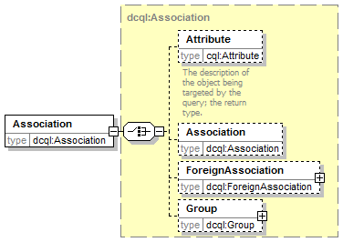
namespace | http://caGrid.caBIG/1.0/gov.nih.nci.cagrid.dcql
type | dcql:Association
children | Attribute Association ForeignAssociation Group
attributes
  Name | Type | Use | Default | Fixed
  name | xsd:string | required
  roleName | xsd:string | optional

element Object/ForeignAssociation
diagram
namespace | http://caGrid.caBIG/1.0/gov.nih.nci.cagrid.dcql
type | dcql:ForeignAssociation
children | JoinCondition ForeignObject
attributes
  Name | Type | Use | Default | Fixed
  targetServiceURL | xsd:string | required

element Object/Group
diagram | 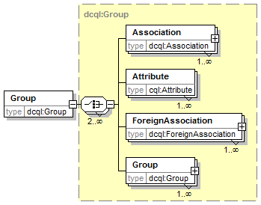
namespace | http://caGrid.caBIG/1.0/gov.nih.nci.cagrid.dcql
type | dcql:Group
children | Association Attribute ForeignAssociation Group
attributes
  Name | Type | Use | Default | Fixed
  logicRelation | cql:LogicalOperator | required

simpleType ForeignPredicate
namespace | http://caGrid.caBIG/1.0/gov.nih.nci.cagrid.dcql
type | restriction of xsd:string
used by
  attribute | JoinCondition/@predicate
facets
  enumeration | EQUAL_TO
  enumeration | NOT_EQUAL_TO
  enumeration | LESS_THAN
  enumeration | LESS_THAN_EQUAL_TO
  enumeration | GREATER_THAN
  enumeration | GREATER_THAN_EQUAL_TO

element cql:CQLQuery
diagram | 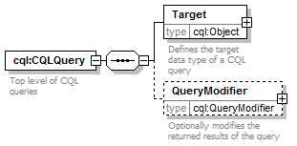
namespace | http://CQL.caBIG/1/gov.nih.nci.cagrid.CQLQuery
children | Target QueryModifier

element cql:CQLQuery/Target
diagram | 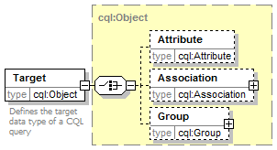
namespace | http://CQL.caBIG/1/gov.nih.nci.cagrid.CQLQuery
type | cql:Object
children | Attribute Association Group
attributes
  Name | Type | Use | Default | Fixed
  name | xsd:string | required

element cql:CQLQuery/QueryModifier
diagram | 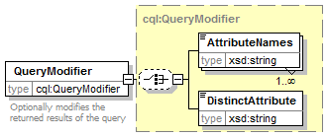
namespace | http://CQL.caBIG/1/gov.nih.nci.cagrid.CQLQuery
type | cql:QueryModifier
children | AttributeNames DistinctAttribute
attributes
  Name | Type | Use | Default | Fixed
  countOnly | xsd:boolean | required

complexType cql:Association
diagram | 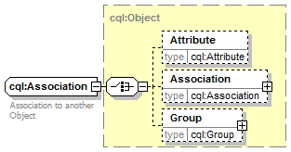
namespace | http://CQL.caBIG/1/gov.nih.nci.cagrid.CQLQuery
type | extension of cql:Object
children | Attribute Association Group
used by
  elements | cql:Object/Association cql:Group/Association
attributes
  Name | Type | Use | Default | Fixed
  name | xsd:string | required
  roleName | xsd:string | optional

complexType cql:Attribute
diagram | 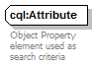
namespace | http://CQL.caBIG/1/gov.nih.nci.cagrid.CQLQuery
used by
  elements | Object/Attribute Group/Attribute cql:Object/Attribute cql:Group/Attribute
attributes
  Name | Type | Use | Default | Fixed
  name | xsd:string | required
  predicate | cql:Predicate | optional | EQUAL_TO
  value | xsd:string | required

complexType cql:Group
diagram | 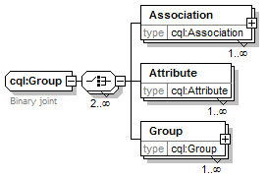
namespace | http://CQL.caBIG/1/gov.nih.nci.cagrid.CQLQuery
children | Association Attribute Group
used by
  elements | cql:Object/Group cql:Group/Group
attributes
  Name | Type | Use | Default | Fixed
  logicRelation | cql:LogicalOperator | required

element cql:Group/Association
diagram | 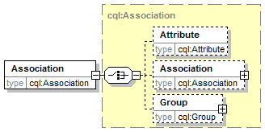
namespace | http://CQL.caBIG/1/gov.nih.nci.cagrid.CQLQuery
type | cql:Association
children | Attribute Association Group
attributes
  Name | Type | Use | Default | Fixed
  name | xsd:string | required
  roleName | xsd:string | optional

element cql:Group/Attribute
diagram
namespace | http://CQL.caBIG/1/gov.nih.nci.cagrid.CQLQuery
type | cql:Attribute
attributes
  Name | Type | Use | Default | Fixed
  name | xsd:string | required
  predicate | cql:Predicate | optional | EQUAL_TO
  value | xsd:string | required

element cql:Group/Group
diagram | 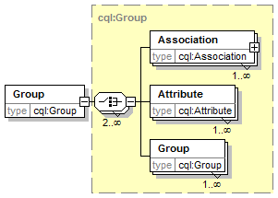
namespace | http://CQL.caBIG/1/gov.nih.nci.cagrid.CQLQuery
type | cql:Group
children | Association Attribute Group
attributes
  Name | Type | Use | Default | Fixed
  logicRelation | cql:LogicalOperator | required

complexType cql:Object
diagram | 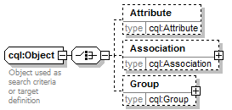
namespace | http://CQL.caBIG/1/gov.nih.nci.cagrid.CQLQuery
children | Attribute Association Group
used by
  element | cql:CQLQuery/Target
  complexType | cql:Association
attributes
  Name | Type | Use | Default | Fixed
  name | xsd:string | required

element cql:Object/Attribute
diagram
namespace | http://CQL.caBIG/1/gov.nih.nci.cagrid.CQLQuery
type | cql:Attribute
attributes
  Name | Type | Use | Default | Fixed
  name | xsd:string | required
  predicate | cql:Predicate | optional | EQUAL_TO
  value | xsd:string | required

element cql:Object/Association
diagram | 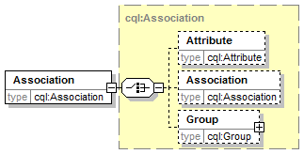
namespace | http://CQL.caBIG/1/gov.nih.nci.cagrid.CQLQuery
type | cql:Association
children | Attribute Association Group
attributes
  Name | Type | Use | Default | Fixed
  name | xsd:string | required
  roleName | xsd:string | optional

element cql:Object/Group
diagram | 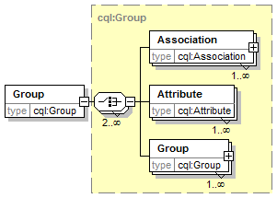
namespace | http://CQL.caBIG/1/gov.nih.nci.cagrid.CQLQuery
type | cql:Group
children | Association Attribute Group
attributes
  Name | Type | Use | Default | Fixed
  logicRelation | cql:LogicalOperator | required

complexType cql:QueryModifier
diagram | 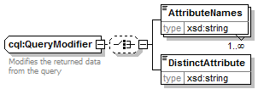
namespace | http://CQL.caBIG/1/gov.nih.nci.cagrid.CQLQuery
children | AttributeNames DistinctAttribute
used by
  element | cql:CQLQuery/QueryModifier
attributes
  Name | Type | Use | Default | Fixed
  countOnly | xsd:boolean | required

element cql:QueryModifier/AttributeNames
diagram | 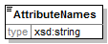
namespace | http://CQL.caBIG/1/gov.nih.nci.cagrid.CQLQuery
type | xsd:string

element cql:QueryModifier/DistinctAttribute
diagram | 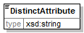
namespace | http://CQL.caBIG/1/gov.nih.nci.cagrid.CQLQuery
type | xsd:string

simpleType cql:LogicalOperator
namespace | http://CQL.caBIG/1/gov.nih.nci.cagrid.CQLQuery
type | restriction of xsd:string
used by
  attributes | Group/@logicRelation cql:Group/@logicRelation
facets
  enumeration | AND
  enumeration | OR

simpleType cql:Predicate
namespace | http://CQL.caBIG/1/gov.nih.nci.cagrid.CQLQuery
type | restriction of xsd:string
used by
  attribute | cql:Attribute/@predicate
facets
  enumeration | EQUAL_TO
  enumeration | NOT_EQUAL_TO
  enumeration | LIKE
  enumeration | IS_NULL
  enumeration | IS_NOT_NULL
  enumeration | LESS_THAN
  enumeration | LESS_THAN_EQUAL_TO
  enumeration | GREATER_THAN
  enumeration | GREATER_THAN_EQUAL_TO

Index
It is very easy to generate an index and extremely helpful to the manual user. See the Technical Style Guide located at: https://cabig.nci.nih.gov/working_groups/Training_SLWG/Documents/Technical_Pubs_Style_Guide_021405_jbh.pdf for directions for inserting index markers and generating an index in MS Word (PC).

Document conventions, Supplement, 3
Glossary, 21
References
caBIG materials, 18
caCORE material, 18
scientific publications, 18
technical manuals, guides, 18
Text conventions, Supplement, 3

