# $ + K @ Overview

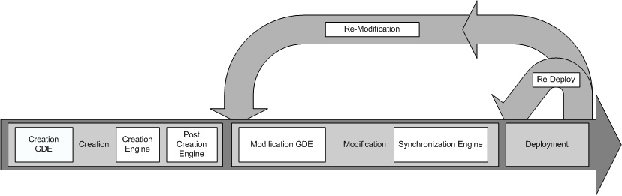
Introduce Overall Service Creation Process

The Introduce toolkit is designed to support the three main steps of service development: 1) Creation of Basic Service Structure. The service developer describes at the highest level some basic attributes about the service such as service name and service namespace. Once the user has set these basic service configuration properties, Introduce will create the basic service implementation, to which the developer can then add application-specific methods and security options through the service modification steps. 2) Service Modification. The modification step allows the developer to add, remove, and modify service methods, properties, resources, service contexts, and service/method level security. In this step, the developer can create a strongly-typed service interface using well-defined, published schemas, which are registered in a system like the Mobius GME, as the type definitions of the input and output parameters of the service methods. One the operations are added to the service the developer will then be able to add the logic which implements the methods. 3) Deployment. The developer can deploy the service which has been created with Introduce to a Grid service container (e.g., a Globus or Tomcat service container). A service developer can access the functions required to execute these three steps through the Graphical Development Environment (GDE) of Introduce. The runtime support behind the GDE functionality is provided by the Introduce engine, which consists of the Service Creator, Service Synchronizer, and Service Deployer components. The toolkit provides an extension framework that allows Introduce to be customized and extended for custom service types and discovery of custom data types. In the following sections, we describe the software prerequisites, the Introduce Graphical Development Environment, the Introduce Engine, and the Introduce Extension Framework in greater detail.

# $ + K @ Software Prerequisites
- Java 1.5 or greater (http://www.java.sun.com)
- Apache Ant 1.6.5 or 1.7.0 (http://www.ant.apache.org)
- The Globus Toolkit Version 4.0.3 or 4.0.4 (http://www.globus.org)

# $ + K @ Changes from Introduce 1.0

- Added a new target in the service build file which enables fixing the soap bindings to work with custom serialization.
- Added property "perform.index.service.registration" to the deploy.properties to enable or disable index service registration.
- Added two new properties in the deploy.properties enabling the metadata pub/sub timing to be controlled.
  - index.service.registration.refresh_seconds=600
  - index.service.index.refresh_milliseconds=30000
- Added "dev" build.xml and build-deploy.xml which the user can freely edit without expecting changes by updates
- Moved ant-contrib.jar to ext/lib in the service instead of lib because the service itself does not need that jar as it is only used for building
- Created a soap binding fix that will enable us to use custom serialization of "some" types of a schema and added it to the services build process.
- Descriptions on the service, methods, inputs, outputs, faults, are now used to create javadoc on the "common" service interface.
- Moved to Policy Decision Point (PDP/authz) based authorization
  - made the authorization class a PDP
  - configures the service security descriptor to use the PDP
  - added a gui panel to enable entering a custom PDP chain if desired
- Added support for resource factory/creation code to automatically be generated and placed into any method which is creating and returning a handle to a new service/resource instance.
- Added upgrader framework to enable migration of services from 1.0 - 1.1
- Added updater framework enabling Introduce to find and install extensions and newer versions directly from the software.
- Refactored service resource framework in order to enable registration of resource properties as well as enable the resource class itself to be user modified and extended to there liking. In doing this the BaseResource class was also renamed to <serviceName>Resource to make more sence to the developer. This also caused the renaming of the etc/registration.xml to etc/<serviceName>_registration.xml in order to support registration for the all the resource framework types.
- Only services which have resource properties that are to be registered will attempt to register with the index service.
- Most fields in the GDE which require user input are all dynamically validated and will give graphical feedback to the user if a warning or error is detected.

# $ + K @ Introduce Graphical Development Environment

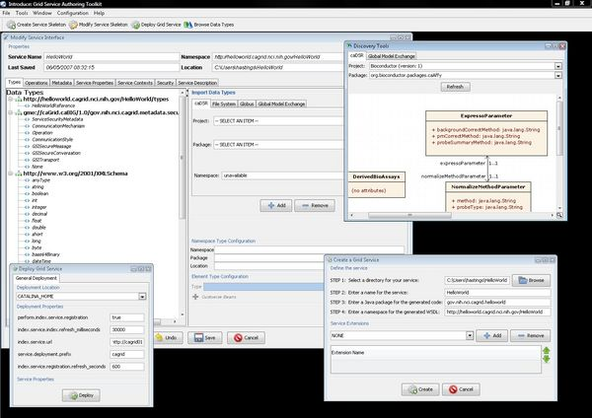The Introduce Graphical Development Environment (GDE)
The Introduce Graphical Development Environment (GDE) can be used to create, modify, and deploy a grid service. It is designed to be very simple to use, enable using community accepted data types, and provide easy configuration of service metadata, operations, resources, and security. It also allows customized plug-ins to be added for such things as discovering data types from grid repositories and for creating custom service style design templates.
The Introduce GDE contains several screens and options for the service developer to 1) create a new service, 2) modify an existing service, 3) discover and use published data types in order to create strongly-typed service methods, and 4) deploy the service.

# $ + K @ Service Creation

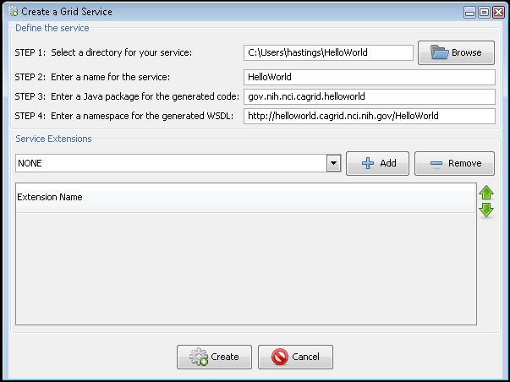Introduce GDE Service Creation Component
The service creation component, shown below, enables the developer to create a new grid service. Using the creation interface, the service developer can provide basic information about the service such as:
Creation Directory
The creation directory is the location of which the grid service will be generated.
Service Name
Service name is the name that will be used to generate the service. The service name must be a valid java identifier.
Package Name
The package name is the base package to be used when generated the grid service source code.
Namespace
The namespace is the namespace to be used when defining the WSDL of the service.
The developer also has the ability to add service extensions. A service extension is an Introduce plug-in (see Service Extensions), which is designed to add customizations to the service. For example, service extensions might add pre-defined operations, resources/resource properties, or security settings. They enable the development of custom service types with predefined methods, which must be implemented. They also enable Introduce to run the custom code implemented in the plug-in, which makes modifications to the underlying service being created. This capability allows the specialization of Introduce to support domain specific common scenarios, further abstracting the individual service developer from responsibilities related to the deployment of grid technologies in a production environment. Once the information has been entered and extensions, if any, have been selected, the user will select the create button. Once the creation button is selected the Introduce creation engine will begin generating the service. After the service is generated is will be compiled and the Modification component will be displayed.

# $ + K @ Service Modification
Service modification can be performed on any new or previously modified Introduce generated service. The service developer can perform a series of operations in order to begin to customize the grid service or modify the existing grid service. The overall flow in the modification of a grid service is to first use the namespaces tab to be sure that all the data types that are desired to be used I the grid service have been selected and added to the service. Next the service can choose to either add/remove or modify operations, metadata in the form of resource properties, service properties, security setting, and service contexts. The following sections will describe in detail how each of the components of the modification viewer can be used to modify the grid service to achieve desired functionality. By selecting the “Modify Service” button on the main menu a prompt will appear to enable choosing the service to be modified. Once the desired directory containing the service to be modified is selected the modification viewer component will be launched. The modification viewer contains 6 main areas where modifications can occur on the main service:

# $ + K @ Data Types
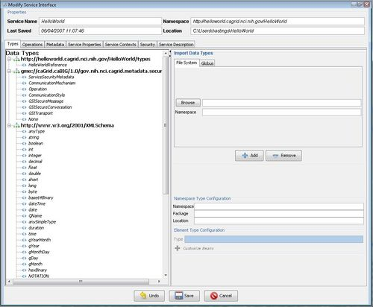
Introduce GDE Service Modification Component
The first task in the modification of a grid service is to discover the data types that are desired to be used as the input and output types of methods of the service and the data types for describing the resource properties of the service. Adding a data types to the service is equivalent to copying schemas into the schema location of the service and importing the schemas into the WSDL file so that the types can be referenced by the service. This is done via the “Types” tab of the Graphical Service Modification Environment. This tab shows the current types the service is using, and provides access to the data type discovery components (such as the Mobius GME), for selecting and configuring additional types. The “Select Type” frame enables several types of ways to locate data types and bring them into the service. Currently there are three main discovery mechanisms (GME, Globus, and File System) that come with introduce, however, this is extensible via the Discovery Extension described in the Extensions section. Once a set of data types from a namespace are brought into the service the user has the ability to describe how these data types will be mapped into there respective Java classes. This can, by default, be done automatically by Introduce via Axis. By default, Axis will create new java beans for each data type and also provide a serializer and deserializer for those objects. If for example, a set of objects already exist for this particular data types then a user can decide to provide there own classes and serialization/deserialization factories.

# $ + K @ Importing Data Types
Using the GDE, developers can obtain the data types that they want to use for operation input parameters and return types from any data type discovery plug-in. Utilizing common and standard data types, which are defined outside of any application-specific service, enables the creation of strongly typed grid service interfaces. This increases service-to-service interoperability. Once a data type is chosen through the GDE, the data type definition is retrieved, written into the schema/<service_name> location of the service, and imported for use in the service WSDL description so that Java beans can be generated and the data types can be programmatically used.
The Introduce toolkit comes with a set of pre-installed discovery plug-ins, such as the Mobius GME and a basic file system browser, which can be used to locate and import schemas. The GME plug-in enables developers to browse, upload, and download schemas published in a GME. These schemas represent the valid data types which can be used during service creation. Using the GME plug-in, a developer can take a schema, create an editable view of the schema, and then submit the schema to the GME. If the namespace of the schema is not managed by the GME, to which the schema is submitted, the plug-in will attempt to add the namespace to the GME before submitting the schema. Once the schema has been uploaded, it can be used by anyone in the Grid through the Introduce toolkit. The GME plug-in browser window enables browsing through all the GME published types by namespace and schema name. It presents the user a quick view of the schema and the option to download the schema bundle. The schema bundle contains the schema and all other schemas which are referenced by that schema.
When importing a data types there are several options in where to acquire the data type definitions. Introduce is build in with the following data type definition tools, however, this is a pluggable piece of Introduce. Once a data type is imported using an import tool that data type can be customized for the generation of Java Beans. If you select data type on the left you will see in the lower left panel that the namespace and package name have been listing. This is called the namespace to package map. This will determine the package name of the Java Beans that get created for the data type. Feel free to alter the package name if the Introduce suggested package name does not work well.
- File System Data Type Importing
The File System tab of the Import Data Types Panel enables the developer to load in schemata which contain data types they wish to use the service from the local filesystem. The developer can browse to choose the schema they wish to import, and the click the add button. Once the add button is clicked the schema and any locally included or imported schemata will be copied to the services schema location in the schema/<service name> directory.
- Global Model Exchange Data Type Importing
The Global Model Exchange Data Type extension enables browsing for schemata from a remote grid service which is responsible for storing them. Introduce can connect to a GME and load in all the available namespaces the GME is storing schemata for. Once the developer selects a namespace the name drop down will be populated with all the available schema names for that schema. Once a namespace and name have been selected then user can select the add button and the schema and any imported schemata will be downloaded and imported into the service. The main Configuration menu at at the top for the GDE will contain the ability for changing the location of the GME to use.
- Globus Data Types Importing
The Globus Data Types extension enable the developer to import schema from the Globus toolkit into their service. There is a drop down containing a list of the available schemata from the current installation of the Globus Tooolkit. Once a namespace has been selected and the add button has been selected then the schema will be added to the service's available data types list.

# $ + K @ Re-Importing a Modified Data Type
Introduce will enable re-importing of a data type if the developer wants to re-import a particular schema which may have been modified or extended. In order to do this you must make sure the "Namespace Type Replacement Policy" configuration setting in the Introduce "Configuration-->Preferences" menu is set to "warn". Once this is done you can simply browse back to the data model and import it again.

# $ + K @ Using Custom or Pre-Existing Java Beans
Once a namespace and corresponding data types have been imported into the service each data type can be further customized. For a particular data type one can chose to use a Custom Java Bean that already exists instead of having Introduce create the java beans for the service. This can be accomplished by selecting the + button beside the Customize Bean label. This will drop down the customization panel for that particular data type. In this panel, to support using a custom bean for the selected data type definition, the developer must fill out the three fields: the classname of the bean to be used (make sure the package name above matches the package name being entered for the custom beans classname), the deserializer factory class, and the serializer factory class. For more information on using custom serialization or what it means to be a custom bean please refer to the most recent Globus documentation on type mapping.

# $ + K @ Operations
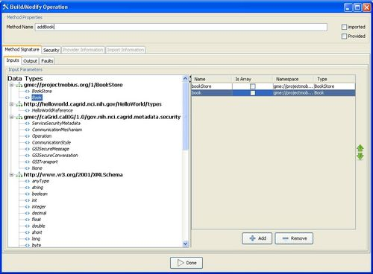
Introduce GDE Method Modification Component
The developer can add, remove, or modify operations on the service, using the “Operations” tab of the GDE Service Modification interface. For each operation, the developer needs to set the input parameters, return type, and any fault types that can be thrown from each service method. The security configuration of the operation should also be set if desired. The input and output types can be selected from the types tree on the left. This tree represents the available data types which can be used by this service. If any input parameter or output type is to be an array the array checkbox must be checked in the table on the right. Also, once an input parameter is added the name of the parameter is defaulted. This name can be edited by the developer by selected the cell in the name column and editing the text. There are two ways to add faults, either choose a type from the types tree which extends WSRF BaseFaultType or create a new fault which will tell Introduce to create you a new fault type which extends the BaseFaultType.

# $ + K @ Using a Pre-Existing Operation Implementation
The implementation of a described operation may already exist in another class which is provided by a jar file. You can tell Introduce not to stub this methods server side implementation but instead call this provided method implementation directly in the class provided. In order to use this functionality the “Provided” checkbox must be selected and the Class name attribute must be filled out in the “Provider” tab. The class name attribute will point to the fully qualified class name of the class which implements this WSDL described operation. The jar file that contains the provided Class which implements this operation must also me copied into the lib directory of the service. This will ensure that the operation will be located at the time the operation is called on the service. For more information on this particular topic refer to the Globus Documentation on Operation Providers.

# $ + K @ Importing Operations
Operations can also be imported from other services. Importing an operation enables the service to implement the exact same operation signature. This enables the service to have an operation which has the exact same WSDL signature of the operation which is being imported. This would enable either client to invoke this operation on either service. Importing can be done in two ways: (1) from an Introduce generated service, or (2) from a WSDL file. For case 1, importing from an Introduce service, the developer would browse and select the Introduce generated service which contains the operation to be imported. Once the Introduce service is selected a list of services which contain this method will be available to select from. Select the service from which you want to import the operation. The methods signature will be imported and the developer will be prompted to make sure to copy over the WSDL and XSD files needed to import the method into the schema<service name> directory of the service. For case 2, if a method is described in another WSDL but the developer wants to implement this exact method from this WSDL. The developer must have the WSDL and corresponding XSD’s in the schema/<service name> directory of the service. Then the developer will be able to browse those WSDL files and select the port type they wish to import the operation from. The importing of a method across services will assure not only that each service has completely protocol compatible methods but also that each service’s method can be invoked by the same base client. This enables the notion of basic inheritance in grid services and is discussed further in Operation Importing .

# $ + K @ Resource Properties
Service state information and metadata in the form of resource properties can be added, removed and configured via the “Metadata” tab of the GDE Service Modification interface. The metadata elements which are added to the service can be populated by a file statically or managed dynamically within the service. Also, these metadata entities can be registered with an index service so that users can use the metadata to locate the service. Once the "Metadata" tab is clicked the left panel will contain a list of available data types that can be used for metadata and the right will contain the list of currently chosen data types. By double-clicking on a data type in the left panel it will be added to the main service's metadata list. Any of the service's metadata can be initially populated from a file if desired. If this is chosen then once the service is started up in the container the file will be used to populate the particular metadata object in the service. Each metadata in the service can also be selected to be published to an index service. This will enable some or all of the metadata to be used in to locate the service via an index service.

# $ + K @ Service Properties
Service properties are key value pairs which can be set at deployment time and are available to the server side implementation of the service at run time. This enables passing in configuration variables to the server side of the service at deployment. These key value pair properties can be declared in “Service Properties” tab of the GDE Service Modification interface. Once the "Service Properties" tab is clicked the main panel will show a table of the service properties. The bottom panel has an entry for which can be used to create a new service property. The properties will be confirmed and/or can be changed from there default values at service deployment time. The variables can then be accessed inside the user’s implementation of the operations through the services ServiceConfiguration class. For example, if you add a property called foo under the service properties tab, and then save the service. Then go look at the source code for the <service package>.service.ServiceConfiguration.java class you will seee that it now has available methods for string getFoo() and void setFoo(string foo). These operations are now available to your service and can be used to pass properties into your service at deployment time as well as other users for configuring and sharing properties in your service. The <service package>.service.ServiceConfiguration.java contains a static method for obtaining an instance of itself called getConfiguration(). Any call to that from anywhere in the service will return the handle to the ServiceConfiguration instance and hence access to the service properties.

# $ + K @ Security

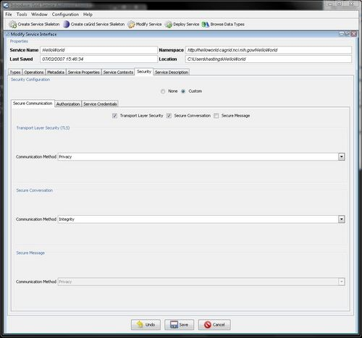
Introduce GSI Security Configuration Panel
Introduce exposes the functionality of Globus GSI through a set of panels which enable the user to customize security for the entire service or specific methods on an service context. The user can choose any of the GSI configuration scenarios such as Transport Level Security with Integrity and Secure Communication with Privacy. Introduce also enables configuring a particular service, operation, or resource, for authorization. Introduce comes with capabilities to configure authorization using GridGrouper and/or Common Security Model, or a Custom PDP based authorization chain. Graphical panels will enable the user to describe an authorization policy which must be met in order to give access to the particular service or operation. For detailed knowledge of what the configuration options for Secure Conversation or Secure Credentials are please refer to documentation for the GSI (http://www.globus.org/toolkit/docs/4.0/security/) framework.

# $ + K @ Service Contexts

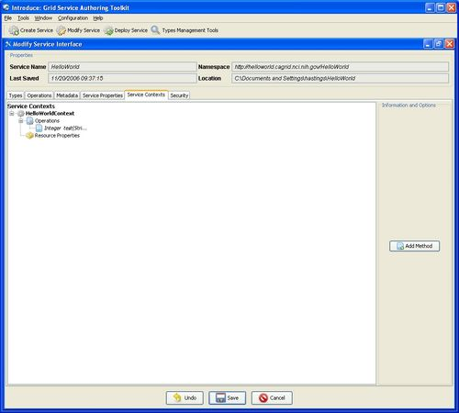
Introduce GDE Service Contexts Modification Component
A power user feature which can be enabled at modification time is the addition or removal of service contexts. A service context a sub-service or complimentary service which is used with the main service or some other service context. The service context is comprised of the service, resource, operations, and resource properties. So, in a sense, service context is exactly the same thing as the main service, except that it is not a singleton based resource and instances can be more dynamically created and or destroyed. Contexts can be added via the “Service Contexts” tab of the GDE Service Modification interface. Service contexts define additional of operations needed to support the desired service functionality. This is enabled by using WSRF capabilities of the Globus Toolkit. As an example, if an operation on the main service enables the user to query a database, that operation might create a resource in another context and return the handle to that context to the user as opposed to the full query result set. This secondary context can then enable the user to iterate through the query results. This is accomplished by operations or resource properties to this secondary service context which will be responsible for iteratively giving results to the user. It should be noted that multiple instances of these contexts can be created and executed concurrently; one for each query that comes in, for example. This style of grid service is supported by the WSRF specifications. Though the details of the WSRF-implementation of these concepts are abstracted away from developers its worth noting how they are realized, and this is described in detail in other sections. Introduce makes it easier for service developers to create such complex services, via the GDE, without having to fully understand the underlying service implementations. Anything that can be done to the main service, except service properties which are globally accessible can be added to a service context. For example, resource properties can be added and used to maintain state or for publishing metadata to an index service. Also, operations can be added to the service context and can also be implemented in the service itself or in the service's resource if they are acting on the state of the instance of the resource.
A Statefull Grid service is comprised of several key components which make it able to maintain state and enable a client to invoke the service several time under the same context. A statefull grid service is composed of the service, a resource home, and the resource type. This service organization can be used in many different scenarios. For, example, when an operation on the service is invoked the service can be implemented to handle that operation, or if the operation is addressing a particular resource instance in the service, the service can lookup the resource and call whatever might be necessary to call on the particular addressed resource.

# $ + K @ Utilizing the Factory Pattern
Link to the entire example service source code described below (https://project.bmi.ohio-state.edu/gf/download/frsrelease/106/278/CounterServiceExample.zip)
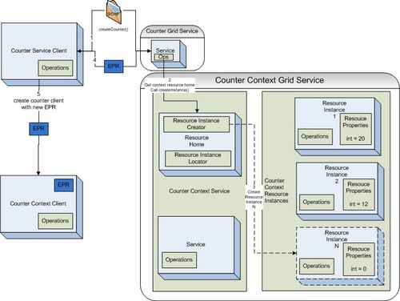
Utilizing Grid Service Factory Pattern
In order to create instances of a resource something must tell the resource home of the service to create them. This is typically done using the factory pattern. A service or method is responsible for telling the resource to create a new instance of a resource type for the service. An example of the factory pattern in action is show it the image above. A factory service, the Counter Grid Service, contains a create operation which is exposed as a grid service method. When the client invokes this method the Counter Grid Service will locate the resource home of the Counter Context Grid Service and ask it to create a new resource instance. Once this resource instance is created the resource home will return a pointer or address to this resource instance called an EndPointReference (EPR). This EPR is then returned from the create method back to the client so that it has a pointer to these new resource that it can act on.
In order to act on this resource it will need to construct a client which can talk to the grid service which represents this resource type. The Counter Context Client will be constructed using the EPR to address the specific resource context for the service. Next the user would like to call the incrementCounter() operation on the Counter Context Grid Service. The client will make the call to the grid service and the service will then look at the EPR sent over by the client. The service will then take the EPR and give it to the resource home and ask for the resource instance back which is represented by the particular EPR. The service will run its logic to increment the counter, which in this case is represented as a resource property of the resource.
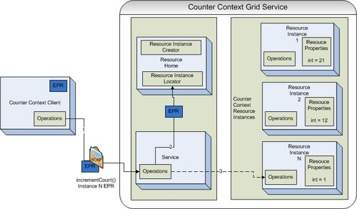
Invoking a Statefull Grid Services
Below shows an example of the code that would be required to implement the incrementCounter() method in the CounterContextServiceImpl.java.

package example.counter.context.service;

import java.rmi.RemoteException;

/**
* TODO:I am the service side implementation class. IMPLEMENT AND DOCUMENT ME
*
* @created by Introduce Toolkit version 1.1
*/
public class CounterContextImpl extends CounterContextImplBase {

public CounterContextImpl() throws RemoteException {
super();
}

public void incrementCounter() throws RemoteException {
int currentCounter;
try {
currentCounter = getResourceHome().getAddressedResource().getIntValue();

currentCounter++;
getResourceHome().getAddressedResource().setIntValue(currentCounter);
} catch (Exception e) {
e.printStackTrace();
}
}

}

# $ + K @ Implementing the Service

When an operation is added in the Introduce GDE and hte save button is clicked. Introduce will add the new stubbed method into the <service package>.service.<service name>Impl.java class. The developer is then responsible for implementing the method prior to deployment. For example the snippet below would be generated in the <service package>.service.<service name>Impl.java if the developer added an add operation to the service with Introduce that took in two integers and returned and integer.
\

public int add(java.math.BigInteger a,java.math.BigInteger b) throws RemoteException {
//TODO: Implement this autogenerated method
throw new RemoteException("Not yet implemented");
}

The developer would then have to edit this method to implement the logic the service would execute on invokation.

public int add(java.math.BigInteger a,java.math.BigInteger b) throws RemoteException {
return a + b;
}

# $ + K @ Deployment

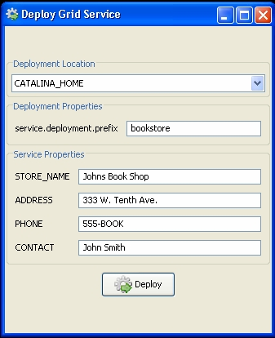
Introduce GDE Service Deployment Component
The deployment option of the GDE allows the service developer to deploy the implemented grid service, which has been created with Introduce, to a Grid service container. The toolkit currently supports deploying a service to either a Globus or Tomcat Grid service container; however, support for other deployment options can easily be added to the GDE. The deployment window allows the service deployer to populate service configuration properties, which the service will have access to at runtime. Then the service is deployed to the selected container.

# $ + K @ Using the Client
Introduce generates a client API for the service which is exactly as described within the graphical editing environment (see Auto-boxing/Unboxing or Service Operations). This client API can be used in order to leverage this type of service from another application or service. The API contains four constructors which can use used, each of which is different depending on having a handle or just an address and the need for security to be used.

/**
* Takes in the url of the service to connect to as a string
*/
HelloWorldClient(String url)

/**
* Takes in the url of the service to connect to as a string and
* a proxy to be used to represent the credentials or the caller
*/
HelloWorldClient(String url, GlobusCredential proxy)

/**
* Takes in the epr which refers to the service or resource
*/
HelloWorldClient(EndpointReferenceType epr)

/**
* Takes in the epr which refers to the service or resource and
* a proxy to be used to represent the credentials or the caller
*/
HelloWorldClient(EndpointReferenceType epr, GlobusCredential proxy)

Once a client handle is constructed each of the operations which were created in the service are available as operations to this newly constructed client instance. Below is an example snippet of code which creates a new client handle to a service called “HelloWorld” and calls the “echo” operation.

try {
HelloWorldClient client = new HelloWorldClient(“http://localhost:8080/wsrf/services/HelloWorld”);
client.echo(“Testing)”;
} catch (Exception e) {
System.out.println("Problem creating handle to or calling service" + e.getMessage(), e);
}

# $ + K @ Software Updates

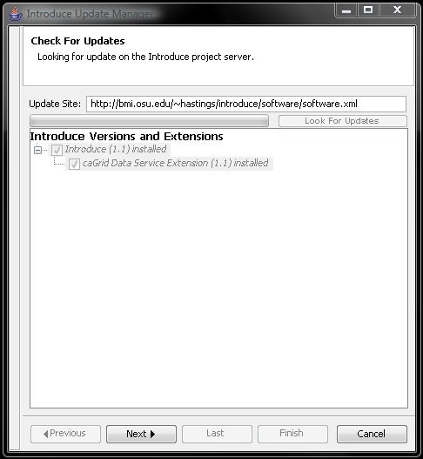
Introduce is now capable of downloading and installing new extensions, upgrades to older extensions, and newer versions of itself. In the GDE there is a Help menu. In this menu there is a Check for Updates button. This button will take the user to a wizard which will walk them through looking for any software updates or new packages which they may want to download and install.

# $ + K @ Service Migration
Introduce has the ability to help migrate a service to a newer version of Introduce. If the developer attempts to open a service generated with an older version of Introduce (1.0 and newer), Introduce will prompt the user to proceed with the migration process. The migration process is fully automated and when it is complete will report out to the developer what might be left for them to adjust based on there potentially custom changes or if there were any errors during the process.

# $ + K @ Introduce Engine
The runtime support to enable service creation, modification, and deployment is provided by the Introduce engine. In this section, we describe the main components of this engine.

# $ + K @ Service Creator
The service creator is composed by a series of templates using the Java Emitter Templates (JET) component, which is part of the Eclipse Modeling Framework (http://www.eclipse.org/emf/), for generating source code and configuration files, and a skeleton set of directories which is used to generate a Grid service that can be built, registered, and deployed in the Grid environment.
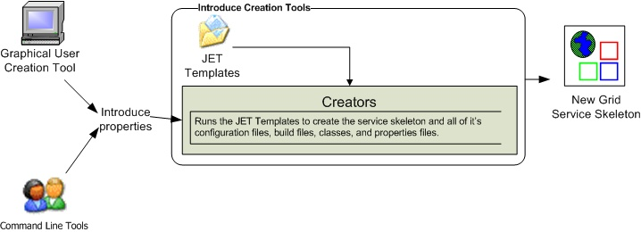
Introduce Creation Framework

Templates for source code and configuration files are used to create all the custom Java source code for the service and the client APIs, and to generate the files required by the GT in order to build and deploy a Grid service. Deployment configuration files are used for resource and resource property configuration in the form of Java Naming and Directory Interface (JNDI), resource property registration configuration, service deployment descriptor in the form of Web Service Deployment Descriptor (WSDD), and security configuration. The basic service created by Introduce has the following components:
- Ant processes for build, deploy, and test operations
- custom configuration files for IDE integration, e.g., Eclipse project files for editing of the service using the Eclipse platform (www.eclipse.org)
- standard interface for both client and service to implement
- fully implemented client APIs
- stub implemented service
- configuration to support service metadata and resource properties and the registration of metadata and properties
- configuration for secure service deployment and authorization

# $ + K @ Service Synchronizer

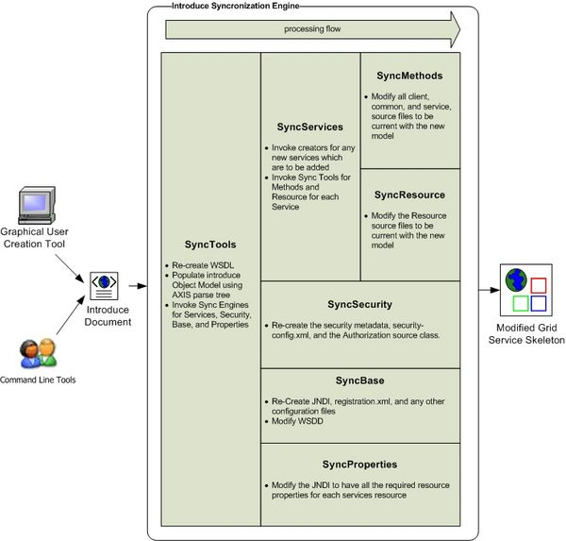
Introduce Synchronization Framework

Service resynchronization is the process by which the source code and configuration generation tools of the Introduce toolkit will analyze the service’s current implementation with that of the desired service description. This process will add, remove, and modify any service methods, resource properties, and service settings which have been added, removed, or modified from the service description. The descriptions and configurations for methods, metadata, and security are those that are generated from the GDE, programmatically or by hand, and that can be validated by the Introduce service schema. The service description is the basis by which the code generation tools add, remove and modify operations, metadata, and change the security configuration of the service by editing the source code, configuration files, and metadata files. This is similar to the way that Axis will use the WSDL to generate the grid stubs of the service. The overall high level process of service resynchronization is illustrated below.
In this process, modified documents created by the GDE are processed using JET templates to create the modified service skeleton. The service synchronizer component manages the service WSDL description. If a service or method has been added or removed, the respective WSDL files must be updated to reflect the changes. Updating the files requires many auto generated code segments. External XML schemas, which describe published data types, must be imported into the respective WSDL files so that the data types can be located and used to generate the required Java beans and SOAP bindings. The WSDL description is basically the Grid layer representation of the Java based service interface. Both the message types, which represent the data types of the input parameters and the return type of a service method, and the complete operation, which reflects the Java based signature of the method being exposed, have to be described in the WSDL file. The synchronization operation automatically keeps this file in sync during the development of services so that the service implementation and the Grid service description represented by the WSDL match up. This ensures that the methods implemented in the Grid service can actually be invoked.

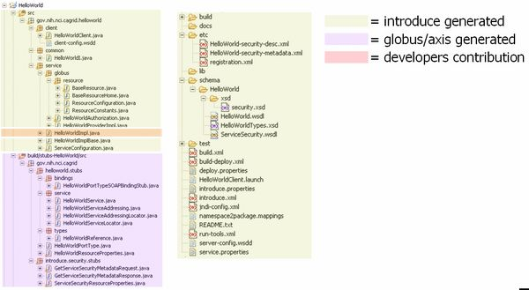Introduce Generated Skeleton

The figure above shows a basic service layout as created by the Introduce Service Creator component. It shows which pieces of this example service are generated by the code generation tools, which pieces are built by the underlying Globus/Axis tools, and which pieces are to be implemented by the service developer.

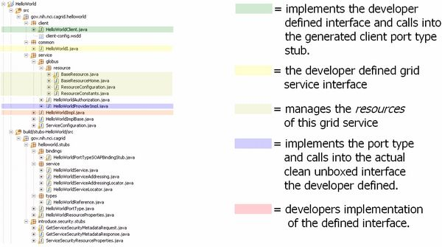Introduce Generated Grid Service Source Code

The figure above describes what some particularly critical source files are generated for in an example service created by the Introduce engine. When a WSDL file is parsed by the Axis engine a PortType interface is created which is the Java representation of the API of the grid service. The Axis generated PortType interface must then be implemented on the service to provide the services implementation. In order to enable the service developer to implement a cleaner, non-documument literal interface, Introduce will automatically create the implementation of this PortType interface (HelloWorldProviderImpl). The Introduced generated implementation of this interface will unbox the document literal calls ot the service and pass them on to the unboxed/clean interface (HelloWorldI) which the user defined. Introduce will generate a stubbed implementation of this interface (HelloWorldImpl) which the user will be responsible for implementing. This class will maintain the services implementation of the methods. This enables the service designer to be shielded from the details of the Axis document literal grid service interface and enable them to implement an interface which is as then originally described. The figure also illustrates the example service’s resource and resource home, which are generated to manage the service resource and the service resource properties, respectively.

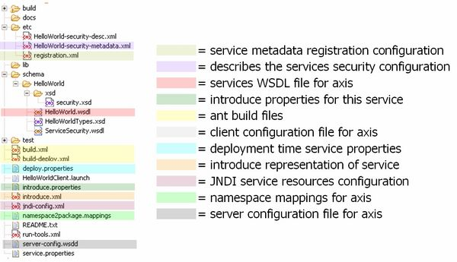
Introduce Generated Configuration File

The figure above shows the use of the different common files of an example Introduce created service. It shows the files used for configuring registration and security for the grid service, as well as those used by Introduce for synchronization, and those used for build and deployment. This example service created by Introduce also contains Eclipse project files so that the service can easily be edited using the Eclipse platform (www.eclipse.org). The service can have an inheritance model by adding methods from another service; possibly along with the implementations of those methods (see Section 0). If a method were imported from another Grid service, the service synchronizer component would also pull in the WSDL description of the method and copy it into the portType of the new service. This enables the service to have a completely protocol compatible implementation of the method.

# $ + K @ Service Deployer
The service deployment features of Introduce currently support deploying Grid services to a Globus or Tomcat container. The deployment framework can easily be extended to provide deployment capability to other Web Service containers. It utilizes the layout of the Grid Archive (GAR) structure to organize and package a deployable service. Once the GAR for a service is generated by the deployment framework, the GAR can be utilized to deploy the service to the appropriate container. The deployment framework also allows for deployment time service properties to be acquired from the application developer or the user deploying the service. These custom service properties allow a service creator to define configurable options that make sense for a particular deployment of the service to have control over. When the service is deployed, the deployer prompts for the desired values, presenting service developer provided defaults. The supplied values are then made available to the service at runtime. For example, if a service implementation accesses a local database, the username and password of the database can be specified as service properties. This allows a very convenient way for those deploying the service to configure it appropriately for their environment, without requiring knowledge of how the grid service implements these configuration points. The deployment process first populates files required in deployment (e.g., the WSDD and JNDI of the service) to specify such values as service deployment path or security configuration file locations. It then gathers the library files required for the service as well as those library files which contain the actual runtime code of the service. All configuration files and service resources are also collected. Finally, a GAR file is generated for this service. Once the GAR file has been generated, it can be handed off to the particular deployment handler for the required container to be used for this deployment.

# $ + K @ Other Features of the Introduce Engine

# $ + K @ Auto-Boxing/Unboxing of Service Operations

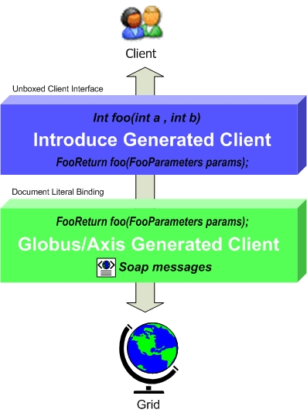
Introduce Generated Client Layers

Grid service code generation and synchronization is one of the most complicated code generation operations in the toolkit. This component has to re-write the basic source code of the service so that the client and the server both agree on the newly modified interface as designed by the service creator. It also has to deal with associating the server side implementation of the service designer’s interface to the actual port type generated by Globus via Axis. The overall process is complicated due to fact that GT/Axis use document literal bindings to create the services portType and bindings to SOAP. For example, if a user describes a new method as shown below: int foo(int bar1, int bar2);
The port type method that will be created for the corresponding Java interface call will look like the one below: FooReturn foo(FooParameters params);
This style is known as document literal binding. This boxing or wrapping of the parameters and the return type of the service method can be confusing to the service user and service developer to deal with, especially since this document literal style is exposed directly through the client API or the service implementation API. Every client using the service will have to box up the parameters to call the operations of the service and un-box the results. Not only will this task be cumbersome for service users, but the document literal interface is not the interface that the service designer intended to be provided to its users. The Introduce toolkit will hide the boxing and un-boxing of methods by providing an interface to the service, which looks exactly as described by the service developer and not as interpreted by Globus via Axis.
In order to do this, the toolkit creates a wrapping layer in the client and service which both implement the clean interface (non document literal). These wrapper layers auto-box and un-box and map the calls from the clean client to the document literal port type client generated by Globus/Axis and visa versa for the service. It is worth noting that the move to document literal binding was made in the GT for interoperability reasons, as the more developer-friendly APIs provided by Introduce, and previously provided by GT, are not standardized and that Introduce created services can still be accessed via the standard document literal interfaces.

# $ + K @ Resource Framework
Introduce provides support for exposing service state and metadata by abstracting away the details of common patterns of use of the WSRF. The WSRF specifications and the GT implementation of these specifications allow the creation of stateful Grid services, whilst remaining compatible with existing Web Service standards. A Grid service’s state (and metadata) is maintained in the Resource represented by the service, as described in the WSRF specification, and is exposed to clients by way of Resource Properties. Introduce allows its users to expose state or metadata of their services by managing the definition, creation, and population of the Resource Properties of a service instance. Upon creating a service, a service developer is able to simply select from a list of common resource usage patterns, and Introduce will manage the complete generation of the necessary backend code and configuration to implement that pattern. Once the resource pattern is defined, a service developer can then select data types they wish to use in order to expose state or metadata of its resources by way of Resource Properties. Developers need only select a data type they wish to expose, and Introduce makes it available as a WSRF standard Resource Property. Developers are able to either programmatically control the values of the property at runtime (as is common for exposed resource state), or supply the initial value from a file at service startup (as is common for exposed metadata). Another powerful feature of Resource Properties is that they can be advertised to, and aggregated at, a remote indexing service – an indexing service can be used by clients and other services to discover services in the Grid environment. GT provides such a service in the form of the Index Service. It acts as the white and yellow pages of the grid, providing resource and service discovery. Introduce allows a service developer to maintain soft-state registration of its resource properties by simply selecting a check box on each property they wish to register. For each such property, it creates all of the necessary source code and configuration changes necessary to periodically register the property with an Index Service, and ensure the most recent value of the property is made available in the Index Service and associated with the service. The combination of these two simple-to-use, yet powerful features, allows a service provider to, for instance, automatically provide and register a description of its service to a central repository when the service is running.

# $ + K @ Compositional Inheritance
Introduce enables the service developer to import methods from other services (i.e., from other port types). This notion is called compositional inheritance. Services under the new WSDL 2.0 specification cannot extend portType definitions. In order to simulate portType extension Introduce implements the ability to copy operation descriptions from other port types and put them in the service’s own description. When using this feature, there are various configuration option the engine must know such as the namespaces of the operations, and whether or not an implementation of the operations are already provided or should be generated and stubbed just as any other Introduce defined operation. In order to be sure that the operation can be correctly imported and copied into the new port type, the WSDL of this operation and any referenced schemas must be brought into this new service and imported. If the operation implementation is not being provided, the synchronization engine must add this operation to the services base interface, and the un-boxing Globus wrapper for this operation must be generated. If the implementation of this operation is being provided, the extra code in the interface, its implementation, and the wrapper do not need to be added. However, the implementation code, in the form of a JAR file, must be brought into the new service, and the operation class must be added to the WSDD of this service.

# $ + K @ Service Contexts
In grid services architecture it is sometimes required that a service not only maintain some extra information about the service but also maintain information (state) which is of particular interest to one particular user. These styles of grid service use cases have driven the requirements for specifying a mechanism for stateful Grid services. Each WSRF service manages its state by creating and manipulating Resources. A Resource can essentially be thought of as an arbitrary state representation, as defined by the service developer. The main restriction is that a given service can only manage a single given resource type. As previously stated in section 0, Introduce supports this mechanism through the Service Context concept. For example, a Data Service may want to define two contexts: the main “Query“ context which provides the ability to query into a backend database, and the secondary “Results Delivery” context which provides the ability to iteratively access query results (similar to a remote cursor). Introduce implements these Service Contexts by creating a WSRF service for each context, and a corresponding Resource type. In this example, the Query Service will have a Resource type that represents the backend database(s), and the Results Delivery Service would have a Resource type that represents query results. In this design, when a client invokes the query operation on the Query Service, the service can query the database and then create an instance of the Results Delivery Service’s Resource. The query operation then returns a pointer, or EndPointReference (EPR), to this Resource. The client is then able to interact with the query results by using the Results Delivery Service’s client, passing in the returned EPR to its constructor. Through its support for multiple Service Contexts, Introduce enables this and other such Resource patterns for stateful grid services. This support is managed by the synchronization component of the Introduce engine. The service description model, created via the GDE or programmatically/hand generated, enables the description of multiple Service Contexts in an Introduce service. Each Introduce service has at least one Service Context (the main service), and can create an arbitrary number of additional Service Contexts to support more complex resource usage patterns, as described above. Each created context has a corresponding source directory containing its own server, client, common, resource, etc. This enables resource properties, operations, and security configurations to be added, removed, and modified for each additional context. Each additional context’s corresponding service and resource are modified, compiled, and deployed with the main service.

# $ + K @ Security
Introduce facilitates the creation and configuration of secure Grid services using the Grid Security Infrastructure (GSI) and allows security to be configured at both the service level and the service method level. Moreover, Security can be enforced on both the client and service sides. Introduce allows service developers to specify the secure communication mechanism(s), in which clients are allowed to communicate with the service. An Introduce generated client can automatically be configured to communicate over the secure communication mechanism specified by the service. In the case where multiple secure communication mechanisms are supported by the service, Introduce will allow the service developer to choose which mechanism the client will use.
Grid security can be complex, and a detailed discussion on it is out of the scope of this document. The Globus documentation (http://www.globus.org/toolkit/docs/4.0/security/) and tutorials (http://gdp.globus.org/gt4-tutorial) provide a good deal of overview and details on the topic. For the most part, Introduce users need not concern themselves with all the details, but should have a basic understanding of what is happening under the hood, and should understand how provide credentials for secure communication with services.
Introduce builds on GSI (Globus Security Infrastructure), and hence uses Public Key Cryptography (PKI). Both services and clients may optionally have credentials (certificates), and authenticate and authorize each other. Services and corresponding clients generated from the Introduce toolkit attempt to automatically configure security appropriately, and this behavior is sufficient for most users, however it can be overridden (either by manually configuring this client “stub” or by overriding the provided configureStubSecurity method). Introduce clients will attempt to communicate anonymously with services, as long as the service allows it (as advertised via its ServiceSecurityMetadata). If a service does not allow anonymous communication, client credentials must be used to authenticate with the service. Introduce created clients will attempt to use the default Globus credentials if present (via a grid-proxy-init, or logging in with Dorian and specifying to set the credentials as the defaults). Alternatively, Introduce created clients have constructors which take credentials (GlobusCredential), and also have an appropriate setter method (setProxy), which can be used after construction. Some services have different security requirements for different operations, so it may not be immediately obvious whether or not credentials are required. As such, when communicating with secure services it is good practice to have a valid grid proxy set as default, or specified on the client; the client APIs will only use it if necessary.

# $ + K @ Introduce Extension Framework

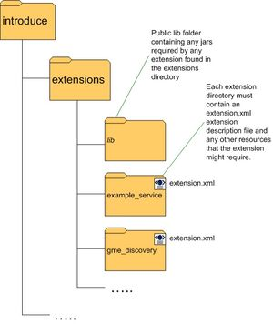

The Introduce Extension framework currently consists of two styles of extensions; service and data type discovery. These extensions are implemented by service or data type discovery components which add custom functionality to the Introduce framework. Extensions are added to the toolkit in the form of extension plug-ins, which the toolkit will then be able to expose to the user. To provide an extension to Introduce, the extension provider must implement or extend the appropriate classes for the style of extension they wish to provide, and must fill out the extension XML configuration document. Once this extension is implemented and configured it can be placed in the extensions directory of Introduce. This directory has a common library (lib) area which enables it to avoid using custom class loaders for each extension.

# $ + K @ Service Extensions

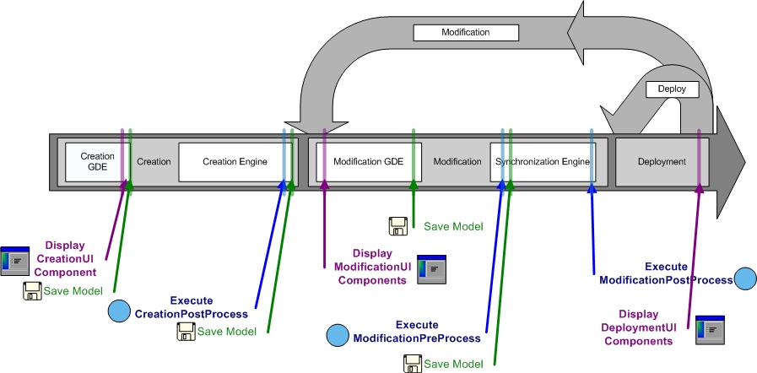
Introduce Service Extension Execution Timing

A service extension is one which enables customization of the service creation and modification processes. These extensions can add required operations, service resources or resource properties, or security settings, for example. The service extension allows the user to provide custom code that will be executed at different times throughout the creation and modification processes of service development. A service extension consists of 6 main extension components that can be implemented and provided by the developer: CreationPostProcess, CreationUIDialog, CodegenPreProcess, CodegenPostProcess, ServiceModificationUIPanel, and ServiceDeploymentUIPanel. Each of these extension components have a predefined class and interface that must be extended or implemented. Three of the service extension components, CreationUIDialog, ServiceModificationUIPanel, and ServiceDeploymentUIPanel are graphical components provided to the Introduce GDE, and the other three are Introduce engine plug-ins.
Each service extension component is invoked at a specific point in the creation or modification steps. These different time points for each component execution are critical for making certain changes. For example, when the CreationUIDialog component for a particular extension is executed, the service has been created as a blank service and no modification or synchronization has been done on the service. At this point the CreationUIDialog might prompt the user for particular information about the creation processes. The CreationUI component would only be executed/displayed once for any given service and its non graphical component, the CreationPostProcess, will also only be ran one time after the service has been created and before it will ever be modified. The modification components are ran every time a service is saved and synchronized. The graphical modification component is always available in the Introduce GDE during modification time. The two service modification engine components, ModificationPreProcess and ModificationPostProcess are executed respectively, before and after the synchronization process is executed. This enables ModificationPreProcess to do such things as modify the ServiceDesription, represented by the Introduce service description file, or the WSDL files of the services. The ModificationPostProcess, on the other hand, might move in required files, or populated stubbed methods, etc.
Below is an example extension.xml for a service extension. You can see that this extension is a SERVICE type extension and that it is version 1.1 of the extension. This version is the version of the extension and not of the Introduce that it works with. You can also see that this extension is called data and is displayed as Data Service. Three is also a list of the extension components and the classes that will be used to invoke them. Each component style must extend or implement from a specific base class or interface in introduce. Each of these is optional, however, this extension is using all components of the service extension framework. This extension also has some configuration propreties; one for the address of the Global Model Exchange and one for the address of the caDSR. This extension also provides an upgrader. It is showing that this upgrader can be ran to move any service with a data extension version of null to be able to be managed by this version of the extension which is 1.1. This will be used by the service migration framework when upgrading service from older versions of introduce or extension to newer versions available.
<ns1:ExtensionDescription extensionType="SERVICE" version="1.1" xmlns:ns1="gme://gov.nih.nci.cagrid.introduce/1/Extension" >
<ns1:ServiceExtensionDescription displayName="Data Service" name="data">
<ns1:CreationPostProcessor>gov.nih.nci.cagrid.data.creation.DataServiceQueryOperationProviderCreator</ns1:CreationPostProcessor>
<ns1:CreationUIDialog>gov.nih.nci.cagrid.data.ui.creation.DataServiceCreationDialog</ns1:CreationUIDialog>
<ns1:CodegenPreProcessor>gov.nih.nci.cagrid.data.codegen.DataServiceCodegenPreProcessor</ns1:CodegenPreProcessor>
<ns1:CodegenPostProcessor>gov.nih.nci.cagrid.data.codegen.DataServiceOperationProviderCodegenPostProcessor</ns1:CodegenPostProcessor>
<ns1:ServiceModificationUIPanel>gov.nih.nci.cagrid.data.ui.DataServiceModificationPanel</ns1:ServiceModificationUIPanel>
<ns1:ServiceDeploymentUIPanel>gov.nih.nci.cagrid.data.ui.auditors.AuditorDeploymentConfigPanel</ns1:ServiceDeploymentUIPanel>
<ns1:Properties>
<ns1:Property makeGlobal="true" type="SERVICE_URL" key="Global Model Exchange URL" value="http://cagrid01.bmi.ohio-state.edu:8080/wsrf/services/cagrid/GlobalModelExchange"/>
<ns1:Property makeGlobal="true" type="SERVICE_URL" key="Cancer Data Standards Repository (caDSR) URL" value="http://cagrid05.bmi.ohio-state.edu:8080/wsrf/services/cagrid/CaDSRService"/>
</ns1:Properties>
</ns1:ServiceExtensionDescription>
<ns1:UpgradesDescription>
<ns1:UpgradeDescription upgradeClass="gov.nih.nci.cagrid.data.upgrades.DataServiceUpgrade1pt0to1pt1" toVersion="1.1"/>
</ns1:UpgradesDescription>
</ns1:ExtensionDescription>

# $ + K @ Data Type Discovery Extensions
These extensions are Introduce GDE components that will be available at the service modification step. These components are intended to be able to provide custom data type discovery for the service developer. The custom data type discovery component must allow the developer to browse types and chose to use those types in the developed service. This means that the data type discovery extension will have to be able to copy the schemas which represent the data types down to the service’s schema directory and produce a NamespaceType object for the namespace of each separate data type. This enables the grid service to utilize the schemas for describing the data types which are used in the WSDL messages traveling in and out of the created service. In addition to default plug-ins, domain specific plug-ins can be installed in Introduce. For example, in the caBIG environment, a caDSR discovery plug-in is provided with Introduce. This plug-in allows service developers to locate and use data types registered in the cancer Data Standards Repository (caDSR), which is a curated repository of common data elements used in caBIG.

# $ + K @ Introduce Developers

# $ + K @ Creating an Update Site
Providing an update site is one way to enable Introduce users to be able to obtain your extensions or modified versions of Introduce. An update site is simply an address which points to a web folder that contains a software.xml file. The software.xml file describes the packages available at the particular update site and the release zip which contains those packages.
<ns1:Software
xmlns:ns1="gme://gov.nih.nci.cagrid.introduce/1/Software">
<ns1:Introduce version="1.0" zipFileURL="http://bmi.osu.edu/~hastings/introduce/software/introduce_1-0.zip" />
<ns1:Introduce version="1.1" zipFileURL="http://bmi.osu.edu/~hastings/introduce/software/introduce_1-1.zip" />
<ns1:Extension version="1.1" compatibleIntroduceVersions="1.1" displayName="caGrid Data Service Extension" name="data" zipFileURL="http://bmi.osu.edu/~hastings/introduce/software/data.zip"/>
<ns1:Extension version="1.1" compatibleIntroduceVersions="1.1" displayName="caGrid Bulk Data Transfer" name="bdt" zipFileURL="http://bmi.osu.edu/~hastings/introduce/software/bdt.zip"/>
<ns1:Extension version="1.1" compatibleIntroduceVersions="1.0,1.1" displayName="caGrid Extensions Package" name="cabigextensions" zipFileURL="http://bmi.osu.edu/~hastings/introduce/software/cabigextensions.zip"/>
<ns1:Extension version="1.1" compatibleIntroduceVersions="1.0,1.1" displayName="caGrid Cancer Data Standards Repository" name="cadsr" zipFileURL="http://bmi.osu.edu/~hastings/introduce/software/cadsr.zip"/>
</ns1:Software>

# $ + K @ Creating an Extension
In order to bundle up an extension so that it can be deployed to introduce the extension directory structure must be laid out in the following way:
- <top of zip file>
  - lib (any jars required to "execute" your extension
  - <your extension name (not display name)>
    - extension.xml (the extension.xml describing your extension)
Once this layout is complete the next step is to create the extension zip file. In order to do this all that is required is to create a zip file with no top level directory and the lib dir and <your extension name> dir as the only directories in the zip. So for instance, if the zip file were extracted there would be the two directories with no top level directory. Now that you have bundled up your extension so that it can be delivered and used by Introduce.

# Overview
$ Overview
+ MAIN:0
K Toolkit;Service Creator;Introduce Engine;Tomcat;Resource;Overview;Introduce Extension Framework;Introduce;Graphical Development Environment;Types;Grid;GDE;Application-specific;Mobius;Globus;Deploy;Service/method;Prerequisites;Namespace;Deployment;Properties;Introduce Overall;Service Modification;Introduce toolkit;Security;Modification;Introduce Graphical Development Environment;Creation;Service Synchronizer;Introduce:Grid;GME;provided;Grid:Introduce;Basic Service Structure;Service Deployer;Service Creation Process;Custom;Contexts;Service Creation;Operations
@ Status|0|||524288||||||
# Software_Prerequisites
$ Software Prerequisites
+ MAIN:0
K Globus;Prerequisites;Www.globus.org;Www.ant.apache.org;Globus Toolkit Version 4.0.3;Software Prerequisites;Apache Ant 1.6.5;Java 1.5;Www.java.sun.com
@ Status|0|||524288||||||
# Changes_from_Introduce_1_0
$ Changes from Introduce 1.0
+ MAIN:0
K Policy Decision Point;perform.index.service.registration;PDP/authz;PDP;index.service.index.refresh_milliseconds;Changes from Introduce 1.0;Changes;index.service.registration.refresh_seconds
@ Status|0|||524288||||||
# Introduce_Graphical_Development_Environment
$ Introduce Graphical Development Environment
+ MAIN:0
K Resource;Types;Metadata;GDE;Deploy;Security;Introduce Graphical Development Environment;provided;Introduce GDE;Custom;Operations
@ Status|0|||524288||||||
# Service_Creation
$ Service Creation
+ MAIN:0
K Java;Introduce:selected;Introduce;WSDL;Types;Selected:Introduce;Defining:WSDL;Service Name;WSDL:defining;Selected;Namespace;Deployment;Service extension;Resources/resource properties;Properties;Security;Modification;Creation;Service Creation Component;provided;Introduce GDE;Creation Directory;Responsibilities;Package Name;Defining;Custom;Service Creation;Operations
@ Status|0|||524288||||||
# Service_Modification
$ Service Modification
+ MAIN:0
K Namespaces;Modify Service;Security setting;Resource;Use;Namespaces:use;Introduce;Types;Metadata;Use:namespaces;Properties;Service Modification;Security;Modification;Add/remove;Contexts;Operations
@ Status|0|||524288||||||
# Data_Types
$ Data Types
+ MAIN:0
K Discovery Extension;Deserializer;Data Types;Resource;Java;Graphical;Factory;Serialization/deserialization factories;Introduce;Types;Serializer;Mobius;Globus;File System;Provides access;Namespace;Extensions;Select Type;Properties;Service Modification;Modification;GME;Service Modification Environment;Service Modification Component;provided;Introduce GDE;Axis;WSDL file
@ Status|0|||524288||||||
# Importing_Data_Types
$ Importing Data Types
+ MAIN:0
K Namespaces;Namespace:selects;GME:namespace;Import Data Types Panel;GME:namespaces;Globus Tooolkit;Data Types;Configuration menu;Java;Service-to-service interoperability;Name:Java Beans;Introduce;Globus Data Types;Global Model Exchange;WSDL;Types;Java Beans;Importing:Data;Grid;GDE;Called:namespace;Application-specific;Mobius;Globus Data Types Importing;Globus;File System;Selected;Namespace:called;Namespace;Schema/<service;Importing Data Types;Data Type Importing;Introduce toolkit;Data;Name;Globus toolkit;Creation;Java Beans:name;GME;Data:Importing;Changes;Called;System;Schema/<service_name;Pluggable;Filesystem;Namespaces:GME;Namespace:GME;Importing;Selected:namespace;Service Creation;Operations
@ Status|0|||524288||||||
# Re_Importing_a_Modified_Data_Type
$ Re-Importing a Modified Data Type
+ MAIN:0
K Re-Importing a Modified Data Type;Data Types;Introduce;Types;Re-Importing;Modified:Re-Importing;Modified;Namespace Type Replacement Policy;Re-Importing:Modified;Configuration-->Preferences
@ Status|0|||524288||||||
# Using_Custom_or_Pre_Existing_Java_Beans
$ Using Custom or Pre-Existing Java Beans
+ MAIN:0
K Using Custom or Pre-Existing Java Beans;Data Types;Using Custom;Java;Factory;Introduce;Types;Pre-Existing Java Beans;Java Beans;Having;Globus;Namespace;Deserializer factory;Introduce:having;Type mapping;Customize Bean;Classname;Having:Introduce;Custom;Serializer factory
@ Status|0|||524288||||||
# Operations
$ Operations
+ MAIN:0
K Extends;BaseFaultType;WSRF;Checkbox;Introduce;Types;GDE;BaseFaultType:extends;WSRF BaseFaultType;Extends:BaseFaultType;Service Modification;Security;Modification;Operations;Introduce GDE Method Modification Component
@ Status|0|||524288||||||
# Using_a_Pre_Existing_Operation_Implementation
$ Using a Pre-Existing Operation Implementation
+ MAIN:0
K Using;Checkbox;Provider;Pre-Existing Operation Implementation:Using;Pre-Existing Operation Implementation;Introduce;WSDL;Globus;Class;Using a Pre-Existing Operation Implementation;provided;Using:Pre-Existing Operation Implementation;Operations;Documentation on Operation Providers
@ Status|0|||524288||||||
# Importing_Operations
$ Importing Operations
+ MAIN:0
K Schema<service;XSD s;Introduce;WSDL;Types;Selected:Introduce;Corresponding;XSD;Importing Operations;Selected;Schema/<service;Operation Importing;Client;XSD s:corresponding;Corresponding:XSD s;Introduce:select;Importing;WSDL file;Operations
@ Status|0|||524288||||||
# Resource_Properties
$ Resource Properties
+ MAIN:0
K Data Types;Resource;Use:metadata;Use;Types;Metadata;GDE;Metadata list;Properties;Service Modification;Resource Properties;Metadata:use
@ Status|0|||524288||||||
# Service_Properties
$ Service Properties
+ MAIN:0
K String:foo;String;GetConfiguration;Seee;GetFoo;Foo:string;Foo;GDE;String:getFoo;SetFoo;Deployment;Properties;Service Modification;Package>.service.ServiceConfiguration.java;ServiceConfiguration;Changes;And/or;GetFoo:string;Service Properties;Operations
@ Status|0|||524288||||||
# Security
$ Security
+ MAIN:0
K Security Configuration Panel;Secure Conversation;Secure Communication;Resource;Integrity;Service Contexts;Globus;PDP;Transport Level Security;GSI;Security;Secure Credentials;Privacy;Custom;Operations;GridGrouper and/or Common Security Model
@ Status|0|||524288||||||
# Service_Contexts
$ Service Contexts
+ MAIN:0
K WSRF-implementation;WSRF;Operations needed;Resource;Service Contexts;Types;Statefull Grid;Metadata;GDE;Globus;Publishing;Metadata:publishing;Introduce GDE Service;Implementations;Properties;Statefull;Service Modification;Client;Publishing:metadata;Iteratively;Modification;Globus toolkit;Modification Component;Contexts;Operations
@ Status|0|||524288||||||
# Utilizing_the_Factory_Pattern
$ Utilizing the Factory Pattern
+ MAIN:0
K Utilizing the Factory Pattern;CounterContextImpl;Factory Pattern:Utilizing;Utilizing:Grid Service;Resource;Factory;CounterContextImplBase;Java.rmi.RemoteException;Implement;EPR;E.printStackTrace;Counter;Utilizing:Factory Pattern;Types;Factory Pattern;Pattern;GetResourceHome;TODO;IMPLEMENT AND DOCUMENT ME;GetAddressedResource;CurrentCounter;Grid Service;Statefull;Resource Properties;Implement:incrementCounter;GetIntValue;Client;SetIntValue;RemoteException;Introduce toolkit;Int currentCounter;CounterContextServiceImpl.java;IncrementCounter:implement;Exception e;Example.counter.context.service;Counter Grid Service;Counter Context Grid Service;IncrementCounter;Utilizing;Contexts;Operations;Grid Service:Utilizing;EndPointReference
@ Status|0|||524288||||||
# Implementing_the_Service
$ Implementing the Service
+ MAIN:0
K Implementing the Service;Implement:Service;Java.math.BigInteger b;Introduce;Implementing;Implement;Autogenerated;TODO;Java.math.BigInteger;Hte;Deployment;Invokation;Service;RemoteException;Package>.service.<service name>Impl.java;Int;Service:Implementing;Introduce GDE;B;Operations
@ Status|0|||524288||||||
# Deployment
$ Deployment
+ MAIN:0
K Toolkit;Introduce;Grid;GDE;Globus;Deploy;Deployment;Properties;Tomcat Grid;Service Deployer;Introduce GDE Service Deployment Component
@ Status|0|||524288||||||
# Using_the_Client
$ Using the Client
+ MAIN:0
K Using;String;E;Resource;Epr;EndpointReferenceType epr;Types;HelloWorldClient;Client API;Client.echo;Service Operations;Localhost;GlobusCredential;API;Using the Client;Client handle;Auto-boxing/Unboxing;String:url;E.getMessage;Client;Url;Security;8080/wsrf/services/HelloWorld;Url:String;Exception e;HelloWorldClient client;Using:Client;System.out.println;Client:Using;HelloWorld;Operations
@ Status|0|||524288||||||
# Software_Updates
$ Software Updates
+ MAIN:0
K Updates button;Help menu;Check:Updates button;GDE;Check;Updates button:Check;Software Updates;Updates
@ Status|0|||524288||||||
# Service_Migration
$ Service Migration
+ MAIN:0
K Introduce;Migration;Changes;Service Migration;Custom
@ Status|0|||524288||||||
# Introduce_Engine
$ Introduce Engine
+ MAIN:0
K Introduce Engine;Deployment;Modification;provided;Service Creation
@ Status|0|||524288||||||
# Service_Creator
$ Service Creator
+ MAIN:0
K Service Creator;Grid:generate;Eclipse Modeling Framework;Resource;Part;Generate;Form;Files;Introduce;Generate:Grid;Metadata;JET;Grid;Client API;Form:Web Service;Deploy;Java Naming:form;IDE;Deployment;Web Service;Web Service:form;Properties;Java Emitter Templates;Files:IDE;Descriptor;Creation Framework;Www.eclipse.org/emf;Resource Properties;JNDI;Directory Interface;Client;Part:Eclipse Modeling Framework;Security;Creation;Eclipse Modeling Framework:part;Www.eclipse.org;WSDD;GT;Form:Java Naming;Custom Java;Java Naming;IDE:files;Custom;Operations;Eclipse
@ Status|0|||524288||||||
# Service_Synchronizer
$ Service Synchronizer
+ MAIN:0
K Service Creator;Resynchronization;Introduce Engine;HelloWorldProviderImpl;Service resynchronization;Underlying:Globus/Axis;Resource;Java;Introduce Synchronization Framework;Use;Ot;Introduce;HelloWorldImpl;External XML;WSDL;Types;Metadata;JET;Grid;GDE;Introduce Generated Configuration File;Implementations;Deployment;API;Properties;Non-documument;Introduce Generated Grid Service Source Code;Unboxed/clean;Globus/Axis:underlying;Synchronization:Introduce;Section;Reflects;Java:reflects;Introduce toolkit;WSDL:use;Synchronization;SOAP;Security;Introduce Generated Skeleton;Introduce:synchronization;Updates;Underlying;Synchronization operation;Service Synchronizer;Globus/Axis;Changes;Www.eclipse.org;provided;PortType;Use:WSDL;Axis;HelloWorldI;WSDL file;Reflects:Java;Operations;Eclipse
@ Status|0|||524288||||||
# Service_Deployer
$ Service Deployer
+ MAIN:0
K Service Creator;Tomcat;Resource;Introduce;GAR;Globus;Deploy;Deployment;Web Service;Properties;Properties allow;JNDI;Deploying Grid;Deployer;Username;Security;WSDD;provided;Grid Archive;Service Deployer;GAR file;Custom
@ Status|0|||524288||||||
# Other_Features_of_the_Introduce_Engine
$ Other Features of the Introduce Engine
+ MAIN:0
K Introduce Engine;Other Features of the Introduce Engine;Other Features
@ Status|0|||524288||||||
# Auto_Boxing_Unboxing_of_Service_Operations
$ Auto-Boxing/Unboxing of Service Operations
+ MAIN:0
K Toolkit;Service Creator;Java;FooParameters params;Auto-boxing/Unboxing:Service Operations;Introduce Generated Client Layers;Introduce;Types;Client API;Globus;Service Operations;FooReturn foo;API;Int foo;Auto-boxing/Unboxing;GT/Axis;Client;Introduce toolkit;GT:interoperability;Auto-Boxing/Unboxing of Service Operations;Synchronization;SOAP;Interoperability:GT;APIs provided;Service Operations:Auto-Boxing/Unboxing;Globus/Axis;provided;PortType;Int bar1;GT;Int bar2;Axis;Interoperability;Operations
@ Status|0|||524288||||||
# Resource_Framework
$ Resource Framework
+ MAIN:0
K Web Service:existing;WSRF;Data Types;Resource;Form;Existing;Resource Framework;Introduce;Types;Metadata;Index Service;Grid;Form:Index Service;Web Service;Properties;Resource Properties;Provides support;Client;Stateful Grid;Index Service:form;Creation;GT provides;Existing:Web Service;Changes;provided;GT;Backend
@ Status|0|||524288||||||
# Compositional_Inheritance
$ Compositional Inheritance
+ MAIN:0
K Namespaces;Form;WSDL 2.0;Introduce;WSDL;Types;Namespaces:operations;Globus;Synchronization;WSDD;provided;PortType;JAR file:form;Form:JAR file;Compositional Inheritance;Operations:namespaces;Operations;JAR file
@ Status|0|||524288||||||
# Service_Contexts_1
$ Service Contexts
+ MAIN:0
K Introduce Engine;Data Service;WSRF;Stateful;Resource;Service Contexts;Results Delivery Service;Query Service;Introduce;EPR;Types;Query;GDE;Represents:backend;Deploy;Results Delivery Service s Resource;Properties;Backend:represents;Service;Represents;Client;Stateful Grid;Iteratively;Synchronization;Security;Context s corresponding;provided;Programmatically/hand;S;Results Delivery Service s client;Results Delivery;Contexts;Backend;Operations;EndPointReference
@ Status|0|||524288||||||
# Security_1
$ Security
+ MAIN:0
K Www.globus.org/toolkit/docs/4.0/security;Overview;Public Key Cryptography;Introduce;Grid Security Infrastructure;Grid;Client API;Security Infrastructure;Globus;GlobusCredential;SetProxy;ServiceSecurityMetadata;Gdp.globus.org/gt4-tutorial;Client;PKI;Introduce toolkit;GSI;Grid-proxy-init;Security;Creation;provided;Dorian;S;Operations;ConfigureStubSecurity
@ Status|0|||524288||||||
# Introduce_Extension_Framework
$ Introduce Extension Framework
+ MAIN:0
K Toolkit;Data Types;XML;Introduce Extension Framework;Introduce;provided;Custom
@ Status|0|||524288||||||
# Service_Extensions
$ Service Extensions
+ MAIN:0
K UpgradesDescription;ServiceDeploymentUIPanel;Introduce Engine;Data Service;Cancer Data Standards Repository;ServiceExtensionDescription displayName;ServiceExtensionDescription;Gov.nih.nci.cagrid.data.upgrades.DataServiceUpgrade1pt0to1pt1;CodegenPostProcess;Resource;CreationUI;CodegenPreProcessor>gov.nih.nci.cagrid.data.codegen.DataServiceCodegenPreProcessor</ns1;CodegenPostProcessor>gov.nih.nci.cagrid.data.codegen.DataServiceOperationProviderCodegenPostProcessor</ns1;Property makeGlobal;Introduce;Global Model Exchange;Cagrid01.bmi.ohio-state.edu;CaDSR;WSDL;Types;ToVersion;Service Extension Execution Timing;Extension.xml;CreationPostProcessor>gov.nih.nci.cagrid.data.creation.DataServiceQueryOperationProviderCreator</ns1;CreationPostProcess;Address:Global Model Exchange;ServiceModificationUIPanel>gov.nih.nci.cagrid.data.ui.DataServiceModificationPanel</ns1;Global Model Exchange:address;Executed/displayed;CreationUIDialog;ServiceModificationUIPanel;Service extension allows;CodegenPostProcessor;CaDSR:address;Xmlns;Service extension;Properties;Point:CreationUIDialog;Modified;Global Model Exchange URL;ExtensionDescription;CreationUIDialog>gov.nih.nci.cagrid.data.ui.creation.DataServiceCreationDialog</ns1;8080/wsrf/services/cagrid/GlobalModelExchange;Upgrader;ServiceDeploymentUIPanel>gov.nih.nci.cagrid.data.ui.auditors.AuditorDeploymentConfigPanel</ns1;SERVICE_URL;Service Modification;SERVICE;CodegenPreProcess;ServiceDesription:modify;ModificationPreProcess;CodegenPreProcessor;URL;Synchronization;Security;Modified:ServiceDesription;Modification;Gov.nih.nci.cagrid.introduce/1/Extension;CreationPostProcessor;Creation;8080/wsrf/services/cagrid/CaDSRService;Point;Ns1;Gme;CreationUIDialog:point;Changes;Service Migration;provided;ModificationPostProcess;Introduce GDE;Cagrid05.bmi.ohio-state.edu;Service Extensions;Custom;Address;UpgradeDescription upgradeClass;ServiceDesription;SERVICE type;Service Creation;Propreties;Operations;ExtensionDescription extensionType;Address:caDSR
@ Status|0|||524288||||||
# Data_Type_Discovery_Extensions
$ Data Type Discovery Extensions
+ MAIN:0
K CaBIG;NamespaceType;Data Types;Produce;Introduce;CaDSR;WSDL;Types;NamespaceType:produce;Produce:NamespaceType;Namespace;Data Type Discovery Extensions;Service Modification;Curated;Data Standards Repository;provided;Introduce GDE;Custom
@ Status|0|||524288||||||
# Introduce_Developers
$ Introduce Developers
+ MAIN:0
K Introduce Developers
@ Status|0|||0||||||
# Creating_an_Update_Site
$ Creating an Update Site
+ MAIN:0
K Cadsr;Creating:Update Site;Software.xml file;Introduce;CaGrid Extensions Package;Cabigextensions;Bmi.osu.edu/~hastings/introduce/software/bdt.zip;Creating an Update Site;Contains:software.xml file;Creating;Xmlns;Gov.nih.nci.cagrid.introduce/1/Software;Bmi.osu.edu/~hastings/introduce/software/introduce_1-0.zip;Bmi.osu.edu/~hastings/introduce/software/data.zip;Software.xml file:contains;Bmi.osu.edu/~hastings/introduce/software/introduce_1-1.zip;Bmi.osu.edu/~hastings/introduce/software/cadsr.zip;Contains;CaGrid Cancer Data Standards Repository;Updates;Update Site;Ns1;Gme;Update Site:Creating;provided;ZipFileURL;DisplayName;Bdt;Service Extensions;CompatibleIntroduceVersions;CaGrid Data;CaGrid Bulk Data Transfer;Bmi.osu.edu/~hastings/introduce/software/cabigextensions.zip
@ Status|0|||524288||||||
# Creating_an_Extension
$ Creating an Extension
+ MAIN:0
K Creating an Extension;Introduce;Extension.xml;Deploy;Creating;Extensions;Creating:Extension;Dir;Extensions:Creating
@ Status|0|||524288||||||

