Class Model

The logical model is made up of the Domain Model - a high level model of business objects and relationships between objects suitable for analysing the business process, and the class model - a rigorous model of classes and their inter-relationships, suitable for building a software product.

Logical Model
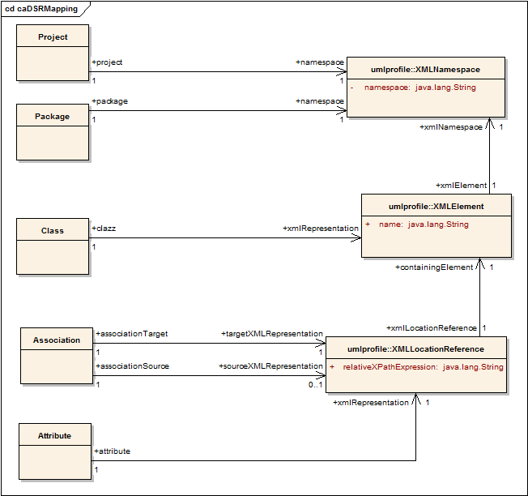Figure 1 : caDSRMapping

Association
Type: public Class
Status: Proposed. Version 1.0. Phase 1.0.
Package: Logical Model
Details: Created on 5/19/2006 11:51:46 AM. Modified on 5/19/2006 1:52:58 PM.

Represents a UML association between Source Class and Target Class. The XML representation (within the Source Object's XML) of the target Object or Colleciton of Objects is pointed to by the targetXMLRepresentation.
If the association is bi-directional, the corresponding representation (within the Target Object's XML) of the source Object or Collection of Objects is pointed to by the sourceXMLRepresentation

Connections
- Association link to class XMLLocationReference<umlprofile>
- Association link to class XMLLocationReference<umlprofile>

Attribute
Type: public Class
Status: Proposed. Version 1.0. Phase 1.0.
Package: Logical Model
Details: Created on 5/19/2006 11:51:19 AM. Modified on 5/19/2006 1:52:28 PM.

Represents a specific UML attribute. Its corresponding XML representation (within the context of the XML representation of a specific Class) is defined by the xmlRepresentation.

Connections
- Association link to class XMLLocationReference<umlprofile>

Class
Type: public Class
Status: Proposed. Version 1.0. Phase 1.0.
Package: Logical Model
Details: Created on 5/19/2006 11:50:07 AM. Modified on 5/19/2006 1:53:28 PM.

Represents a specific UML Class. If a class is modified in anyway during resuse, it should be represented by a different one of these. If it is resused completely in multiple projects, there should only be one of these. Its XML representation is defined by the associated xmlRepresentation.

Connections
- Association link to class XMLElement<umlprofile>

Package
Type: public Class
Status: Proposed. Version 1.0. Phase 1.0.
Package: Logical Model
Details: Created on 5/19/2006 11:49:39 AM. Modified on 5/19/2006 1:54:55 PM.

Represents a specific UML package. Each package is required to link to a unique XML schema, as defined by the associated namespace. The XML Schema will either define the types (of its contained Classes) locally, or simply import other XSD, or a combination of both.

Connections
- Association link to class XMLNamespace<umlprofile>

Project
Type: public Class
Status: Proposed. Version 1.0. Phase 1.0.
Package: Logical Model
Details: Created on 5/19/2006 11:49:31 AM. Modified on 5/19/2006 1:09:03 PM.

Represents a specific UML project. Each project is required to link to a unique XML schema, as defined by the associated namespace. The XML Schema will either define the types (of its contained Classes) locally, or simply import other XSD (such as those of its contained Packages), or a combination of both.

Connections
- Association link to class XMLNamespace<umlprofile>

umlprofile::XMLElement
Type: public Class
Status: Proposed. Version 1.0. Phase 1.0.
Package: umlprofile
Details: Created on 5/19/2006 11:56:32 AM. Modified on 5/19/2006 1:47:16 PM.

Represents an XML QName (namespace qualified Element). It should have a global element definition in the XML Schema for the associated Namespace.

Connections
- Association link from class Class <Logical Model>
- Association link from class XMLLocationReference
- Association link to class XMLNamespace

umlprofile::XMLElement Attributes
Attribute | Type | Notes
name | public :  java.lang.String

umlprofile::XMLLocationReference
Type: public Class
Status: Proposed. Version 1.0. Phase 1.0.
Package: umlprofile
Details: Created on 5/19/2006 12:18:27 PM. Modified on 5/19/2006 1:51:16 PM.

Defines a specific location within an XMLElement. The contained XPath expression should be interpreted as a pointer relative to the associated XMLElement. The expression should be namespace unaware, and in the event namespace differentiation is required, the XPath operator "namespace-uri()" should be used as a predicate to specify the desired namespace.

Connections
- Association link from class Association <Logical Model>
- Association link from class Attribute <Logical Model>
- Association link from class Association <Logical Model>
- Association link to class XMLElement

umlprofile::XMLLocationReference Attributes
Attribute | Type | Notes
relativeXPathExpression | public :  java.lang.String

umlprofile::XMLNamespace
Type: public Class
Status: Proposed. Version 1.0. Phase 1.0.
Package: umlprofile
Details: Created on 5/19/2006 11:56:19 AM. Modified on 5/19/2006 1:46:28 PM.

Represents an XML namespace.
It should have a corresponding XML Schema in GME.

Connections
- Association link from class Package <Logical Model>
- Association link from class Project <Logical Model>
- Association link from class XMLElement

umlprofile::XMLNamespace Attributes
Attribute | Type | Notes
namespace | private :  java.lang.String

