Federated Query Processor Usage Overview
The caGrid Federated Query Infrastructure provides a mechanism to perform basic distributed aggregations and joins of queries over multiple data services. As caGrid data services all use a uniform query language, CQL, the Federated Query Infrastructure can be used to express queries over any combination of caGrid data services. Federated queries are expressed with a query language, DCQL, which is an extension to CQL to express such concepts as joins, aggregations, and target services. The infrastructure is composed of a core engine and grid services which provide access to and management of the use of the core engine.

DCQL, the language used to express federated queries, is an extension to CQL, the language used to express single data service queries. Both CQL and DCQL use a declarative approach to describe the desired data by identifying the nature of the instance data with respect to its containing UML information model. That is, a query can be seen as identifying a class in a UML model, and restricting its instances to those which meet criteria defined over that class’s UML attributes and UML associations.
The primary additions to CQL, which DCQL provides, are the introduction of the ability to specify multiple target services (aggregations), and the ability to specify object restrictions through relationships to Objects on remote data services (joins). The other primary difference between the languages is that CQL is context dependent, meaning the language must be interpreted against the service receiving the query, and DCQL itself specifies the context of the queries (by identifying the target services). As such, services accepting DCQL (such as the FQP service), generally don’t expose any local data. Details on DCQL can be found in the Federated Query Processor design document.

An example DCQL query, represented in XML, is shown below in Figure 1. In this fictitious example, a PersonRegistry Data Service is joined with a StudyRegistry Data Service. The query specifies Persons in the PersonRegistry should be returned which have an “ssn” that is equal to that of a Participant’s “patientSSN” and the Participant should have an “age” greater than 18. The specification of the target service can be seen on line 18 in the example (in this case only one service is targeted, though may could have been listed). Additionally, the “join” is specified starting on line 6, wherein the second target service is identified, and the join condition is defined. The join condition creates a link between the containing Object (in this case, Person), and an Object (in this case Participant, as defined on line 10) in the second target service. The condition specifies a predicate to be evaluated against an attribute in each of the two linked Objects (in this case Person.ssn and Participant.patientSSN). It is worth noting that as DCQL is a recursive language, the ForeignObject defined on line 10 could have also specified a join to a third Data Service, or other more complex criteria.

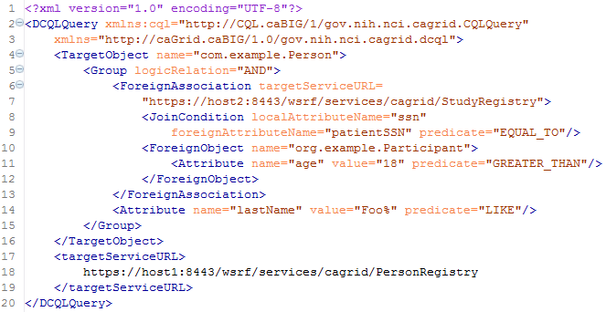
Figure 1 Example DCQL Query

The Federated Query Engine is a simple but powerful design. The main functionality of the engine is to process a DCQL query by converting it into regular CQL queries to the targeted data services, appropriately aggregating results. As such, all of the actual “joining” of data is offloaded to the remote data services. This allows the engine to be reused as a client API as no databases or complex service infrastructure is needed; it’s simply a client-side querying tool. The engine requires no special support from data services. Each service which is contacted to satisfy the distributed query is only sent one or more standard, but potentially complex, CQL queries. It is possible to construct a DCQL query which is essentially a standard CQL query, with the addition of specifying one or more target data services. In this case, the engine simply “forwards” that query on to the targeted services, and aggregates their results. Details on the implementation and query processing logic of the engine can be found in the Federated Query Processor design document.

The Federated Query Processing Infrastructure contains three main client-facing components: an API implementing the business logic of federated query support, a grid service providing remote access to that engine, and a grid service for managing status and results for queries that were invoked asynchronously using the query service.

Federated Query Engine
For clients not wishing to use the grid service, the FederatedQueryEngine is the client-facing entry point to the engine. It provides two methods which accept DCQL queries, and return the results. Each of the two methods provides a different variant on how results are represented. The first method is the executeAndAggregateResults method, which returns the standard CQLQueryResults (the same result type returned by data services’ query method). Each CQLResult obtained from each targeted data service is merged into an aggregate list, and a master CQLQueryResults object is constructed which contains them all. The information about which result came from which data service is lost in this scenario, but this provides the ability to reuse existing data service tooling and APIs when that information is not relevant.

In cases where it is important to know from which data service a given result came, the second query method called execute can be used. This method returns a new type called DCQLQueryResultsCollection. The DCQLQueryResultsCollection contains a list of DCQLResult, wherein each DCQLResult specifies a CQLQueryResults object, and the data service URL from which it came. That is, the result type is a collection of tuples containing the standard data service results, and that service’s URL.

Both query methods will throw a RemoteDataServiceException in the event a queried data service returns invalid results (such as the wrong target class type), or if a data service itself throws an exception when being queried, or if there is any problem querying the data service. Additionally, a FederatedQueryProcessingException, which is the parent class of RemoteDataServiceException, may be thrown if there is a problem processing the query itself.

Federated Query Processor Service
The Federated Query Processor service is main service interface to the federated query engine. It provides three query execution operations. The first two are: execute which takes a DCQL query and returns a DCQLQueryResultsCollection, and executeAndAggregateResults which returns a CQLQueryResults. These are both simple grid service wrappers for the corresponding methods in the FederatedQueryEngine API. The third operation, executeAsynchronously, provides asynchronous, non-blocking, access to the execute method, and returns a FederatedQueryResultsReference. The FederatedQueryResultsReference is a typed container for an EPR to the Federated Query Results service. The Federated Query Results service client API can be used to subsequently retrieve the DCQLQueryResultsCollection.

Federated Query Results Service
The Federated Query Results service is the service responsible for providing access to query results and processing status for asynchronously executed queries. The service can only be contacted with a resource-qualified EPR, provided by the Federated Query Processor service. Whenever the query processor service is requested to execute an asynchronous query, a Resource is created and an EPR, which identifies that Resource in the results service, is returned. The Federated Query Results service’s only purpose is to expose information about, and management of, these Resource instances. This Resource contains the current status of the query it corresponds to, any exceptions which occurred during processing, and eventually the results of the query. It supports standard WSRF Resource Lifetime behavior. As such, it exposes, as Resource Properties, the current time (as believed by the local system), and the termination time of the Resource. Once created, the resource will be terminated/destroyed by the service once its termination time is past. This lifetime is initially controlled by a setting in the grid service. The client can also immediately destroy the resource with the Destroy operation, or change its termination time with the SetTerminationTime operation. Both of these operations are standardized operations for resources supporting Resource Lifetime and as such corresponding common Resource Lifetime clients may be used (though the Federated Query Results client API also makes these operations available).

In addition to the operations and resource properties necessary to support Resource Lifetime on the resource, the service also provides the getResults and isProcessingComplete operations. The isProcessingComplete operation returns a simple Boolean value, indicating whether or not the query processing has completed. Once the query processing has completed, the results can be accessed via the getResults operation, which returns a DCQLQueryResultsCollection. If the operation is invoked prior to the processing being complete, a ProcessingNotCompleteFault fault will be thrown. If the processing is complete, but an exception occurred, a FederatedQueryProcessingFault will be thrown, and its cause will be the exception that occurred during query processing.

Security Considerations
The Federated Query Processor services support two deployment scenarios. The first is an insecure deployment, wherein no security (authentication or authorization) is enforced by the container. In this scenario, no encryption is used and no protection of query results is enforced. That is, anonymous communication is used over an open channel, and it is possible for one client to manipulate the query resources of another, given it knows the EPR.

The recommended second scenario is when the services are deployed securely, such as with transport level security (https). Deployments using transport level security ensure integrity and privacy of the communication channel (and obviously the data traveling over it). In this scenario, no authorization is performed by the query service, but any query results created via asynchronous queries are protected such that only the issuer of the query can view or manipulate the results. In this scenario, clients should use credentials to ensure proper protection of query results.

The services do not make use of delegated credentials, and as such, remote data services are accessed either or anonymously, or with the Federated Query Processor’s credentials (depending on the deployment scenario and the settings of the remote data services). While future work may enable this feature, clients needing this capability (credentialed access of data services) now may leverage the federated query engine directly using the API.

API Details

gov.nih.nci.cagrid.fqp.client.FederatedQueryProcessorClient
The FederatedQueryProcessorClient is the main client interface to the federated query service.

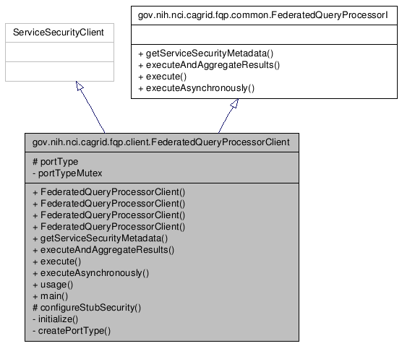
Figure 2 FederatedQueryProcessor Inheritence Model

Constructor Documentation
- FederatedQueryProcessorClient (String url)
- throws MalformedURIException, RemoteException
- FederatedQueryProcessorClient (String url, GlobusCredential proxy)
- throws MalformedURIException, RemoteException
- FederatedQueryProcessorClient (EndpointReferenceType epr)
- throws MalformedURIException, RemoteException
- FederatedQueryProcessorClient (EndpointReferenceType epr, GlobusCredential proxy)
- throws MalformedURIException, RemoteException

Member Function Documentation
Access to caGrid Service Security Metadata:
- gov.nih.nci.cagrid.metadata.security.ServiceSecurityMetadata getServiceSecurityMetadata ()
  - throws RemoteException
  - Description: Returns the caGrid service security metadata

Distributed Query methods:
- gov.nih.nci.cagrid.cqlresultset.CQLQueryResults executeAndAggregateResults (gov.nih.nci.cagrid.dcql.DCQLQuery query)
  - throws RemoteException, gov.nih.nci.cagrid.fqp.stubs.types.FederatedQueryProcessingFault
  - Description: Executes the DCQL query, aggregating and returning them as standard data service results
- gov.nih.nci.cagrid.dcqlresult.DCQLQueryResultsCollection execute (gov.nih.nci.cagrid.dcql.DCQLQuery query)
  - throws RemoteException, gov.nih.nci.cagrid.fqp.stubs.types.FederatedQueryProcessingFault
  - Description: Executes the DCQL query, aggregating and returning them as standard data service results
- gov.nih.nci.cagrid.fqp.results.client.FederatedQueryResultsClient executeAsynchronously (gov.nih.nci.cagrid.dcql.DCQLQuery query)
  - throws RemoteException, org.apache.axis.types.URI.MalformedURIException
  - Description: Executes the DCQL query asynchronously, returning a results client which can be used to access the results

gov.nih.nci.cagrid.fqp.results.client.FederatedQueryResultsClient
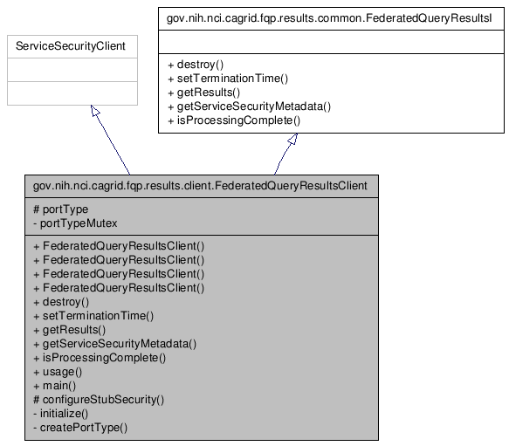
Figure 3 FederatedQueryResultsClient Inheritence Model

Constructor Documentation
- FederatedQueryResultsClient (String url)
- throws MalformedURIException, RemoteException
- FederatedQueryResultsClient (String url, GlobusCredential proxy)
- throws MalformedURIException, RemoteException
- FederatedQueryResultsClient (EndpointReferenceType epr)
- throws MalformedURIException, RemoteException
- FederatedQueryResultsClient (EndpointReferenceType epr, GlobusCredential proxy)
- throws MalformedURIException, RemoteException

Member Function Documentation
Access to caGrid Service Security Metadata:
- gov.nih.nci.cagrid.metadata.security.ServiceSecurityMetadata getServiceSecurityMetadata ()
  - throws RemoteException
  - Description: Not used.

Resource Lifetime methods:
- org.oasis.wsrf.lifetime.DestroyResponse destroy (org.oasis.wsrf.lifetime.Destroy params)
- throws RemoteException
- Description: Destroys the corresponding resource and query results.
- org.oasis.wsrf.lifetime.SetTerminationTimeResponse setTerminationTime (org.oasis.wsrf.lifetime.SetTerminationTime params)
- throws RemoteException
- Description: Sets the time at which the resource and corresponding query results should be destroyed.

Query Results methods:
- gov.nih.nci.cagrid.dcqlresult.DCQLQueryResultsCollection getResults ()
- throws RemoteException, gov.nih.nci.cagrid.fqp.results.stubs.types.ProcessingNotCompleteFault, gov.nih.nci.cagrid.fqp.stubs.types.FederatedQueryProcessingFault, gov.nih.nci.cagrid.fqp.stubs.types.InternalErrorFault
- Description: Returns the query results, if processing is complete. If processing is not complete, throws ProcessingNotCompleteFault. If processing is complete, but threw an exception, that exception is then rethrown.
- boolean isProcessingComplete ()
- throws RemoteException
- Description: Returns true if and only if processing of the query is complete.

gov.nih.nci.cagrid.fqp.processor.FederatedQueryEngine

Constructor Documentation

gov.nih.nci.cagrid.fqp.processor.FederatedQueryEngine.FederatedQueryEngine ()
Default constructor

Member Function Documentation

DCQLQueryResultsCollection gov.nih.nci.cagrid.fqp.processor.FederatedQueryEngine.execute (DCQLQuery dcqlQuery) throws FederatedQueryProcessingException
Call Federated Query Processor, and send the generated CQLQuery to each targeted service, placing each results into a single DCQLQueryResults object.

Parameters:
dcqlQuery

Returns:

Exceptions:
FederatedQueryProcessingException

CQLQueryResults gov.nih.nci.cagrid.fqp.processor.FederatedQueryEngine.executeAndAggregateResults (DCQLQuery dcqlQuery) throws FederatedQueryProcessingException
Call Federated Query Processor, and send the generated CQLQuery to each targeted service, aggregating the results into a single CQLQueryResults object.

Parameters:
dcqlQuery

Returns:

Exceptions:
FederatedQueryException

API Usage Examples
The examples below show various uses of the federated query infrastructure; both execution the grid services and the engine’s stand alone API. The exception handling is omitted from the examples for demonstration purposes. Additionally, the result processing shown is simplistic. The results returned from the federated query APIs, DCQLResultsCollection instances, are simple container objects for standard Data Service results, CQLQueryResults. A DCQLResult is just a CQLQueryResult and the address of the service which created the result. Additional details on how Data Service results can be processed can be found in the Data Service section of this document.

Executing a Blocking Query
The first example, shown below in Figure 4, demonstrates the simplest case of executing a query using the Federated Query Processor grid service, via the FederatedQueryProcessorClient. An instance of the client is constructed on lines 1 and 2, wherein the address of the service is provided. Next, a query document is created by loading it from a file (in this case the “exampleDCQL.xml” file) on the local file system. The caGrid common utilities are used to accomplish this on lines 4 and 5. Though not shown, DCQL queries can also be constructed programmatically, just as CQL queries can. On line 7, the service is requested to perform the query as described in the DCQLQuery; this operation will block until the processing is complete. The result of the invocation is a DCQLResultsCollection, which contains an array of DCQLResult. Lines 10-16 loop over these results, and then print out the URL of service which yielded the result, and the number of data instances it produced.

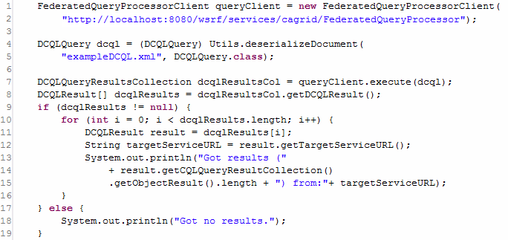
Figure 4 Executing a Distributed Query

Executing a Non-Blocking Query
The next example, shown in Figure 5, illustrates the capability of the federated query service infrastructure to execute queries in the background, and allow clients to process the results later (suitable for long running queries, or distributed processing of results). It begins to diverge from the example above when it invokes executeAsynchronously on line 8 (as opposed to execute, as shown in Figure 4). This operation returns a new instance of the FederatedQueryResultsClient, which can be used to access the results once they are completed. This instance is returned before the service actually starts processing the query. The FederatedQueryProcessorClient abstracts the details that an EPR was actually returned by the service, and it directly provides the caller the appropriate API to communicate with the stateful service container the not yet populated query results. Lines 10-15 demonstrate checking the status of the processing, printing out a “.” to the screen each second until the processing is complete. Future versions of the service will support subscriptions and notifications of query status and completion. The isProcessingComplete operation will return false until the query results are available, or the processing is terminated by failure. Once processing is complete, the results can be accessed via the getResults operation, shown on line 17. This returns a DCQLQueryResultsCollection, just as execute did in Figure 4. At this point, in terms of result processing, there is no longer a difference between asynchronous (this example) and synchronous (the previous example) query logic. However, to further demonstrate how to process the results, the example below loops over each DCQLResult (as before), and prints out the service which yielded it (on line 23). It then, on line 24-27, accesses the standard Data Service query result type, and constructs a CQLQueryResultsIterator iterate over each Object result. This iteration, shown on lines 29-33, prints the XML representation of each Object, as the iterator was constructed to use “xml only” by passing true to the second argument of its constructor on line 27.

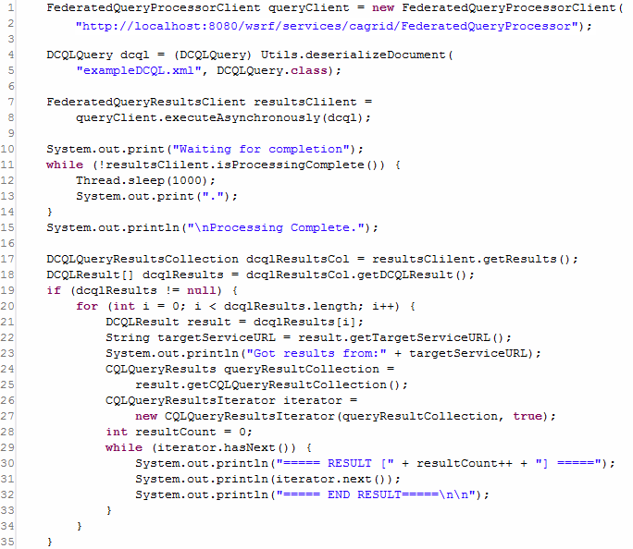
Figure 5 Executing a Non-Blocking Distributed Query

Removing Query Results
As mentioned above, the Federated Query Results grid service is a stateful WSRF service, and executing asynchronous queries with the Federated Query Processor service generates Resources on it. These resources house the query results for clients, and can be accessed multiple times. The example shown below in Figure 6, demonstrates how, after the client is done with the results, they should be removed from the service by invoking the destroy operation, of the FederatedQueryResultsClient, shown on line 12. The results will eventually “expire” and be automatically removed after a service-specified lifetime, unless their lifetime is extended as shown in Figure 7, but it is good practice to manually release unneeded resources.

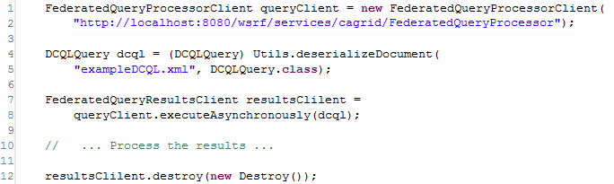
Figure 6 Destroying Query Results

Scheduling Removal of Query Results
As mentioned above, query results will expire after a service-configure default lifetime. However, this can be controlled by the client by specifying a new termination time for the resource. The example shown below in Figure 7, demonstrates how one client may request the service to perform a federated query, set the lifetime of the yet to be created results, and hand off an EPR to those results to some other processing thread or client. In this example, the query is executed asynchronously just as before (on lines 7-8). However, rather than waiting on completion of the results, the example uses, on line 13, the setTerminationTime operation of the results client to request the results live on the service for 4 hours. This is accomplished by creating a Resource Lifetime standard SetTerminationTime request, and providing it a Calendar instance configured to be 4 hours later than the current time, as shown on lines 11 and 12. The result of this operation is a Resource Lifetime standard SetTerminationTimeResponse, which indicates the current time, as believed by the service, and the time at which the resource will be destroyed. The example prints these out, as well as the value of the local Calendar instance, on lines 18-23. Finally, the code demonstrates, on line 25, how an EPR to the result Resource can be accessed from the client with the getEndPointReference method.

It should be noted that if the client’s system clock and the service’s system clock have significant differences in believe of the current time, this example code could cause the resource to terminate either earlier or later than expected. In cases where this may be an issue for clients, the results service provides as a Resource Property, the current time as believed by the service. A client could access this resource property, and construct the Calendar instance from it, rather than using its local system clock.

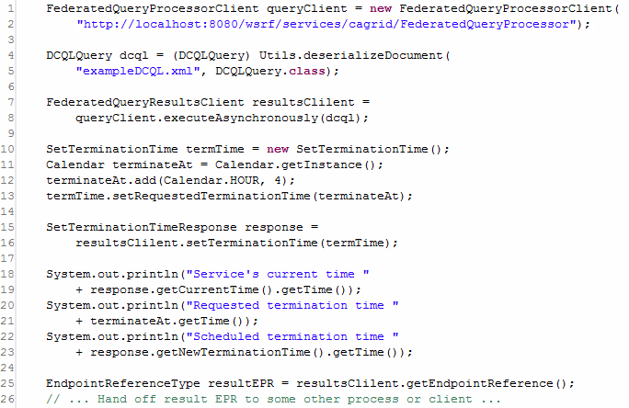
Figure 7 Scheduling the Destruction of Query Results

Using the Engine directly to Access Protected Data Services
The final example, shown below in Figure 8, demonstrates how the federated query infrastructure can be used to locally execute federated queries (as opposed to requesting the service to execute them). While most clients will opt to use the service interfaces, there are many reasons why a client may wish to invoke the engine locally, such as minimizing data movement. The most common reason to use the engine locally is if the Data Services being targeted requires authorization to access the data of interest. The federated query processor service infrastructure does not currently have the capability to assume the identity of the client requesting the query; it queries Data Services either anonymously, or with its own credentials (depending on deployment scenarios). When executing the engine locally, the client has the ability to use credentials when it queries data services. When executing locally, the engine will make use of the “default” Globus credentials if the Data Service being accessed does not allow anonymous access. Consult the caGrid security documentation on how to get and set default Globus credentials.

Using the engine locally is very similar to using the processor service. The engine can be constructed, as shown on line 1, by instantiating a FederatedQueryEngine. This has the same query execution methods as the grid service, except it does not provide asynchronous execution (as this is easily done locally). The example below shows the ability of the engine to aggregate DCQL results and return them as standard Data Service Results, shown on line 4. It then uses the CQLQueryResultsIterator to print the XML representation of the results, just as in Figure 5.

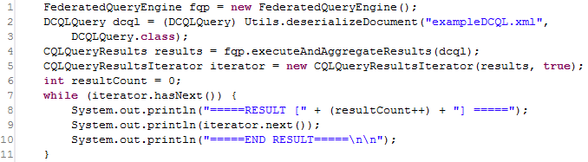
Figure 8 Invoking the FederatedQueryEngine Locally

