Metadata API Usage Overview
All caGrid services are expected to expose a standard set of service metadata. Details about this design and the specifics of the metadata can be found in the caGrid Metadata Design document. This section describes the high-level API which can be used to access and manipulate instances of this metadata. All the standard metadata models have bean representations which can be used to programmatically interact with the models. Shown below in Figure 1 and Figure 2 respectively, are the Standard Service (ServiceMetadata) and Data Service (DomainModel) metadata models. The APIs described herein can be used access these models from services, and serialize and deserialize them to and from XML. These methods complement the Discovery API, as once an EPR (End Point Reference) is returned from the Discovery API, these methods can be used access and inspect the full metadata.

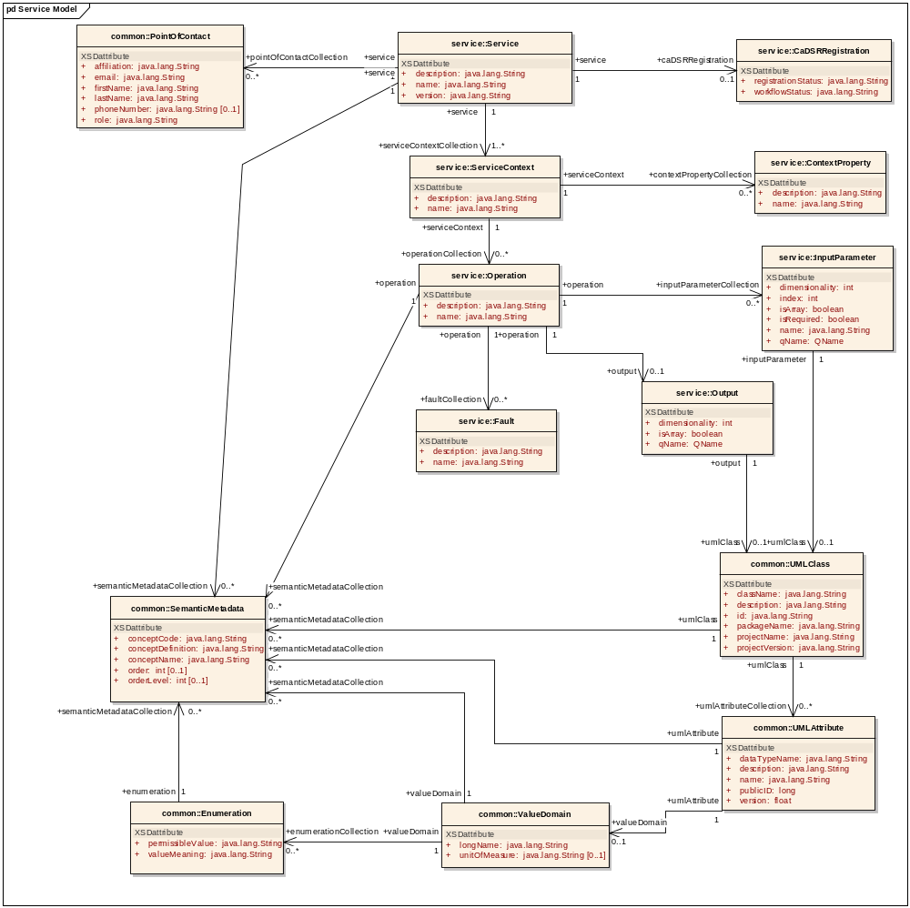
Figure 1 : Service Model

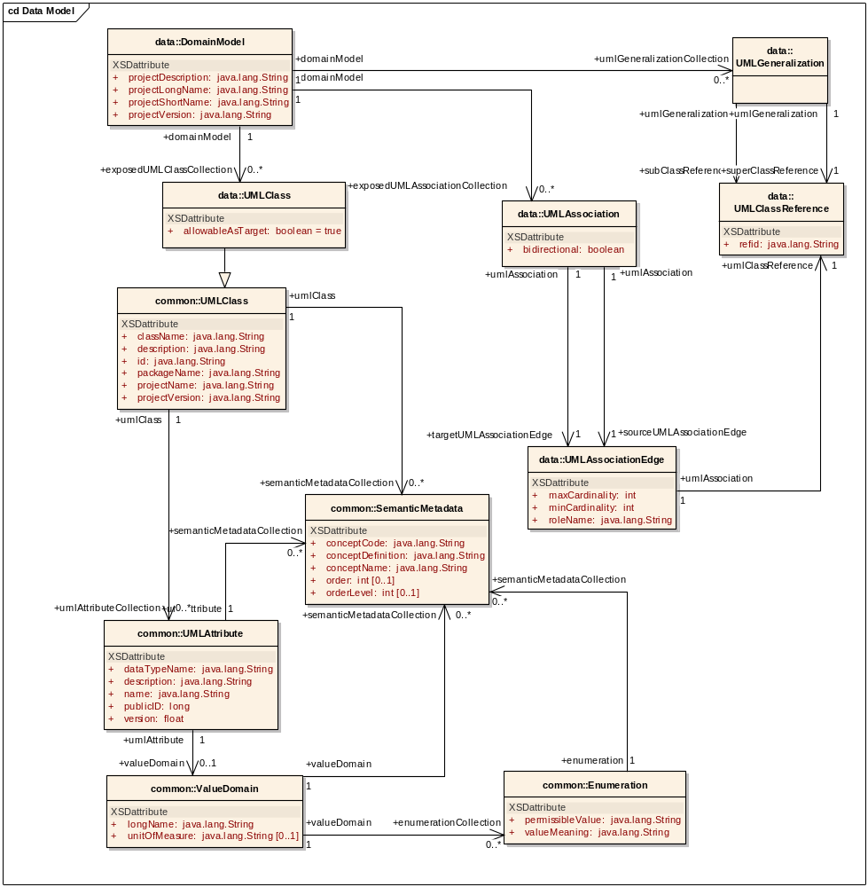
Figure 2 : Data Service Metadata Model

The ResourcePropertyHelper API not detailed here, is the lower level API which can be used to directly gather information about ResourceProperties (which is how metadata is exposed in caGrid). The MetadataUtils, described herein, leverage this API, and expose some of its exceptions. The possible exceptions generated by the metadata utility methods are detailed below in Figure 3. A non discerning client may simple opt to catch ResourcePropertyRetrievalException, as it is the base checked exception. An additional non-checked exception, InternalRuntimeException, can also be thrown, but it is solely used to represent an internal logic error in the APIs and so it is not expected clients can “recover” from such an exception. As such, client should not attempt to catch this runtime exception for any other reason than to mask the problem. QueryInvalidException, is thrown if an invalid XPath query is issued. Problems originating from remote services are thrown in the subclass, RemoteResourcePropertyRetrievalException. In general use of the metadata utilities, this is the most likely exception clients may see, as it is thrown if a service is not properly exposing the proper metadata. Clients leveraging the lower level resource property APIs should take care to appropriately address each type of exception if they are communicating with services. For example, even though it is a caBIG requirement to expose the standard service metadata, clients should properly handle the case where it is not present. Asking for specific metadata that a service does not provide would yield an InvalidResourcePropertyException.

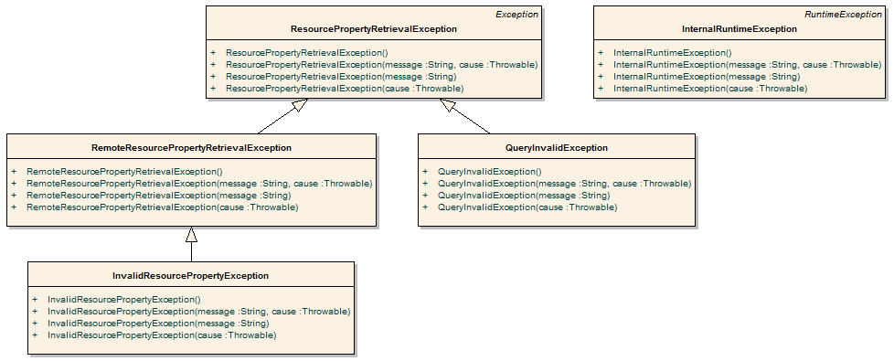
Figure 3 Metadata Exceptions

API Details

gov.nih.nci.cagrid.metadata.MetadataUtils

Member Function Documentation

static ServiceMetadata gov.nih.nci.cagrid.metadata.MetadataUtils.getServiceMetadata (EndpointReferenceType serviceEPR) throws InvalidResourcePropertyException, RemoteResourcePropertyRetrievalException, ResourcePropertyRetrievalException [static]
Obtain the service metadata from the specified service.

Parameters:
serviceEPR

Returns:

Exceptions:
InvalidResourcePropertyException
RemoteResourcePropertyRetrievalException
ResourcePropertyRetrievalException

static DomainModel gov.nih.nci.cagrid.metadata.MetadataUtils.getDomainModel (EndpointReferenceType serviceEPR) throws InvalidResourcePropertyException, RemoteResourcePropertyRetrievalException, ResourcePropertyRetrievalException [static]
Obtain the data service metadata from the specified service.

Parameters:
serviceEPR

Returns:

Exceptions:
InvalidResourcePropertyException
RemoteResourcePropertyRetrievalException
ResourcePropertyRetrievalException

static void gov.nih.nci.cagrid.metadata.MetadataUtils.serializeServiceMetadata (ServiceMetadata metadata, Writer writer) throws Exception [static]
Write the XML representation of the specified metadata to the specified writer. If either are null, an IllegalArgumentException will be thown.

Parameters:
metadata
writer

Exceptions:
Exception

static ServiceMetadata gov.nih.nci.cagrid.metadata.MetadataUtils.deserializeServiceMetadata (Reader xmlReader) throws Exception [static]
Create an instance of the service metadata from the specified reader. The reader must point to a stream that contains an XML representation of the metadata. If the reader is null, an IllegalArgumentException will be thown.

Parameters:
xmlReader

Returns:

Exceptions:
Exception

static void gov.nih.nci.cagrid.metadata.MetadataUtils.serializeDomainModel (DomainModel domainModel, Writer writer) throws Exception [static]
Write the XML representation of the specified metadata to the specified writer. If either are null, an IllegalArgumentException will be thown.

Parameters:
domainModel
writer

Exceptions:
Exception

static DomainModel gov.nih.nci.cagrid.metadata.MetadataUtils.deserializeDomainModel (Reader xmlReader) throws Exception [static]
Create an instance of the data service metadata from the specified reader. The reader must point to a stream that contains an XML representation of the metadata. If the reader is null, an IllegalArgumentException will be thown.

Parameters:
xmlReader

Returns:

Exceptions:
Exception

API Usage Examples
The following section describes typical usage of the Metadata API. The exception handling shown in the code examples is not recommended practice, and is simplistic for demonstration purposes. The MetadataUtils class is the primary means of accessing and manipulating service metadata. It provides a number of static utility methods which can be directly invoked. This API provides an abstraction layer over lower-level APIs, specializing them to deal with the standard metadata types. Clients wishing to work with custom (or non-standard) metadata, will need to use the lower-level APIs, and can consult the source code of the MetadataUtils class for guidance.

Accessing Metadata from a Service
In order to access a service’s metadata, an End Point Reference pointing to the service must be provided. This can be obtained as a direct result of an invocation of a discovery method from the Discovery API, or manually constructed by specifying the service’s Address. Examples of both can be found in the programmer’s guide for the Discovery API.

As caBIG requires that standard metadata be made publicly available, client credentials are not necessary for invocation of these methods.
The first example, shown below in Figure 4, demonstrates accessing a service’s standard ServiceMetadata, which is common to all caGrid services. As described above, the first step is to obtain an appropriate EPR (line 1). Given this EPR, the MetadataUtils’s getServiceMetadata method, shown on line 4 in Figure 4, can be used to obtain the bean representation of the metadata. Upon successful completion of this method, the fully populated bean can be inspected to obtain the information of interest. Several exceptions, subclassed from the base ResourcePropertyRetrievalException, can be thrown by this operation. A non-discriminating client may choose simply to handle this base exception. Additional details on the other exceptions, and why they may be throw, is described in the overview of the guide, as well as the javadoc of the APIs.

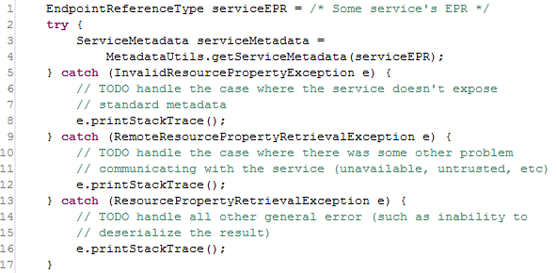
Figure 4 Accessing Standard Service Metadata

The process for accessing data service DomainModel metadata, shown in Figure 5, is the same as accessing standard metadata. Once the metadata is obtained, in line 3, it can be inspected, as shown in line 4 where the long name of the project being exposed by the data service is printed to the console.

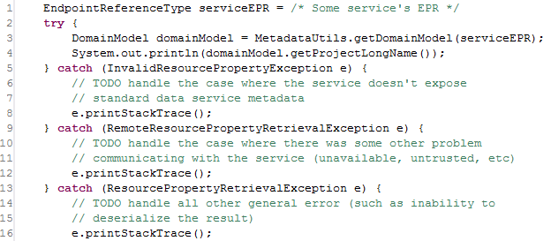
Figure 5 Accessing Standard Data Service Metadata

Processing Metadata as XML
In addition to accessing metadata from services, the MetadataUtils provide the capability to read and write metadata instances as XML documents. This can not only be useful for storage and display of metadata, but also grid service’s expose metadata as XML, and these methods provide a way to inspect the metadata in object (bean) form.

In Figure 6, example code is shown which saves an instance of standard service metadata to a file named “seviceMetadata.xml.” The metadata instance, defined in line 1, can be acquired using code similar to that shown in Figure 4, or by some other mechanism. The serializeServiceMetadata method can be then passed this instance, and an instance of the java.io.Writer interface, as shown on line 11. Any Writer implementation will work, but the example below shows using a FileWriter, on line 5, to write the metadata to the specified file. After the MetadataUtils have been used to write the metadata to XML, the Writer used should be closed, as shown on line 18. Though not shown, a similar method, serializeDomainModel, exists for writing data service metadata to XML; its usage pattern is the same.

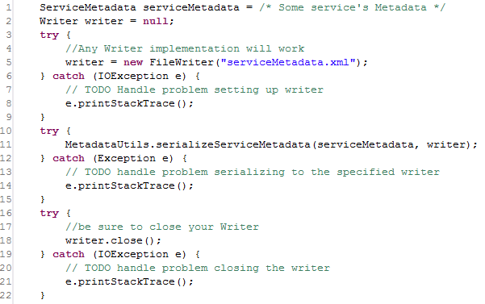
Figure 6 Serializing Metadata to a File

As a complement to the serialization methods described and shown above, deserialization methods also exist which read XML representations of metadata and return appropriately populated metadata beans. In Figure 7, example code is shown which populates a new ServiceMetadata instance from an XML representation stored in a file named “serviceMetadata.xml.” This code, used in conjunction with the previous example, would reconstitute the original metadata instance. Similar to the serialization methods which use a java.io.Writer, the deserialization methods use a java.io.Reader to read the XML representation. In the example below, a FileReader is used on line 4. This Reader is then passed to the deserializeServiceMetadata method on line 11, and the populated ServiceMetadata instance is returned. As with the Writer instance in the serialization methods, the Reader instance should be closed once used (as shown on line 18). Though not shown, a similar method, deserializeDomainModel, exists for reading data service metadata from XML; its usage pattern is the same.

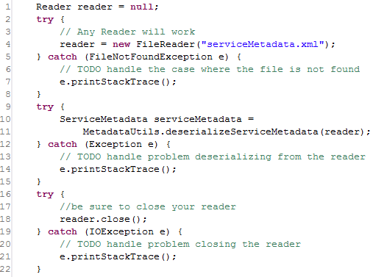
Figure 7 Deserializing Metadata from a File

