Overview

The main responsibility of the Authz component is to provide an integration point between local authorization policy and grid-wide authorization policy. Authorization policy in caGrid is based on membership in groups that are defined in GridGrouper. While authorization policy within an organization, is usually based in an individual's identity within that organization. The Authz component provides a framework to integrate groups that have been defined in the Commons Security Module (CSM), which is the authorization policy management system used by the NCICB, and GridGrouper groups. The result is that local administrators can extend access privileges to members of the caBIG community based on membership in GridGrouper groups, rather than having to create local identities for each individual.

The document describes the components that comprise the Authz project, and how to interact with the Authz API.

Components

To integrate authorization into a grid service, the grid service developer can code against the Authz API, which consists of a single interface defined in gov.nih.nci.cagrid.authorization.GridAuthorizationManager. That interface looks like this:

public interface GridAuthorizationManager {
public boolean isAuthorized(String identity, String objectId, String privilege);
}

The arguments to the isAuthorized method are as follows:
- identity: The grid identity of the caller.
- objectId: A unique identifier for the object to be accessed.
- privilege: The name of the privilege that the caller must have on the object identified by objectId.

If the caller has the required privilege on the object, this method returns true. Otherwise, it returns false.

The Authz component provides a single implementation of this interface, defined in gov.nih.nci.cagrid.authorization.impl.CSMGridAuthorizationManager. This implementation fulfills the GridAuthorizationManager contract, but also implements interfaces from the CSM framework that allow it to be seamlessly plugged into the CSM system. The result is that systems which are currently using CSM can extend their authorization policy to include caGrid users without making any code changes, simply by reconfiguring their CSM system to use CSMGridAuthorizationManager. In this way, pre-existing, local authorization policy is enforced in parallel to grid-wide authorization policy.

The following UML class diagram shows the components involved.

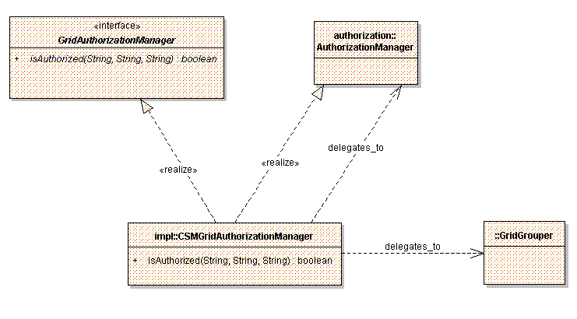

When the client calls GridAuthorizationManager.isAuthorized, CSMGridAuthorizationManager first assumes that the supplied identity is a local identity and invokes AuthorizationManager.checkPermission(String,String,String), passing in the identity, objectId, and privilege. If the call to checkPermissions returns true, then isAuthorized returns true.

Otherwise, CSMGridAuthorizationManager assumes the identity is a group name, and invokes AuthorizationManager.getAccessibleGroups(String,String), passing in the objectId and privilege. For each returned group, CSMGridAuthorizationManager checks if the group name matches a particular format that identifies it as a GridGrouper group name. If so, GridGrouper.isMemberOf(String,String) is called, passing in the identity and group name. If that call returns true, a final call to AuthorizationManager.checkPermissionForGroup(String,String,String) is made, passing in the group name, objectId, and privilege. If that call returns true, then the isAuthorized method returns true, indicated that the identity is authorized. Otherwise, isAuthorized returns false, indicating that the identity is not authorized.

A group name is identified as a GridGrouper group name, if it matches this regular expression:

^\{http(s?)\:\/\/.*\}.+

Following is an example group name that matches this pattern:

{https://some.host:8443/wsrf/services/cagrid/GridGrouper}mystem:mygroup

The URL inside the curly braces should point to GridGrouper endpoint in which “mystep:mygroup” is defined.

Using the API

The following snippet illustrates how code running within the Globus container would use this API to determine if the caller is authorized to update a given object.

String appContextName = "MYAPP";
String privilege = "UPDATE";
String identity = org.globus.wsrf.security.SecurityManager.getManager()
.getCaller();
String objectId = obj.getId();
AuthorizationManager mgr = SecurityServiceProvider
.getAuthorizationManager(appContextName);
boolean authorized =
mgr.checkPermission(identity, objectId, privilege);
if(authorized){
//Update the object
}else{
throw new Exception("Update Permission Denied!");
}

Since the CSMGridAuthorizationManager also implements the gov.nih.nci.security.authentication.AuthenticationManager interface, this implementation can be used to create a secure session with a caCORE services that supports security. The following snippet illustrates this usage scenario.

MyObject myObjPrototype = …initialize the object…
String coreSvcUrl = "http://myhost:8080/myCoreService";
String gridSvcUrl = "http://myhost:8080/myGridService";
ApplicationService svc = ApplicationService
.getRemoteInstance(coreSvcUrl);
ClientSession sess = ClientSession.getInstance();
String identity = org.globus.wsrf.security.SecurityManager.getManager()
.getCaller();
boolean loggedIn = sess.startSession(identity, gridSvcUrl);
if (!loggedIn) {
throw new Exception("Couldn't authenticate " + identity);
}
svc.search(MyObject.class, myObjPrototype);
sess.terminateSession();

Notice that AuthenticationManager is never actually referenced in this code. That’s because caCORE systems that have security turned on will instantiate an implementation of AuthorizationManager based on the configuration specified in ApplicationSecurityConfig.xml. For the above code to work, two conditions must be true. First, CSMGridAuthorizationManager must be specified as the AuthorizationManager implementation to use (See the Authz Administrator’s Guide for more information). Second, the caller identity must be a member of a GridGrouper group that has been granted the “ACCESS” privilege on a projection element with an object ID of http://myhost:8080/myGridService, by the local CSM administrator.

