Security Quick Start
caGrid 1.0 Beta

Technical Guide

caBIG™ is an initiative of the National Cancer Institute, NIH, DHHS

Copyright and License page

Insert Names of Development Team(s) here
Development | Programmer’s guide |  | Program Management
Names of developers | Names of technical writers and reviewers |  | Names of program managers
Stephen Langella | Stephen Langella
¹ Footnote contributing companies/ contractors/ divisions |  | ³ company
² department or division

Contacts and Support
Enter training contact | name (email address)
Enter customer support contact | Web hyperlink  Telephone: 111-222-3456  Toll free: 888-234-1234

LISTSERV Facilities Pertinent to software teams
LISTSERV | URL | Name
caGrid_Developers | https://list.nih.gov/archives/cagrid_developers.html | caGrid Developers Discussion

Table of Contents
Chapter 1 Security Quick Start 2
Synchronizing with the Trust Fabric 2
Logging On to the Grid 2
Registration 3
Logging Onto to the Grid 4
Configuring a Secure Container 5

List of Figures
Figure 1 Registration 3
Figure 2 Creating a Grid Proxy 4
Figure 3Proxy Manager 4

- Security Quick Start
This guide provides a quick start to using the caGrid 1.0 Beta security framework, it is assumed that you have built and installed caGrid 1.0 beta prior to following any instructions in this guide.

Synchronizing with the Trust Fabric

The Globus Toolkit facilitates the authentication of clients against a list of trusted certificate authorities; this consists of validating the client’s certificate to ensure that it was issued and signed by a trusted certificate authority. The Grid Trust Service (GTS) maintains the trusted certificate authorities or trust fabric for caGrid. In order for Globus to authenticate users against the caGrid trust fabric, both client and server caGrid installations must be synched with the caGrid trust fabric. The caGrid SyncGTS tool provides three methods for syncing with the trust fabric (1) Command Line (2) Service Based (3) Programmatic. For the purpose of this quick start we will provide directions for the command line and service base approaches. The SyncGTS command line utility can be used to sync once with the trust fabric, meaning you environment will authenticate users and services against the trust fabric at the point in time in which you last synced. This command line approach is recommended for clients and is NOT recommended for servers. To sync once using the command line approach type the command ”ant syncWithTrustFabric” from the directory caGrid-1.0-beta/caGrid. Under the service-based approach the SyncGTS is deployed to a Globus service container and synchronizes with the GTS every X minutes (where X is configurable). The service-base approach is recommended for server environments, constantly inheriting changes in the trust fabric. To deploy the SyncGTS to a service container type the following from the caGrid-1.0-beta/caGrid/projects/SyncGTS directory:
Deploy to a Globus Container:
ant deployGlobus
Deploy to a Tomcat Container:
ant deployTomcat

Logging On to the Grid

Dorian is the account provisioning system for caGrid, the Dorian portal provides a mechanism for users to register and log onto the grid. Before running the Dorian portal, you must first synchronize with the trust fabric (”ant syncWithTrustFabric”, see previous section). Once you have synced with the trust fabric you can run the Dorian portal by typing the command ”ant dorian” from the directory caGrid-1.0-beta/caGrid.

Registration
Every user of Dorian must have account information registered with the Dorian server before being allowed to logon. Users need to provide a potential username and a password and a valid email address among other fields. In its default configuration, Dorian also requires certain personal information before it sends an application to the server for processing by the grid administrator. When the portal first displays on your desktop, click Identity Provider from the toolbar or from the Tools drop down menu. From the Identity Provider menu, choose Register and click Select. In the Login information section, choose the service you wish to register with and supply a username and password. Then fill in the fields in the Personal Information section. Figure 1 shows the Dorian portal framing the form for entering basic account information.

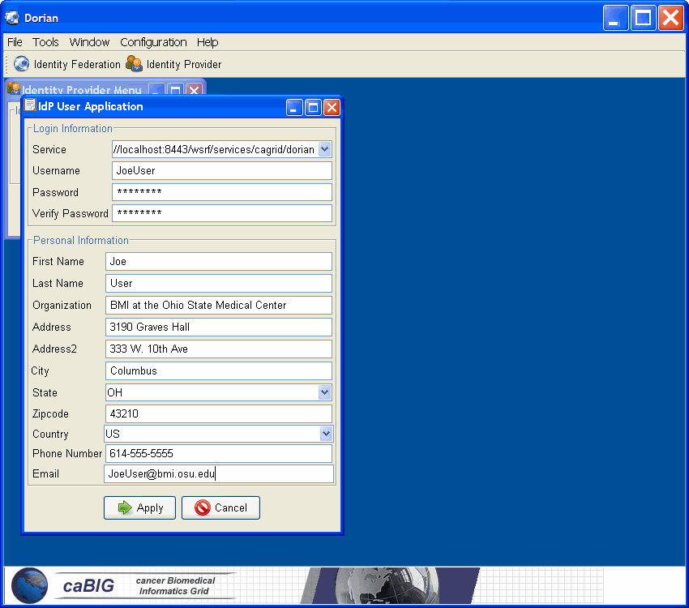
Figure 1 Registration
Once you have supplied all the required information, Click the Apply button to send your account and personal information to the Dorian server so that an administrator can review your application.

Logging Onto to the Grid
Once you have an account with Dorian, you are ready to log onto the grid. To log on to the grid click Identity Federation menu item in the Dorian portal will bring up a dialogue with a number of radio button options on it. Select the Create Proxy radio button and click Select, this will bring up the dialogue in Figure 2. Fill in your username, password, and select how long you want your credentials to be good for. Clicking Authenticate will contact Dorian to generate a grid proxy for your session and return the proxy manager (Figure 3). The proxy manager dialogue allows you to manage your active grid proxies, clicking the “Set Default” button specifies the proxy which should be used to access the grid. At this time you should click he “Set Default” button such that the proxy you just created is used for accessing the grid.
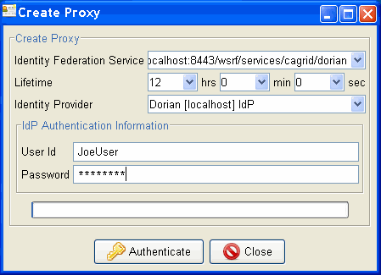
Figure 2 Creating a Grid Proxy
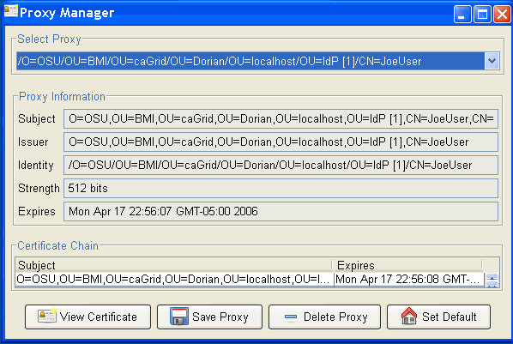
Figure 3Proxy Manager

Configuring a Secure Container

There are a number of ways of securing services in the grid, this guide will focus on deploying secure services with transport layer security or https. In order to run services over https, services need to be deployed in a secure container. Establishing a secure container requires host credentials. To obtain host credentials type ”ant requestHostCertificate” from the directory caGrid-1.0-beta/caGrid. This utility will ask for a hostname and generate a public/private key pair and a security descriptor. The generated key pair and security descriptor will be written out to the file system in the directory USER_HOME/.cagrid/gridca under the following file names:
Public Key: HOSTNAME-public-key.pem
Private Key: HOSTNAME-private-key.pem
Security Descriptor: HOSTNAME-security-descriptor.xml
The utility will then ask you to send an email to langella@bmi.osu.edu, attaching the generated public key and specifying you reason for needing credentials. If you request is approved, a signed certificate will be set back to you via email. Once you have received the certificate save it the file system as USER_HOME/.cagrid/gridca/HOSTNAME-cert.pem, where HOSTNAME is replace with the hostname you entered when making the request.
Once you have obtained credentials, you need to configure your container to sync with the trust fabric, this can be done by deploying the SyncGTS tool to the container, see the “Syncing with the Trust Fabric” section of this guide for more details.
Now that you have host credentials you need to configure your container to run securely using these credentials. For the Globus container, this is done by specifying the generated security descriptor when starting the container, for example
GLOBUS_LOCATION/bin/globus-start-container –containerDesc USER_HOME/.cagrid/gridca/ HOSTNAME-security-descriptor.xml
For the tomcat container, download and install Tomcat 5.0.30. Then, set up an environmental variable pointing to the Tomcat 5.0.30 directory and name it CATALINA_HOME. Make sure to include the CATALINA_HOME/bin directory in the PATH. Before configuring tomcat we must deploy Globus to Tomcat, this can be done by typing the following from the GLOBUS_LOCATION:
ant -f share/globus_wsrf_common/tomcat/tomcat.xml deploySecureTomcat -Dtomcat.dir=CATALINA_HOME

Now we are going to setup Tomcat to run securely. For the following steps you will be editing the <tomcat_root>/conf/server.xml configuration file.
  - Add a HTTPS Connector in the <Service name="Catalina"> section and update the parameters appropriately with your local configuration:
<Connector
className="org.globus.tomcat.coyote.net.HTTPSConnector"
port="8443" maxThreads="150" minSpareThreads="25" maxSpareThreads="75"
autoFlush="true"
disableUploadTimeout="true" scheme="https"
enableLookups="true" acceptCount="10" debug="0"
cert=" USER_HOME/.cagrid/gridca/HOSTNAME-cert.pem "
key=" USER_HOME/.cagrid/gridca/HOSTNAME-private-key.pem "
cacertdir="/path/to/ca/certificates/directory"/>
  - Add a HTTPS Valve in the <Engine name="Catalina" ... > section:
<Valve className="org.globus.tomcat.coyote.valves.HTTPSValve"/>

Once you have configured your secure Globus or Tomcat container, you are ready to deploy and run secure services.

