SAML Specification
caGrid Dorian

Technical Specification

caBIG™ is an initiative of the National Cancer Institute, NIH, DHHS

Copyright and License page

Insert Names of Development Team(s) here
Development | Programmer’s guide |  | Program Management
Names of developers | Names of technical writers and reviewers |  | Names of program managers
Stephen Langella | Stephen Langella
Chad La Joie | Chad La Joie
¹ Footnote contributing companies/ contractors/ divisions |  | ³ company
² department or division

Contacts and Support
Enter training contact | name (email address)
Enter customer support contact | Web hyperlink  Telephone: 111-222-3456  Toll free: 888-234-1234

LISTSERV Facilities Pertinent to software teams
LISTSERV | URL | Name
caGrid_Developers | https://list.nih.gov/archives/cagrid_developers.html | caGrid Developers Discussion

Table of Contents
Chapter 1 Overview 2
Chapter 2 Dorian Overview 3
Introduction 3
Architecture Overview 4
Architectural Overview 6
Identity Federation Service (IFS) 7
Dorian Identity Provider 9
Chapter 3 Dorian SAML Specification 10
Authentication Statement 10
Authentication Method 10
Subject 11
Attribute Statement 12
Local User Id 12
First Name 12
Last Name 13
Email 13
Appendix A Sample Dorian SAML Assertion 14

List of Figures
Figure 1 Example Dorian Usage Scenarios 6
Figure 2 Dorian Components 7
Figure 4 Authentication Method 11
Figure 5 Subject 12

- Overview
Dorian is grid service developed by the caGrid team to address the Identity Management and Federation requirements of caBIG. The Security Assertion Markup Language (SAML) is an XML standard for exchanging authentication and authorization data between security domains. Generally the exchange of authentication and authorization data is made between an Identity Provider (IdP) and another party. An institution’s authentication system or identity management system is an example of an IdP. Dorian uses SAML authentication assertions as the enabling mechanism for federating users from local institutions to the grid. The purpose of this document is to define a specification for the SAML Authentication Assertions used by Dorian to ensure interoperability between IdPs and Dorian.

- Dorian Overview
Identity management and federation is becoming an ever present problem in large multi-institutional environments. By their nature, Grids span multiple institutional administration boundaries and aim to provide support for the sharing of applications, data, and computational resources in a collaborative environment. One underlying problem is to enable participating institutions to manage the identities of their own members by leveraging existing institutional identity management systems, while at the same time facilitating the participation in larger Grids through the deployment of grid-wide user credentials. Those grid-wide identities are used for features such as single sign-on, secure communication, and are the basis for authorization decisions. Below we will present the design and implementation of Dorian, a grid service infrastructure component that enables the federation of users across the collaboration.

Introduction

As Grid technologies gain acceptance and adoption, the transition from highly specialized Grids with only a few institutional participants to more general purpose Grids with dozens to hundreds of institutions is becoming a reality. Security is of primary importance in such environments, in particular in settings where sensitive data (e.g., patient medical information) needs to be accessed and exchanged. Mechanisms are needed for such functions as secure communication, authentication, and authorization. This paper is concerned with the management and federation of user identities and authentication in the Grid.
Identity management and federation is becoming a critical problem in enabling access to resources across multiple security domains. In such an environment, it is highly unlikely that participating institutions use the same mechanism for managing the identities of their members. A common application of identity federation in the business domain is to enable single sign-on between two interacting companies that employ different internal authentication mechanisms, and vouch for their access to resources without needing to adopt the same security technologies or maintain a shared, centralized system for managing member identities. The Grid introduces additional challenges since it aims to facilitate the sharing of resources in a collaborative environment that spans multiple institutional boundaries. As a consequence, a Grid environment has to facilitate access by its users to resources at disparate institutions, while enforcing authentication and authorization policies set forth by the different institutions.
When the number of institutions participating in a Grid environment reaches hundreds, the number of individuals wishing to join the Grid can be expected to be well within the neighborhood of thousands or tens of thousands. This creates a huge challenge in terms of managing users, creating and managing their Grid identities, and supporting authentication such that Grid services can be accessed securely. When the number of users is large, it would be neither desirable nor tractable to have a central system to manage the identities for all participants. It is also undesirable to require that each shared service or group of services in the Grid maintains separate identity management and authentication mechanisms. Therefore, a Grid-enabled infrastructure is needed to facilitate the federation of institutional identities. In this paper we describe the design and implementation of Dorian, a Grid service infrastructure to address these issues.
Dorian provides a complete Grid-enabled solution, based on public key certificates and SAML, for managing and federating user identities in a Grid environment. Grid technologies have adopted the use of X509 identity certificates to support user authentication. The Security Assertion Markup Language (SAML) has been developed as a standard for exchanging authentication and authorization statements between security domains. Note that Grid certificates and SAML assertions serve different purposes. SAML is mainly used between institutions for securely exchanging authentication information coming from trusted identity providers. The primary use of the certificates is to uniquely identify Grid users, facilitate authentication and authorization across multiple resource providers, and to enable secure delegation of credentials such that a service or a client program can access resources on behalf of the user. A salient feature of Dorian is that it provides a mechanism for the combined use of both SAML and Grid certificates to authenticate users to the Grid environment through their institution’s authentication mechanism. Furthermore, Dorian also hides the complexities of creating and managing Grid credentials from the users.

Architecture Overview

One of the challenges in building an identity management and federation infrastructure is to create an architecture that incorporates multiple differing authentication mechanisms used by various institutions. In addressing this challenge we identify two possible approaches. The first is to build an infrastructure that would allow pluggable authentication modules, wherein a module would be developed for each authentication mechanism. In this architecture, a user’s authentication information would be routed to the appropriate module that contains the logic for authenticating the user with its institution. Although this approach solves the problem, it requires at least one module be developed for each authentication mechanism. This would require the Grid infrastructure administrators to become intimately familiar with each institution’s authentication mechanisms, and would increase the system’s complexity with each new module added.
Another approach would be for the infrastructure to accept an institutionally supplied, standard “token” as a method of authentication. In this approach users would first authenticate with their institution’s identity management system. Upon successfully authentication the institution’s identity management system issues a token which can then be given to the federated grid identity management system in exchange for grid credentials. The benefit of this approach over the first is that it does not require writing a plug-in every time a new institutional authentication mechanism comes online. It does, however, require every institutional authentication system to agree upon and be able to provide a common token. As SAML has been adopted by many institutions, we have chosen that token format as the basis of the second approach for Dorian.
The Security Assertion Markup Language (SAML) is an XML standard for exchanging authentication and authorization data between security domains. Generally the exchange of authentication and authorization data is made between an Identity Provider (IdP) and another party. An institution’s authentication system or identity management system is an example of an IdP. Dorian uses SAML authentication assertions as the enabling mechanism for federating users from local institutions to the grid. illustrates an example usage scenario for Dorian. To obtain grid credentials or a proxy certificate, users authenticate with their institution using the institution’s conventional mechanism. Upon successfully authenticating the user, the local institution issues a digitally signed SAML assertion, vouching that the user has authenticated. The user then sends this SAML assertion to Dorian in exchange for grid credentials. Dorian will only issue grid credentials to users that supply a SAML assertion from a Trusted Identity Provider. Dorian’s grid service interface provides mechanisms for managing trusted identity providers; this will be discussed in greater detail later in this document. For example, in

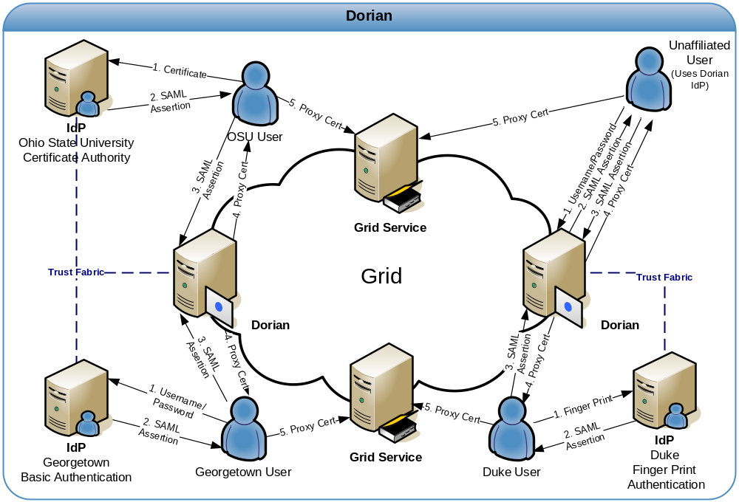
Figure 1 Example Dorian Usage Scenarios

To facilitate smaller groups or institutions without an existing IdP, Dorian also has its own internal IdP. This allows users to authenticate to Dorian directly, thereby enabling them to access the grid. It provides administrators with facilities for approving and managing users. All of the Dorian IdP’s functionality is made available through a grid service interface. Details of the Dorian IdP are provided later in this document.

Architectural Overview

The high level architecture is illustrated in Figure 2. Dorian is built on top of the Globus Toolkit and runs as a WSRF compliant grid service. Clients communicate with Dorian though its web service interface. All communication between clients and Dorian is secured via Transport Level Security (TLS) or WS-SecureConversation, depending on the deployment configuration.
The Dorian architecture consists of two core components: the Identity Federation Service (IFS) and the Dorian Identity Provider (IdP). The IFS component handles all the identity federation and management aspects for Dorian including the management of grid user accounts and Trusted IdPs. Dorian’s internal IdP component provides the functionality for registering, authenticating, and managing users. Dorian provides a complete client API which provides complete programmatic access to all operations. Dorian also provides a complete graphical user interface.

Identity Federation Service (IFS)

The Identity Federation Service (IFS) component of Dorian facilitates the federation of the local user accounts from multiple institutions to the grid. Architecturally (Figure 2) the IFS consists of four components: the Trusted IdP Manager, the Certificate Authority, the Grid User Manager, and the Grid Credentials Manager. The Trusted IdP Manager component manages the list of Institutional IdPs from which Dorian will accept SAML assertions as a mechanism of authentication. The Certificate Authority component provides Dorian the ability to create and renew grid credentials for users. By default, Dorian uses its own internal certificate authority, but it can be configured to use an external certificate authority of choice. The Grid Credentials Manager component interfaces with the Certificate Authority and maintains the private key and certificate for each user. Finally, the Grid User Manager component manages the account information for each grid user. This information includes the user’s identity provider, institutional user id, email address, account status, and the user’s role within the IFS.

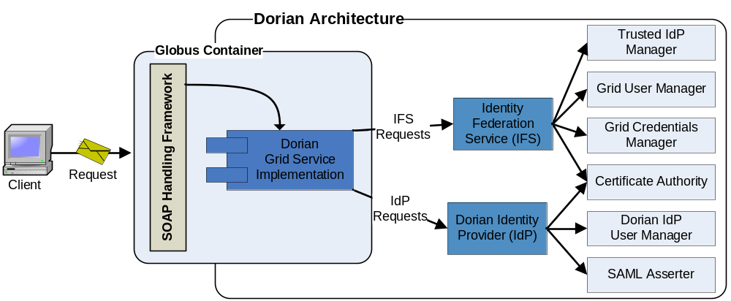
Figure 2 Dorian Components

The IFS exposes its functionality through Dorian’s grid service interface. This functionality can be divided into two sub interfaces, the IFS user interface, and the IFS administrative interface. The IFS user interface allows local users to create grid credentials. The IFS administrative interface provides operations that allow administrators to manage Trusted IdPs and grid user accounts. Note that invoking an administrative operation requires a grid proxy of an administrative user.

Trusted Identity Providers. The institutional Identity Providers (IdPs) that Dorian is configured to trust are referred to as Trusted Identity Providers (Trusted IdPs). Dorian only creates credentials for users whose identity assertions come from a Trusted IdP. The set of Trusted IdPs can be managed by Dorian IFS administrators through its grid service interface. The Dorian grid service interface provides functionality for adding, modifying, and removing Trusted IdPs. The Trusted IdP information consists of the following: IdP Id, IdP Name, IdP Status, User Policy, Certificate, and acceptable authentication methods. The IdP Id is a unique id assigned by Dorian to identify the IdP. The IdP name is assigned by an administrator and provides human readable name to easily identify an IdP. The IdP Status specifies the current status of the IdP: Active or Suspended. Users associated with a “suspended” IdP will be refused access to Dorian. Each Trusted IdP is associated with a set of configurable User Policies that are applied to each user when they authenticate. These policies designate how Dorian should handle users from a specified Trusted IdP. As an example, a policy might dictate what to do when a new user tries to create grid credentials for the first time. An automatic approval policy would automatically register the user with Dorian and create a grid account for the user. A manual approval policy would automatically register the user but not enable the grid account until an administrator manually approves it. User policies can also be used to dictate what to do when a user’s grid credentials expire. For example, an automatic renewal policy would enable automatic creation of a new set of credentials using the Dorian certificate authority, where as a manual renewal policy would require and administrator to do so. The User Policy framework is extensible; administrators can implement local policies.
Each Trusted IdP must also specify its own certificate. When Dorian receives a SAML assertion from a Trusted IdP it verifies that the assertion was signed with the private key that corresponds to the Trusted IdP’s certificate. Finally, each Trusted IdP must be configured with a list of acceptable authentication methods. A SAML authentication assertion specifies the method in which the Trusted IdP authenticated the user. In order for the SAML assertion to be accepted by Dorian, the authentication method specified in the assertion must be specified as acceptable in the corresponding Trusted IdP.

Grid User Management. When a user first attempts to create a proxy using Dorian, a grid user account is created for them. The account includes user information, user status, user role, and a set of grid credentials including the associated grid identity. The user information includes the user’s local institution id, the id of the Trusted IdP the user is associated with, and an email address. The user’s status corresponds to the user’s current status: Active, Suspended, Pending, or Expired. Only users with an “Active” status may access Dorian. A user’s role specifies whether or not the grid user is a Dorian IFS administrator. Only administrators may access the administrative functionality to manage Trusted IdPs or to manage grid accounts. A user’s grid credentials consist of a certificate and private key that are used by Dorian to issue grid proxy certificates. A user’s grid identity is composed of the Certificate Authority’s Subject DN (Distinguished Name), the IdP Id, and the user’s id at his institution. When a user’s grid account is created the initial status of the account is “Pending”. As mentioned earlier, if the TrustedIdP has an Auto Approval User Policy in place, the status will automatically be changed to “Active”, giving the user instant access to Dorian. Administrators can update a user’s status and role, and can renew a user credentials.

Proxy Creation. Users authenticate with grid services using grid proxy certificate [15]. Such a grid “proxy” is a short-term credential (private key and certificate) that is created from a user’s long-term grid credentials. Dorian facilitates the creation of grid proxies for its users. To create a grid proxy the user supplies a proxy lifetime and the SAML assertion provided by their identity provider to the Dorian client. The Dorian client generates a new public/private key pair and sends the proxy lifetime, public key, and SAML assertion to the Dorian Grid Service. The Dorian Grid Service validates the SAML assertion and employs the user’s previously stored grid credentials to create and sign a proxy certificate for the user-supplied public key. The proxy certificate is then returned to the user. The proxy certificate and locally generated private key can then be used as a grid proxy credential to invoke secure grid services. It is important to note that throughout this process no sensitive information, i.e. private keys, are passed over the network.
Dorian will also provide an additional security mechanism to prevent any party other than the party that authenticated with the IdP to submit a SAML assertion to Dorian. This is accomplished by having the authenticating client create a public/private key pair. The public key is sent by the client to the IdP with their authentication request. After authenticating the client the IdP includes the public key supplied in the signed SAML assertion. The client then creates a proxy request (includes SAML assertion) and signs the request with the newly created private key. When Dorian receives the proxy request from the client it uses the public key included in the SAML assertion to verify that the proxy request was signed with the clients private key, thus ensuring that the SAML assertion originated from the client that the IdP issued it to.

Dorian Identity Provider

The Dorian Identity Provider (DorianIdP) gives developers, smaller groups, research labs, unaffiliated users, and other groups that don’t have their own IdP, the ability to leverage Dorian. The DorianIdP provides a method for prospective users to register for an account. The DorianIdP can be configured to automatically approve registration requests or can be configured to require an administrative approval. When users register they create a user id and password which they can subsequently use to authenticate with the Dorian IdP. When a user authenticates, the Dorian IdP provides the user with a SAML authentication assertion, which can then be used to authenticate with Dorian’s IFS to create grid credentials. The DorianIdP provides mechanisms for administrators to manage users; this includes modifying user information (name, address, email, etc.), changing passwords, granting and revoking access, and other administrative actions. All operations provided by the Dorian IdP are made available through Dorian’s grid service interface. Administrative operations require administrators to authenticate with a trusted grid proxy.
- Dorian SAML Specification

Dorian uses SAML 1.1 assertions as the enabling mechanism for federating users from local institutions to the grid. Under Dorian users authenticate with their local Institution’s IdP. Upon successful authentication, the local Institution IdP will issue and sign a SAML Assertion, which can then be used to authenticate with Dorian and obtain grid credentials.
When Dorian receives a SAML Assertion from a user it verifies that the SAML Assertion was signed by a trusted IdP. In order for the verification process to be successful, it will make sure that the signer of the assertion is a registered Trusted IdP. This is accomplished by ensuring that the SAML Assertion is assigned with the private key that corresponds to the certificate that Dorian has registered with the trusted IdP.
The Dorian SAML Assertion (Appendix A) consists of three main parts, the conditions, an authentication statement and an attribute statement. The conditions specify the timeframe that the assertion is valid for. The conditions element specifies a “NotBefore” and “NotOnOrAfter” attributes. The “NotBefore” attribute specifies the date and time for the beginning of the time frame that the assertion for, the “NotOnOrAfter” attribute specifies the ending date and time. Dorian does not place restrictions on Identity Providers as to how long assertions should be valid for however Dorian will only except assertions that fall within the specified time frame. It is recommended that the time frame be minimized (with an acceptable buffer) to the amount of time needed for the user to receive the SAML assertions from the IdP and send it on to Dorian. The Authentication Statement specifies the identity of the user and how they locally authenticated. The Attribute Statement consists of several user attributes describing the user. The attributes are used as information by Dorian administrators in assisting them with user account management.

Authentication Statement

The Authentication Statement (Figure 3) consists of two relevant parts the Authentication Method and the Subject.

<AuthenticationStatement AuthenticationInstant="2006-08-14T13:06:00.401Z" AuthenticationMethod="urn:oasis:names:tc:SAML:1.0:am:password">
<Subject>
<NameIdentifier Format="urn:oasis:names:tc:SAML:1.1:nameid-format:unspecified" NameQualifier="O=OSU,OU=BMI,OU=caGrid,OU=Dorian,OU=localhost,CN=Dorian IdP Authentication Asserter">JohnDoe</NameIdentifier>
<SubjectConfirmation>
<ConfirmationMethod>urn:oasis:names:tc:SAML:1.0:cm:bearer</ConfirmationMethod>
</SubjectConfirmation>
</Subject>
</AuthenticationStatement>

Figure 3 Authentication Statement

Authentication Method
The AuthenticationMethod, shown in bold text in Figure 3, specifies the method in which the user used to authenticate to the IdP. The following is a list of acceptable authentication methods as define by SAML (see SAML 1.1 specification for more details):

- urn:oasis:names:tc:SAML:1.0:am:password
- urn:ietf:rfc:1510
- urn:ietf:rfc:2945
- urn:oasis:names:tc:SAML:1.0:am:HardwareToken
- urn:ietf:rfc:2246
- urn:oasis:names:tc:SAML:1.0:am:X509-PKI
- urn:oasis:names:tc:SAML:1.0:am:PGP
- urn:oasis:names:tc:SAML:1.0:am:SPKI
- urn:oasis:names:tc:SAML:1.0:am:XKMS
- urn:ietf:rfc:3075
- urn:oasis:names:tc:SAML:1.0:am:unspecified

<AuthenticationStatement AuthenticationInstant="2006-05-11T16:21:24.575Z"
AuthenticationMethod="urn:oasis:names:tc:SAML:1.0:am:password">
<Subject>
<NameIdentifier Format="urn:oasis:names:tc:SAML:1.1:nameid-format:unspecified" NameQualifier="O=OSU,OU=BMI,OU=caGrid,OU=Dorian,OU=localhost,CN=Dorian IdP Authentication Asserter">JohnDoe</NameIdentifier>
<SubjectConfirmation>
<ConfirmationMethod>urn:oasis:names:tc:SAML:1.0:cm:bearer</ConfirmationMethod>
</SubjectConfirmation>
</Subject>
</AuthenticationStatement>

Figure 4 Authentication Method

Subject

Dorian requires the subject element in both the Authentication and Attribute statements. Within the subject element Dorian requires a NameIdentifier and SubjectConfirmation. Dorian does not use the NameIdentifier element, therefore it does not place any restrictions on the format or value of the NameIdentifier element. Dorian does require the NameIdentifier specified in the AuthenticationStatement to “strongly match” the NameIdentifier element specified in the AttributeStatement. The SubjectConfirmation should contain the ConfirmationMethod for a bearer assertion. The subject element for the AuthenticationStatement is illustrated in bold black text in .

<AuthenticationStatement AuthenticationInstant="2006-05-11T16:21:24.575Z"
AuthenticationMethod="urn:oasis:names:tc:SAML:1.0:am:password">
<Subject>
<NameIdentifier Format="urn:oasis:names:tc:SAML:1.1:nameid-format:unspecified" NameQualifier="O=OSU,OU=BMI,OU=caGrid,OU=Dorian,OU=localhost,CN=Dorian IdP Authentication Asserter">JohnDoe</NameIdentifier>
<SubjectConfirmation>
<ConfirmationMethod>urn:oasis:names:tc:SAML:1.0:cm:bearer</ConfirmationMethod>
</SubjectConfirmation>
</Subject>
</AuthenticationStatement>

Figure 5 Subject

Attribute Statement

The Attribute Statement () consists of a set of attributes describing the user and a subject identifying the user. The subject is required to strongly match the subject in the Authentication Statement (Section 3.1.2). Dorian requires four attributes: local user id, first name, last name, and email address. In order to facilitate interoperability with many differing IdPs, Dorian is flexible in the attributes it can accept from IdPs. In caBIG Dorian abstractly defines the need for the attribute localUserId, first name, last name, and email address. Dorian requires the localUserId attribute because it requires that IdP have a way of uniquely identifying it users. Dorian does not care of what an IdP calls its localUserId or the format of it. Dorian can be configured to use an individual IdPs representation for a given attribute. For example take the localUserId attribute, which specifies a User's Identity. When registering an IdP we can configure Dorian to look for the attribute that IdP uses for a User's Identity. For example a Shibboleth based IdP would use eduPersonPrincipalName, where as another IdP may use UID. Since Dorian is flexible with regards to attributes, this specification is also flexible and will abstractly define the attributes required. This specification will also specify format constraints on the attribute values where necessary.

Local User Id

This specification requires all Identity Providers to be able to uniquely identify each of its users that it asserts. The Local User Id attribute contains the value of this unique identity. Dorian uses the Local User Id attribute to uniquely Identify a user within an IdP. The Local User Id Attribute is required to be specified every time an assertion is made to Dorian. The value of the Local User Id must always be the same each time an assertion is made an may never change. The format of the local user id attribute, is any string no more than 255 characters. An example of the local user id attribute is highlighted in bold green text in .

First Name

This specification requires all Identity Providers to be able to provide the first name of the user that the IdP is asserting. The format of the first name attribute’s value, is any string no more than 255 characters. An example of the first name attribute is highlighted in bold black text in .

Last Name

This specification requires all Identity Providers to be able to provide the last name of the user that the IdP is asserting. The format of the last name attribute’s value, is any string no more than 255 characters. An example of the last name attribute is highlighted in bold blue text in .

Email

This specification requires all Identity Providers to be able to provide the email address of the user that the IdP is asserting. The format of the email attribute’s value should conform to RFC 2822.
The length of the value can be no more than 255 characters. An example of the email attribute is highlighted in bold red text in .
<AttributeStatement>
<Subject>
<NameIdentifier Format="urn:oasis:names:tc:SAML:1.1:nameid-format:unspecified" NameQualifier="O=OSU,OU=BMI,OU=caGrid,OU=Dorian,OU=localhost,CN=Dorian IdP Authentication Asserter">JohnDoe</NameIdentifier>
<SubjectConfirmation>
<ConfirmationMethod>urn:oasis:names:tc:SAML:1.0:cm:bearer</ConfirmationMethod>
</SubjectConfirmation>
</Subject>
<Attribute AttributeName=”localUserId” AttributeNamespace="http://cabig.nci.nih.org/dorian">
<AttributeValue>jdoe</AttributeValue>
</Attribute>
<Attribute AttributeName="urn:mace:dir:attribute-def:givenName” AttributeNamespace="urn:mace:shibboleth:1.0:attributeNamespace:uri">
<AttributeValue>John</AttributeValue>
</Attribute>
<Attribute AttributeName="urn:mace:dir:attribute-def:sn " AttributeNamespace=” urn:mace:shibboleth:1.0:attributeNamespace:uri ">
<AttributeValue>Doe</AttributeValue>
</Attribute>
<Attribute AttributeName="urn:mace:dir:attribute-def:mail" AttributeNamespace=" urn:mace:shibboleth:1.0:attributeNamespace:uri ">
<AttributeValue>jdoe@osu.edu</AttributeValue>
</Attribute>
</AttributeStatement>

Figure 6 Attribute Statement

- Sample Dorian SAML Assertion
<?xml version="1.0" encoding="UTF-8"?>
<Assertion xmlns="urn:oasis:names:tc:SAML:1.0:assertion" xmlns:saml="urn:oasis:names:tc:SAML:1.0:assertion" xmlns:samlp="urn:oasis:names:tc:SAML:1.0:protocol" xmlns:xsd="http://www.w3.org/2001/XMLSchema" xmlns:xsi="http://www.w3.org/2001/XMLSchema-instance" AssertionID="_71fd1edd724149f11800150e0b2bc2e7" IssueInstant="2006-08-14T13:06:00.422Z" Issuer="O=OSU,OU=BMI,OU=caGrid,OU=Dorian,OU=localhost,CN=Dorian IdP Authentication Asserter" MajorVersion="1" MinorVersion="1">
<Conditions NotBefore="2006-08-14T13:06:00.201Z" NotOnOrAfter="2006-08-14T13:08:00.201Z" />
<AuthenticationStatement AuthenticationInstant="2006-08-14T13:06:00.401Z" AuthenticationMethod="urn:oasis:names:tc:SAML:1.0:am:password">
<Subject>
<NameIdentifier Format="urn:oasis:names:tc:SAML:1.1:nameid-format:unspecified" NameQualifier="O=OSU,OU=BMI,OU=caGrid,OU=Dorian,OU=localhost,CN=Dorian IdP Authentication Asserter">JohnDoe</NameIdentifier>
<SubjectConfirmation>
<ConfirmationMethod>urn:oasis:names:tc:SAML:1.0:cm:bearer</ConfirmationMethod>
</SubjectConfirmation>
</Subject>
</AuthenticationStatement>
<AttributeStatement>
<Subject>
<NameIdentifier Format="urn:oasis:names:tc:SAML:1.1:nameid-format:unspecified" NameQualifier="O=OSU,OU=BMI,OU=caGrid,OU=Dorian,OU=localhost,CN=Dorian IdP Authentication Asserter">dorian</NameIdentifier>
<SubjectConfirmation>
<ConfirmationMethod>urn:oasis:names:tc:SAML:1.0:cm:bearer</ConfirmationMethod>
</SubjectConfirmation>
</Subject>
<Attribute AttributeName="localUserId" AttributeNamespace="http://cabig.nci.nih.org/dorian">
<AttributeValue>dorian</AttributeValue>
</Attribute>
<Attribute AttributeName="urn:mace:dir:attribute-def:givenName" AttributeNamespace="urn:mace:shibboleth:1.0:attributeNamespace:uri">
<AttributeValue>Mr.</AttributeValue>
</Attribute>
<Attribute AttributeName="urn:mace:dir:attribute-def:sn" AttributeNamespace="urn:mace:shibboleth:1.0:attributeNamespace:uri">
<AttributeValue>Administrator</AttributeValue>
</Attribute>
<Attribute AttributeName="urn:mace:dir:attribute-def:mail" AttributeNamespace="urn:mace:shibboleth:1.0:attributeNamespace:uri">
<AttributeValue>dorian@dorian.org</AttributeValue>
</Attribute>
</AttributeStatement>
<ds:Signature xmlns:ds="http://www.w3.org/2000/09/xmldsig#">
<ds:SignedInfo>
<ds:CanonicalizationMethod Algorithm="http://www.w3.org/2001/10/xml-exc-c14n#" />
<ds:SignatureMethod Algorithm="http://www.w3.org/2000/09/xmldsig#rsa-sha1" />
<ds:Reference URI="#_71fd1edd724149f11800150e0b2bc2e7">
<ds:Transforms>
<ds:Transform Algorithm="http://www.w3.org/2000/09/xmldsig#enveloped-signature" />
<ds:Transform Algorithm="http://www.w3.org/2001/10/xml-exc-c14n#">
<ec:InclusiveNamespaces xmlns:ec="http://www.w3.org/2001/10/xml-exc-c14n#" PrefixList="code ds kind rw saml samlp typens #default xsd xsi" />
</ds:Transform>
</ds:Transforms>
<ds:DigestMethod Algorithm="http://www.w3.org/2000/09/xmldsig#sha1" />
<ds:DigestValue>GQ9icA9yZcSGGCBxA2pnTP77OJg=</ds:DigestValue>
</ds:Reference>
</ds:SignedInfo>
<ds:SignatureValue>PsBUYBxzGQTcJM019AuAhuYHxEdT21ixpwkuh22Ogh1vXzgkcFU4ZwhrnC0GNwqJ+RwDzrzcZMPl
k7wEtqkn38RnH2bHbqU/OII84CgIBpxe+XbzWg07luZgHJV06DYjuBcj1ZRemqNbFCeQXGInJzLn
FjH7WntDyfAGmewcCEQ=</ds:SignatureValue>
<ds:KeyInfo>
<ds:X509Data>
<ds:X509Certificate>MIICxzCCAjCgAwIBAgIGAQ0MxEo6MA0GCSqGSIb3DQEBBAUAMG0xDDAKBgNVBAoTA09TVTEMMAoG
A1UECxMDQk1JMQ8wDQYDVQQLEwZjYUdyaWQxDzANBgNVBAsTBkRvcmlhbjESMBAGA1UECxMJbG9j
YWxob3N0MRkwFwYDVQQDExBjYUdyaWQgRG9yaWFuIENBMB4XDTA2MDgxNDEyNTk1M1oXDTExMDgx
NDEyNTk0OVowfzEMMAoGA1UEChMDT1NVMQwwCgYDVQQLEwNCTUkxDzANBgNVBAsTBmNhR3JpZDEP
MA0GA1UECxMGRG9yaWFuMRIwEAYDVQQLEwlsb2NhbGhvc3QxKzApBgNVBAMTIkRvcmlhbiBJZFAg
QXV0aGVudGljYXRpb24gQXNzZXJ0ZXIwgZ8wDQYJKoZIhvcNAQEBBQADgY0AMIGJAoGBAJVJO9Y8
72zGcW2dd2GexQduSlaRc0/hxCQJIjp8K56eeOcjkJrcGB5CRf97BNJ7lPlBqR5jDYLyxubwcMwq
xCzHImliZu9QeSjpugZ+ZIYhdxwa85dpw1RS/MeM3HfQ2lwLfxa+YkhL2DVaGBZBJKkNra36HNE/
2cJKrKCqaX5dAgMBAAGjYDBeMAwGA1UdEwEB/wQCMAAwDgYDVR0PAQH/BAQDAgWgMB0GA1UdDgQW
BBTCdSL1cZ6NI8sxg5r1K1IMoSSRGzAfBgNVHSMEGDAWgBSbn8ySrMmXOv2cj04a7MMwYK3QujAN
BgkqhkiG9w0BAQQFAAOBgQCbUmHxepezWeatUolwXOE3tk21epYZ1Rtiy/XUcsRN78e1RtG61KKi
4nxAd6jckj4hiSlA3FgR/vIWvI/gQeeTg3d2mpcCxD02aeect60gf/tiN79Rr3KanEgHvrjMgRQb
v2GgNurMLKfO73FPL6iFRQKhWdin5RZCIbiHipnjiQ==</ds:X509Certificate>
</ds:X509Data>
</ds:KeyInfo>
</ds:Signature>
</Assertion>

