The GAARDS Security Infrastructure provides services and tools for the administration and enforcement of security policy in an enterprise Grid. GAARDS was developed on top of the Globus Toolkit and extends the Grid Security Infrastructure. GAARDS services can be used individually or grouped together to meet the authentication and authorization needs for Grids.

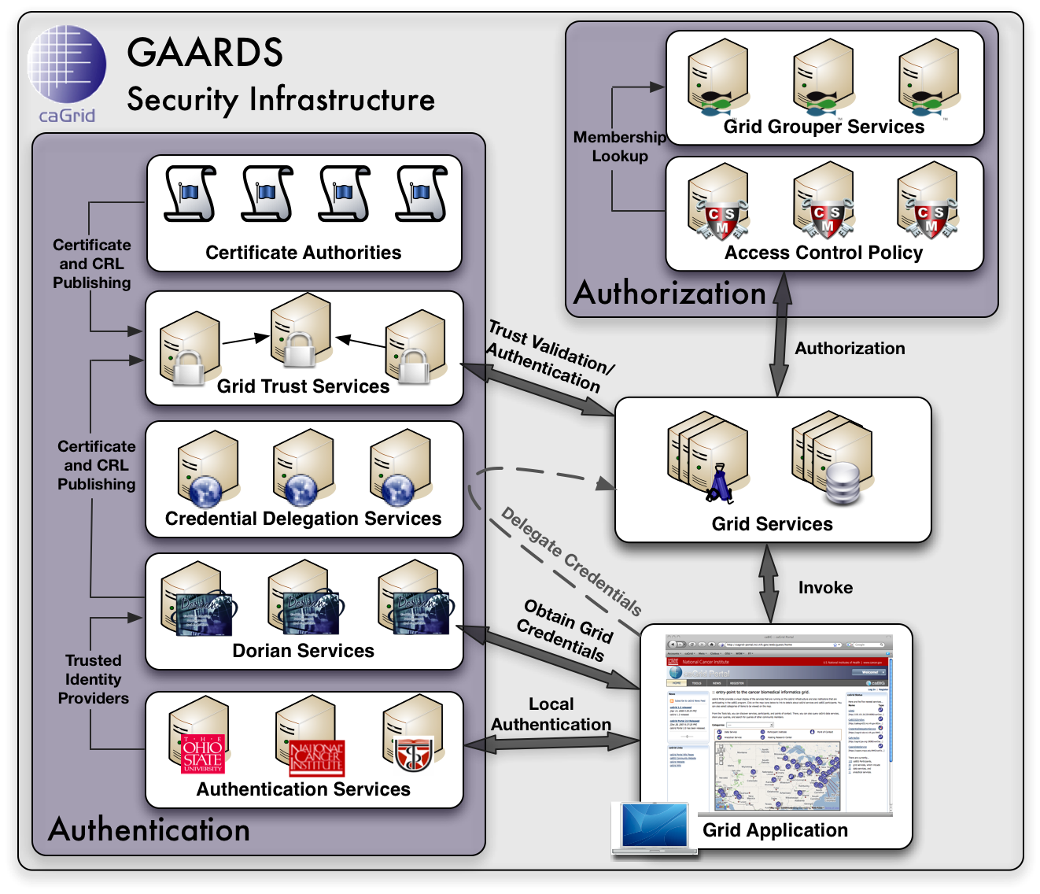

GAARDS comprises three principal components: Dorian, Grid Trust Service, and Grid Grouper.
Dorian
Identity management and federation is becoming an ever-present problem in large multi-institutional Grid environments. One underlying problem is to enable participating institutions to manage the identities of their own members by leveraging existing institutional identity management systems, while at the same time facilitating the participation in larger Grids through the deployment of Grid-wide user credentials.
Dorian is a Grid service for the provisioning and management of Grid user accounts. Dorian provides an integration point between external security domains and the Grid, allowing accounts managed in external domains to be federated and managed in the Grid. Other benefits of Dorian include the following:
- Provides graphical UI for account administration
- Provides built-in certificate authority
- Enables users to authenticate and create Grid proxies, which are used to access the Grid
- Issues and manages service credentials
- Creates and manages local accounts

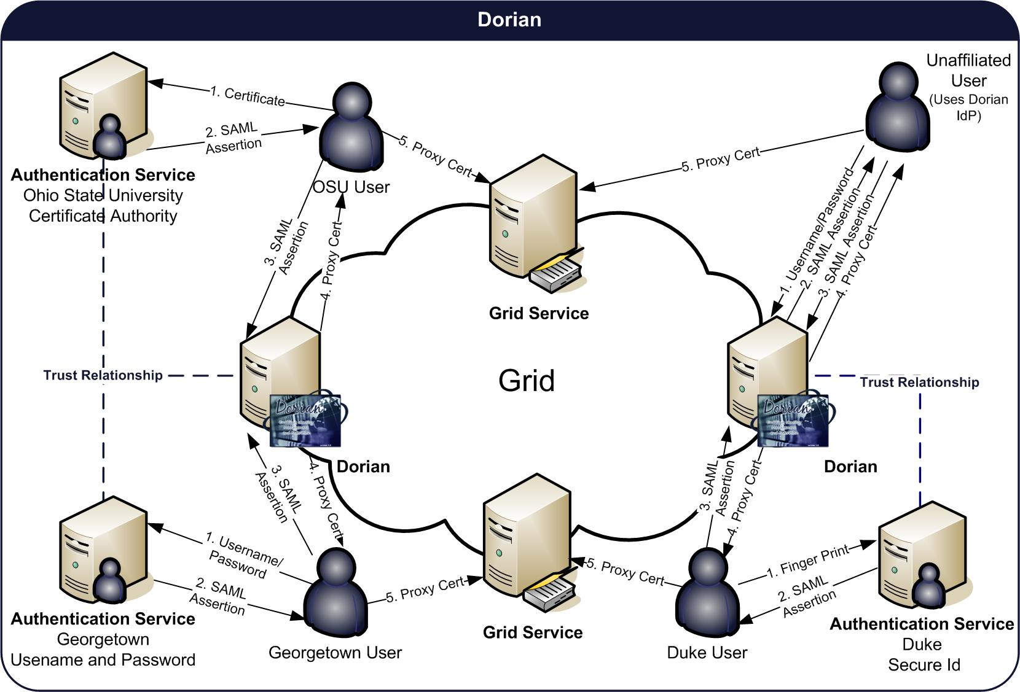
Grid Trust Service (GTS)
In order to authenticate and authorize users and other services, Grid services must maintain a list of certificate authorities they trust as a source for issuing credentials. Provisioning trusted certificate authorities and certificate revocation lists to both clients and servers in the Grid is a complicated task. The GTS is a federated Grid infrastructure enabling the provisioning and management of a Grid trust fabric. GTS features include the following:
- Provides a Grid-enabled federated solution for registering, managing, and distributing certificate authority certificates and CRLs, facilitating the enforcement of trust agreements against the latest trusted roots
- Allows the definition and management of trust levels, such that CAs may be grouped and discovered by the level of trust that is acceptable to the consumer
- Facilitates the curation of numerous independent trust overlays across the same physical Grid
- Provides a graphical UI for trust fabric administration

Grid Grouper
Grid Grouper provides a group-based authorization solution for the Grid, wherein Grid services and applications enforce authorization policy based on membership to groups defined and managed at the Grid level
Grid Grouper features include the following:
- Service for managing/accessing groups
- Basic group management
- Support for subgroups
- Support for composite groups (set logic)
- Set logic based membership queries
- Facilitation of group-based authorization
- UI for administering Grid Grouper

Credential Delegation Service (CDS)
The Credential Delegation Service (CDS) is a WSRF-compliant Grid service that enables users/services (delegators) to delegate their Grid credentials to other users/services (delegatees) such that the delegatee(s) may act on the delegator's behalf. The CDS enables secure workflow, distributed queries, web single sign on, and other secure distributed interactions in the Grid.
When delegating their credentials, delegators specify a delegation policy. The delegation policy specifies to the CDS who may be issued the delegators credential. Currently the CDS supports multiple delegation policies, these include a list based delegation policy and a Grid Grouper based delegation policy. Additional delegation policies can easily be plugged into the CDS.
Other GAARDS Features
In addition, GAARDS provides a fully functional graphical user interface. GAARDS also provides an Authentication Service framework for integrating existing credential providers into the Grid under a standardized Grid service interface; and a Common Security Module (CSM), a centralized approach to managing and enforcing access control policy authorization. In the future GAARDS will provide a Credential Delegation Service, enabling clients and services to remotely access delegated credentials.
