CaGrid Transfer 1.2 Design

Contents
CaGrid Transfer 1.2 Design 1
Architecture 2
Transfer Service 3
Transfer Service Helper 4
Transfer Webapp 4
Transfer Client Helper 5
Performance 6

Architecture
The architecture of the caGrid Transfer Service is simple yet powerful. It is comprised of the following 4 main components:
- Transfer Service
- Transfer Service Helper
- Transfer WebApp
- Transfer Client Helper
Each component plays a role in either staging the data, persisting the information representing the data to be transfered, securing the data, transferring the data from service to client or client to service, and cleaning the data up.
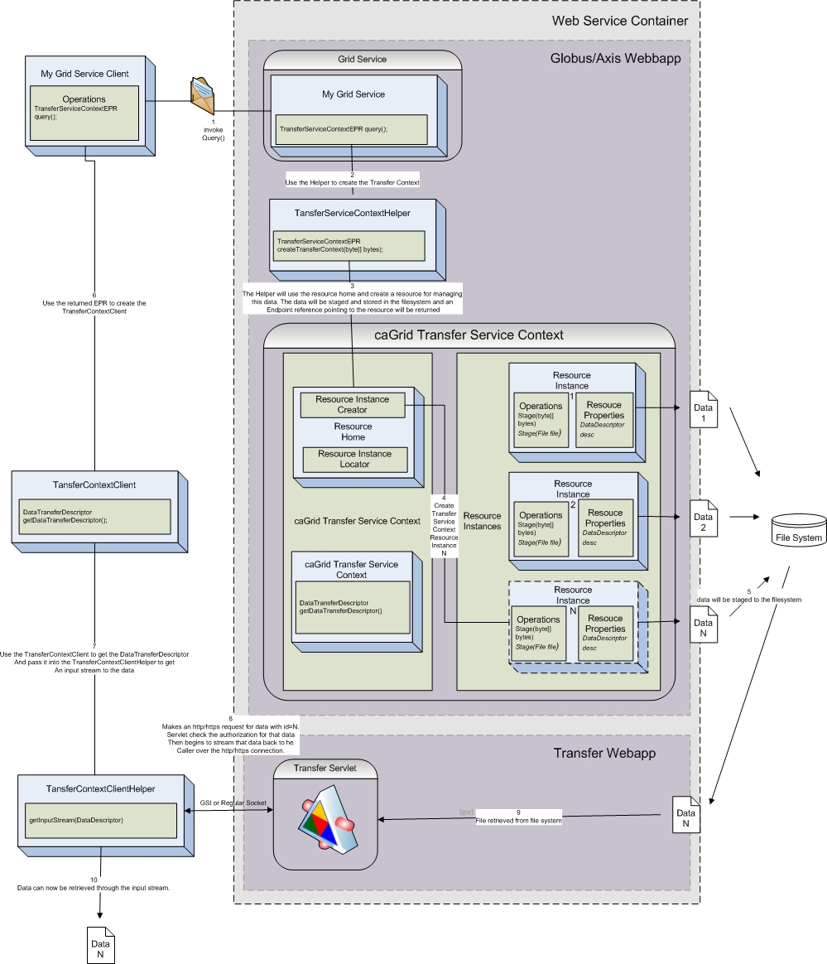

Transfer Service
The transfer service is a WSRF based grid service that is responsible for creating resources which represent the data to be held and transferred. This service utilizes the WS-ResourceFramework in order to create unique stateful resource instances for each data item desired to be transferred. The user of this service is intended to be another service running in the same container which has a large data item that the service does not wish to transmit over soap in the envelope as an XML element. The user will be able to pass either a pointer to a file or the data itself to the TransferServiceHelper. This Helper will create an Instance of the TransferServiceContext resource, via its ResourceHome, which will be responsible for storing this data and persisting a pointer to this data until the user’s client either picks this data up, or it is destroyed. The data will be stored as a file on the file system where it will sit until it is transferred and/or destroyed. The resource is also persistent, meaning it stores the information needed to operate, so that it can survive a container or system restart. This information will be persisted as a ResourceProperty on the service of the type DataStorageDescriptor. The service also supports the WS-Notification specification where as a client can subscribe to listen for changes to the DataStorageDescriptor (QNAME= http://transfer.cagrid.org/Transfer DataStorageDescriptor). This will enable the client to be notified of changes to the data staging status of the resource.
If this service is deployed into a secure container it will use the caller’s identity to protect the data. It will write the callers DN and the location of the file into its persisted data so that this data can be used by the TransferSerlvlet to validate the retriever of the data has the appropriate identification to retrieve the data item. The service will have a public method called getTransferDataDescriptor() which apon invoking will return a TransferDataDescriptor object to the user. This object will contain the URL required to retrieve this data over http or https.

Transfer Service Helper
The Transfer Service Helper is an API to be used on the server side to create the TransferServiceContextResource for the data item to be transferred. It will use the ResourceHome of the TransferServiceContext to create an instance of a TransferServiceContextResource which will maintain the user identification and the file location of the data to be transferred. The Transfer Service Helper has several createTransferContext methods which can be used to create a Transfer resource. Currently it can take in either a byte array, input stream, or file for download scenarios and doesn't need to have the data for upload scenarios. Each of these methods will return a TransferServiceContextReference which contains the EPR to the resource. The user will then be able to use this EPR to get the DataTransferDescriptor of the resource to be used for retrieval or submission.

Transfer Webapp
The Transfer Webapp is responsible for delivering the data to the consumer over an HTTP or GSI based HTTPS connection. This is written as a java servlet and deployed as a webapp into the same container that globus has been delployed. If the globus is deployed to this container in a non secure mode this container will be using basic http sockets and security is not enforced, i.e. anyone with the URL to the data item will be able to retrieve it. If the container is running securely than having this servlet in a webapp that is deployed to the same container enables this servlet to communicate over the same secure sockets, for example by using the same connector in Tomcat or JBoss, which is used by Axis/Globus. Using this same connector enables https connections using the GSI secure sockets to be used to invoke the java servlet. This secure connection will contain the credentials of the caller enabling the Transfer Webapp to compare the caller’s identity to the identity of the resource they are requesting. The Transfer Webapp will read the persistence resource properties file from the resource which represents this data in the TransferServiceContext, the DataStorageDescriptor, for this resource from the Globus container and compare the userDN attribute with the servlet callers authenticated DN. If they match then the caller has the same credentials as the creator of the data item and the data will then be streamed back to the caller. If not the connection will be dropped and the data will remain protected on the server.

Transfer Client Helper
The Transfer Client Helper is an API to be used on the client for retrieving or submitting the data item. The data item is either created by the grid service and being held by the servlet waiting to deliver it or will later be received by the servlet and held for the service to process. In the download scenario, if the container is secure than the user will call the operation below (if insecure null can be passed in for the credentials):


InputStream getData(DataTransferDescriptor desc, GSSCredential credentials);
and else the user can call the:

InputStream getData(DataTransferDescriptor desc);
This call will create the appropriate socket connection to the url provided in the DataTransferDescriptor which points to the data item to be transferred or the url where the data can be posted. If this connection is opened properly and the user is athorized the InputStream to the data will be returned. This InputStream will then be able to be read by the user to obtain the data. Once the data is read in total the user can call destroy on the TransferServiceContextClient to let the server know it can now remove the cached data.
In the case of upload, the same applies, except different methods will be used.

OutputStream putData(DataTransferDescriptor desc, GSSCredential credentials);
and else the user can call the:

OutputStream putData(DataTransferDescriptor desc);
In this case after the data has been written to the OutputStream the user should then call setStatus(Status.Staged) on the TransferServiceContextClient to let the service know that the data is now present and can be processed. If the user service registered a callback with the TransferServiceContextResource when it was created with the TransferServiceHelper that callback method will then be invoked.

Performance
The chart below is designed to show transfer time vs data size trends. It shows that the performance with respect to data size grows linearly. It also shows that using plain http vs GSI Encrypted https is on average an order of magnitude slower. The tests were ran with the client and server on the same machine to remove the possible variations due to network traffic. This allows the tests to show the latency trends of the software itself and ignore those caused by network anomalies or bandwidth.
