Authorization Management
The caGrid Authorization (Authz) component provides an integration point between local authorization policy and grid-wide authorization policy. Authorization policy in caGrid can be based on membership in groups that are defined in Grid Grouper. Authorization policy within an organization is usually based on an individual's identity within that organization. The Authz component provides a framework to map groups that have been defined in the NCICB’s Common Security Module (CSM) with groups that have been defined in a Grid Grouper service. The result is that local CSM administrators can extend access privileges to members of the caBIG community based on membership in Grid Grouper groups, rather than having to create local identities for each individual.
Since the Authz component has been designed to plug into the CSM framework, caCORE systems that use CSM can plug in the Authz component without changing code. (Authz requires version 3.2.1 of CSM).
This section describes how to configure CSM for a caCORE service to use the Authz component. A detailed, step-by-step tutorial on using the Authz component can be found on the caGrid wiki here: http://www.cagrid.org/mwiki/index.php?title=CaGrid:How-To:IntegrateCSMAuthorizationPolicy

JAAS Configuration
No changes are required to be made to CSM’s JAAS configuration.

ApplicationSecurityConfig.xml
caCORE services that are using CSM will have configured the gov.nih.nci.security.configFile system property to point to an ApplicationSecurityConfig.xml file. To use the Authz component, specify gov.nih.nci.cagrid.authorization.CSMGridAuthorizationManager as the implementation to use for both the authorization manager.
Figure Error! No text of specified style in document.-1 contains an example ApplicationSecurityConfig.xml file.
<security-config>
<upt-context-name>UPT</upt-context-name>
<application-list>
<application>
<context-name>SDK</context-name>
<authentication>
<lockout-time>100</lockout-time>
<allowed-login-time>100</allowed-login-time>
<allowed-attempts>3</allowed-attempts>
<authentication-provider-class>
</authentication-provider-class>
</authentication>
<authorization>
<authorization-provider-class>
gov.nih.nci.cagrid.authorization.impl.CSMGridAuthorizationManager
</authorization-provider-class>
<hibernate-config-file>
/my/app/etc/hibernate.cfg.xml
</hibernate-config-file>
</authorization>
</application>
</application-list>
</security-config>
Figure Error! No text of specified style in document.-1 ApplicationSecurityConfig.xml file

hibernate.cfg.xml
Hibernate must be configured to use the c3p0 connection pool. Add the following properties to the session-factory element in the hibernate.cfg.xmlfile.
<property name="hibernate.c3p0.min_size">5</property>
<property name="hibernate.c3p0.max_size">20</property>
<property name="hibernate.c3p0.timeout">300</property>
<property name="hibernate.c3p0.max_statements">50</property>
<property name="hibernate.c3p0.idle_test_period">3000</property>

Web Applications Classpath
Table Error! No text of specified style in document.-1 contains the jars that must be added to the web applications classpath.
From the Globus 4.0.3  WS Core Distribution | From other caGrid 1.1 Projects (these end up in cagrid-1-1/ext/lib, when building the Authz project). | From the Authz project’s lib folder:
addressing-1.0.jar | caGrid-1.1-core.jar | c3p0-0.8.5.2.jar
axis.jar | caGrid-1.1-gridca.jar | clm.jar
cog-axis.jar | caGrid-1.1-gridgrouper-client.jar | csmapi.jar
cog-jglobus.jar | caGrid-1.1-gridgrouper-common.jar | hibernate-3.0.5.jar
cryptix-asn1.jar | caGrid-1.1-gridgrouper-stubs.jar | spring-core.jar
cryptix.jar | caGrid-1.1-metadata-common.jar | spring-beans.jar
cryptix32.jar | caGrid-1.1-metadata-security.jar
jce-jdk13-125.jar | caGrid-1.1-ServiceSecurityProvider-client.jar
jgss.jar | caGrid-1.1-ServiceSecurityProvider-common.jar
puretls.jar | caGrid-1.1-ServiceSecurityProvider-service.jar
wsrf_common.jar | caGrid-1.1-ServiceSecurityProvider-stubs.jar
wsrf_core_stubs.jar | cglib-nodep-2.1_3.jar
wsrf_core.jar | grouper.jar
wss4j.jar | mobius_common_client.jar
 | mobius_factories.jar
 | mobius_gme_client.jar
 | mobius_mako_client.jar
 | mobius_tools.jar
 | subject-0.2.1.jar
Table Error! No text of specified style in document.-1 jars to add to the web applications classpath
Finally, a file named ObjectStateLoggerConfig.xml must be added to the classpath. That file should look like the following (Figure Error! No text of specified style in document.-2).
<?xml version="1.0" encoding="UTF-8"?>
<logging-config>
<logger-name>CSM.Audit.Logging.ObjectState.Authorization</logger-name>
<logger-config-file>log4jConfig.xml</logger-config-file>
<log-level>info</log-level>
<messageType>string</messageType>
<domainObjectList>
<object-name>gov.nih.nci.security.authorization.domainobjects.Application</object-name>
<object-name>gov.nih.nci.security.authorization.domainobjects.ApplicationContext</object-name>
<object-name>gov.nih.nci.security.authorization.domainobjects.Group</object-name>
<object-name>gov.nih.nci.security.authorization.domainobjects.GroupRoleContext</object-name>
<object-name>gov.nih.nci.security.authorization.domainobjects.Privilege</object-name>
<object-name>gov.nih.nci.security.authorization.domainobjects.ProtectionElement</object-name>
<object-name>gov.nih.nci.security.authorization.domainobjects.ProtectionElementPrivilegeContext</object-name>
<object-name>gov.nih.nci.security.authorization.domainobjects.ProtectionGroup</object-name>
<object-name>gov.nih.nci.security.authorization.domainobjects.ProtectionGroupRoleContext</object-name>
<object-name>gov.nih.nci.security.authorization.domainobjects.Role</object-name>
<object-name>gov.nih.nci.security.authorization.domainobjects.User</object-name>
<object-name>gov.nih.nci.security.authorization.domainobjects.UserGroupRoleProtectonGroup</object-name>
<object-name>gov.nih.nci.security.authorization.domainobjects.UserProtectionElement</object-name>
<object-name>gov.nih.nci.security.authorization.domainobjects.UserRoleContext</object-name>
<object-name>gov.nih.nci.security.authorization.dao.hibernate.ProtectionGroupProtectionElement</object-name>
<object-name>gov.nih.nci.security.authorization.dao.hibernate.RolePrivilege</object-name>
<object-name>gov.nih.nci.security.authorization.dao.hibernate.UserGroup</object-name>
</domainObjectList>
<loggingEnabled>true</loggingEnabled>
</logging-config>
Figure Error! No text of specified style in document.-2 ObjectStateLoggerConfig.xml

CSM Administration
This section provides an example scenario to illustrate the steps that a local CSM administrator would take to extend access privileges to caGrid users.
In this scenario, the administrator would like to permit members of the “cabig:researchers” group to query his caCORE system for gov.nih.nci.cabio.domain.Gene objects. The Grid Grouper instance in which this group is defined is running at https://some.host:8443/wsrf/services/cagrid/GridGrouper.
Perform the following steps with the UPT.
- Create a group named {https://some.host:8443/wsrf/services/cagrid/GridGrouper}cabig:researchers (Figure Error! No text of specified style in document.-3).
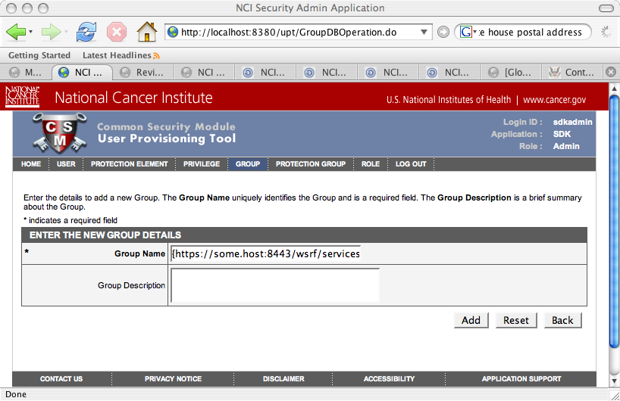
Figure Error! No text of specified style in document.-3 Create a group in the UPT
In this scenario, it is assumed that the “gov.nih.nci.cabio.domain.Gene” protection element already exists, and is a member of the “Domain Objects” protection group (Figure Error! No text of specified style in document.-4).
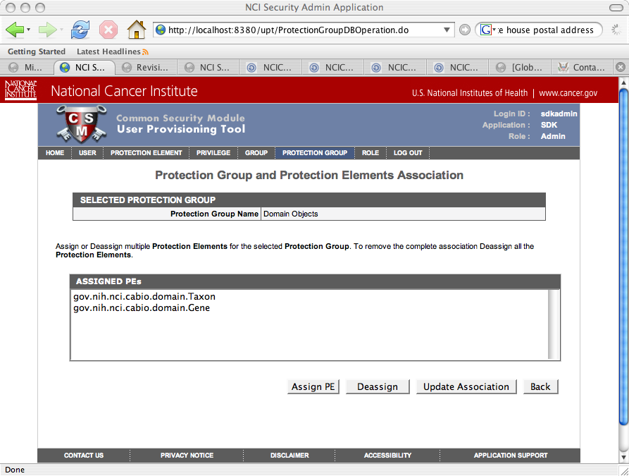
Figure Error! No text of specified style in document.-4 Protection groups and protection group elements in the UPT
- It is also assumed that a role named “Domain Object Readers” exists and has a single “READ” privilege (Figure Error! No text of specified style in document.-5).
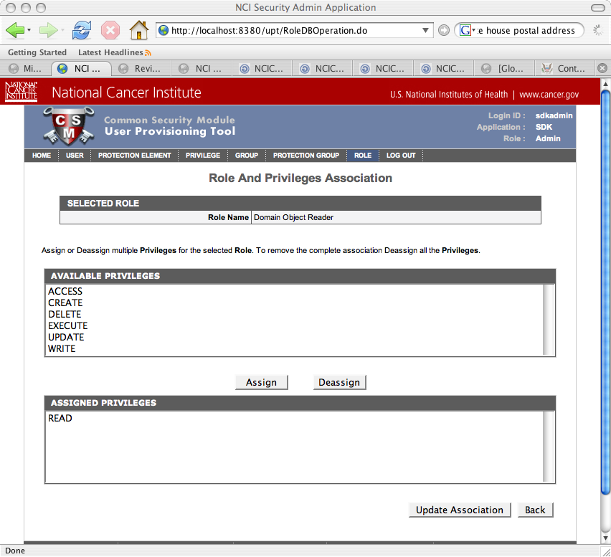
Figure Error! No text of specified style in document.-5 Role and privileges association in the UPT
- To grant the “READ” privilege to members of the “{https://some.host:8443/wsrf/services/cagrid/GridGrouper}cabig:researchers” group, assign the “Domain Objects” protection group and “Domain Object Readers” role to this group (Figure Error! No text of specified style in document.-6 and Figure Error! No text of specified style in document.-7).
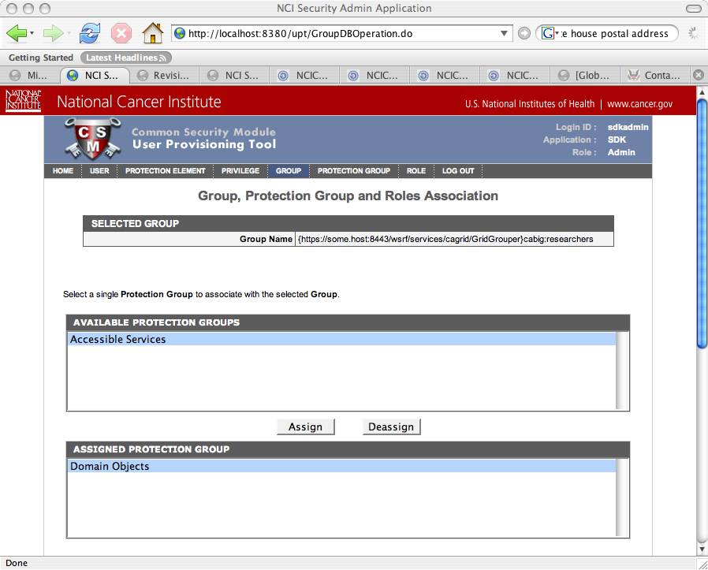
Figure Error! No text of specified style in document.-6 Group, Protection Group and Roles Association in the UPT
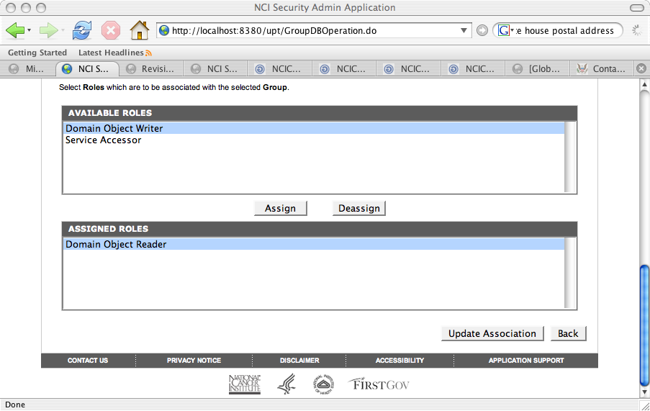
Figure Error! No text of specified style in document.-7 Group, Protection Group and Roles Association in the UPT
- Now, assuming that the following /O=NIH/OU=NCI/OU=NCICB/OU=DEV/OU=localhost/OU=IdP [1]/CN=george identity is a member of the “cabig:researchers” group, the following code should print “Authorized: true” (Figure Error! No text of specified style in document.-8).
String identity =
"/O=NIH/OU=NCI/OU=NCICB/OU=DEV/OU=localhost/OU=IdP [1]/CN=george";
String app = "myapp";
String objectId = "gov.nih.nci.cabio.domain.Gene";
String privilege = "READ";
AuthorizationManager mgr = SecurityServiceProvider.getAuthorizationManager(app);
boolean authorized = mgr.checkPermission(identity, objectId, privilege);
System.out.println("Authorized: " + authorized);
Figure Error! No text of specified style in document.-8 Code verification

