Design Document Artifact for Workflow Submission GUI

Introduction: The Workflow Submission GUI allows the users to submit, monitor BPEL workflows. It also allows users discover and add services to be used in the workflow. User can also get output of the workflow once the workflow is done execution.

In the following paragraphs we try to outline some of the capabilities of the GUI.

Submitting a Workflow: The user can enter the path to the BPEL document inside the BPEL File text field or the user can browse to the location of the BPEL document.
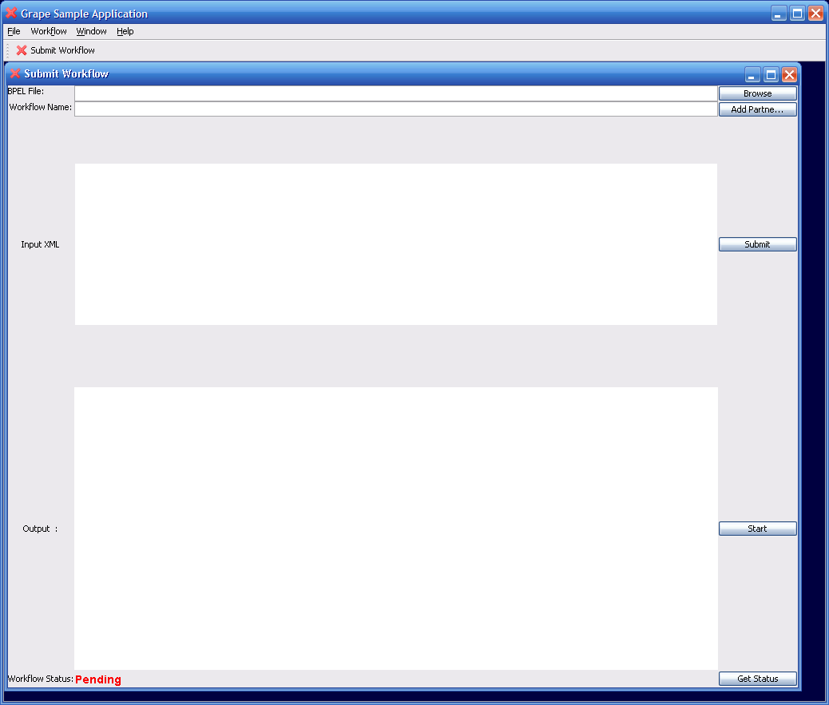

The workflow name should be the name of the BPEL doc. Once the user is done with having valid values for both the text fields, press Submit button. This would submit the workflow to a pre-configured Workflow Factory Service. After this step the BPEL document is validated and submitted to the Workflow Engine. If there are no errors the Status is changed from Pending - > Submitted.

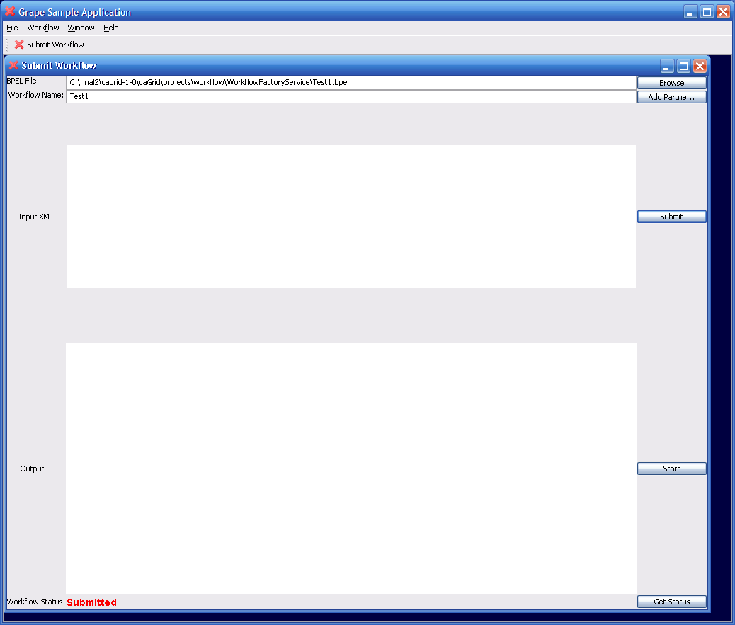

Execution of the Workflow: The next step is to execute the submitted workflow with some input. In the current implementation the user has to paste the input XML in to the text area and press the Start button. If the workflow is started without problems then the Status is changed to Active.
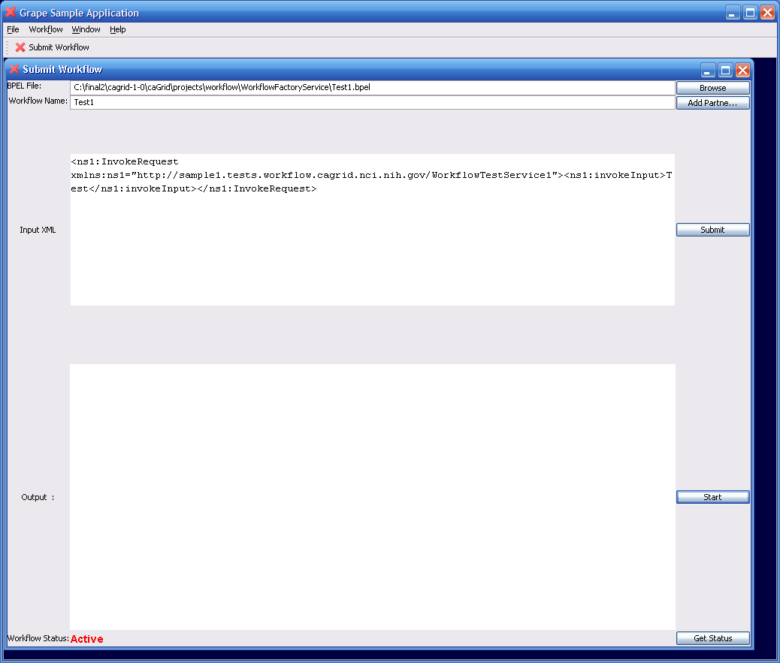

Querying for Status: Press the Get Status button and if the status is different from the existing status that is on the left hand corner of the GUI, the status changes to the latest status.

Getting Workflow Output: Press the Get Status button and if the status of workflow is Done the workflow output is displayed in the output text area.

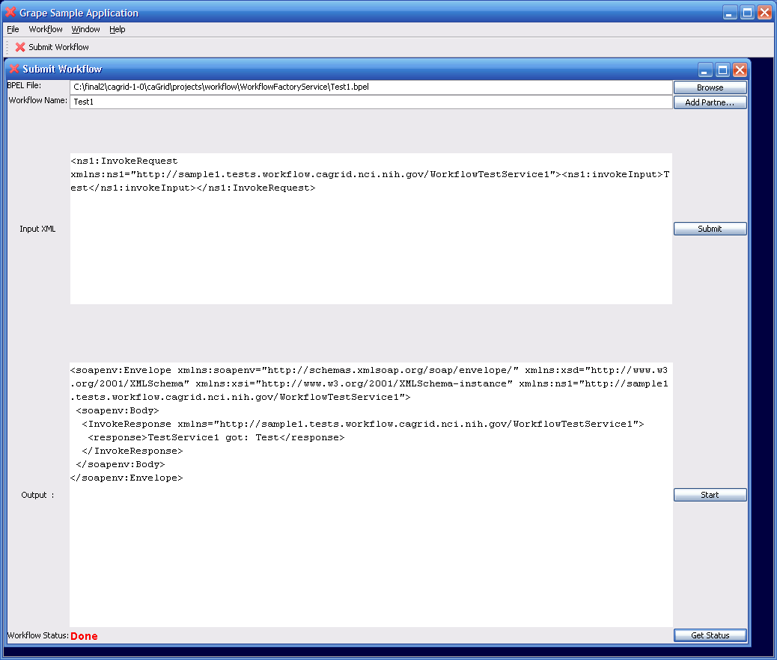

Future Work: Future work includes tying this GUI to a BPEL authoring GUI, adding partnerLinks (services to be used in the workflow) to the workflow and adding support for getting more detailed status.

