Use Case Document

caGrid 1.0 Workflow
Ravi Madduri, Argonne National Labs
Patrick McConnell, Duke Comprehensive Cancer Center

DOCUMENT REVISION HISTORY
Version Number | Date | Description
0.1 | 8/23/2006 | Initial template draft by Patrick

Background/Summary
caBIG aims to bring together disparate data and analytic resources into a “World Wide Web of cancer research.” This will be achieved through common standards and software frameworks for the federation of these resources into “grid” services. Many of the tasks in the collection and analysis of cancer-related data on the grid involve the use of workflow. Here, we define workflow as the connecting of services to solve a problem that each individual service could not solve. In bioinformatics, this is sometimes referred to as a pipeline. This is different than the workflow in wet-lab information management (LIMS), where workflow refers to the steps that a lab sample takes through processing. This is also different than workflow often seen in a clinical trials management system, where patient data is tracked through multiple systems and departments. Furthermore, this is different from modeling of biological processes, where each node in the workflow represents some biological entity and the connections represent the interactions. Instead, analytical workflow involves the consumption of analytic and data services, where data is piped between them, logical decisions are made along the way, and data transformations are common.
It can be useful to think of a workflow as representing a process in the real world. Though this definition has roots in modeling business processes, it has application to modeling bioinformatics processes as well. For example, you can envision a researcher collecting a set of related microarray experiments from various services across various institutions. This process can be modeled as a grid workflow, where the actors are the researcher and the services, and the actions are the invocation of the services and the collation of the results.
In contrast, it is also useful to think of a workflow as a grid-aware scripting language. For example, you can envision a script that takes all of the expressed genes from a microarray experiment, searches for all up-stream genes in pathways, and finally finds gene ontology information for these genes. Here, there is a specific set of steps to be executed that can be expressed in a way natural to a grid environment.

Table of Contents
1 Introduction 4
1.1 Overview 4
1.2 Related Documents 4
2 Actors and Goals 4
2.1 Grid node administrator 4
2.2 Workflow consumer 4
3 System Use Cases 5
3.1 Deploy the WMS 5
3.2 Create workflow 6
3.3 Start workflow 7
3.4 Get workflow status 8
3.5 Cancel workflow 9
3.6 Pause a workflow 10
3.7 Resume a workflow 11
3.8 Get workflow results 11
3.9 Destroy a workflow 12
4 Scientific/Application Use Cases 13
4.1 Proteomics analysis workflow 13
4.2 Microarray analysis workflow 16
4.3 Image analysis workflow 17
4.4 Genomic identifier workflow 19
5 Overall Requirements 20
5.1 Requirements Prioritization 20
6 Sign Off 21
6.1 Approval 21

Introduction

Overview
Workflow in caGrid is implemented as a grid service that performs a workflow described by a Business Execution Process Language (BPEL) document. That document contains the endpoints (dynamically or statistically defined) of the services to contact, the formats of the messages to transfer between the services, and the logic in between. Here, we describe the use cases for that engine: both from a system standpoint and a scientific/application standpoint.

Related Documents
caGrid documentation:
- http://gforge.nci.nih.gov/plugins/scmcvs/cvsweb.php/cagrid-1-0/Documentation/docs/?cvsroot=cagrid-1-0
Workflow documentation
- http://gforge.nci.nih.gov/plugins/scmcvs/cvsweb.php/cagrid-1-0/Documentation/docs/workflow/?cvsroot=cagrid-1-0

Actors and Goals

Grid node administrator
A grid node administrator deploys and maintains the components necessary to run the workflow service. This includes any services, databases, security components, and other resources required.

Workflow consumer
A workflow consumer composes workflows and submits them to the workflow management service (WMS).

System Use Cases

Deploy the WMS

Brief Description
The grid node administrator deploys the WMS.

Primary Actor
Grid node administrator

Secondary Actors
None

Preconditions

ActiveBPEL
ActiveBPEL and all of its dependencies are running and accessible to the WMS

Basic Flow of Events

The grid node administrator runs the caGrid installer for the WMS

The caGrid installer makes modifications to ActiveBPEL

The caGrid installer installs the WMS into the specified grid container

The grid node administrator restarts the specified grid container

Alternate flows
None

Postconditions
The WMS is installed and ActiveBPEL is modified.

Special Requirements
None

Create workflow

Brief Description
The workflow consumer creates a workflow by submitting a BPEL document wrapped in an input message to the WMS.

Primary Actor
Workflow consumer

Secondary Actors
None

Preconditions

ActiveBPEL
ActiveBPEL is running and accessible to the WMS

WMS
The workflow management service is deployed, running, and accessible

Partner links
All partner links defined in the workflow are accessible to the workflow engine

Authentication
The workflow consumer is authenticated and has a valid user proxy certificate

Basic Flow of Events

The workflow consumer constructs a workflow input object

The workflow consumer invokes the createWorkflow method of the WMS

The WMS submits the workflow to ActiveBPEL

ActiveBPEL performs the workflow

ActiveBPEL returns the results to the WMS

The WMS returns the results to the workflow consumer

Alternate flows

Exceptional situations
If the input message is not constructed properly, an Exception will be returned to the workflow consumer.

Postconditions
The workflow is in the pending state

Special Requirements
None

Start workflow

Brief Description
The workflow consumer starts a workflow by invoking start on the WMS.

Primary Actor
Workflow consumer

Secondary Actors
None

Preconditions

WMS
A created workflow is pending or paused

Basic Flow of Events

The workflow consumer invokes the start method of the WMS

Alternate flows
None

Postconditions
The workflow is active

Special Requirements
None

Get workflow status

Brief Description
The workflow consumer gets the status of a workflow by invoking getStatus on the WMS.

Primary Actor
Workflow consumer

Secondary Actors
None

Preconditions
None

Basic Flow of Events

The workflow consumer invokes the getStatus method of the WMS

Alternate flows
None

Postconditions
None

Special Requirements
None

Cancel workflow

Brief Description
The workflow consumer cancels a workflow by invoking cancel on the WMS.

Primary Actor
Workflow consumer

Secondary Actors
None

Preconditions

WMS
A created workflow is active or pending

Basic Flow of Events

The workflow consumer invokes the cancel method of the WMS

Alternate flows
None

Postconditions
The workflow is cancelled

Special Requirements
None

Pause a workflow

Brief Description
The workflow consumer pauses a workflow by invoking pause on the WMS.

Primary Actor
Workflow consumer

Secondary Actors
None

Preconditions

WMS
A created workflow is active

Basic Flow of Events

The workflow consumer invokes the pause method of the WMS

Alternate flows
None

Postconditions
The workflow is paused

Special Requirements
None

Resume a workflow

Brief Description
The workflow consumer resumes a paused workflow by invoking resume on the WMS.

Primary Actor
Workflow consumer

Secondary Actors
None

Preconditions

WMS
A created workflow is paused

Basic Flow of Events

The workflow consumer invokes the resume method of the WMS

Alternate flows
None

Postconditions
The workflow is active

Special Requirements
None

Get workflow results

Brief Description
The workflow consumer gets the results of a completed workflow by invoking getWorkflowResults on the WMS.

Primary Actor
Workflow consumer

Secondary Actors
None

Preconditions

WMS
A created workflow is done

Basic Flow of Events

The workflow consumer invokes the getWorkflowResults method of the WMS

Alternate flows
None

Postconditions
None

Special Requirements
None

Destroy a workflow

Brief Description
The workflow consumer destroys a created workflow by invoking destroy on the WMS.

Primary Actor
Workflow consumer

Secondary Actors
None

Preconditions

WMS
None

Basic Flow of Events

The workflow consumer invokes the destroy method of the WMS

Alternate flows
None

Postconditions
The workflow no longer exists

Special Requirements
None

Scientific/Application Use Cases

Proteomics analysis workflow

Use Case Model
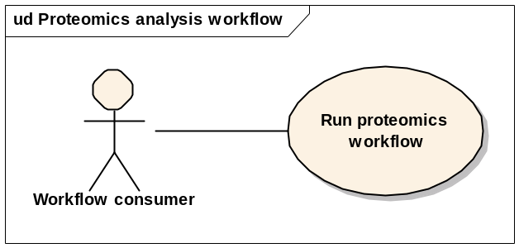

Brief Description
In this use case, a workflow is constructed to perform various analysis steps in the low-level proteomics analysis pipeline. This consists of interpolation, denoising, background removal, alignment, and normalization. The input to the workflow is a set of ScanFeatures documents, and the output is a set of processed ScanFeatures documents. More than one RProteomics services can be used.

Primary Actor
Workflow consumer

Secondary Actors
None

Preconditions

RProteomics service deployed
An RProteomics analysis service is deployed and accessible.

Workflow service deployed
A workflow management service has been deployed and is accessible.

Input data
A set of ScanFeatures documents exists as input.

Basic Flow of Events
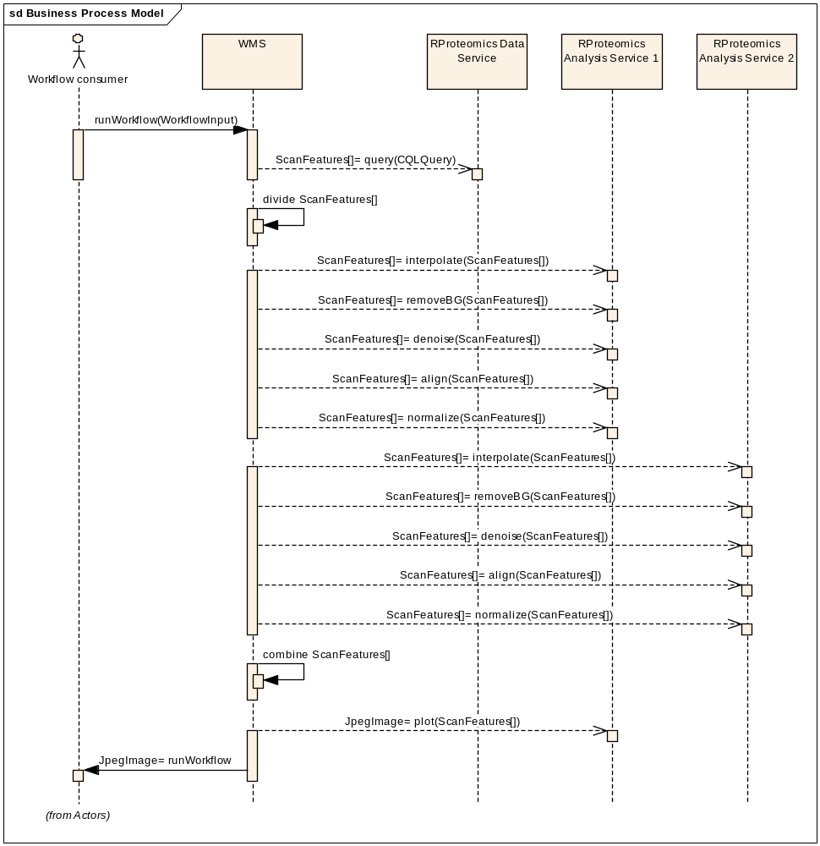

Postconditions
None

Output data
A JPEG image is available

Special Requirements
None

Microarray analysis workflow

Use Case Model
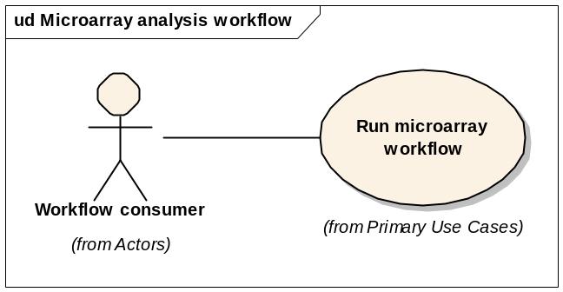

Brief Description
In this use case, a workflow is constructed to get data from a microarray data service and then run various analysis steps on it. These could consist of normalization and clustering-based analyses. The input of the workflow is a set of MAGE objects and the output is a set of analyzed MAGE objects or a set of cluster objects (respectively).

Primary Actor
Workflow consumer

Secondary Actors
None

Preconditions

Workflow service deployed
A workflow management service has been deployed and is accessible.

Basic Flow of Events

The user submits the workflow

The WMS performs the workflow
- caArray is queries and MAGE objects are returned
- The MAGE objects are sent to a normalization service
- The resulting MAGE objects are sent to a clustering service

The user gets the results of the workflow

Postconditions
None

Output data
A set of MAGE or cluster objects are available

Special Requirements
None

Image analysis workflow

Use Case Model
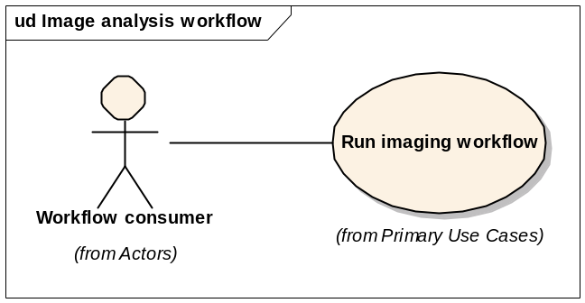

Brief Description
In this use case, a workflow is constructed to perform various analysis steps in an image analysis pipeline. Data is retrieved from NCIA and piped through various GridIMAGE steps.

Primary Actor
Workflow consumer

Secondary Actors
None

Preconditions

Workflow service deployed
A workflow management service has been deployed and is accessible.

Basic Flow of Events

The user submits the workflow

The WMS performs the workflow
- NCIA is queried and DICOM objects are returned
- The DICOM objects are sent to the GridIMAGE service

The user gets the results of the workflow

Postconditions
None

Output data
A set of DICOM objects is available

Special Requirements
None

Genomic identifier workflow

Use Case Model
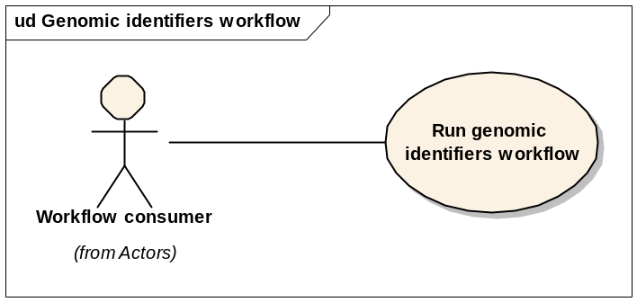

Brief Description
In this use case, genomic identifies are used to reference data in an analysis pipeline.

Primary Actor
Workflow consumer

Secondary Actors
None

Preconditions

Workflow service deployed
A workflow management service has been deployed and is accessible.

Basic Flow of Events

The user submits the workflow

The WMS performs the workflow
- A data service is queried, and grid identifiers are returned
- The grid identifiers are passed into an analysis service, and resulting data is returned

The user gets the results of the workflow

Postconditions

Output data
A set of data objects or identifiers to data objects exist

Special Requirements
None

Overall Requirements

Requirements Prioritization

Priority | Use Case Name | Supp Requirement Ref #
1 | System use cases
2 | Scientific use cases

Sign Off

Approval

Workspace General Contractor Rep Print Name Date
Architecture Workspace Rep Print Name Date
VCDE Workspace Rep Print Name Date
Workspace Working Group Rep Print Name Date
NCICB Rep Print Name Date

