Workflow Requirements Proposal

caBIG Architecture Workflow SIG

Shannon Hastings, Ohio State University
Moses Hohman, Northwestern University
Steve Lagou, Panther Informatics
Patrick McConnell, Duke University

Technology and Language Reviews:

Shannon Hastings, Ohio State University
Moses Hohman, Northwestern University
Manav Kher, SAIC/NCICB
Vinay Kumar, 9 Star Research
Steven Lagou, Panther Informatics
Nick Marcou, Lombardi Comprehensive Cancer Center
Patrick McConnell, Duke Comprehensive Cancer Center
Salvatore Mungal, Duke Comprehensive Cancer Center

Document Revision History

Version Number | Date | Editor | Description
0.1 | 2/1/2005 | Patrick McConnell | Draft
0.1 | 2/2/2005 | Patrick McConnell | Continued draft
0.2 | 2/14/2005 | Patrick McConnell | Continued draft
0.3 | 2/15/2005 | Patrick McConnell | Updated with Shannon Hasting’s comments
0.4 | 2/16/2005 | Patrick McConnell | Added use cases, updated with feedback from SIG
0.5 | 2/21/2005 | Shannon Hastings | Edited parallelism
0.6 | 2/21/2005 | Patrick McConnell | Edited revision table  Added parallelism to feature table
0.7 | 2/22/2005 | Moses Hohman | Revised use case/usage narrative section
0.8 | 2/28/2005 | Moses Hohman | More changes to usage narrative section
0.9 | 2/28/2005 | Steven P Lagou | Added workflow control patterns to appendices
0.10 | 3/1/2005 | Patrick McConnell | Minor formatting and changes
0.11 | 3/1/2005 | Steven P Lagou | Added details to Patterns 10 & 11 and added language comparison table (section 9.2)
0.12 | 3/3/2005 | Shannon Hastings | Added text about workflow aware services (section 6.4)
0.13 | 3/2/2005 | Patrick McConnell | Added languages and technologies.  Reformatted document.  Added and sorted authors.  Minor grammar changes in Shannon’s latest edits.
0.14 | 3/7/2005 | Patrick McConnell | Added language and technology overview tables
0.15 | 3/8/2005 | Patrick McConnell | Added timeout exception requirement and WS-CDL language
0.16 | 3/9/2005 | Patrick McConnell | Added missing async requirement
0.17 | 3/30/2005 | Patrick McConnell | Added GOMiner usage narrative
0.18 | 3/31/2005 | Patrick McConnell | Added semantics requirements  Added biological process workflow type  Added testing harness requirements
0.19 | 5/20/2005 | Patrick McConnell | Added usage narrative from Dartmouth
0.20 | 7/25/2005 | Patrick McConnell | Updated Scope  Added requirements analysis  Added recommendation
0.21 | 7/27/2005 | Moses Hohman | Grammatical and working changes
1.1 | 10/25/2005 | Patrick McConnell | Added new engine requirements  Added service operations
1.2 | 11/3/2005 | Patrick McConnell | Revised engine requirements

Contents
1 Contents 2
2 Introduction 4
3 Background 4
4 Scope 5
5 Usage narratives 5
5.1 The Integrative Cancer Research Workspace 5
5.1.1 Translational narratives 5
5.1.2 Proteomics narratives 6
5.1.3 Data analysis narratives 6
5.1.4 Microarray narratives 9
5.1.5 Gene annotation narratives 9
5.2 The Clinical Trials Management Systems Workspace 9
5.2.1 Microarray clinical data, David Fenstermacher 10
5.2.2 Clinical data integration, Terry Braun 11
5.3 The Tissue Bank and Pathology Workspace 11
6 Requirements 11
6.1 Requirements overview 11
6.2 Functional language requirements 12
6.3 Nonfunctional language requirements 16
6.4 Functional implementation requirements 16
6.5 Nonfunctional implementation requirements 18
7 Technology review 19
7.1 Overview 19
7.2 Workflow languages 20
7.2.1 Ant 20
7.2.2 BPEL 20
7.2.3 DAX/VDL 20
7.2.4 DPML 20
7.2.5 JXPL 20
7.2.6 MoML 20
7.2.7 Scufl 21
7.2.8 UML 21
7.2.9 WSBAW 21
7.2.10 WS-CDL 21
7.2.11 WSCI 22
7.2.12 WSFL 22
7.2.13 XLANG 22
7.2.14 XPDL 22
7.2.15 xWFL 22
7.3 Workflow engines 22
7.3.1 BioWBI 22
7.3.2 COG 23
7.3.3 DiscoveryNet 23
7.3.4 GridAnt 24
7.3.5 GridBus 24
7.3.6 GridNexus 25
7.3.7 GSFL 25
7.3.8 Kepler 26
7.3.9 Pegasus 26
7.3.10 Pegasys 26
7.3.11 Taverna 27
7.3.12 Triana 27
7.3.13 WfMOpen 28
7.3.14 WINNER 28
8 Requirements analysis 29
8.1 Methodology 29
8.2 Results 30
9 Recommendation 31
9.1 Workflow language recommendation 31
9.2 Workflow engine recommendation 32
10 Workflow implementation 32
10.1 Workflow service operations 32
11 Appendices 33
11.1 Workflow Control Patterns 33
11.1.1 Basic Control Patterns 33
11.1.2 Advanced Branching and Synchronization Patterns 36
11.1.3 Structural Patterns 41
11.1.4 Patterns Involving Multiple Instances 43
11.1.5 State-based patterns 43
11.1.6 Cancellation Patterns 43
11.2 Workflow definition standard control pattern support 44

Introduction
This paper will introduce a recommendation for caBIG Workflow to the Architecture Workspace. It will first define the need for workflow within caBIG, and delineate the scope of the proposed solution. It will then lay out the proposal in the form of a systems overview. Finally it will call out any unresolved issues and summarize the proposal.

Background
caBIG aims to bring together disparate data and analytic resources into a “World Wide Web of cancer research.” This will be achieved through common standards and software frameworks for the federation of these resources into “grid” services. Many of the tasks in the collection and analysis of cancer-related data on the grid involve the use of workflow. Here, we define workflow as the connecting of services to solve a problem that each individual service could not solve. In bioinformatics, this is sometimes referred to as a pipeline. This is different than the workflow in wet-lab information management (LIMS), where workflow refers to the steps that a lab sample takes through processing. This is also different than workflow often seen in a clinical trials management system, where patient data is tracked through multiple systems and departments. Furthermore, this is different from modeling of biological processes, where each node in the workflow represents some biological entity and the connections represent the interactions. Instead, analytical workflow involves the consumption of analytic and data services, where data is piped between them, logical decisions are made along the way, and data transformations are common.

It can be useful to think of a workflow as representing a process in the real world. Though this definition has roots in modeling business processes, it has application to modeling bioinformatics processes as well. For example, you can envision a researcher collecting a set of related microarray experiments from various services across various institutions. This process can be modeled as a grid workflow, where the actors are the researcher and the services, and the actions are the invocation of the services and the collation of the results.

In contrast, it is also useful to think of a workflow as a grid-aware scripting language. For example, you can envision a script that takes all of the expressed genes from a microarray experiment, searches for all up-stream genes in pathways, and finally finds gene ontology information for these genes. Here, there is a specific set of steps to be executed that can be expressed in a way natural to a grid environment.

Scope
There is a wide spectrum of technologies and languages that in some way implement or leverage workflow. In this recommendation, we do not propose to select one language or one implementation as the only way to perform workflow on the caBIG grid. Instead, we aim to lay out the requirements that the domain workspaces have for workflow. We then will examine existing workflow languages and implementations to find those that do fit the requirements. We will select one language as a reference language for performing workflow on the caBIG grid. This is simply one path to implementing workflow which meets the requirements we were given. After selecting a workflow language, we will lay out the grid interfaces necessary for a workflow service to be accessible and useful on the grid. Finally, we will create a high-level architectural specification for implementing these interfaces with the workflow language selected. These specifications are but suggestions to the team that will ultimately be implementing the workflow engine. Through this process, we will identify existing components and technologies that could potentially be reused in the implementation process. The reference implementation should be considered as an example for other workflow engines and languages to utilize the caBIG grid.

Usage narratives
It is a common misperception that workflow is not needed or can be replaced with distributed querying. Here we describe usage narratives taken from the caBIG domain workspaces that demonstrate a clear need for workflow, as well as help provide a high-level view of the requirements of the workflow language.

We have opted to keep descriptions of workflow use at a high, narrative level, rather than in detailed use cases. This reflects our perception that the community is new to the use of workflow languages, and is not yet ready to be more specific. For this reason we use the term “usage narrative” to distinguish from the more specific and more precise “use case” formalism.

The Integrative Cancer Research Workspace
The Integrative Cancer Research Workspace has provided the richest set of workflow usage narratives because of the heavy amount of analysis-type services being implemented. We describe a handful of these narratives here.

Translational narratives

Cross-workspace, Paul Courtney
Researcher X is PI for a multi-site prevention trial at Institution A that examines the effect of aspirin and/or folate on the development of adenomas of the large colon. A subject must have at least one adenomous polyp to be eligible for this trial. This polyp is put in formalin and then in a paraffin block and a section put on a slide and stained for the pathologist to examine. The blocks are kept at the local path labs. During the 3-5 years of follow-up that a subject is in this trial, blood is obtained at enrollment and at three years after randomization; this blood is stored in a -70° C freezer in the Biospecimen Repository of Institution A. A total of 1100 subjects are randomized in this trial. During follow-up colonoscopies, any polyps removed from the subjects are placed again in formalin and in paraffin blocks and sections placed on slides for a path diagnosis. The number of polyps and their diagnosis is the primary endpoint of this trial. Again, the blocks are held at the local path labs.

After the end of the trial, Researcher Y at Institution B wishes to obtain blood samples from this study. The research plan is to obtain blood, send the aliquots to a lab where the DNA will be extracted and amplified. That DNA would then be analyzed for SNP's, comparing baseline and Year 3 bloods for being on asprin and off asprin treatment. The Biospecimen Repository admin at Institution A uses Freezerworks to find the appropriate blood aliquots for this study, pulls them and ships them out.
Researcher Z at Institution C wishes to obtain tissue sections from each of the tissue labs. K-ras analysis will be done on sections from each treatment group.

Proteomics narratives

RProteomics, Patrick McConnell
We have a set of proteomics analysis routines that will be exposed on the grid. These services fall into three categories: low level, feature extraction, and high level. Each level accepts a different kind of complex and large data, along with a variety of parameters. The user will want to process data through a pipeline within each of these categories and across the categories. The user may want to look at the data at each individual step, as well as use the data at individual steps for other workflows. Finally, when a user finds a particular workflow that works for him, he will probably want to save it. Also, workflows for particular categories of services may be strung together. Some of these services will take a long time to complete (hours to days), so the user needs to be notified when a workflow completes.

Data analysis narratives

Magellan, Chris Kingsley
Background:
Tumors were analyzed by array CGH. Briefly, DNA samples from the tumors and from normal tissues were labeled with CY3 and CY5, respectively, and hybridized to array comprised of replicate BAC clones distributed at ~ megabase intervals along the genome. Hybridized arrays were counterstained with DAPI to facilitate array element segmentation. CY3/CY5/DAPI images were analyzed to determine CY3/CY5 intensity ratios for each element in the array using custom software. Measurements of individual array elements were discarded if the within-spot Cy3:Cy5 pixel intensity correlation was <0.81, or if the number of pixels per array element was <25 (the average spot size was 65 pixels) or if the CY3:CY5 ratio was >20% from the mean of 4 replicate measurements). This resulted in 2309 genomic loci after quality control and elimination of loci where more than 50% of samples had missing values.

For the affy data, the huGeneFL chip was used and data was normalized using MAS.
Survival was represented by a binary outcome variable.

Several different analyses were performed:
- Clustering after variable subselection - for class discovery and to look at the relationship between genomic variables and patient survival, genes and loci that correlated with survival were selected for hierarchical clustering of samples. Survival data was included in the clustering output.
- Correlation of genomic variables with patient outcome - both CGH and expression data sets were correlated with patient outcome by t-statistic. Correction for multiple comparisons was achieved using maxT (method of family-wise error rates).
- Classification - samples were classified using CGH or expression by a leave one out cross validation using the k-nearest neighbors method. Variable selection in each round was done using t-statistic of genes/loci against survival in the training set.
- Visualization of the effect of copy number on gene expression - an all by all correlation of genes and loci was performed, binning correlations on genomic position. The resulting plot showed increased correlation values on the diagonal (i.e. genes and BACs that were close to each other), indicating a positive correlation between gene expression and copy number. I can provide greater detail on this if needed.
- Projection of variables between data types. This involves finding 'equivalent' variables between the two genomic variables - equivalency in this case is defined by close genomic proximity of genes/loci.
- First, the top 1% of genes with high t-statistics vs. survival was used to select loci within 1Mb. The t-statistics of these loci against survival were compared to the t-statistics of all loci.
- Second, those loci that were frequently aberrant were used to select genes that were within 1Mb. The t-statistics of these genes against survival were compared to the t-statistics of all genes.

The point I would stress about these analyses is that several of them involved the use of annotation information on the variables of the genomic data types (genomic position, pathway info, etc), along with a means of variable selection. I think both processes are very common (selection of genes that have specific GO terms, by variance across samples, etc.) and it would be very useful if analysis markup language supported them.

Summary
The author describes a number of standard analyses applied to microarray experiments, each of which may involve multiple steps and correlation with other data sources. Each of these analyses would naturally correspond to an independent workflow. He also describes algorithms that compare the results of two other analyses, indicating that individual workflows may be composed into larger workflows. Finally, it is clear that the author expects to be able to retrieve intermediate results.

GenePattern, Ted Liefeld
GenePattern is a general tool for performing workflows and wrapping command-line programs with a web service interface and a GUI. It includes (at time of writing) 37 analysis and visualization methods primarily oriented towards microarray analysis. Each analysis task and visualizer accepts parameter inputs including files, numeric and string data types. Workflows (pipelines) are created by stringing together tasks and hooking outputs from one task to the input file of a later task. Users can look at the workflow as a whole or the details of the individual tasks including the parameters and input files. Workflows may be saved and shared. A version management system for workflows is included as of version 1.3 (Dec. ’04) allowing users to look at changes and previous versions of a workflow. Workflows and the tasks they contain are identified by LSIDs and are executable via SOAP calls. Execution of tasks and workflows may be performed on the host server or delegated to a compute cluster using technologies such as LSF (Platform computing). Workflows may be included in other workflows as if they were an analysis task.

Workflows (and tasks) are executed asynchronously and users can be emailed of task or workflow completion.

Whatever technology used for caBIG workflow execution must be able to express the full flow and parameters in its language. As an example I have included the diagram and XML specification for an analysis methodology for ALL-AML analysis as an example of what level of detail is required for GenePattern. This is using the OXML language GenePattern currently uses.

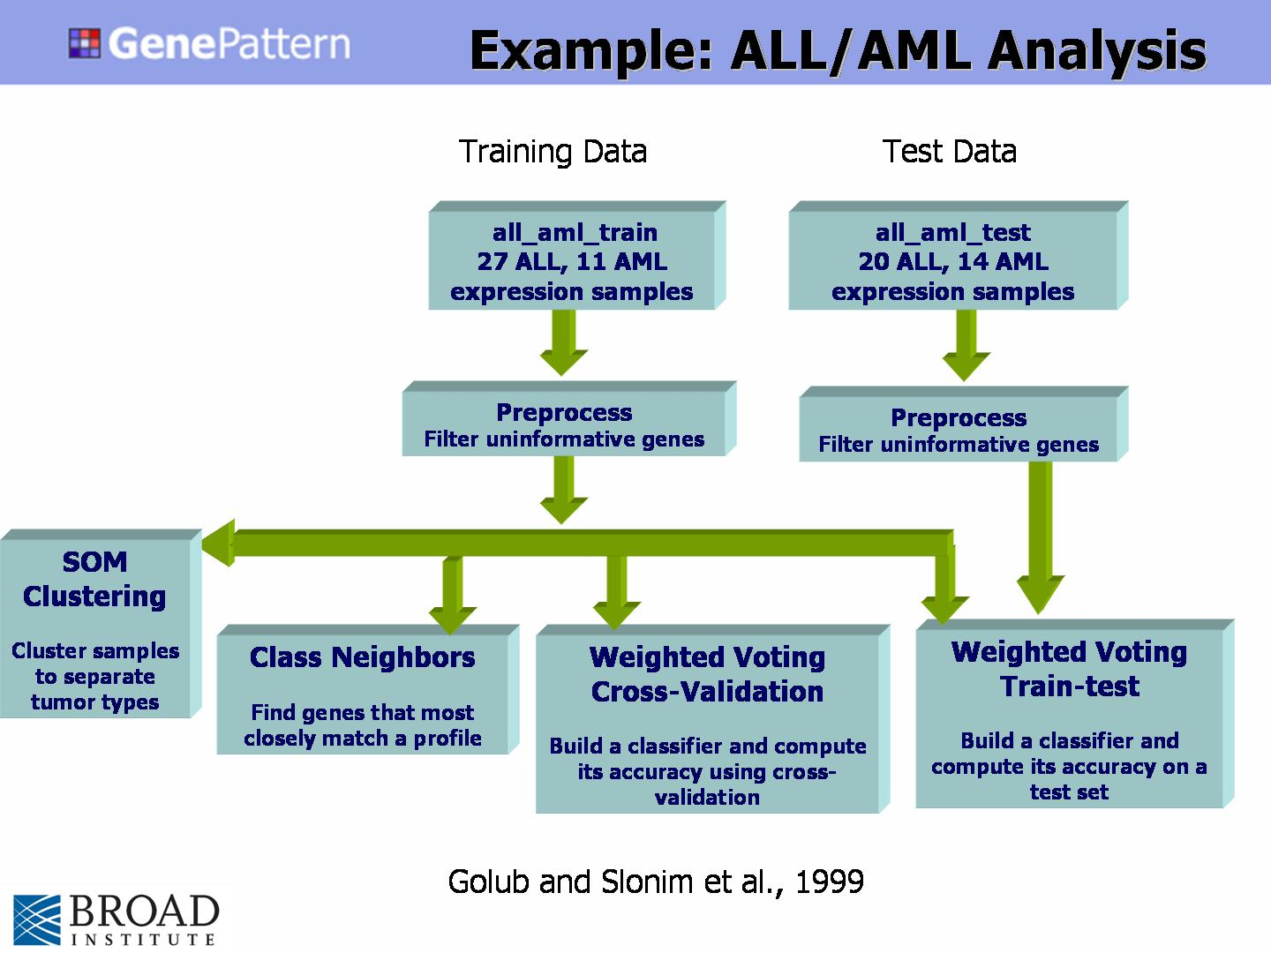
Figure 1

Microarray narratives

Cross-domain, Patrick McConnell
The goal is to discover upstream genes for upregulated genes involved in apoptosis from a microarray experiment. The user first queries caArray to get a set of expression data. This data is sent to DWD, where genes of interest are selected. These genes are then annotated with Gene Ontology information from caBIO. All genes not annotated with the Gene Ontology term for apoptosis are filtered out. Finally, the remaining genes are annotated with upstream genes using a gene pathway service.

Gene annotation narratives

GOMiner, David Kane
At the most basic, GoMiner operates on a list of all the genes and a list of changed genes. At the moment, users prepare these lists as flat files. As part of caBIG, we are moving to a model in which we can directly pull these lists from an array repository. There are a couple possible ways to think of this. We looked at one array tool (mAdb) that has a notion of sets. Once you have an experiment, you might apply normalization or filtering algorithms. Each of these steps would be saved as a discrete data set. A user might select the normalized list to draw the list of all the genes, and then select one of the filtered subsets to be the list of the changed genes. While this processing model is an in application feature set, it is easy to see how this might yield a grid work flow. A user might have a tool that would extract results from a repository. You could send those results to various analytical tools on the grid, to normalize the data and apply thresholding algorithms. The orchestrated this workflow would allow the user to specify which steps along the way should be persisted. Then these could be sent to GoMiner. Our current focus is microarray analysis, but because GoMiner operates on list of genes, one could imagine all sorts of analytical processes that might be distilled into gene lists.

On the other end, GoMiner has a number of reports, but at the most basic, what GoMiner identifies are lists of interesting genes, and lists of interesting categories. There are other data and meta-data, but I can imagine other workflow tools that might intake GoMiner output. E.g. one area that we are exploring in a non-grid fashion now, is to find the pathway diagrams for all of the genes in categories identified as interesting in GoMiner.

The Clinical Trials Management Systems Workspace
The Clinical Trials Management Systems Workspace has a rich set of narratives involving heavy querying of data services, as well as the collection and translation of such data. These queries can very quickly become so complex and numerous for a single application that their expression in a distributed query may become burdensome. Such queries may be expressed more naturally in a workflow language. We describe some of these queries here. Note that in time we may discover that distributed query handles these use cases satisfactorily, and workflow is not required. Nevertheless, it is prudent at this early stage to be aware of these possible workflow uses.

Microarray clinical data, David Fenstermacher
Question:
A researcher would like to perform a study to compare the type of cancer treated with a particular chemotherapeutic agent, involved in clinical trials, in which the study subjects lived longer than 2 years post-study to find gene expression patterns that might be predictive of a positive outcome. The researcher has expression data (Affy) for patients that lived less than two years.
Query:
I want to collect all microarray data (Affy only) available from all cancer centers from patients with bladder or ovarian cancer that were part of any clinical trial protocol using cisplatin within the past five years. In addition, I want to know all available tissue samples, cancerous and non-cancerous (normal) tissue localized within 10mm of tumor site from this patient group such that I can perform Affy gene expression studies to include with previously performed studies that were identified by the query. Finally, I need all severe adverse events for the group of patients identified that had a severity rating of 3-4 and are likely linked to cisplatin administration.

Summary
In this narrative, there are four queries:

- Get all affy data for patients with bladder/ovarian cancer and part of any clinical trial using cisplatin within last five years.
- Also, get grid identifiers for all of the associated patients.
- Get all associated tissue samples localized within 10mm of tumor site
- Find all severe adverse events for patient group with severity rating of 3 to 4 and likely link to cisplatin administration

Offline the resesarcher will perform microarray analysis on the tissue samples and correlate these results with the existing microarray data from query 1.

For this narrative there are two possible uses of workflow. One, a workflow language could very naturally feed the results of query 2 into queries 1, 3 and 4, and save intermediate results: patients, affy data, samples and adverse events. This may or may not be easier than writing four separate distributed queries. Two, the process of analyzing the new microarray data and correlating it with the preexisting data will very likely be more naturally expressed using a workflow language, as shown in previous narratives.

Clinical data integration, Terry Braun
A clinician records patient demographic data (name, age, address, etc.) and clinical data (diagnosis/phenotype [tumor type, tissue samples, medical images], blood pressure, platelet count, treatment history, surgeries, etc., and outcome. Biological samples are used for assays by either the Phenotyping core, or the molecular core. The phenotyping core records phenotypes (histology, various medical imaging, etc). The molecular core records “experimental results” – gene expression profiles (Affymetrix, glass slides, EST sequencing, SAGE, etc.), proteomics, mutation screening, etc. The three data categories (patient demographic data, patient phenotypic data, and patient experimental results) are then integrated by the system. A user may then query the integrated data to explore correlations between phenotypic data and genotypic data (experimental results).

Summary
Although not described in detail, searches for correlations among these data sets will likely require the use of various statistical analysis services working together in a pipeline. These pipelines would be described and stored for later use using a workflow language.

The Tissue Bank and Pathology Workspace
Similar the to the Clinical Trials Management Systems Workspace, the Tissue Bank and Pathology Workspace is laden with data-type services. The querying of these services can sometimes lend itself better to being expressed in a workflow language. We describe some of these queries here. [WE NEED SOME USE CASES HERE]

Requirements
We use the terms MUST, SHOULD and MAY throughout the document to specify the extent to which an item is a requirement for the Workflow. MUST means the item is an absolute requirement. SHOULD means that there may be valid reasons not to treat this item as a requirement, but the implementation should provide ample reasons why it does not support it, if it chooses to discard the item. MAY means that an item deserves our attention but further investigation is need to know whether or not it is truly required.

Requirements overview
Requirement | Functional/  Non-functional | Language/  engine | Must, Should, May | Usage narratives
Invocation of grid services | F | L | Must
Exchange of data between service invocations | F | L | Must
Translation of data between service invocations | F | L | Should
Conditional control | F | L | Should
Looping control | F | L | Should
Dynamic service discovery | F | L | Should
Parallelism | F | L | Should
Implicit and explicit copies of filters | F | L | Should
Implicit termination | F | L | Should
Timeout exception | F | L | May
Asynchronous service invocation | F | L | Should
Fault handling | F | L | Should
Transactional control | F | L | May
Provenance tracking | F | L | Should
Workflow as service | F | L | May
Semantic constructs | F | L | May
Standard language | N | L | Should
Expressible in XML | N | L | Must
Open source solution | N | L | May
Extensible | N | L | Must
Agnostic of service implementation | N | L | Must
Stored workflows | N | L | May
Embedded workflows | N | L | Should
Describe how the results of the workflow will be described and formatted | N | L | May
Semantic reasoning | F | E | May
Tradeoff between complexity and power | N | E | Should
Workflow aware service fabric | N | E | May
Testing harness | N | E | Should

Functional language requirements
The primary requirement of caBIG workflow is that it must be capable of binding to and invoking grid services. The architecture of caBIG is based on grid standards, where services on the grid take two flavors: data and analysis. The workflow language must be able to invoke these services in a natural and effortless manner. Furthermore, in order to move from invoking a single service to a true workflow, data must be exchanged between service invocations. This allows for the desired “pipeline” between services to be formed. Finally, the output data format from one service may not match the input data format for another service, though the workflow author knows that there is a logical mapping. The workflow language then should support the translation of data between service invocations. This translation need not be performed in an automatic way where the workflow engine detects differences in data formats and searches for a proper translator. However, the language should support constructs to facilitate manual translation. This translation could be handled by a translation grid service, but, for convenience, the user should be able to embed standard XML translation constructs directly into the workflow document. For example, XSLT or XPath would be appropriate translation languages. These three requirements: invocation, data exchange, and data translation comprise the core requirements for any grid-enabled workflow language.

Many bioinformatics workflows include more complex logic than simply piping data between services. For example, workflows may take different paths of execution based on conditional tests. Also, a common theme in bioinformatics analysis is repetition and recursion of execution within the workflow. For example, often the same operation is invoked repeatedly but with slightly different parameters so that results can be compared in a “beauty contest”. Therefore, the workflow language should support conditional control and should support looping control. Though these features could be implemented at the service level, it would be more convenient for grid-users to be able to embed conditional and looping statements directly into the workflow language.

One of the greatest powers of the grid is the ability to dynamically discover which services are available from a given criteria, so the workflow language should support dynamic service discovery. This feature could be employed at two stages in the workflow: during workflow authoring and workflow execution. The former allows for users to discover useful services to place into their workflow. The latter prevents the need for the “hard-coding” of service endpoints into the workflow. This facilitates the use of identical or near-identical service invocation should a service be busy, unreachable, or broken.

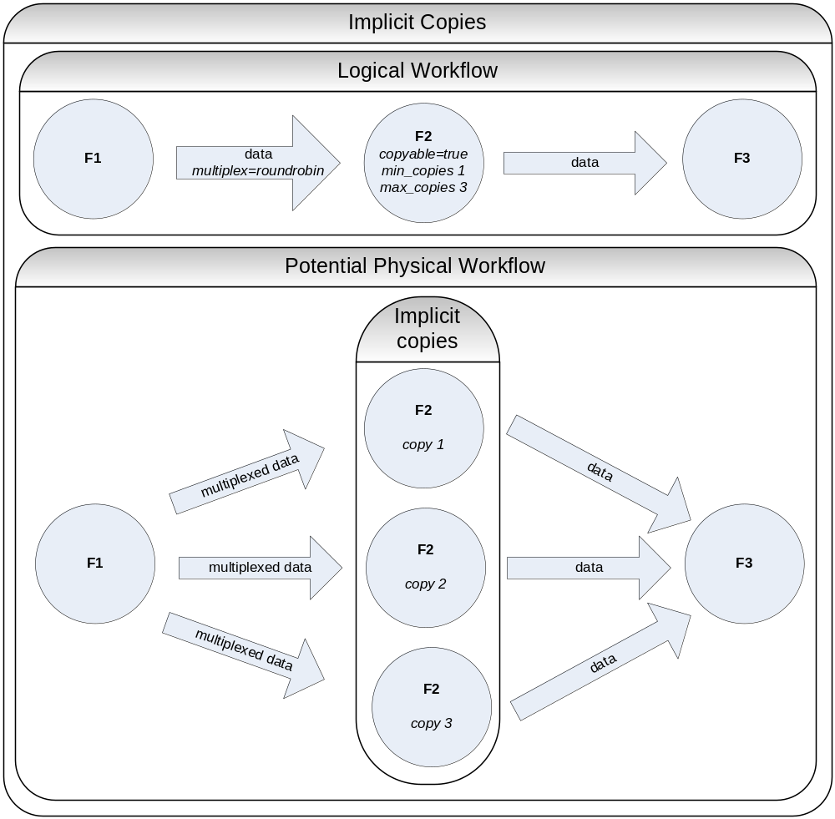
Figure 2

Bioinformatics analysis and data can be computationally and memory intensive to access. There are three traditional methods for speeding up such service invocations: optimizing the algorithms employed, optimizing the hardware employed, and utilizing more hardware. In an effort to support the latter option, the workflow language and the workflow service should support parallelism. That is, service invocations and/or paths of execution through the workflow which are non-dependent should be able to be described in the language and also should be able to he handled by the workflow execution service. The workflow language should also support describing implicit and explicit copies of filters as well as the ability to manage the input and output ports of these implicit or explicit copies of filters and there border filters. For example, if a piece of the workflow pipeline can be scaled up by simply adding more filters of a particular type then a user would like to make implicit copies of a filter to scale that part of the pipeline, see Error: Reference source not found. Explicit copies are copies that the user explicitly places in the logical definition of the workflow and does not let the workflow engine determine the number or buffer management. The workflow execution service framework would need to be able to manage the data buffers as they travel through this implicit copy section of the workflow so that the described parallelism can be utilized. The workflow service should also support implicit termination of the workflow. That is, the user should not have to send data to a “Done” filter to signal the end of a workflow job. The workflow service should be able to detect the end of a workflow by using it’s own control flow mechanisms to determine that all depended tasks have been completed. Similar, the language may support timeout exceptions, where the use can define the maximum time a particular block in the workflow can take to complete before some other action is taken. The workflow language should support asynchronous service invocation. Some services on the grid may support asynchronous-style messaging, where a client does not block while waiting for a service invocation to complete. Instead, the client is notified by the service when the operation is complete. This facilitates long-running operations.

For any programming language or IT infrastructure, it is important to be able to handle unexpected errors or exceptional situations. For example, the work should gracefully handle faults when execution of a workflow or invocation of a service generates an error. Workflow execution errors include improperly formatted workflow documents and runtime errors such as division by zero. Service invocation errors include invalid parameters sent, improperly formatted messages sent, or simply some unexpected error thrown from within the service. A group of such service requests can be thought of as a transaction, which is especially important when considering database updates. The workflow may support transactional control, where a set of service calls could “unwind”, releasing the necessary resources and removing the added records.

In science it is very important to track all the procedures that have been applied to a particular sample throughout an experiment so that scientific conclusions can be justly made and experiments can be repeated. Similarly, workflow should track the provenance of data and service invocation in at least enough detail so that the workflow can be repeated such that the same output is produced for the same input. This provenance tracking also may aid the construction and debugging of workflows because the workflow author may be able to inspect data at each step of the workflow. Provenance tracking should be optional for the user because of the vast amount of data that could be collected. Furthermore, provenance tracking may be handled at another level of the architecture. For example, service invocation may automatically generate provenance data.

Workflows will likely include data that needs to be kept secure from other users. This is especially important with patient data and intellectual property, which are common in the caBIG domain workspaces. It is most appropriate for security to be handled at a different layer in the architecture. To facilitate this, workflow may need to be invoked in the same way as other grid services, thereby conferring the same security scheme.

It may be necessary to for the workflow language to support semantic constructs such that semantic relationships can be determined. This can be important in dynamic service discovery, where the workflow finds services based upon semantically identical inputs, outputs, or metadata. Furthermore, conditional statements within the workflow may support semantic equivalence in addition to value-based comparison. As more services and data types are added to the grid, this requirement may become more important.

Nonfunctional language requirements
There are many benefits for encoding a workflow in a community accepted standard language. caBIG would immediately gain the support of any tools built for the language, benefit from the knowledge and work put into the design of the language, and possibly have a larger number of existing solutions to work from. Thus, a standard language should be considered over a non-standard language. Furthermore, this language must be expressible in XML because all data and service messages are expressed in XML. Not expressing the workflow in XML would add a level of incompatibility that may cause problems or provide complexities in the architecture.

It is impossible to predict now what the needs of workflow will be five or ten years from now. Thus, the workflow language must be extensible so that features are easily added in the future. It may be useful to add specific caBIG constructs to the language, such as fine-tuning provenance tracking. To aid in this, the language must be expressed in a way that is agnostic of how the service is implemented. The interaction between the workflow language and services must be based on exposed programming interfaces and/or message formats and not on the internals of the service itself.

Workflows can solve a potentially interesting problem that may generalize or be useful for other users. Thus, to help and encourage in the sharing of workflows, it may be beneficial to store the workflow itself as an invokable grid service. This design model also makes it easier for workflows to be built upon each other. It should be possible to embed workflows so that workflows that solve simple problems can be combined to solve a more complex problem. This also helps in designing and debugging workflows, much the same way that encapsulation in object-oriented programming aids in software design. For either of these concepts to work, it may be necessary for the input and outputs of the workflow to be described in much the same way as grid services. This would describe the programming interface to the workflow, not the input and output formats of individual services being invoked within the workflow. Furthermore, the input to a workflow may be very different from the inputs for any particular service invoked. For example, the first step in a workflow may be to invoke two different services, so the input to that workflow may involve data for two different services.

Functional implementation requirements
The workflow system may require workflow aware service fabric. Workflow aware service fabric is the idea that the services involved in the workflow are able to be configured to know information about the workflow that they are involved in. This information ranges from where to read the input and write the output to making logic decisions described in the workflow model. A workflow architecture which has workflow aware services enables a peer-2-peer runtime workflow environment as opposed to a master-slave runtime environment. This distinction is not so much a language distinction but more so a runtime environment distinction as to where the decisions that happen in workflow such as loop control, input output data delivery, logical operations etc. In a workflow aware environment these decisions can be made at the services involved in workflow and not back at the workflow invocation service itself. In an environment where workflow services are not aware that they are being executed as part of a workflow may not have the ability to multiplex and deliver/ingest their input/output to/from the border services and will have to read from and deliver to the workflow engine itself. This centralization of data processing can create a runtime data bottleneck. They may also not be able to make runtime logic decisions which are described in the user’s workflow and will have to send this information back to the workflow engine. In order to provide a runtime environment where data can be seamlessly streamed and multiplexed through the workflow environment in order to maximize data and task parallelism, the services themselves must be aware that they are involved in workflow. Furthermore, they must be able to be configured to manage their own input and output streams to the upstream and downstream services participating in the workflow, as shown in Error: Reference source not found.

It may be necessary for the workflow language to utilize the semantics of the grid, such that the engine can do some semantic reasoning during the execution of the workflow. One example is for the engine to check whether the output data from one service is semantically compatible with the input data of a following service. This sort of semantic reasoning may make the engine more fault tolerant and would in the least make the engine more “grid-friendly”.

The workflow engine should implement all of the features outlined in the language requirements. This is to ensure that maximal functionality is available to users of the workflow system. Furthermore, not implementing all required features of the language would greatly weaken the requirements analysis of the language.

The workflow engine should detect runaway workflows and handle the situation accordingly. Any automated system runs the risk of acting unexpectedly in such a way that prevents termination. This can be due to a looping construct that does not terminate or will not terminate in the foreseeable future, as well as recursive workflow invocation without a terminal base case. Because of the distributed nature of the grid, the impact of a runaway workflow can be catastrophic to all nodes on the grid. Imagine a runaway workflow that sends millions of queries every minute to even a fraction of the nodes on the grid. This would not only cripple the nodes involved, but would consume the bandwidth in between. It is not expected that the workflow engine determine this from reading the workflow. Instead, runway workflow detection could be handled by managing the lifetime of the workflow, as well as tracking the number of subworkflows on the call stack. Also, runaway workflow detection can be aided by the infrastructure underlying invoked services. For example, batch schedules can manage spawned jobs wrapped by grid services.

The workflow engine must plug into the caGRID infrastructure for the workflow engine to be useful within caBIG. This means that the workflow engine must be able to at a minimum instantiate and invoke caGRID-style services as they are designated within a workflow. This includes data and analytical services, as well as any other types of services that are added. Note that this does not limit the types of services invoked by the workflow engine to just caGRID-style services. For example, it is conceivable that the workflow engine would allow for the invocation of local executables, web services, Java methods, etc.

The workflow engine must support caGRID-style security. Data that a workflow will be accessing on the grid may be patient information or intellectual property. The grid itself will have a security layer that the workflow engine must be able to utilize for authentication of a workflow user and authorization to access the grid services specified in a workflow.

Medical research involves the use of very large, complex datasets that can take significant time to query, transfer, and process. Furthermore, algorithms that analyze the data themselves can take a long time to complete. Thus, the workflow engine should support long running workflows. This includes support for failover and check-pointing should the workflow engine crash, a service fail, or an unexpected error occur. This means that upon one of these situations, the workflow should be able to be executed or restarted without having to perform already completed work. This requirement should be enabled by the storage of intermediary results in a grid cache. This data should be accessible to users at run-time such that the user can inspect the progress of the workflow. Furthermore, the user should be able to get a copy of the cache or make the cache data permanently stored in order to provide evidence of what work has been done and what data has been consumed/produced.

The purpose of the grid is to enable sharing of data and tools. In this vein, the workflow engine should support the storage of workflows such that they can be shared and invoked later. Along these lines, the workflow engine should allow the invoking of a workflow from another workflow. This pattern is similar to that of functional programming, where methods are invoked from within methods. To enable this, the workflow engine should expose stored workflows as a grid service. That is to say, a user should be able to invoke a stored workflow by invoking a grid service. This will greatly enable the reuse of workflows, and by doing so increase the usefulness of the grid.

Nonfunctional implementation requirements
If the workflow language is extremely complex or not powerful enough to solve complex problems, then it will not be used in place of traditional programming languages. Similarly, if the implementation is extremely complex, then it will be difficult to maintain and likely be bug-prone. A tradeoff between complexity and power should be made. To mitigate this, the use of an existing open-source solution may be appropriate. Several such projects will be reviewed later in this paper.

The workflow engine should implement a testing harness that allows users to test workflow execution, monitoring inputs and outputs, and visualizing what nodes are active. This is especially important for debugging and monitoring for run-away workflows.

Technology review

Overview
Language | Initial recommendation
ANT | Not a full workflow language
BPEL | Strong candidate
DAX/VDL | Proprietary
DPML | Proprietary
JXPL | Proprietary
MoML | Proprietary
Scufl | Proprietary
UML | Not a full workflow language
VDL | Proprietary
WSBAW | Proprietary
WS-CDL | Strong candidate
WSCI | Superseded by WS-CDL
WSFL | Superseded by BPEL
XLANG | Superseded by BPEL
XPDL | Strong candidate

Technology | Initial recommendation
BioWBI | Proprietary
COG | Strong candidate, proprietary language
DiscoveryNet | String candidate, proprietary language
GridAnt | Not full implementation
GridBus | Not available yet
GridNexus | Good candidate, proprietary language
GSFL | Proprietary
Kepler | Good candidate, research project
Pegasus | Good candidate, proprietary language
Pegasys | Proprietary language
Taverna | Good candidate, proprietary language
Triana | Good candidate, multiple language support
WfMOpen | Strong candidate
WINNER | Not available yet

Workflow languages

Ant
Ant is a Java-based build tool. In theory, it is kind of like Make, without Make's wrinkles and with the full portability of pure Java code. Ant's buildfiles are written in XML. Each buildfile contains one project and at least one (default) target. Targets contain task elements. Each task element of the buildfile can have an id attribute and can later be referred to by the value supplied to this. The Ant language is not a true workflow language and does not provide many of the workflow constructs. It has been extended to workflow use, but only loosely.

BPEL
In computer science, the Business Process Execution Language (BPEL) is an XML language to describe business processes. A BPEL program is invoked as a Web service, and it can interact with the external world only by calling Web services. The standard that defines how BPEL is used in Web service transactions is BPEL4WS also known as WS-BPEL. BPEL is designed by IBM and Microsoft, based on their respective work on WSFL and XLANG, which are both superseded by BPEL. In April 2003, BPEL was submitted to OASIS and is now being standardized in the Web Services BPEL Technical Committee (http://www.oasis-open.org/committees/tc_home.php?wg_abbrev=wsbpel).

DAX/VDL
The workflow languages used solely by Pegasus.

DPML
The Discovery Process Markup Language is used solely by Discovery Net.

JXPL
JXPL, used exclusively by GridNexus, is an XML scripting language that bridges XML and Java. Extensions allow it to interact with web and grid services in a workflow.

MoML
Actors are components that execute and communicate with other actors in a model. Actors method of communication is through ports. Values transported through actors ports are encapsulated as tokens. A port can be either an input port, an output port or both, and it can either support a single or multiple connections (represented as black and white ports correspondingly). E.g., the Expression has a single-port output port; the Display has a multi-port input port. Each connection, which is a path from an output port to an input port, is treated as a separate channel. A single port can be linked to at most one relation.

MoML is used almost exclusively by Kepler.

Scufl
Taverna’s workflow language is XScufl, where the X stands for XML and SCUFL stands for “simple conceptual unified flow language”. Processors are either local or remote services, connected with data and control links (data links provide data flow, control links allow for the coordination of services not connected with data flow), with defined workflow inputs and outputs. Salient features include:

- Input/Output metadata: ontology terms (from a proprietary myGrid ontology) that describe them (e.g. biological sequence identifier), a free text description, and MIME types
- Implicit iteration: iteration occurs if a process expects fewer inputs than it receives. This is simple for N received to one expected, but there is also a way to handle M to N.
- Conditional branching: conditionals accomplished by making a given processor in the workflow graph only run if all its upstream processors have finished. One can provide both control and data upstream processors. Control processors provide logic, data processors provide data, so the simultaneous satisfaction of these means that the data is ready for the current processor and the logical state of the system permits processor execution.
- Beanshell scripting (www.beanshell.org) - you can define a custom processor that executes a beanshell (a flavor of dynamic Java) script. Beanshell scripts can be shared with others by wrapping them in a workflow and publishing the workflow on the Web.
- Other built-ins: BioMoby, (extensive!) Biomart Query integration, EBI’s Soaplab, SeqHound, Web Services support, and Styx streaming grid services (experimental)

UML
The UML activity diagram can be used to describe a workflow. See http://csdl.computer.org/comp/proceedings/hicss/2002/1435/09/14350291abs.htm for more information.

WSBAW
WSBAW is a bioinformatics analysis workflow language developed by IBM. It is an IBM proprietary language. WSBAW works in conjunction with its proprietary bioinformatics workflow execution engine called BioWBI. It is NOT a Grid aware platform. WSBAW supports 4 operators, namely, iterations, recursion, pipes, and conditional execution.

WS-CDL
The Web Services Choreography Description Language (WS-CDL) is an XML-based language that describes peer-to-peer collaborations of Web Services participants by defining, from a global viewpoint, their common and complementary observable behavior; where ordered message exchanges result in accomplishing a common business goal.

The Web Services Choreography specification is targeted for composing interoperable peer-to-peer collaborations between any type of Web Service participant regardless of the supporting platform or programming model used by the implementation of the hosting environment.

WSCI
WSCI is not a workflow language, but a choreography description language. Furthermore, WSCI has been superseded by WS-CDL, Web Services Choreography Description Language, which is substantially different.
Choreography is not so much about defining a workflow as about defining the observable behavior of a set of web services as they interact. That is, you cannot “run” a choreography, rather a choreography validates a set of web service calls among a group of services. If these services participate together in a larger, multi-endpoint process, the choreography can define the sequencing and interrelations among the calls that properly follow the process.

WSFL
The Web Services Flow Language has been superseded by BPEL.

XLANG
XLAND has been superseded by BPEL.

XPDL
XPDL (XML Process Definition Language) Standard supports multiple control structures (AND, XOR splits, conditional loops, and parallel branching), implicit workflow termination and nested Workflow Definitions.

Also here is a list of workflow vendors that support XPDL:
http://www.wfmc.org/standards/XPDL.htm

xWFL
xWFL is a workflow description expressed in XML format consisting of three parts, namely parameter definitions, task definitions and data link definitions. It is used exclusively by GridBus/GWFE.

Workflow engines

BioWBI
BioWBI is a web based graphical frontend for building and analysis bioinformatics workflows. BioWBI comes pre-bundled with bioinformatics knowledge base and tools. Workflows can be stored in BioWBI for future executions. Additionally, monitoring and reporting of workflow executions is supported.

COG
“Commodity Grid (CoG) Kits allow Grid users, Grid application developers, and Grid administrators to use, program, and administer Grids from higher-level framework.”

“The Java CoG Kit significantly enhances the capabilities of the Globus Toolkit by introducing Grid workflows, control flows, and a task based programming model”

Java CoG kit is a client side toolkit that greatly enhances the usability of the grid layer by providing a common API across different grid implementation (more specifically the Globus toolkit). Currently support GT2, GT3 and GT4 toolkits.

  - Language based on XML/ant
  - Workflow engine called Karajan (German conductor)
  - Workflow viewer and monitor
  - Portal components (to be completed)

Karajan is a Grid parallel task management language and an execution engine. It aims to provide the scientific community with an easy-to-use tool to define and manage complex jobs on computational Grids, while keeping scalability and offering some advanced features, such as failure handling, checkpointing, dynamic execution, and distributed execution.

It supports a range of Grid back-end services, through the Java CoG Kit Core abstraction layer, making it easy to work with heterogeneous Grid environments.

DiscoveryNet
Discovery Net is an EPSRC-funded project to build a platform for scientific discovery from the data generated by a wide variety of high throughput devices at Imperial College London. Discovery Net provides a service-oriented computing model for knowledge discovery, allowing users to connect to and use data analysis software as well as data sources that are made available online by third parties. In particular, Discovery Net defines the standards, architecture and tools that:
- Allow scientists to plan, manage, share and execute complex knowledge discovery and data analysis procedures available as remote services.
- Allow service providers to publish and make available data mining and data analysis software components as services to be used in knowledge discovery procedures.
- Allow data owners to provide interfaces and access to scientific databases, data stores, sensors and experimental results as services so that they can be integrated in knowledge discovery processes.
Discovery Net is based on an open architecture re-using common protocols and common infrastructures such as the Globus Toolkit and the OGSI. It also defines its own protocol for workflows, Discovery Process Markup Language (DPML) which allows the definition of data analysis tasks to be executed on distributed resources. Using Discovery Net architecture it easy to build and deploy a variety of fully distributed data intensive applications.
D-NET makes use of its own workflow language, Discovery Process Markup Language (DPML). DPML is an XML-based language that describes processes as dataflow graphs. Nodes representing datasets and functions are composed as a directed acyclic graph whose edges determine where each node’s output should be piped. Nodes are annotated with structured notes by the user at authoring/editing time to describe the rationale behind the process. The authoring environment also records a history of how the process was constructed. As such, DPML represents a complete description of a discovery process including information for execution and reporting.

GridAnt
Apache Ant is a Java-based build tool. In theory, it is similar to Make, but without Make's wrinkles. Ant is a Java-based build tool with the full portability of pure Java code. Grid Ant incorporates the features of Ant and have (are still adapting) adapted it for use on the Grid.

“Grid-Ant is an XML/Java-based tool for representing and executing the flow of control around scientific computational codes and web services. It is composed of an “engine” and a set of visualization components that provide dynamic views of the progress through the execution graph. The engine is built on fully backwards-compatible extensions to Apache Ant (http://ant.apache.org/) and incorporates functionality typically required by distributed, computational-grid-enabled applications, such as secure file transfer (GridFTP), web service method invocation (Apache Axis, http://ws.apache.org/axis/), and remote publication/reception of application and workflow events. Execution of native computational code is handled by a wrapper which allows for stream monitoring, asynchronous (non-waiting) execution, and failure-handling; a file monitor makes available information concerning new and/or updated files. By virtue of its built-in runtime environment, Grid Ant enhances standard Ant capabilities by providing:

- Interpreter or script-like manipulation of variables; evaluation of logic-arithmetic expressions
- Looping control structure
- Data communication between targets and/or tasks
- Inter-target sharing of objects, especially for task synchronization

GridBus
Gridbus Workflow Engine (GWFE) facilitates users to link standalone applications and execute their workflow applications on Grids. GWFE provides a XML-based workflow language for the users to define tasks and dependencies. It also supports a just in-time scheduling system, thus allowing the resource allocation decision to be made at the time of task execution and hence adapt to changing grid environments. Also in use are tuple spaces approach to enable an event-driven scheduling architecture for simplifying workflow execution.
The GWFE is developed by the Gridbus Project, Grid Computing and Distributed Systems (GRIDS) Lab., Dept. of Computer Science and Software Engineering, the University of Melbourne, Australia. The project is partially supported by Australian Research Council Discovery Project grant, Storage Technology and the University of Melbourne.
http://www.gridbus.org/workflow/

GridNexus
GridNexus, a graphical system for creating and executing scientific workflows in a Grid environment. GridNexus allows the user to assemble complex processes involving data retrieval, analysis and visualization by building a directed graph in a visual environment. The graphical user interface (GUI) of GridNexus is based on Ptolemy II, an open source project from UC Berkeley. The Kepler project is another workflow system that is also based on Ptolemy II. A key feature that distinguishes GridNexus from Kepler is that GridNexus separates the graphical, interactive construction of the model from its execution. GridNexus uses the GUI to write a script in a new XML based language called JXPL. The execution of the script is handled by the JXPL interpreter, which may be running on the same machine as the GUI, or may be a remote service. JXPL is a flexible and extensible language that is intended to be used in conjunction with more specialized languages. We will illustrate this with an example involving OGSA-DAI Grid Data Service (GDS) components.
GDS services are designed to work together. For example, the output of a service that performs a database query can be delivered to a transform service for further processing. An individual GDS is controlled by an OGSA-DAI script. Executing a workflow involving more than one GDS requires thread management and the dynamic generation of OGSA-DAI scripts.
Consider the simplest case of a source GDS delivering output to a sink GDS. Typical steps for executing this workflow are:
- Call a factory to create the sink service instance and store the instance handle.
- Run the sink service method in a separate thread so it can wait for output.
- Create the script for the source service, incorporating the handle of the sink.
- Create the source service instance and call a method.
A JXPL program can carry out these steps, and GridNexus provides a graphical user
interface for creating and executing the JXPL program.

GSFL
The Open Grid Services Architecture (OGSA) tries to address the challenge of integrating services spread across distributed, heterogenous, dynamic "virtual organizations" using the concepts and technologies from both the Grid and Web service communities. The Web service community has realized that Web services can reach their full potential only if there exists a mechanism to describe the various interactions between the services and dynamically compose new services out of existing ones. This is true in the case of Grid services as well.
The Grid Services Flow Language (GSFL) is an effort to examine technologies that address workflow for Web services and leverage this technology for Grid services. This project contains both an XML schema definition for the specification of workflow in Grid environments and a reference implementation of the Workflow engine for use in the Open Grid Services Infrastructure (OGSI).

Kepler
Kepler is based on the UC Berkely Ptolemy II project. It is an open-source solution that can integrate grid services. The proprietary workflow language is called MoML. It claims to be a cross-project collaboration between Ptolemy II, Vergil (graphics), and others.

The focus of Kepler is on actor-oriented design. Actors are re-useable components that execute and communicate with other actors in a scientific workflow through input and output channels. Kepler provides a large variety of computational models, inherited from Ptolemy II. Scientific workflows are often dataflow-oriented and thus in most Kepler models either of two computational semantics are used, Process Networks and Synchronous Dataflow.

Kepler’s workflow language is MoML.

Pegasus
Pegasus is a system which maps application workflow descriptions to abstract workflows then to a concrete workflow on the grid. Pegasus is meant to take a workflow and a set of resource and determine how to execute that workflow on those resources.

At the abstract level DAX is used as the workflow language, which is a DAG in xml format. VDL is used to describe data transformation routines.

Pegasys
Pegasys is an open source, flexible and modular package designed to enable creation, execution and integration of biological sequence analyses in the form of workflows. The project is hosted by the University of British Columbia’s Bioinformatics Centre. The project links together a set of tools for operating on large scale sequences. It is designed to operate on clusters in parallel when possible. The main application of Pegasys is for genome annotation, however it can be used in many diverse bioinformatics settings. Pegasys follows a client/server architecture model.

Pegasys renders its workflow in XML, before converting to a directed acyclic graph (DAG). While traversing the DAG, the application schedules all of the analyses on a distributed compute cluster and facilitates the flow of data so that a particular node's program is only executed once all of its inputs are ready (i.e. all of the 'parent' analyses are complete). As each analysis completes, the results are inserted into the backend database layer. Complete reports and computational features of a sequence are inserted into relational tables. Sophisticated queries on the data, which result from selected programs can be integrated together over a portion or all of the input sequence, and then be run to compile data for output.

The data is exported from the system via the adaptor layer in various formats (currently GFF, GAME XML and raw output from each analysis tool) for human interpretation or for import into other applications such as viewing tools (DAS), editing tools (Apollo) or statistical analysis tools such as R.

Pegasys has a GUI for Linux, Windows and Mac OS X. The client interface seems to be well done and intuitive. It involves a simple layout for chalking the workflow based on available resources and sequences.

Taverna
Taverna is an open source, life sciences workflow desktop application with an integrated GUI environment and workflow engine. Taverna is written in Java, and is part of the tool suite that provided by myGrid (www.mygrid.org.uk). Taverna’s (built-in) workflow engine is currently the myGrid Workflow Enactment Engine, but soon it will integrate another, presumably higher-octane workflow orchestration engine, Freefluo, which supports both Taverna’s Scufl and IBM’s WSFL workflow language.

Scufl is Taverna’s proprietary workflow language, developed specifically for use with myGrid.

Triana
Triana is a complete, open source, grid aware workflow management system. Triana can define, process, analyze, manage, execute and monitor workflows. Worksflows in Triana consist of tasks/tools interconnected via data and control links. Triana has looping (do, while, repeat, until, etc.) and logic tools (if, then, etc.) that can be used to graphically control the data flow. Users can create composite tools/tasks from a list of existing tools. Triana can distribute sections of a workflow to remote machines, and to connect workflows to existing services already running on remote machines. Distribution of workflow is independent of the underlying Grid middleware. Triana can use JXTA, P2PS, HTTP/SOAP (?), OGSA (?) Grid middleware to distribute workflows.

Triana consists of three main components: Triana GUI, TaskGraph and the Triana Service.

Triana GUI is a process modeling tool that provides users with easy to use drag and drop GUI to construct workflow networks for a specific behavior. Using the GUI, users can easily specify the remote/local machine on which to run the entire/partial workflow.

TaskGraph: In Triana, a workflow is represented using an XML based WSFL like representation format. WSFL is used for composing and choreographing web services flow. WSFL uses WSDL for the description of service interfaces and their protocol bindings. Infact, Triana has added extensions to both WSFL and WSDL to accomplish Triana specific tasks.
Triana Service is responsible for interpreting and validating the incoming TaskGraph and executing it. Additionally, it distributes the partial TaskGraphs to other Triana services running on remote servers through the Grid middleware (GAT). The service also helps in the management and monitoring of workflows being executed. Triana TaskGraphs can be saved for future/repeat executions.

Triana represents a modular architecture. It allows different workflow readers/writers to be plugged in, e.g. BPEL4WS, WSFL formats. Triana has been used to read/write VDLx/DAX workflows.

Triana is written in Java and can be downloaded from http://www.trianacode.org/projects/triana/ .

WfMOpen
WfmOpen is a J2EE based implementation of a workflow facility (workflow engine) as proposed by the Workflow Management Coalition (WfMC) and the Object Management Group (OMG).
The workflow component is based on a set of JAVA interfaces that define an API for a workflow management facility. The basic "omgcore" interfaces follow OMG's Workflow Management Facility Specification, V1.2 very closely, while making some modifications to adapt the CORBA service to the established design practices for a Java API.
Workflows are specified using WfMC's XML Process Definition Language (XPDL) with some extensions.
The workflow component may be used as the core for any process based application implementation and is thus e.g. suited to provide a solution for BPM (Business Process Management) related tasks.

WINNER
Workflow Integrated Network Resource Orchestration provides the following features:

Resourcee discovery
- Available physical resources in network domains
- Available network services in network domains
- Resource properties, status and updates
Resource Utilization
- Resource collection and abstraction
- Resource reservation and scheduling
- Job status and feedback
Resource management
- Resource allocation and release
- Network configuration and control
- Security and AAA
Application-aware smarts on resources
- Multiple service gateways: Grid, workflow, storage
- Resource policy, SLA
- Resource optimization
- Resource monitor and performance

The WINNER engine implements the following:

WINNER Process
- • Defines the workflow activities specific on network resources
- • Acts in either standalone or extension to a legacy process
- • Invocated from apps, and related business services
WINNER Process services (PS)
- Web services that provide the activities of the business process
- Realize the resource operations of the WINNER process
- Support the workflow processing of network resources
WINNER Resource services (RS)
- Web services that support PS by provisioning necessary resources to conduct the process and its activities
- Perform the allocation of network resources
- Update the status of network resources
- Work closely with DRAC

Requirements analysis

Methodology
We performed a systematic analysis of existing workflow languages and implementations. Based on our broad overview of the languages, we selected five languages for a quantitative analysis (see Table 1). We created a matrix where the rows are the requirements and the columns are the languages. Each language was then given a score for each requirement. These scores were A for fully supported the requirement, B for limited support for the requirement, C for no support for the requirement but support could be added, and D for no support for the requirement and it would be prohibitively difficult to add support. We chose this categorical scoring versus numerical scoring because it is subjective as to the importance of one category versus the other. Thus, we tallied the count for each score for each language as our final indicator for how well a language met the domain workspace requirements.

The same analysis has yet to be performed on the workflow implementations.

Results
 |  | Languages
 |  | BPEL | XPDL | WS-CDL | Scufl | VDL
 | Reviewers | Shannon | Patrick | Moses | Patrick | Mike
Functional Requirements | Priorities
Invocation of grid services | Must | A | A |  | A | A
Exchange of data between invocations | Must | A | B |  | A | A
Translation of data between invocations | Should | B | A |  | C | C
Conditional control | Should | A | A |  | B | C
Looping control | Should | A | A |  | B | C
Dynamic service discovery | Should | A | D |  | B | A
Parallelism | Should | A | A |  | D | A
Implicit and explicit copies of filters | Should | D | D |  | A | B
Implicit termination | Should | A | D |  | A | A
Timeout exception | May | A | A |  | B | A
Asynchronous service invocation | Should | A | C |  | D | A
Fault handling | Should | A | A |  | B | B
Transactional control | May | C | B |  | D | C
Provenance tracking | Should | C | C |  | C | C
Workflow as service | May | C | C |  | D | C
Semantic constructs | May | D | D |  | B | D
Non-functional Requirements | Priorities
Standard language | Should | A | A |  | D | C
Expressible in XML | Must | A | A |  | A | A
Open source solution | May | A | A |  | A | A
Extensible | Must | A | A |  | B | A
Agnostic of service implementation | Must | A | A |  | A | A
Stored workflows | May | C | C |  | B | B
Embedded workflows | Should | B | B |  | A | B
Describe format of results | May | A | A |  | D | C
Capability Score Totals (A / B / C / D) |  | 16 /2 /4 /2 | 13 /3 /4 /4 | 0 /0 /0 /0 | 8 /8 /2 /6 | 11 /4 /8 /1
Table 1 Requirements analysis of workflow languages. The WS-CDL column is blank because it was determined that this choreography language is not appropriate for the orchestration nature of the requirements

 |  | Engines
 | Priorities | Triana | ActiveBPEL | Twister
Functional Requirements
Workflow aware service fabric | May
Semantic reasoning | May
Implement all of recommended language | Should
Runaway workflow detection | Should
Plug into caGrid infrastructure | Must
Plug into grid infrastructure | May
Support caGrid security | Must
Support grid security | May
Support long running workflows | Should
Support intermediary results | Should
Stored workflows | Should
Stored workflow as a workflow component | Should
Stored workflow as a grid service | Should
Non-functional Requirements
Tradeoff between complexity and power | Should
Open source | Should
Testing harness | Should
Capability Score Totals (A / B / C / D) |  | 0 /0 /0 /0 | 0 /0 /0 /0 | 0 /0 /0 /0
Table 2 Requirements analysis of workflow engines.

Technology Capability Legend
A | Fully Supported
B | Limited Support
C | No Support, but could be added
D | Not Supported
Requirement Priority Legend
MUST | Any suitable implementation should satisfy it.
SHOULD | Might be valid reasons not to support, but should be justified.
MAY | Deserves attention, but is currently unclear if it is required.
 | Indicates non-consensus or indecision
Table 3 Key for Table 1 and Table 2

Recommendation

Workflow language recommendation
Given the requirements analysis, we have found the Business Process Execution Language (BPEL) to meet the majority of the requirements. BPEL has been considered as the de facto standard for service orchestration, such that there are already and will be more tools available for constructing and implementing BPEL-based workflows. Furthermore, BPEL is designed to orchestrate web services, which should integrate well with the caGRID proposed architecture with minimal extensions. Finally, BPEL met the majority of the technical requirements, such as looping control, parallelism, and fault handling. The importance of these requirements can easily be overlooked, but they will greatly enhance the amount of work that can be performed with workflow.

We also reviewed 4 other languages, which had varying scores in the requirements analysis. We reviewed XPDL because it is the next most popular standard for service orchestration and has vast community support. Still, we found that XPDL was extremely difficult to use because many of its elements leveraged internal references. This subjective observation, in addition to the quantitative results, placed it behind BPEL as a choice. WS-CDL was reviewed because it has become a W3C standard; however, we found that this choreography language was not appropriate for the orchestration nature of the requirements. Scufl was reviewed because it is the most popular language for bioinformatics workflow and is leveraged by the Taverna project. However, we found Scufl to be missing many of the language constructs necessary to be a viable solution. Finally, we reviewed VDL, which is the language used to describe workflow for the Pegasus grid project. Though this language has many interesting and useful features, and we are told that more features are planned in the near-to-mid future, it still did not meet enough requirements to be a feasible solution. For example, the language is not designed to work with strongly typed data, which is an important feature of the caBIG grid.

It is important to remember we simply propose BPEL as a language for a workflow reference implementation, not as the only way to perform workflow on the caBIG grid. BPEL should be considered as a language that meets many of the requirements of the domain workspaces and as an example for implementing workflow on the grid.

Workflow engine recommendation
To be determined.

Workflow implementation
We aim to provide guidance for the implementation of workflow on the grid based upon the recommendations for the language and engine.

Workflow service operations
As it is recommended that the workflow engine be exposed as a grid service, we outline some of the potential operations and method signatures.

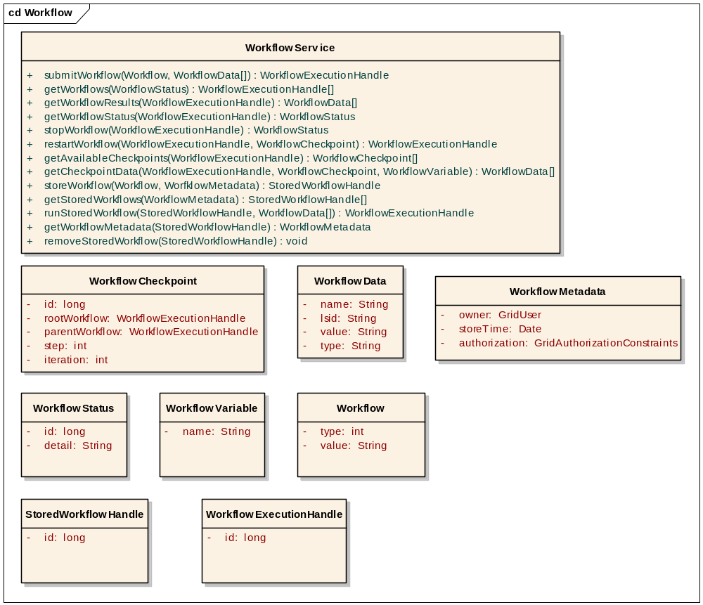
Figure 3 Proposed operations and data structures for the workflow engine grid service.

Appendices

Workflow Control Patterns
The workflow control patterns in this section are derived from:
W.M.P. van der Aalst, A.H.M. ter Hofstede, B. Kiepuszewski, and A.P. Barros.
Workflow Patterns. Distributed and Parallel Databases, 14(3), pages 5-51, July 2003.

Basic Control Patterns
Pattern 1: Sequence
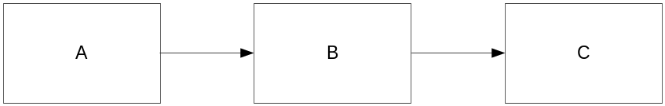
Description: An activity in a workflow process is enabled after the completion of another activity in the same process.
Synonyms: Sequential routing, serial routing
Implementation: The sequence pattern is used to model consecutive steps in a workflow process and is directly supported by each of the workflow management systems available. The typical implementation involves linking two activities with an unconditional control flow arrow.
Pattern 2: Parallel Split

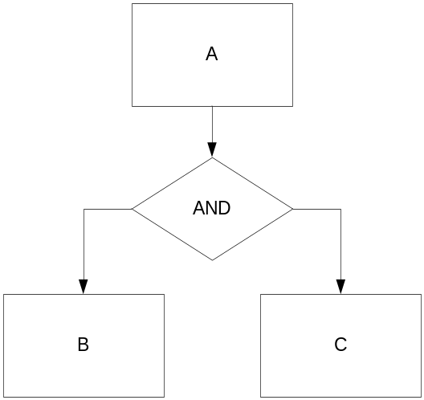
Description: A point in the workflow process where a single thread of control splits into multiple threads of control which can be executed in parallel, thus allowing activities to be executed simultaneously or in any order.
Synonyms: AND-split, parallel routing, fork.

Implementation: Two basic approaches can be identified: explicit AND-splits and implicit AND-splits. Workflow engines supporting the explicit AND-split construct define a routing node with more than one outgoing transition which will be enabled as soon as the routing node gets enabled. Workflow engines supporting implicit AND-splits do not provide special routing constructs - each activity can have more than one outgoing transition and each transition has associated conditions. To achieve parallel execution the workflow designer has to make sure that multiple conditions associated with outgoing transitions of the node evaluate to True (this is typically achieved by leaving the conditions blank).

Pattern 3: Synchronization

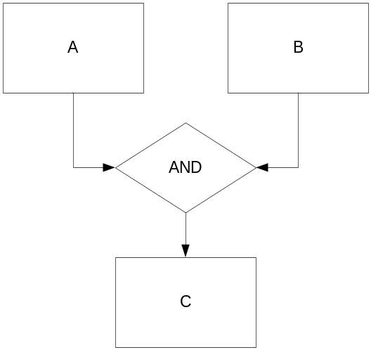
Description: A point in the workflow process where multiple parallel sub-processes/activities converge into one single thread of control, thus synchronizing multiple threads. It is an assumption of this pattern that each incoming branch of a synchronizer is executed only once (if this is not the case, then see Patterns 13-15 (Multiple Instances Requiring Synchronization)).
Synonyms: AND-join, rendezvous, synchronizer.
Implementation: Similarly to Pattern 2 one can identify two basic approaches: explicit AND-joins and implicit joins in an activity with more than one incoming transition. When an explicit synchronization construct is available (synchronizer), it will typically have more than one incoming transition and exactly one outgoing transition.
Pattern 4: Exclusive Choice

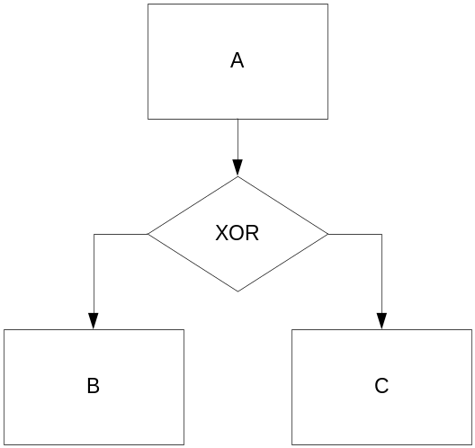
Description: A point in the workflow process where, based on a decision or workflow control data, one of several branches is chosen.

Synonyms: XOR-split, conditional routing, switch, decision.

Implementation: Similarly to Parallel Split (Pattern 2) there are two basic strategies - an explicit construct for the implementation of the exclusive choice pattern, and implicit. i.e. the workflow designer has to emulate the exclusiveness of choice by a selection of transition conditions.

Pattern 5: Simple Merge

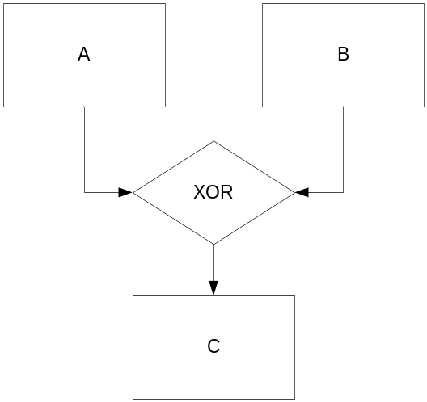
Description: A point in the workflow process where two or more alternative branches come together without synchronization. It is an assumption of this pattern that none of the alternative branches is ever executed in parallel (if this is not the case, then see Pattern 8 (Multi-merge) or Pattern 9 (Discriminator)).
Synonyms: XOR-join, asynchronous join, merge.
Implementation: Given that we are assuming that parallel execution of alternative threads does not occur, this is a straightforward situation and all workflow engines support a construct that can be used to implement the simple merge. It is interesting to note here that some languages impose a certain level of structuredness to automatically guarantee that not more than one alternative thread is running at any point in time. In other languages workflow designers themselves are responsible for the design not having the possibility of parallel execution of alternative threads.

Advanced Branching and Synchronization Patterns

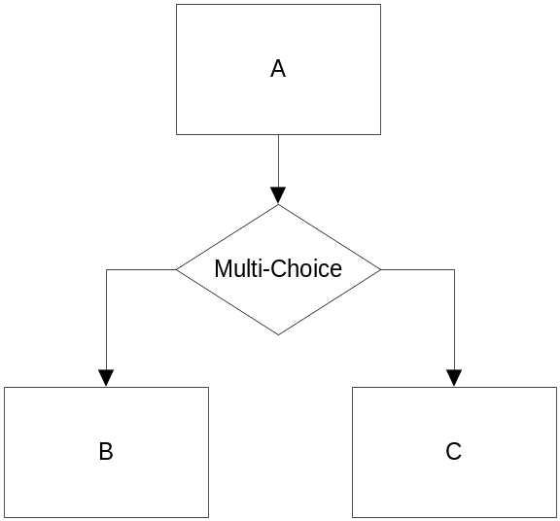
Pattern 6: Multiple Choice

Description: A point in the workflow process where, based on a decision or workflow control data, a number of branches are chosen.
Synonyms: Conditional routing, selection, OR-split
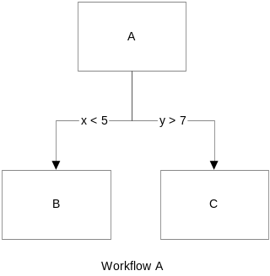
Implementation: Workflow languages that assign transition conditions to each transition the implementation of the multi-choice is straightforward. The workflow designer simply specifies desired conditions for each transition. It may be noted that the multi-choice pattern generalizes the parallel split (Pattern 2) and the exclusive choice (Pattern 4). An example is below as Workflow A:
For languages that only supply constructs to implement the parallel split and the exclusive choice, the implementation of the multi-choice has to be achieved through a combination of the two. Each possible branch is preceded by an XOR-split which decides, based on control data, either to activate the branch or to bypass it. All XOR-splits are activated by one AND-split.
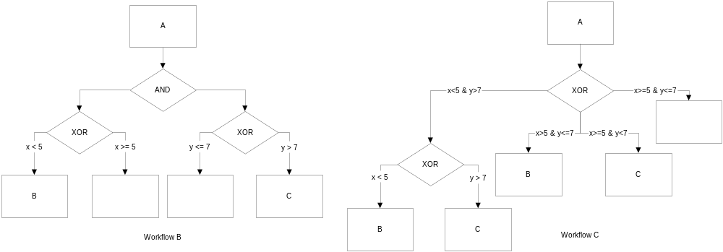
A solution similar to the previous one is obtained by reversing the order of the parallel split pattern and the exclusive choice pattern. For each set of branches which can be activated in parallel, one AND-split is added. All AND-splits are preceded by one XOR-split which activates the appropriate AND-split. Note that, typically, not all combinations of branches are possible. Therefore, this solution may lead to a more compact workflow specification. Both solutions are depicted as workflows B and C.

Pattern 7: Synchronizing Merge
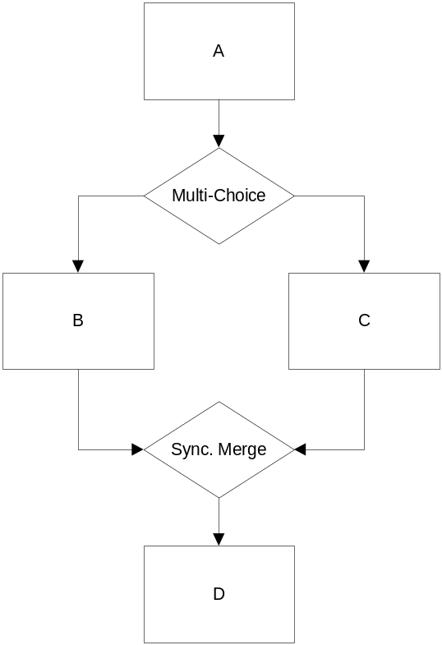
Description: A point in the workflow process where multiple paths converge into one single thread. If more than one path is taken, synchronization of the active threads needs to take place. If only one path is taken, the alternative branches should reconverge without synchronization. It is an assumption of this pattern that a branch that has already been activated, cannot be activated again while the merge is still waiting for other branches to complete.
Synonyms: Synchronizing join.
Implementation: If a synchronizing merge follows an OR-split and more than one outgoing transition of that OR-split can be triggered, it is not until runtime that we can tell whether or not synchronization should take place.
In some workflow engines the implementation of the synchronizing merge typically is not straightforward. The only solution is to avoid the explicit use of the OR-split that may trigger more than one outgoing transition and implement it as a combination of AND-splits and XOR-splits (see Pattern 6 (Multi-choice)). This way we can easily synchronize corresponding branches by using AND-join and standard merge constructs.

This pattern aims to address the problem with Simple Merge (5), which is the situation when more than one incoming transition of a merge is being activated.

Pattern 8: Multiple Merge
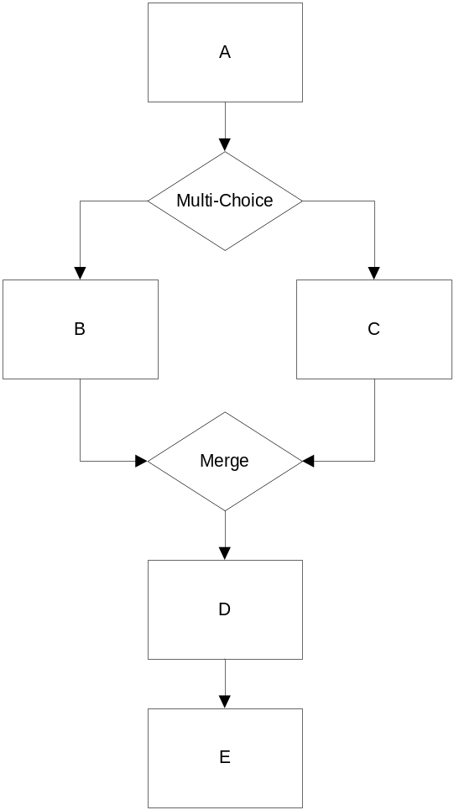
Description: Multi-merge is a point in a workflow process where two or more branches reconverge without synchronization. If more than one branch gets activated, possibly concurrently, the activity following the merge is started once for every incoming branch that gets activated. (i.e. in the diagram, D and E will be instantiated twice.

Implementation: If the multi-merge is not part of a loop, the common design pattern for languages that are not able to create more than one active instance of an activity is to replicate this activity in the workflow model. If the multi-merge is part of a loop, then typically the number of instances of an activity following the multi-merge is not known during design time. For a typical solution to this problem, see Pattern 14 (Multiple Instances with a Priori Runtime Knowledge) and Pattern 15 (Multiple Instances Without a Priori Runtime Knowledge).

Pattern 9: Discriminator

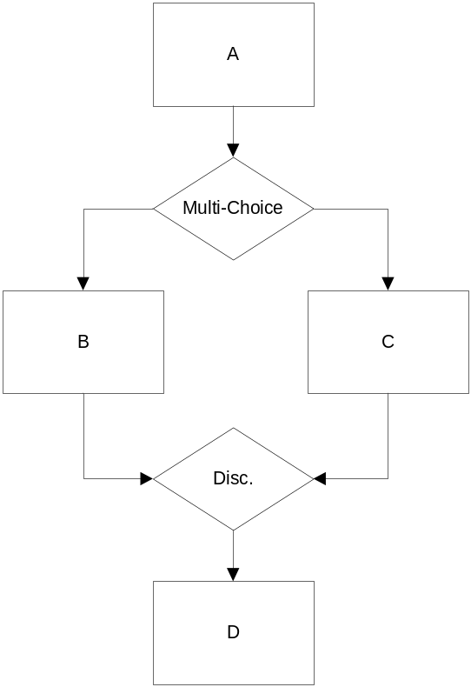
Description: The discriminator is a point in a workflow process that waits for one of the incoming branches to complete before activating the subsequent activity. From that moment on it waits for all remaining branches to complete and "ignores" them. Once all incoming branches have been triggered, it resets itself so that it can be triggered again (which is important otherwise it could not really be used in the context of a loop).

This pattern can be seen as the converse of the multi-merge. It should be used when only one activity should be instantiated after merge.

Implementation: Most workflow engines do not have a construct that can be used for a direct implementation of the discriminator pattern. As mentioned in Pattern 8 (Multi-merge), the standard merge construct in some workflow engines will not generate the second instance of an activity if the first instance is still active. This does not provide a solution for the discriminator, however, since if the first instance of the activity finishes before an attempt is made to start it again, a second instance will be created (in the diagram shown this would mean that a trace like ABDCD is possible).
The discriminator semantics can be implemented in products supporting Custom Triggers. Custom triggers define the condition, typically using some internal script language, which when satisfied should lead to execution of a certain activity. Such a script can be used to achieve a semantics close to that of a discriminator (again, in the context of a loop such a script may be more complicated). The downside of this approach is that the semantics of a join that uses custom triggers is impossible to determine without carefully examining the underlying trigger scripts. As such, the use of custom triggers may result in models that are less suitable and hard to understand.

Some workflow management systems allow for data-dependent executions. In other workflow engines the discriminator is impossible to implement directly in the workflow modeling language supplied.

Pattern 9a: N-out-of-M Join

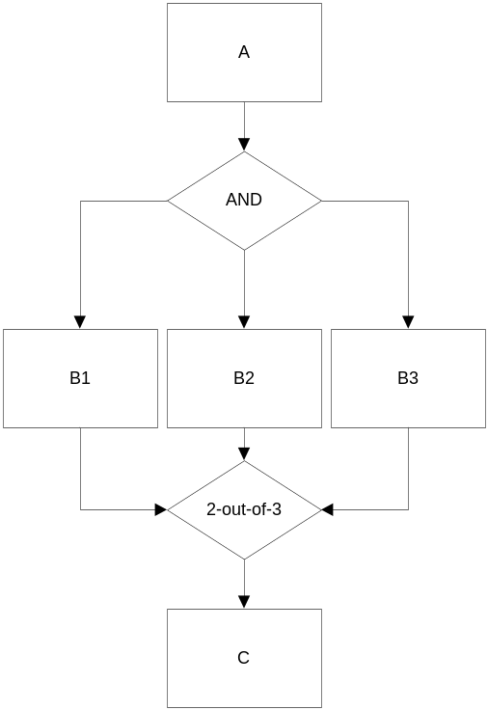
Description: This pattern is a generalization of the basic Discriminator. We would like to synchronize N threads from M incoming transitions. The N-out-of-M Join is a point in a workflow process where M parallel paths converge into one. The subsequent activity should be activated once N paths have completed. Completion of all remaining paths should be ignored. Similarly to the discriminator, once all incoming branches have "fired", the join resets itself so that it can fire again.

Synonyms: Partial join

Implementation: Implementation approaches to this pattern are similar to those for the basic discriminator when custom triggers can be used In languages that provide direct support for the basic
discriminator an n-out-of-m join can be realized with the additional use
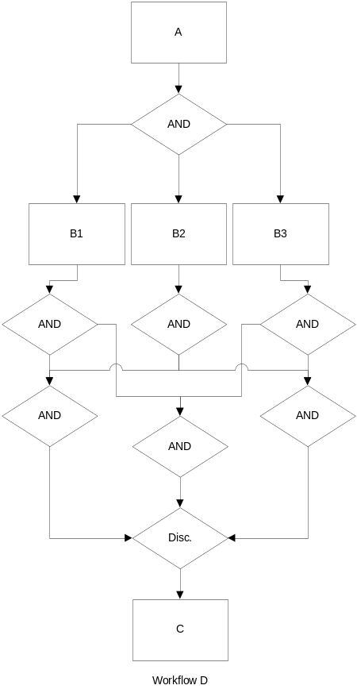
of a combination of AND-joins and AND-splits (the resulting workflow definition becomes large and complex though). An example of the realization of a 2-out-of-3 join is shown in Workflow D below.

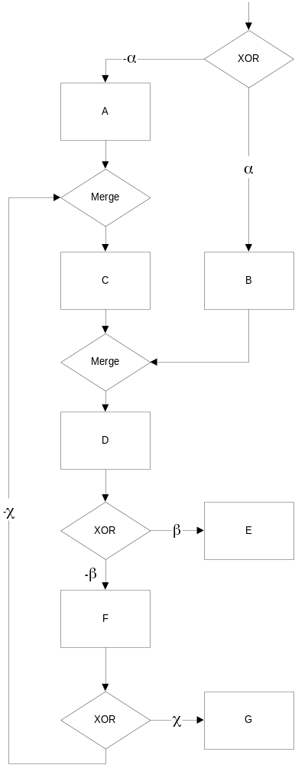
Structural Patterns

Pattern 10: Arbitrary Cycles

Description: A point in a workflow process where one or more activities can be done repeatedly.
Synonyms: Loop, iteration, cycle.
Implementation: Arbitrary cycles can typically be converted into structured cycles unless they contain one of the more advanced patterns such as multiple instances (see Pattern 14 (Multiple Instances With a Priori Runtime Knowledge)). The conversion is done through auxiliary variables and/or node repetition.

Pattern 11: Implicit Termination
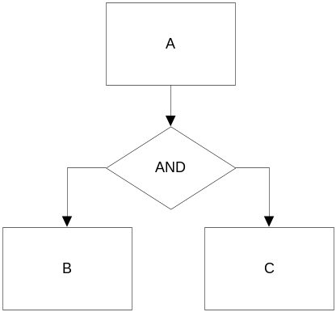
Description: A given subprocess should be terminated when there is nothing else to be done. In other words, there are no active activities in the workflow and no other activity can be made active (and at the same time the workflow is not in deadlock).
Implementation: Many workflow engines terminate the process when an explicit Final node is reached. Any current activities that happen to be running at that time will be aborted. For workflow products that do not support this pattern directly, the typical solution to this problem is to transform the model to an equivalent model that has only one terminating node, this is shown in Workflow E below. The complexity of that task depends very much on the actual model. Sometimes it is easy and fairly straightforward, typically by using a combination of different join constructs and activity repetition. However, there are situations where it is difficult or even impossible to do so. A model that involves multiple instances and implicit termination is typically very hard to convert to a model with explicit termination.
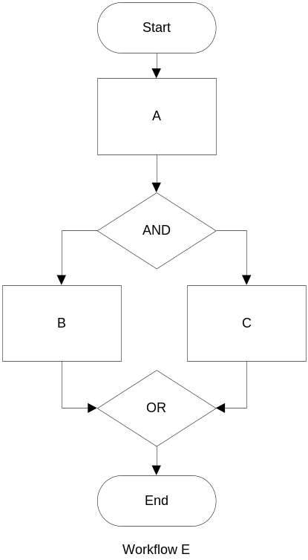

Patterns Involving Multiple Instances
Pattern 12: MI with a priori known design time knowledge - generate many instances of one activity when a number of instances is known at the design time

Pattern 13: MI with a priori known runtime knowledge - generate many instances of one activity when a number of instances can be determined at some point during the runtime (as in FOR loop)

Pattern 14: MI with no a priori runtime knowledge - generate many instances of one activity when a number of instances cannot be determined (as in WHILE loop)

Pattern 15: MI requiring synchronization - generate many instances of one activity and synchronize them afterwards

State-based patterns
Pattern 16: Deferred Choice - execute one of the two alternatives threads. The choice which thread is to be executed should be implicit.

Pattern 17: Interleaved Parallel Routing - execute two activities in random order, but not in parallel.

Pattern 18: Milestone - enable an activity until a milestone is reached

Cancellation Patterns
Pattern 19: Cancel Activity - cancel (disable) an enabled activity

Pattern 20: Cancel Case - cancel (disable) the process

Workflow definition standard control pattern support

The table below summarizes the results of a comparison of various standards.
For each standard-pattern combination, we checked whether it is possible to realize the workflow pattern with the language. If a standard directly supports the pattern through one of its constructs, it is rated +. If the pattern is not directly supported, it is rated +/-. Any solution which results in spaghetti diagrams or coding, is considered as giving no direct support and is rated -. Note that a pattern is only supported directly if there is a feature provided by the language, which supports the construct without resorting to any of solutions mentioned in the implementation part of the pattern.

Pattern | Workflow definition standard
 | XPDL | UML | BPEL | XLANG | WSFL | BPML | WSCI
Sequence | + | + | + | + | + | + | +
Parallel Split | + | + | + | + | + | + | +
Synchronization | + | + | + | + | + | + | +
Exclusive Choice | + | + | + | + | + | + | +
Simple Merge | + | + | + | + | + | + | +
Multi Choice | + | - | + | - | + | - | -
Synchronizing Merge | + | - | + | - | + | - | -
Multi Merge | - | - | - | - | - | +/- | +/-
Discriminator | - | - | - | - | - | - | -
Arbitrary Cycles | + | - | - | - | - | - | -
Implicit Termination | + | - | + | - | + | + | +
MI without Synchronization | + | - | + | + | + | + | +
MI with a Priori Design Time Knowledge | + | + | + | + | + | + | +
MI with a Priori Runtime Knowledge | - | + | - | - | - | - | -
MI without a Priori Runtime Knowledge | - | - | - | - | - | - | -
Deferred Choice | - | + | + | + | - | + | +
Interleaved Parallel Routing | - | - | +/- | - | - | - | -
Milestone | - | - | - | - | - | - | -
Cancel Activity | - | + | + | + | + | + | +
Cancel Case | - | + | + | + | + | + | +

