caGrid Portal Adminstrators’ Guide

Contents
- creating the administrative user
- editing news feeds
- editing the calendar

Creating the Administrative User

In order to create a caGrid Portal administrative account, we will need valid caGrid credentials. If you already have an account with the NCICB Dorian Identity Provider (IdP), or with the NCICB AuthenticationService IdP (i.e. you have an NIH account), then you do not need to create a new caGrid account. If you don’t have either of these accounts, you can create a new caGrid account through the portal.

To create a new account, go to the REGISTER tab, and enter the required information. When you have successfully completed the registration, you will immediately have a caGrid account, but you need to login at least once in order to have a caGrid Portal account. Go to the HOME tab and click the Login link. Enter your username and password and click the Login button. You’ll see a greeting. Then click the Logout link.

At this point, we’ve created a caGrid Portal account. Now we need to give this account administrative privileges.

After the portal is installed, there will be a single default administrative user whose username is ‘portaladmin’. The password of this user is determined at installation time. See the installation guide for details.

Login as portaladmin by going to:
https://<host>:8443/user/portaladmin/1

NOTE: Make sure you go to the HTTPS version of this URL. Otherwise, the portaladmin password will be sent in clear text across the network, which is a security risk.

You will be presented with the following screen:

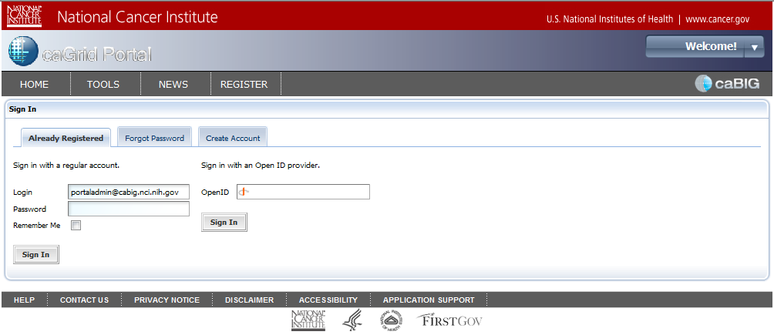

In the Login field, enter ‘portaladmin@cabig.nci.nih.gov’. In the Password field, enter the password for this user. Then press the Sign In button. You will see the following page.

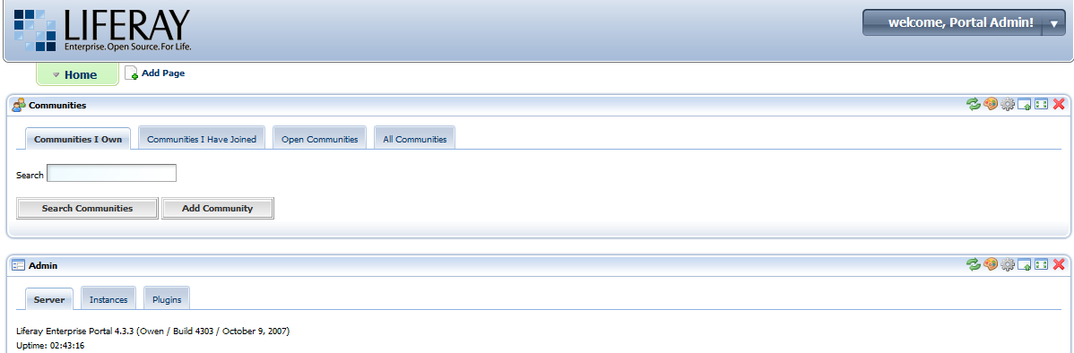

From this page, you can perform all Liferay administrative operations. The Liferay administrative guide is here: http://content.liferay.com/4.2/doc/user/liferay_4_portal_administration_guide/onepage/

NOTE: That is the 4.2 version. The 4.3 version was not ready at the time of writing.

Scroll down the page to the Enterprise Admin portlet. Then select the Roles tab. You should see a list of role names and one of them should be “Adminstrator”. All the way to the right of this row will be some icons. When you mouse over the center icon, a tool-tip will display the text “Assign Members”. Click on this icon.

Now you should see the following screen:

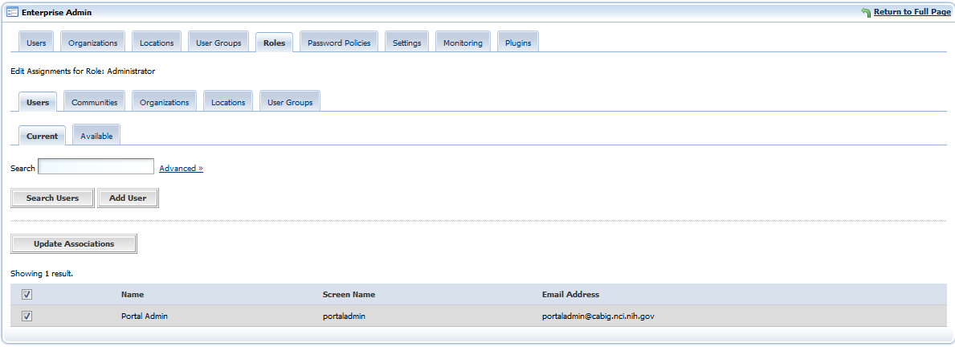

Notice that the Current tab is selected. Select the Available tab. In the Available tab, you should see the account that you just created. Select the checkbox next to this account and press the Update Associations button.

Now, sign out by select the “Sign Out” link in the “welcome Portal Admin” drop-down list that is in the upper, right-hand corner of the page. You’ll be redirected to the caGrid Portal home page.

Editing News Feeds

The caGrid Portal can be used to maintain an RSS news feed. To edit the new feed you will need to login to the portal using an account that has the Administrators role (see Creating the Administrative User section for details).

After logging in with an Adminstrators account, go to the NEWS tab. In the upper, right-hand corner of the News portlet you’ll see the several controls.

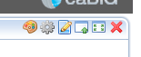

When you mouse of the third icon from the left, you should see a tool-tip that displays the text “Preferences”. Click on this icon.

Click the Add Channel link. You’ll see the New Channel form. Enter the title, link and description. The link should point to some page that describes the channel. News pages are created and maintained outside of the portal.

Once you’ve entered this information, press the Save button. An “Edit news items” link will appear below the form. Click on this link. Then click the “Add item” link. A form will appear in which you can enter the title, link, width, height, and description of the news item. Again the link must point to a real web page that contains the content. The width and height values control the dimensions of the IFrame that will display the news item to portal users. You should probably use a width of ‘100%’ and a height of ‘250px’.

Editing the Calendar

The Home page of the caGrid Portal displays a calendar portlet. This is a full featured calendaring application. The calendar contents can be imported and exported using the standard iCal format (http://tools.ietf.org/html/rfc2445).

You must be logged in with an account that has the Administrators role in order to edit the calendar.

