caGrid Portal Tests

In your browser, go to http://<host>:8080

You should see the following page

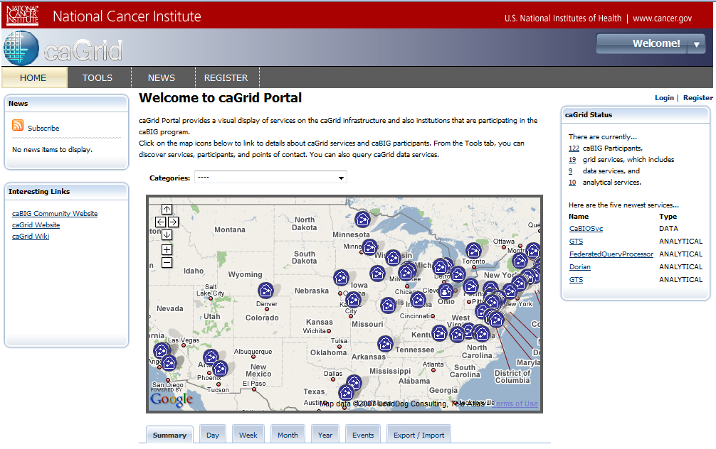

Home Page Tests

Map Portlet Tests

These tests apply to the Google Map portlet that is displayed in the Home tab of the portal. This map displays the following items:

Description | Icon
Active Data Service
In-active Data Service
Analytical Service
In-active Analytical Service
Fully Active Hosting Research Center
Partially Active Hosting Research Center
Fully In-active Hosting Research Center
Participant
Point of Contact

Categories Test

Selecting items from the Categories drop-down list will cause items that are in the selected category to be displayed. Try selecting each item in the drop-down list and make sure something is displayed on the list
Notes:
The All Points of Contact item will not display any items on the map.

Link to Service Test

Find a data service or analytical service icon on the map. Click the icon. You should see a “bubble” appear, and in the bubble will be a short description of the service. The service name is hyperlinked. Click on the name of the service. You will be directed to the Tools tab and the Discovery portlet will display the details for the selected service.

Link to Services Test

Find a hosting research center icon. Click on the icon. In the bubble that appears, you should see a message indicating how many services are at this location. Click on the View… link. You will be redirected to the Tools tab and the Discovery portlet will display a list of the services at that location.

List to Participant Test

Find a participant icon. Click on the icon. In the bubble that appears, you should see the hyperlinked name of the participant, and a hyperlink to the participant’s homepage (if it exists).

Status Portlet Tests

The status portlet displays the count of participants, all services, data services, and analytical services. Each of these counts is hyperlinked. The status portlet also displays the five most recently registered services. The name of each service is hyperlinked.

Link to Participants/Services Test

Click on each of the hyperlinked counts in the status portlet. In each case, you will be directed to the Tools tab where a list of the selected items will be displayed.

Link to Service Test

Click on each of the hyperlinked service names in the status portlet. In each case, you will be directed to the Tools tab where the service details will be displayed.

Interesting Links Portlet Tests

Click on each of the links to ensure that they are correct.

Footer Links Test

In the footer of the Home tab page, there are several links (e.g. HELP, SUPPORT, etc). Click each one of these to ensure that appropriate content is displayed.

Register Tests

If you are not already authenticated, there will be two links in the upper, right-hand corner of the Home tab page: “Login | Register”.

Click on the Register link. The browser will be redirected to the URL: https://<host>:8443/web/guest/register

If the browser does not redirect to HTTPS, it is an error.

You may see a warning indicating that the server certificate is not trusted. If this test is being run against the production deployment, the such a warning constitutes an error. If the test is against a deployment in DEV, QA, or STAGE, then it is not an error.

You will be presented with a registration form. Enter the required information to register for a caGrid account.

Required Field Test

Try to submit without filling out a required field. You should see a message indicating that the field is required.

Duplicate User Test

Try to register twice using the same username. You should see a message saying that the user already exists.

Username/Password Constraints Test

Try registering with a username or password that does NOT satisfy the username or password constraints. You should see an error message indicating what was wrong.

Login Tests

Link to Login Test

From the Home tab page, click the Login link in the upper, right-hand corner. You should be redirected to https://<host>:8443/web/guest/login. If you are not redirected to an HTTPS URL it is an error.

The login portlet should appear.

Valid Login Test

Login with a valid username and password. You should see a greeting indicating your first and last name, and there should be a link to get back to the Home tab page. Click that link. When you are back at the Home tab page, you should see a greeting indicating your first and last name.

Invalid Login Test

Login with an invalid username and password. You should see a message indicating that your username/password are invalid.

Discovery Tests

Click on the Tools tab. You should see the Discovery and Data Service Query portlets.

Directory List View Test

In the Disovery portlet, select the Discovery > List View tab. Select the “All Services” directory. Page through through the results. Select each of the directories and verify that paging works.

Directory Map View Test

First select some directory in the Directory > List View tab. The click on the Map View tab. You should see those items on the map (unless they are Points of Contact).

Search Services Test

Search Participants Test

Search POCs Test

Discovery Results Test

The portal maintains discovery search results in the user’s session. So, after you have searched for service, participants or POCs, you should be able to view those results by selecting one of the items in the “Search Results” drop-down list in the Discovery > List View or Discovery > Map View tab.

Service Details Tests

Do a search for the caBIO service. Then click the “More Details” link in the Discovery > List View tab. The service details for the caBIO service should appear. Try expanding all of the tree nodes.

Link to Query from Service Discovery Results Test

Do a search for some data service. In the results view, click on the “Query…” link. The Data Service Query portlet should update and display the UML classes that are available in the data services domain model.

Link to Query from Domain Model Test

Do a search for some data service, then view the service details. Expand the Domain Model node and navigate to some UML class. There should be a button labeled “Select for Query”. Click that button. The Data Service Query portlet should update and display a working query.

Adminstrator Login Test

To login as the portal administrator, go to https://<host>:8443/user/portaladmin/1

You should see a page like this:

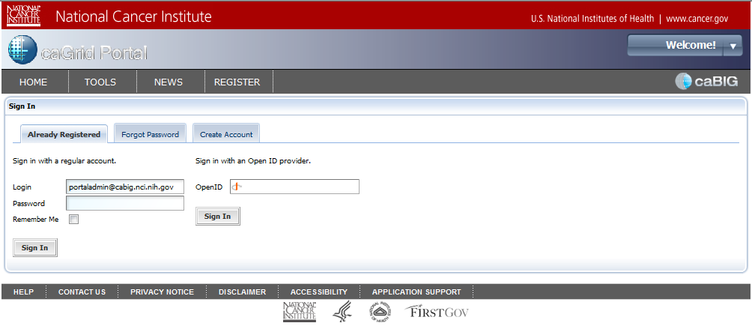

Enter the username (portaladmin@cabig.nci.nih.gov) and password. Click the Sign In button. You will then see a page that looks like this:

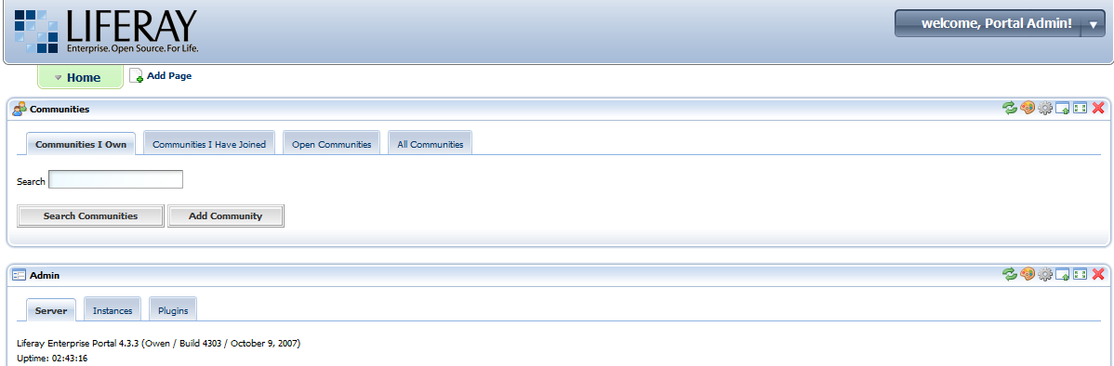

From the “Welcome, Portal Admin” drop-down list, select My Places > Guest > Public Pages. You will be directed back to the caGrid Portal Home tab page.

New Tests

