Analysis of Authorization Approaches
caGrid 1.0

Version No: 0.1
Last Modified: 05/24/2006

Author : Stephen Langella and Vinay Kumar
Team : caGrid

Client : National Cancer Institute - Center for Bioinformatics,
National Institutes of Health,
US Department of Health and Human Services

Document History

Document Location
The most current version of this document is located in CVS under security/docs.

Revision History
Version Number | Revision Date | Author | Summary of Changes
0.1 | 06/07/06 | Stephen Langella | Initial draft

Review
Name | Team/Role | Version | Date Reviewed | Reviewer Comments

Related Documents
More information can be found in the following related CSM documents:
Document Name

Table of Contents
1. Introduction 4
1.1 Purpose 4
2. Use case Scenarios 4
3. Group/Virtual Organization Approach 5
3.1 Addressing the Use Case 6
3.2 Infrastructure Considerations 7
3.3 Integration with the Grid and Local Policy 7
3.4 Integration with CSM (Not Required) 7
4. Attribute Based Authorization 7
4.1 Addressing the Use Case 8
4.2 Infrastructure Considerations 9
4.3 Integration with the Grid and Local Policy 10
4.4 Integration with CSM (Not Required) 10

Introduction
Authorization is the process of determining who is allowed to perform what actions. The goal of the caGrid 1.0 authorization framework is to empower service providers and data owners to make authorization decisions. One of the major focuses of the caGrid 1.0 authorization framework is extensibility, allowing service providers to leverage their authorization mechanism of choice for enforcing access control policies. It is not the mission of the caGrid team to advocate one authorization mechanism over another but to facilitate the integration of authorization mechanisms required by applications for meeting authorization policies. To facilitate the integration the caGrid team will provide integration points within the grid infrastructure. Another focus of the caGrid 1.0 authorization framework is to provide higher level services to facilitate authorization at the grid level. These services will be made available to service providers and will be developed based on community demand. In this document we will refer to these higher level services as extension points. Extension points are implementations of higher level community services that will be accessed through the integration points within the grid infrastructure. The purpose of this document is to design and present the architecture for the authorization integration points in the caGrid 1.0 . This document will also present the design and architecture of higher level authorization services or extension points. As new higher level services are made available their design and architecture will be maintained in this document. Please note this document assumes that the reader has a firm understanding of grid security, for a good overview of grid security please consult the following:

Purpose
The purpose of this document is to analyze different approaches to authorization. Our analysis will be based on how an approach meets a simple use case, infrastructure required to leverage the approach in caGrid, how the approach can be integrated with local authorization policy, and maintainability and scalability based on the current state of the caBIG community.

Use case Scenarios

Suppose we have a Patient Provider service, that provides patient information about an institution’s Patients, and that any user classified as a Doctor can access the patient information provided by the Patient Provider service. The deployment scenario shown in Figure X contains three Patient Provider services one at Duke, one at Georgetown, and one at the Ohio State University. The Duke Patient Provider Service allows access to users that are classified as Doctors by Duke (represented by the Duke Doctors group). The Georgetown Patient Provider Service allows access to users that are classified as Doctors by Georgetown (represented by the Georgetown Doctors group). The Ohio State University Patient Provider Service allows access to users that are classified as Doctors by caBIG, where a user is classified as a caBIG Doctor if they are classified as a Doctor by a caBIG affiliated institution. In current scenario caBIG Doctors are all the users classified by Duke as Doctors and all the users classified by Georgetown as Doctors.

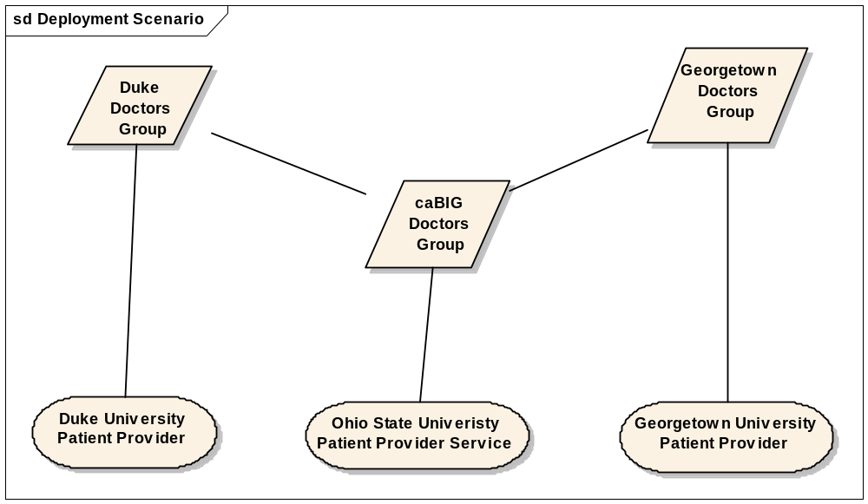

In order to be able to efficiently manage and scale access control policy it is critical that policy is based on “groups or users” or “attributes of users”. In this simple use case access to the Ohio State Patient Provider service is based on membership to the caBIG Doctors group. It is important to note that as users are added and removed to that group, the authorization policy is not changed.

Group/Virtual Organization Approach

Group/VO authorization is a commonly used for meeting access control requirements in many of today’s applications. Under this approach access control policy is based on membership within a group or VO. For example if the user is in the Doctors group, they have access to this set of data, if the user is in the Patients group they have access to another set of data. In for the group/role model to scale and be manageable in a multi-institution grid environment, groups must be maintained and federated at the grid level. For example imagine trying to manage the caBIG Doctors Group locally, every time a Doctor is added or removed from either of the two sub groups (Georgetown, Duke) the caBIG Doctors group needs to be updated. In this trivial example one can see how difficult it is to provision group membership across related groups, this difficulty will increase exponentially as the relationships between groups become more an more complex. To solve this problem grid infrastructure is needed for provisioning and federating groups at the grid level. The Grid Virtual Organization Service (GVOS) defines and manages a set of virtual organizations at the grid level, where a virtual organization is compromised as a set of users and set of other virtual organizations, which may be defined on another GVOS.

Addressing the Use Case

Figure XX demonstrates how GVOS address the use case scenario defined earlier. Georgetown and Duke each maintain a GVOS service that manages a Doctor VO, consisting of a list of all the Doctors within their respective institution. Both the Georgetown and Duke Patient Provider Service authorize users based on membership in the Doctor VO maintained at the GVOS of their respective institution. The NCICB maintains a GVOS services that contains a Doctors VO consisting of two sub Doctor VOs, the one defined in the GVOS at Duke and the one defined in the GVOS at Georgetown. The Ohio State Patient Provider allows access to users if they are a member of the NCICB Doctors VO or more specifically are a member of the Duke Doctors VO o the Georgetown Doctors VO.

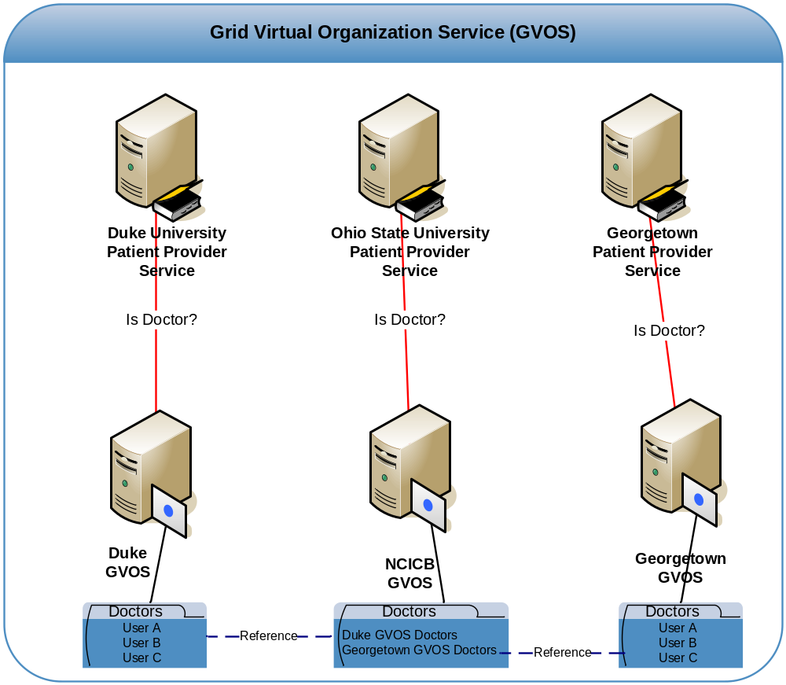

Infrastructure Considerations

In order for this approach to be manageable and scale it is critical that Virtual Organizations (VO) are managed at the grid level and that VO can be federated across the grid, such that one VO may contain other VOs. An example of this is illustrated in our usecases where the NCICB Doctors VO consists of all the Doctors in both the Georgetown VO and Duke VO. Grid infrastructure is required to manage and maintain VOs at the grid level. The infrastructure should facilitate the following:

- Creation of a VO.
- Management of a VO.
- Removal of a VO.
- Determining if a user is a Member of a VO.

Integration with the Grid and Local Policy

As mentioned earlier local authorization policy should be designed around performing access control on groups. Access control is enforced by local policy based on membership in VOs. Grid applications enforce local policy by determining VO membership.

Integration with CSM (Not Required)

CSM currently provides a means of managing and enforcing local access control policy. To integrate CSM with the VO grid authorization approach, CSM would need to support configuring access control policy based on VO membership. Modification to CSM would be required to support resolving membership to a VO.

Attribute Based Authorization

Under Attribute Based Authorization, authorization is enforced based on the value of a set of attributes associated with a given user. A user attribute can be anything but is generally information describing the user, for example the user’s mailing address or phone number. Applications make authorization decisions by obtaining a set of user attributes from an attribute authority. Access control policy is then used to examine the attributes to determine whether our not the user will be authorized. Attribute based authorization poses many technical, political, and social challenges in a grid environment, these include discovering attribute authorities, trusting attribute authorities, provisioning attributes, and standardization of attributes. Consider the following scenario of two users Jack and Jill, Jack graduated from RPI with a masters degree, and has a driver license from the state of Ohio, Jill graduated from UCLA with a masters degree and has a driver license from the state of Maryland. Now suppose there is a grid service that grants access to users with a valid drivers license attribute and a masters degree attribute. One of the challenges is this scenario is deciding who should provision each of the attributes for a given user. Logistically it would make sense for the state of Ohio to maintain the license attribute for all Ohio licensed drivers since they are the ones doing the licensing. Similarly the state of Maryland should provision the license attribute for all Maryland licensed drivers. The masters degree attribute should be maintained by the institution that granted the degree, for Jack it would be RPI, for Jill it would be UCLA. As this example suggests a user’s attributes be come from many attribute authorities, provisioning of attributes poses a technical challenge because infrastructure is needed to support this, however more importantly it poses a social/political/policy challenge in deciding who should provision which attributes. The grid service performing the authorization needs to know which attribute authorities to get a user’s attribute from. This can pose a significant challenge since their can be multiple attribute authorities for a given attribute and a user’s attribute may exist across multiple authorities. Another related challenge is determine how to trust a given attribute authority. For example you would trust the UCLA to provide attributes for degrees but you would not trust UCLA to provides attributes for driver licenses. Grid services will need mechanisms for determining which attribute authorities can be trusted for providing specific attribute types, the amount of trust on a given authority and which attributes they are trusted to provide may differ from service to service. Standardization on a common set of attribute is also a challenge and is critical in managing the scope of provisioning attributes. The more attributes there are the more complicated provisioning become, since each user may need to be assigned each attribute.

Addressing the Use Case

Figure XX demonstrates how attribute based authorization can be used to address the use case scenario defined earlier. Georgetown and Duke each maintain a Attribute Authority that manages the Doctor’s attribute for each user that is a Doctor at their institution. Both the Georgetown and Duke Patient Provider Service authorize users based on the user having a Doctor attribute maintained in the Attribute Authority at their respective institution. The Ohio State Patient Provider allows access to users that have a Doctor’s attribute in either the Georgetown attribute authority or Duke attribute authority.
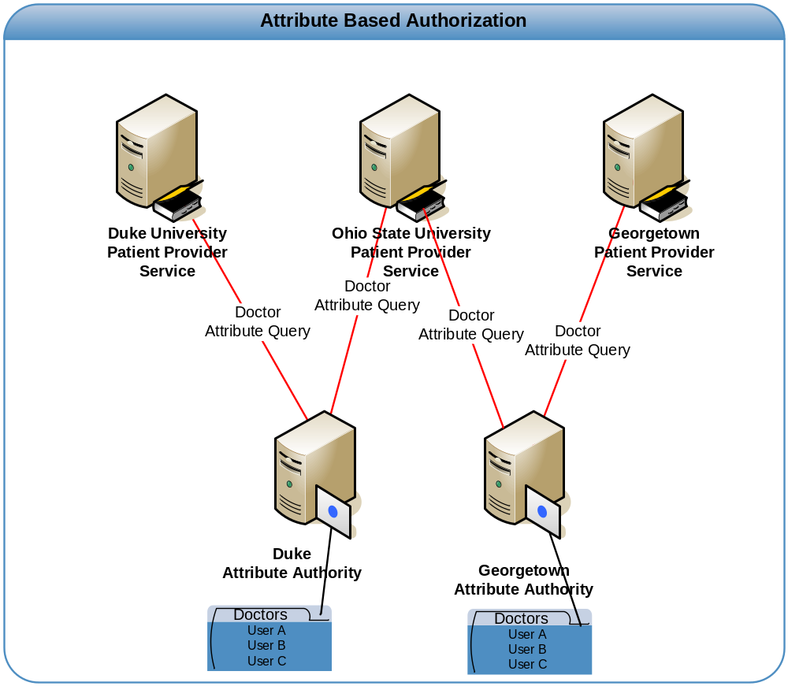

Infrastructure Considerations

In order for this approach to be manageable and scale in a grid environment significant infrastructure enhancements to caGrid would be required. The following infrastructure would be required:

- Attribute Authority Discovery Registry - This should facilitate the discovery of attribute authorities based on the attribute type and user.
- Attribute Authority – Infrastructure for provisioning attributes for users. An attribute authority should be able to manage a set of attributes for a given user, allowing attributes to be added, modified, and removed. The Attribute Authority should be able to provide access control on user attributes, allowing grid services to access all or a subset of a user’s attributes.
- Trusting Attribute Authorities – Infrastructure is required services to maintain which attribute authorities they trust for providing a specific attribute for a specific user.

Integration with the Grid and Local Policy

Local authorization policy should be designed for performing access control based on a set of attributes. Access control is enforced by obtaining the obtaining and evaluating the user attributes required in making the authorization decision.

Integration with CSM (Not Required)

CSM currently provides a means of managing and enforcing local access control policy. To integrate CSM with the attribute based approach, CSM would need to support configuring access control policy based on a set of attributes. Modification to CSM would be required to support resolving attributes for users.

