Metadata API Usage Overview
All caGrid services are expected to expose a standard set of service metadata. Details about this design and the specifics of the metadata can be found in the caGrid Metadata Design document. This section describes the high-level API which can be used to access and manipulate instances of this metadata. All the standard metadata models have bean representations which can be used to programmatically interact with the models. Shown below in Figure 1 and Figure 2 respectively, are the Standard Service (ServiceMetadata) and Data Service (DomainModel) metadata models. The APIs described herein can be used access these models from services, and serialize and deserialize them to and from XML. These methods complement the Discovery API, as once an EPR (End Point Reference) is returned from the Discovery API, these methods can be used access and inspect the full metadata.

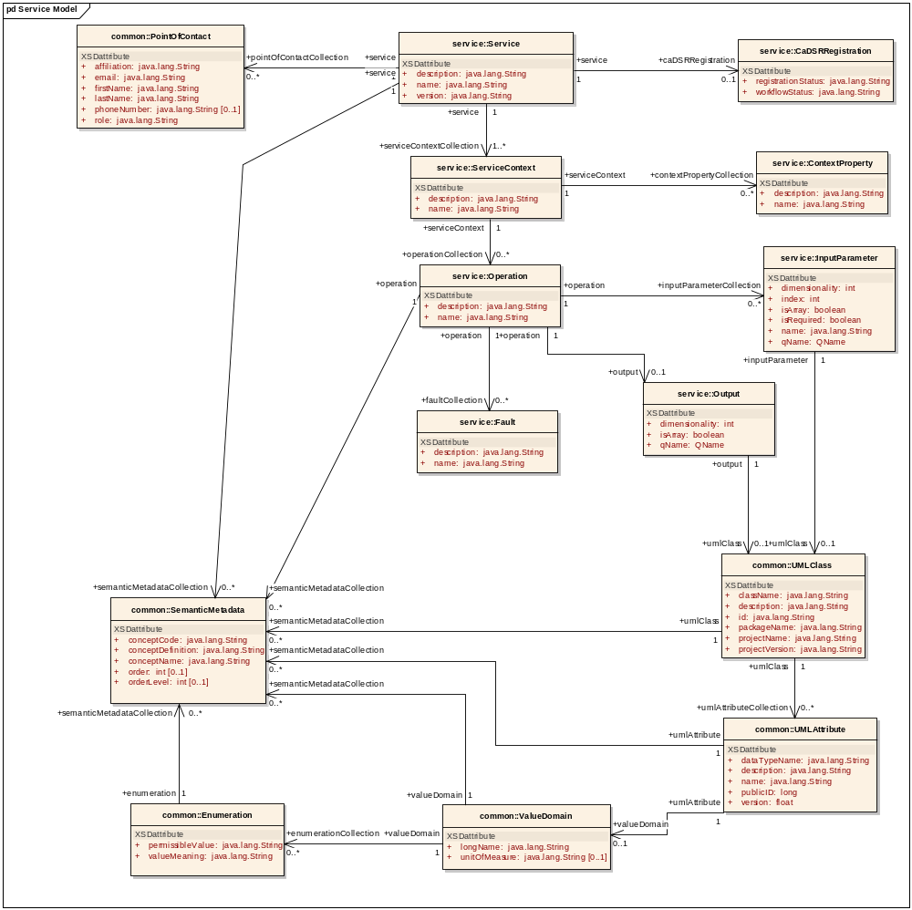
Figure 1 : Service Model

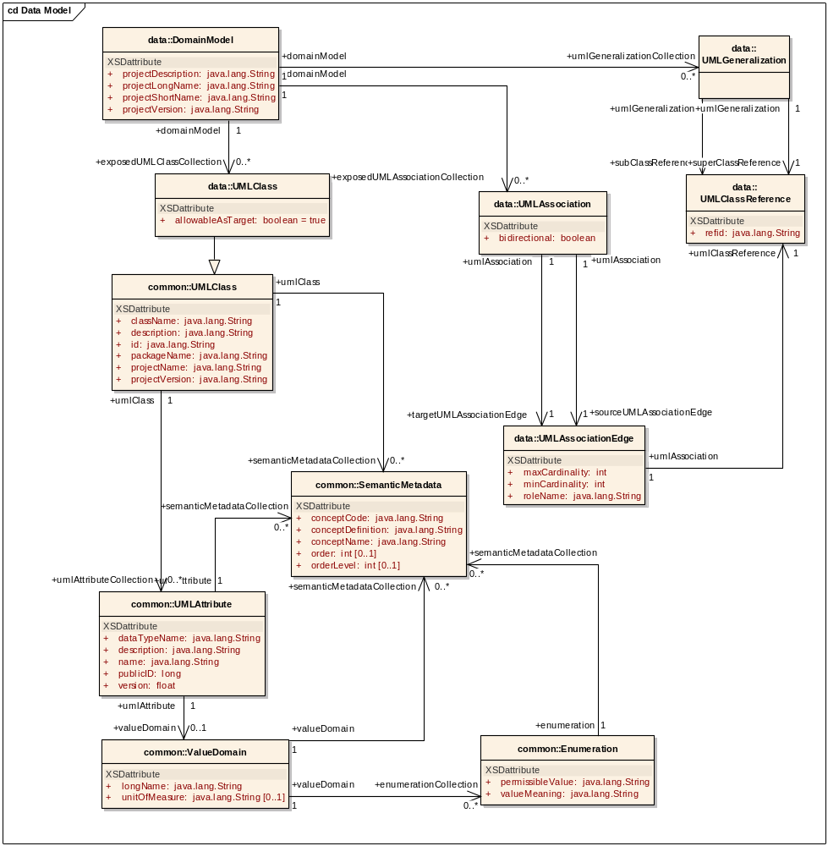
Figure 2 : Data Service Metadata Model

The ResourcePropertyHelper API not detailed here, is the lower level API which can be used to directly gather information about ResourceProperties (which is how metadata is exposed in caGrid). The MetadataUtils, described herein, leverage this API, and expose some of its exceptions. The possible exceptions generated by the metadata utility methods are detailed below in Figure 3. A non discerning client may simple opt to catch ResourcePropertyRetrievalException, as it is the base checked exception. An additional non-checked exception, InternalRuntimeException, can also be thrown, but it is solely used to represent an internal logic error in the APIs and so it is not expected clients can “recover” from such an exception. As such, client should not attempt to catch this runtime exception for any other reason than to mask the problem. QueryInvalidException, is thrown if an invalid XPath query is issued. Problems originating from remote services are thrown in the subclass, RemoteResourcePropertyRetrievalException. In general use of the metadata utilities, this is the most likely exception clients may see, as it is thrown if a service is not properly exposing the proper metadata. Clients leveraging the lower level resource property APIs should take care to appropriately address each type of exception if they are communicating with services. For example, even though it is a caBIG requirement to expose the standard service metadata, clients should properly handle the case where it is not present. Asking for specific metadata that a service does not provide would yield an InvalidResourcePropertyException.

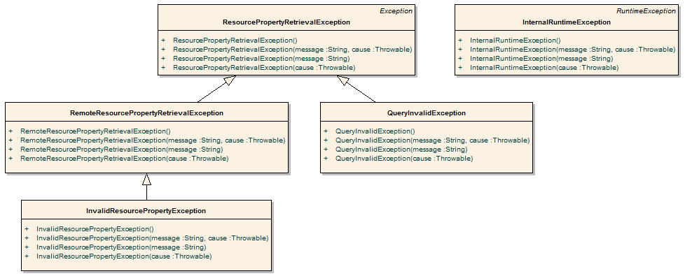
Figure 3 Metadata Exceptions

API Details

gov.nih.nci.cagrid.metadata.MetadataUtils

Member Function Documentation

static ServiceMetadata gov.nih.nci.cagrid.metadata.MetadataUtils.getServiceMetadata (EndpointReferenceType serviceEPR) throws InvalidResourcePropertyException, RemoteResourcePropertyRetrievalException, ResourcePropertyRetrievalException [static]
Obtain the service metadata from the specified service.

Parameters:
serviceEPR

Returns:

Exceptions:
InvalidResourcePropertyException
RemoteResourcePropertyRetrievalException
ResourcePropertyRetrievalException

static DomainModel gov.nih.nci.cagrid.metadata.MetadataUtils.getDomainModel (EndpointReferenceType serviceEPR) throws InvalidResourcePropertyException, RemoteResourcePropertyRetrievalException, ResourcePropertyRetrievalException [static]
Obtain the data service metadata from the specified service.

Parameters:
serviceEPR

Returns:

Exceptions:
InvalidResourcePropertyException
RemoteResourcePropertyRetrievalException
ResourcePropertyRetrievalException

static void gov.nih.nci.cagrid.metadata.MetadataUtils.serializeServiceMetadata (ServiceMetadata metadata, Writer writer) throws Exception [static]
Write the XML representation of the specified metadata to the specified writer. If either are null, an IllegalArgumentException will be thown.

Parameters:
metadata
writer

Exceptions:
Exception

static ServiceMetadata gov.nih.nci.cagrid.metadata.MetadataUtils.deserializeServiceMetadata (Reader xmlReader) throws Exception [static]
Create an instance of the service metadata from the specified reader. The reader must point to a stream that contains an XML representation of the metadata. If the reader is null, an IllegalArgumentException will be thown.

Parameters:
xmlReader

Returns:

Exceptions:
Exception

static void gov.nih.nci.cagrid.metadata.MetadataUtils.serializeDomainModel (DomainModel domainModel, Writer writer) throws Exception [static]
Write the XML representation of the specified metadata to the specified writer. If either are null, an IllegalArgumentException will be thown.

Parameters:
domainModel
writer

Exceptions:
Exception

static DomainModel gov.nih.nci.cagrid.metadata.MetadataUtils.deserializeDomainModel (Reader xmlReader) throws Exception [static]
Create an instance of the data service metadata from the specified reader. The reader must point to a stream that contains an XML representation of the metadata. If the reader is null, an IllegalArgumentException will be thown.

Parameters:
xmlReader

Returns:

Exceptions:
Exception

API Usage Examples
Asdf

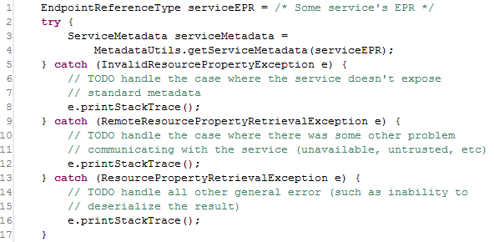
Figure 4 Accessing Standard Service Metadata

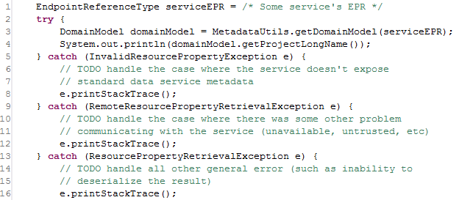
Figure 5 Accessing Standard Data Service Metadata

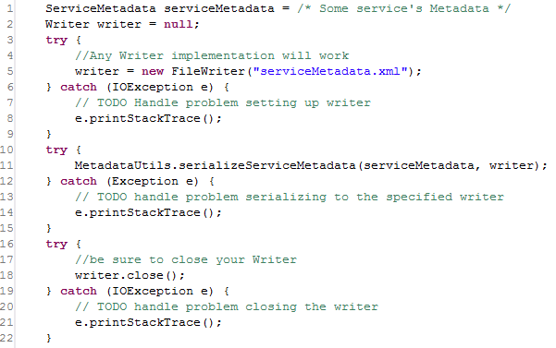
Figure 6 Serializing Metadata to a File

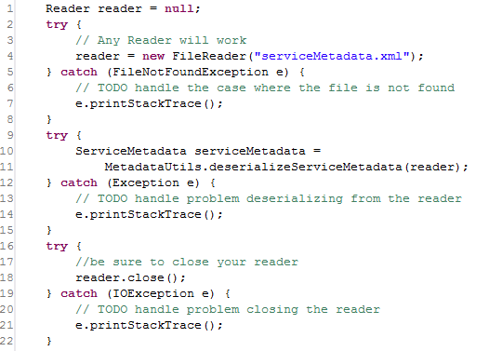
Figure 7 Deserializing Metadata from a File

