The cancer Biomedical Informatics Grid, or caBIG™, is a voluntary virtual informatics infrastructure that connects data, research tools, scientists, and organizations to leverage their combined strengths and expertise in an open federated environment with widely accepted standards and shared tools. The underlying service oriented infrastructure that supports caBIG™ is referred to as caGrid. Driven primarily by scientific use cases from the cancer research community caGrid provides the core enabling infrastructure necessary to compose the Grid of caBIG™. It provides the technology that enables collaborating institutions to share information and analytical resources efficiently and securely, and allows investigators to easily contribute to and leverage the resources of a national-scale, multi-institutional environment

The caGrid 0.5 "test bed" infrastructure was released in September 2005, which included the initial set software tools to effectively realize the goals of caBIG™. The grid technologies and methodologies adopted for caBIG™, and implemented in caGrid, provide a loosely coupled environment wherein local providers are given freedom of implementation choices and ultimate control over access and management, but harmonize on community accepted virtualizations of the data they use, and make them available using standardized service interfaces and communication mechanisms. While caGrid enables numerous complex usage scenarios, in its simplest base, its goals are to: enable universal mechanisms for providing interoperable programmatic access to data and analytics to caBIG™, create a self-describe infrastructure wherein the structure and semantics of data can be programmatically determined, and provide a powerful means by which resources available in caBIG™ can be programmatically discovered and leveraged. Additional information about the caGrid 0.5 effort, and a good overview of the motivation of the grid approach of caBIG™, can be found in the Bioinformatics Journal article (http://bioinformatics.oxfordjournals.org/cgi/content/full/22/15/1910).

Building on the foundation of caGrid 0.5, caGrid 1.0 was extensively enhanced based on the feedback & input from the early adopters of the caGrid 0.5 infrastructure and additional requirements from the various caBIG™ Domain Workspaces. The release of caGrid version 1.0 represented a major milestone in the caBIG™ program towards achieving the program goals. It provided the implementation of the required core services, toolkits and wizards for the development and deployment of community provided services, APIs for building client applications, and some reference implementations of applications and services available in the production grid. The caGrid 1.1 release represents a minor, backwards compatible release of caGrid, with a focus on increased usability, bug fixes, and various feature enhancements. A detailed listing of the changes from caGrid 1.0 can be found in the release notes and on the project website.

Standards Compliant
As a primary principle of caBIG™ is open standards, caGrid is built upon the relevant community-driven standards of the World Wide Web Consortium (W3C http://www.w3.org/) and OASIS (http://www.oasis-open.org). It is also informed by the efforts underway in the Open Grid Forum (OGF http://ogf.org/). The Open Grid Forum (OGF) is a community of users, developers, and vendors leading the global standardization effort for grid computing. The OGF community consists of thousands of individuals in industry and research, representing over 400 organizations in more than 50 countries. As such, while the caGrid infrastructure is built upon the 4.0 version of the Globus Toolkit (GT4 http://globus.org/toolkit/), it shares a Globus goal to be programming language and toolkit agnostic by leveraging existing standards. Specifically, caGrid services are standard WSRF v1.2 services and can be accessed by any specification-compliant client.

caGrid 1.0 also represented an increased involvement in relevant working groups, standards bodies, and organizations involved in the standardization and adoption of grid technologies. The caGrid team consists of several members involved in both the development of the Globus toolkit, and authors on some of the relevant specifications. Furthermore, some of the components developed by caGrid have been published in peer-reviewed articles, have been vetted by the grid community in several invited talks, and are undergoing an incubation process to become part of the Globus toolkit itself.

Model Driven
Extending beyond the basic grid infrastructure, caBIG™ specializes these technologies to better support the needs of the cancer research community. A primary distinction between basic grid infrastructure and the requirements identified in caBIG and implemented in caGrid is the attention given to data modeling and semantics. caBIG™ adopts a model-driven architecture best practice and requires that all data types used on the grid are formally described, curated, and semantically harmonized. These efforts result in the identification of common data elements, controlled vocabularies, and object-based abstractions for all cancer research domains. caGrid leverages existing NCI data modeling infrastructure to manage, curate, and employ these data models. Data types are defined in caCORE UML and converted into ISO/IEC 11179 Administered Components, which are in turn registered in the Cancer Data Standards Repository (caDSR). The definitions draw from vocabulary registered in the Enterprise Vocabulary Services (EVS), and their relationships are thus semantically described. caGrid 1.0 represented a significant improvement in its leveraging of these technologies and the corresponding information they make available. caGrid 1.0 added support for grid service access to both the EVS and caDSR, and its new service metadata standards include significant additions of information extracted from the caDSR and EVS.

In caGrid, both the client and service APIs are object oriented, and operate over well-defined and curated data types. Clients and services communicate through the grid using respectively grid clients and grid service infrastructure. The grid communication protocol is XML, and thus the client and service APIs must transform the transferred objects to and from XML. This XML serialization of caGrid objects is restricted in that each object that travels on the grid must do so as XML which adheres to an XML schema registered in the Global Model Exchange (GME). As the caDSR and EVS define the properties, relationships, and semantics of caBIG™ data types, the GME defines the syntax of their XML materialization. Furthermore, caGrid services are defined by the Web Service Description Language (WSDL). The WSDL describes the various operations the service provides to the grid. The inputs and outputs of the operations, among other things, in WSDL are defined by XML schemas. As caBIG™ requires that the inputs and outputs of service operations use only registered objects, these input and output data types are defined by the XSDs which are registered in GME. In this way, the XSDs are used both to describe the contract of the service and to validate the XML serialization of the objects which it uses. Figure 1 details the various services and artifacts related to the description of and process for the transfer of data objects between client and service.

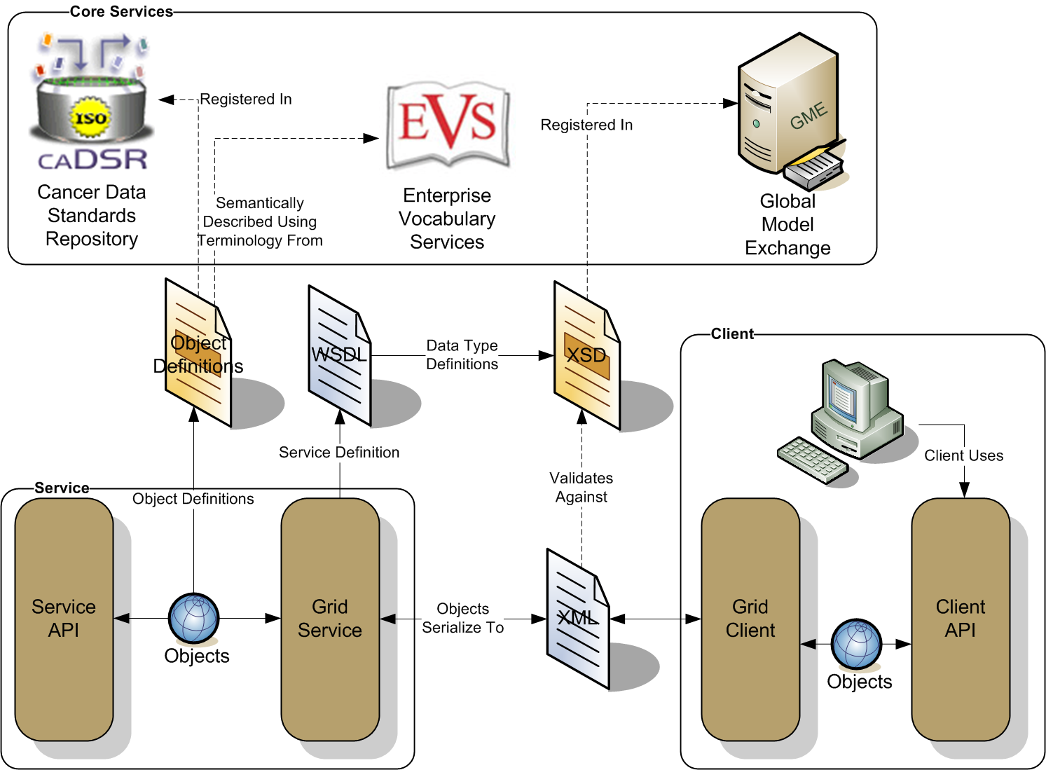
Figure 1 caGrid Data Description Infrastructure

Semantically Discoverable
As caBIG™ aims to connect data and tools from 50+ disparate cancer centers and many other institutions, a critical requirement of its infrastructure is that it supports the ability of researchers to discover these resources. caGrid enables this ability by taking advantage of the rich structural and semantic descriptions of data models and services that are available. Each service is required to describe itself using caGrid standard service metadata. When a grid service is connected to the caBIG™ grid, it registers its availability and service metadata with a central indexing registry service (Index Service). This service can be thought of as the “yellow pages” and “white pages” of caBIG™. A researcher can then discover services of interest by looking them up in this registry. caGrid provides a series of high-level APIs and user applications for performing this lookup which greatly facilitate the discovery process.

As the Index Service contains the service metadata of all the currently advertised and available services in caBIG™, the expressivity of service discovery scenarios is limited only by the expressivity of the service metadata. For this reason, caGrid provides standards for service metadata to which all services must adhere. At the base is the common Service Metadata standard that every service in caBIG™ is required to provide. This metadata contains information about the service-providing cancer center, such as the point of contact and the institution’s name. Data Services, as a standardized type of caGrid services, also provide an additional Domain Model metadata standard. Both of these standards leverage the data models registered in caDSR and link them to the underlying semantic concepts registered in EVS. The Data Service Metadata details the domain model from which the Objects being exposed by the service are drawn. Additionally, the definitions of the Objects themselves are described in terms of their underlying concepts, attributes, attribute value domains, and associations to other Objects being exposed. Similarly, the common Service Metadata details the Objects, used as input and output of the services operations, using the same format as the Data Service metadata. In addition to detailing the Objects definitions, the Service Metadata defines and describes the operations or methods the service provides, and allows semantic concepts to be applied to them. In this way, all services fully define the domain objects they expose by referencing the data model registered in caDSR, and identify their underlying semantic concepts by referencing the information in EVS. The caGrid metadata infrastructure and supporting APIs and toolkits are defined with extensibility in mind, encouraging the development of additional domain or application specific extensions to the advertisement and discovery process.

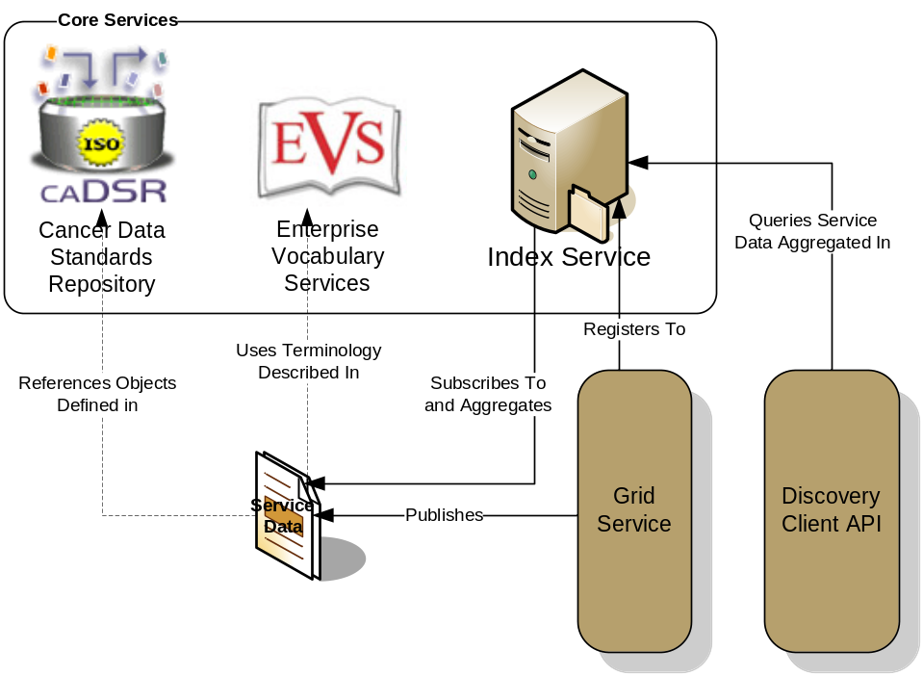
Figure 2 caGrid Discovery Overview

As shown in Error: Reference source not found, the caGrid discovery API and tools allow researchers to query the Index Service for services satisfying a query over the service metadata. That is, researchers can lookup services in the registry using any of the information used to describe the services. For instance, all services from a given cancer center can be located, data services exposing a certain domain model or objects based on a given semantic concept can be discovered, as can analytical services that provide operations that take a given concept as input.

Secure and Manageable
Security is an especially important component of caBIG™ both for protecting intellectual property and ensuring protection and privacy of patient related and sensitive information. caGrid 1.0 provided a complete overhaul of federated security infrastructure to satisfy caBIG™ security needs, incorporating many of the recommendations made in the caBIG™ Security White Paper, culminating in the creation of the Grid Authentication and Authorization with Reliably Distributed Services (GAARDS) infrastructure. GAARDS provides services and tools for the administration and enforcement of security policy in an enterprise Grid. caGrid 1.1 represents a major thrust to deploy GAARDS to the cancer research community, in that its release is timed and informed by the first set of policies and procedures created by the caBIG™ Security Working Group. The Security Working Group is a collaborative effort of the caBIG™ Architecture and Data Sharing and Intellectual Capital (DSIC) Workspaces that is intended to create and implement security policies to enable data sharing across the caBIG Federation. The initial policies in place for caGrid 1.1 formalize the envisioned Levels of Assurance for credentials in the grid, and detail the policies and practices of a credential provider adhering to the initial Level of Assurance (LOA1) which will govern the baseline credentials all caBIG™ participants may use.

GAARDS was developed on top of the Globus Toolkit and extends the Grid Security Infrastructure (GSI) to provide enterprise services and administrative tools for:
- Grid user management
- Identity federation
- Trust management
- Group/VO management
- Access control policy management and enforcement
- Integration between existing security domains and the grid security domain

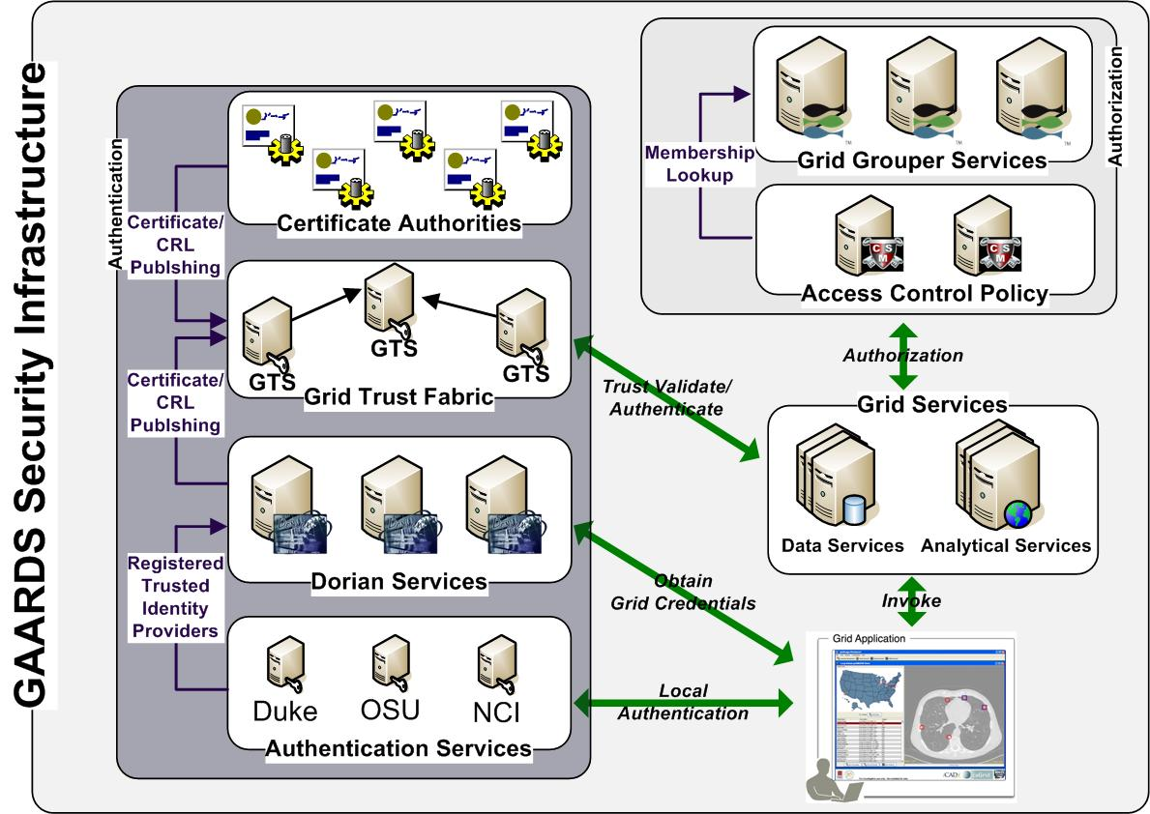
Figure 3 GAARDS Security Infrastructure

Figure 3 illustrates the GAARDS security infrastructure, in order for users/applications to communicate with secure services, they need grid credentials. Obtaining grid credentials requires having a Grid User Account. Dorian provides two methods for registering for a grid user account: 1) registering directly with Dorian 2) having an existing user account in another trusted security domain. In order to use an existing user account to obtain grid credentials, the existing credential provider must be registered in Dorian as a Trusted Identity Provider. It is anticipated that the majority of grid user accounts will be provisioned based on existing accounts. The advantages to this approach are: 1) users can use their existing credentials to access the grid 2) administrators only need to manage a single account for a given user. To obtain grid credentials, Dorian requires proof (a digitally signed SAML assertion) that proves that the user locally authenticated. The GAARDS Authentication Service provides a framework for issuing SAML assertions for existing credential providers such that they may be used to obtain grid credentials from Dorian. The Authentication Service also provides a uniform authentication interface in on which applications can be built. Figure 3 illustrates the process for obtaining grid credentials, wherein the user/application first authenticates with their local credential provider via the Authentication Service and obtains a SAML assertion as proof they authenticated. They then use the SAML assertion provided by the Authentication Service to obtain grid credentials from Dorian. Assuming the local credential provider is registered with Dorian as a trusted identity provider and that the user’s account is in good standing, Dorian will issue grid credentials to the user. It should be noted that the use of the Authentication Service is not required; an alternative mechanism for obtaining the SAML assertion required by Dorian can be used. If a user is registered directly with Dorian and not through an existing credential provider, they may contact Dorian directly for obtaining grid credentials.
Once a user has obtained grid credentials from Dorian they may invoke secure services. Upon receiving grid credentials from a user, a secure service authenticates the user to ensure that the user has presented valid grid credentials. Part of the grid authentication process is verifying that grid credentials presented were issued by a trusted grid credential provider (i.e Dorian, other certificate authorities). The Grid Trust Service (GTS) maintains a federated trust fabric of all the trusted digital signers in the grid. Credential providers such as Dorian and grid certificate authorities are registered as trusted digital signers and regularly publish new information to the GTS. Grid services authenticate grid credentials against the trusted digital signers in a GTS (shown in Figure 3).
Once the user has been authenticated, a secure grid service next determines if a user is authorized to perform what they requested. Grid services have many different options available to them for performing authorization. It is important to note that all authorizing decisions are made by the local provider, but GAARDS provides some services and tools which facilitate some common authorization mechanisms. The GAARDS infrastructure provides two approaches which can each be used independently or can be used together. It is important to note any other authorization approach can be used in conjunction with the GAARDS authentication/trust infrastructure. The Grid Grouper service provides a group-based authorization solution for the Grid, wherein grid services and applications enforce authorization policy based on membership to groups defined and managed at the grid level. Grid services can use Grid Grouper directly to enforce their internal access control policies. Assuming the authorization policy is based on membership to groups provisioned by Grid Grouper; services can determine whether a caller is authorized by simply asking grid grouper whether the caller is in a given group. The caCORE Common Security Module (CSM), an existing component many providers are already using, is a more centralized approach to authorization. CSM is a tool for managing and enforcing access control policy centrally. CSM supports access control policies which can be based on membership to groups in Grid Grouper. Grid services that use CSM for authorization simply ask CSM with a user can perform a given action. Based on the access control policy maintained in CSM, CSM decides whether or not a user is authorized. In Figure 3, the grid services defer the authorization to CSM. CSM enforces its group based access control policy by asking Grid Grouper whether the caller is a member of the groups specified in the policy, and enforces any other local data access policies defined in CSM.

Revolutionary Development
caGrid 1.0 represented a complete rewrite of caGrid to better support the requirements and current standards. Building on lessons learned from caGrid 0.5 and feedback from the community, it provided a large number of additional features, services, and vast improvements in caGrid technologies beyond what is described above. One such example was the development of a unified grid service authoring toolkit, dubbed Introduce. Introduce is an extensible framework and graphic workbench which provides an environment for the development and deployment of caBIG™ compatible grid enabled data and analytical services. The Introduce toolkit reduces the service developer’s responsibilities, by abstracting away the need to manage the low level details of the WSRF specification and integration with the Globus Toolkit, allowing them to focus on implementing their business logic. Developers with existing caBIG™ Silver compatible services need only follow simple a wizard-like process for creating the “adapter” between the grid and their existing system. At the same time, extremely complex and powerful new services can be created. All caGrid developed core services were implemented with the Introduce toolkit. caGrid 1.1 adds the ability to migrate caGrid 1.0 Introduce services to caGrid 1.1 services, and provides the migration framework to handle all such future migrations.

Another significant feature added with caGrid 1.0 is the service support for orchestration of grid services using the industry standard Business Process Execution Language (BPEL). caGrid provides a workflow management service, enabling the execution and monitoring of BPEL-defined workflows in a secure grid environment. It is expected this work will provide the groundwork for a large number of powerful applications, enabling the harnessing of data and analytics made available as grid services. Another such higher-level support service made available in caGrid 1.0, is the federated query infrastructure. The caGrid Federated Query Infrastructure provides a mechanism to perform basic distributed aggregations and joins of queries over multiple data services. Working in collaboration with the Cancer Translational Research Informatics Platform (caTRIP) project, a caBIG™ funded project, an extension to the standard Data Service query language was developed to describe distributed query scenarios, as well as various enhancements to the Data Service query language itself. The Federated Query Infrastructure contains three main client-facing components: an API implementing the business logic of federated query support, a grid service providing remote access to that engine, and a grid service for managing status and results for queries that were invoked asynchronously using the query service.

Numerous improvements to the handling of large data sets and distributed information processing were also made. Support for the implantation of the WS-Enumeration (http://www.w3.org/Submission/WS-Enumeration/) standard has been implemented and added to the Globus Toolkit. This standard and its corresponding implementation provide the capability for a grid client to enumerate over results provided by a grid service (much like a grid-enabled cursor). This provides the framework necessary for clients to access large results from a service. This support has been integrated into the caGrid Data Service tooling providing a mechanism for iterating query results. Additionally, an effort to standardize a “bulk data transport” interface for large data was started in caGrid 1.0, and improved in caGrid 1.1, which is intended to provide uniform mechanism by which clients may access data sets form arbitrary services. This initial work currently supports access via WS-Enumeration, WS-Transfer, and GridFTP. Additional enhancements and tooling are expected in a future release of caGrid, based on feedback from the user community.

Lastly, caGrid 1.0 represented a significant improvement in quality of caGrid, as a considerable effort was placed on the development of unit, system, and integration testing. Several hundred unit tests are executed every time the caGrid code base is changed, and a variety of builds and tests are run each night. This effort was continued throughout the development and release of caGrid 1.1, and several hundred additional tests have been added. Interested users may view results of these tests on a centralized dashboard (http://quality.cagrid.org:8081/caGrid-1.0/Dashboard/), execute these test frameworks locally, or leverage the testing framework during the development of their own services.

