caGrid Portal 2.2
Administrator's Guide



This is a U.S. Government work. February 21, 2009

caBIG® Open Source Software License caGrid 1.2
Copyright Notice. Copyright 2009 The Ohio State University Research Foundation ("OSURF"), Argonne National Laboratory ("ANL"), SemanticBits LLC ("SemanticBits"), and Ekagra Software Technologies Ltd. ("Ekagra") ("caBIG® Participant"). The caGrid 1.3 software was created with NCI funding and is part of the caBIG® initiative. The software subject to this notice and license includes both human readable source code form and machine readable, binary, object code form (the "caBIG® Software").
This caBIG® Software License (the "License") is between caBIG® Participant and You. "You" (or "Your") shall mean a person or an entity, and all other entities that control, are controlled by, or are under common control with the entity. "Control" for purposes of this definition means (i) the direct or indirect power to cause the direction or management of such entity, whether by contract or otherwise, or (ii) ownership of fifty percent (50%) or more of the outstanding shares, or (iii) beneficial ownership of such entity.
License. Provided that You agree to the conditions described below, caBIG® Participant grants You a non-exclusive, worldwide, perpetual, fully-paid-up, no-charge, irrevocable, transferable and royalty-free right and license in its rights in the caBIG® Software, including any copyright or patent rights therein, to (i) use, install, disclose, access, operate, execute, reproduce, copy, modify, translate, market, publicly display, publicly perform, and prepare derivative works of the caBIG® Software in any manner and for any purpose, and to have or permit others to do so; (ii) make, have made, use, practice, sell, and offer for sale, import, and/or otherwise dispose of caBIG® Software (or portions thereof); (iii) distribute and have distributed to and by third parties the caBIG® Software and any modifications and derivative works thereof; and (iv) sublicense the foregoing rights set out in (i), (ii) and (iii) to third parties, including the right to license such rights to further third parties. For sake of clarity, and not by way of limitation, caBIG® Participant shall have no right of accounting or right of payment from You or Your sublicensees for the rights granted under this License. This License is granted at no charge to You. Your downloading, copying, modifying, displaying, distributing or use of caBIG® Software constitutes acceptance of all of the terms and conditions of this Agreement. If you do not agree to such terms and conditions, you have no right to download, copy, modify, display, distribute or use the caBIG® Software.
- Your redistributions of the source code for the caBIG® Software must retain the above copyright notice, this list of conditions and the disclaimer and limitation of liability of Article 6 below. Your redistributions in object code form must reproduce the above copyright notice, this list of conditions and the disclaimer of Article 6 in the documentation and/or other materials provided with the distribution, if any.
- Your end-user documentation included with the redistribution, if any, must include the following acknowledgment: "This product includes software developed by the Ohio State University Research Foundation ("OSURF"), Argonne National Laboratory ("ANL"), SemanticBits LLC ("SemanticBits"), and Ekagra Software Technologies Ltd. ("Ekagra")." If You do not include such end-user documentation, You shall include this acknowledgment in the caBIG® Software itself, wherever such third-party acknowledgments normally appear.
- You may not use the names "The Ohio State University Research Foundation", "OSURF", "Argonne National Laboratory", "ANL", "SemanticBits LLC", "SemanticBits", "Ekagra Software Technologies Ltd.", "Ekagra", "The National Cancer Institute", "NCI", "Cancer Biomedical Informatics Grid" or "caBIG®" to endorse or promote products derived from this caBIG® Software. This License does not authorize You to use any trademarks, service marks, trade names, logos or product names of either caBIG® Participant, NCI or caBIG®, except as required to comply with the terms of this License.
- For sake of clarity, and not by way of limitation, You may incorporate this caBIG® Software into Your proprietary programs and into any third party proprietary programs. However, if You incorporate the caBIG® Software into third party proprietary programs, You agree that You are solely responsible for obtaining any permission from such third parties required to incorporate the caBIG® Software into such third party proprietary programs and for informing Your sublicensees, including without limitation Your end-users, of their obligation to secure any required permissions from such third parties before incorporating the caBIG® Software into such third party proprietary software programs. In the event that You fail to obtain such permissions, You agree to indemnify caBIG® Participant for any claims against caBIG® Participant by such third parties, except to the extent prohibited by law, resulting from Your failure to obtain such permissions.
- For sake of clarity, and not by way of limitation, You may add Your own copyright statement to Your modifications and to the derivative works, and You may provide additional or different license terms and conditions in Your sublicenses of modifications of the caBIG® Software, or any derivative works of the caBIG® Software as a whole, provided Your use, reproduction, and distribution of the Work otherwise complies with the conditions stated in this License.
- THIS caBIG® SOFTWARE IS PROVIDED "AS IS" AND ANY EXPRESSED OR IMPLIED WARRANTIES (INCLUDING, BUT NOT LIMITED TO, THE IMPLIED WARRANTIES OF MERCHANTABILITY, NON-INFRINGEMENT AND FITNESS FOR A PARTICULAR PURPOSE) ARE DISCLAIMED. IN NO EVENT SHALL THE OHIO STATE UNIVERSITY RESEARCH FOUNDATION ("OSURF"), ARGONNE NATIONAL LABORTORY ("ANL"), SEMANTICBITS LLC ("SEMANTICBITS"), AND EKAGRA SOFTWARE TECHNOLOGIES LTD. ("EKAGRA") OR ITS AFFILIATES BE LIABLE FOR ANY DIRECT, INDIRECT, INCIDENTAL, SPECIAL, EXEMPLARY, OR CONSEQUENTIAL DAMAGES (INCLUDING, BUT NOT LIMITED TO, PROCUREMENT OF SUBSTITUTE GOODS OR SERVICES; LOSS OF USE, DATA, OR PROFITS; OR BUSINESS INTERRUPTION) HOWEVER CAUSED AND ON ANY THEORY OF LIABILITY, WHETHER IN CONTRACT, STRICT LIABILITY, OR TORT (INCLUDING NEGLIGENCE OR OTHERWISE) ARISING IN ANY WAY OUT OF THE USE OF THIS caBIG® SOFTWARE, EVEN IF ADVISED OF THE POSSIBILITY OF SUCH DAMAGE.
Contents
Document Change History v
About This Guide 1
Topics Covered 1
Text Conventions Used 1
Credits and Resources 2
Chapter 1 Logging in as the Portal Administrator 3
Chapter 2 Creating the Administrative User 5
Chapter 3 Editing News Feeds 7
Chapter 4 Banning and Unbanning Services 8
Administrative User Interface 8
Command Line Utility 9
Chapter 5 Deleting User Accounts 10
Delete Liferay User 10
Delete Portal User 11
Chapter 6 Updating caBIG Participants 13
Chapter 7 Editing the Calendar 14
Chapter 8 Refresh Service Metadata 15

Document Change History
The following is the revision history for this document.

Date | Version | Description | Revised By
February 18, 2009 | 2.2 | Updated content from the wiki for version 2.2. Replaced caBIG® logo in front matter. | Carolyn Kelley Klinger
October 5, 2008 | 2.1 | Applied styles from CBIIT Word template. Changed version number throughout for the 2.1 release. Added Credits section. Added registered trademark for caBIG®. Changed title page to say CBIIT. Added chapter on banning and unbanning services. | Carolyn Kelley Klinger

About This Guide
This section introduces you to the caGrid Portal 2.2 Administrator's Guide and provides an orientation to using the guide. It also includes support contact information.
Topics in this section:
- Topics Covered on page 1
- Text Conventions Used on page 1
- Credits and Resources on page 2

Topics Covered
This guide includes the following topics.
- Chapter 1, Logging in as the Portal Administrator on page 3
- Chapter 2, Logging in as the Portal Administrator on page 3
- Chapter 3, Editing News Feeds on page 7
- Chapter 4, Banning and Unbanning Services on page 8
- Chapter 5, Deleting User Accounts on page 10
- Chapter 6, Updating caBIG Participants on page 13
- Chapter 7, Editing the Calendar on page 14
- Chapter 8, Refresh Service Metadata on page 15

Text Conventions Used
This section explains conventions used in this guide. The various typefaces represent interface components, keyboard shortcuts, toolbar buttons, dialog box options, and text that you type.
Convention | Description | Example
Bold | Highlights names of option buttons, check boxes, drop-down menus, menu commands, command buttons, or icons. | Click Search.
URL | Indicates a Web address. | http://domain.com
text in Small Caps | Indicates a keyboard shortcut. | Press Enter.
text in Small Caps + text in Small Caps | Indicates keys that you press simultaneously. | Press Shift + Ctrl.
Italics | Highlights references to other documents, sections, figures, and tables. | See Figure 4.5.
Italic boldface monospace type | Represents text that you type. | In the New Subset text box, enter Proprietary Proteins.
Note: | Highlights information of particular importance. | Note: This concept is used throughout this document.
{ } | Surrounds replaceable items. | Replace {last name, first name} with the Principal Investigator’s name.

Credits and Resources

caGrid Portal Development and Management Teams
Development | Quality Assurance | Program and Project Management
Joshua Phillips 2 | Aynur Abdurazik 3 | Krishnakant Shanbhag 1
Manav Kher 2 |  | John Eisenschmidt 4
 | Documentation
 | Carolyn Kelley Klinger 5
- NCI Center for Biomedical Informatics and Information Technology (CBIIT) | - SemanticBits, LLC | - Science Applications International Corporation (SAIC)
- 5AM Solutions | - Lockheed Martin Management System Designers

Contacts and Support
NCICB Application Support | http://ncicbsupport.nci.nih.gov/sw/  Telephone: 301-451-4384  Toll free: 888-478-4423

Logging in as the Portal Administrator
After you install the caGrid Portal, the default administrative user is called portaladmin. The password of this user is determined during installation. See the caGrid Installation and Upgrade Guide at http://www.cagrid.org/wiki/Portal:2.2:Installation_Guide for details.
To log in as the default administrative user, portaladmin:
- Go to https://<host>:<secure_port>/user/portaladmin/1.
Note Make sure you go to the HTTPS version of this URL. Otherwise, the portaladmin password will be sent in clear text across the network, which is a security risk.
The following screen appears.
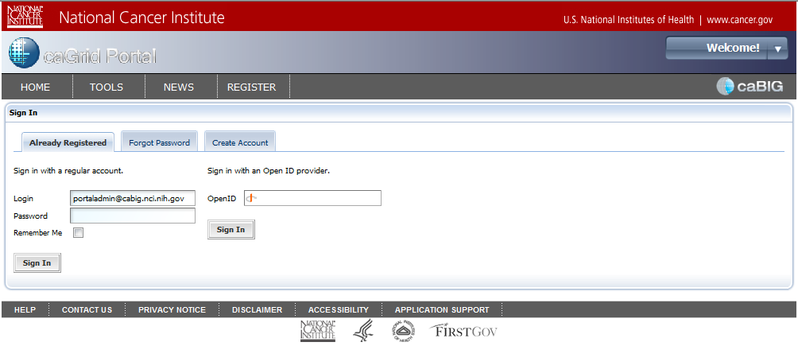
Figure 1-1. portaladmin Login Page
- In the Login field, enter portaladmin@cabig.nci.nih.gov. In the Password field, enter the password for this user.
Note: If you have previously created another administrative user account, you can use that username and password to login as an administrative user.
- Click Sign In. The following page appears.
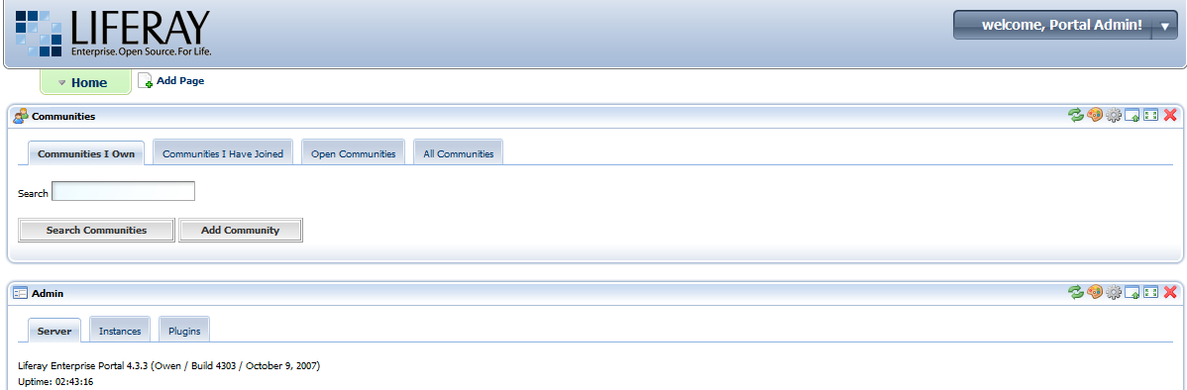
Figure 1-2. portaladmin's Private Page
From this page, you can perform all Liferay administrative operations. The Liferay administrative guide is available at the following location: http://docs.liferay.com/portal/4.3/official/liferay-administration-guide-4.3.pdf

Creating the Administrative User
To create a caGrid Portal administrative account, you need valid caGrid credentials. If you already have an account with the NCICB Dorian Identity Provider (IdP) or the NCICB AuthenticationService IdP (that is, you have an NIH account), you do not need to create a new caGrid account. If you do not have an account from either authority, you can create a new caGrid account through the caGrid Portal.
To create a caGrid account:
- Select the Register tab and enter the required information.
You now have a caGrid account but need to log in at least once to create a caGrid Portal account.
- Select the Home tab and then click the Login link. Enter your username and password and then click the Login button. A greeting appears.
- Click the Logout link.
You have a caGrid Portal account. Now you must assign administrative privileges to this account.
To assign administrative privileges to a caGrid account:
- Scroll down the page to the Enterprise Admin portlet.
- Select the Roles tab. Among the roles listed there is Administrator.
- At the far right of this row, place your mouse over the center icon. The tool tip for this icon displays the text Assign Members. Click this icon
The following page appears.
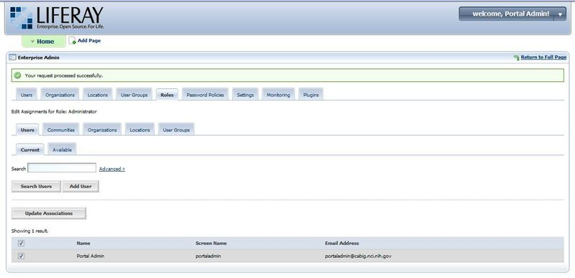
Figure 2-3. Adding Members
- Notice that the Current tab is selected. Select the Available tab. In the Available tab, the account you just created appears. Select the checkbox next to this account and then click Update Associations.
- In the drop-down list in the upper-right corner of the page, click the Sign Out link. The caGrid Portal home page appears.

Editing News Feeds
The caGrid Portal can be used to maintain an RSS news feed. To edit the new feed you must log in to the Portal using an account that has the Administrator role (see Creating the Administrative User on page 5 for details).
To edit news feeds:
- After logging in with an Administrator account, go to the News tab. In the upper, right-hand corner of the News portlet you see several controls.
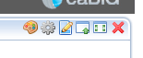
- Click the third tool from the left, which has a tool tip with the text Preferences.
- Click the Add Channel link. The New Channel page appears.
- Enter the title, link, and description. The link should point to some page that describes the channel. News pages are created and maintained outside of the portal.
- Click the Save button. An “Edit news items” link appears below the form.
- Click this link.
- Click the Add item link. A page appears in which you can enter the title, link, width, height, and description of the news item.
Again the link must point to a real web page that contains the content. The width and height values control the dimensions of the IFrame that will display the news item to portal users. Use a width of 100% and a height of 250px.

Banning and Unbanning Services
Services can be banned by the Portal administrator. That means the service is assigned the state of Banned and the Portal can no longer discover it. However, there may be cases where banned services eventually come back on-line. In such cases, the Portal continues to ignore the service. It is then the responsibility of the service owner to recognize that the service is not being displayed in the Portal, and contact the Portal administrator to request that the service be unbanned.

Administrative User Interface
To ban and unban services in the caGrid Portal, you must log in to the Portal using an account that has the Administrator role (see Creating the Administrative User on page 5 for details).
To ban or unban a service:
- Navigate to the caGrid Portal homepage in a web browser. For example: http://localhost:8080/web/guest/home
- Click the Services menu.
- In the Discovery portlet, search for the service you want to ban or unban. As an admin user, you will be able to see ALL services, including those that are already banned.
- Click the More Details link to see the details of this service
- On the details page, click the Ban Service or Unban Service button as appropriate. The service is immediately banned or unbanned.
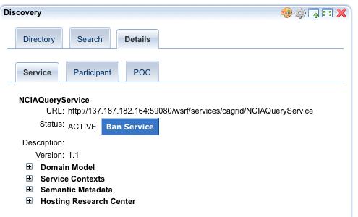
Note: A banned service can only be unbanned and vice versa.
Once you ban a service, the service is immediately hidden in the caGrid Portal. Alternatively, once you unban a previously banned service, the service is immediately visible to all Portal users.

Command Line Utility
You can also use a command-line tool to ban or unban a service. To run the tool, you must have access to the cagrid-portal release and the configuration for the target instance.
To unban a service, run the following from the cagrid-portal directory:
ant aggr:ban-mgr -Dtarget.env=<env_name>
The tool prompts you to choose whether to ban or unban the service and then asks for the service's URL. You can manually ban services by specifying ban as the operation.

Deleting User Accounts
The caGrid Portal requires that user accounts be associated with exactly one email address. However, caGrid users can have multiple sets of grid credentials that are all associated with the same email address. If a user tries to log in with more than one of these sets of credentials, the Portal notes that an account already exists with that email address, and indicates that the user should either log in with those credentials or contact the administrator to request that the account be deleted.
Deleting user accounts is a two step process. You must first delete the user account in Liferay and then clear the user from the Portal database.

Delete Liferay User
To delete a user account, you must log in to the Portal using an account that has the Administrator role (see Creating the Administrative User on page 5 for details).
NOTE If the following message appears: "You do not have the roles required to access this portlet," close your browser, re-open it, and try again.
- Go to the Users tab of the Enterprise Admin portlet and search for the desired user account (as shown in the figure below)
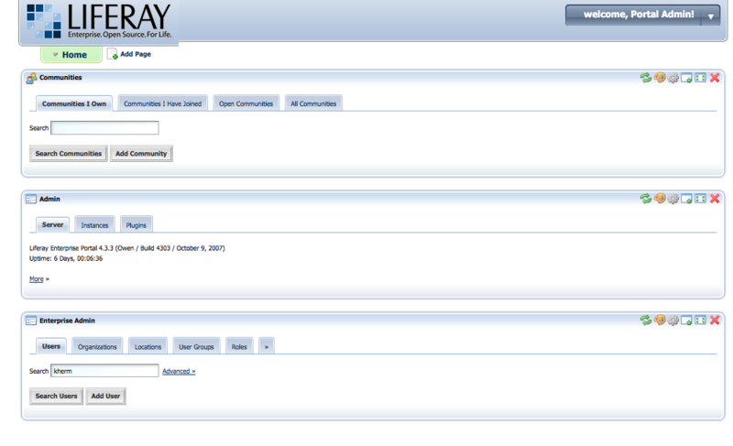
Figure 5-4. Enterprise Admin: Search User
- Select the checkbox next to the user's account row, then click the Deactivate button (as shown in Figure 7).
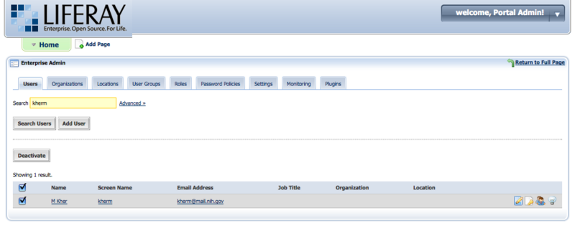
Figure 5-5. Enterprise Admin: Deactivate User
- Search for the account again, this time selecting No from the Active drop-down list in the advanced search view (as shown in Figure 8).
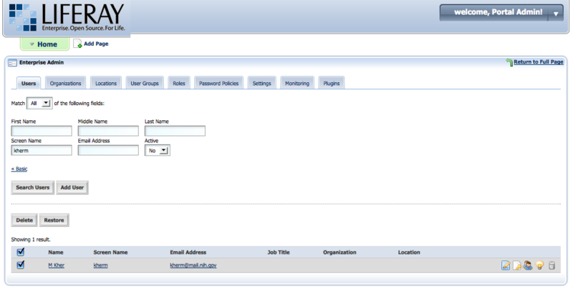
Figure 5-6. Enterprise Admin: Delete User
- Select the checkbox next to the account and click the Delete button. You see a success message.

Delete Portal User
While the previous process deletes the Liferay user account, you must also delete the user details from the Portal database. Run the following ant script to delete the account in the Portal
ant -Dtarget.env=nci_dev aggr:delete-user
This prompts for the user's grid identity. Provide the grid identity of the user that you want to delete from the Portal database. See the following example.
aggr:delete-user:
[input] Enter Grid Identity of User:/O=caBIG/OU=caGrid/OU=LOA1/OU=NCI/CN=userA
[java] AbandonedObjectPool is used (org.apache.commons.dbcp.AbandonedObjectPool@a7c3ef)
[java] LogAbandoned: true
[java] RemoveAbandoned: true
[java] RemoveAbandonedTimeout: 300
[java] Will try and delete user with Grid Identity:/O=caBIG/OU=caGrid/OU=LOA1/OU=NCI/CN=userA
[java] Found User in Database
[java] Successfully deleted User with Grid Identity:/O=caBIG/OU=caGrid/OU=LOA1/OU=NCI/CN=userA

Updating caBIG Participants
The caGrid Portal maintains a list of all cancer centers and institutes participating in caBIG®. This list is uploaded to the Portal database from an Excel spreadsheet when the Portal is first installed. It is possible to update the participant list (in other words, delete old participants and upload new ones), by uploading an updated Excel spreadsheet.
Use the command line utility to update the Participants in the caGrid Portal. This utility takes the path to an Excel spreadsheet, parses it, and then uploads the participant data. The default path is for the Excel spreadsheet that is part of the Portal release. To run this tool, you must have access to the cagrid-portal release and the configuration for the target instance. For more information, see http://www.cagrid.org/wiki/CaGrid:How-To:ChangeTargetGrids.
Run the following command (see the figure below)
ant aggr:load-workspaces -Dtarget.env=nci_dev

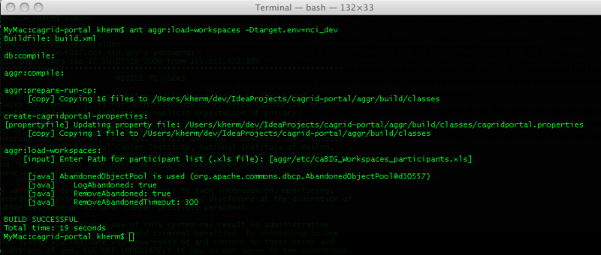
Figure 6-7. Update Participants

Editing the Calendar
The Home page of the caGrid Portal displays a calendar portlet. This is a full-featured calendar application. The calendar contents can be imported and exported using the standard iCalendar format (http://tools.ietf.org/html/rfc2445).
To import iCalendar format files into the caGrid Portal calendar, do the following.
- Log in to the Portal using an account that has the Administrator role (see Creating the Administrative User on page 5 for details)
- Navigate to the caGrid Portal homepage by going to: http://<host>:<port>
You see an Export/Import tab in the calendar portlet (as shown in Figure 7-8)
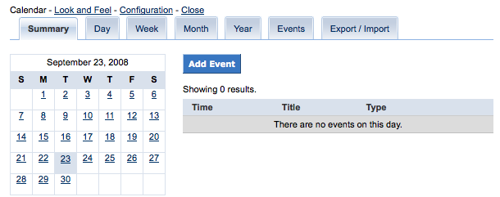
Figure 7-8. Calendar Portlet
- Import an iCalendar format file (as shown in Figure 7-9)
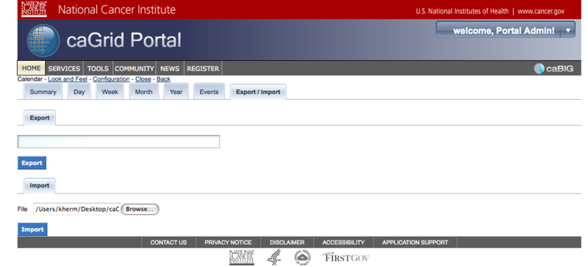
Figure 7-9. Calendar Import/Export
When the import is complete, a success message appears.

Refresh Service Metadata
It is possible for the Portal administrator to force the reloading of a service's metadata by the Portal. The following administrative user interface can schedule a reload of the metadata.
Log in to the Portal using an account that has the Administrator role (see Creating the Administrative User on page 5 for details).
To refresh service metadata:
- Navigate to the caGrid Portal homepage in a web browser. For example, http://localhost:8080/web/guest/home.
- Click the Services menu.
- In the Discovery portlet, search for the service you want to ban or unban. As an administrative user, you can see ALL services, including those that are already banned.
- Click the More Details link to see the details of this service.
- As shown below, click Reload Metadata on the Details page to schedule a metadata reload for the service.
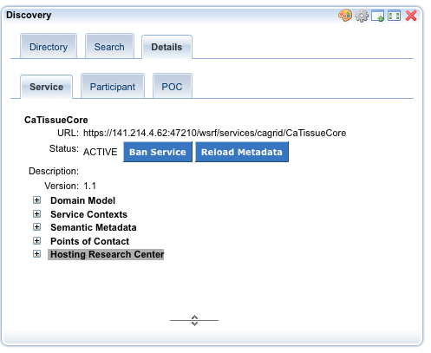
Figure 12: Reload Metadata
The metadata and the domain model, in the case of a data service, is fetched and loaded into the Portal within approximately 30 minutes.

