caGrid Portal 2.0.2

Administrator's Guide

 |   Center for Bioinformatics


This is a U.S. Government work. June 30, 2008

Model caBIG™ Open Source Software License
v.2
Release Date: January 7, 2008
Copyright Notice. Copyright 2008 The Ohio State University Research Foundation (OSURF), Argonne National Labs (ANL), SemanticBits LLC (SemanticBits), and Ekagra Software Technologies Ltd. (Ekagra) (“caBIG™ Participant”). The caGrid 1.2 software was created with NCI funding and is part of the caBIG™ initiative. The software subject to this notice and license includes both human readable source code form and machine readable, binary, object code form (the “caBIG™ Software”).
This caBIG™ Software License (the “License”) is between caBIG™ Participant and You. “You (or “Your”) shall mean a person or an entity, and all other entities that control, are controlled by, or are under common control with the entity. “Control” for purposes of this definition means (i) the direct or indirect power to cause the direction or management of such entity, whether by contract or otherwise, or (ii) ownership of fifty percent (50%) or more of the outstanding shares, or (iii) beneficial ownership of such entity.
License. Provided that You agree to the conditions described below, caBIG™ Participant grants You a non-exclusive, worldwide, perpetual, fully-paid-up, no-charge, irrevocable, transferable and royalty-free right and license in its rights in the caBIG™ Software, including any copyright or patent rights therein, to (i) use, install, disclose, access, operate, execute, reproduce, copy, modify, translate, market, publicly display, publicly perform, and prepare derivative works of the caBIG™ Software in any manner and for any purpose, and to have or permit others to do so; (ii) make, have made, use, practice, sell, and offer for sale, import, and/or otherwise dispose of caBIG™ Software (or portions thereof); (iii) distribute and have distributed to and by third parties the caBIG™ Software and any modifications and derivative works thereof; and (iv) sublicense the foregoing rights set out in (i), (ii) and (iii) to third parties, including the right to license such rights to further third parties. For sake of clarity, and not by way of limitation, caBIG™ Participant shall have no right of accounting or right of payment from You or Your sublicensees for the rights granted under this License. This License is granted at no charge to You. Your downloading, copying, modifying, displaying, distributing or use of caBIG™ Software constitutes acceptance of all of the terms and conditions of this Agreement. If you do not agree to such terms and conditions, you have no right to download, copy, modify, display, distribute or use the caBIG™ Software.
- Your redistributions of the source code for the caBIG™ Software must retain the above copyright notice, this list of conditions and the disclaimer and limitation of liability of Article 6 below. Your redistributions in object code form must reproduce the above copyright notice, this list of conditions and the disclaimer of Article 6 in the documentation and/or other materials provided with the distribution, if any.
- Your end-user documentation included with the redistribution, if any, must include the following acknowledgment: “This product includes software developed by the Ohio State University Research Foundation (OSURF), Argonne National Labs (ANL), SemanticBits LLC (SemanticBits), and Ekagra Software Technologies Ltd. (Ekagra).” If You do not include such end-user documentation, You shall include this acknowledgment in the caBIG™ Software itself, wherever such third-party acknowledgments normally appear.
- You may not use the names “The Ohio State University Research Foundation”, "OSURF", “Argonne National Labs”, “ANL”, “SemanticBits LLC”, "SemanticBits", “Ekagra Software Technologies Ltd.”, “Ekagra”, “The National Cancer Institute”, “NCI”, “Cancer Bioinformatics Grid” or “caBIG™” to endorse or promote products derived from this caBIG™ Software. This License does not authorize You to use any trademarks, service marks, trade names, logos or product names of either caBIG™ Participant, NCI or caBIG™, except as required to comply with the terms of this License.
- For sake of clarity, and not by way of limitation, You may incorporate this caBIG™ Software into Your proprietary programs and into any third party proprietary programs. However, if You incorporate the caBIG™ Software into third party proprietary programs, You agree that You are solely responsible for obtaining any permission from such third parties required to incorporate the caBIG™ Software into such third party proprietary programs and for informing Your sublicensees, including without limitation Your end-users, of their obligation to secure any required permissions from such third parties before incorporating the caBIG™ Software into such third party proprietary software programs. In the event that You fail to obtain such permissions, You agree to indemnify caBIG™ Participant for any claims against caBIG™ Participant by such third parties, except to the extent prohibited by law, resulting from Your failure to obtain such permissions.
- For sake of clarity, and not by way of limitation, You may add Your own copyright statement to Your modifications and to the derivative works, and You may provide additional or different license terms and conditions in Your sublicenses of modifications of the caBIG™ Software, or any derivative works of the caBIG™ Software as a whole, provided Your use, reproduction, and distribution of the Work otherwise complies with the conditions stated in this License.
- THIS caBIG™ SOFTWARE IS PROVIDED "AS IS" AND ANY EXPRESSED OR IMPLIED WARRANTIES (INCLUDING, BUT NOT LIMITED TO, THE IMPLIED WARRANTIES OF MERCHANTABILITY, NON-INFRINGEMENT AND FITNESS FOR A PARTICULAR PURPOSE) ARE DISCLAIMED. IN NO EVENT SHALL THE OHIO STATE UNIVERSITY RESEARCH FOUNDATION ("OSURF"), ARGONNE NATIONAL LABS (“ANL”), SEMANTICBITS LLC ("SEMANTICBITS"), AND EKAGRA SOFTWARE TECHNOLOGIES LTD. (EKAGRA) OR ITS AFFILIATES BE LIABLE FOR ANY DIRECT, INDIRECT, INCIDENTAL, SPECIAL, EXEMPLARY, OR CONSEQUENTIAL DAMAGES (INCLUDING, BUT NOT LIMITED TO, PROCUREMENT OF SUBSTITUTE GOODS OR SERVICES; LOSS OF USE, DATA, OR PROFITS; OR BUSINESS INTERRUPTION) HOWEVER CAUSED AND ON ANY THEORY OF LIABILITY, WHETHER IN CONTRACT, STRICT LIABILITY, OR TORT (INCLUDING NEGLIGENCE OR OTHERWISE) ARISING IN ANY WAY OUT OF THE USE OF THIS caBIG™ SOFTWARE, EVEN IF ADVISED OF THE POSSIBILITY OF SUCH DAMAGE.
Contents
About This Guide 1
Creating the Administrative User 2
Editing News Feeds 4
Editing the Calendar 5

About This Guide
This guide includes the following topics.
- Creating the Administrative User on page 2
- Editing News Feeds on page 4
- Editing the Calendar on page 5

Creating the Administrative User
In order to create a caGrid Portal administrative account, we will need valid caGrid credentials. If you already have an account with the NCICB Dorian Identity Provider (IdP), or with the NCICB AuthenticationService IdP (i.e. you have an NIH account), then you do not need to create a new caGrid account. If you don’t have either of these accounts, you can create a new caGrid account through the portal.
To create a new account, go to the REGISTER tab, and enter the required information. When you have successfully completed the registration, you will immediately have a caGrid account, but you need to login at least once in order to have a caGrid Portal account. Go to the HOME tab and click the Login link. Enter your username and password and click the Login button. You’ll see a greeting. Then click the Logout link.
At this point, we’ve created a caGrid Portal account. Now we need to give this account administrative privileges.
After the portal is installed, there will be a single default administrative user whose username is ‘portaladmin’. The password of this user is determined at installation time. See the installation guide for details.
Login as portaladmin by browsing to:
https://<host>:8443/user/portaladmin/1
Note: Make sure you go to the HTTPS version of this URL. Otherwise, the portaladmin password will be sent in clear text across the network, which is a security risk.
The following screen appears.
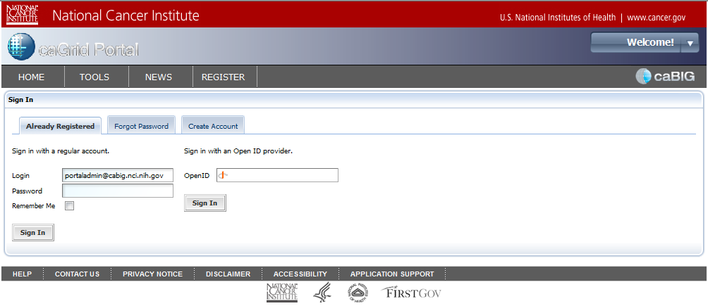
In the Login field, enter ‘portaladmin@cabig.nci.nih.gov’. In the Password field, enter the password for this user. Click Sign In. The following page appears.
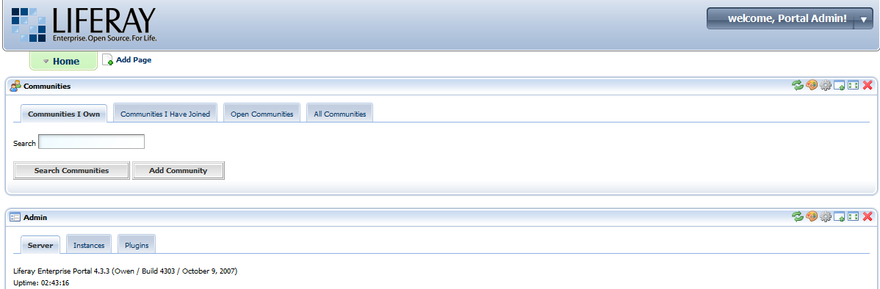
From this page, you can perform all Liferay administrative operations. The Liferay administrative guide is here: http://content.liferay.com/4.2/doc/user/liferay_4_portal_administration_guide/onepage/
Note: That is the 4.2 version. The 4.3 version was not available at the time of writing.
Scroll down the page to the Enterprise Admin portlet. Then select the Roles tab. You should see a list of role names and one of them should be “Administrator.” At the far right of this row, you can see some icons. When you mouse over the center icon, a tool-tip displays the text “Assign Members.” Click on this icon.
The following screen appears.
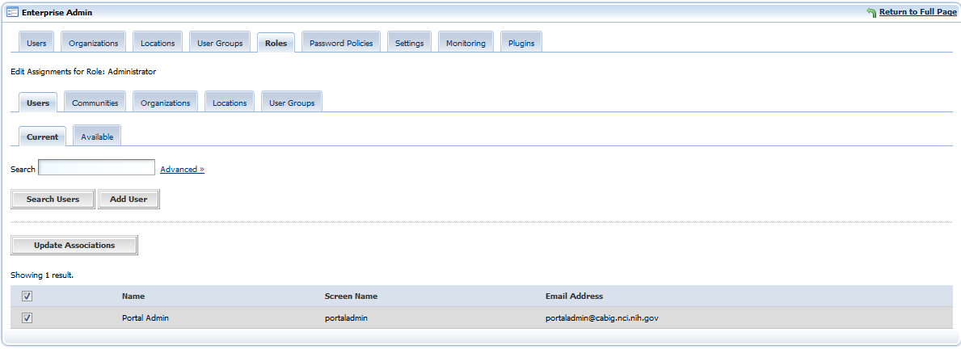
Notice that the Current tab is selected. Select the Available tab. In the Available tab, you should see the account that you just created. Select the checkbox next to this account and click Update Associations.
In the welcome Portal Admin drop-down list in the upper-right corner of the page, click the Sign Out link. You are redirected to the caGrid Portal home page.

Editing News Feeds
The caGrid Portal can be used to maintain an RSS news feed. To edit the new feed you need to log in to the portal using an account that has the Administrators role (see Creating the Administrative User on page 2 for details).
After logging in with an Adminstrator account, go to the NEWS tab. In the upper, right-hand corner of the News portlet you’ll see the several controls.
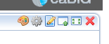
When you mouse of the third icon from the left, you should see a tool tip that displays the text "Preferences." Click this icon.
Click the Add Channel link. The New Channel page appears. Enter the title, link, and description. The link should point to some page that describes the channel. News pages are created and maintained outside of the portal.
Once you’ve entered this information, press the Save button. An “Edit news items” link appears below the form. Click this link. Then click the Add item link. A page appears in which you can enter the title, link, width, height, and description of the news item. Again the link must point to a real web page that contains the content. The width and height values control the dimensions of the IFrame that will display the news item to portal users. You should probably use a width of 100% and a height of 250px.

Editing the Calendar
The Home page of the caGrid Portal displays a calendar portlet. This is a full featured calendaring application. The calendar contents can be imported and exported using the standard iCal format (http://tools.ietf.org/html/rfc2445).
You must be logged in with an account that has the Administrators role in order to edit the calendar.

