Workflow Services Testing

Workflow service testing involves deployment of 2 Test services into a Tomcat location that is pre-installed with caGrid and configured with caGrid Security framework.

The test services can be downloaded from: http://gforge.nci.nih.gov/frs/download.php/2223/workflow-services.zip

The Test plan includes two parts. The first part is validation of the Workflow services deployment using the Workflow client GUI. The second part is running the Workflow Junit tests to test the API of the Workflow services.

Installation of Test Services:

- Download the services from http://gforge.nci.nih.gov/frs/download.php/2223/workflow-services.zip
- Unzip them
- cd workflow-services/TestService1
- Make sure you have $CATALINA_HOME set and points to a working Tomcat installed with caGrid 1.1.
- run ant deployTomcat
- This will deploy the Test service1 in tomcat. Do not install the second service as yet
- Restart the tomcat and check if the service is up by doing : http://<hostname>:<port>/wsrf/services/cagrid/WorkflowTestService1?wsdl

Validation Test:

Prerequisites: A tomcat container with caGrid installed. A tomcat container with ActiveBPEL installed. Note that these are already done if you installed the Workflow component using the caGrid installer.

The Workflow Submission GUI allows the users to submit, monitor BPEL workflows. It also allows users discover and add services to be used in the workflow. User can also get output of the workflow once the workflow is done execution.

In the following paragraphs we try to outline some of the capabilities of the GUI.

Launching of the UI: Browse to the WorkflowFactoryService dir under caGrid source distribution (caGrid/projects/workflow/WorkflowFactoryService/). From that directory run ant ui. This will launch the Workflow GUI. Once the GUI is launched click on Window -> Preferences Menu option. Browse to the WorkflowFactoryService(s) endpoint option and make sure it points to the Workflow service that needs to be validated. Use Add/Remove buttons to add new Workflow services endpoints. Use the Move up/Decrease keys to move the endpoint up and down.

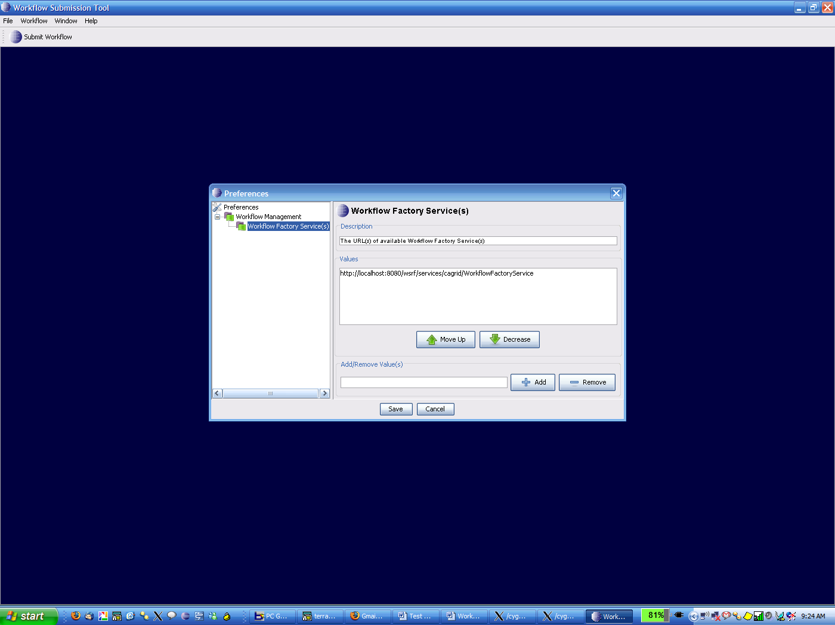

Submitting a Workflow: Click on Submit Workflow Button and the following window is open. The user can enter the path to the BPEL document inside the BPEL File text field or the user can browse to the location of the BPEL document.
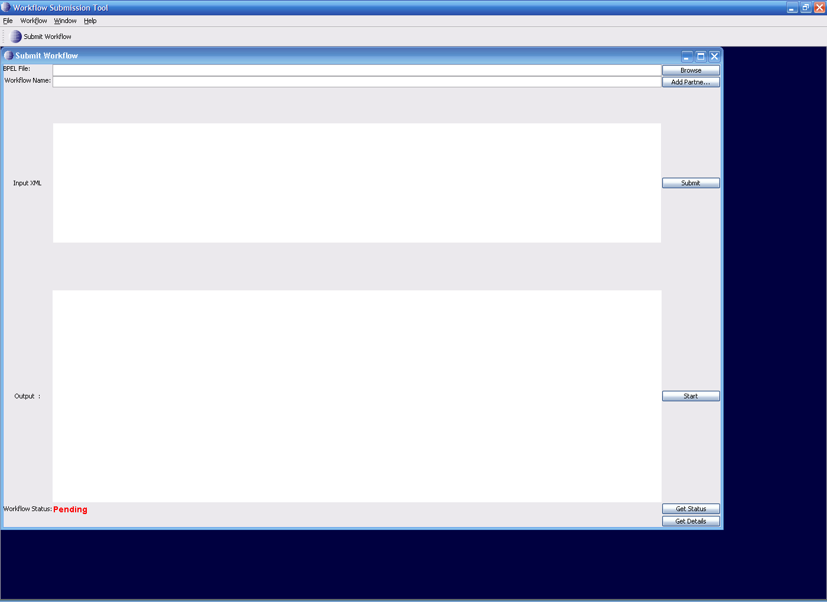

The workflow name should be the name of the BPEL doc. Once the user is done with having valid values for both the text fields, press Add Partner Links button.

Adding PartnerLinks:
When this button is presses the following GUI opens. This GUI is used to enter Endpoints of the services taking part in this workflow. In this example we have one service invoked twice in the workflow. Enter appropriate values to the fields in the PartnerLinkFrame GUI. For this test the values are as follows:

Select Type: Static
Service Endpoint: http://localhost:8080/wsrf/services/cagrid/WorkflowTestService1
WSDL Location : http://localhost:8080/wsrf/share/schema/WorkflowTestService1/WorkflowTestService1.wsdl
Namespace: http://sample1.tests.workflow.cagrid.nci.nih.gov/WorkflowTestService1

The localhost:8080 should be replaced with appropriate host:port on which the test service is deployed ( From the first part of the document ). Click Add.
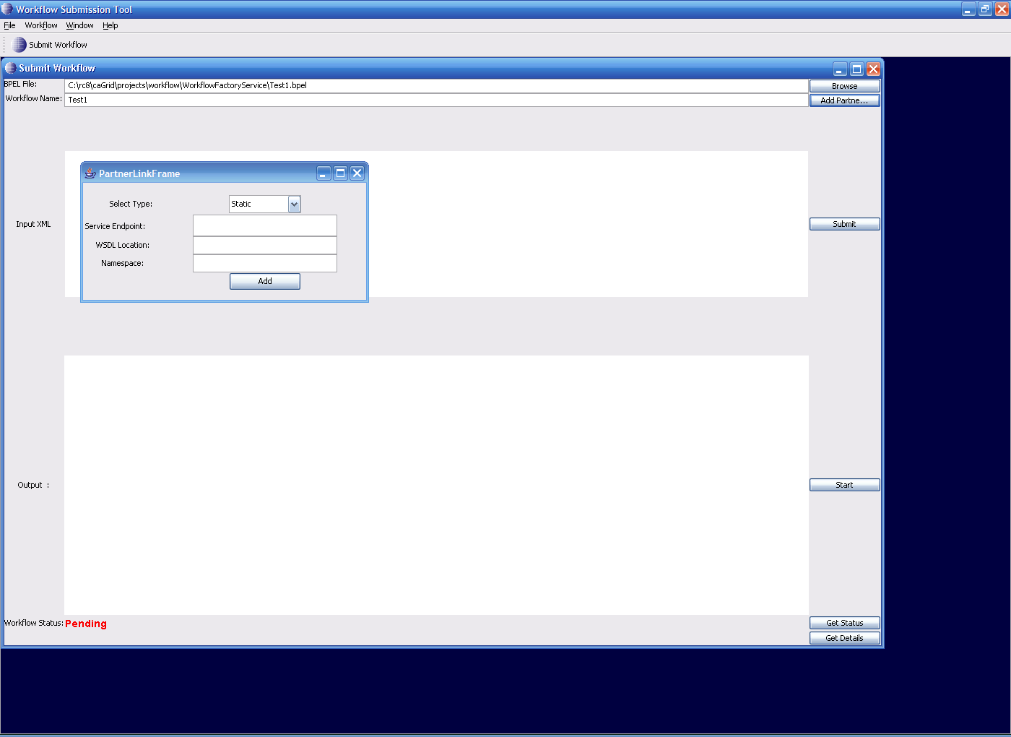

Submission of Workflows:
Now you are ready to submit the Workflow. Click on Submit.This would submit the workflow to a pre-configured Workflow Factory Service. After this step the BPEL document is validated and submitted to the Workflow Engine. If there are no errors the Status is changed from Pending - > Submitted.

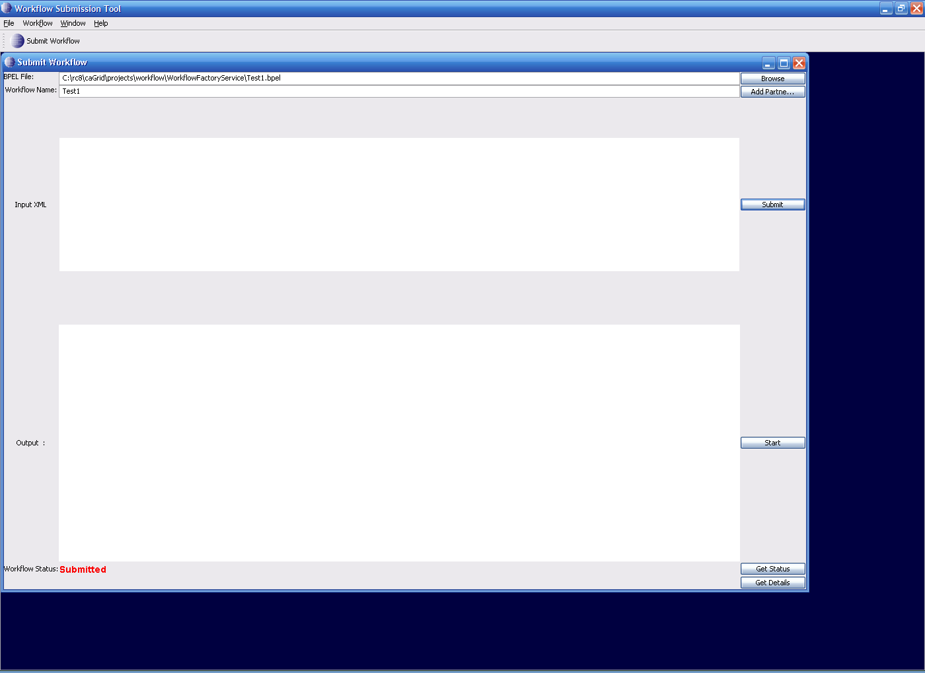

Execution of the Workflow: The next step is to execute the submitted workflow with some input. In the current implementation the user has to paste the input XML in to the text area and press the Start button. If the workflow is started without problems then the Status is changed to Active.

Copy the following XML blob into the input XML Text area:

<ns1:InvokeRequest xmlns:ns1="http://sample1.tests.workflow.cagrid.nci.nih.gov/WorkflowTestService1"><ns1:invokeInput>Test</ns1:invokeInput></ns1:InvokeRequest>

Click Start. This will Start the workflow and change the status from Submitted to Active.
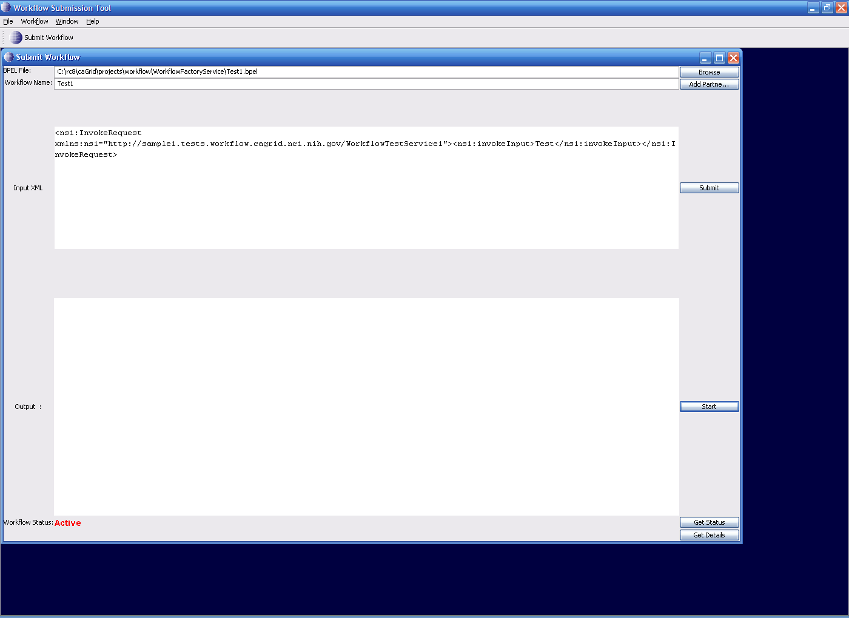

Querying for Status: Press the Get Status button and if the status is different from the existing status that is on the left hand corner of the GUI, the status changes to the latest status.

Getting Workflow Output: Press the Get Status button and if the status of workflow is Done the workflow output is displayed in the output text area.

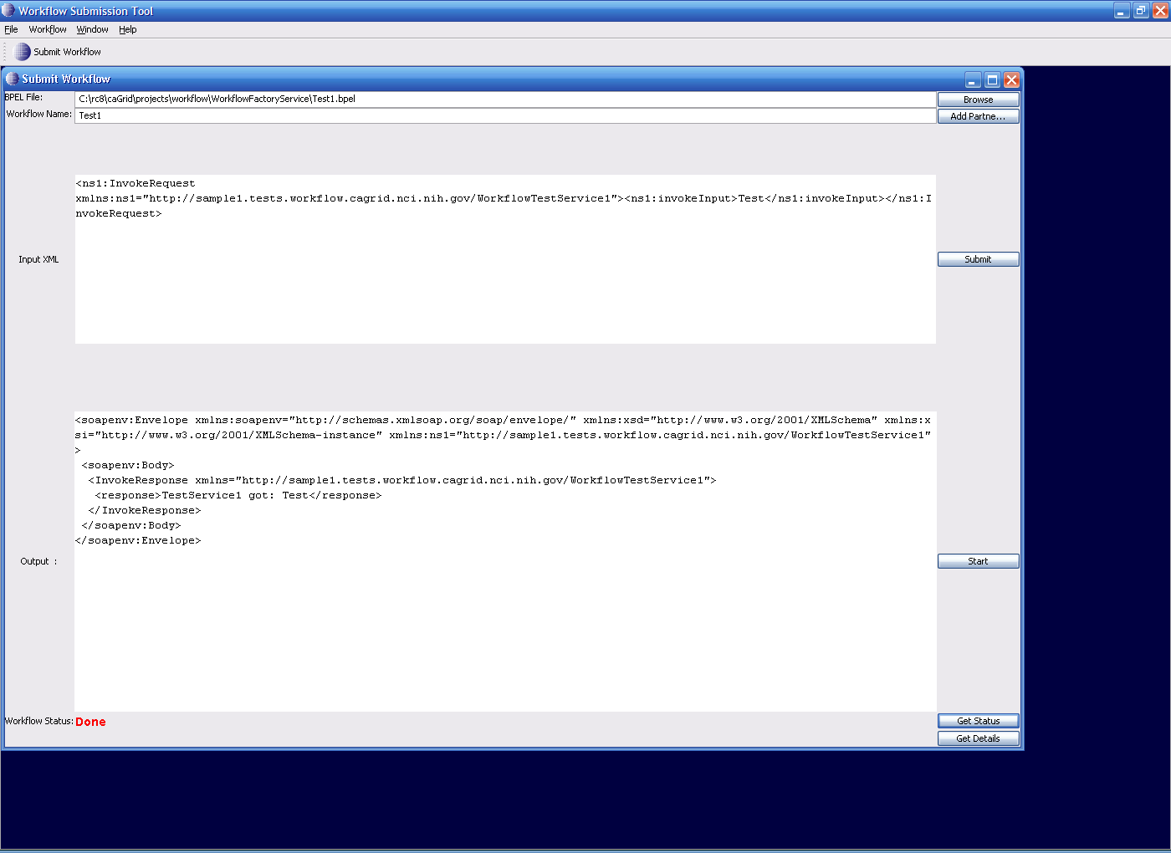

Getting Detailed Status:
If you submit a long workflow you would like to see which portion of Workflow is currently being executed. Press the Get Details button to see where the current workflow execution is taking place. The GUI displays XPath expression of the node in Workflow Document and its status
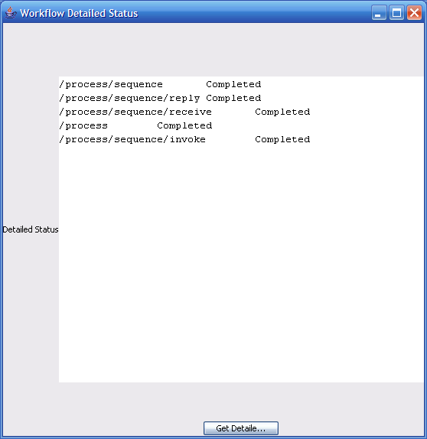

Running Unit Tests:

Unit tests test deployment, execution of the workflows along with other API that the workflow services expose like for example, getStatus, cancel etc. The Unit tests require you have the test services deployed and running. You need to get the endpoints of these services before you begin the tests. Go to the WorkflowFactoryService directory and edit the test.properties file.

WORKFLOW_ENDPOINT=http://localhost:8080/wsrf/services/cagrid/WorkflowFactoryService
SERVICE1_ENDPOINT=http://localhost:8080/wsrf/services/cagrid/WorkflowTestService1
SERVICE1_WSDL=http://localhost:8080/wsrf/share/schema/WorkflowTestService1/WorkflowTestService1.wsdl
SERVICE1_NAMESPACE=http://sample1.tests.workflow.cagrid.nci.nih.gov/WorkflowTestService1
SERVICE2_ENDPOINT=http://localhost:8080/wsrf/services/cagrid/WorkflowTestService2
SERVICE2_WSDL=http://localhost:8080/wsrf/share/schema/WorkflowTestService2/WorkflowTestService2.wsdl
SERVICE2_NAMESPACE=http://sample1.tests.workflow.cagrid.nci.nih.gov/WorkflowTestService2

In order to run the tests put appropriate values (from the first section of this document that talks about deployment of test services). Run ant runTests. You should get the following output:

$ ant runTests
Buildfile: build.xml

setGlobus:

checkGlobus:
[echo] Globus: C:\globus\ws-core-4.0.3

runTests:
[echo] Test results dir: test/logs/junit
[junit] Running gov.nih.nci.cagrid.workflow.tests.PackageTests
[junit] <ns1:InvokeRequest xmlns:ns1="http://sample1.tests.workflow.cagrid.n
ci.nih.gov/WorkflowTestService1"><ns1:invokeInput>Test</ns1:invokeInput></ns1:In
vokeRequest>
[junit] Done
[junit] Done
[junit] result: <soapenv:Envelope xmlns:soapenv="http://schemas.xmlsoap.org/
soap/envelope/" xmlns:xsd="http://www.w3.org/2001/XMLSchema" xmlns:xsi="http://w
ww.w3.org/2001/XMLSchema-instance" xmlns:ns1="http://sample1.tests.workflow.cagr
id.nci.nih.gov/WorkflowTestService1">
[junit] <soapenv:Body>
[junit] <InvokeResponse xmlns="http://sample1.tests.workflow.cagrid.nci.ni
h.gov/WorkflowTestService1">
[junit] <response>TestService1 got: Test</response>
[junit] </InvokeResponse>
[junit] </soapenv:Body>
[junit] </soapenv:Envelope>
[junit] Status RP : <ns1:Status xmlns:ns1="http://workflow.cagrid.nci.nih.g
ov/WorkflowServiceImpl">Active</ns1:Status>
[junit] Pending
[junit] Active
[junit] <ns1:InvokeRequest xmlns:ns1="http://sample1.tests.workflow.cagrid.n
ci.nih.gov/WorkflowTestService1"><ns1:invokeInput>Test</ns1:invokeInput></ns1:In
vokeRequest>
[junit] Done
[junit] Tests run: 8, Failures: 0, Errors: 0, Time elapsed: 5.538 sec

BUILD SUCCESSFUL
Total time: 7 seconds

