caGrid Metadata
Infrastructure

Technical Guide

caBIG™ is an initiative of the National Cancer Institute, NIH, DHHS

Copyright and License page

Insert Names of Development Team(s) here
Development | Programmer’s guide |  | Program Management
Names of developers | Names of technical writers and reviewers |  | Names of program managers
¹ Footnote contributing companies/ contractors/ divisions |  | ³ company
² department or division

Contacts and Support
Enter training contact | name (email address)
Enter customer support contact | Web hyperlink  Telephone: 111-222-3456  Toll free: 888-234-1234

LISTSERV Facilities Pertinent to software teams
LISTSERV | URL | Name
caGrid_Developers | https://list.nih.gov/archives/cagrid_developers.html | caGrid Developers Discussion

Table of Contents

Chapter 1 Introduction to the {document name} Guide 5
Chapter Organization and Content 6
Overview of the Guide 6
Organization of the Technical Guide 6
Getting Started with this programmer’s guide 6
Using This Template 7
Viewing Style Headings 7
Examples of Style Headings 7
(Style Heading 2--Second level heading) 7
Style Heading 3--Third level heading (Palatino Linotype 14-point) 7
Installing the Software 8
Headers and Footers 8
Document Text Conventions 8
Chapter 2 caGrid Metadata Infrastructure Overview 11
Introduction 11
Core Metadata Services 12
Chapter 3 caGrid Metadata 13
caGrid Standard Metadata Model 13
Standard Metadata Model (gov.nih.nci.cagrid.metadata) 13
Common Components (gov.nih.nci.cagrid.metadata.common) 14
Standard Data Service Metadata Model (gov.nih.nci.cagrid.metadata.data) 21
Service Description Components (gov.nih.nci.cagrid.metadata.service) 25
caDSR Re-Used Components (gov.nih.nci.cadsr.umlproject.domain) 32
Chapter 4 Advertisement and Discovery 33
Introduction 33
Chapter 5 Serialization and Deserialization 36
overview 36
Object Serialization 36
Standard Globus Serialization 36
caCORE SDK Serialization 37
Custom Serialization 37
Schema Creation 38
XMI Based Generation 39
User Authored Approach 41
Object Based Generation 41
caDSR/Mapping 42
caGrid restrictions on use of caDSR types: 42
XML Schema Existence Rules: 42
caDSR to XML Schema Mapping Rules: 42
Resources discussing UML to XSD Mapping: 45
0.5 Approach: 45
Uniqueness assumed (versions aside): 46
Issues: 46
Example UML Project 46
Project Mappings 47
Best Practices / Recommendations 51
Starting from Nothing 52
Starting from Existing Objects 52
Future Approach 52
Chapter 6 Global Model Exchange 53
Chapter 7 caDSR Service 54
Chapter 8 Index Service 55
overview 55
use 55
"trusted/official registration" design 55
Chapter 9 Introduce Integration 57
type discovery 57
standard metadata 57
Appendix A References 59
Technical Manuals/Articles 59
Scientific Publications 59
caBIG Material 59
caCORE Material 59
Appendix B Glossary 63
Index 66

List of Illustrations (optional)

If your manual images are mostly screen shots, a list may not be necessary. They don’t mean much outside of the text context.

- Introduction to the {document name} Guide
Before you Begin:
It’s important that you decide early in this process the focus of this programmer’s manual and its target audience and that you write accordingly. This guide can be written to describe software requirements, architecture, and information for programmers writing new APIs and tools that will integrate with your software. Your developers and those of adopter centers will have important input regarding the contents of this technical guide.
Some of the chapters in the technical guide are essential and others are optional. It is up to your writing team and subject matter experts to make the final decision about content and to adapt this template to your specific situation.
- Chapters 1 through 7 are essential. Chapters 8 and 9 are optional and should be included if your application warrants it.
In other cases, chapters can be combined or separated, depending on the nature and length of the material.
- Chapters 3 and 4 on Requirements and Design could be combined into one chapter.
- Chapter 6 could be divided into two chapters about APIs
Notes about an Administration Guide:
Information for your system that falls under the category of “administration” can be included in specified chapters in this technical guide, or if the amount of the information warrants it, you can create a separate administration guide, using this template for that document, as well.
Examples of “Administration” topics that can be included (but are optional) are:
- Managing users and processes
- Importing and deleting {datatype} data
- Maintaining databases
- Updating data files
- Installing plug-ins
It is important to remember that the chapters and suggested sections in the technical guide are to be adapted to your particular context. If you have questions, contact the caBIG™ Training Workspace lead or NCICB Application Support: http://ncicb.nci.nih.gov/NCICB/support

Chapter Organization and Content
Chapter content: For this first chapter, write a very brief paragraph introducing the software for which this manual is written. Then tie that into the purpose of this chapter which is to describe the purpose, objectives, and brief directions for using this manual.
Chapters always begin with an introductory statement and list of topics as shown in this example. List topics in the chapter and cross reference them. If you add automatic cross-references, then the user can use the cross-ref as a hyperlink. (For example, use CTRL + SHIFT on the page number of the last bulleted item in this list.)
For instance, “Topics in this chapter include”: (You could include the following:)
- Overview of the Guide on this page
- Organization of the Guide on page 2
- The {Software} User (background and experience expected to use software)
- Getting Started with the Software on page 6

Overview of the Guide
Brief overview of this developer’s guide.

Organization of the Technical Guide
Summarize each chapter in the table.
Chapter in {name} Technical Guide  Table Title Style | Chapter Contents
Chapter 1
Apply Table Text style
Table 1Include captions for each table and figure in the guide

Getting Started with this programmer’s guide
Bulleted list of sections in this guide to help user get started. You could include statements similar to the following to help programmer’s get started:
- List Bullet Circle Style
- Review Chapter 1 to learn about the manual structure
- Review Chapter 2 for a brief overview of the software
- Review Chapter X to learn system requirements
- Refer to …. To learn about activating your license
- To start the software, refer to …..
If the installation guide is a separate document, be sure and name the document. If it is posted to a website, include a URL.

Using This Template
This template is written using formats defined with Microsoft Word 2003 styles. For more information about using Word while creating your software user’s guides, see Chapter 4 in the Technical Publications Style Guide downloaded from the caBIG website:
https://cabig.nci.nih.gov/working_groups/Training_SLWG/Documents/Technical_Pubs_Style_Guide_021405_jbh.pdf
Style names and brief descriptions appear throughout this guide, and are highlighted in red. This is Body Text Style.

Viewing Style Headings
There are three ways to view the various Style names of the template sample text:
- Style List number style
- Select Format > Styles and Formatting. The style for the selected text shows in the Styles and Formatting task pane, Formatting of selected text, at the top right of the viewer window.
- Click in any paragraph and view the style name on the Formatting toolbar.
- With the document open in Normal view or Outline view (under the View menu), select Tools > Options. Click the View tab. In the Style Area Width box, specify the width and click OK. Each paragraph’s style name displays in the Style area while you work .
To apply styles, select text, then click on the style in the Styles and Formatting task pane, or select the style on the Formatting toolbar, Styles drop-down list. A simple way to apply heading styles is to select the heading text, then press CTRL + ALT + 1 (Heading 1), …+ 2 (Heading 2) , or … + 3 (Heading 3).
Note: If you get frustrated using styles, apply formatting manually. It will override any applied styles.

Examples of Style Headings

(Style Heading 2--Second level heading)

Style Heading 3--Third level heading (Palatino Linotype 14-point)
Style Heading 4—Fourth-level heading (Palatino linotype 12-point bold)
Style Heading 5—Fifth-level heading(Palatino linotype 12-point italic)
Note: To change the name of the manual in the left-facing page headers, select File > Properties. On the Summary tab, change the name of the book title. The header name will change correspondingly.
Text in a note is a 0.5 inch hanging indent. Select Format > Paragraph. On the Indents and Spacing tab, select Hanging in the Special drop-down list, and enter 0.5” in the By section.

Installing the Software
Example of Heading 3.
Downloading Software Files
Example of Heading 4

Headers and Footers
The headers and footers in this template were preconfigured. The header for even-numbered pages is the book title. To change the header, select File > Properties. On the Summary tab, change the name of the title. The header should change automatically. If it does not, double-click on the header and make the change manually. It will change concurrently throughout the guide. The header for odd-numbered pages is the chapter title. As you type in new chapter titles, the associated headers should change automatically. Although they were preconfigured, they sometimes seem buggy, so you can make changes in the header manually, as a last resort.

Document Text Conventions
The following table shows various typefaces to differentiate between regular text and menu commands, keyboard keys, and text that you type. This illustrates how conventions are represented in this guide.
Convention | Description | Example
Bold & Capitalized Command  Capitalized command > Capitalized command | Indicates a Menu command  Indicates Sequential Menu commands | Admin > Refresh
text in small caps | Keyboard key that you press | Press enter
text in small caps + text in small caps | Keyboard keys that you press simultaneously | Press shift + ctrl and then release both.
Special typestyle | Used for filenames, directory names, commands, file listings, source code examples and anything that would appear in a Java program, such as methods, variables, and classes. | URL_definition ::= url_string
Boldface type | Options that you select in dialog boxes or drop-down menus. Buttons or icons that you click. | In the Open dialog box, select the file and click the Open button.
Italics | Used to reference other documents, sections, figures, and tables. | caCORE Software Development Kit 1.0 Programmer’s Guide
Italic boldface type | Text that you type | In the New Subset text box, enter Proprietary Proteins.
Note: | Highlights a concept of particular interest | Note: This concept is used throughout the installation manual.
Warning! | Highlights information of which you should be particularly aware. | Warning! Deleting an object will permanently delete it from the database.
{} | Curly brackets are used for replaceable items. | Replace {root directory} with its proper value such as c:\cabio
Table ‎0-2 Document Conventions

- caGrid Metadata Infrastructure Overview

Introduction
Extending beyond the basic grid infrastructure, caBIG specializes these technologies to better support the needs of the cancer research community. A primary distinction between basic grid infrastructure and the requirements identified in caBIG and implemented in caGrid is the attention given to data modeling and semantics. caBIG adopts a model-driven architecture best practice and requires that all data types used on the grid are formally described, curated, and semantically harmonized. These efforts result in the identification of common data elements, controlled vocabularies, and object-based abstractions for all cancer research domains. caGrid leverages existing NCI data modeling infrastructure to manage, curate, and employ these data models. Data types are defined in caCORE UML and converted into ISO/IEC 11179 Administered Components, which are in turn registered in the Cancer Data Standards Repository (caDSR). The definitions draw from vocabulary registered in the Enterprise Vocabulary Services (EVS), and their relationships are thus semantically described.
In caGrid, both the client and service APIs are object oriented, and operate over well-defined and curated data types. Clients and services communicate through the grid using respectively Globus grid clients and service infrastructure. The grid communication protocol is XML, and thus the client and service APIs must transform the transferred objects to and from XML. This XML serialization of caGrid objects is restricted in that each object that travels on the grid must do so as XML which adheres to an XML schema registered in the Global Model Exchange (GME). As the caDSR and EVS define the properties, relationships, and semantics of caBIG data types, the GME defines the syntax of the XML serialization of them. Furthermore, Globus services are defined by the Web Service Description Language (WSDL). The WSDL describes the various operations the service provides to the grid. The inputs and outputs of the operations, among other things, in WSDL are defined by XML schemas (XSDs). As caBIG requires that the inputs and outputs of service operations use only registered objects, these input and output data types are defined by the XSDs which are registered in GME. In this way, the XSDs are used both to describe the contract of the service and to validate the XML serialization of the objects which it uses. Figure 1 details the various services and artifacts related to the description of and process for the transfer of data objects between client and service.
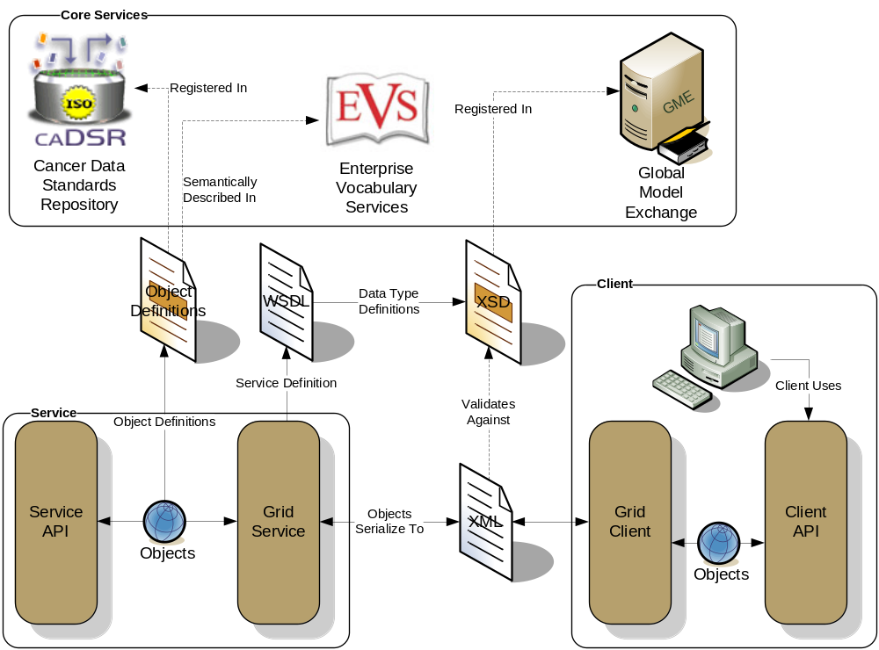
Figure 1 Data Description Overview

Core Metadata Services
asdf

- caGrid Metadata
asdfasd

caGrid Standard Metadata Model
All caGrid Services are expected to publish a set of standard metadata which draws heavily from the metadata registered in caDSR and EVS; it details the functionality of the service, and the institution providing it. The following sections describe these models.

Standard Metadata Model (gov.nih.nci.cagrid.metadata)
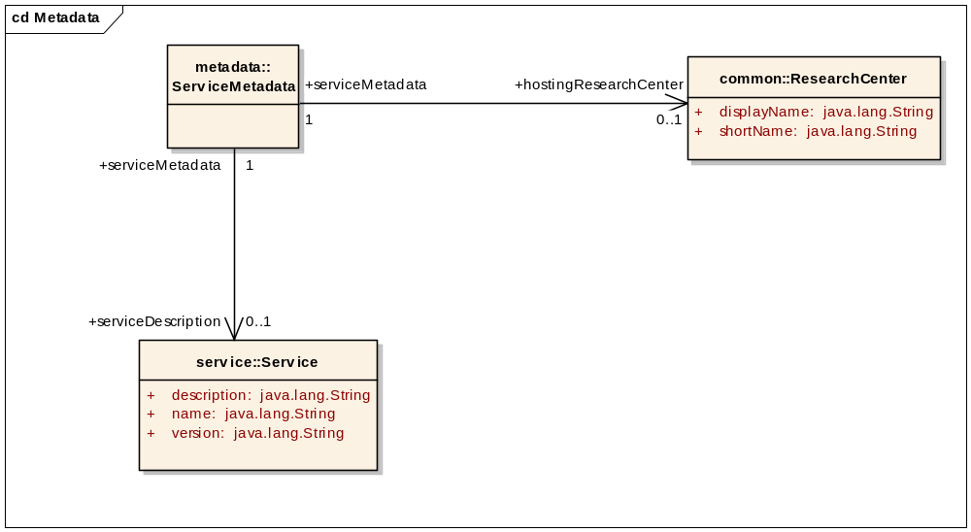
Figure 2 : caGrid Standard Service Metadata

metadata::ServiceMetadata
public Class:

metadata::ServiceMetadata Connections
Connector | Source | Target | Notes
Association  source > target | ServiceMetadata  +serviceMetadata  1, unordered | Service  +serviceDescription  0..1, unordered
Association  source > target | ServiceMetadata  +serviceMetadata  1, unordered | ResearchCenter  +hostingResearchCenter  0..1, unordered

Common Components (gov.nih.nci.cagrid.metadata.common)
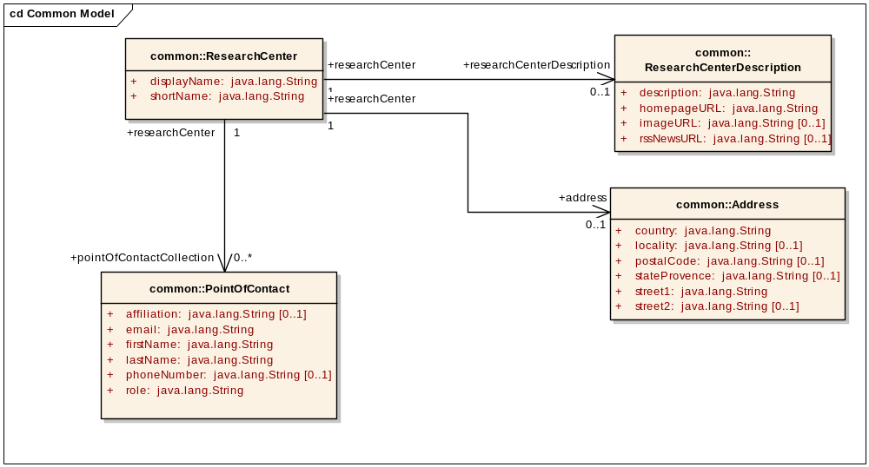
Figure 3 : Common Model

common::Address
public Class:

common::Address Connections
Connector | Source | Target | Notes
Association  source > target | ResearchCenter  +researchCenter  1, unordered | Address  +address  0..1, unordered

common::Address Attributes
Attribute | Type | Notes
street1 | public :  java.lang.String
street2 | public  Range:0 to 1:  java.lang.String
locality | public  Range:0 to 1:  java.lang.String
stateProvence | public  Range:0 to 1:  java.lang.String
postalCode | public  Range:0 to 1:  java.lang.String
country | public :  java.lang.String

common::PointOfContact
public Class: For the static model, instances of these should be the POCs associated with the design and implementation of the service itself (not deployments of it, e.g. not system support staff)
The "role" attribute should probably be an enumeration of known types

common::PointOfContact Connections
Connector | Source | Target | Notes
Association  source > target | Service  +service  1, unordered | PointOfContact  +pointOfContactCollection  0..*, unordered
Association  source > target | ResearchCenter  +researchCenter  1, unordered | PointOfContact  +pointOfContactCollection  0..*, unordered

common::PointOfContact Attributes
Attribute | Type | Notes
firstName | public :  java.lang.String
lastName | public :  java.lang.String
email | public :  java.lang.String
phoneNumber | public  Range:0 to 1:  java.lang.String
affiliation | public  Range:0 to 1:  java.lang.String
role | public :  java.lang.String

common::ResearchCenter
public Class:

common::ResearchCenter Connections
Connector | Source | Target | Notes
Association  source > target | ResearchCenter  +researchCenter  1, unordered | Address  +address  0..1, unordered
Association  source > target | ServiceMetadata  +serviceMetadata  1, unordered | ResearchCenter  +hostingResearchCenter  0..1, unordered
Association  source > target | ResearchCenter  +researchCenter  1, unordered | ResearchCenterDescription  +researchCenterDescription  0..1, unordered
Association  source > target | ResearchCenter  +researchCenter  1, unordered | PointOfContact  +pointOfContactCollection  0..*, unordered

common::ResearchCenter Attributes
Attribute | Type | Notes
shortName | public :  java.lang.String
displayName | public :  java.lang.String

common::ResearchCenterDescription
public Class:

common::ResearchCenterDescription Connections
Connector | Source | Target | Notes
Association  source > target | ResearchCenter  +researchCenter  1, unordered | ResearchCenterDescription  +researchCenterDescription  0..1, unordered

common::ResearchCenterDescription Attributes
Attribute | Type | Notes
description | public :  java.lang.String
imageURL | public  Range:0 to 1:  java.lang.String
homepageURL | public :  java.lang.String
rssNewsURL | public  Range:0 to 1:  java.lang.String

common::UMLAttribute
public Class: caDSR-related
Represents a UML attribute of the parent UML Class. Indication of isRequired=false means the operation will function without the existence of this attribute.

common::UMLAttribute Connections
Connector | Source | Target | Notes
Association  source > target | UMLClass  +umlClass  1, unordered | UMLAttribute  +umlAttributeCollection  0..*, unordered
Association  source > target | UMLAttribute  +umlAttribute  1, unordered | SemanticMetadata  +semanticMetadataCollection  0..*, unordered

common::UMLAttribute Attributes
Attribute | Type | Notes
name | public :  java.lang.String
description | public :  java.lang.String

common::UMLClass
public Class: caDSR-related
Represents the UML Class of the given input or output.

common::UMLClass Connections
Connector | Source | Target | Notes
Association  source > target | UMLClass  +umlClass  1, unordered | UMLAttribute  +umlAttributeCollection  0..*, unordered
Association  source > target | DomainModel  +domainModel  1, unordered | UMLClass  +exposedUMLClassCollection  0..*, unordered | Tagged Values  modelGroup: all
Association  source > target | Output  +output  1, unordered | UMLClass  +umlClass  1, unordered
Association  source > target | UMLClass  +umlClass  1, unordered | SemanticMetadata  +semanticMetadataCollection  0..*, unordered
Association  source > target | InputParameter  +inputParameter  1, unordered | UMLClass  +umlClass  1, unordered

common::UMLClass Attributes
Attribute | Type | Notes
className | public :  java.lang.String
description | public :  java.lang.String
id | public :  java.lang.String | This is used soley for the purposes of referencing this class in associations. It does not represent any caDSR identifier.
packageName | public :  java.lang.String
projectName | public :  java.lang.String
projectVersion | public :  java.lang.String

Standard Data Service Metadata Model (gov.nih.nci.cagrid.metadata.data)
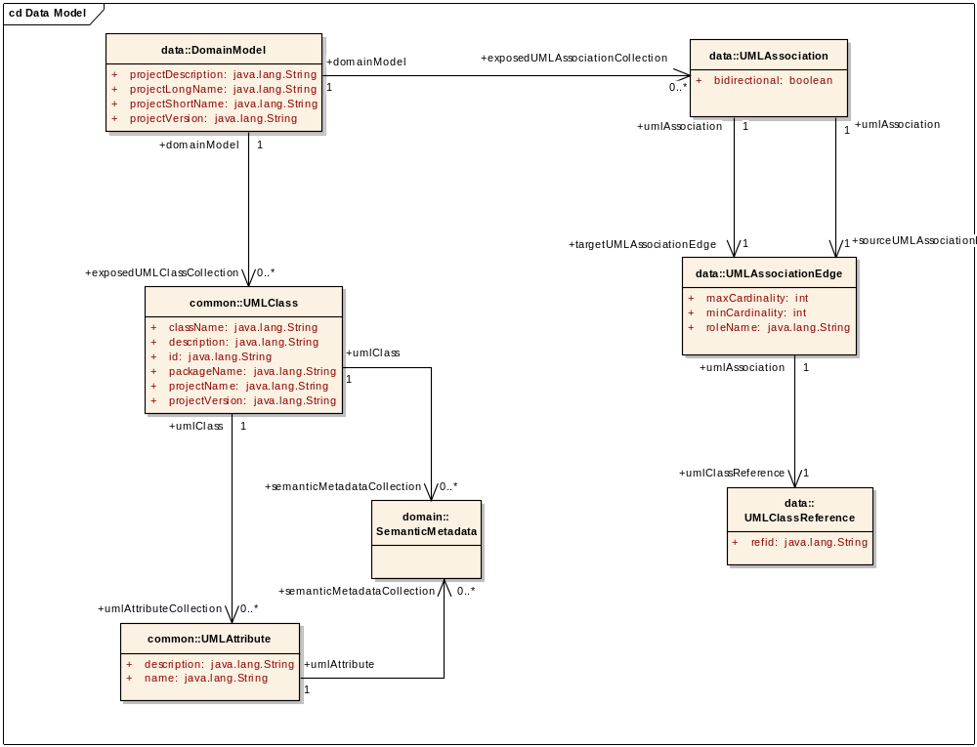
Figure 4 : Data Service Metadata Model

data::DomainModel
public Class:

data::DomainModel Connections
Connector | Source | Target | Notes
Association  source > target | DomainModel  +domainModel  1, unordered | UMLClass  +exposedUMLClassCollection  0..*, unordered | Tagged Values  modelGroup: all
Association  source > target | DomainModel  +domainModel  1, unordered | UMLAssociation  +exposedUMLAssociationCollection  0..*, unordered

data::DomainModel Attributes
Attribute | Type | Notes
projectDescription | public :  java.lang.String
projectShortName | public :  java.lang.String
projectLongName | public :  java.lang.String
projectVersion | public :  java.lang.String

data::UMLAssociation
public Class:

data::UMLAssociation Connections
Connector | Source | Target | Notes
Association  source > target | UMLAssociation  +umlAssociation  1, unordered | UMLAssociationEdge  +sourceUMLAssociationEdge  1, unordered
Association  source > target | UMLAssociation  +umlAssociation  1, unordered | UMLAssociationEdge  +targetUMLAssociationEdge  1, unordered
Association  source > target | DomainModel  +domainModel  1, unordered | UMLAssociation  +exposedUMLAssociationCollection  0..*, unordered

data::UMLAssociation Attributes
Attribute | Type | Notes
bidirectional | public :  boolean

data::UMLAssociationEdge
public Class:

data::UMLAssociationEdge Connections
Connector | Source | Target | Notes
Association  source > target | UMLAssociation  +umlAssociation  1, unordered | UMLAssociationEdge  +sourceUMLAssociationEdge  1, unordered
Association  source > target | UMLAssociationEdge  +umlAssociation  1, unordered | UMLClassReference  +umlClassReference  1, unordered
Association  source > target | UMLAssociation  +umlAssociation  1, unordered | UMLAssociationEdge  +targetUMLAssociationEdge  1, unordered

data::UMLAssociationEdge Attributes
Attribute | Type | Notes
minCardinality | public :  int
maxCardinality | public :  int
roleName | public :  java.lang.String

data::UMLClassReference
public Class: Represents a "pointer/reference" to a UMLClass exposed by this DomainModel. The refid attribute must share the value of an UMLClass.id on the exposedClassCollection of this model. This exists solely as an optimization for not duplicating the UMLClass (in XML) everywhere it is associated (which is a significant savings).

data::UMLClassReference Connections
Connector | Source | Target | Notes
Association  source > target | UMLAssociationEdge  +umlAssociation  1, unordered | UMLClassReference  +umlClassReference  1, unordered

data::UMLClassReference Attributes
Attribute | Type | Notes
refid | public :  java.lang.String | Must be the value of the UMLClass.id for the "referenced" UMLClass

Service Description Components (gov.nih.nci.cagrid.metadata.service)

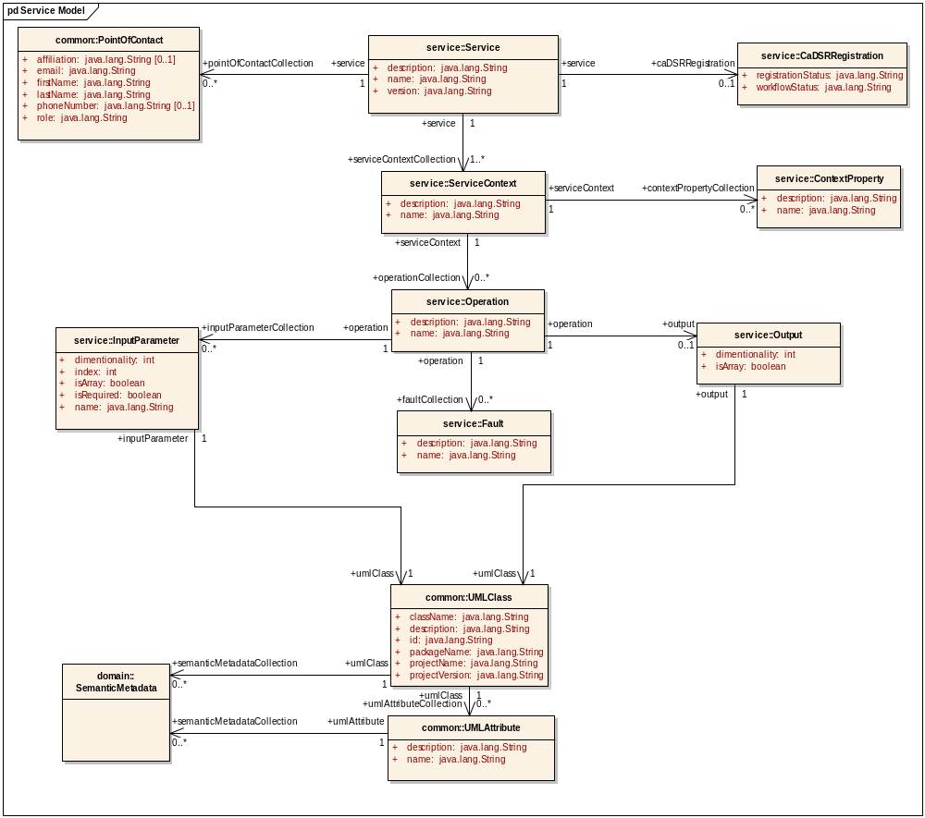
Figure 5 : Service Model

service::CaDSRRegistration
public Class:

service::CaDSRRegistration Connections
Connector | Source | Target | Notes
Association  source > target | Service  +service  1, unordered | CaDSRRegistration  +caDSRRegistration  0..1, unordered

service::CaDSRRegistration Attributes
Attribute | Type | Notes
workflowStatus | public :  java.lang.String
registrationStatus | public :  java.lang.String

service::ContextProperty
public Class: This represents an exposed property of a service context's state.
This is manifested as a resource property in the grid.

service::ContextProperty Connections
Connector | Source | Target | Notes
Association  source > target | ServiceContext  +serviceContext  1, unordered | ContextProperty  +contextPropertyCollection  0..*, unordered

service::ContextProperty Attributes
Attribute | Type | Notes
name | public :  java.lang.String
description | public :  java.lang.String

service::Fault
public Class: This represents an error that could occur during the execution of the operation.
This is manifested as an operation fault in the grid.

service::Fault Connections
Connector | Source | Target | Notes
Association  source > target | Operation  +operation  1, unordered | Fault  +faultCollection  0..*, unordered

service::Fault Attributes
Attribute | Type | Notes
name | public :  java.lang.String
description | public :  java.lang.String

service::InputParameter
public Class: Represents an input parameter to an operation.
This is manifested as a parameter of a service request in the grid.

service::InputParameter Connections
Connector | Source | Target | Notes
Association  source > target | Operation  +operation  1, unordered | InputParameter  +inputParameterCollection  0..*, unordered
Association  source > target | InputParameter  +inputParameter  1, unordered | UMLClass  +umlClass  1, unordered

service::InputParameter Attributes
Attribute | Type | Notes
name | public :  java.lang.String
index | public :  int | This is the 0-based index of the parameter in the operation's signature
isRequired | public :  boolean | Whether the given parameter is allowed to be null or not
isArray | public :  boolean
dimentionality | public :  int | Only valid if isArray is true; represents the dimensionality of the array

service::Operation
public Class: This represents a method/operation/function in a service context. Its input parameters are described by its InputParameter associations, its output by its Output association, and any errors it produces by its Fault associations.
This is manifested as an operation of a service in the grid.

service::Operation Connections
Connector | Source | Target | Notes
Association  source > target | Operation  +operation  1, unordered | Fault  +faultCollection  0..*, unordered
Association  source > target | Operation  +operation  1, unordered | Output  +output  0..1, unordered
Association  source > target | Operation  +operation  1, unordered | InputParameter  +inputParameterCollection  0..*, unordered
Association  source > target | ServiceContext  +serviceContext  1, unordered | Operation  +operationCollection  0..*, unordered

service::Operation Attributes
Attribute | Type | Notes
name | public :  java.lang.String
description | public :  java.lang.String

service::Output
public Class: Represents the result/output of an operation. Its non-existence represents the operation produces no result.
This is manifested as the value of an operation response in the grid.

service::Output Connections
Connector | Source | Target | Notes
Association  source > target | Operation  +operation  1, unordered | Output  +output  0..1, unordered
Association  source > target | Output  +output  1, unordered | UMLClass  +umlClass  1, unordered

service::Output Attributes
Attribute | Type | Notes
isArray | public :  boolean
dimentionality | public :  int | Only valid if isArray is true; indicates number of deminions in the array

service::Service
public Class: A service is a "conceptual" definition of a collection of functional contexts.
This has no physical manifestation in the grid.

service::Service Connections
Connector | Source | Target | Notes
Association  source > target | Service  +service  1, unordered | CaDSRRegistration  +caDSRRegistration  0..1, unordered
Association  source > target | Service  +service  1, unordered | PointOfContact  +pointOfContactCollection  0..*, unordered
Association  source > target | Service  +service  1, unordered | ServiceContext  +serviceContextCollection  1..*, unordered
Association  source > target | ServiceMetadata  +serviceMetadata  1, unordered | Service  +serviceDescription  0..1, unordered

service::Service Attributes
Attribute | Type | Notes
name | public :  java.lang.String
version | public :  java.lang.String
description | public :  java.lang.String

service::ServiceContext
public Class: This is a functional collection of operations that work over a common collection of stateful resources.
A service without stateful resources would have a single context.
This is manifested as an actual service in the grid.

service::ServiceContext Connections
Connector | Source | Target | Notes
Association  source > target | Service  +service  1, unordered | ServiceContext  +serviceContextCollection  1..*, unordered
Association  source > target | ServiceContext  +serviceContext  1, unordered | ContextProperty  +contextPropertyCollection  0..*, unordered
Association  source > target | ServiceContext  +serviceContext  1, unordered | Operation  +operationCollection  0..*, unordered

service::ServiceContext Attributes
Attribute | Type | Notes
name | public :  java.lang.String
description | public :  java.lang.String

caDSR Re-Used Components (gov.nih.nci.cadsr.umlproject.domain)

domain::SemanticMetadata
public Class: This is a placeholder for a real association to the existing caDSR class.

domain::SemanticMetadata Connections
Connector | Source | Target | Notes
Association  source > target | UMLAttribute  +umlAttribute  1, unordered | SemanticMetadata  +semanticMetadataCollection  0..*, unordered
Association  source > target | UMLClass  +umlClass  1, unordered | SemanticMetadata  +semanticMetadataCollection  0..*, unordered

- Advertisement and Discovery

Introduction
As caBIG aims to connect data and tools from 50+ disparate cancer centers, a critical requirement of its infrastructure is that it supports the ability of researchers to discover these resources. caGrid enables this ability by taking advantage of the rich structural and semantic descriptions of data models and services that are available. Each service is required to describe itself using caGrid standard service metadata. When a grid service is connected to the caBIG grid, it registers its availability and service metadata with a central indexing registry service (Index Service). This service can be thought of as the “yellow pages” and “white pages” of caBIG. A researcher can then discover services of interest by looking them up in this registry. caGrid provides a series of high-level APIs and user applications for performing this lookup which greatly facilitate the process.
As the Index Service contains the service metadata (or service data) of all the currently advertised and available services in caBIG, the expressivity of service discovery scenarios is limited only by the expressivity of the service metadata. For this reason, caGrid provides standards for service metadata to which all services must adhere. At the base is the Common Service Metadata standard that every service in caBIG is required to provide. This metadata contains information about the service-providing cancer center, such as the point of contact and the institution’s name. Extending beyond this generic metadata are two standards that are specialized for the two types of community-provided services: Data Services and Analytical Services. Both of these standards leverage the data models registered in caDSR and link them to the underlying semantic concepts registered in EVS. The Data Service Metadata details the domain model from which the Objects being exposed by the service are drawn. Additionally, the definitions of the Objects themselves are described in terms of their underlying concepts, attributes, and associations to other Objects being exposed. Similarly, the Analytical Service Metadata details the Objects using the same format as the Data Service Metadata. In addition to detailing the Objects definitions, the Analytical Service Metadata defines the operations or methods the service provides. The input parameters and output of the operations are defined by referencing the appropriate Object definition. In this way, both the data and analytical services fully define the domain objects they expose by referencing the data model registered in caDSR, and identify their underlying semantic concepts by referencing the information in EVS.

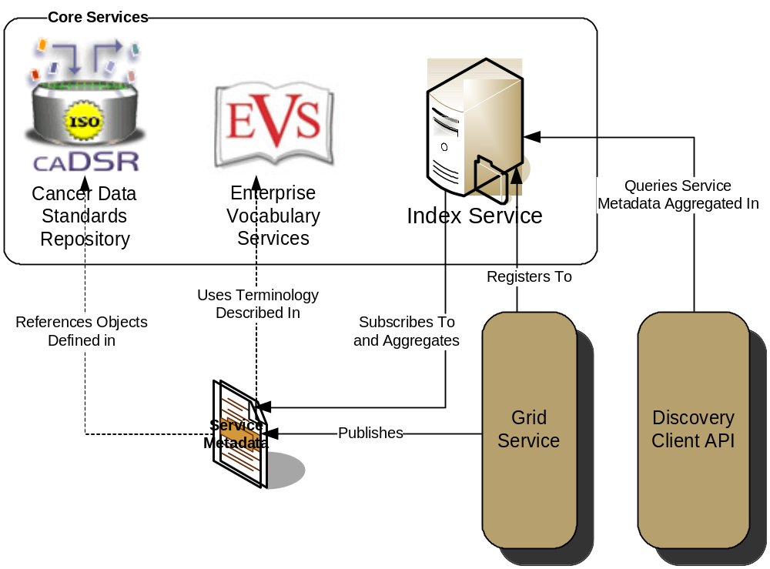
Figure 6 Advertisement and Discovery Overview
As shown in Figure 6, the caGrid discovery API and tools allow researchers to query the Index Service for services satisfying a query over the service metadata. That is, researchers can lookup services in the registry using any of the information used to describe the services. For instance, all services from a given cancer center can be located, data services exposing a certain domain model or objects based on a given semantic concept can be discovered, as can analytical services that provide operations that take a given concept as input.

- Serialization and Deserialization

overview
XML schemas play a role in several aspects of the caBIG runtime environment. Figure 1 illustrates the various services and artifacts related to the description of and process for the transfer of data objects between client and service. Both the client and service APIs are object oriented, and operate over well-defined and curated data types. The objects are defined in caCORE UML and converted into ISO/IEC 11179 Administered Components, which are in turn registered in the Cancer Data Standards Repository (caDSR). The definitions draw from vocabulary registered in the Enterprise Vocabulary Services (EVS), and their relationships are thus semantically described.
Client and services in caBIG communicate through the grid using respectively Globus grid clients and service infrastructure. The grid communication protocol is XML, and thus the client and service APIs must transform the transferred objects to and from XML. This XML serialization of caBIG objects is restricted in that each object that travels on the grid must do so as XML which adheres to an XML schema registered in the Global Model Exchange (GME). As the caDSR and EVS define the properties, relationships, and semantics of caBIG data types, the GME defines the syntax of the XML serialization of them. Furthermore, Globus services are defined by the Web Service Description Language (WSDL). Actually, Globus uses an extension to WSDL called GWSDL, but its differences are irrelevant to this discussion. The WSDL describes the various operations the service provides to the grid. The inputs and outputs of the operations, among other things, in WSDL are defined by XML schemas. As caBIG requires that the inputs and outputs of service operations use only registered objects, these input and output data types are defined by the XSDs which are registered in GME. In this way, the XSDs are used both to describe the contract of the service and to validate the XML serialization of the objects which it uses.

Object Serialization
As mentioned in a preceding section, objects must serialize to and from XML as they traverse the grid. This section details the alternative approaches for said process.

Standard Globus Serialization
caGrid is built using the Globus 4 toolkit. The Globus toolkit has a complete set of tools for automatic generation of serializable objects using models defined in XSDs. Using this mechanism, Globus has the ability to automatically create a set of Java Beans which represent this model which will be able to be serialized and de-serialized automatically at client and service runtime via the Globus toolkit with no extra configuration.
In order to use these types in a grid service the developer must describe the types that they will be using in the WSDL file. This will enable Globus to locate the types, and generate the required beans during stub generation time. For more information on this process please see the Globus documentation.
Using this approach, the object-oriented client and service APIs are written using the Globus generated Java Objects. The toolkit will automatically serialize and deserialize the Objects as the travel to and from the grid.

caCORE SDK Serialization
discuss XMLUtils and caGrid SDKSerializer

Custom Serialization
If a developer already has a java object model t hat they are already using which is either not serializable or uses a custom serialize the developer will need to configure the Globus service and client to be able to use the custom serialize. This can be done by using the Globus type mapping configuration xml in the services WSDD and in the client’s configuration WSDD. This type mapping paradigm is document in the Globus documentation but we will cover the basics in this document.
If a user has an object called MyObject which has its own serializer then the following configuration (Figure 7) must be placed in the service WSDD and in the client configuration WSDD:

<service …>
…
<typeMapping
encodingStyle="http://schemas.xmlsoap.org/soap/encoding/"
serializer="gov.nih.nci.cabig.MySerializerFactory"
deserializer="gov.nih.nci.cabig.MyDeserializerFactory"
type="java:gov.nih.nci.cabig.bean.MyType"
qname="ns1:myType"
xmlns:ns1=http://cabig.nci.nih.gov/1/myType
/>
…
</service>
Figure 7Example Custom Serialization configuration

This configuration will now allow the service to use the MySerializerFactory and MyDeserializerFactory to marshal its object back and forth across the grid. The typeMapping element must be in the server and client wsdd and in order for the custom serializer and deserializer to be invoked.

Schema Creation
As detailed above, XML Schemas play an important role in the runtime environment of caBIG. This section details some of the alternatives for creating these schemas. It should be clear from the preceding sections that the mechanism used to serialize the objects for a given service are highly dependant on the schemas it uses, as the XML serialization must conform to the schemas. In other words, if the runtime objects were not generated from an existing schema, it is unlikely a schema

XMI Based Generation
Object Management Group’s standard for XML Metadata Interchange (XMI) is data representation developed to enable easy interchange of metadata between modeling tools (based on the OMG-UML) and metadata repositories (OMG-MOF based) in distributed heterogeneous environments.
As caBIG requires the modeling of data types in UML, and provides a UML modeling tool capable of generating XMI, Enterprise Architect, to its developers, it is a reasonable create schema generation tools that process XMI. Furthermore, the UML Loader, which is responsible for registering metadata in the caDSR, takes a semantically annotated XMI file as input. The following sections detail approaches for generating XML schemas from XMI.

Enterprise Architect
In Enterprise Architect, an XML schema corresponds to a UML package. Therefore the XSD generation is a package-level operation in EA. The basic generation is fairly simple to invoke, and is detailed below in Table ‎0-3. Using this process on the caBIO model, data types such as the Chromosome shown in Figure 4-9 are produced.
1. | Select the package to be converted to XSD by right-clicking on the package in the Project Browser.
2. | Select Project | Generate XML Schema from the main menu.
3. | Set the desired output file using the Filename field.
4. | Set the desired xml encoding using the Encoding field.
5. | Click on the Generate button to generate the schema.
6. | The progress of the schema generator will be shown in the Progress edit box.
Table ‎0-3 Steps to generate an XSD in EA

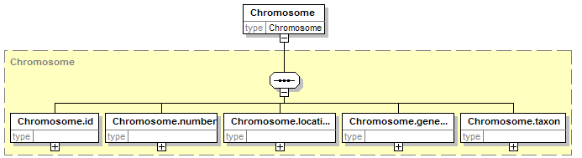
Figure 4- 9 EA generated Chromosome type from caBIO
As can be seen in the example, the naming scheme used by EA is possibly not what one would expect. The parent data type’s name is prefixed on all of its children. This is not only overly verbose, but also would produce non-standardly named Objects if it was used. Another disadvantage is fact that schemas are generated on a package-level basis and thus if a project contains several packages, the process must be done manually for each. Furthermore, EA seems incapable of properly creating the links between packages when it generates schemas for packages which depend on other packages.
EA does provide several configuration points for customizing the XSD generation. More details can be found in the user documentation: http://www.sparxsystems.com.au/resources/xml_schema_generation.html. Of particular interest are the mechanisms to set the namespaces. All customizations can be set using the “tagged values” feature of EA. See the EA documentation for more details on how to create tagged values. The basic steps are to open the tagged values view, click on a package of interest, click the new tag button in the tagged values view, type the appropriate name (see below), then edit its value appropriately. Specifically the “targetNamespace” and “defaultNamespace” should be set to the namespace under which the generated schema will be published. Additionally, the “targetNamespacePrefix” should be set to a meaningful abbreviation (e.g. cabio for the caBIO schema).

1) Model metadata in Enterprise Architect
2) For each package:
2.1) Set tagged values:
memberNames = unqualified
elementFormDefault = qualified
anonymousType = false -- THIS IS SUPPOSED TO BE THE DEFAULT (but appears to be a bug in some versions of EA [at least 6.1])
targetNamespace = <according to caGrid rules>
targetNamespacePrefix = <something short and unique in the project>
2.2) Right-click, Code Engineering ... Generate XML Schema
2.3) Save as appropriate *.xsd
3) Fix all XSDs by cleaning up xsd:imports
4) Use XSDs as types in Globus build (generate beans from XSD)

hyperModel
Another tool capable of generating XSDs from XMI, amongst other things, is hyperModel (www.xmlmodeling.com). It has many more features than EA, and generally creates a better schema than EA, as can be seen again by the Chromosome example in Figure 4-10. However, it suffers from the same package-level issues as EA. It claims to offer more configuration points that can be easily identified through its user interface. The documentation of hyperModel is fairly lacking. There is a book published on its use and philosophies, so it is likely more detail is provided therein.

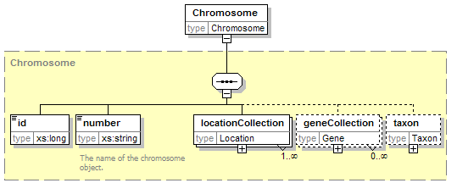
Figure 4- 10 hyperModel generated Chromosome type from caBIO
As they stand, neither EA nor hyperModel can reliably be used to completely generate a usable schema from XMI. However, they do a very good job at creating about 95% of what is needed. It is a fairly straightforward task to hand -edit the schemas to make them useable. Most notably some included types may need to be included.

User Authored Approach
In the event an existing set of Java Objects planned to be used on the grid which has the ability to serialize and deserialize to XML already, it is likely desirous to use those capabilities. In this case, unless an XML schema already exist to describe the serialized XML, the schema will probably need to be hand written to describe the format of the XML. Most XML Schema editing tools have the capability to create a schema from an existing XML document. This mechanism could be leveraged to create a starting schema using an existing XML serialization, though care should be taken to review the schema for things like cardinality, enumerations, and data types, as those things may very from document to document.

Object Based Generation
When an existing set of Java Objects planned to be used on the grid, Globus provides a mechanism to create a complete grid service for them. In this creation process, an XML Schema is created to describe the XML used to serialize the Objects. This process is support to the grid service tools (http://www-unix.globus.org/toolkit/3.0/ogsa/docs/tools_guide.html) , and is referred to as the “Bottom-Up Approach”. This approach may not handle complex models very well, as the tools cannot easily map all complex java types to XSD. The created XSD will be nested inside of a Web Service Description Language (WSDL) file. This schema could be cut from the WSDL and pasted into its own file. It is likely it will contain complex types and elements which are applicable to the operations in the object model. These should be removed, leaving only the “data types” themselves. Again, this approach is not suitable to use without user intervention, though it may create an acceptable starting point.

caDSR/Mapping

caGrid restrictions on use of caDSR types:
- Cyclic package dependencies are not allowed.
  - e.g. Package A cannot contain a Class with an association to Class B, if Class B’s containing Package contains a Class with an association to Package A
    - Nor can this be true through transitivity
- Data exposed (classes and attributes) must be used under a consistent project version
  - That is, even though Classes and Attributes can be versioned individually, in order to use those types on the grid, they need to be packaged together in a consistent project version.
- Data services can only expose a (non-proper) subset of a single project
  - one can always create a new project to aggregate existing projects

XML Schema Existence Rules:
- We don’t currently require attribute sharing, as a CDE is an attribute bound to a Class… we enforce at the Class-level, and the class is required to handle the structure of its attributes (e.g. what to call them, whether to use xml attributes or elements, etc)
- Each caDSR data object (as part of a specific Project version) used in the grid must have its XML format modeled in an XML Schema that is registered in the GME. It is expected to be able to be represented as an XML document (a self-standing element). That is, the object must be able to be passed around the grid (as result of a query to a data service, or invocation of an analytical service, as well as act as input to a operation).
- Every caDSR Package (as part of a specific Project version) must have a corresponding XML Schema that is registered in the GME, even if it just imports a series of other XML Schemas and doesn’t define any of its own types.
- Every caDSR Project must have a corresponding XML Schema registered in the GME. It will most likely just imports a series of other XML Schemas (corresponding to its Packages’ schemas), though it may define its own types.
- These rules let the XSD modeler create any level of schema granularity from 1 per project, down to 1 per Class, but there is always a defined way to retrieve all of the types for a given Project, Package, and Class.
- We need a default heuristic for assigning namespaces (can use what we had in 0.5), but user’s should be able to specify a non-default mapping.

caDSR to XML Schema Mapping Rules:
- Project -> Namespace
- Package -> Namespace
- Class -> SchemaTypeReference (must define a global element, should also define a type)
  - This is a one-to-one mapping, right? For a given Project/Package, a CDE can only map to a single SchemaTypeReference. However, a CDE can be shared between Projects/Packages and have different Schemas, right?
    - Right, a given Class should have one representation in the grid (one XSD definition). However, a CDE may be represented multiple ways, as defined by the containing Class it is used in.
- Attribute -> SchemaTypeReference (+ XPath or XPointer?)
  - If we require that the attribute exist as either an attribute of the Class’s Element or as a direct sub-Element, we don’t need a complex description like XPath or XPointer, we can just have a structure to represent “name” and “type (attribute, sub element, or element’s text)”. We will also have to allow for the text of an element (elements that extend string or some other xs type) to be modeled as an attribute of a class because the caDSR does not allow for the extension of basic types. For example, an element that extends xs:string and has attributes would likely be modeled in the caDSR as a class with a value attribute in addition to its other attributes.
    - Will this always be the case for existing XSD though? It’s certainly possible to not be. And in the trivial cases, the expression would be simple anyway, so might as well use the more expressive language.
- Association -> SchemaTypeReference (+ XPath or XPointer?)
  - We don’t currently specify how Class associations should be modeled. This isn’t necessarily a critical issue because as long as the source Class adheres to the specifications, it is responsible for managing access to the target Class. That is, if the source Class is transported over the grid, it is expected to manage the serialization/deserialization of its associated Classes.
    - It is an application specific decision to control the extent to which (if any) associations are populated in transported Classes. For example, the current behavior of data services is that each Class instance (Object) returned, is only has its attributes populated and no associated objects. However, the input to the query operation is (will be) itself a caDSR registered class (CQLQuery – name may change), that does have associated objects populated as it is transported over the grid.
    - However, for applications or middleware working directly at the XML layer (such as the workflow infrastructure, distributed query infrastructure, or any generic grid client), the representation of associations may be important. For example, if Class A has two different named associations to Class B, it may be important to know how to extract, from an XML representation of Class A, a particular Class B instance from one of the associations. In this case, there needs to be a well-defined way to go from the logical model of the associations in caDSR, to how it is represented in the corresponding XML Schema definition for Class A.
    - There are 3 main approaches to representing Class associations I have seen:
      - Create a sub-element in the source Class’s corresponding Element that shares the name of the target role name. Nest the instances of the target Class as their corresponding Elements. I consider this the preferred approach.
<A>
<bCollection>
<B someAttributeOfB=”foo”/>
<B someAttributeOfB=”foo”/>
</bCollection>
</A>
      - Nest the instances of the target Class as their corresponding Elements directly under the corresponding element of the source Class, ignoring the rolename. Basically doesn’t work for multiple named associations to the same class.
<A>
<B someAttributeOfB=”foo”/>
<B someAttributeOfB=”foo”/>
</A>
      - Nest sub-elements, that share the name of the target role name, in the source Class’s corresponding Element. These elements are of the “type” of the target Classes corresponding type. Requires not only global element defections for each Class, but also global type definitions. Also generally not what the modeler intended (multiple occurrences of the association name). Also problematic for extracting associated instances and using them on their own. This is what the caCORE SDK 3.1 generated XSDs look like.
<A>
< bCollection someAttributeOfB=”foo”/>
< bCollection someAttributeOfB=”foo”/>
</A>
    - It seems the best approach is to share a common model for pointing to both attributes and associated classes. This should probably be an (restricted) XPath relative to the containing Class’s representation. For the examples above this would be:
      - /bCollection/B
      - /B
      - /bCollection
    - Model designers may wish to provide an arbitrary amount of indirection between associated classes in the schema. For example, a schema defines /A/B/C/D and I only want to expose A->D in my model. However, it seems this can be handled fine by the XPath strategy.

It may be necessary to map XML Schema types to caDSR CDEs. For example, inspect WSDL from a service to determine if it exposes some CDE. This is certainly a one-to-one mapping and should be trivial to implement a reverse-lookup.

Resources discussing UML to XSD Mapping:
- http://www.xml.com/lpt/a/2001/08/22/uml.html
- http://www.xml.com/lpt/a/2001/09/19/uml.html
- http://www.xml.com/lpt/a/2001/10/10/uml.html
- http://www.sparxsystems.com.au/resources/xml_schema_generation.html

SchemaTypeReference (represents a global type in a given schema)
- Schema’s Namespace
- Type (element, complexType, simpleType)
- Name (of the Type)

0.5 Approach:
The caGrid 0.5 Technical Guide has a detailed explanation of the approach in Chapter 4.
It is essentially a rule based approach to naming XML schema namespaces from information in caDSR:
gme://<Classification Scheme>.<Context Name>/<Classification Scheme Version>/<Classification Scheme Item>
Or in other words:
gme://<Project Short Name>.<Context Name>/<Project Version>/<Package Name>

Uniqueness assumed (versions aside):
- context name
- project short name in context
- package name in project
- class name in package
- attribute name in class

Issues:
- (critical) The naming assumptions above are not correct (the names used are allowed to be edited).
- (critical) Doesn’t handle external standard schemas (e.g. MAGE-ML)

Example UML Project

Project Name: Mapping Test Project

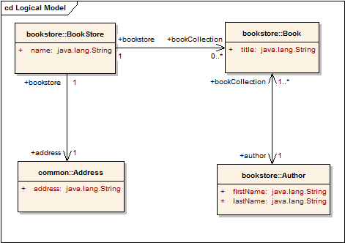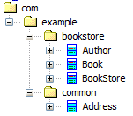

UML Profile Mappings

Project Mappings
Project maps to:
- namespace -> XMLNamespace
  - namespace=gme://example.com/version/1.0
I made up this namespace when I created the XSD. The XSD just imports the XSDs of each of the project’s packages.

Package Mappings
com.example.common Package maps to:
- namespace -> XMLNamespace
  - namespace= gme://common.example.com/version/2.5
I made up this namespace when I created the XSD.

com.example.bookstore Package maps to:
- namespace -> XMLNamespace
  - namespace= gme://bookstore.example.com/version/1.0
I made up this namespace when I created the XSD.

Class Mappings
com.example.common.Address Class maps to:
- xmlRepresentation -> XMLElement
  - name= Address
  - xmlNamespace -> XMLNamespace
    - namespace= gme://common.example.com/version/2.5

com.example.bookstore.Author Class maps to:
- xmlRepresentation -> XMLElement
  - name= Author
  - xmlNamespace -> XMLNamespace
    - namespace= gme://bookstore.example.com/version/1.0

com.example.bookstore.Book Class maps to:
- xmlRepresentation -> XMLElement
  - name= Book
  - xmlNamespace -> XMLNamespace
    - namespace= gme://bookstore.example.com/version/1.0

com.example.bookstore.BookStore Class maps to:
- xmlRepresentation -> XMLElement
  - name= BookStore
  - xmlNamespace -> XMLNamespace
    - namespace= gme://bookstore.example.com/version/1.0

Class Association Mappings
BookStore (bookstore 1…1) to Book ( bookCollection 0…*)Association maps to:
- targetXMLRepresentation -> XMLLocationReference
  - relativeXPathExpression=bookCollection/Book
  - containingElement -> XMLElement
    - name= BookStore
    - xmlNamespace -> XMLNamespace
      - namespace= gme://bookstore.example.com/version/1.0
Notice how this association is unidirectional from BookStore to Book, and the “targetXMLRepresentation” is what is populated. However, the containingElement is actually the Source. Think of the mapping representing the location of the target within the source. Also notice there is no sourceXMLRepresentation as the target does not contain a link back to the source (the association is unidirectional).

BookStore (bookstore 1…1) to Address (address 1…1)Association maps to:
- targetXMLRepresentation -> XMLLocationReference
  - relativeXPathExpression=address/Address
  - containingElement -> XMLElement
    - name= BookStore
    - xmlNamespace -> XMLNamespace
      - namespace= gme://bookstore.example.com/version/1.0

Book (bookCollection 1…*) to Author(author1…1)Association maps to:
- targetXMLRepresentation -> XMLLocationReference
  - relativeXPathExpression=author/Author
  - containingElement -> XMLElement
    - name= Book
    - xmlNamespace -> XMLNamespace
      - namespace= gme://bookstore.example.com/version/1.0
- sourceXMLRepresentation -> XMLLocationReference
  - relativeXPathExpression=bookCollection/Book
  - containingElement -> XMLElement
    - name= Author
    - xmlNamespace -> XMLNamespace
      - namespace= gme://bookstore.example.com/version/1.0

Attribute Mappings
Author firstName Attribute maps to:
- xmlRepresentation -> XMLLocationReference
  - relativeXPathExpression=@firstName
  - containingElement -> XMLElement
    - name= Author
    - xmlNamespace -> XMLNamespace
      - namespace= gme://bookstore.example.com/version/1.0

Author lastName Attribute maps to:
- xmlRepresentation -> XMLLocationReference
  - relativeXPathExpression=@lastName
  - containingElement -> XMLElement
    - name= Author
    - xmlNamespace -> XMLNamespace
      - namespace= gme://bookstore.example.com/version/1.0

Book title Attribute maps to:
- xmlRepresentation -> XMLLocationReference
  - relativeXPathExpression= title
  - containingElement -> XMLElement
    - name= Book
    - xmlNamespace -> XMLNamespace
      - namespace= gme://bookstore.example.com/version/1.0

BookStore name Attribute maps to:
- xmlRepresentation -> XMLLocationReference
  - relativeXPathExpression= name
  - containingElement -> XMLElement
    - name= BookStore
    - xmlNamespace -> XMLNamespace
      - namespace= gme://bookstore.example.com/version/1.0

Address address Attribute maps to:
- xmlRepresentation -> XMLLocationReference
  - relativeXPathExpression= address
  - containingElement -> XMLElement
    - name= Address
    - xmlNamespace -> XMLNamespace
      - namespace= gme://common.example.com/version/2.5

Example XML Schemas
gme://example.com/version/1.0
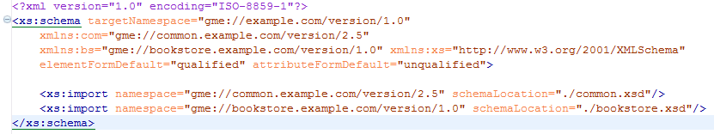
gme://common.example.com/version/2.5
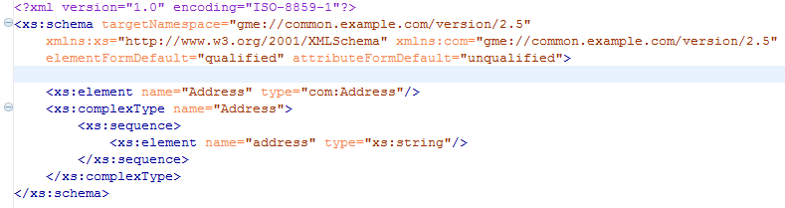
gme://bookstore.example.com/version/1.0
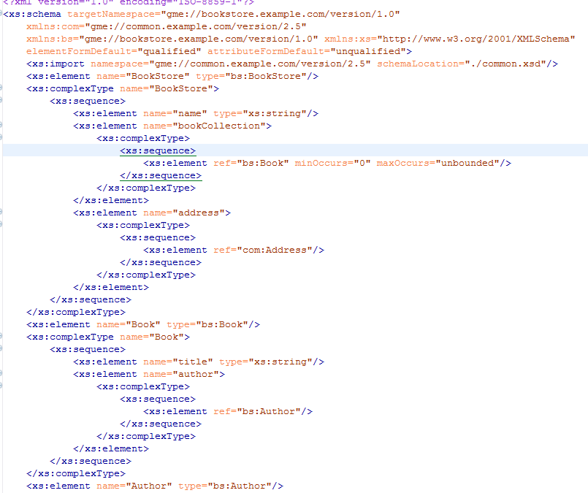
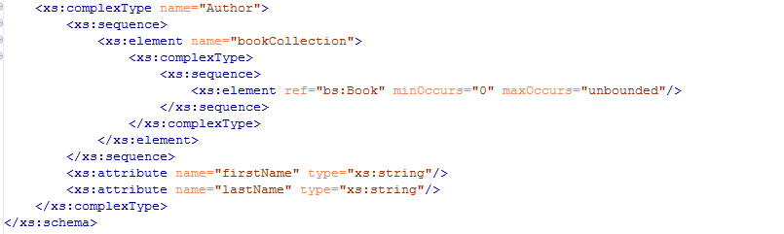

Best Practices / Recommendations
As detailed above, XML Schemas play an important role in the runtime framework of caBIG. Furthermore, they are tightly-coupled to the mechanism used to serialize the Object representation of data types. Therefore, the approach to schema generation and object serialization which is most suitable for a given situation is dependant on which artifacts and components exist at the time one wishes to create their grid service.

Starting from Nothing
When starting completely from scratch, the first step should be to model the data types in UML and undergo the semantic harmonization process. Once the data model is appropriately modified and approved, a tool such as EA or hyperModel should be used to create a starting XML schema; experience has shown hyperModel does a better job. This schema should then be review for correctness and modified accordingly, setting the namespace using the recommendations in Section Error: Reference source not found. Then either the Analytical Toolkit or the Globus tools should be used to create all the necessary Java Objects and serialization code.

Starting from Existing Objects
When starting from existing Objects, it is likely a schema will need to be created to match the serialization mechanism. The objects will either have the capability to serialize to meaningful XML and deserialize from it, or a tool will be used to provide such a feature. In which case, custom serialization, described in Section , must be used. A descriptive schema must then be created to describe the format of this XML, using the process described in Section . As above, the namespace should be defined using the recommendations in Section Error: Reference source not found

Future Approach
As caBIG matures and if the caGrid approach is adopted, XML schemas should play a larger role earlier in the data modeling process. As the schema, the object model, and the caDSR descriptions are all meant to be harmonious, the schemas should be approved and published to the GME at the time the data model is published to caDSR. Furthermore, the caCORE SDK should generate object capable of serializing to XML and deserializing from it in a Globus-compatible way, such that custom serialization is not needed. It should then also create an XML schema which describes said XML.
- Global Model Exchange

asdfasdf

- caDSR Service

asdfasdf

- Index Service

We are currently using the DefaultIndexService which doesn't use Resources.
This essentially makes the service single purpose, grouping all services into a single service group.

Alternatively we could use the IndexService which can manage multiple IndexResources.
Each resource can act as a separate service group. For example we could have one resource for all of caBIG and other resources
for more sepecific uses (such as a consortium, project, or VO). In this approach, the DefaultIndexService would only be used to
store "pointers" to the IndexResources. More specifically, the pointer would contain the EPR of the IndexResource, and some
metadata used to identify it (such as a name and description). This is advantageous as we could have a single location act as the
registry of registries, and the actual registries could actually be stored on remote hosts. This has the advantage of scalability
but added complexity. Clients need to first discover the EPR of the registry they want to use, then query that resource as they would normally do.

A small but important issue is how to create the initial "caBIG" resource in the index when it starts up. We probably would need
the IndexResources to be persistent.

My current thinking is to just use the DefaultIndexService to directly store the "caBIG" service metadata, but provide
the API/design for additionally storing these "pointers" in it as well. This way, the baseline advertisement/discovery can
be done the simple way (it needs to all be stored in a single resource anyway), but we gain the ability to register additional
specialized registries in it.

overview

use

"trusted/official registration" design
design "official index service" that uses 3rd party secure registration
- no services should directly register to it
- 3rd party should manually/programmatically add "compliant services" to it
- could also publish public certificate of the service credentials
- client could perform client side authz matching service certificate with published certificate
- could use resource-centric IndexService to create multiple service groups (gold-compliant, etc, )

- Introduce Integration

type discovery

standard metadata

- References
This appendix could include lists and hypertext links, where appropriate, to technical manuals, articles, scientific publications, etc. Examples are shown:

Technical Manuals/Articles
- National Cancer Institute. "caCORE 2.0 Technical Guide", ftp://ftp1.nci.nih.gov/pub/cacore/caCORE2.0_Tech_Guide.pdf
- Java Bean Specification: http://java.sun.com/products/javabeans/docs/spec.html
- Foundations of Object-Relational Mapping: http://www.chimu.com/publications/objectRelational/
- Object-Relational Mapping articles and products: http://www.service-architecture.com/object-relational-mapping/
- Hibernate Reference Documentation: http://www.hibernate.org/hib_docs/reference/en/html/
- Basic O/R Mapping: http://www.hibernate.org/hib_docs/reference/en/html/mapping.html
- Java Programming: http://java.sun.com/learning/new2java/index.html
- Javadoc tool: http://java.sun.com/j2se/javadoc/
- JUnit: http://junit.sourceforge.net/
- Extensible Markup Language: http://www.w3.org/TR/REC-xml/
- XML Metadata Interchange: http://www.omg.org/technology/documents/formal/xmi.htm

Scientific Publications

caBIG Material
- caBIG: http://cabig.nci.nih.gov/
- caBIG Compatibility Guidelines: http://cabig.nci.nih.gov/guidelines_documentation

caCORE Material
- caCORE: http://ncicb.nci.nih.gov/core
- caBIO: http://ncicb.nci.nih.gov/core/caBIO
- caDSR: http://ncicb.nci.nih.gov/core/caDSR
- EVS: http://ncicb.nci.nih.gov/core/EVS
- CSM: http://ncicb.nci.nih.gov/core/CSM

- Glossary
Following is an example list of terms and their definitions.
Term | Definition
{jboss-home} | The base directory where JBoss is installed on the server
API | Application Programming Interface
caArray | cancer Array Informatics
caBIG | cancer Biomedical Informatics Grid
caBIO | Cancer Bioinformatics Infrastructure Objects
caCORE | cancer Common Ontologic Representation Environment
caDSR | Cancer Data Standards Repository
caMOD | Cancer Models Database
cardinality | Cardinality describes the minimum and maximum number of associated objects within a set
CDE | Common Data Element
CGAP | Cancer Genome Anatomy Project
CMAP | Cancer Molecular Analysis Project
CN | Common Name
CS | Classification Scheme
CSI | Classification Scheme Item
CSM | Common Security Module
CTEP | Cancer Therapy Evaluation Program
CUI | Concept Unique Identifier
CVS | Concurrent Versions System
DAML | DARPA Agent Markup Language
DAO | Data Access Objects
DARPA | Defense Advanced Research Projects Agency
DAS | Distributed Annotation System
DL | Description Logic
EA | Enterprise Architect
EBI | European Bioinformatics Institute
EVS | Enterprise Vocabulary Services
GAI | CGAP Genetic Annotation Initiative
GEDP | Gene Expression Data Portal
HIPPA | Health Insurance Portability and Accountability Act
HLGT | High Level Group Term
HLT | High Level Term
HTTP | Hypertext Transfer Protocol
ISO | International Organization for Standardization
JAAS | Java Authentication and Authorization Service
JAR | Java Archive
Javadoc | Tool for generating API documentation in HTML format from doc comments in source code (http://java.sun.com/j2se/javadoc/)
JDBC | Java Database Connectivity
JET | Java Emitter Templates
JMI | Java Metadata Interface
JSP | JavaServer Pages
JUnit | A simple framework to write repeatable tests (http://junit.sourceforge.net/)
LDAP | Lightweight Directory Access Protocol
LLT | Lowest Level Term
LOINC | Logical Observation Identifier Names and Codes
MAGE | MicroArray and Gene Expression
MAGE-OM | MicroArray Gene Expression - Object Model
MedDRA | Medical Dictionary for Regulatory Activities
metadata | Definitional data that provides information about or documentation of other data.
MGED | Microarray Gene Expression Data
MMHCC | Mouse Models of Human Cancers Consortium
MO | MGED Ontology
multiplicity | Multiplicity of an association end indicates the number of objects of the class on that end may be associated with a single object of the class on the other end
NCI | National Cancer Institute
NCICB | National Cancer Institute Center for Bioinformatics
OIL | Ontology Inference Layer
OilEd | Ontology editor allowing you to build ontologies using DAML+OIL
OLLT | Obsolete Lower Level Terms
OMG | Object Management Group
ORM | Object Relational Mapping
PT | Preferred Term
RDBMS | Relational Database Management System
SDK | Software Development Kit
Semantic connector | A development kit to link model elements to NCICB EVS concepts.
SOC | System Organ Class
SPORE | Specialized Programs of Research
SQL | Structured Query Language
SSC | Special Search Categories
UI | User Interface
UID | User Identification
UML | Unified Modeling Language
UMLS | Unified Medical Language System
UPT | User Provisioning Tool
URL | Uniform Resource Locators
VD | Value Domain
WAR | Web Application Archive
WSDL | Web Services Description Language
XMI | XML Metadata Interchange (http://www.omg.org/technology/documents/formal/xmi.htm) - The main purpose of XMI is to enable easy interchange of metadata between modeling tools (based on the OMG-UML) and metadata repositories (OMG-MOF) in distributed heterogeneous environments
XML | Extensible Markup Language (http://www.w3.org/TR/REC-xml/) - XML is a subset of Standard Generalized Markup Language (SGML). Its goal is to enable generic SGML to be served, received, and processed on the Web in the way that is now possible with HTML. XML has been designed for ease of implementation and for interoperability with both SGML and HTML

Index
It is very easy to generate an index and extremely helpful to the manual user. See the Technical Style Guide located at: https://cabig.nci.nih.gov/working_groups/Training_SLWG/Documents/Technical_Pubs_Style_Guide_021405_jbh.pdf for directions for inserting index markers and generating an index in MS Word (PC).

Document conventions, Supplement, 8
Glossary, 29
References
caBIG materials, 27
caCORE material, 27
scientific publications, 27
technical manuals, guides, 27
Text conventions, Supplement, 8

