caGrid Data Services

Technical Overview

caBIG™ is an initiative of the National Cancer Institute, NIH, DHHS

Insert Names of Development Team(s) here
Development | Programmer’s guide |  | Program Management
Names of developers | Names of technical writers and reviewers |  | Names of program managers
David W. Ervin | David W. Ervin
¹ Footnote contributing companies/ contractors/ divisions |  | ³ company
² department or division

Contacts and Support
Enter training contact | name (email address)
Enter customer support contact | Web hyperlink  Telephone: 111-222-3456  Toll free: 888-234-1234

LISTSERV Facilities Pertinent to software teams
LISTSERV | URL | Name
caGrid_Developers | https://list.nih.gov/archives/cagrid_developers.html | caGrid Developers Discussion

Table of Contents

Document Text Conventions 5
Chapter 1 Overview of caGrid Data Services 6
Software Overview 6
Chapter 2 caGrid Data Service Requirements 8
Chapter 3 caGrid Data Service Design and Architecture 9
Architecture 9
Chapter 4 CQL 11
The CQL Schema 11
CQL Examples 13
CQL Caveats 18
Chapter 5 Introduce Extension 19
User Interface 19
caCORE Data Source Wizard 23
Backend Extension Functionality 26
Chapter 6 Future Enhancements 27
Appendix A References 28
Technical Manuals/Articles 28
Scientific Publications 28
caBIG Material 28
caCORE Material 28
Appendix B Glossary 29
Index 33

Document Text Conventions
The following table shows various typefaces to differentiate between regular text and menu commands, keyboard keys, and text that you type. This illustrates how conventions are represented in this guide.
Convention | Description | Example
Bold & Capitalized Command  Capitalized command > Capitalized command | Indicates a Menu command  Indicates Sequential Menu commands | Admin > Refresh
text in small caps | Keyboard key that you press | Press enter
text in small caps + text in small caps | Keyboard keys that you press simultaneously | Press shift + ctrl and then release both.
Special typestyle | Used for filenames, directory names, commands, file listings, source code examples and anything that would appear in a Java program, such as methods, variables, and classes. | URL_definition ::= url_string
Boldface type | Options that you select in dialog boxes or drop-down menus. Buttons or icons that you click. | In the Open dialog box, select the file and click the Open button.
Italics | Used to reference other documents, sections, figures, and tables. | caCORE Software Development Kit 1.0 Programmer’s Guide
Italic boldface type | Text that you type | In the New Subset text box, enter Proprietary Proteins.
Note: | Highlights a concept of particular interest | Note: This concept is used throughout the installation manual.
Warning! | Highlights information of which you should be particularly aware. | Warning! Deleting an object will permanently delete it from the database.
{} | Curly brackets are used for replaceable items. | Replace {root directory} with its proper value such as c:\cabio

Overview of caGrid Data Services

Software Overview

caGrid Data Services present an object view of a data resource. The data resource is exposed through a well defined query method, which also relies on well defined objects to perform queries and return results as a strongly typed set. Since caGrid Data Services operate with objects registered in the caDSR and modeled via XML schema stored in the GME, caGrid Data Services are caBIG Gold Level services.

Data services in their most basic form can be modeled from a high level view with the following diagram:
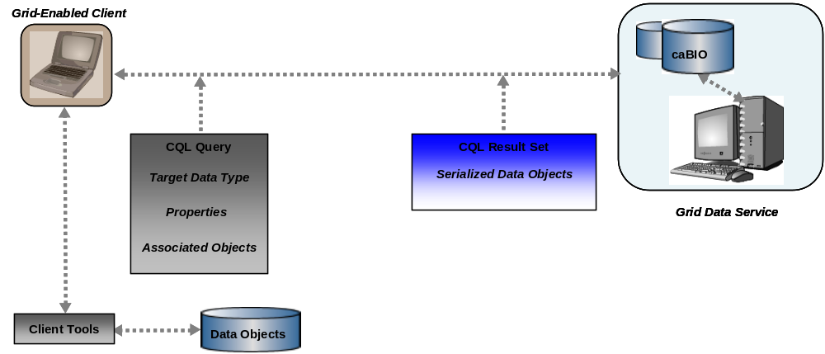
Figure 1caGrid Data Service Diagram
In this diagram, a client formulates a CQL Query. This query contains information regarding which data type will be targeted and therefore returned by the query, as well as properties which the returned objects must fulfill. Additionally, the query specifies associated objects which further qualify the target data objects. The query is then submitted to the grid method on the caGrid Data Service via standard grid protocol. This method deserializes the XML received into an object model representation of the query, and then hands it off to a query processor. The query processor has the task of interpreting the CQL Query in a manner that allows it to query an underlying data source (for example, a Silver level caCORE SDK generated system), and generating the result set. Once the result set has been generated, the results are serialized as XML and returned to the client as a single query results set object. The client has tools which can iterate the result set as either raw XML strings, or deserialize the XML into objects. A simplified data service handle class is provided which immediately returns an object iterator without the intermediate step of creating one and configuring it to return objects instead of XML.

caGrid Data Service Requirements
caGrid Data Services must meet the following requirements:
- Must expose specialized metadata to describe the content available from the data service.
- Must expose data as registered objects.
- Must conform to a standard and consistent query interface.
- The standard query interface must be based on a well defined query language, including both the input query type and returned result type.
- Must provide client tooling to simplify handling of returned results.
- Must provide an implementation of the standard query language to easily expose existing data models created with the caCORE SDK to the grid.
- Should integrate fully with caGrid security infrastructure.
- Should provide simplified tooling to allow users to create Data Services, configuring target data types and their serialization.

caGrid Data Service Design and Architecture

Architecture
To fulfill the requirements laid out for caGrid Data Services, implementation has proceeded as a specialization of standard grid services. As such, some of the data service requirements are immediately met:

- Security integration:
  - All security concepts that apply to any other grid service are immediately available and enforced on caGrid data services.
- Simplified creation tooling:
  - The Introduce Toolkit allows creation of grid services, including configuring their metadata, security, and service functionality.
  - The Introduce Toolkit also provides a pluggable backend architecture and graphical user interface, which allows specialized services to be created with a minimum of interaction from end users.
Further requirements are met through implementation of a standardized query schema and client tooling to manipulate it:

- Standard query language is CQL, defined by a schema registered in the GME.
  - Allows creation of CQL Query objects which can be passed to the caGrid data service describing the target data type and all qualifications and restrictions that must be met for the requested object.
- Query results described by a CQL Results schema, also registered in the GME.
- Client tooling implemented as an iterator over the result set. The iterator deserializes the XML returned in the CQL Result object as a series of registered objects. An alternative implementation simply returns the XML without any processing applied to it.

A standard interface for caGrid Data Services has been identified, and consists of a single ‘query’ method. This method takes a single CQL Query parameter, and returns a single CQL Result Set object. All data services must follow this implementation pattern, but are free to include additional methods, such as domain-specific querying capabilities.

To both simplify creation of data services and ensure interoperability between data services, this query operation is provided in a pre-built service and implementation, and is imported into user-created services.

The query result schema wraps the serialized XML of registered data objects. These objects are identified by their schemas, which are included in the WSDL of the caGrid Data Service. This enables clients to discover which types are available from a given service.

An abstract base class for querying a data source with CQL is provided with the caGrid Data service, which data providers are required to implement. To aid in moving existing silver level data sources to gold compliance, an implementation of the CQL query processor will be provided with the caGrid data service architecture which queries against a caCORE SDK generated data source. Serialization of SDK generated objects is also automatically configured when the service is created through the Introduce Toolkit.

CQL

The CQL Schema

CQL is defined in an XML document conforming to a well defined schema with the URI http://CQL.caBIG/1/gov.nih.nci.cagrid.CQLQuery. This schema can be graphically represented by the following diagram:
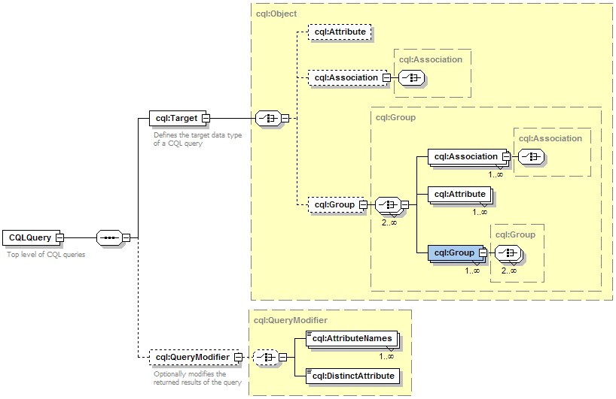

Parts of the CQL schema:

CQLQuery: CQL Query is a simple wrapper element at the head of every CQL query document. It contains the target element.

Target: The Target element is of the type Object, and describes the data type which the query will return.
QueryModifier: An optional element modifying the returned result set. This modifier has a required attribute ‘countOnly’ which can tell the data service to return the number of results the query would return. The modifier optionally allows for a choice of a list of Attribute Names or a single Distinct Attribute to return. When the list of attribute names is specified, sets of tuples are returned containing the attribute names and corresponding values for each object instance returned by the query. When distinct attribute is used, only unique attribute values are placed in the returned attribute sets.

Object: The Object element contains the required attribute ‘name.’ This attribute’s value defines the caDSR class of the object. When the Object is the top level target of a CQL query, it identifies the data type that will be returned by the caGrid Data Service. The Object allows for a choice between three child elements. The possible child elements are Attribute, Association, and Group. Objects may have at most one of these child elements.

Attribute: An Attribute type in CQL describes a restriction for an attribute of an Object. The Attribute contains three XML attributes, which define the restriction. The attribute ‘name’ defines the name of the attribute to be restricted. The attribute ‘value’ defines the restriction on the attribute. The attribute ‘predicate’ describes what type of restriction the Attribute defines. Allowable predicates are defined by the schema’s simple type ‘Predicate’, which defines an enumeration of allowable values. The predicate values are generally self-descriptive: “EQUAL_TO", “NOT_EQUAL_TO", “LIKE", "LESS_THAN", "LESS_THAN_EQUAL_TO", “GREATER_THAN", and “GREATER_THAN_EQUAL_TO." Two additional predicates, "IS_NOT_NULL", and “IS_NULL" check only for the presence or absence, respectively, of an attribute, and do not restrict its value at all. Therefore, any ‘value’ attribute will be ignored when using these predicates.

Association: An association describes a related Object, which defines the associated Object’s restrictions for the query, as well as the relationship from one object to another. Specifically, it defines the relationship down the object model tree. The Association complex type is an extension of Object. The Association has a single, optional attribute named ‘roleName.’ This attribute identifies which associated object field the Association is defining. For example, a person may have more than one address, perhaps business and home. To perform a restriction against the home address, a query must specify the home address role name for the associated object. If the query omits the role name, such a query becomes ambiguous, as there is more than one field of Person which has a type of Address. In this case, the data service will throw a MalformedQueryException explaining that the requested association is ambiguous. In the case of an object where there is only one field of a given type, the roleName attribute may be omitted, and the data service will resolve the correct name as the query is processed.

Group: Groups define logical joints of two or more conditions, and operate against the Object to which they are attached. Groups must have two or more children, which may be a mixture of type Attribute, Association, or Group. Groups also have an attribute named ‘logicOperator,’ whose type is defined in the schema’s simple type LogicalOperator. This type is an enumeration of the values “AND” and “OR.” The operator is applied to all children in the group. The “AND” operator requires that all conditions in the group be true for the group to evaluate as true. The “OR” operator requires that any condition in the group evaluate as true.

CQL Examples

Return all objects of a given type: The simplest CQL query defines only one Object. The data service will return all objects in its underlying data source of the given type.

This query will return all Gene objects in the data source:
<CQLQuery xmlns="http://CQL.caBIG/1/gov.nih.nci.cagrid.CQLQuery">
<Target name="gov.nih.nci.cabio.domain.Gene"/>
</CQLQuery>

Count all objects of a given type: A variant of the same simple CQL query defines only the target object and a query modifier to count the number of results. Such a query may be useful in situations where the returned result set is potentially very large, and knowing the size of this set may determine handling ahead of actually retrieving results.

This query will return the number of all Gene objects in the data source:
<CQLQuery xmlns="http://CQL.caBIG/1/gov.nih.nci.cagrid.CQLQuery">
<Target name="gov.nih.nci.cabio.domain.Gene"/>
<QueryModifier countOnly="true"/>
</CQLQuery>

Objects with a single attribute restriction: A simple extension to the above query is to ask for all Objects with a single Attribute restriction. Here, a LIKE restriction is used. Note that the syntax for LIKE queries mimics that of SQL.

This query will return all Genes with a symbol starting with ‘BRCA’:
<CQLQuery xmlns="http://CQL.caBIG/1/gov.nih.nci.cagrid.CQLQuery"
<Target name="gov.nih.nci.cabio.domain.Gene">
<Attribute name="symbol" value="BRCA%" predicate="LIKE"/>
</Target>
</CQLQuery>

Distinct attributes of an object: The following query will return only distinct symbol names from all genes with symbol names starting with ‘BRCA’.

This query will return distinct symbol values for all Genes with a symbol starting with ‘BRCA’:
<CQLQuery xmlns="http://CQL.caBIG/1/gov.nih.nci.cagrid.CQLQuery"
<Target name="gov.nih.nci.cabio.domain.Gene">
<Attribute name="symbol" value="BRCA%" predicate="LIKE"/>
</Target>
<QueryModifier countOnly="false">
<DistinctAttribute>symbol</DistinctAttribute>
</QueryModifier>
</CQLQuery>

Multiple attributes of a target object: The final query modification which can be used is one where multiple attributes of a target object are returned.

This query will both id and symbol values for all Genes with a symbol starting with ‘BRCA’:
<CQLQuery xmlns="http://CQL.caBIG/1/gov.nih.nci.cagrid.CQLQuery"
<Target name="gov.nih.nci.cabio.domain.Gene">
<Attribute name="symbol" value="BRCA%" predicate="LIKE"/>
</Target>
<QueryModifier countOnly="false">
<AttributeNames>symbol</AttributeNames>
<AttributeNames>id</AttributeNames>
</QueryModifier>
</CQLQuery>

Objects with a single association: A more involved CQL query defines an Object and an Association to another Object. The data service will return all objects of the requested data type and meeting the restriction on their association.

This query will return all Genes with an associated Taxon whose id is equal to 6:
<CQLQuery xmlns="http://CQL.caBIG/1/gov.nih.nci.cagrid.CQLQuery">
<Target name="gov.nih.nci.cabio.domain.Gene">
<Association roleName="taxon" name="gov.nih.nci.cabio.domain.Taxon">
<Attribute name="id" value="6" predicate="EQUAL_TO"/>
</Association>
</Target>
</CQLQuery>

Groups: Groups are required when more than one restriction on an Object is needed. In this example, a group is made with an AND logical operator, meaning that all conditions defined within the Group must be met.

This query will return all Genes with a symbol beginning with ‘BRCA’ and have an associated Taxon with an id equal to 6:
<CQLQuery xmlns="http://CQL.caBIG/1/gov.nih.nci.cagrid.CQLQuery">
<Target name="gov.nih.nci.cabio.domain.Gene">
<Group logicRelation="AND">
<Attribute name="symbol" value="BRCA%" predicate="LIKE"/>
<Association roleName="taxon" name="gov.nih.nci.cabio.domain.Taxon">
<Attribute name="id" value="6" predicate="EQUAL_TO"/>
</Association>
</Group>
</Target>
</CQLQuery>

Nested groups: Nested groups can be used to build up sophisticated compound queries. The groups may have differing logical relations to express restrictions on various portions of the object.

This query will return all Genes with an associated Taxon that has a scientificName attribute of ‘Mus musculus’ and have either a symbol like ‘BRCA’ or like ‘ICR’:
<CQLQuery xmlns="http://CQL.caBIG/1/gov.nih.nci.cagrid.CQLQuery" >
<Target name="gov.nih.nci.cabio.domain.Gene">
<Group logicRelation="AND">
<Association roleName="taxon" name="gov.nih.nci.cabio.domain.Taxon">
<Attribute name="scientificName" value="Mus musculus" predicate="EQUAL_TO"/>
</Association>
<Group logicRelation="OR">
<Attribute name="symbol" value="BRCA%" predicate="LIKE"/>
<Attribute name="symbol" value="ICR%" predicate="LIKE"/>
</Group>
</Group>
</Target>
</CQLQuery>

CQL Caveats

- CQL does not permit querying for attributes with values that are XML schema complex types. Only values that can be represented as XML schema simple types are allowed.
- CQL Attribute Results cannot contain attribute values which are XML schema complex types. Only values that can be represented as XML schema simple types are allowed.
- CQL does not provide a facility for returning object instances other than the targeted data type. It also cannot return populated associations on instances of the targeted data type.

Introduce Extension

User Interface

caGrid Data Services can be built with a set of extensions to the Introduce Toolkit. This provides grid service developers with a simple and well defined starting point to create caBIG gold compliant Data Services. When the extension is selected in creating new services, the user is presented with the both standard service modification interface, and a new section containing options specific to configuring data services.

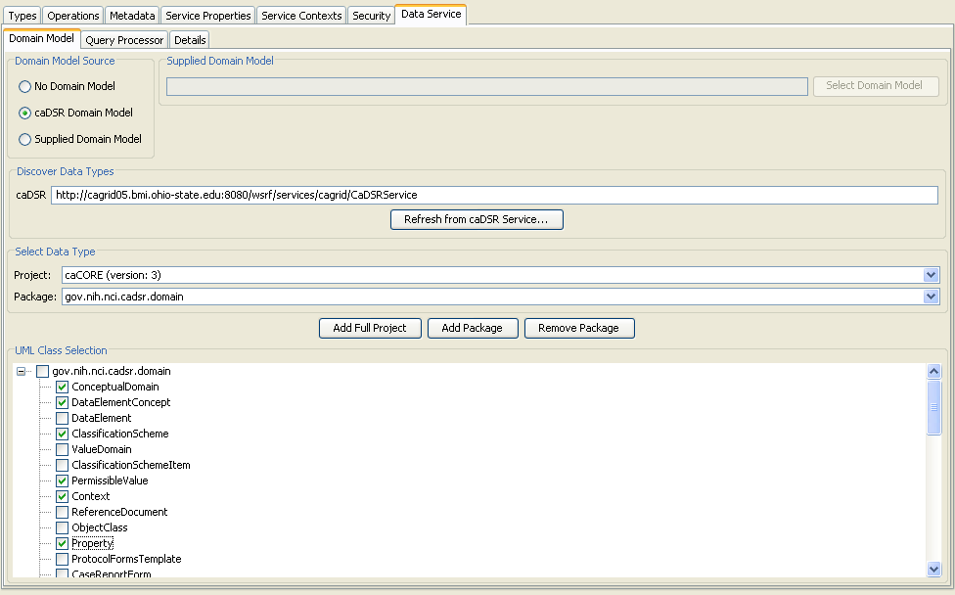

The Data Service extension adds a graphical component to the Introduce Toolkit’s service modification view. This tab contains three sub tabs, each containing major points of configuration for the data service:
- Domain Model
  - Provides facilities for selecting the domain of data types available to be queried by the data service
- Query Processor
  - Allows the user to select the implementation of CQL to use in the data service and provides for configuration of its parameters
- Details
  - Serialization of data types, mapping classes to XML Schema element names, and enabling / disabling query validation

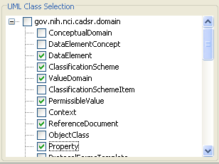
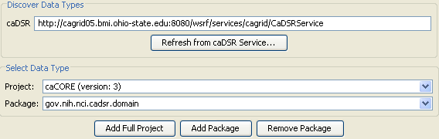
On the Domain Model tab, the group of radio buttons allows selection of the domain model’s origin. The domain model can be generated when the service is saved from the caDSR, supplied from an existing XML file, or be omitted. This last option is primarily for testing purposes. The top field labeled ‘caDSR’ indicates the URL of the caDSR grid service to access. The button ‘Refresh from caDSR Service’ queries the grid service to retrieve a list of Projects and UML Packages available in the caDSR. Projects and packages can be selected with the two dropdown menus provided. When the caDSR option is selected, the controls selecting information from the caDSR grid service, adding a project, adding a package, and removing a package become active. The ‘Add Full Project’ button will insert all packages and classes from the project into the domain model. Add Package will insert a single selected package, and remove package will take a package out of the domain model. When a package is added, its contents will appear in the tree below the buttons. This tree contains check boxes next to the package and the individual classes. Placing a check next to a class will add it to the domain model as an object which can be queried, and by default, used as a type which can be targeted with a query. Placing a check by a package will automatically add all the classes in that package in the same way. When packages are added, the extension attempts to retrieve a schema to match the package from the GME and add it to the service’s list of namespace types.

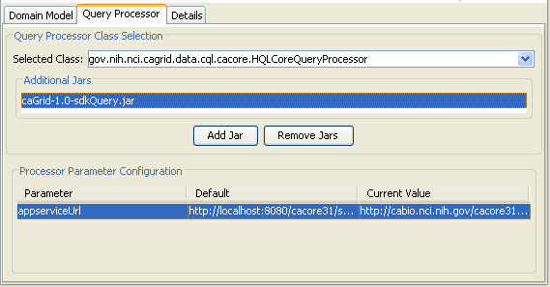
The Class Selection tab shows a drop down of all currently available CQL Query Processor implementations. When a new jar file is added to the service, this list will update to reflect the changes. The class selection is not limited to these classes specifically, as the drop down is manually editable. The added jar files will be copied into the service’s library directory, and deployed with the service. Selecting a class from the drop down will make it the query processor implementation which is invoked by the data service to handle queries at runtime. Its configuration properties (if any) will be shown in the table at the bottom of the screen. This table shows the name of every parameter, its default value, and an editable field where a custom value may be entered. These parameters are stored as service properties in the generated service and are made available at runtime through JNDI.

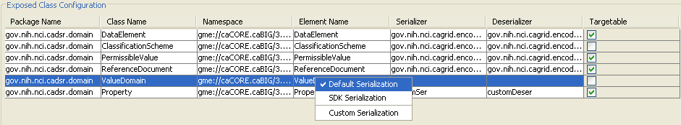
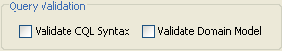
The Details page allows configuration of lower level items in the data service. This tab contains a table allowing configuration of the way each type in the domain model will be serialized by the data service, as well as a flag to indicate if each type may be targeted and returned by a CQL query. Types can be selected either individually or in groups and their serialization is configured by a popup menu. This menu allows selection of either the default serialization, SDK serialization for caCORE SDK generated objects, or a custom serialization. Selecting SDK Serialization assigns the SDK serializer and deserializer factories to the types. Custom serialization presents the user with a dialog box in which to enter the serializer and deserializer classes which will be assigned to the schema type. This information is recorded in the generated client-config.wsdd file, as well as the server-config.wsdd. These configuration files may be used later in the data service client to properly deserialize results of queries. When the data service is saved, the backend of the introduce extension will process the information regarding the caDSR project and package selection, and proceed to create a domain model metadata document. This can be a very expensive and time consuming operation, so an option is given to supply this document. If the document is supplied, the data service will receive a copy of it instead of generating a new one. This tab also allows the service developer to select what type of query validation they desire to be performed. Selecting to validate CQL syntax will cause the Data Service to ensure that the executed CQL query conforms to the CQL schema. Selecting validate domain model will cause the data service to parse the CQL query against the domain model, ensuring that all aspects of the query remain within the confines of the exposed domain model. Using these options in conjunction ensures that every query that reaches the CQL query processor implementation is both syntactically correct and conforms to the domain model, which can substantially simplify handling for potential errors in the query processor.

caCORE Data Source Wizard
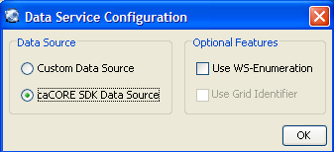
The Introduce extension provides a simplified means of creating a data service which exposes a caCORE SDK generated data source. When a new service is created, a dialog is presented to the service developer allowing selection of various features of the data service. If the feature ‘caCORE SDK Data Source’ is selected, a wizard is launched to create the new service. The wizard will walk the developer through four steps to create and configure the new service, performing only those steps necessary to create a data source using the caCORE SDK as a backend, automatically configuring the data service along the way.
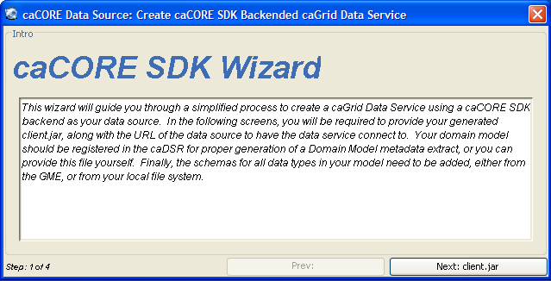
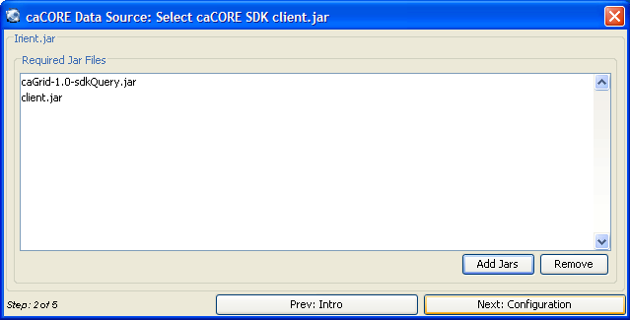
The wizard presents the user with a series of panels, each of which is designed to configure a different aspect of the data service using a caCORE SDK backend data source. The wizard indicates to the service developer which step of the process they are currently on, the previous step in the process (on a button to move to that step), the next step of the process (also on a button), and the current step being worked on. The next and previous step buttons may become enabled or disabled based on completion of each step of the process. Additionally, the button to move to the next step becomes a button to complete the wizard when all steps are complete and the service can be built correctly. Closing the wizard prematurely will display a warning message, indicating that such an action can have adverse results for the service being built. The first panel informs the developer of what steps are necessary to complete the wizard, and indicates what information will be needed in the future steps. Behind the graphical interface, the data service backend will copy required libraries and schemas into the data service. Should this (or any other process) fail, an error message indicating the failure will be shown.
The next step in the process is to select the caCORE generated client.jar file. The jar files listed here will be copied into the service’s library directory. Any jars already listed in this window will be added to the service, and are required for proper functionality of the caCORE SDK query processor. The button to advance to the next step in the wizard will be disabled until a valid client.jar file has been selected.
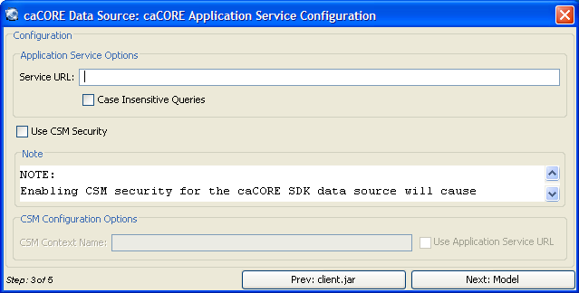
The next step in the wizard allows the service developer to configure some properties of the caCORE SDK query processor implementation. These paramaters include the URL of the remote caCORE service to connect to, a flag to select case insensitive queries, and configuration for CSM security on the remote service. Checking the box to use CSM security will enable the configuration options for CSM. The URL of the application service can be selected as the CSM context name by checking the box for it, or a custom context name may be supplied. Note that due to limitations inherent in the caCORE API, enabling CSM security will only permit one query to execute at a time, diminishing performance in cases where multiple queries are submitted to the Data Service at the same time.
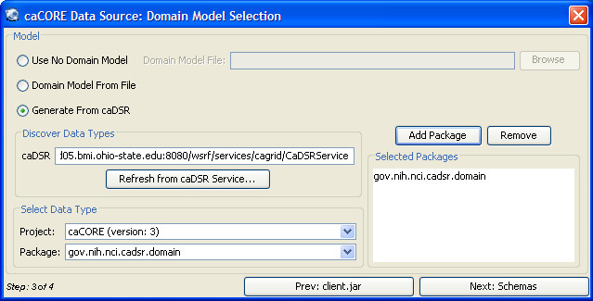
The next step allows the service developer to configure the domain model exposed by the caCORE SDK backend. There are three ways to complete this panel. The first option is to create a data service with no domain model provided. This option is primarily for testing, as the lack of a domain model will make query validation for semantic correctness impossible. The next option for domain models is to supply one from an XML file. The domain model will be copied in to the service, and parsed for UML packages and classes. These classes must be mapped to schema types. The final way to specify a domain model is to use the caDSR to build one from scratch. This panel behaves similarly to the one used in the standard (non-wizard) Introduce Extension user interface, but no option for selecting or deselecting specific classes is provided.
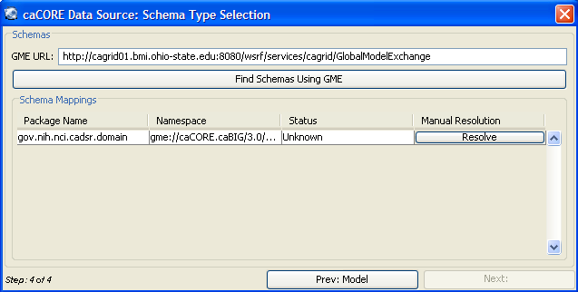
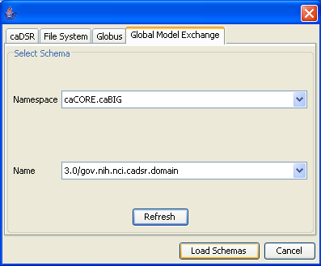
The fourth and final step in the process of creating a data service which uses the caCORE SDK as its data source is to supply schemas for each UML package exposed by the domain model. If no packages are specified, no schemas will need to be added. The wizard will attempt to retrieve all the required schemas from the GME using the URL specified at the top of the dialog. Each namespace successfully located will have its status on the table marked as ‘Found.’ Error conditions and namespaces without schemas will be indicated in the status field as well. Schemas which have not been found can be resolved manually with the ‘Resolve’ button in the table for each row. This gives the service developer the opportunity to specify a schema other than the one located by the GME, to change namespace mappings, or use a schema from some other source. Only when all namespaces and packages have a status of ‘Found’ will the wizard be complete and the ‘Done’ button will become active. At this point, the service wizard has all the information needed to create a caGrid Data Service using a caCORE SDK generated data source. The wizard will close, and the normal introduce build operations will occur. If the option to build a domain model from the caDSR is selected, the domain model file will be created. This can be an expensive operation, and may take several minutes to complete. When the creation process is finished, the service modification dialog will appear. At this point, the service may be deployed and invoked, or modified and saved.

Backend Extension Functionality

The Introduce Toolkit allows for extensions to be included in the service development process which add functionality to almost any step of the service build process. The Data Service extension makes use of three of these extension points. The first extension point used is immediately following service creation. This post-creation operation makes the following changes to the generated service:
- The data service WSDL file is copied into the service.
- The data service schemas for CQL and Domain Models are copied into the generated service.
- The data service libraries are copied in to the service.
- The base data service query method is added, and defined to be implemented in the copied libraries and provided in the copied WSDL.
- Service properties are added to define the query processor class.
The next step in the build process added by the Data Service extension is invoked when modifications to the service are saved. This operation happens before the standard operations provided by Introduce are executed which generate code for user defined methods, edit WSDL files, and copy schemas. This pre code generation operation makes the following changes to the service:
- Modifies service properties.
  - The property defining the query processor class implementation is populated with the user’s defined value.
  - Properties required by the query processor implementation for initialization are created and added to the service.
- Adds domain model metadata.
  - If the user has defined an XML file containing the domain model definition, it will be copied into the service.
  - If no file is specified, the caDSR grid service is contacted to generate one. This process can be time consuming depending on the network connection to the caDSR and the specific package and project combination selected.

Following the execution of the pre code generation extension, the standard Introduce build operations are invoked. This process uses up the changes made by the extension and generates appropriate code such as the Service Configuration to add access to the added functionality. When this is complete, the final extension operation is invoked on the new service. This operation modifies the generated Eclipse files to add the new jar library files to the project’s classpath.

Future Enhancements
There are further features of caGrid Data Services which will be provided in future versions:
- Target data type restrictions.
  - Presently, any type exposed in the service’s domain model may be queried for and returned.
  - Future work will allow for restricting the returnable data types. This restriction will be exposed in the service’s metadata as well as the WSDL document so that users may more effectively query the data service.
- Service-side iteration of query result sets.
  - Queries against large data sources may return very large result sets.
  - Serialization and transport of such result sets may not be practical given finite restrictions on hardware resources of grid connected machines.
  - Future work will allow queries to be submitted which create a resource on the Data Service, which can be accessed via an iterator to return individual results.

- References
This appendix could include lists and hypertext links, where appropriate, to technical manuals, articles, scientific publications, etc. Examples are shown:

Technical Manuals/Articles
- National Cancer Institute. "caCORE 2.0 Technical Guide", ftp://ftp1.nci.nih.gov/pub/cacore/caCORE2.0_Tech_Guide.pdf
- Java Bean Specification: http://java.sun.com/products/javabeans/docs/spec.html
- Foundations of Object-Relational Mapping: http://www.chimu.com/publications/objectRelational/
- Object-Relational Mapping articles and products: http://www.service-architecture.com/object-relational-mapping/
- Hibernate Reference Documentation: http://www.hibernate.org/hib_docs/reference/en/html/
- Basic O/R Mapping: http://www.hibernate.org/hib_docs/reference/en/html/mapping.html
- Java Programming: http://java.sun.com/learning/new2java/index.html
- Javadoc tool: http://java.sun.com/j2se/javadoc/
- JUnit: http://junit.sourceforge.net/
- Extensible Markup Language: http://www.w3.org/TR/REC-xml/
- XML Metadata Interchange: http://www.omg.org/technology/documents/formal/xmi.htm

Scientific Publications

caBIG Material
- caBIG: http://cabig.nci.nih.gov/
- caBIG Compatibility Guidelines: http://cabig.nci.nih.gov/guidelines_documentation

caCORE Material
- caCORE: http://ncicb.nci.nih.gov/core
- caBIO: http://ncicb.nci.nih.gov/core/caBIO
- caDSR: http://ncicb.nci.nih.gov/core/caDSR
- EVS: http://ncicb.nci.nih.gov/core/EVS
- CSM: http://ncicb.nci.nih.gov/core/CSM
- Glossary
Following is an example list of terms and their definitions.
Term | Definition
{jboss-home} | The base directory where JBoss is installed on the server
API | Application Programming Interface
caArray | cancer Array Informatics
caBIG | cancer Biomedical Informatics Grid
caBIO | Cancer Bioinformatics Infrastructure Objects
caCORE | cancer Common Ontologic Representation Environment
caDSR | Cancer Data Standards Repository
caMOD | Cancer Models Database
cardinality | Cardinality describes the minimum and maximum number of associated objects within a set
CDE | Common Data Element
CGAP | Cancer Genome Anatomy Project
CMAP | Cancer Molecular Analysis Project
CN | Common Name
CS | Classification Scheme
CSI | Classification Scheme Item
CSM | Common Security Module
CTEP | Cancer Therapy Evaluation Program
CUI | Concept Unique Identifier
CVS | Concurrent Versions System
DAML | DARPA Agent Markup Language
DAO | Data Access Objects
DARPA | Defense Advanced Research Projects Agency
DAS | Distributed Annotation System
DL | Description Logic
EA | Enterprise Architect
EBI | European Bioinformatics Institute
EVS | Enterprise Vocabulary Services
GAI | CGAP Genetic Annotation Initiative
GEDP | Gene Expression Data Portal
HIPPA | Health Insurance Portability and Accountability Act
HLGT | High Level Group Term
HLT | High Level Term
HTTP | Hypertext Transfer Protocol
ISO | International Organization for Standardization
JAAS | Java Authentication and Authorization Service
JAR | Java Archive
Javadoc | Tool for generating API documentation in HTML format from doc comments in source code (http://java.sun.com/j2se/javadoc/)
JDBC | Java Database Connectivity
JET | Java Emitter Templates
JMI | Java Metadata Interface
JSP | JavaServer Pages
JUnit | A simple framework to write repeatable tests (http://junit.sourceforge.net/)
LDAP | Lightweight Directory Access Protocol
LLT | Lowest Level Term
LOINC | Logical Observation Identifier Names and Codes
MAGE | MicroArray and Gene Expression
MAGE-OM | MicroArray Gene Expression - Object Model
MedDRA | Medical Dictionary for Regulatory Activities
metadata | Definitional data that provides information about or documentation of other data.
MGED | Microarray Gene Expression Data
MMHCC | Mouse Models of Human Cancers Consortium
MO | MGED Ontology
multiplicity | Multiplicity of an association end indicates the number of objects of the class on that end may be associated with a single object of the class on the other end
NCI | National Cancer Institute
NCICB | National Cancer Institute Center for Bioinformatics
OIL | Ontology Inference Layer
OilEd | Ontology editor allowing you to build ontologies using DAML+OIL
OLLT | Obsolete Lower Level Terms
OMG | Object Management Group
ORM | Object Relational Mapping
PT | Preferred Term
RDBMS | Relational Database Management System
SDK | Software Development Kit
Semantic connector | A development kit to link model elements to NCICB EVS concepts.
SOC | System Organ Class
SPORE | Specialized Programs of Research
SQL | Structured Query Language
SSC | Special Search Categories
UI | User Interface
UID | User Identification
UML | Unified Modeling Language
UMLS | Unified Medical Language System
UPT | User Provisioning Tool
URL | Uniform Resource Locators
VD | Value Domain
WAR | Web Application Archive
WSDL | Web Services Description Language
XMI | XML Metadata Interchange (http://www.omg.org/technology/documents/formal/xmi.htm) - The main purpose of XMI is to enable easy interchange of metadata between modeling tools (based on the OMG-UML) and metadata repositories (OMG-MOF) in distributed heterogeneous environments
XML | Extensible Markup Language (http://www.w3.org/TR/REC-xml/) - XML is a subset of Standard Generalized Markup Language (SGML). Its goal is to enable generic SGML to be served, received, and processed on the Web in the way that is now possible with HTML. XML has been designed for ease of implementation and for interoperability with both SGML and HTML

Index
It is very easy to generate an index and extremely helpful to the manual user. See the Technical Style Guide located at: https://cabig.nci.nih.gov/working_groups/Training_SLWG/Documents/Technical_Pubs_Style_Guide_021405_jbh.pdf for directions for inserting index markers and generating an index in MS Word (PC).

Document conventions, Supplement, 8
Glossary, 29
References
caBIG materials, 27
caCORE material, 27
scientific publications, 27
technical manuals, guides, 27
Text conventions, Supplement, 8

