caBIG® Technology Infrastructure

Concept of Operations

Oct 1, 2009

For Internal Use Only

CONFIDENTIAL
I. Vision 4
II. Mission 5
III. Objectives 6
IV. caBIG® Technology Infrastructure Overview 6
V. Stakeholders 14
VI. Alternatives/Constraints/Contracting Approach 15

Version Number | Date | Description
0.1 | 10/2/09 | Initial draft version based on Presentation for Review
0.2 | 10/3/09 | Revised version incorporating feedback from Core Infrastructure team
0.3 | 10/5/09 | Revised version incorporating additional feedback from core infrastructure team

Version Number | Date | Contributor/Editor
0.1 | 10/2/09 | Avinash Shanbhag
0.2 | 10/3/09 | Dave Hau/Avinash Shanbhag
0.3 | 10/5/09 | Sichen Liu, Dave Hau/Avinash Shanbhag

Vision
NCI’s vision is to reduce the burden of cancer on patients and the nation. The caBIG® mission is to support this vision by creating a virtual web of interconnected data, analytical resources, individuals, and organizations that redefines how research is conducted, care is provided, and patients/participants interact with the biomedical research enterprise. This mission is informed by and supportive of the broader DHHS effort to build a comprehensive health IT infrastructure that supports personalized medicine and integrated care.
The vision of the caBIG® infrastructure is to:
- Connect the cancer and broader medical and research community through shareable, interoperable “network of networks”
- Support the business/transaction/message based dynamic semantics that will underlie the emerging information infrastructure supporting healthcare delivery
- Deploy and extend standards and a common syntax and semantics to more easily share information
- Build and adapt tools for collecting, analyzing, integrating and disseminating information
- Enable cancer centers and vendors to leverage this infrastructure to provide support of the broader community
The vision for the caBIG® Technology Infrastructure program is to provide electronic infrastructure, platform and software tools to enable interoperable data sharing to support the caBIG® vision. To achieve this vision, the technology infrastructure must:
- Provide industry standard, open source electronic infrastructure that supports the connectivity of the caBIG network with other networks
- Provide open source software tools that lower the level of effort for individuals and organizations to use and share data within this electronic infrastructure in an secure manner
- Provide reusable software components that act as building blocks and lower the cost of development of information management tools
The Technology Infrastructure Group composes of caGrid®, tools supporting syntactic interoperability from the CORE program area, caBIG® Architecture workspace and software components from the Enterprise Security Program.

Management personnel for the caBIG® Technology Infrastructure includes:
- Product Management
  - Director for Core Infrastructure Engineering (Avinash Shanbhag)
  - Director for Semantics Infrastructure and Operations (Frank Hartel)
  - Director for Enterprise Security Program (Braulio Cabral)
  - Associate Director for Core Infrastructure Engineering (Sichen Liu)
- Engineering Management
  - Director for Core Infrastructure Engineering (Avinash Shanbhag)
  - Associate Director for Core Infrastructure Engineering (Sichen Liu)
  - Associate Director for Core Infrastructure Engineering (Dave Hau)

Mission

The technology infrastructure project is an enabling project. It does not produce health data or business processes, but produces infrastructure for enabling access and use of data in a secure and compliant manner. Its orientation and initiatives will be aligned to support the NCI enterprise vision.

NCI has made personalized medicine and translational research priorities. These are interrelated: each requires that researchers, clinicians, industry and government agencies share health care related information quickly, accurately and in ways that will allow the information to help discover, test and release new modalities for detection and treatment and improve care. These capabilities must be effectively integrated with broader health IT systems for interoperability with both national and international infrastructures.

In order to meet these challenges, CBIIT has embarked on a substantial overhaul of the NCI CBIIT Semantics Infrastructure, and the development of overarching enterprise architecture, namely, BIG Health Enterprise Architecture (BIG HEA). Additionally, NCI has launched Enterprise Security Program (ESP) to ensure that the exchange and use of the information occur in a secure manner that engenders trust among the participants. Therefore, the CBIIT technology infrastructure must be designed to realize the visions of these related activities, as well as support the needs of the health care and research IT community that ultimately will use the infrastructure for their local needs.

The mission of the NCI CBIIT Technology Infrastructure Group is to accomplish the following tasks:

- Develop or extend core infrastructure to leverage the work products from the semantic infrastructure group
- Build and adapt tools for supporting the development of services and applications that support the BIG HEA vision
- Enhance the security infrastructure to ensure that the exchange and use of information occurs within established security trust fabric per ESP
- Supply foundational technology platform that can serve as building blocks for faster deployment and use of the infrastructure by the heath IT community
- Provide mentoring, training and support program to the community, by working with Knowledge Centers, Workspaces and other community based resources as they become available

Objectives

The objectives of the initiatives (to be presented in a later section) are to make operational, the changes to the infrastructure and tools, in support of the substantial enhancements envisioned for the semantics infrastructure and enterprise security.

The scientific goals of the initiatives are:
- Improve the use of the infrastructure for both clinical and research information
- Improve the practical utility of using semantics to support translational research and personalized medicine
- Improve the interoperation between networks that use BIG Health Enterprise Architecture Specifications
- Make it easier for adoption/use of the infrastructure

The programmatic objectives of the initiative are:

- Deploy BIG HEA compliant federated, distributed infrastructure that provide IT community access to rich semantic infrastructure for access and use of the information. This should involve both the clinical and translation research domains and with minimal overhead of performance and scale.
- Extend and/or build new tools that support the rapid development of services that are compatible with the infrastructure and allow services to support data sharing securely and efficiently. This includes supporting standards approved by NCI, such as ISO 21090. And, platforms such as .NET, Semantic Web and Enterprise Service Bus (ESB) based Grids.
- Participate in the development of network interoperability efforts both nationally and internationally. Demonstrate the practicality of BIG HEA compliant infrastructure for ease of interoperation.
- Develop security infrastructure that is compliant with the NCI Enterprise Security Program. This includes changes to the infrastructure and tools based on approved policies as well as enterprise architecture guidelines for authentication and authorization.
- Develop platforms, best practices, guidelines and tools for maximizing the use of the IT infrastructure by community.

caBIG® Technology Infrastructure Overview

Existing Technology Infrastructure and Tools

The existing technology infrastructure consists of deployed infrastructure at CBIIT and supporting tools used for development of compliant services.

Core Service Infrastructure

The caGrid production infrastructure is shown in Figure 1. It consists of services that support the following major areas:

- Metadata Services:
  - Provides enterprise service for runtime access to metadata published via the current semantic infrastructure, including:
    - Cancer Data Standards Repository (caDSR)
    - Enterprise Vocabulary Service (EVS)
    - Global Model Exchange (GME))
    - Metadata Model Service (MMS)

- Registry
  - Provides runtime access to service metadata, including operations, inputs, outputs, via Index Service

- Security Services (GAARDS)
  - Provides enterprise services and administration tools for:
    - Grid User Management
    - Identity Federation
    - Trust management
    - Group management
    - Access Control Policy management and enforcement
    - Integration between existing security domains and the grid security domain
    - Delegation
    - Web Application integration
    - Single Sign-on Capabilities

- Higher Level Services
  - Federated Query Service that supports distributed aggregation and queries over multiple services
  - Workflow Service that supports service orchestration using industry standard Business Process Execution Language (BPEL) and Simple Conceptual Unified Flow Language (SCUFL) favored by bioinformatics researchers
  - Grid Transfer Service that supports transfer of large scale data in a performant manner

- Visualization
  - caGrid Portal provides a powerful tool that shows the breadth and diversity of resources available on the caGrid Infrastructure
  - Taverna Workbench integration with caGrid infrastructure provides powerful workflow authoring and execution environment

Figure 1: caGrid Production Infrastructure

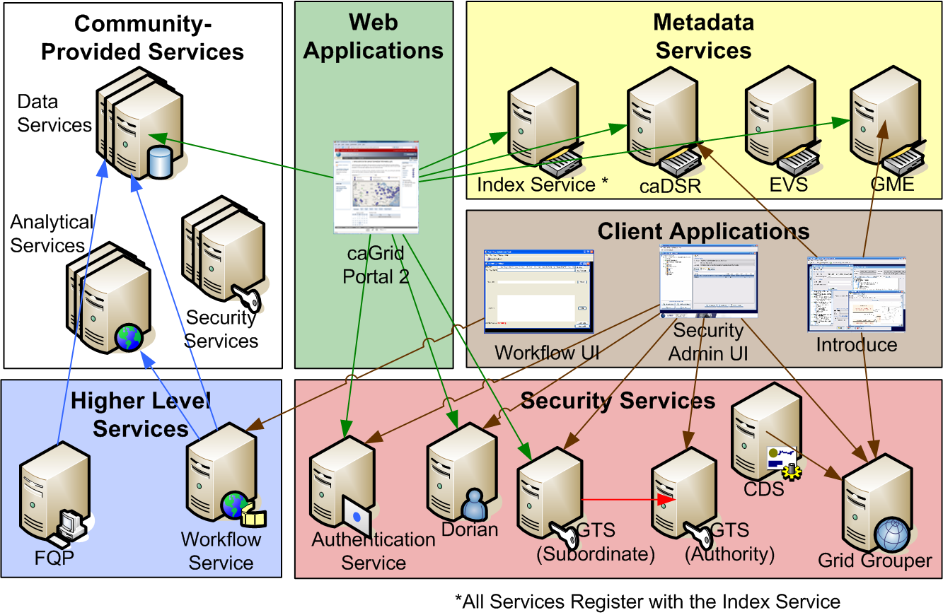

Additional Service Infrastructure

caXchange
The caXchange system is a configurable service and messaging hub for integrating services and exchanging clinical trial information between applications and systems. caXchange is currently NOT part of the core infrastructure but could potentially be integrated into core infrastructure especially to support clinical information management.

Service Authoring Tools

caBIG provides a substantial number of tools for developing services that can be deployed on the current infrastructure and support the static semantics of the current semantic infrastructure.

Below is initial list of the most common tools used by service developers.

caCORE Workbench

The Workbench, shown below integrates the existing suite of core infrastructure development tools including caAdapter, Semantic Integration Workbench (SIW), Software Development Kit (SDK), Common Security Module (CSM), User Provisioning Tool (UPT) and Common Logging Module (CLM) to provide an integrated development environment for developing caBIG® compatible services.

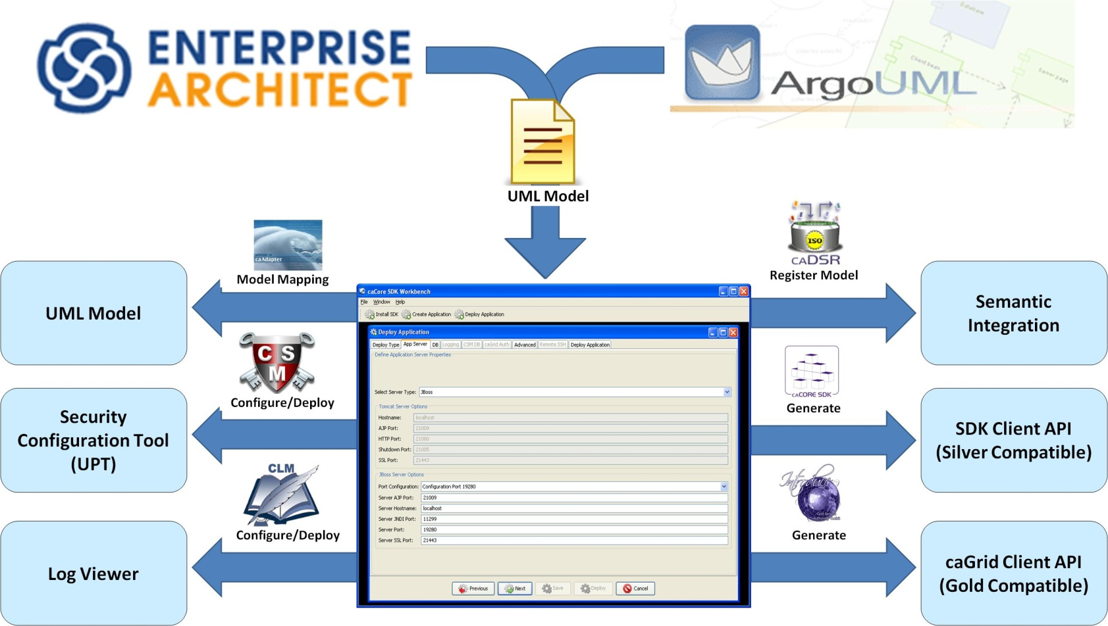

Software Development Kit (SDK)
The SDK is a set of tools designed to aid in the design and development of caBIG® compatible services. The SDK generated system is built on the principles of Model Driven Architecture (MDA), n-tier architecture and standard query API for data access.
Common Security Module (CSM)
CSM provides security services for authentication and authorization that can be reused easily by application services. There are various authentication models available that provide integration with institutional authentication facilities such as LDAP and Role Based Access Control (RBAC) service for data access. This helps eliminate the need for application teams to create their own security methodology.
Common Logging Module (CLM)
CLM is a set of services and tools that provides a flexible and comprehensive solution for auditing and logging. It can be easily integrated into services and customized to meet auditing needs for regulatory compliance.
User Provisioning Tool (UPT)
UPT provides web based user management tool that can be easily integrated into applications for user administration and access control. Along with CSM and CLM, it provides comprehensive security solution for services and applications.
caAdapter
caAdapter provides services to facilitate data mapping and transformation among different kinds of data sources including HL7 v2 messages, HL7 v3 messages, and CDISC SDTM (Study Data Tabulation Model) datasets. caAdapter supports and facilitates standard-based data exchange.
Introduce Toolkit
Introduce Toolkit provides a simple, yet powerful graphical user interface (GUI) to develop data and analytical services that can interoperate on the caGrid infrastructure. Introduce integrates with the current semantic infrastructure and enables rapid development of secure semantic services.

Initiatives

The caBIG technology infrastructure and its operational model will be extended to provide integrated support for:

- Use of behavioral semantics for service advertisement, discovery and choreography.
- Tools for developing services that make use of the distributed federated metadata repositories and are compliant with CBIIT Enterprise Architecture and approved standards such as ISO 21090.
- Enterprise security requirements including support for attribute based access control (ABAC) and policy guidelines.
- Use of W3C service oriented architecture resources.
- Assessment of Cloud environment for providing scalable service hosting facilities

Each initiative will include initial evaluation of existing tooling and will leverage existing tooling to the greatest extent consistent with cost effectiveness and engineering considerations. Requirements collected from the semantic infrastructure initiatives, NCI Enterprise Security Program and subsequent projects leveraging the infrastructures such as caEHR, will be the basis for the actual work products stemming from this Concept of Operations.

Initiative 1: This initiative is a complementary effort to the initiative 3 in the Semantics Infrastructure Concept of Operations (called as “Semantic ConOps”) which deals with the creation of new behavioral semantics components for managing rules and policies surrounding service contracts. The focus of this initiative will be to surface the information to the users in runtime environment, and provide them capability to use the information in a meaningful manner. Therefore, this initiative will include:

- Develop and deploy production quality registry that provides runtime access to behavioral semantics components
- Develop support for creating semantically aware workflow services based on behavioral semantics and metadata, that can reason over both data and service components
- Provide technology support in the caGrid infrastructure for execution of rules and policies, including transaction support and complex data types

It is clearly evident from the BIG Health Enterprise Architecture Specification and the initiatives in the “Semantics ConOps”, that NCI CBIIT leadership has concluded that both static and behavioral semantics are key for reaching the goals of translational research. One of the key consequences of that decision is for CBIIIT to provide research community with enterprise services and tools that surface the wealth of semantics information in a useable manner.

The current registry and metadata services support primarily static semantics. This will require to be upgraded (new or enhanced) to support behavioral semantics.

Additionally, some of the higher level services such as Grid Transfer Service will need to be enhanced in the context of supporting richer semantics in a scalable manner. One of the exploratory tasks in the initiative is to identify the feasibility of delivering service components at the location where the data is stored instead of transferring data over the network.

Scientific workflows are one of the most powerful benefits of the federated infrastructure. The support for workflows in the current infrastructure, thru Taverna Workbench and BPEL based service orchestration is clearly inadequate for leveraging the updated behavioral semantics information. One of the areas for exploration, as part of this initiative, will be to develop or enhance workflow infrastructure that can assist users in creating computational experiments about the data and services using the underlying rich semantics infrastructure.

One of the key shortcomings already identified in the current infrastructure, is the lack of support for transactions. This is a requirement especially in the clinical arena, and is typically supported thru integration with Enterprise Service Bus (ESB). One of the areas of enhancement for the infrastructure will be to develop native support for ESB and other common mechanisms of connectivity, including simple web services (WS-I) and (Representational State Transfer) RESTful services that are favored by life science research community. This will ease interoperability with other federated infrastructures in the health care field.

Initiative 2: This initiative will focus on improving the tools for service development for caGrid and other BIG HEAS compliant infrastructure. This initiative is complementary to initiative 1 in the “Semantic ConOps” document, which deals with the architecture of distributed, federated metadata repositories.

Specifically, the initiative will include:

- Evaluation of existing tools for their ability to support service development in BIG HEAS
- Tool(s) for developing services targeted for caGrid, that are able to leverage the distributed, federated metadata repository architecture in both service development and generation of service metadata
- Tool(s) for developing services using CBIIT approved ISO 21090 standard data types and compliant with BIG HEAS framework
- Tool(s) for developing services that support rules and policies of service contracts
- Tool(s) for supporting service development on other platforms, including .NET
- Tool(s) for supporting service development under Model Driven Architecture (MDA) using additional model formats including OWL, RDF
As discussed in the previous section, CBIIT has a mature set of tools that support the requirements of static semantics and standard data access (via query capabilities) pretty well.
Additionally, some of the tools, such as Introduce Toolkit, support both the standard data query services and also in the creation of analytical services. These tools will be evaluated for their ability to support “contract designs” envisioned by the Semantics ConOps. Other open source tools, such as Eclipse (which is integrated with Introduce Toolkit) may also be candidates for supporting service development, especially if there is existing support for standards such as ISO 21090.

Initiative 3: This initiative will focus on supporting the needs of the Enterprise Security Program (ESP) as provided by the NCI Enterprise Security Program Concept of Operations. The primary focus of the initiative is to ensure that the security technology components and tools provide by the core infrastructure meet the policy requirements of the program. The initiative will include:

- Evaluation and enhancement of the current security infrastructure components, including GAARDS, Common Security Module and Common Logging Module for policy compliance and enterprise architecture
- Tighter integration of the security components used by services and applications deployed in federated manner.
- Provide interoperability with external security trust fabrics, such as ONIX, CVRG, NHIN, CTSA and BIRN
The security infrastructure components are expected to comply with the specific security policies articulated in the “Security Policy” tasks of the ESP. This includes the implementation of the policies, articulated in the following documents:

- NCI Enterprise Security Policy
- caBIG Security Policy Statement for caGrid (the “Thin Book”)
- caBIG Security Policy for caGrid Handbook and Toolkit (the “Thick Book”)

Additionally, the initiative will support developing security operations tasks including C&A, contingency planning, auditing and business continuity plans.

The initiative will also support the overall adoption of the security infrastructure by the community by technical engagement with application teams in other parts of the organization and joining the “outreach” initiative of the ESP.

Initiative 4: This initiative is complementary to the initiative 4 in the “Semantics ConOps” and will focus on developing end user accessible tooling in support of the work carried out in the field of semantic web technologies on caGrid. The initiative will include:

- Development of services and end user tools to support the ontologically aware query capabilities on caGrid, dynamically leveraging ontologies stored in the semantic infrastructure
- Collaboration with NCRI, W3C and other groups that are developing Grid to Grid semantic interoperation using semantic web standards.
Initiative 5: This initiative will focus on introduction of Cloud Computing environment to the CBIIT operations. The focus will be execution of several tasks identified by initial assessment of the Cloud Computation platform. Specifically:

- Assessment of Cloud environment as a Software As a Service (SAAS), Platform As a Service (PaaS) and Infrastructure As a Service (IaaS) model
- Exploration of Clouds as a sandbox environment for deploying enterprise services and applications in a secure, reliable manner
- Exploration of incorporating automatic cloud deployment into service generation tools supported by the technology infrastructure
While this initiative is exploratory in nature, it could potentially become a critical need for CBIIT, especially for delivering new and enhanced work products (services, applications, etc) in a timely manner.
The current CBIIT systems resources (hardware and staff) are stretched to the limit trying to keep up with the current operations. It is possible that the system resources may get overwhelmed in the next 12-15 months, due to potential increase in work products in the core infrastructure, Clinical and Life Science. And, this may result in lack of timely delivery and operations of critical products, infrastructure components etc. Cloud Computation environment could provide an alternative and cost-effective deployment model that may mitigate the situation for both CBIIT and caBIG community.
Additionally, the new semantics infrastructure is being designed for use in a federated manner. Ability to deploy the infrastructure on “Clouds” may provide a lower barrier of entry to caBIG community, especially the cancer centers, which may not have the IT resources to operate the infrastructure.
This initiative will develop standard usage models, reusable components and support infrastructure for use of cloud computing resources that could be leveraged by CBIIT core and application services/applications.
The technology infrastructure team is aware that CBIIT is considering leveraging clouds for large data storage and hosting of services/applications. The effort is led by the CBIIT Systems Group. This initiative will support the CBIIT Systems Group in the effort as needed.

Stakeholders

The caBIG® Technology Infrastructure will operate within a broad stakeholder community consisting of representatives of all of the professions and services involved in biomedical research and clinical care, as well as information engineering.

The primary stakeholders of the caBIG® Technology Infrastructure include caBIG® and BIG Health, federal and international development partners, developers and users of the infrastructure and the software tools. The Semantic Infrastructure Group and the Enterprise Security Team are also critical stakeholders in the activity of the technology infrastructure group.

The primary users of the infrastructure and tools are those who use the capabilities to build software, design services and electronic application systems of their domains. Other users may integrate the core technology software components or services with their own internal application systems, or may be end users of the services or application systems supported by caBIG.

Primary User
- Software and application designers and architects
- Software and application engineers and developers

Broader Users – those who benefit from the services or application systems enabled by the infrastructure and software tools, include:

- The caBIG® community
- Vendors
- Patients
- Clinicians
- Medical research study participants
- Scientific and medical researchers
- Insurance and payer communities
- Health care community
- Information technology communities
- Health care and biomedical research industry
- Government and regulatory bodies

Alternatives/Constraints/Contracting Approach

General Approach:
The general approach to be taken by the caBIG® Technology Infrastructure is as follows:

- Evaluate results of the current infrastructure projects with emphasis on addressing shortcomings, reducing the barriers to adoption, adaptation and deployment of the infrastructure technology and software tools
- Align priorities, scope, schedule with caBIG® enterprise projects and prioritize via C-Team guidance
- Engage Clinical and Life Science Governance Groups regarding infrastructure needs and project priorities
- Identify existing projects to be continued and new projects to be started in the coming year
- Engage with standards development organizations to influence and use critical existing and emerging health informatics, technologies and services standards

Contracting Approach

- Project resources: Project resources are projected to derive from the base annual (FY09) CBIIT budget for enterprise core infrastructure, and from ARRA funds associated with expansion of the cancer research program, the electronic medical record and national health information network. In most cases, appropriated funds will be expended to support operations and maintenance and evolution of existing products and services. Existing vendor contracts will generally be renewed and extended to leverage the accumulated expertise in existing teams and avoid project disruption. However, if necessary, such resources can also be acquired using conventional contracting mechanisms available to the NCI and governed by the FAR. This may include some open bid contracts as well as some sole source contracts.

Risks:
- Poor Adoption Risks: The caBIG implementation of the infrastructure would achieve highest success if adoption increases over time. This includes other networks as well as using the implementations developed by core technology team, including caGrid infrastructure, service development tools and security components. Use of BIG HEA to produce implementation should help reduce the risk for 3rd party adoption/interoperation. Also gathering and responding to user needs during all phases of the ECCF process should help to assure that the infrastructure are suited to community needs.
- ARRA Driven Risks: The emphasis on EHR adoption and use and related national initiatives such as NHIH, has increased the breadth of support the caBIG® Technology infrastructure must address. Related changes such as introduction of BIG HEA, SAEAF and ECCF offer adaptive advantages in the context of increased scope. However, the combination of evolving organizational practices and greatly expanded scope increases both technical and management risk. The best mitigation for this risk is to pursue development initiatives in an iterative fashion and continually assess the progress and programmatic value of ongoing initiatives so that the initiatives can be adjusted. The Technology Infrastructure Group will rely heavily on the Semantic Infrastructure Group, Enterprise Security Team, C-Team/ECAT and other caBIG Governance Groups in pursuing this risk management strategy.
- Coordination Risks: Even while the Infrastructure Team is pursuing its initiatives, the domain workspaces will be creating solutions that will be expected to interoperate/integrate/conform with the infrastructure technologies. Absent an existing formal mechanism for coordination, management of this risk requires that infrastructure team managers become involved in the Domain Governance Groups as well as the Composite Architecture Teams, and that they establish clear and continual exchange of information about the relationships of initiatives and effects of decisions. Prompt access to the C-Team for mediation and decisions about priorities and direction will also be needed.

