Workflow management service for caGrid 1.0 Beta

Introduction: The Workflow Management service (WMS ) is a caGrid 1.0 compliant GT4 service built using introduce. The primary objective of this service is to deploy and run workflows written in WS-BPEL (TODO: add reference). Workflows in this context are defined as interactions between caGrid 1.0 compliant services.

Technologies: ActiveBPEL 2.0.1, Jakarta Tomcat 5.0.30, Java 1.4.2, Ant 1.6.2, GT4.0.1 Core, Introduce.

Implementation:

Interface: The service has a single method, runWorkFlow. A call to this method takes a BPEL workflow description as input and returns the results of the workflow as output.

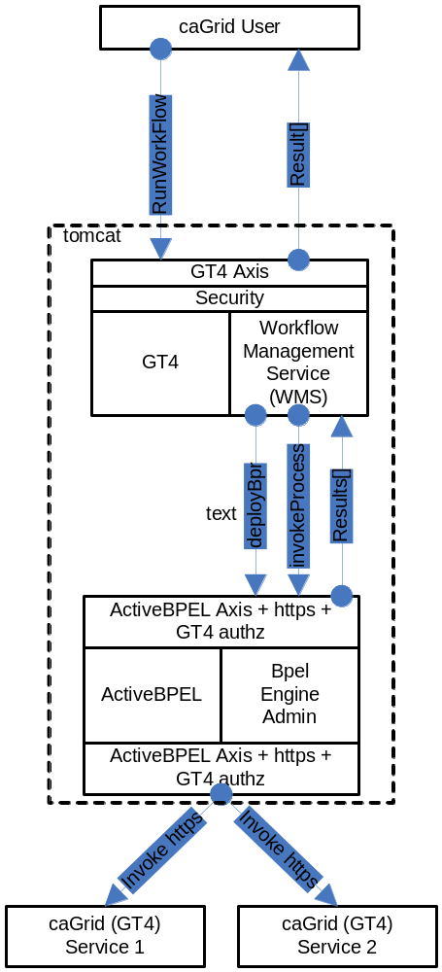Public WMSOutputType runWorkFlow(WMSInputType input)

In the initial implementation, the client is expected to wait until the results are returned.

Behavior: The following actions are performed when a user invokes runWorkFlow on the workflow management service
- The input BPEL document is parsed and an exception is thrown if it is not well-formed (with respect to schema compliance).
- The input arguments to the workflow are declared as an array of xsd:any. They are parsed and cast to the types that they are meant to be.
- The service implementation invokes PDDGenerator to generate the deployment descriptor for the workflow.
- The service implementation invokes BPRGenerator to generate the BPelArchive (called bpr hereafter) that is ready to be deployed.
- The workflow management service is bootstrapped with the location of ActiveBPEL admin service location.
- The service implementation invokes deployBpr operation on the admin service, which is a vanilla Axis-based Web Service, to deploy the workflow created.
- The admin service responds with deployment summary reporting success if the workflow is deployed successfully.
- Once the workflow is deployed successfully, it is deployed as a web service inside ActiveBPEL.
- To start the workflow, a message is sent to the receiving partnerLink in the workflow.
- After the workflow successfully executes the results are returned to the client app/user.

Security: The workflow management service requires user credentials in order to access other services during workflow execution. Thus, users must use the GT4 Delegation service interface to delegate credentials prior to invoking the workflow management service. The workflow management service retrieves these credentials from the Delegation service and sends them to the ActiveBPEL container, so that they can be passed with all service invocations performed by the workflow engine on the user’s behalf.

Future Work:
- Support for dynamic enpoints (activebpel supports this already but i will make sure it works within cagrid) .
- Support for WS-Security specs which involve WS-SecureConv WS-Secure Message.
- Support for different GT Authorization methods.

