caGrid 1.1
Programmer’s Guide






Center for Bioinformatics

Credits and Resources

caGrid Development and Management Teams
Development | Support (Systems, QA, Documentation) | Management
Scott Oster (Lead Architect)¹ | Aynur Abdurazik⁹ | Avinash Shanbhag (Product Manager)⁹
Stephen Langella¹ | Ye Wu⁹ | Michael Keller⁸
Shannon Hastings¹ | Todd Cox⁹ | Arumani Manisundaram⁸
David Ervin¹ | Wendy Erickson-Hirons⁷
Tahsin Kurc¹ | Chet Bochan¹¹
Joel Saltz¹ | Vanessa Caldwell¹¹
Ravi Madduri² | Craig Fee¹¹
Ian Foster² | Alan Klink¹¹
Patrick McConnell³ | Gavin Brennan¹¹
Joshua Phillips⁵
Vijay Parmar¹⁰
¹Ohio State University - Biomedical Informatics Department | ²University of Chicago/Argonne National Laboratory | ³Duke Comprehensive Cancer Center
⁴ScenPro, Inc. | ⁵SemanticBits, LLC. | ⁶Science Application International Corporation (SAIC)
⁷Northern Taiga Ventures, Inc. (NTVI) | ⁸Booz Allen Hamilton | ⁹NCI - Center for Biomedical Informatics and Information Technology (CBIIT)
¹⁰Ekagra Software Technologies, Ltd. | ¹¹Terrapin Systems LLC (TerpSys)

Other Acknowledgements
GeneConnect – Project - Washington University
GridIMAGE – Project - Ohio State University
caBIO – Project - National Cancer Institute Center for Bioinformatics (NCICB)
caArray – Project - National Cancer Institute Center for Bioinformatics (NCICB)
caTRIP – Project – Duke Comprehensive Cancer Center
GenePattern – Project – Broad Institute
geWorkbench – Columbia University
caBiocondutor – Project – Fred Hutchinson Cancer Research Center

Contacts and Support
NCICB Application Support | http://ncicbsupport.nci.nih.gov/sw/  Telephone: 301-451-4384  Toll free: 888-478-4423

LISTSERV Facilities Pertinent to caGrid
LISTSERV | URL | Name
cagrid_users-l@list.nih.gov | https://list.nih.gov/archives/cagrid_users-l.html | caGrid Users Discussion Forum

Table of Contents
Chapter 1 About This Guide 1
Purpose 1
Release Schedule 1
Audience 1
Getting Help 1
How to Use This Guide 1
Relevant Documents 2
Document Text Conventions 2
Chapter 2 Overview of caGrid 5
Introduction 5
Standards Compliant 6
Model Driven 6
Semantically Discoverable 8
Secure and Manageable 10
Revolutionary Development 12
Chapter 3 caGrid Release Structure 15
Overview 15
caGrid Projects 15
Multiple Grid Support 22
Chapter 4 caGrid Metadata Infrastructure 25
Code Example Information 25
Metadata API Usage Overview 25
Discovery API Usage Overview 34
caDSR Grid Service Usage Overview 55
EVS API Usage Overview 67
Chapter 5 caGrid Security 75
Dorian Overview 75
Grid Grouper Overview 79
Chapter 6 caGrid Data Services 87
Overview 87
Utility Classes 91
Validation Tools 93
CQL Query Processors 95
Service Styles Architecture 97
Federated Query Processor Usage Overview 98
API Details 102
Chapter 7 WS-Enumeration 113
Overview 113
Client API 113
Chapter 8 Workflow Management Service 125
Overview 125
Workflow Architecture 125
WorkflowFactoryService API 127
WorkflowServiceImpl API 129
Security in WorkflowFactory and Context Services 132
Service Selection 133
Provenance Tracking 133
WS-RF Resources in Workflows 133
Chapter 9 caGrid Global Model Exchange 141
Overview 141
GME Client 145
Appendix A References 147
Scientific Publications 147
Technical Manuals/Articles 150
caBIG Material 151
caCORE Material 151
Glossary………………………………………………………………………………………………… 153
Index……………………………………………………………………………………………………….157

About This Guide

Purpose
The cancer Biomedical Informatics Grid, or caBIG™, is a voluntary virtual informatics infrastructure that connects data, research tools, scientists, and organizations to leverage their combined strengths and expertise in an open environment with common standards and shared tools. The current grid architecture of caBIG™ is dubbed caGrid. The software embodiment and corresponding documentation of this architecture constitute the caGrid release. This guide describes the APIs provided by caGrid.

Release Schedule
This guide has been updated for the caGrid 1.1 release. It may be updated between releases if errors or omissions are found. The current document refers to the 1.1 version of caGrid, released in September 2007 by caBIG.

Audience
The primary audience of this guide is the programmer who wants to learn about the APIs provided by caGrid and/or requires access to one or more caGrid APIs. For additional information about using caGrid, see the caGrid User’s Guide.
This guide assumes that you are familiar with the java programming language and/or other programming languages, database concepts, and the Internet. If you intend to use caGrid resources in software applications, it assumes that you have experience with building and using complex data systems.

Getting Help
NCICB Application Support
http://ncicbsupport.nci.nih.gov/sw/
Telephone: 301-451-4384
Toll free: 888-478-4423

How to Use This Guide
This guide is divided into sections that each describes a different caGrid API. The following list briefly describes the contents of each chapter.
- Chapter 1, this chapter, provides an overview of the guide.
- Chapter 2 provides an overview of the cancer Biomedical Informatics Grid, or caBIG™, a voluntary virtual informatics infrastructure that connects data, research tools, scientists, and organizations to leverage their combined strengths and expertise in an open federated environment with widely accepted standards and shared tools.
- Chapter 3 describes the basic layout of the caGrid release.
- Chapter 4 describes the caGrid metadata infrastructure and describes the Discovery API, caDSR Grid Service, and EVS APIs.
- Chapter 5 describes using Dorian and Grid Grouper as part of caGrid security.
- Chapter 6 describes the caGrid Data Services infrastructure.
- Chapter 7 describes the client-side APIs for enumerations.
- Chapter 8 describes the architecture and APIs for interacting with caGrid workflow.
- Chapter 9 describes the caGrid Global Model Exchange (GME).

Relevant Documents
This Programmer’s Guide addresses caGrid Application Programming Interfaces (API) and API examples. Additional information about caGrid architecture, design, user-oriented overview and examples, and tool-specific guides can be found in:
Document | Location
caGrid 1.1 User’s Guide | http://gforge.nci.nih.gov/frs/?group_id=25
caGrid 1.1 Design Documents and Tool-specific Guides | http://gforge.nci.nih.gov/docman/index.php?group_id=25&selected_doc_group_id=1870&language_id=1

Document Text Conventions
The following table shows how text conventions are represented in this guide. The various typefaces differentiate between regular text and menu commands, keyboard keys, and text that you type.
Convention | Description | Example
Bold & Capitalized Command  Capitalized command > Capitalized command | Indicates a Menu command  Indicates Sequential Menu commands | Admin > Refresh
text in small caps | Keyboard key that you press | Press enter
text in small caps + text in small caps | Keyboard keys that you press simultaneously | Press shift + ctrl and then release both.
Special typestyle | Used for filenames, directory names, commands, file listings, source code examples and anything that would appear in a Java program, such as methods, variables, and classes. | URL_definition ::= url_string
Boldface type | Options that you select in dialog boxes or drop-down menus. Buttons or icons that you click. | In the Open dialog box, select the file and click the Open button.
Italics | Used to reference text that you type. | Enter antrun.
Note: | Highlights a concept of particular interest | Note: This concept is used throughout the installation manual.
Hyperlink | Links text to another part of the document or to a URL | Overview
Table 1-1 Document Conventions

Overview of caGrid
This chapter provides an overview of the cancer Biomedical Informatics Grid, or caBIG™, a voluntary virtual informatics infrastructure that connects data, research tools, scientists, and organizations to leverage their combined strengths and expertise in an open federated environment with widely accepted standards and shared tools.
Topics in this chapter include:
- Introduction on this page
- Standards Compliant on page 6
- Model Driven on page 6
- Semantically Discoverable on page 8
- Secure and Manageable on page 10
- Revolutionary Development on page 12

Introduction
The cancer Biomedical Informatics Grid, or caBIG™, is a voluntary virtual informatics infrastructure that connects data, research tools, scientists, and organizations to leverage their combined strengths and expertise in an open federated environment with widely accepted standards and shared tools. The underlying service oriented infrastructure that supports caBIG™ is referred to as caGrid. Driven primarily by scientific use cases from the cancer research community, caGrid provides the core enabling infrastructure necessary to compose the Grid of caBIG™. It provides the technology that enables collaborating institutions to share information and analytical resources efficiently and securely, and allows investigators to easily contribute to and leverage the resources of a national-scale, multi-institutional environment.
The caGrid 0.5 "test bed" infrastructure was released in September 2005 and included the initial set of software tools to effectively realize the goals of caBIG™. The grid technologies and methodologies adopted for caBIG™, and implemented in caGrid, provide a loosely coupled environment wherein local providers are given freedom to implement choices and have ultimate control over access and management. Local providers must also harmonize on community-accepted virtualizations of the data they use, and make them available using standardized service interfaces and communication mechanisms. caGrid enables numerous complex usage scenarios but its base goals are to: enable universal mechanisms for providing interoperable programmatic access to data and analytics to caBIG™, create a self-described infrastructure wherein the structure and semantics of data can be programmatically determined, and provide a powerful means by which resources available in caBIG™ can be programmatically discovered and leveraged. Additional information about the caGrid 0.5 effort, and a good overview of the motivation of the grid approach of caBIG™, can be found in the Bioinformatics Journal article (http://bioinformatics.oxfordjournals.org/cgi/content/full/22/15/1910).
Building on the foundation of caGrid 0.5, caGrid 1.0 was extensively enhanced based on the feedback and input from the early adopters of the caGrid 0.5 infrastructure and additional requirements from the various caBIG™ Domain Workspaces. The release of caGrid version 1.0 represented a major milestone in the caBIG™ program towards achieving the program goals. It provided the implementation of the required core services, toolkits and wizards for the development and deployment of community provided services, APIs for building client applications, and some reference implementations of applications and services available in the production grid. The caGrid 1.1 release represents a minor, backwards compatible release of caGrid, with a focus on increased usability, bug fixes, and various feature enhancements. A detailed listing of the changes from caGrid 1.0 can be found in the release notes and on the project website.

Standards Compliant
A primary principle of caBIG™ is open standards. Thus, caGrid is built upon the relevant community-driven standards of the World Wide Web Consortium (W3C http://www.w3.org/) and OASIS (http://www.oasis-open.org). It is also informed by the efforts underway in the Open Grid Forum (OGF http://ogf.org/), which is a community of users, developers, and vendors leading the global standardization effort for grid computing. The OGF community consists of thousands of individuals in industry and research, representing over 400 organizations in more than 50 countries. As such, while the caGrid infrastructure is built upon the 4.0 version of the Globus Toolkit (GT4 http://globus.org/toolkit/), it shares a Globus goal to be programming language and toolkit independent by leveraging existing standards. Specifically, caGrid services are standard WSRF v1.2 services and can be accessed by any specification-compliant client.
caGrid 1.0 also represented an increased involvement in relevant working groups, standards bodies, and organizations involved in the standardization and adoption of grid technologies. The caGrid team consists of several members involved in both the development of the Globus toolkit, and authors on some of the relevant specifications. Furthermore, some of the components developed by caGrid have been published in peer-reviewed articles, have been recognized by the grid community in several invited talks, and are undergoing an incubation process to become part of the Globus toolkit itself.

Model Driven
Extending beyond the basic grid infrastructure, caBIG™ specializes these technologies to better support the needs of the cancer research community. A primary distinction between basic grid infrastructure and the requirements identified in caBIG and implemented in caGrid is the attention given to data modeling and semantics. caBIG™ adopts a model-driven architecture best practice and requires that all data types used on the grid are formally described, curated, and semantically harmonized. These efforts result in the identification of common data elements, controlled vocabularies, and object-based abstractions for all cancer research domains. caGrid leverages existing NCI data modeling infrastructure to manage, curate, and employ these data models. Data types are defined in caCORE UML and converted into ISO/IEC 11179 Administered Components, which are in turn registered in the Cancer Data Standards Repository (caDSR). The definitions draw from vocabulary registered in the Enterprise Vocabulary Services (EVS), and their relationships are thus semantically described. caGrid 1.0 represented a significant improvement in its leveraging of these technologies and the corresponding information they make available. caGrid 1.0 added support for grid service access to both the EVS and caDSR, and its new service metadata standards include significant additions of information extracted from the caDSR and EVS.
In caGrid, both the client and service APIs are object oriented, and operate over well-defined and curated data types. Clients and services communicate through the grid using respectively grid clients and grid service infrastructure. The grid communication protocol is XML, and thus the client and service APIs must transform the transferred objects to and from XML. This XML serialization of caGrid objects is restricted in that each object that travels on the grid must do so as XML which adheres to an XML schema registered in the Global Model Exchange (GME). As the caDSR and EVS define the properties, relationships, and semantics of caBIG™ data types, the GME defines the syntax of their XML materialization. Furthermore, caGrid services are defined by the Web Service Description Language (WSDL). The WSDL describes the various operations the service provides to the grid. The inputs and outputs of the operations, among other things, in WSDL are defined by XML schemas. As caBIG™ requires that the inputs and outputs of service operations use only registered objects, these input and output data types are defined by the XSDs which are registered in GME. In this way, the XSDs are used both to describe the contract of the service and to validate the XML serialization of the objects which it uses. Figure 2-1 details the various services and artifacts related to the description of and process for the transfer of data objects between client and service.
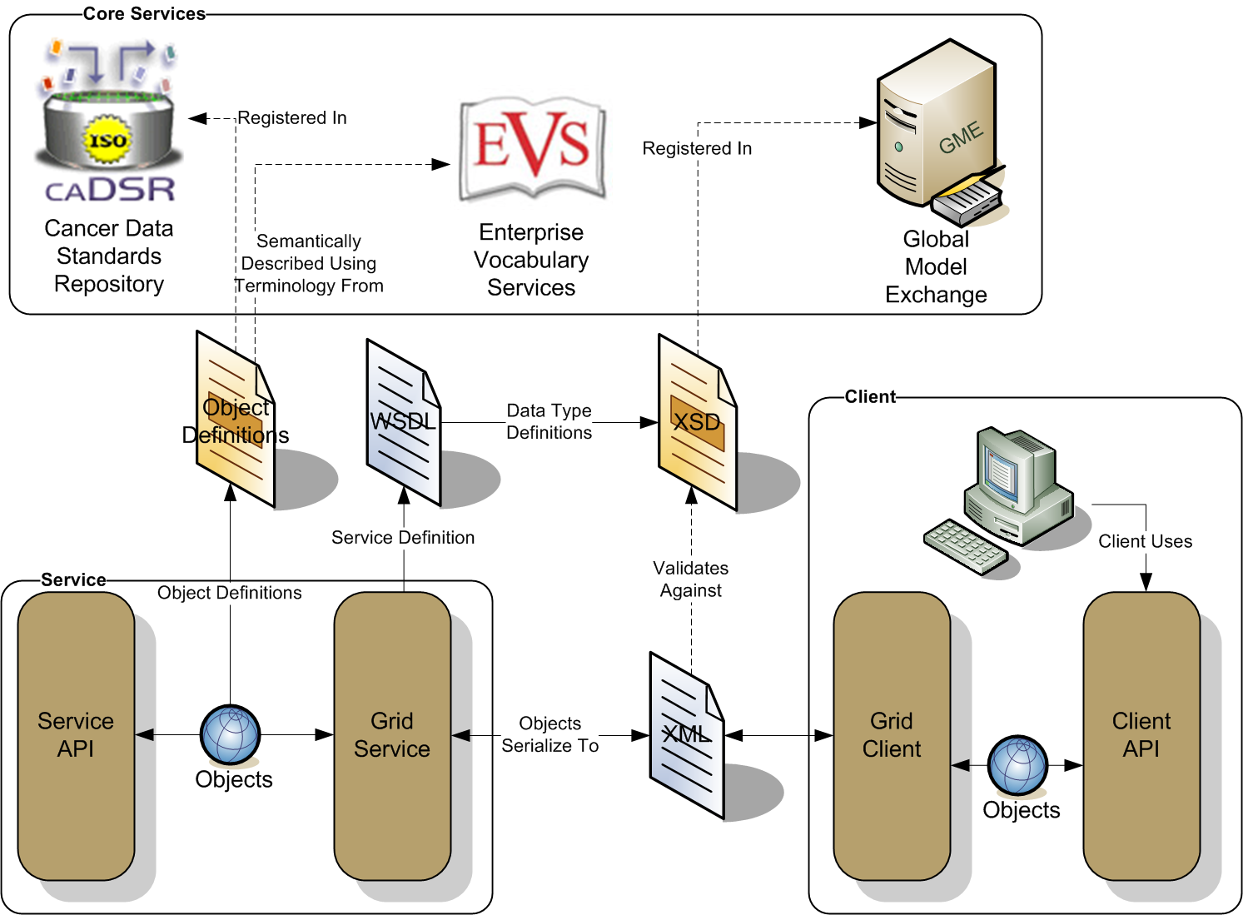
Figure 2-1 caGrid Data Description Infrastructure

Semantically Discoverable
As caBIG™ aims to connect data and tools from more than 50 disparate cancer centers and many other institutions, a critical requirement of its infrastructure is that it supports the ability of researchers to discover these resources. caGrid enables this ability by taking advantage of the rich structural and semantic descriptions of data models and services that are available. Each service is required to describe itself using caGrid standard service metadata. When a grid service is connected to the caBIG™ grid, it registers its availability and service metadata with a central indexing registry service (Index Service). This service can be thought of as the “yellow pages” and “white pages” of caBIG™. A researcher can then discover services of interest by looking them up in this registry. caGrid provides a series of high-level APIs and user applications for performing this lookup which greatly facilitate the discovery process.
As the Index Service contains the service metadata of all the currently advertised and available services in caBIG™, the expressivity of service discovery scenarios is limited only by the expressivity of the service metadata. For this reason, caGrid provides standards for service metadata to which all services must adhere. At the base is the common Service Metadata standard that every service in caBIG™ is required to provide. This metadata contains information about the service-providing cancer center, such as the point of contact and the institution’s name. Data Services, as a standardized type of caGrid services, also provide an additional Domain Model metadata standard. Both of these standards leverage the data models registered in caDSR and link them to the underlying semantic concepts registered in EVS. The Data Service Metadata details the domain model from which the Objects being exposed by the service are drawn. Additionally, the definitions of the Objects themselves are described in terms of their underlying concepts, attributes, attribute value domains, and associations to other Objects being exposed. Similarly, the common Service Metadata details the Objects, used as input and output of the services operations, using the same format as the Data Service metadata. In addition to detailing the Objects definitions, the Service Metadata defines and describes the operations or methods the service provides, and allows semantic concepts to be applied to them. In this way, all services fully define the domain objects they expose by referencing the data model registered in caDSR, and identify their underlying semantic concepts by referencing the information in EVS. The caGrid metadata infrastructure and supporting APIs and toolkits are defined with extensibility in mind, encouraging the development of additional domain or application specific extensions to the advertisement and discovery process.
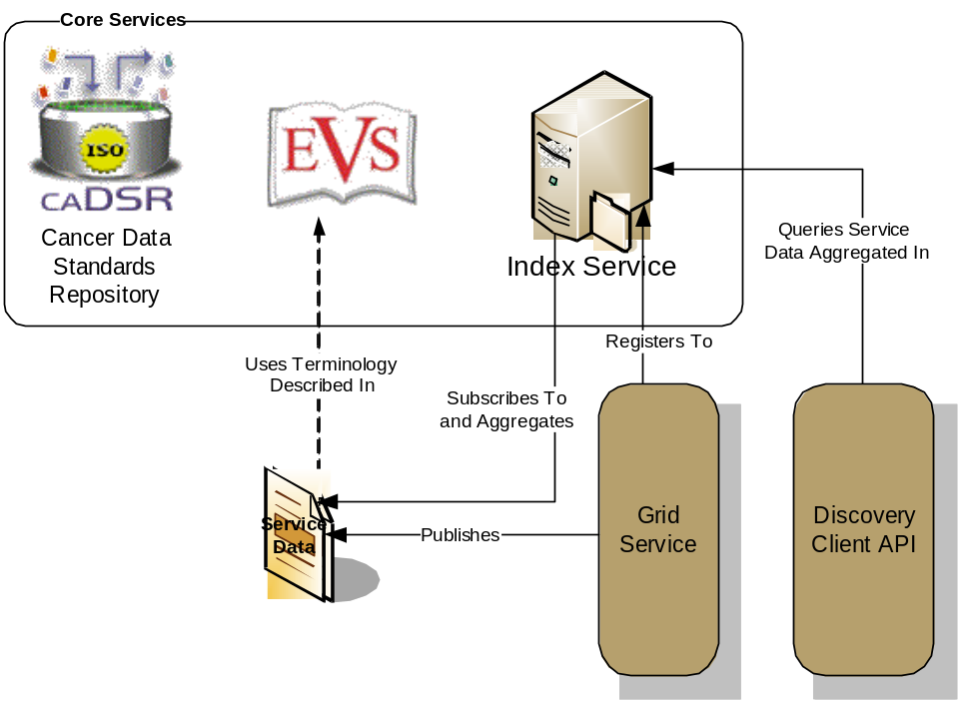
Figure 2-2 caGrid Discovery Overview
As shown in Figure 2-2, the caGrid discovery API and tools allow researchers to query the Index Service for services satisfying a query over the service metadata. That is, researchers can look up services in the registry using any of the information used to describe the services. For instance, all services from a given cancer center can be located, data services exposing a certain domain model or objects based on a given semantic concept can be discovered, as can analytical services that provide operations that take a given concept as input.

Secure and Manageable
Security is an especially important component of caBIG™ both for protecting intellectual property and ensuring protection and privacy of patient related and sensitive information. caGrid 1.0 provided a complete overhaul of federated security infrastructure to satisfy caBIG™ security needs, incorporating many of the recommendations made in the caBIG™ Security White Paper, culminating in the creation of the Grid Authentication and Authorization with Reliably Distributed Services (GAARDS) infrastructure. GAARDS provides services and tools for the administration and enforcement of security policy in an enterprise Grid. caGrid 1.1 represents a major thrust to deploy GAARDS to the cancer research community, in that its release is timed and informed by the first set of policies and procedures created by the caBIG™ Security Working Group. The Security Working Group is a collaborative effort of the caBIG™ Architecture and Data Sharing and Intellectual Capital (DSIC) Workspaces that is intended to create and implement security policies to enable data sharing across the caBIG Federation. The initial policies in place for caGrid 1.1 formalize the envisioned Levels of Assurance for credentials in the grid, and detail the policies and practices of a credential provider adhering to the initial Level of Assurance (LOA1) which will govern the baseline credentials all caBIG™ participants may use.
GAARDS was developed on top of the Globus Toolkit and extends the Grid Security Infrastructure (GSI) to provide enterprise services and administrative tools for:
- Grid user management
- Identity federation
- Trust management
- Group/VO management
- Access control policy management and enforcement
- Integration between existing security domains and the grid security domain
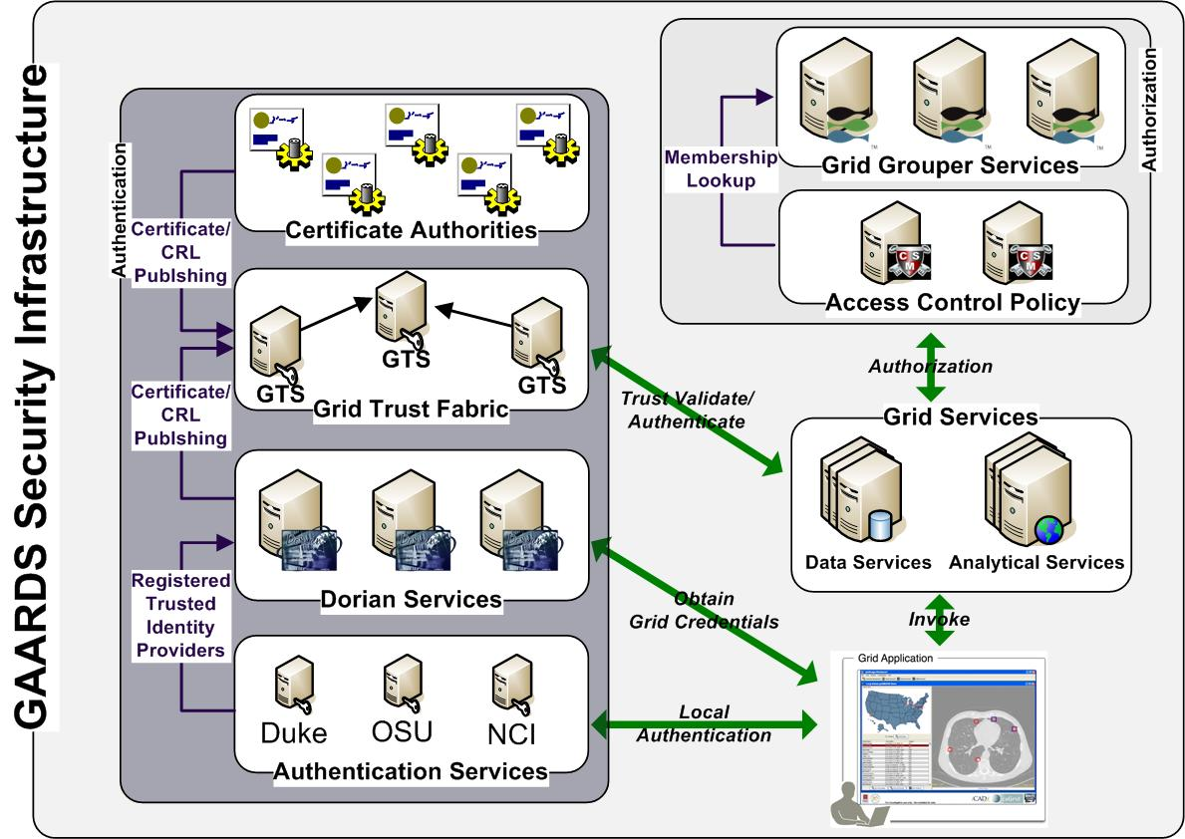
Figure 2-3 GAARDS Security Infrastructure
Figure 2-3 illustrates the GAARDS security infrastructure. In order for users/applications to communicate with secure services, they need grid credentials. Obtaining grid credentials requires a Grid User Account. Dorian provides two methods for registering for a grid user account: 1) registering directly with Dorian 2) having an existing user account in another trusted security domain. In order to use an existing user account to obtain grid credentials, the existing credential provider must be registered in Dorian as a Trusted Identity Provider. It is anticipated that the majority of grid user accounts will be provisioned based on existing accounts. The advantages to this approach are: 1) users can use their existing credentials to access the grid 2) administrators only need to manage a single account for a given user. To obtain grid credentials, Dorian requires proof (a digitally signed SAML assertion) that proves that the user locally authenticated. The GAARDS Authentication Service provides a framework for issuing SAML assertions for existing credential providers such that they may be used to obtain grid credentials from Dorian. The Authentication Service also provides a uniform authentication interface in on which applications can be built. Figure 2-3 illustrates the process for obtaining grid credentials, wherein the user/application first authenticates with their local credential provider via the Authentication Service and obtains a SAML assertion as proof they authenticated. They then use the SAML assertion provided by the Authentication Service to obtain grid credentials from Dorian. Assuming the local credential provider is registered with Dorian as a trusted identity provider and that the user’s account is in good standing, Dorian will issue grid credentials to the user. It should be noted that the use of the Authentication Service is not required; an alternative mechanism for obtaining the SAML assertion required by Dorian can be used. If a user is registered directly with Dorian and not through an existing credential provider, they may contact Dorian directly for obtaining grid credentials.
Once a user has obtained grid credentials from Dorian, they may invoke secure services. Upon receiving grid credentials from a user, a secure service authenticates the user to ensure that the user has presented valid grid credentials. Part of the grid authentication process is verifying that grid credentials presented were issued by a trusted grid credential provider (e.g. Dorian or other certificate authorities). The Grid Trust Service (GTS) maintains a federated trust fabric of all the trusted digital signers in the grid. Credential providers such as Dorian and grid certificate authorities are registered as trusted digital signers and regularly publish new information to the GTS. Grid services authenticate grid credentials against the trusted digital signers in a GTS (shown in Figure 2-3).
Once the user has been authenticated, a secure grid service next determines if a user is authorized to perform what they requested. Grid services have many different options available to them for performing authorization. It is important to note that all authorizing decisions are made by the local provider, but GAARDS provides some services and tools which facilitate some common authorization mechanisms. The GAARDS infrastructure provides two approaches which can each be used independently or can be used together. It is important to note any other authorization approach can be used in conjunction with the GAARDS authentication/trust infrastructure. The Grid Grouper service provides a group-based authorization solution for the Grid, wherein grid services and applications enforce authorization policy based on membership to groups defined and managed at the grid level. Grid services can use Grid Grouper directly to enforce their internal access control policies. Assuming the authorization policy is based on membership to groups provisioned by Grid Grouper; services can determine whether a caller is authorized by simply asking grid grouper whether the caller is in a given group. The caCORE Common Security Module (CSM), an existing component many providers are already using, is a more centralized approach to authorization. CSM is a tool for managing and enforcing access control policy centrally. CSM supports access control policies which can be based on membership to groups in Grid Grouper. Grid services that use CSM for authorization simply ask CSM if a user can perform a given action. Based on the access control policy maintained in CSM, CSM decides whether or not a user is authorized. In Figure 2-3, the grid services defer the authorization to CSM. CSM enforces its group-based access control policy by asking Grid Grouper whether the caller is a member of the groups specified in the policy, and enforces any other local data access policies defined in CSM.

Revolutionary Development
caGrid 1.0 represented a complete redevelopment of caGrid to better support the requirements and current standards. Building on lessons learned from caGrid 0.5 and feedback from the community, it provided a large number of additional features, services, and vast improvements in caGrid technologies beyond what is described above. One such example was the development of a unified grid service authoring toolkit, named Introduce. Introduce is an extensible framework and graphic workbench which provides an environment for the development and deployment of caBIG™ compatible grid enabled data and analytical services. The Introduce toolkit reduces the service developer’s responsibilities by abstracting away the need to manage the low level details of the WSRF specification and integration with the Globus Toolkit, allowing them to focus on implementing their business logic. Developers with existing caBIG™ Silver compatible services need only follow simple a wizard-like process for creating the “adapter” between the grid and their existing system. At the same time, extremely complex and powerful new services can be created. All caGrid developed core services were implemented with the Introduce toolkit. caGrid 1.1 adds the ability to migrate caGrid 1.0 Introduce services to caGrid 1.1 services, and provides the migration framework to handle all such future migrations.
Another significant feature added with caGrid 1.0 is the service support for orchestration of grid services using the industry standard Business Process Execution Language (BPEL). caGrid provides a workflow management service, enabling the execution and monitoring of BPEL-defined workflows in a secure grid environment. It is expected this work will provide the groundwork for a large number of powerful applications, enabling the harnessing of data and analytics made available as grid services. Another such higher-level support service made available in caGrid 1.0, is the federated query infrastructure. The caGrid Federated Query Infrastructure provides a mechanism to perform basic distributed aggregations and joins of queries over multiple data services. Working in collaboration with the Cancer Translational Research Informatics Platform (caTRIP) project, a caBIG™ funded project, an extension to the standard Data Service query language was developed to describe distributed query scenarios, as well as various enhancements to the Data Service query language itself. The Federated Query Infrastructure contains three main client-facing components: an API implementing the business logic of federated query support, a grid service providing remote access to that engine, and a grid service for managing status and results for queries that were invoked asynchronously using the query service.
Numerous improvements to the handling of large data sets and distributed information processing were also made. Support for the implantation of the WS-Enumeration (http://www.w3.org/Submission/WS-Enumeration/) standard has been implemented and added to the Globus Toolkit. This standard and its corresponding implementation provide the capability for a grid client to enumerate over results provided by a grid service (much like a grid-enabled cursor). This provides the framework necessary for clients to access large results from a service. This support has been integrated into the caGrid Data Service tooling providing a mechanism for iterating query results. Additionally, an effort to standardize a “bulk data transport” interface for large data was started in caGrid 1.0, and improved in caGrid 1.1, which is intended to provide a uniform mechanism by which clients may access data sets from arbitrary services. This initial work currently supports access via WS-Enumeration, WS-Transfer, and GridFTP. Additional enhancements and tooling are expected in a future release of caGrid, based on feedback from the user community.
Lastly, caGrid 1.0 represented a significant improvement in the quality of caGrid, as a considerable effort was placed on the development of unit, system, and integration testing. Several hundred unit tests are executed every time the caGrid code base is changed, and a variety of builds and tests are run each night. This effort was continued throughout the development and release of caGrid 1.1, and several hundred additional tests have been added. Interested users may view results of these tests on a centralized dashboard (http://quality.cagrid.org:8081/caGrid-1.0/Dashboard/), execute these test frameworks locally, or leverage the testing framework during the development of their own services.

caGrid Release Structure
This chapter describes the basic layout of the caGrid release.
Topics in this chapter include:
- Overview on this page
- caGrid Projects on this page
- Multiple Grid Support on page 22

Overview
caGrid is released as a source release, as well as with an automated installer. In order to use any feature of caGrid or to develop applications with it, you must build caGrid. The installer will do this automatically for you, but if you are using the source release, you must build it yourself. You can find detailed instructions on building caGrid on the cagrid.org wiki, but generally you just need to type the following command from the caGrid directory:
ant all
The caGrid release is oriented around a number of individual projects and the build process manages inter-project dependencies. Each project provides a specific set of functionality, and is self-contained once caGrid is built. That is, once caGrid is built, each of the projects can be used independently. For example, if you are only interested in Introduce, you can safely copy around caGrid/projects/introduce as a standalone copy of Introduce. The same is true for core services; once caGrid is built, all their dependencies are copied into the lib and ext/lib directories of the service.

caGrid Projects
The following is a list of the projects provided in the caGrid release and a brief description of each.
- advertisement
  - Description: This project contains the APIs needed for programmatically registering a service with the Index Service.
  - Type: Service APIs
  - Usage: These APIs are automatically integrated into Introduce-created services, and so are generally not needed by caGrid users, unless they are developing their own services without using Introduce.
- authentication-service
  - Description: This project contains the Authentication Service which provides a standardized service interface for exposing Dorian Identity Providers on the grid.
  - Type: Service
  - Usage: Anyone wishing to integrate an institutional user management system as a Dorian Identity Provider, can implement this service. Similarly, applications which provide log-in capabilities should use the client APIs provided by this service.
- authz
  - Description: This project contains the various authorization components caGrid provides for applying local authorization policy to services.
  - Type: Service APIs
  - Usage: Introduce provides integration with these components, but they can also be used standalone by service developers.
- bulkDataTransfer
  - Description: This project contains the Bulk Data Transfer service and Introduce Extension, which is intended as a common interface for returning large data to a client from a service.
  - Type: Introduce Extension
  - Usage: Introduce provides integration with this component for service developers, but clients can use its client APIs for interacting with services that support this interface.
- cabigextensions
  - Description: This project contains a variety of Introduce extensions which customize Introduce for caBIG needs. These extensions include the caGrid metadata, ws-Enumeration, metadata viewers, and XMI based XSD creation extensions.
  - Type: Introduce Extension
  - Usage: Introduce provides integration with these components and they generally are not needed by caGrid users.
- cadsr
  - Description: This project contains the caDSR Grid Service, which is detailed later in this document.
  - Type: Service
  - Usage: This project contains the client APIs, code examples, and client tooling for interacting with the caDSR Grid service, as well as the code and configuration necessary to deploy a local instance.
- core
  - Description: This project contains a common set of utilities and APIs used by many caGrid projects.
  - Type: APIs
  - Usage: Most caGrid users will find the utilities provided by the project to be of general use in developing applications and services with caGrid. Some examples in this document use some of these APIs, but a complete reference can be found in the javadoc.
- data
  - Description: This project contains the core data service infrastructure, tooling and utilities, as well as the definition and APIs for CQL.
  - Type: APIs/Service APIs
  - Usage: Most of the service code provided by this project is already added to data services which are created with Introduce, but the utilities it provides are of general use for custom data service implementations. Those developing applications which make use of data services or CQL will want to use the client APIs and utilities this project provides.
- dataExtensions
  - Description: This project contains the Introduce extensions which add support for the data service infrastructure to Introduce.
  - Type: Introduce Extension
  - Usage: Introduce provides integration with these components and they generally are not needed by caGrid users. However, those developing custom data service extensions may find this a useful starting point.
- discovery
  - Description: This project contains the APIs and code examples for discovering services from the Index Service. Examples are provided elsewhere in this document.
  - Type: APIs
  - Usage: Those developing applications which make use of discovery may use the client APIs provided by this project.
- dorian
  - Description: This project contains the Dorian Service which provides a user and credential management service. Dorian is described elsewhere in this document.
  - Type: Service
  - Usage: The client APIs and utilities provided by this project can be used to provide authentication capabilities to applications. It also provides an administrative GUI, but its functionality can also be used through the general security GUI. It also contains the code and configuration necessary to deploy a local instance of Dorian.
- evs
  - Description: This project contains the EVS Grid Service, which is detailed later in this document.
  - Type: Service
  - Usage: This project contains the client APIs, code examples, and client tooling for interacting with the EVS Grid service, as well as the code and configuration necessary to deploy a local instance.
- fqp
  - Description: This project contains the Federated Query Processor (FQP) Grid Service and engine, which are detailed later in this document.
  - Type: Service / APIs
  - Usage: This project contains the client APIs, code examples, and client tooling for interacting with the FQP Grid service, the code and configuration necessary to deploy a local instance, and the APIs for interacting with the FQP query engine locally in an application.
- gme
  - Description: This project contains the Global Model Exchange (GME) Grid Service, which is detailed later in this document.
  - Type: Service
  - Usage: This project contains the client APIs, code examples, and client tooling for interacting with the GME Grid service, as well as the code and configuration necessary to deploy a local instance.
- grape
  - Description: This project contains the Grid Application Environment (GrApE), which is a framework for developing component-oriented applications.
  - Type: APIs/Tools
  - Usage: Various caGrid GUI tools (such as the security administrative portal and workflow GUIs) leverage these APIs as a framework for developing graphical applications. APIs and sample configurations can be found for those wishing to build on this framework for “thick client” applications.
- gridca
  - Description: This project contains various APIs and command line tools for working with Certificates.
  - Type: APIs/Tools
  - Usage: Most caGrid users will not need to work with these APIs or command line tools unless they are developing low level security components. Most of the caGrid security components use these APIs internally.

- gridftpauthz
  - Description: This project contains the code necessary to hook in caGrid authorization to GridFTP..
  - Type: Service APIs
  - Usage: Service developers wishing to make use of GridFTP and provide an integrated security solution can make use of these APIs to secure the GridFTP server with an authorization callout which the service can control. A GridGrouper and Database implementation are provided.
- gridgrouper
  - Description: This project contains the GridGrouper Grid Service, which is detailed later in this document.
  - Type: Service
  - Usage: This project contains the client APIs, code examples, and client tooling for interacting with the GridGrouper Grid service, as well as the code and configuration necessary to deploy a local instance. It also provides an administrative GUI, but its functionality can also be used through the general security GUI.
- gts
  - Description: This project contains the Grid Trust Service (GTS) Grid Service, which provides the capability to manage the trust fabric of the grid.
  - Type: Service
  - Usage: This project contains the client APIs, code examples, and client tooling for interacting with the GTS Grid service, as well as the code and configuration necessary to deploy a local instance. It also provides an administrative GUI, but its functionality can also be used through the general security GUI.
- index
  - Description: This project contains the code necessary to deploy the Globus Index Service.
  - Type: Service
  - Usage: Those wishing to deploy a local instance of the Index Service may use this project.
- installer
  - Description: This project contains the code used to create the caGrid installer.
  - Type: APIs/Tools
  - Usage: caGrid users generally do not need to use this project, though it could be used to create a specialized installer.
- introduce
  - Description: This project contains the Introduce graphical service development toolkit.
  - Type: APIs/Tools
  - Usage: Service developers can launch Introduce from this project (or using the ant target in the main caGrid build file). Those wishing to develop extensions to Introduce can also make use of its APIs and configuration examples.
- metadata
  - Description: This project contains the schemas and beans for the caGrid standard metadata formats.
  - Type: APIs
  - Usage: Those wishing to programmatically work with caGrid metadata can use the libraries provided by this project.
- metadatautils
  - Description: This project contains utilities for working with caGrid metadata and retrieving it from services.
  - Type: APIs
  - Usage: Those wishing to programmatically work with caGrid metadata and access it from services can use the libraries provided by this project.
- opensaml
  - Description: This project contains a repackaged version of opensaml (to avoid conflicts with the version used in Globus).
  - Type: APIs
  - Usage: This is used internally by Dorian and the Authentication Service, and is not generally usable by caGrid users.
- portal
  - Description: This project contains the caGrid Portal web application.
  - Type: Web Application
  - Usage: This project can be used by those wishing to deploy a local instance of the portal or modify it.
- sdkQuery
  - Description: This project contains the caCORE SDK version 3.1 implementation of a CQL Query processor.
  - Type: Service APIs
  - Usage: These APIs are automatically integrated into Introduce-created, SDK-backed, data services, and so are generally not needed by caGrid users, unless they wish to create a modified version of the query processor.
- sdkQuery32
  - Description: This project contains the caCORE SDK version 3.2.x implementation of a CQL Query processor.
  - Type: Service APIs
  - Usage: These APIs are automatically integrated into Introduce-created, SDK-backed, data services, and so are generally not needed by caGrid users, unless they wish to create a modified version of the query processor.
- security-ui
  - Description: This project contains no source code and just holds the configuration files and libraries necessary for the unified security GUI.
  - Type: APIs/Tools
  - Usage: This project can be used to launch the unified security GUI (in addition to the main caGrid build file)
- service-security-provider
  - Description: This project contains the client service implementation of the operation used to configure operation security settings based on caGrid standard security metadata.
  - Type: Service APIs
  - Usage: Introduce-generated clients already make use of these libraries, so they are not explicitly needed by most service developers or clients. caGrid users developing low level generic service consuming applications may find use for them. Also, services wishing to override the default behavior of clients may also modify this code.
- syncgts
  - Description: This project contains the SyncGTS Grid Service and client APIs, which provide the capability to manage a node’s trust certificates by querying one or more GTS services.
  - Type: Service/APIs
  - Usage: This project contains the client APIs, code examples, and client tooling for managing a node’s trusted certificates as well as the code and configuration necessary to deploy a local SyncGTS service.
- wizard
  - Description: This project contains a simple wizard framework for building swing wizard-style interfaces.
  - Type: APIs
  - Usage: This is used internally by the caGrid installer, but may be of use to others doing similar functions.
- workflow
  - Description: This project contains the Workflow Factory Grid Service, which provides the capability to execute BPEL-based workflows.
  - Type: Service/Tools
  - Usage: This project contains the client APIs, code examples, and client tooling for interacting with the workflow service, as well as the code and configuration necessary to deploy a local instance. It also provides a GUI for executing and monitoring workflows.
- wsEnum
  - Description: This project contains the schemas, APIs, and utilities for implementing and working with the WS-Enumeration standard.
  - Type: APIs
  - Usage: Clients wishing to use generic WS-Enumeration clients may use the client libraries from this project.
- ws-transfer
  - Description: This project contains the service and client APIs for the ws-transfer specification, which provides a simple “get” operation for returning arbitrary data from a service.
  - Type: Service/APIs
  - Usage: This project contains the ws-transfer client APIs and the code and configuration necessary to deploy a local ws-transfer service.

Multiple Grid Support
caGrid 1.1 provides the ability to be easily reconfigured to access multiple different grid environments. That is, when clients and applications access "the grid" they are configured with the appropriate settings (e.g. service addresses, security settings, etc) for the appropriate grid. The most common use for this capability is to easily target a development or training grid when learning to use caGrid or while developing applications and services, and then retargeting the official production grid for production development or deployment.

Process
Once caGrid is built, it is already configured to target a default grid. If you are using a development checkout of caGrid, this will be the development grid. If you are using a 1.1 release, this will be the production grid. You can find details about which grid you are currently targeting at anytime by typing the following command from the caGrid directory:
ant configureHelp
Running this command should output something similar to the following.
configureHelp:
[echo] =============================================================================
[echo] | CONFIGURED TO USE GRID: osu_dev AT: 2007/06/05 22:34
[echo] |
[echo] | THE VALID TARGET GRIDS ARE:
[echo] | - nci_dev
[echo] | - nci_prod
[echo] | - osu_dev
[echo] | - training
[echo] |
[echo] --------------------------------------------------------------------------
[echo] | NOTE: To use a different target grid, set property 'target.grid'
[echo] | to the grid's name, and run the 'configure' target.
[echo] |
[echo] | For example, type:
[echo] | ant -Dtarget.grid=osu_dev configure
[echo] =============================================================================

BUILD SUCCESSFUL
Total time: 2 seconds

The first line shows the current target grid, and when caGrid was configured to use it. Next the available target grids are listed. Finally, brief instructions are given for how to change to a different grid.
In order to use the training grid, the following command should be run from the caGrid directory:
ant -Dtarget.grid=training configure
Running this command will:
- runs through a process of reconfiguring all of the projects which have some dependency on the grid.
- removes any locally stored preferences which are grid specific (such as those used by Introduce and the security UIs).
- reinstalls all caGrid Introduce extensions into Introduce.
- synchronizes your local machine with the appropriate trust fabric.
- displays the configuration information that was just applied (as is shown above from the configureHelp target).
Note: If the command is not successful, make sure you are using a target.grid as specified in the list of valid grids from the configureHelp target, and you have previously built caGrid (ant all). Also note that cleaning and rebuilding caGrid does not remove these settings; they must be reset with the configure command (or configure-clean).
To return to the default grid at any time, type the following command from the caGrid directory:
ant configure

caGrid Metadata Infrastructure
This chapter describes the caGrid metadata infrastructure, the Discovery API, the caDSR Grid Service, and the EVS APIs.
- Topics in this chapter include:Code Example Information on this page
- Metadata API Usage Overview on page 25
- Discovery API Usage Overview on page 34
- caDSR Grid Service Usage Overview on page 56
- EVS API Usage Overview on page 68

Code Example Information
Unless otherwise fully specified, the following set of imports can be assumed for the code examples provided in this chapter (they are omitted to make the examples more readable).
import gov.nih.nci.cadsr.umlproject.domain.*;
import gov.nih.nci.cagrid.cadsr.client.*;
import gov.nih.nci.cagrid.cadsrservice.*;
import gov.nih.nci.cagrid.discovery.client.*;
import gov.nih.nci.cagrid.metadata.*;
import gov.nih.nci.cagrid.metadata.common.*;
import gov.nih.nci.cagrid.metadata.dataservice.*;
import gov.nih.nci.cagrid.metadata.exceptions.*;

import org.apache.axis.message.addressing.Address;
import org.apache.axis.message.addressing.EndpointReferenceType;
import org.apache.axis.types.URI.MalformedURIException;

Metadata API Usage Overview
The following link provides a reference to the technical architecture and design document(s) for caGrid metadata:
http://gforge.nci.nih.gov/plugins/scmcvs/cvsweb.php/~checkout~/cagrid-1-0/Documentation/docs/metadata/caGrid-metadata-infrastructure-design.doc?rev=1.12;content-type=application%2Foctet-stream;cvsroot=cagrid-1-0
All caGrid services are expected to expose a standard set of service metadata. Details about this design and the specifics of the metadata can be found in the caGrid Metadata Design Document. This section describes the high-level API, which can be used to access and manipulate instances of this metadata. All the standard metadata models are representations, which can be used to programmatically interact with the models. Figure 4-4 and Figure 4-5 are the Standard Service (ServiceMetadata) and Data Service (DomainModel) metadata models respectively. The APIs described here can be used access these models from services, and serialize and deserialize them to and from XML. These methods complement the Discovery API. Once an EPR (End Point Reference) is returned from the Discovery API, these methods can be used to access and inspect the full metadata.
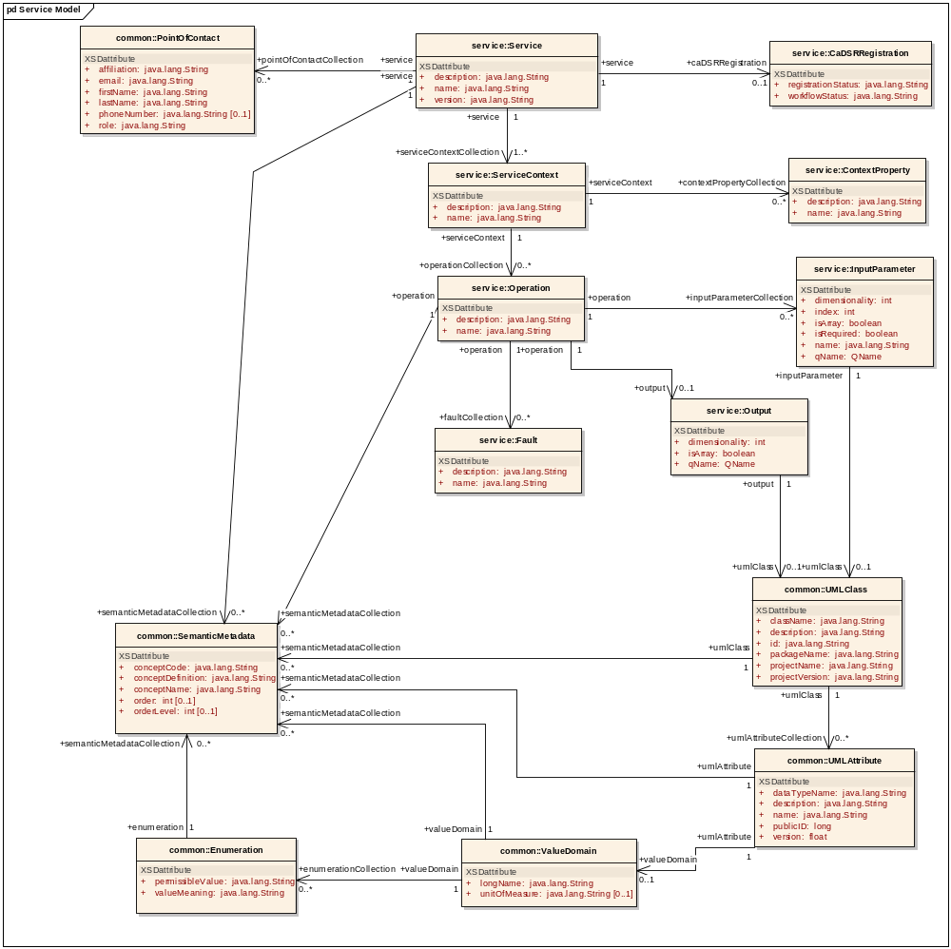
Figure 4-4 Service Model
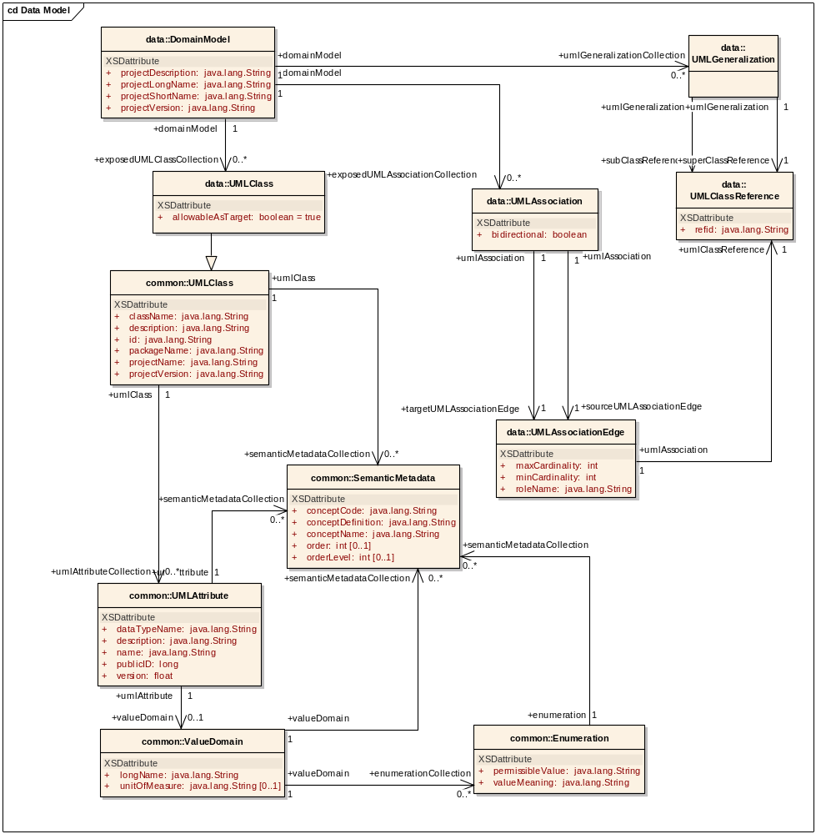
Figure 4-5 Data Service metadata model
The ResourcePropertyHelper API, not detailed here, is the lower level API, which can be used to directly gather information about ResourceProperties (this is how metadata is exposed in caGrid). The MetadataUtils, described here, leverage this API, and expose some of its exceptions. The possible exceptions generated by the metadata utility methods are detailed in Figure 4-6.
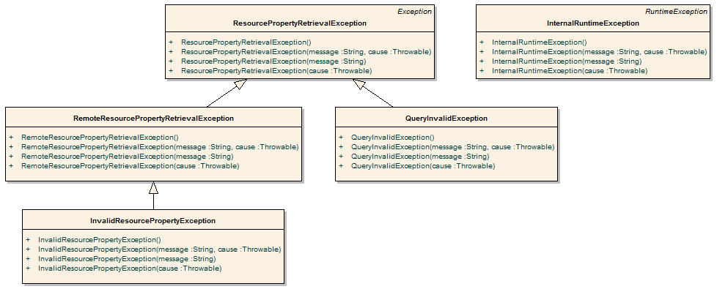
Figure 4-6 Metadata Exceptions
A non-discerning client may simply opt to catch ResourcePropertyRetrievalException, as it is the base-checked exception. An additional non-checked exception, InternalRuntimeException, can also be thrown but is solely used to represent an internal logic error in the APIs. It is not expected clients can “recover” from such an exception. As such, clients should not attempt to catch this runtime exception for any other reason than to mask the problem.
QueryInvalidException is thrown if an invalid XPath query is issued. Problems originating from remote services are thrown in the subclass RemoteResourcePropertyRetrievalException. During general use of the metadata utilities, this is the most likely exception clients may see, as it is thrown if a service is not properly exposing the proper metadata. Clients leveraging the lower level resource property APIs should take care to appropriately address each type of exception if they are communicating with services. For example, even though it is a caBIG requirement to expose the standard service metadata, clients should properly handle the case where it is not present. Asking for specific metadata that a service does not provide would yield an InvalidResourcePropertyException.

API Details

gov.nih.nci.cagrid.metadata.MetadataUtils

Member Function Documentation

static ServiceMetadata gov.nih.nci.cagrid.metadata.MetadataUtils.getServiceMetadata (EndpointReferenceType serviceEPR) throws InvalidResourcePropertyException, RemoteResourcePropertyRetrievalException, ResourcePropertyRetrievalException [static]
Obtain the service metadata from the specified service.

Parameters:
serviceEPR

Returns:

Exceptions:
InvalidResourcePropertyException
RemoteResourcePropertyRetrievalException
ResourcePropertyRetrievalException

static DomainModel gov.nih.nci.cagrid.metadata.MetadataUtils.getDomainModel (EndpointReferenceType serviceEPR) throws InvalidResourcePropertyException, RemoteResourcePropertyRetrievalException, ResourcePropertyRetrievalException [static]
Obtain the data service metadata from the specified service.

Parameters:
serviceEPR

Returns:

Exceptions:
InvalidResourcePropertyException
RemoteResourcePropertyRetrievalException
ResourcePropertyRetrievalException

static void gov.nih.nci.cagrid.metadata.MetadataUtils.serializeServiceMetadata (ServiceMetadata metadata, Writer writer) throws Exception [static]
Write the XML representation of the specified metadata to the specified writer. If either is null, an IllegalArgumentException will be thrown.

Parameters:
metadata
writer

Exceptions:
Exception

static ServiceMetadata gov.nih.nci.cagrid.metadata.MetadataUtils.deserializeServiceMetadata (Reader xmlReader) throws Exception [static]
Create an instance of the service metadata from the specified reader. The reader must point to a stream that contains an XML representation of the metadata. If the reader is null, an IllegalArgumentException will be thrown.

Parameters:
xmlReader

Returns:

Exceptions:
Exception

static void gov.nih.nci.cagrid.metadata.MetadataUtils.serializeDomainModel (DomainModel domainModel, Writer writer) throws Exception [static]
Write the XML representation of the specified metadata to the specified writer. If either is null, an IllegalArgumentException will be thrown.

Parameters:
domainModel
writer

Exceptions:
Exception

static DomainModel gov.nih.nci.cagrid.metadata.MetadataUtils.deserializeDomainModel (Reader xmlReader) throws Exception [static]
Create an instance of the data service metadata from the specified reader. The reader must point to a stream that contains an XML representation of the metadata. If the reader is null, an IllegalArgumentException will be thrown.

Parameters:
xmlReader

Returns:

Exceptions:
Exception

API Usage Examples
This section describes typical usage of the Metadata API. The exception handling shown in the code examples is not recommended practice, and is simplistic for demonstration purposes. The MetadataUtils class is the primary means of accessing and manipulating service metadata. It provides a number of static utility methods that can be directly invoked. This API provides an abstraction layer over lower-level APIs, specializing them to deal with the standard metadata types. Clients wishing to work with custom (or non-standard) metadata need to use the lower-level APIs and can consult the source code of the MetadataUtils class for guidance.

Accessing Metadata from a Service
In order to access a service’s metadata, an End Point Reference pointing to the service must be provided. This can be obtained as a direct result of an invocation of a discovery method from the Discovery API, or manually constructed by specifying the service’s Address. Examples of both can be found in the Discovery API Usage Overview starting on page 34.
As caBIG requires that standard metadata be made publicly available, client credentials are not necessary for invocation of these methods.
The first example, shown in Figure 4-7, demonstrates accessing a service’s standard ServiceMetadata, which is common to all caGrid services. As described above, the first step is to obtain an appropriate EPR (line 1). Given this EPR, the MetadataUtils’s getServiceMetadata method, shown on line 4 in Figure 4-7, can be used to obtain the bean representation of the metadata. Upon successful completion of this method, the fully populated bean can be inspected to obtain the information of interest. Several exceptions, subclassed from the base ResourcePropertyRetrievalException, can be thrown by this operation. A non-discriminating client may choose to simply handle this base exception. Additional details on the other exceptions, and why they may be thrown, are described in the Metadata API Usage Overview on page 25, as well as the javadoc of the APIs.
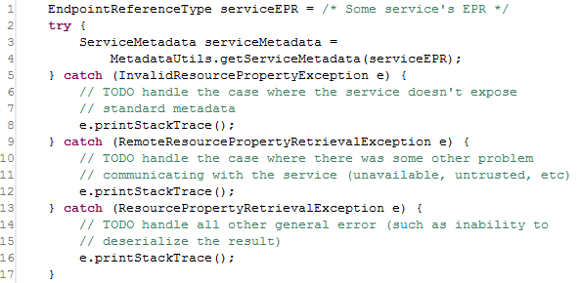
Figure 4-7 Accessing standard service metadata
The process for accessing data service DomainModel metadata, shown in Figure 4-8, is the same as accessing standard metadata. Once the metadata is obtained, in line 3, it can be inspected, as shown in line 4 where the long name of the project being exposed by the data service is printed to the console.
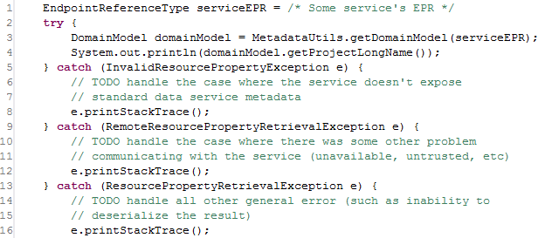
Figure 4-8 Accessing standard data service metadata

Processing Metadata as XML
In addition to accessing metadata from services, the MetadataUtils provide the capability to read and write metadata instances as XML documents. This can be useful for not only storage and display of metadata, but also for exposing grid service metadata as XML. These methods also provide a way to inspect the metadata in object (bean) form.
In Figure 4-9, example code is shown that saves an instance of standard service metadata to a file named seviceMetadata.xml. The metadata instance, defined in line 1, can be acquired using code similar to that shown in Figure 4-9, or by some other mechanism. The serializeServiceMetadata method can be then passed this instance, and an instance of the java.io.Writer interface, as shown on line 11. Any Writer implementation works, but the example below shows using a FileWriter, on line 5, to write the metadata to the specified file. After the MetadataUtils have been used to write the metadata to XML, the Writer used should be closed, as shown on line 18. Though not shown, a similar method, serializeDomainModel, exists for writing data service metadata to XML; its usage pattern is the same.
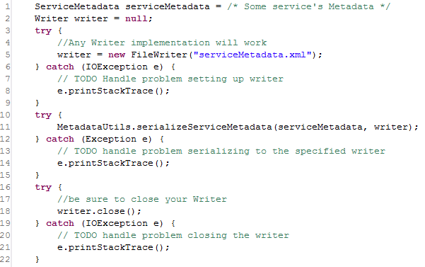
Figure 4-9 Serializing metadata to a file
As a complement to the serialization methods described and shown above, deserialization methods also exist which read XML representations of metadata and return appropriately populated metadata beans. In Figure 4-10, example code is shown which populates a new ServiceMetadata instance from an XML representation stored in a file named serviceMetadata.xml. This code, used in conjunction with the previous example, reconstitutes the original metadata instance. Similar to the serialization methods that use a java.io.Writer, the deserialization methods use a java.io.Reader to read the XML representation. In the example below, a FileReader is used on line 4. This Reader is then passed to the deserializeServiceMetadata method on line 11, and the populated ServiceMetadata instance is returned. As with the Writer instance in the serialization methods, the Reader instance should be closed once it is used (as shown on line 18). Though not shown, a similar method, deserializeDomainModel, exists for reading data service metadata from XML; its usage pattern is the same.
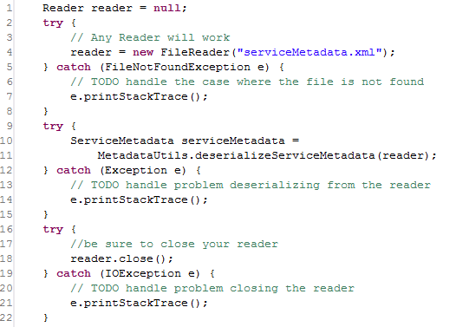
Figure 4-10 Deserializing metadata from a file

Discovery API Usage Overview
The Discovery API provides an abstraction over the standard operations used to query the Index Service. It provides a number of operations that can be used to discover services of interest. The basic process of use is to construct an instance of the DiscoveryClient, optionally specifying the End Point Reference (EPR) of the Index Service to query, and then invoking the appropriate discovery methods. Each method returns an array of EPRs of the matching appropriate services. These returned EPRs can then be used to invoke the services, or ask them for their metadata for further discrimination. It is worth noting that the Index Service, as an aggregated source of distributed information, inherently operates on out of date information. It is possible that services that are running do not yet have their metadata aggregated in the Index Service, and it is possible that services present in the Index Service have recently been taken down. caGrid attempts to strike a balance between performance and reliability of information in the Index Service. The information returned by the Discovery API should be accurate within a few minutes, but applications building upon it should be aware of this, and should not assume a service in the Index Service will always be available when it is invoked.
The DiscoveryClient uses the lower level “metadata utils” project to communicate with the Index Service. It exposes the exceptions generated from this lower level API, instead of wrapping them with discovery-specific exceptions. The possible exceptions that discovery methods can throw are detailed below in Figure 4-11. A non-discerning client may simply opt to catch ResourcePropertyRetrievalException, as it is the base checked exception. An additional non-checked exception, InternalRuntimeException, can also be thrown, but it is solely used to represent an internal logic error in the APIs and so it is not expected clients can “recover” from such an exception. As such, clients should not attempt to catch this runtime exception for any other reason than to mask the problem. Generic problems caused by the DiscoveryClient itself are thrown in the base ResourcePropertyRetrievalException. A subclass of it, QueryInvalidException, is thrown if an invalid XPath query is issued. Unless the DiscoveryClient is extended, it is not expected that clients should encounter this. Problems originating from remote services are thrown in the subclass, RemoteResourcePropertyRetrievalException. During general use of the metadata utilities, this is the most likely exception clients may see, as it is thrown if a service is not properly exposing the proper metadata. In the context of the DiscoveryClient, it is not expected clients should experience any exceptions unless there is an issue with the Index Service. However, clients leveraging the lower level APIs should take more care to appropriately address each type of exception if they are communicating with other (community provided) services. For example, even though it is a caBIG requirement to expose the standard service metadata, clients should properly handle the case where it is not present. Asking for specific metadata that a service does not provide would yield an InvalidResourcePropertyException.
Figure 4-11 Metadata exceptions
While the methods in the API are designed around the caGrid standard metadata, it is also acceptable to have services register additional domain or application specific metadata to the Index Service. The Discovery API is designed for easy extensibility, such that additional application or domain specific discovery scenarios can be provided to compliment such additional metadata. The “business logic” of the DiscoveryClient, consists almost entirely of constructing appropriate XPath queries over the appropriate metadata, and leveraging lower-level APIs to actually invoke the queries. These lower-level APIs are made available to extenders of the client, such that they need only construct appropriate XPath queries to implement additional discovery scenarios.
The DiscoveryClient uses commons-logging to log general and debugging information. If configured to DEBUG level, the client prints out the XPaths it is sending to the Index Service, which may facilitate the creation of new discovery operations, or help track down problems.
As with most Globus clients, a properly configured client-config.wsdd file must be accessible by the underlying Axis engine. The simplest way to do this is to either run with your $GLOBUS_LOCATION as the “working directory,” add $GLOBUS_LOCATION to your classpath, or copy $GLOBUS_LOCATION/client-config.wsdd to your working directory or classpath. If you don’t do this, you will most likely see an exception similar to that shown in Figure 4-12, when you run the DiscoveryClient.
gov.nih.nci.cagrid.metadata.exceptions.RemoteResourcePropertyRetrievalException: org.xml.sax.SAXException:SimpleDeserializer encountered a child element, which is NOT expected, in something it was trying to deserialize.

Figure 4-12 Common DiscoveryClient exception

API Details

gov.nih.nci.cagrid.discovery.client.DiscoveryClient
DiscoveryClient represents the base discovery API. The client should be constructed passing a URL of an Index Service. Services can then be discovered by calling the discover methods and passing in the necessary criteria. The methods all return an EndPointReferenceType[]. See the main method for examples. This should be extended to provide specialized service-type discovery (beyond data services).

Constructor Documentation

gov.nih.nci.cagrid.discovery.client.DiscoveryClient.DiscoveryClient () throws MalformedURIException
Uses the Default Index Service

Exceptions:
MalformedURIException if the Default Index Service is invalid

DiscoveryClient.java.gov.nih.nci.cagrid.discovery.client.DiscoveryClient.DiscoveryClient (EndpointReferenceType indexEPR)
Uses the specified Index Service

Parameters:
iemndexEPR the EPR to the Index Service to use

Member Function Documentation

EndpointReferenceType [] gov.nih.nci.cagrid.discovery.client.DiscoveryClient.getAllServices (boolean requireMetadataCompliance) throws RemoteResourcePropertyRetrievalException, QueryInvalidException, ResourcePropertyRetrievalException
Query the registry for all registered services

Parameters:
requireMetadataCompliance if true, only services providing the standard metadata will be returned. Otherwise, all services registered will be returned, regardless of whether or not any metadata has been aggregated.

Returns:
EndpointReferenceType[] contain all registered services

Exceptions:
ResourcePropertyRetrievalException
QueryInvalidException
RemoteResourcePropertyRetrievalException

EndpointReferenceType [] gov.nih.nci.cagrid.discovery.client.DiscoveryClient.discoverServicesBySearchString (String searchString) throws RemoteResourcePropertyRetrievalException, QueryInvalidException, ResourcePropertyRetrievalException
Searches ALL metadata to find occurrence of the given string. The search string is case-sensitive.

Parameters:
searchString the search string.

Returns:
EndpointReferenceType[] matching the criteria

Exceptions:
ResourcePropertyRetrievalException
QueryInvalidException
RemoteResourcePropertyRetrievalException

EndpointReferenceType [] gov.nih.nci.cagrid.discovery.client.DiscoveryClient.discoverServicesByResearchCenter (String centerName) throws RemoteResourcePropertyRetrievalException, QueryInvalidException, ResourcePropertyRetrievalException
Searches research center info to find services provided by a given cancer center.

Parameters:
centerName research center name

Returns:
EndpointReferenceType[] matching the criteria

Exceptions:
ResourcePropertyRetrievalException
QueryInvalidException
RemoteResourcePropertyRetrievalException

EndpointReferenceType [] gov.nih.nci.cagrid.discovery.client.DiscoveryClient.discoverServicesByPointOfContact (PointOfContact contact) throws RemoteResourcePropertyRetrievalException, QueryInvalidException, ResourcePropertyRetrievalException
Searches to find services that have the given point of contact associated with them. Any fields set on the point of contact are checked for a match. For example, you can set only the lastName, and only it will be checked, or you can specify several fields and they all must be equal.

Parameters:
contact point of contact

Returns:
EndpointReferenceType[] matching the criteria

Exceptions:
ResourcePropertyRetrievalException
QueryInvalidException
RemoteResourcePropertyRetrievalException

EndpointReferenceType [] gov.nih.nci.cagrid.discovery.client.DiscoveryClient.discoverServicesByName (String serviceName) throws RemoteResourcePropertyRetrievalException, QueryInvalidException, ResourcePropertyRetrievalException
Searches to find services that have a given name.

Parameters:
serviceName The service's name

Returns:
EndpointReferenceType[] matching the criteria

Exceptions:
ResourcePropertyRetrievalException
QueryInvalidException
RemoteResourcePropertyRetrievalException

EndpointReferenceType [] gov.nih.nci.cagrid.discovery.client.DiscoveryClient.discoverServicesByConceptCode (String conceptCode) throws RemoteResourcePropertyRetrievalException, QueryInvalidException, ResourcePropertyRetrievalException
Searches to find services based on the given concept code.

Parameters:
conceptCode A concept code the service is based upon.

Returns:
EndpointReferenceType[] matching the criteria

Exceptions:
ResourcePropertyRetrievalException
QueryInvalidException
RemoteResourcePropertyRetrievalException

EndpointReferenceType [] gov.nih.nci.cagrid.discovery.client.DiscoveryClient.discoverServicesByOperationName (String operationName) throws RemoteResourcePropertyRetrievalException, QueryInvalidException, ResourcePropertyRetrievalException
Searches to find services that have a given operation.

Parameters:
operationName The operation's name

Returns:
EndpointReferenceType[] matching the criteria

Exceptions:
ResourcePropertyRetrievalException
QueryInvalidException
RemoteResourcePropertyRetrievalException

EndpointReferenceType [] gov.nih.nci.cagrid.discovery.client.DiscoveryClient.discoverServicesByOperationInput (UMLClass clazzPrototype) throws RemoteResourcePropertyRetrievalException, QueryInvalidException, ResourcePropertyRetrievalException
Searches to find services that have an operation defined that takes the given UMLClass as input. Any fields set on the UMLClass are checked for a match. For example, you can set only the packageName, and only it will be checked, or you can specify several fields and they all must be equal.
Note: Only attributes of the UMLClass are examined (associated objects (e.g. UMLAttributeCollection and SemanticMetadataCollection) are ignored).

Parameters:
clazzPrototype The prototype UMLClass

Returns:
EndpointReferenceType[] matching the criteria

Exceptions:
ResourcePropertyRetrievalException
QueryInvalidException
RemoteResourcePropertyRetrievalException

EndpointReferenceType [] gov.nih.nci.cagrid.discovery.client.DiscoveryClient.discoverServicesByOperationOutput (UMLClass clazzPrototype) throws RemoteResourcePropertyRetrievalException, QueryInvalidException, ResourcePropertyRetrievalException
Searches to find services that have an operation defined that produces the given UMLClass. Any fields set on the UMLClass are checked for a match. For example, you can set only the packageName, and only it will be checked, or you can specify several fields and they all must be equal.
NOTE: Only attributes of the UMLClass are examined (associated objects (e.g. UMLAttributeCollection and SemanticMetadataCollection) are ignored).

Parameters:
clazzPrototype The prototype UMLClass

Returns:
EndpointReferenceType[] matching the criteria

Exceptions:
ResourcePropertyRetrievalException
QueryInvalidException
RemoteResourcePropertyRetrievalException

EndpointReferenceType [] gov.nih.nci.cagrid.discovery.client.DiscoveryClient.discoverServicesByOperationClass (UMLClass clazzPrototype) throws RemoteResourcePropertyRetrievalException, QueryInvalidException, ResourcePropertyRetrievalException
Searches to find services that have an operation defined that produces the given UMLClass or takes it as input. Any fields set on the UMLClass are checked for a match. For example, you can set only the packageName, and only it will be checked, or you can specify several fields and they all must be equal.
Note: Only attributes of the UMLClass are examined (associated objects (e.g. UMLAttributeCollection and SemanticMetadataCollection) are ignored).

Parameters:
clazzPrototype The prototype UMLClass

Returns:
EndpointReferenceType[] matching the criteria

Exceptions:
ResourcePropertyRetrievalException
QueryInvalidException
RemoteResourcePropertyRetrievalException

EndpointReferenceType [] gov.nih.nci.cagrid.discovery.client.DiscoveryClient.discoverServicesByOperationConceptCode (String conceptCode) throws RemoteResourcePropertyRetrievalException, QueryInvalidException, ResourcePropertyRetrievalException
Searches to find services that have an operation based on the given concept code

Parameters:
conceptCode The concept to look for

Returns:
EndpointReferenceType[] matching the criteria

Exceptions:
ResourcePropertyRetrievalException
QueryInvalidException
RemoteResourcePropertyRetrievalException

EndpointReferenceType [] gov.nih.nci.cagrid.discovery.client.DiscoveryClient.discoverServicesByDataConceptCode (String conceptCode) throws RemoteResourcePropertyRetrievalException, QueryInvalidException, ResourcePropertyRetrievalException
Searches to find services that have an operation defined that produces the or takes as input, a Class with an attribute , attribute value domain , enumerated value meaning, or the class itself based on the given concept code.

Parameters:
conceptCode The concept to look for

Returns:
EndpointReferenceType[] matching the criteria

Exceptions:
ResourcePropertyRetrievalException
QueryInvalidException
RemoteResourcePropertyRetrievalException

EndpointReferenceType [] gov.nih.nci.cagrid.discovery.client.DiscoveryClient.discoverServicesByPermissibleValue (String value) throws RemoteResourcePropertyRetrievalException, QueryInvalidException, ResourcePropertyRetrievalException
Searches to find services that have an operation defined that produce or take as input, a Class with an attribute allowing the given value.

Parameters:
value The permissible value to look for

Returns:
EndpointReferenceType[] matching the criteria

Exceptions:
ResourcePropertyRetrievalException
QueryInvalidException
RemoteResourcePropertyRetrievalException

String gov.nih.nci.cagrid.discovery.client.DiscoveryClient.createPermissibleValuePredicatedUMLClass (String value, boolean isDataService) [protected]
Creates a UMLClass step that is predicated to contain either an attribute, attribute value domain, or enumerated value meaning, or the class itself based on that concept.

Parameters:
conceptCode the code to look for

Returns:

String gov.nih.nci.cagrid.discovery.client.DiscoveryClient.createConceptPredicatedUMLClass (String conceptCode, boolean isDataService) [protected]
Creates a UMLClass step that is predicated to contain either an attribute, attribute value domain, enumerated value meaning, or the class itself based on that concept.

Parameters:
conceptCode the code to look for

Returns:

EndpointReferenceType [] gov.nih.nci.cagrid.discovery.client.DiscoveryClient.getAllDataServices () throws RemoteResourcePropertyRetrievalException, QueryInvalidException, ResourcePropertyRetrievalException
Query the registry for all registered data services

Returns:
EndpointReferenceType[] contain all registered services

Exceptions:
ResourcePropertyRetrievalException
QueryInvalidException
RemoteResourcePropertyRetrievalException

EndpointReferenceType [] gov.nih.nci.cagrid.discovery.client.DiscoveryClient.discoverDataServicesByDomainModel (String modelName) throws RemoteResourcePropertyRetrievalException, QueryInvalidException, ResourcePropertyRetrievalException
Searches to find data services that are exposing a subset of given domain (short name or long name).

Parameters:
modelName The model to look for

Returns:
EndpointReferenceType[] matching the criteria

Exceptions:
ResourcePropertyRetrievalException
QueryInvalidException
RemoteResourcePropertyRetrievalException

EndpointReferenceType [] gov.nih.nci.cagrid.discovery.client.DiscoveryClient.discoverDataServicesByModelConceptCode (String conceptCode) throws RemoteResourcePropertyRetrievalException, QueryInvalidException, ResourcePropertyRetrievalException
Searches to find data services that expose a Class with an attribute , attribute value domain , enumerated value meaning, or the class itself based on the given concept code.

Parameters:
conceptCode The concept to look for

Returns:

Exceptions:
RemoteResourcePropertyRetrievalException
QueryInvalidException
ResourcePropertyRetrievalException

EndpointReferenceType [] gov.nih.nci.cagrid.discovery.client.DiscoveryClient.discoverDataServicesByExposedClass (gov.nih.nci.cagrid.metadata.dataservice.UMLClass clazzPrototype) throws RemoteResourcePropertyRetrievalException, QueryInvalidException, ResourcePropertyRetrievalException
Searches for data services that expose the given class. Any fields set on the UMLClass are checked for a match. For example, you can set only the packageName, and only it will be checked, or you can specify several fields and they all must be equal.
Note: Only attributes of the UMLClass are examined (associated objects (e.g. UMLAttributeCollection and SemanticMetadataCollection) are ignored).

Parameters:
clazzPrototype The prototype UMLClass
clazzPrototype

Returns:

Exceptions:
RemoteResourcePropertyRetrievalException
QueryInvalidException
ResourcePropertyRetrievalException

EndpointReferenceType [] gov.nih.nci.cagrid.discovery.client.DiscoveryClient.discoverDataServicesByPermissibleValue (String permissibleValue) throws RemoteResourcePropertyRetrievalException, QueryInvalidException, ResourcePropertyRetrievalException
Searches for data services that expose a class with an attribute allowing the given value.

Parameters:
value The permissible value to look for

Returns:

Exceptions:
RemoteResourcePropertyRetrievalException
QueryInvalidException
ResourcePropertyRetrievalException

EndpointReferenceType [] gov.nih.nci.cagrid.discovery.client.DiscoveryClient.discoverDataServicesByAssociationsWithClass (gov.nih.nci.cagrid.metadata.dataservice.UMLClass clazzPrototype) throws RemoteResourcePropertyRetrievalException, QueryInvalidException, ResourcePropertyRetrievalException
Searches for data services that expose an association to or from the given class. Any fields set on the UMLClass are checked for a match. For example, you can set only the packageName, and only it will be checked, or you can specify several fields and they all must be equal.
Note: Only attributes of the UMLClass are examined (associated objects (e.g. UMLAttributeCollection and SemanticMetadataCollection) are ignored).

Parameters:
clazzPrototype

Returns:

Exceptions:
RemoteResourcePropertyRetrievalException
QueryInvalidException
ResourcePropertyRetrievalException

static String gov.nih.nci.cagrid.discovery.client.DiscoveryClient.buildPOCPredicate (PointOfContact contact) [static, protected]
Builds up a predicate for a PointOfContact, based on the prototype passed in.

Parameters:
contact the prototype POC

Returns:
"*" if the prototype has no non-null or non-whitespace values, or the predicate necessary to match all values.

static String gov.nih.nci.cagrid.discovery.client.DiscoveryClient.buildUMLClassPredicate (UMLClass clazz) [static, protected]
Builds up a predicate for a UMLClass, based on the prototype passed in.
Note: Only attributes of the UMLClass are examined (associated objects (e.g. UMLAttributeCollection and SemanticMetadataCollection) are ignored).

Parameters:
clazz the prototype UMLClass

Returns:
"*" if the prototype has no non-null or non-whitespace values, or the predicate necessary to match all values.

static String gov.nih.nci.cagrid.discovery.client.DiscoveryClient.buildDataUMLClassPredicate (gov.nih.nci.cagrid.metadata.dataservice.UMLClass clazz) [static, protected]

static String gov.nih.nci.cagrid.discovery.client.DiscoveryClient.addNonNullPredicate (String name, String value, boolean isAttribute) [static, protected]

Parameters:
name the element or attribute name to check
value the value to add the predicate filter against if this is null or whitespace only, no predicated is added.
isAttribute whether or not name represents an attribute or element

Returns:
"" or the specified predicate (prefixed with " and " )

EndpointReferenceType [] gov.nih.nci.cagrid.discovery.client.DiscoveryClient.discoverByFilter (String xpathPredicate) throws RemoteResourcePropertyRetrievalException, QueryInvalidException, ResourcePropertyRetrievalException [protected]
Applies the specified predicate to the common path in the Index Service's Resource Properties to return registered services' EPRs that match the predicate.

Parameters:
xpathPredicate predicate to apply to the "Entry" in Index Service

Returns:
EndpointReferenceType[] of matching services @

Exceptions:
ResourcePropertyRetrievalException
QueryInvalidException
RemoteResourcePropertyRetrievalException

String gov.nih.nci.cagrid.discovery.client.DiscoveryClient.translateXPath (String xpathPredicate) [protected]
Adds the common Index RP Entry filter, and translates the xpath to IndexService friendly XPath.

Parameters:
xpathPredicate

Returns:
the modified xpath

EndpointReferenceType gov.nih.nci.cagrid.discovery.client.DiscoveryClient.getIndexEPR ()
Gets the EPR of the Index Service being used.

void gov.nih.nci.cagrid.discovery.client.DiscoveryClient.setIndexEPR (EndpointReferenceType indexEPR)
Sets the EPR of the Index Service to use.

Parameters:
indexEPR the EPR of the Index Service to use.

static void gov.nih.nci.cagrid.discovery.client.DiscoveryClient.main (String[] args) [static]
testing stub

Parameters:
args optional URL to Index Service to query.

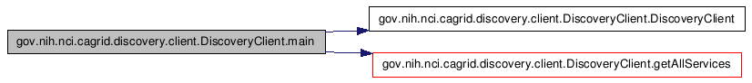

gov.nih.nci.cagrid.discovery.XPathUtils

Member Function Documentation

static String gov.nih.nci.cagrid.discovery.XPathUtils.translateXPath (String prefixedXpath, Map namespaces) [static]
This utility takes an XPath that uses namespace prefixes (such as /a:B/a:C) and converts it to one without prefixes, by using the appropriate operators instead (such as /*[namespace-uri()='http://DOMAIN.COM/SCHEMA' and local-name()='B']/*[namespace-uri()='http://DOMAIN.COM/SCHEMA' and local-name()='C']). The only conceivable use for this function is to write sane XPath and convert it to the insane XPath Globus index service supports.

Note: This is not perfect. The known limitations are: 1) its overly aggressive, and will replace QName-looking string literals, 2) it will not work if you have namespaces attributes 3) it will silently not replace any QNames that you haven't supplied a prefix mapping for

Parameters:
prefixedXpath An xpath [optionally] using namespace prefixes in nodetests
namespaces A Map<String,String> keyed on namespace prefixes to resolve in the xpath, where the value is the actual namespace that should be used.

Returns:
a converted, conformant, xpath

API Usage Examples
This section describes typical usage of the Discovery API. The exception handling shown in the code examples is not recommended practice and is simplistic for demonstration purposes. Additional examples can be found in the source code of the discovery project, in the main of the DiscoveryClient itself, as well as in the test source directory.
The main method of the DiscoveryClient can be run from the project’s source folder by entering ant runClient. The discovery unit tests can also be run by entering ant test. The unit tests do not actually communicate with the Index Service; rather they simulate it with a Mock object.

Configuring an Index Service
The first step in using the Discovery API is constructing an instance of the DiscoveryClient. There are three constructors that can be used. The first, shown in line 7 of Figure 4-13, takes no arguments, and indicates that the “default” Index Service should be used for discovery queries. A second constructor, shown in line 5 of Figure 4-13, takes a String as an argument, and the String is expected to represent the service URL of the Index Service to query. The final constructor, not shown, takes an EndPointReferenceType, which can be used to directly indicate the Index Service Resource to query. The standard caGrid Index Service installation is stateless, and so a resource unqualified EPR can be used, but most clients can just use the shortcut String constructor.
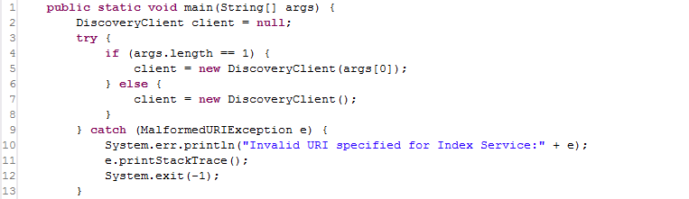
Figure 4-13 DiscoveryClient constructor example
The Index Service to use can also be reconfigured at runtime, by invoking the setIndexEPR method, shown in line 11 of Figure 4-14. Just as specifying the Index Service in the constructor generates an exception if the Address is not valid, so will the setter method.
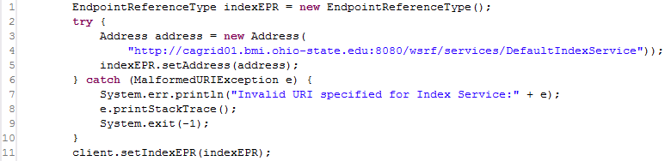
Figure 4-14 Configuring Index Service code

Discovering Services
Once a DiscoveryClient is configured, it can be continually used to discover services of interest. While the client is technically thread safe as long as the Index Service is not reconfigured during use, it is recommended a new DiscoveryClient instance is used in each thread context where discovery operations are performed, as it is an extremely light weight object.
The simplest discovery scenario, shown in Figure 4-15, is to query the Index Service for all registered services. The boolean value specified in line 3, indicates whether services should be ignored if they do not expose the caGrid standard metadata. In most application scenarios, a value of “true” is used, but specifying “false” is useful for identifying all services that are attempting to register. It is common for a service running behind a firewall to maintain registration status with the Index Service, but not have caGrid metadata aggregated, as the Index Service is not able to communicate with the inaccessible service
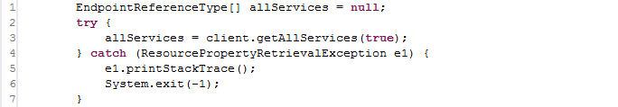
Figure 4-15 Discovering all services
There are numerous discovery operations which take some form of text input, and all are case sensitive. The simplest discovery operation that takes some form of input is the basic string search operation, discoverServicesBySearchString, which is shown in Figure 4-16. This is a full text search that examines all registered metadata values for the specified input. It is not likely this operation will be useful for programmatic discovery (as it is a completely unstructured query), but it is useful for applications that take direct input from the user (such as a web form), and makes a good starting point for applications that provide capability to “drill down” and examine the full metadata of the satisfying services.
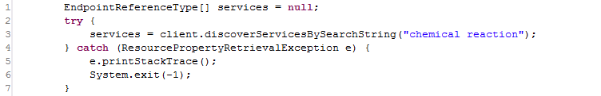
Figure 4-16 Discovering by Search String
Beyond the full text search operation, there are many discovery operations that take a search string as input, but perform a more structured search and are more useful for programmatic discovery. For example, services providing a named operation can be discovered using the method discoverServicesByOperationName, or Data Services exposing a given model can be discovered, as shown below in Figure 4-17, using the discoverDataServicesByDomainModel method. This operation, and all methods named like discoverDataServices* only return services that implement the standard Data Service operations.
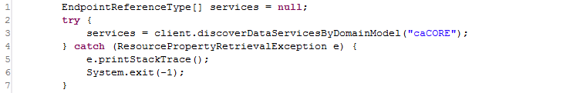
Figure 4-17 Discovering Data Services by Model Name
Another potentially useful method for discovering services or displaying information about available services on the grid is the discoverServicesByResearchCenter method, shown below in Figure 4-18.
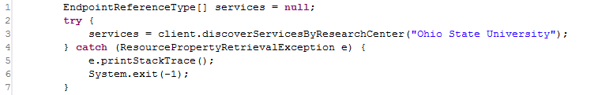
Figure 4-18 Discovering by Research Center
There are several discovery methods that support semantic discovery by allowing search on concept code. The simplest of these methods, discoverServicesByConceptCode, shown below in Figure 4-19, searches for services based on concepts applied to the services itself. There is a concept representing “Grid Service” in the ontology and derived concepts such as “Analytical Grid Service” and “Data Grid Service.” By determining these concept codes, or any other specialized concepts, this operation provides a simple way to discover services of a certain “type.” Similarly, there is a method to discover services by the semantics of the operations they provide using the discoverServicesByOperationConceptCode method. At the time of this writing, services operations are not yet semantically annotated, but are expected to be soon. Finally, two methods: discoverDataServicesByModelConceptCode and discoverServicesByDataConceptCode provide the capability to discover services based on the information about the data types they operate over. Both examine the semantic information of the UML Classes used by the services. The first, discoverDataServicesByModelConceptCode, locates Data Services that are exposing access to data based on the concept. The second, discoverServicesByDataConceptCode, locates services that directly produce or consume data based on the concept. In both cases, the concept is considered a match if the Class is based on the concept or one of its attributes, attribute value domains, or enumerated value meanings. These methods are all based on direct concept matching; not only ontological operations. However, these methods coupled with the EVS grid service, provide a powerful ability to traverse the caBIG ontology for information of interest, and discover services providing this information, or the ability to manipulate it.
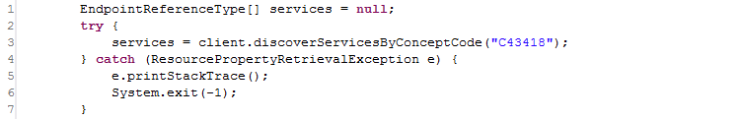
Figure 4-19 Discovering Services by Concept Code
Beyond the simple String based discovery methods, some discovery methods take complex objects as input, such as a PointOfContact or UMLClass. In these cases, the objects act as a prototype (or “query by example” as in the caCORE APIs), and can be as partially populated as desired. For example, the method show below in Figure 4-20, discoverServicesByPointOfContact, searches for services which are associated with a person with the information described by the supplied PointOfContact instance; in this case services associated with “Scott Oster” are located. There are many other fields in PointOfContact that are not populated in this example, and are ignored.
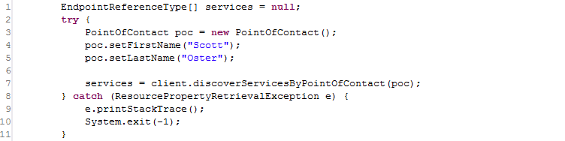
Figure 4-20 Discover Services by Point of Contact
There are many discovery methods that take a UMLClass prototype to discover services based on data types; an example is shown below in Figure 4-21. This method, discoverServiceByOperationInput, locates services that provide an operation that takes, as input, an instance of the specified data type. In the example below, services provide operations taking caBIO’s Gene instances as input. Again, this object can be as partially populated as desired (such as only specifying the package name, or being more explicit in specifying the exact project name and version).
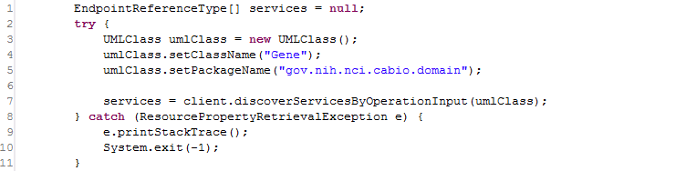
Figure 4-21 Discover Services by Input

caDSR Grid Service Usage Overview
The following link provides a reference to the technical architecture and design document(s) for the caDSR Grid Service:
http://gforge.nci.nih.gov/plugins/scmcvs/cvsweb.php/~checkout~/cagrid-1-0/Documentation/docs/cadsr/caGrid-cadsr-design.doc?rev=1.7;content-type=application%2Foctet-stream;cvsroot=cagrid-1-0
The caGrid caDSR Grid Service provides access to information in the caDSR that is relevant to caGrid, and has capabilities to generate caGrid standard metadata instances. Specifically, the service provides operations to access UML-like information stored in the caDSR. It also has operations to generate Data Service metadata for a described subset of a given project registered in caDSR. Finally, it has an operation that augments a description of an Analytical Service, via a partially populated service metadata instance, with the necessary UML-like and semantic information, extracted from caDSR, to describe the service and its operations.
The caDSR Grid Service is a simple, stateless service, created with Introduce. The service exposes three main categories of operations. The first are operations that expose access to the UML-like view of caDSR registered items like findProjects, findPackagesInProject, findClassesInPackage, findAttributesInClass, etc. These provide basic discovery and access to the UML information in the caDSR. While these operations are stateless, they take sufficient context during each invocation to enable traversal of all registered projects. Aside from the operations to locate Projects, each operation takes a description of the caDSR Project of interest. Each operation in turn throws an InvalidProjectException if the Project specified is not valid.
The second set of operations enables clients to generate caGrid standard Data Service metadata. There are four operations that take variations of information specifying what data is to be exposed by the Data Service for which the metadata is being created. Each operation throws an InvalidProjectException if the Project specified is not valid or if it ambiguously identifies more than one Project (for example, if a version is not specified, yet there are multiple versions of a given Project registered in caDSR). The first operation, generateDomainModelForProject, takes only the project description and generates a model that describes the entire domain model being exposed for the project. The second, generateDomainModelForPackage, additionally takes an array of Strings that represent UML package names in the Project to expose. The method generates a model that describes exposing all UML Classes in UML Packages with a name specified in the array. Any associations to UML Classes outside of the specified packages are not exposed. The third method, generateDomainModelForClasses, also takes an array of Strings that represent the fully qualified UML Class names to be exposed in the model. Any association between classes not specified is omitted. The final method, generateDomainModelForClassesWithExcludes, also takes an additional array of Strings that represent the fully qualified UML Class names to be exposed in the model, but also takes an array of UMLAssociationExcludes to be used to exclude specific associations from the model (in addition to the already excluded associations that reference classes not specified in the array of class names). The UMLAssociationExclude Class allows the client to specify a sourceRoleName, sourceClassName, targetRoleName, and targetClassName. Any UML Association that would otherwise be included in the computed subset of the DomainModel is omitted if it meets the criteria described by any of the UMLAssociationExcludes. The value of any attribute of the UMLAssociationExclude can be the wildcard “*”, which indicates it should match anything. As such, specifying an exclude with “*” as the value for all attributes effectively omits all associations from the DomainModel. By using no wildcards, a single association can be omitted, and by using a combination of some values and some wildcards, groups of associations can be omitted. For example, specifying an exclude instance with a sourceClassName value of “gov.nih.nci.cabio.domain.Gene” and wildcards for all other attributes would effectively omit any associations from the DomainModel where gov.nih.nci.cabio.domain.Gene was the source of the association. Using these methods, in combination with the operations for finding all Projects, Packages, Classes, and Associations, Data Service metadata exposing any subset of Classes and Associations can be created.
The final type of operation is the operation, annotateServiceMetadata, which provides clients the ability to augment a ServiceMetadata (standard caGrid service metadata) skeleton instance with the information extracted from caDSR. The caGrid common service metadata specifies information about a grid service and its operations. For more information on the model, consult the caGrid metadata design document. The annotateServiceMetadata operation takes this model and populates the UML and semantically oriented components by querying the caDSR appropriately. Specifically, it populates the semantically annotated UML Class information (similar to the type used in Data Service Domain Model metadata) for each input and output type of every operation the service provides. It does this by examining the XML Qualified Name (QName) of each type used in the signature of the operation and locating its UML equivalent in caDSR. In caGrid every grid service operation is required to use data types which are XML representations of UML Classes registered in the caDSR. There is a one to one mapping of UML Class to XML QNames (XML elements). The caGrid Metadata Design Document and caDSR Grid Service Design Document can be consulted for more information on how this binding (XML QName to caDSR type) occurs, and what restrictions it places on the models.
The primary data types used by the caDSR grid service are those that are defined in caCORE 3.1 in the gov.nih.nci.cadsr.domain model, which represents the caDSR information and the gov.nih.nci.cadsr.umlproject.domain, which represents a UML-like view of information in the caDSR. The umlproject model, shown below in Figure 4-22, is the main model but it associates with and extends a few classes from the caDSR base model, so it is used as well. As is evident from the figure below, the model provides a UML-like view of the caDSR registered projects. One class of note is the SemanticMetadata class which is associated to many UML-like classes, and provides a link to the semantic content of those items. Specifically, it exposes information about the EVS-maintained concepts.
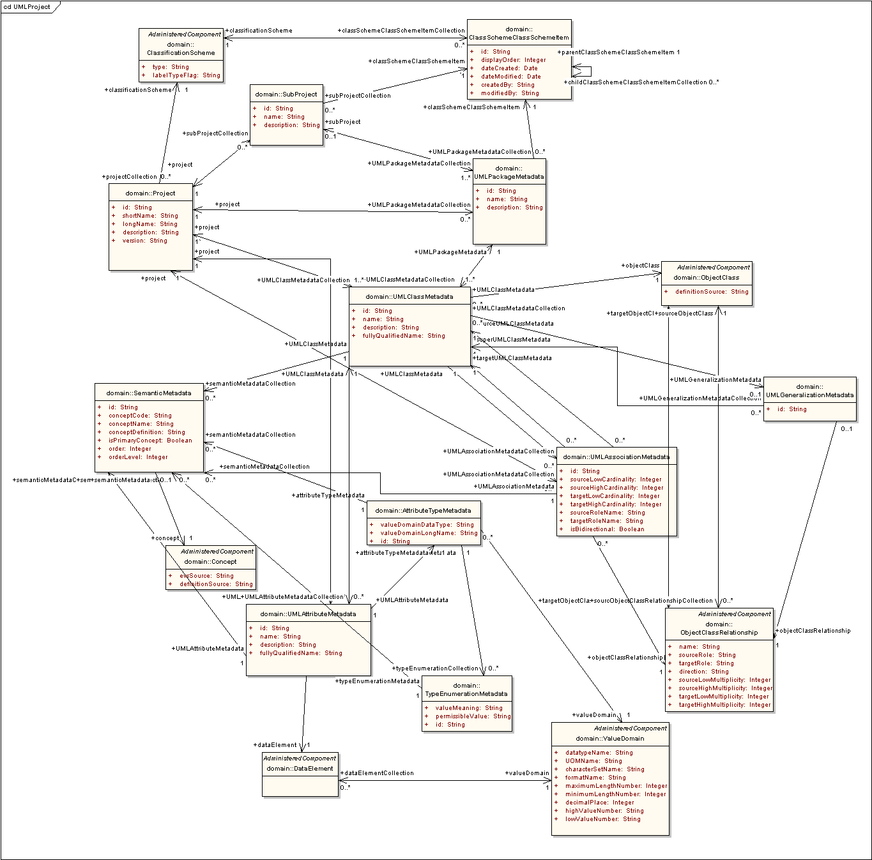
Figure 4-22 UML project model
In addition to the existing caCORE-defined types, the caDSR grid service defines two new data types for exclusive use by its exposed operations. The first is the UMLAssociationExclude, described above as the type used to specify UML Associations which should be excluded from a generated DomainModel. The second is an alternative representation of a UML Association, namely the UMLAssocation class. This has the same semantics as the UMLAssociationMetadata class in the umlproject model, but uses an alternate syntactic representation which is more suitable to transport over the grid.
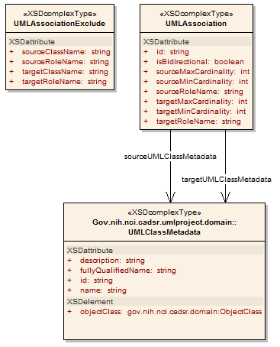
Figure 4-23 caDSR Grid Service Types
Finally the service also makes use of the ServiceMetadata and DomainModel caGrid metadata models, as it provides operations to manipulate them. For more information on these models, consult the caGrid Metadata Design Document.

Security Considerations
The caDSR grid service requires no grid credentials for any operations. Its typical deployment is in a service container using an open communication channel. However, even if it is deployed to a container making use of transport level security (https), it will not require credentials from the user and can be communicated with anonymously.

API Details
The caDSRServiceClient is the main client interface to the caDSR grid service (Figure 4-24).
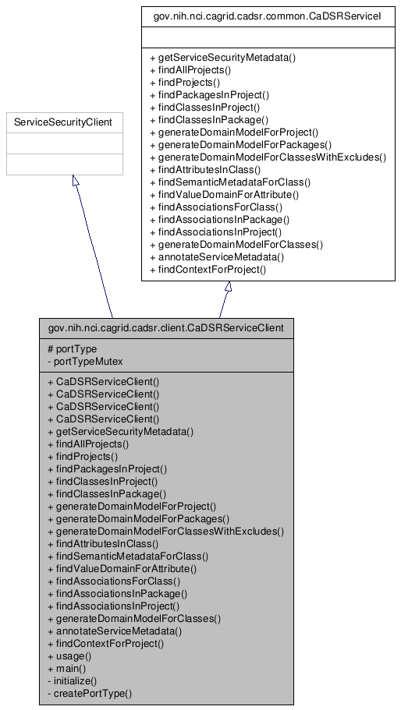
Figure 4-24 CaDSRServiceClient Inheritance Graph

gov.nih.nci.cagrid.cadsr.client.CaDSRServiceClient

Constructor Documentation
CaDSRServiceClient (String url) - throws MalformedURIException, RemoteException
CaDSRServiceClient (String url, GlobusCredential proxy) - throws MalformedURIException, RemoteException
CaDSRServiceClient (EndpointReferenceType epr) - throws MalformedURIException, RemoteException
CaDSRServiceClient (EndpointReferenceType epr, GlobusCredential proxy) - throws MalformedURIException, RemoteException

Member Function Documentation
Access to caGrid Service Security Metadata:
- gov.nih.nci.cagrid.metadata.security.ServiceSecurityMetadata getServiceSecurityMetadata ()
  - throws RemoteException
  - Description: Returns the caGrid service security metadata

Navigation and discovery of UML-like information:
- gov.nih.nci.cadsr.umlproject.domain.Project[] findAllProjects ()
  - throws RemoteException
  - Description: Returns all Projects registered in the caDSR
- gov.nih.nci.cadsr.umlproject.domain.Project[] findProjects (java.lang.String context)
  - throws RemoteException
  - Description: Returns all Projects registered in the caDSR under the given context
- gov.nih.nci.cadsr.umlproject.domain.UMLPackageMetadata[] findPackagesInProject (gov.nih.nci.cadsr.umlproject.domain.Project project)
  - throws RemoteException, gov.nih.nci.cagrid.cadsr.stubs.types.InvalidProjectException
  - Description: Returns all Packages in the given Project
- gov.nih.nci.cadsr.umlproject.domain.UMLClassMetadata[] findClassesInProject (gov.nih.nci.cadsr.umlproject.domain.Project project)
  - throws RemoteException, gov.nih.nci.cagrid.cadsr.stubs.types.InvalidProjectException
  - Description: Returns all Classes in the given Project
- gov.nih.nci.cadsr.umlproject.domain.UMLClassMetadata[] findClassesInPackage (gov.nih.nci.cadsr.umlproject.domain.Project project, java.lang.String packageName)
  - throws RemoteException, gov.nih.nci.cagrid.cadsr.stubs.types.InvalidProjectException
  - Description: Returns all Classes in the given Package
- gov.nih.nci.cadsr.umlproject.domain.UMLAttributeMetadata[] findAttributesInClass (gov.nih.nci.cadsr.umlproject.domain.Project project, gov.nih.nci.cadsr.umlproject.domain.UMLClassMetadata clazz)
  - throws RemoteException, gov.nih.nci.cagrid.cadsr.stubs.types.InvalidProjectException
  - Description: Returns all Attributes of the given Class
- gov.nih.nci.cadsr.umlproject.domain.SemanticMetadata[] findSemanticMetadataForClass (gov.nih.nci.cadsr.umlproject.domain.Project project, gov.nih.nci.cadsr.umlproject.domain.UMLClassMetadata clazz)
  - throws RemoteException, gov.nih.nci.cagrid.cadsr.stubs.types.InvalidProjectException
  - Description: Returns the semantic information about the given Class
- gov.nih.nci.cadsr.domain.ValueDomain findValueDomainForAttribute (gov.nih.nci.cadsr.umlproject.domain.Project project, gov.nih.nci.cadsr.umlproject.domain.UMLAttributeMetadata attribute)
  - throws RemoteException, gov.nih.nci.cagrid.cadsr.stubs.types.InvalidProjectException
  - Description: Returns the Value Domain information for the given Attribute
- gov.nih.nci.cagrid.cadsrservice.UMLAssociation[] findAssociationsForClass (gov.nih.nci.cadsr.umlproject.domain.Project project, gov.nih.nci.cadsr.umlproject.domain.UMLClassMetadata clazz)
  - throws RemoteException, gov.nih.nci.cagrid.cadsr.stubs.types.InvalidProjectException
  - Description: Returns all Associations of the given Class
- gov.nih.nci.cagrid.cadsrservice.UMLAssociation[] findAssociationsInPackage (gov.nih.nci.cadsr.umlproject.domain.Project project, java.lang.String packageName)
  - throws RemoteException, gov.nih.nci.cagrid.cadsr.stubs.types.InvalidProjectException
  - Description: Returns all Associations in the given Package
- gov.nih.nci.cagrid.cadsrservice.UMLAssociation[] findAssociationsInProject (gov.nih.nci.cadsr.umlproject.domain.Project project)
  - throws RemoteException, gov.nih.nci.cagrid.cadsr.stubs.types.InvalidProjectException
  - Description: Returns all Associations in the given Project
- gov.nih.nci.cadsr.domain.Context findContextForProject (gov.nih.nci.cadsr.umlproject.domain.Project project)
  - throws RemoteException, gov.nih.nci.cagrid.cadsr.stubs.types.InvalidProjectException
  - Description: Returns the Context of the given Project

caGrid standard metadata generation and manipulation:
- gov.nih.nci.cagrid.metadata.dataservice.DomainModel generateDomainModelForProject (gov.nih.nci.cadsr.umlproject.domain.Project project)
  - throws RemoteException, gov.nih.nci.cagrid.cadsr.stubs.types.InvalidProjectException
  - Description: Generates standard Data Service metadata for the given Project
- gov.nih.nci.cagrid.metadata.dataservice.DomainModel generateDomainModelForPackages (gov.nih.nci.cadsr.umlproject.domain.Project project, java.lang.String[] packageNames)
  - throws RemoteException, gov.nih.nci.cagrid.cadsr.stubs.types.InvalidProjectException
  - Description: Generates standard Data Service metadata for the given Packages
- gov.nih.nci.cagrid.metadata.dataservice.DomainModel generateDomainModelForClasses (gov.nih.nci.cadsr.umlproject.domain.Project project, java.lang.String[] fullClassNames)
  - throws RemoteException, gov.nih.nci.cagrid.cadsr.stubs.types.InvalidProjectException
  - Description: Generates standard Data Service metadata for the given Classes
- gov.nih.nci.cagrid.metadata.dataservice.DomainModel generateDomainModelForClassesWithExcludes (gov.nih.nci.cadsr.umlproject.domain.Project project, java.lang.String[] fullClassNames, gov.nih.nci.cagrid.cadsrservice.UMLAssociationExclude[] associationExcludes)
  - throws RemoteException, gov.nih.nci.cagrid.cadsr.stubs.types.InvalidProjectException
  - Description: Generates standard Data Service metadata for the given Classes, excluding the specified (if any) Associations
- gov.nih.nci.cagrid.metadata.ServiceMetadata annotateServiceMetadata (gov.nih.nci.cagrid.metadata.ServiceMetadata serviceMetadata)
  - throws RemoteException
  - Description: Annotates the given standard service metadata instance with semantically annotated UML class information for all operations inputs and outputs

API Usage Examples
This section describes typical usage of the caDSR Grid Service Client API. The exception handling shown in the code examples is not recommended practice, and is simplistic for demonstration purposes.

Examining a Project’s Information Model
The example shown below in Figure 4-25, shows simple logic that can be used to list out the Projects, Packages, Classes, and Attributes registered in the caDSR. It is a simplified extract of the main method of the CaDSRServiceClient, and can run in full from the project by typing “ant runClient.” The first step in communicating with the service, as with all caGrid services, is to construct an instance of the client, passing the URL of the service. This can be seen in line 1 of the example. Next in line 4, the example asks the caDSR for all of the registered Projects, and then loops over them in line 6. For each returned Project, the caDSR is then asked for the Packages registered in that Project, shown in line 9. This demonstrates the basic process which is used to navigate the UML-like information in the caDSR, wherein context of the previous operation (in this case a Project), is passed to a successive operation which provides more detailed information. This can be seen again in line 15, line 22, and line 31, where respectively the Classes in a Package, Attributes in a Class, and Associations in a Class are accessed. The result of running this example is a printout out of a “tree like” view of all caDSR registered Projects. While generally one does not want to navigate all information in the caDSR, this basic model can be followed to find whatever information is desired (first locating the Project of interest, then passing it to operations which provide more detail).
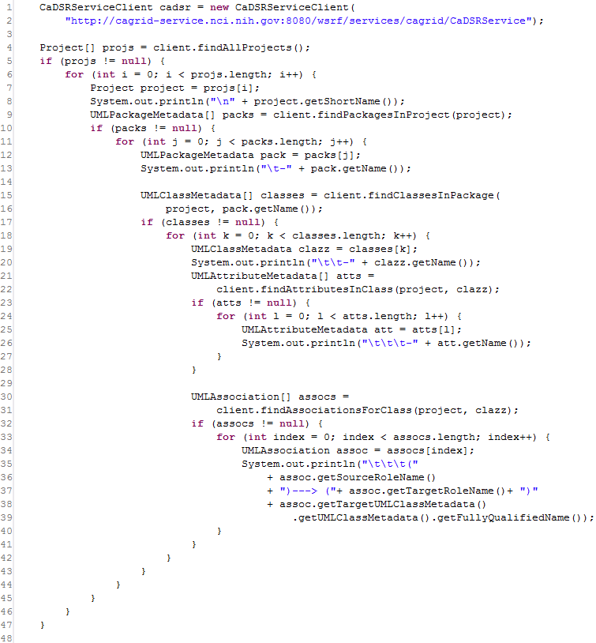
Figure 4-25 Navigating projects registered in the caDSR

Generating Data Service Metadata
As described above, there are four operations which provide the ability to generate instances of caGrid standard Data Service metadata. Three examples of using this capability are shown below, wherein the resulting DomainModel is written to a local file, and some basic information about the model is printed to the screen. It should be noted that most users will not need to make use of these APIs, as the Introduce toolkit automatically does this for them when creating a Data Service, using the appropriate information based on the configuration of the service.
The first example, shown in Figure 4-26, demonstrates how to create metadata which describes an entire Project being exposed; in this case the 3.1 version of caCORE. Lines 4-6 demonstrate the construction of a “prototype” Project instance, which describes the Project being exposed. Then, in line 8, this is passed to the generateDomainModelForProject operation of the caDSR grid service, and the resulting metadata instance is returned. This is the simplest of the Data Service metadata generation operations, and does not allow for configuration or restriction of the model. However, the resulting object could then be manipulated by the client appropriately.
The following lines (10-19) are common to all the following examples and show how the DomainModel can be written to a local file (lines 10-13), and how the model can be inspected as a Java Bean. Line 17 shows how the descriptions of the Associations of the model are accessed, and line 19 shows how the descriptions of the exposed Classes can be accessed.
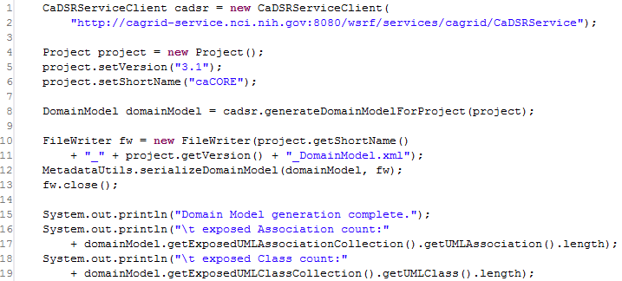
Figure 4-26 Generating a Domain Model for a Whole Project
The next example, shown in Figure 4-27, demonstrates how a metadata instance that describes exposing a subset of a Project can be created. In this case, on line 9, an array of package names, containing only caBIO, is constructed and passes to the generateDomanModelForPackages operation. This operation restricts the returned model to only contain Classes that are in the specified package(s), and Associations between those Classes.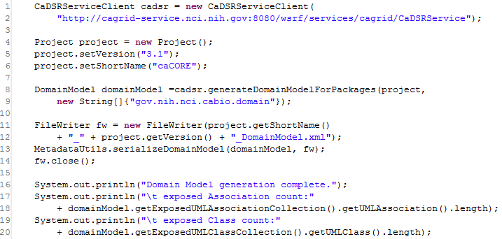
Figure 4-27 Generating a domain model for a package
The final example, shown in Figure 4-28, demonstrates the most powerful domain model generation operation, which allows the explicit specification of the Classes which are being exposed and the restriction of Associations between those Classes. Shown in lines 8 and 9, an array of Class names is constructed, in this case the generated model will specify the Data Service is only exposing 4 classes: Gene, Chromosome, Taxon, and Tissue. If we generated a model using these Classes, all Associations between them would be included. However, in the example some of these Associations are specified to be excluded from the model, signifying clients may not query over these associations. Lines 10 and 11, first show the construction of an AssociationExclude that explicitly specifies to exclude the Association from Gene to Chromosome where Gene is the source, with the role “geneCollection” and Chromosome is the target with “chromosome” as the role. This only matches a single association in the model. Next, in lines 12-13, a broader exclude is constructed which specifies that an Association with Tissue as the target should be excluded. Both these restrictions are then added to an array, in lines 14 and 15, and passed to the service with the Project and Class names on line 16.
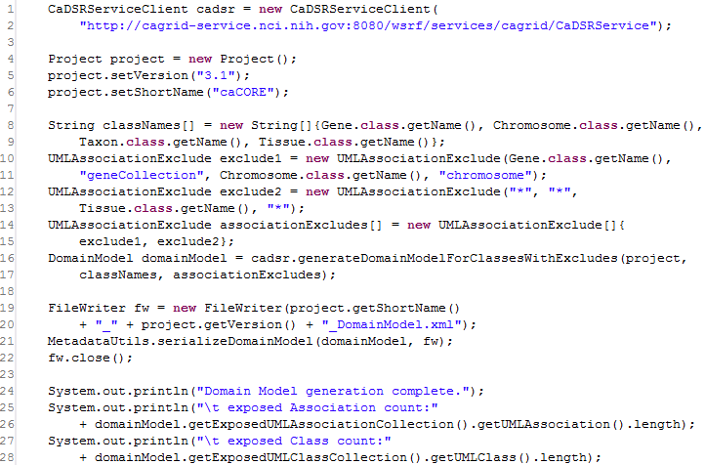
Figure 4-28 Generating a restricted domain model

EVS API Usage Overview
The following link provides a reference to the technical architecture and design document(s) for the EVS API:

http://gforge.nci.nih.gov/plugins/scmcvs/cvsweb.php/~checkout~/cagrid-1-0/Documentation/docs/evs/EVS%20Grid%20Service%20Design%20and%20Implementation.doc?rev=1.4;content-type=application%2Foctet-stream;cvsroot=cagrid-1-0

getMetaSources
This API provides a list of vocabularies presented by the NCI Metathesaurus. The NCI Metathesaurus maps terms from one standard vocabulary to another, facilitating collaboration, data sharing and data pooling for clinical trials and scientific data services. The Metathesaurus is based on the National Library of Medicine’s (NLM) Unified Medical Language System (UMLS) and is composed of over 70 biomedical vocabularies.
Input:
None
Output:
gov.nih.nci.evs.domain.Source[]
Exception:
RemoteException

Examples of Use
The following is an example of the java client code invoking the API:
EVSGridServiceClient client = new EVSGridServiceClient(endpoint);
gov.nih.nci.evs.domain.Source[] sources = client.getMetaSources();
where endpoint provides an Endpoint Reference (EPR) to the EVS core grid service deployed on caGrid.

getVocabularyNames
This API provides a list of vocabularies whose concepts are programmatically accessible to the users via the Description Logic representation. All the vocabularies that are accessible via the caCORE 3.1 EVS API are supported by this API.
Input:
None
Output:
gov.nih.nci.cagrid.evs.service.DescLogicConceptVocabularyName []
Exception:
RemoteException

Examples of Use
The following is an example of the java client code invoking the API:
EVSGridServiceClient client = new EVSGridServiceClient(endpoint);
gov.nih.nci.cagrid.evs.service.DescLogicConceptVocabularyName[] dlcNames = client.getVocabularyNames();
where endpoint provides an Endpoint Reference (EPR) to the EVS core grid service deployed on caGrid.

searchDescLogicConcept
This API provides access to concepts and terms that are published by the vocabularies using the Description Logic representation and exposed via the caCORE 3.1 EVS API.
The input to the API (EVSDescLogicConceptSearchParams) consists of appropriate vocabulary to query for concepts (vocabularyName), the concept name or code to search (searchTerm) and a tuning parameter (limit) to restrict the amount of objects returned by the API.
The API returns an array of Description Logic concepts with most of the attributes populated. The user can navigate associated data based on the caCORE 3.1 EVS domain model.
Input:
gov.nih.nci.cagrid.evs.service.EVSDescLogicConceptSearchParams
Output:
gov.nih.nci.evs.domain.DescLogicConcept[]
Exception:
RemoteException
InvalidInputExceptionType

Examples of Use
The following is an example of the java client code invoking the API:
EVSDescLogicConceptSearchParams evsSearchParams = new EVSDescLogicConceptSearchParams();
evsSearchParams.setVocabularyName("NCI_Thesaurus");
evsSearchParams.setSearchTerm(searchTerms[count]);
evsSearchParams.setLimit(100);
EVSGridServiceClient client = new EVSGridServiceClient(endpoint);
DescLogicConcept[] dlc= client.searchDescLogicConcept(evsSearchParams);
where endpoint provides an Endpoint Reference (EPR) to the EVS core grid service deployed on caGrid.

API-Specific Considerations
The API has the following restrictions:
- Instances of gov.nih.nci.evs.domain.EdgeProperties are not populated currently by the API. These objects are used to specify a relationship between a concept and its immediate parent when a DefaultMutableTree is generated. The caGrid EVS 1.0 service is not required to support the generation of a Tree.
- Instances of gov.nih.nci.evs.domain.Qualifier are not populated by the caGrid EVS 1.0 service.
- Instances of gov.nih.nci.evs.domain.TreeNode are not populated by the caGrid EVS 1.0 service.

Exception Handling
The API validates inputs and throws InvalidInputExceptionType if any of the following invalid values are present in the input to the API:
- If the input instance EVSDescLogicConceptSearchParams is null.
- If the value of the tuning parameter(limit) is less than or equal to zero.
- If vocabulary name (vocabularyName) is not set (null or empty string) or the vocabulary name is not present in the list of available vocabularies supported by caCORE 3.1 EVS API for concepts based on Description Logic representation.

getHistoryRecords
This API provides a complete History for concepts and traces the evolution of concepts as they are created, merged, modified, split, or retired. This history mechanism is provided completely for the NCI Thesaurus and is published by the NCI EVS team. For all other vocabularies that provide concepts based on Description Logic representation, a dummy value for History is provided.
The input to the API (EVSHistoryRecordsSearchParams) consists of appropriate vocabulary to query for concepts (vocabularyName) and a valid concept code to search (conceptCode).
The API returns an array of History records for the specified Description Logic Concept with attributes populated. The user can navigate associated data based on the caCORE 3.1 EVS domain model.
Input:
gov.nih.nci.cagrid.evs.service.EVSHistoryRecordsSearchParams
Output:
gov.nih.nci.evs.domain.HistoryRecord[]
Exception:
RemoteException
InvalidInputExceptionType

Examples of Use
The Following is an example of the java client code invoking the API:
EVSHistoryRecordsSearchParams evsHistoryParams = new EVSHistoryRecordsSearchParams();
evsHistoryParams.setVocabularyName("NCI_Thesaurus");
evsHistoryParams.setConceptCode("C16612");

EVSGridServiceClient client = new EVSGridServiceClient(endpoint);
HistoryRecord[] historys = client.getHistoryRecords(evsHistoryParams);
where endpoint provides an Endpoint Reference (EPR) to the EVS core grid service deployed on caGrid.

API-Specific Considerations
None

Exception Handling
The API validates inputs and throws InvalidInputExceptionType if any of the following invalid values are present in the input to the API:
- If the input instance EVSHistoryRecordsSearchParams is null.
- If the concept code (conceptCode) is not set (null or empty string) or an invalid concept code is passed to the API. All concept codes are expected to start with the letter “C”.
- If the vocabulary name (vocabularyName) is not set (null or empty string) or the vocabulary name is not present in the list of available vocabularies supported by caCORE 3.1 EVS API for concepts based on Description Logic representation.

searchMetaThesaurus
This API provides access to concepts that are supported by the NCI Metathesaurus. The input to the API (EVSMetaThesaurusSearchParams) consists of a search term or a concept unique identifier (CUI) (searchTerm), a valid Metathesaurus source (source), and tuning parameters to control the amount of results (limit, shortResponse and score). The API returns an array of concepts from the Metathesaurus with all the attributes populated and the user can navigate associated data based on the caCORE 3.1 EVS domain model.
Input:
gov.nih.nci.cagrid.evs.service.EVSMetaThesaurusSearchParams
Output:
gov.nih.nci.evs.domain.MetaThesaurusConcept[]
Exception:
RemoteException
InvalidInputExceptionType

Examples of Use
The following is an example of the java client code invoking the API:
EVSMetaThesaurusSearchParams evsMetaThesaurusSearchParam = new EVSMetaThesaurusSearchParams();
evsMetaThesaurusSearchParam.setLimit(100);
evsMetaThesaurusSearchParam.setSource("*");
evsMetaThesaurusSearchParam.setCui(false);
evsMetaThesaurusSearchParam.setShortResponse(false);
evsMetaThesaurusSearchParam.setScore(false);
EVSGridServiceClient client = new EVSGridServiceClient(endpoint);
MetaThesaurusConcept[] metaConcept = client.searchMetaThesaurus(metaParams);
where endpoint provides an Endpoint Reference (EPR) to the EVS core grid service deployed on caGrid.

API-Specific Considerations
The API has the following constraints:
- The source input to the API has to be a valid metathesaurus source abbreviation (present in the list from the API getMetaSources. A value of “*” indicates that the search term will be queried against ALL available sources.
- Search term refers to the concept “name” to be searched in the appropriate source or all sources as indicated above.
- The appropriate settings of the tuning parameters to indicate whether the search term is a Concept Unique Identifier (CUI) or a regular search term. If the search term is a CUI, then, the search term is validated to adhere to the following restrictions:
  - The CUI begins with the letter “C”
  - The CUI has a maximum length of 8 characters

Exception Handling
The API validates inputs and throws InvalidInputExceptionType if any of the following invalid values are present in the input to the API:
- If the input instance EVSMetaThesaurusSearchParams is null.
- If the search term (searchTerm) is not set (null or empty).
- If the search term is a CUI, then if an invalid CUI is passed to the API. All CUIs are expected to start with the letter “C” and are 8 characters long.
- If the value of the tuning parameter (limit) is less than or equal to zero.
- If the Metathesaurus source abbreviation (source) is not set (null or empty string) or the source is not present in the list of available vocabularies supported by caCORE 3.1 EVS API ( “*” is valid source abbreviation indicating ALL sources)

searchSourceByCode
This API provides access to concepts that are supported by the NCI Metathesaurus. The input to the API (EVSSourceSearchParams) consists of a concept unique identifier (CUI) (code) and a valid Metathesaurus source (source). The API returns an array of concepts from the Metathesaurus with all the attributes populated and the user can navigate associated data based on the caCORE 3.1 EVS domain model.
Input:
gov.nih.nci.cagrid.evs.service.EVSSourceSearchParams
Output:
gov.nih.nci.evs.domain.MetaThesaurusConcept[]
Exception:
RemoteException
InvalidInputExceptionType

Examples of Use
The following is an example of the java client code invoking the API:
EVSSourceSearchParams evsSourceParam = new EVSSourceSearchParams();
evsSourceParam.setCode("0000001800");
evsSourceParam.setSourceAbbreviation("AOD2000");
EVSGridServiceClient client = new EVSGridServiceClient(endpoint);
MetaThesaurusConcept[] mC = client.searchSourceByCode(evsSourceParam);
where endpoint provides an Endpoint Reference (EPR) to the EVS core grid service deployed on caGrid.

API-Specific Considerations
The API will take following input:
- A valid MetaThesaurus source abbreviation (present in the list from the API getMetaSources). The ALL sources value of “*” is not permitted for this API.
- A valid value for “code”. Some of the concepts in the MetaThesaurus do not have code associated with them and are displayed in the NCI Meta Thesaurus Browser with the value of “NOCODE”. The “NOCODE” value is not valid input for the API.

Exception Handling
The API validates inputs and throws InvalidInputExceptionType if any of the following invalid values are present in the input to the API:
- If the input instance EVSSourceSearchParams is null.
- If the concept code (code) is not set (null or empty) or has the value “NOCODE”.
- If the Metathesaurus source abbreviation (source) is not set (null or empty string) or the source is not present in the list of available vocabularies supported by caCORE 3.1 EVS API.

caGrid Security
This chapter describes using Dorian and Grid Grouper as part of caGrid security.
Topics in this chapter include:
- Dorian Overview on this page
- Grid Grouper Overview on page 81

Dorian Overview
Managing users and provisioning accounts in the grid is complex. The Globus Toolkit implements support for security via its Grid Security Infrastructure (GSI). The GSI utilizes X509 Identity Certificates for identifying a user. An X509 Certificate with its corresponding private key forms a unique credential or so-called “grid credential” within the Grid. Since Grid credentials are long term credentials and are not directly used in authenticating users to the grid, a short term credential called a grid proxy is used instead. Grid proxies consist of a private key and a corresponding long term certificate signed by the long term grid credential private key. A grid proxy is an extension to traditional X509 certificates providing the ability to delegate your credentials to other services, as in the case of a workflow for example. Although this approach is effective and secure, it is difficult to manage in a multi-institutional environment., The provisioning of grid credentials is a manual process using the base Globus Toolkit, which is far too complicated for users. The overall process is further complicated if a user wishes to authenticate from multiple locations, as a copy of their private key and certificate has to be present at every location. Not only is this process complicated, securely distributing private keys is error prone and poses a security risk. There are also many complexities in terms of provisioning user accounts in an environment consisting of tens of thousands of users from hundreds of institutions, each of which most likely has a user account at their home institution. A practical solution to this problem for both users and their institutions is to allow users to authenticate with the grid through the same mechanism in which they authenticate with their institution. Dorian is a grid user management service that (1) hides the complexities of creating and managing grid credentials from the users and (2) provides a mechanism for users to authenticate using their institution’s authentication mechanism, assuming a trust agreement is in place between Dorian and the institution.
Dorian provides a complete Grid-enabled solution, based on public key certificates and SAML, for managing and federating user identities in a Grid environment. Grid technologies have adopted the use of X509 identity certificates to support user authentication. The Security Assertion Markup Language (SAML) has been developed as a standard for exchanging authentication and authorization statements between security domains. Note that Grid certificates and SAML assertions serve different purposes. SAML is mainly used between institutions for securely exchanging authentication information coming from trusted identity providers. The primary use of the certificates is to uniquely identify Grid users, facilitate authentication and authorization across multiple resource providers, and enable secure delegation of credentials such that a service or a client program can access resources on behalf of the user. A salient feature of Dorian is that it provides a mechanism for the combined use of both SAML and Grid certificates to authenticate users to the Grid environment through their institution’s authentication mechanism.
One of the challenges in building an identity management and federation infrastructure is to create an architecture that incorporates multiple differing authentication mechanisms used by various institutions. In addressing this challenge we identify two possible approaches. The first is to build an infrastructure that would allow pluggable authentication modules, wherein a module would be developed for each authentication mechanism. In this architecture, a user’s authentication information would be routed to the appropriate module that contains the logic for authenticating the user with its institution. Although this approach solves the problem, it requires at least one module be developed for each authentication mechanism. This would require the Grid infrastructure administrators to become intimately familiar with each institution’s authentication mechanisms, and would increase the system’s complexity with each new module added.
Another approach is for the infrastructure to accept an institutionally-supplied, standard “token” as a method of authentication. In this approach users would first authenticate with their institution’s identity management system. Upon successful authentication, the institution’s identity management system issues a token which can then be given to the federated grid identity management system in exchange for grid credentials. The benefit of this approach over the first is that it does not require writing a plug-in every time a new institutional authentication mechanism comes online. It does, however, require every institutional authentication system to agree upon and be able to provide a common token. As SAML has been adopted by many institutions, we have chosen that token format as the basis of the second approach for Dorian.
The Security Assertion Markup Language (SAML) is an XML standard for exchanging authentication and authorization data between security domains. Generally the exchange of authentication and authorization data is made between an Identity Provider (IdP) and another party. An institution’s authentication system or identity management system is an example of an IdP. Dorian uses SAML authentication assertions as the enabling mechanism for federating users from local institutions to the grid.
Figure 5-29 illustrates an example usage scenario for Dorian. To obtain grid credentials or a proxy certificate, users authenticate with their institution using the institution’s conventional mechanism. Upon successfully authenticating the user, the local institution issues a digitally signed SAML assertion, vouching that the user has authenticated. The user then sends this SAML assertion to Dorian in exchange for grid credentials. Dorian will only issue grid credentials to users that supply a SAML assertion from a Trusted Identity Provider. Dorian’s grid service interface provides mechanisms for managing trusted identity providers; this will be discussed in greater detail later in this document. For example, in Figure 5-29, when a Georgetown user wishes to invoke a grid service that requires grid credentials, they first supply the application with their username and password to the Georgetown Authentication Service as they would normally do. The application client authenticates the Georgetown user with the Georgetown Authentication Service, receives a signed SAML assertion which it subsequently passes to Dorian in exchange for grid credentials. These credentials can then be used to invoke the grid services. This illustrates how Dorian can leverage an institution’s existing authentication mechanism and bring its users to the grid.
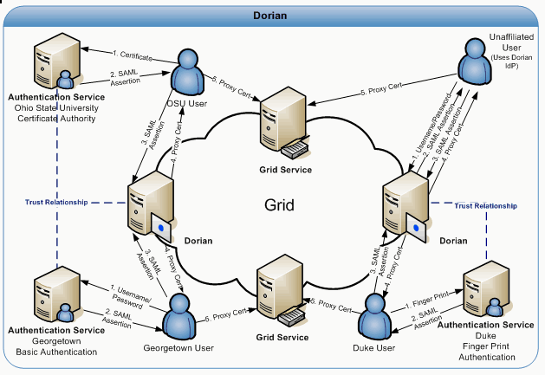
Figure 5-29 Dorian
To facilitate smaller groups or institutions without an existing IdP, Dorian also has its own internal IdP. This allows users to authenticate to Dorian directly, thereby enabling them to access the grid. It provides administrators with facilities for approving and managing users. All of Dorian IdP’s functionality is made available through a grid service interface. Details of the Dorian IdP are provided later in this document. Figure 5-29 illustrates a scenario of a client using the Dorian IdP to authenticate to the Grid. In this scenario, the unaffiliated User wishes to invoke a grid service. Given that this unaffiliated user has registered and been approved for an account, she is able to authenticate with the Dorian IdP by supplying their username and password. Upon successfully authenticating the user, the Dorian IdP issues a SAML Assertion just like institutional IdPs, which can be presented to Dorian in exchange for grid credentials. The credentials can be used to invoke the grid service.

Creating a Grid Proxy Programmatically
Figure 5-30 provides an example of how to create a grid proxy programmatically with Dorian. In order to create a grid proxy using Dorian you must first obtain a signed SAML Assertion from an Identity Provider Trusted by Dorian. caGrid’s Authentication Service provides a common interface and client tooling for exposing a local Identity Provider, such that a user may authenticate using their local credentials and obtain a SAML assertion using a common client or AuthenticationClient. Although it is not required to obtain the SAML Assertion from a caGrid Authentication Service, it is the recommended approach and the approach used in Figure 5-30. Besides obtaining a SAML assertion, Dorian also requires the specification of a proxy lifetime and a delegation path length in order to create a grid proxy. The proxy lifetime specifies the amount of time for which the proxy is valid. A proxy lifetime is specified in terms of hours, minutes, and seconds. The delegation path length specifies how many times a proxy can be delegated to other services. Once you have obtained a SAML Assertion and specified a proxy lifetime and delegation path length, you can use Dorian’s IFSUserClient to create a proxy with Dorian.

try{
String authURI = "http://some.service.uri";
String dorianURI = "http://some.dorian.uri";

//Create an instance of my institution provided credentials
Credential localCredential = new Credential();
BasicAuthenticationCredential userPass = new BasicAuthenticationCredential();
userPass.setUserId("MyUserId");
userPass.setPassword("MyPassword");
localCredential.setBasicAuthenticationCredential(userPass);

//User the caGrid common authentication client to authenticate with the local
//IdP and obtain a SAML Assertion

AuthenticationClient auth = new AuthenticationClient(authURI, localCredential);
SAMLAssertion saml = auth.authenticate();

//Specify the lifetime of the desired proxy
ProxyLifetime lifetime = new ProxyLifetime();
lifetime.setHours(12);
lifetime.setMinutes(0);
lifetime.setSeconds(0);

//Specify the delegation path length of the desired proxy
int delegationPathLength = 0;

//Now Create a proxy using the Dorian IFS User Client
IFSUserClient client = new IFSUserClient(dorianURI);
GlobusCredential proxy = client.createProxy(saml, lifetime, delegationPathLength);

//Now specify to Globus to use the aquired proxy as the default credentials
ProxyUtil.saveProxyAsDefault(proxy);
}catch(Exception e){
e.printStackTrace();
}
Figure 5-30 Programmatically creating a grid proxy with Dorian

Grid Grouper Overview
Grid Grouper provides a group-based authorization solution for caGrid, where grid services and applications enforce authorization policy based on membership to groups defined and managed at the grid level. Grid Grouper is built on top of Grouper, an internet2 initiative focused on providing tools for group management. Grouper is a java object model which currently supports: basic group management by distributed authorities; subgroups; composite groups (whose membership is determined by the union, intersection, or relative complement of two other groups); custom group types and custom attributes; trace back of indirect membership; and delegation. Applications interact with Grouper by embedding the Grouper’s java object model within applications. Grouper does not provide a service interface for accessing groups. Grid Grouper (Figure 5-31) is a grid-enabled version of Grouper, providing a web service interface to the Grouper object model. Grid Grouper make groups managed by Grouper available and manageable to applications and other services in the grid. Grid Grouper provides an almost identical object model to the Grouper object model on the grid client side. Applications and services can use the Grid Grouper object model much like they would use the Grouper object model to access and manage groups as well as enforce authorization policy based on membership to groups. Grid Grouper provides a fully functional administrative UI for accessing and administrating groups in Grid Grouper.
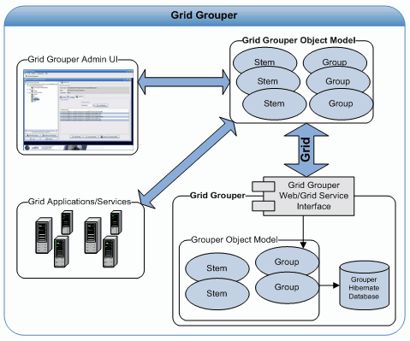
Figure 5-31 Grid Grouper
In Grouper/Grid Grouper groups are organized into namespaces or stems. Each stem can have a set of child stems and a set of child groups with exception to the root stem which cannot have any child groups. The Stem hierarchy in Grid Grouper is publicly visible to anyone accessing the service; however the ability to view a group within a stem publicly depends on the privileges for the group. A Stem can have two types of privileges associated with it; the “Stem Privilege” and the “Create Privilege”. Users with the “Stem Privilege” can create, modify, and remove child stems. Users with the “Create Privilege” can create, modify, and remove child groups.
In Grouper/Grid Grouper groups are comprised of a set of metadata describing the group, a set of members in the groups, and a set of privileges assigned to users for protecting access to the group. Grid Grouper provides three mechanisms for adding members to a group: 1) directly adding a member 2) adding a subgroup to a group 3) making a group a composite of other groups. Directly adding a user as a member to a group is straight forward and these members are referred to as “Immediate Members”. Adding a subgroup to a group makes all the members of the subgroup members of the group in which the subgroup was added. Members in a group whose membership is granted by membership in a subgroup are referred to as “Effective Members”. A group can also be set up as a Composite group, which consists of a set operation (union, intersection, or complement) on two other groups. For example a composite group consisting of the intersection of Group X and Group Y would contain all the members that are both members of Group X and Group Y. Members whose membership is granted through a composite group are referred to as “Composite Members”.
To protect access to groups in Grid Grouper, users can be assigned the following privileges on a group: View, Read, Update, Admin, Optin, and Optout. Users with the View privilege can see that the group exists. Users with the Read privilege can read basic information about the group. Users with the Update Privilege can manage memberships to the group as well as administer View, Read, and Update privileges. Users with the Admin privilege can modify/administer anything on the group: metadata, privileges, and memberships. Users with the Optin privilege can add themselves as a member to a group; similarly users with the Opout privilege can remove themselves from a group. By default Grid Grouper grants Read and View privileges to all users on each group.
Initially Grid Grouper has a root stem with one child stem named “Grouper Administration” (grouperadministration). The Grouper Administrative stem contains one group named “Grid Grouper Administrators” (grouperadministration:gridgrouperadministrators). The “Grid Grouper Administrators” is the super user group for Grid Grouper, all members of this group will have admin privileges on all the stems and groups within Grid Grouper. This group is initially empty, but at least one administrative user must be added during Grid Grouper installation. This can be done using the GridGrouperBootstrapper command line tool.

Grid Grouper Object Model
The Grid Grouper object model provides an API for applications and services to access groups managed by Grid Grouper. The object model can be used to enforce access control policies in applications. For example, the object model can be used for determining membership to a group in an application that allows access to a specific area of the application if the user is a member of a specified group. The Grouper object model can also be used to administrate Grid Grouper. As a testament to this, the Grid Grouper Admin UI application was built on top of the Grid Grouper object model. The Grid Grouper object model consists of several objects: GridGrouper, Stem, Group, Member, Membership, NamingPrivilege, and AccessPrivilege. The GridGrouper object corresponds to an instance of a Grid Grouper service; it provides high level operations such as finding stems and groups or determining whether or not a user is a member of a group, etc. The Stem object represents an instance of a stem within Grid Grouper. The Stem object provides operations for managing the stem: viewing metadata, managing child stems, managing child groups, managing stem privileges, etc. The Group object models a group instance within Grid Grouper, providing operations for managing metadata, managing privileges, and managing members. The remainder of this section will provide several code examples of performing common tasks with the Grid Grouper object model.

Determining if a Subject is a Member of a Group

try {
String uri ="https://localhost:8443/wsrf/services/cagrid/GridGrouper";
String user = "/O=OSU/OU=BMI/OU=caGrid/OU=Dorian/OU=cagrid05/CN=jdoe";
String group = "MyStem:MyGroup";

//Create a Grid Grouper Instance
GrouperI grouper = new GridGrouper(uri);

//Determiner if the user is a member of the group.
boolean isMember = grouper.isMemberOf(user, group);

if(isMember){
System.out.println("The user "+user+" is a member of "+group);
}else{
System.out.println("The user "+user+" is NOT a member of "+group);
}
} catch (Exception e) {
e.printStackTrace();
}

Listing All Members of a Group
try {
String uri = "https://localhost:8443/wsrf/services/cagrid/GridGrouper";
String group = "MyStem:MyGroup";

// Create a Grid Grouper Instance
GrouperI grouper = new GridGrouper(uri);

// Obtain a handle to the group object.
GroupI mygroup = grouper.findGroup(group);

Set s = mygroup.getMembers();
Iterator itr = s.iterator();
//Iterate over and print out the members of the group
while (itr.hasNext()) {
Member m = (Member) itr.next();
System.out.println("The user " + m.getSubjectId()
+ " is a member of " + mygroup.getDisplayExtension());
}
} catch (Exception e) {
e.printStackTrace();
}

Adding a Member to a Group
try {
//Group Administrators Grid Credentials
GlobusCredential adminProxy = ProxyUtil.getDefaultProxy();
String uri = "https://localhost:8443/wsrf/services/cagrid/GridGrouper";
String newMember = "/O=OSU/OU=BMI/OU=caGrid/OU=Dorian/OU=cagrid05/CN=jdoe";
String group = "MyStem:MyGroup";

// Create a Grid Grouper Instance
GrouperI grouper = new GridGrouper(uri,adminProxy);

// Obtain a handle to the group object
GroupI mygroup = grouper.findGroup(group);

//Add the member to the group
mygroup.addMember(SubjectUtils.getSubject(newMember));

System.out.println("Successfully added the user " + newMember + " as a member of the group " + group);
} catch (Exception e) {
e.printStackTrace();
}

Removing a Member from a Group
try {
//Group Administrators Grid Credentials
GlobusCredential adminProxy = ProxyUtil.getDefaultProxy();
String uri = "https://localhost:8443/wsrf/services/cagrid/GridGrouper";
String member = "/O=OSU/OU=BMI/OU=caGrid/OU=Dorian/OU=cagrid05/CN=jdoe";
String group = "MyStem:MyGroup";

// Create a Grid Grouper Instance
GrouperI grouper = new GridGrouper(uri,adminProxy);

// Obtain a handle to the group object
GroupI mygroup = grouper.findGroup(group);

//Remove the member to the group
mygroup.deleteMember(SubjectUtils.getSubject(member));

System.out.println("Successfully removed the user " + member + "from the group " + group);
} catch (Exception e) {
e.printStackTrace();
}

caGrid Data Services
This chapter describes the caGrid Data Services infrastructure.
Topics in this chapter include:
- Overview on this page
- Utility Classes on page 96
- Validation Tools on page 98
- CQL Query Processors on page 100
- Service Styles Architecture on page 102
- Federated Query Processor Usage Overview on page 104
- API Details on page 108

Overview
caGrid Data Services provide an object view of a data resource across the grid. The data resource is exposed through a well defined query method, which also relies on well defined query language objects to perform queries and return results as a strongly typed set. caGrid Data Services are designed to expose objects whose XML schemas are registered in the GME, and also expose metadata about those data objects derived from the caDSR.
Data Services also provide support for integration with alternate results delivery mechanisms such as WS-Enumeration and caGrid’s Bulk Data Transport framework. Enabling these features adds new query methods to the Grid-facing API.

CQL
CQL (Common/caGrid Query Language) is the caGrid query language used for all data services, and is defined in an XML document conforming to a well defined schema with the URI http://CQL.caBIG/1/gov.nih.nci.cagrid.CQLQuery.
The CQL Schema consists of the following man components:
- CQL Query
  - A simple wrapper element at the head of every CQL query document. It contains the target element.
- Target
  - The Target element is of the type Object, and describes the data type which the query will return.
- QueryModifier
  - An optional element modifying the returned result set. This modifier has a required attribute ‘countOnly’ which can tell the data service to return the number of results the query would return. The modifier optionally allows for a choice of a list of Attribute Names or a single Distinct Attribute to return. When the list of attribute names is specified, sets of tuples are returned containing the attribute names and corresponding values for each object instance returned by the query. When distinct attribute is used, only unique attribute values are placed in the returned attribute sets.
- Object
  - The Object element contains the required attribute ‘name.’ This attribute’s value defines the caDSR class of the object. When the Object is the top level target of a CQL query, it identifies the data type that will be returned by the caGrid Data Service. The Object allows for a choice between three child elements. The possible child elements are Attribute, Association, and Group. Objects may have at most one of these child elements.
- Attribute
  - An Attribute type in CQL describes a restriction for an attribute of an Object. The Attribute contains three XML attributes, which define the restriction. The attribute ‘name’ defines the name of the attribute to be restricted. The attribute ‘value’ defines the restriction on the attribute. The attribute ‘predicate’ describes what type of restriction the Attribute defines. Allowable predicates are defined by the schema’s simple type ‘Predicate’, which defines an enumeration of allowable values. The predicate values are generally self-descriptive: “EQUAL_TO", “NOT_EQUAL_TO", “LIKE", "LESS_THAN", "LESS_THAN_EQUAL_TO", “GREATER_THAN", and “GREATER_THAN_EQUAL_TO." Two additional predicates, "IS_NOT_NULL", and “IS_NULL" check only for the presence or absence, respectively, of an attribute, and do not restrict its value at all. Therefore, any ‘value’ attribute will be ignored when using these predicates.
- Association
  - An association describes a related Object, which defines the associated Object’s restrictions for the query, as well as the relationship from one object to another. Specifically, it defines the relationship down the object model tree. The Association complex type is an extension of Object. The Association has a single, optional attribute named ‘roleName.’ This attribute identifies which associated object field the Association is defining. For example, a person may have more than one address, perhaps business and home. To perform a restriction against the home address, a query must specify the home address role name for the associated object. If the query omits the role name, such a query becomes ambiguous, as there is more than one field of Person which has a type of Address. In this case, the data service will throw a MalformedQueryException explaining that the requested association is ambiguous. In the case of an object where there is only one field of a given type, the roleName attribute may be omitted, and the data service will resolve the correct name as the query is processed.
- Group
  - Groups define logical joints of two or more conditions, and operate against the Object to which they are attached. Groups must have two or more children, which may be a mixture of type Attribute, Association, or Group. Groups also have an attribute named ‘logicOperator,’ whose type is defined in the schema’s simple type LogicalOperator. This type is an enumeration of the values “AND” and “OR.” The operator is applied to all children in the group. The “AND” operator requires that all conditions in the group be true for the group to evaluate as true. The “OR” operator requires that any condition in the group evaluate as true.

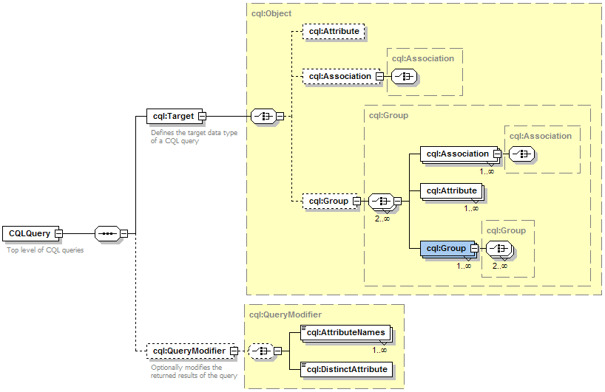
Figure 32 CQL Schema
Several example CQL queries can be found on the caGrid wiki at: http://www.cagrid.org/mwiki/index.php?title=Data_Services:CQL

Generic Data Service Clients
The caGrid Data Services infrastructure supplies three basic client classes which can be used to invoke any arbitrary caGrid Data Service. This capability is due to the query methods of all data services being defined in a common, well known WSDL which each unique service instance imports.
The basic data service client, which is capable of invoking any caGrid Data Service, is the class gov.nih.nci.cagrid.data.client.DataServiceClient. The class defines the query() method, which takes a CQL Query as its single parameter and returns a CQL Query Results instance. A sample usage of this class is provided below:
import gov.nih.nci.cagrid.common.Utils;
import gov.nih.nci.cagrid.cqlquery.CQLQuery;
import gov.nih.nci.cagrid.cqlquery.Object;
import gov.nih.nci.cagrid.cqlresultset.CQLQueryResults;
import gov.nih.nci.cagrid.data.DataServiceConstants;

public class SampleDataServiceInvocation {

public static void main(String[] args) {
try {
DataServiceClient client = new DataServiceClient(args[0]);
CQLQuery query = new CQLQuery();
Object target = new Object();
target.setName("some.class.name");
query.setTarget(target);
CQLQueryResults results = client.query(query);
Utils.serializeDocument("myResults.xml", results,
DataServiceConstants.CQL_RESULT_COLLECTION_QNAME);
} catch (Exception ex) {
ex.printStackTrace();
System.exit(1);
}
}
}
This small sample will create a new data service client using a URL specified on the command line and submit a query to it for all objects of the type “some.class.name”. The results will be stored on disk in an XML document named “myResults.xml”. The DataServiceConstants class used in this example provides static Strings and QNames used throughout the data service infrastructure. The constant CQL_RESULT_COLLECTION_QNAME is the QName which defines the XML type for result sets returned from the data service’s query method.
Additionally, the caGrid Data Services infrastructure provides clients that can connect to data services which support WS-Enumeration and the caGrid Bulk Data Transfer infrastructure. Respectively, these clients are gov.nih.nci.cagrid.data.enumeration.client.EnumerationDataServiceClient and gov.nih.nci.cagrid.data.bdt.client.BDTDataServiceClient. These clients provide public APIs which return an EnumerationContext instance or a BulkDataHandlerReference respectively. These return types may be used to start up an instance of the Globus provided ClientEnumIter class, or make use of the caGrid Bulk Data Transfer Client directly.
The client classes provided with the data service infrastructure, as well as any other clients generated by the Introduce toolkit, should not be assumed to be thread safe. Each thread communicating with a data service should have its own instance of the client class. Since client instances are unique, multiple data service clients may be used within the same thread or JVM to communicate with multiple data services simultaneously.

Client Side Utilities
The caGrid Data Services infrastructure provides a number of utility classes to make invocation of remote data services a simpler process for the application developer. The package gov.nih.nci.cagrid.data.utilities contains utilities can invoke standard, enumeration, and BDT data services, as well as tools for handling domain models and working with wsdd and castor mapping files.
The interface DataServiceIterator specifies a single query() method, which takes a CQL Query and returns an instance of java.util.Iterator. The iterator can be used to walk through the results of a query issued to a data service. Three concrete implementations of the DataServiceIterator interface are provided, each for communicating with a different type of data service. The DataServiceHandle class can be used to invoke a standard caGrid Data Service, while the EnumerationDataServiceHandle and BdtDataServiceHandle classes are designed for WS-Enumeration and Bulk Data Transfer supporting data services, respectively.
Additionally, this package contains an Iterator utility for handling CQLQueryResults instances. The class CQLQueryResultsIterator implements java.util.Iterator, and has three constructors. The choice of constructor affects the behavior of calling the next() method.
- CQLQueryResultsIterator(CQLQueryResults)
  - Creates an Iterator over the results which will return materialized objects deserialized using the default type mappings.
- CQLQueryResultsIterator(CQLQueryResults, Boolean)
  - Creates an Iterator over the results, and the value of the Boolean parameter indicates if XML strings should be returned from the next() method. If the Boolean value is true, XML text of each item is returned, otherwise the results will be deserialized using the default type mappings.
- CQLQueryResultsIterator(CQLQueryResults, InputStream)
  - Creates an Iterator over the results, and expects the InputStream will point to a client or server side wsdd. The contents of this wsdd file will be used to configure deserialization of the objects contained in the results.

Creating a Query
Data services in caGrid use CQL to compose queries. A query can be produced programmatically, building up parts of the query using the supplied object model:
gov.nih.nci.cagrid.cqlquery.CQLQuery query =
new gov.nih.nci.cagrid.cqlquery.CQLQuery();
gov.nih.nci.cagrid.cqlquery.Object target =
new gov.nih.nci.cagrid.cqlquery.Object();
target.setName(gov.nih.nci.cabio.domain.Gene.class.getName());
gov.nih.nci.cagrid.cqlquery.Attribute symbolAttribute =
new gov.nih.nci.cagrid.cqlquery.Attribute(
"symbol",
gov.nih.nci.cagrid.cqlquery.Predicate.LIKE,
"IL%");
target.setAttribute(symbolAttribute);
query.setTarget(target);
Alternatively, a CQL query can be loaded from a string of XML text or an XML file on disk and deserialized into the object model:
// from a string
CQLQuery query2 = (CQLQuery) gov.nih.nci.cagrid.common.Utils.deserializeObject(
new StringReader("<CQLQuery ... />"), CQLQuery.class);
// from a file
CQLQuery query3 = (CQLQuery) gov.nih.nci.cagrid.common.Utils.deserializeObject(
new FileReader(cqlFile), CQLQuery.class);

Query Result Iteration
When a query is performed using the standard caGrid Data Service client’s query method, a CQLQueryResults object is returned. This object is a container for both the results themselves and some information pertaining to their type. This container can contain object results, attribute name/value pairs, caBIG identifiers (not yet implemented), or a count of the total number of items in the result set. The difficulty of manipulating a container which may have such a wide variety of result types stored in it is handled by an iterator class provided with the data service infrastructure.
The class gov.nih.nci.cagrid.data.utilities.CQLQueryResultsIterator implements the java.util.Iterator interface, and so can be used in a while() loop like any other iterator over a Java collection. Depending on what the query to the data service asked for, calls to the next() method of this iterator will return different types of objects.
- If the query was for object results, then:
- The iterator returns objects of the type specified as the target for the query.
- Objects which require custom serialization and/or deserialization require that the iterator be configured with an InputStream to the client-config.wsdd file containing the type mappings for the objects.
- Alternatively, the iterator can be configured to return only the XML representation of those objects.
- If the query was for attribute results, including distinct attributes, then:
- Each successive call to next() returns an array of TargetAttribute types. These types contain the name of an attribute and its value. The value is null if the value was null on the object satisfying the query. Each array of TargetAttributes corresponds to one object instance which satisfied the CQL query criteria.
- If the query was for a count of object instances, then:
- The iterator returns a single java.lang.Long value.
An example usage of this iterator is below:
import gov.nih.nci.cagrid.cqlquery.CQLQuery;
import gov.nih.nci.cagrid.cqlresultset.CQLQueryResults;
import gov.nih.nci.cagrid.data.utilities.CQLQueryResultsIterator;

import java.util.Iterator;

public class SampleDataServiceInvocation {

public static void main(String[] args) {
try {
DataServiceClient client = new DataServiceClient(args[0]);
CQLQuery query = new CQLQuery();
// build up the query
CQLQueryResults results = client.query(query);
Iterator iter = new CQLQueryResultsIterator(results,
SampleDataServiceInvocation.class.getResourceAsStream(
"client-config.wsdd"));
while (iter.hasNext()) {
java.lang.Object result = iter.next();
// do something with the result object
}
} catch (Exception ex) {
ex.printStackTrace();
System.exit(1);
}
}
}

Most Current Information and Examples
The most current information regarding the caGrid Data Services client side APIs and utilities may be found on the caGrid.org wiki page: (http://www.cagrid.org/mwiki/index.php?title=Data_Services:Client_API)

Utility Classes

Utilities
The caGrid data services infrastructure includes several utility classes which can be used to ease development and use of data services. These classes are found in the gov.nih.nci.cagrid.data.utilities package distributed with the data service infrastructure.

CQLResultsCreationUtil
This class provides convenience methods for creating CQLQueryResults objects for object results, attribute results, and a counting result. A convenience method for identifier results may be added in the future. The class provides three public static methods, one for each type of results currently supported.
public static CQLQueryResults createObjectResults(List objects, String targetName, Mappings classToQname)
- objects – a list of Java objects to be placed in a new CQLQueryResults object.
- targetName - the name of the class targeted by the query which produced these object results. All items in the objects list should be of this type.
- classToQname – a mapping from class name to QName. This is a generated Java bean from the XML schema for the data service infrastructure and contains an array of name/value pairs that map class names to QNames.
public static CQLQueryResults createAttributeResults(List attribArrays, String targetClassname, String[] attribNames)
- attribArrays - a List of Object arrays. Each array should have one value for one attribute of an object. These values may be null. The values must be in an order corresponding the ordering of attribute names
- targetClassname - the name of the class targeted by the query which produced these attribute results. All attribute arrays should have some from this type.
- attribNames - the names of the attributes returned by the query. These should be in the same ordering used by the attribute arrays.
public static CQLQueryResults createCountResults(long count, String targetClassname)
- count - the number of resulting items (objects, attribute sets) from a query
- targetClassname - the name of the class which was the target of the query

DataServiceIterator
The data service iterator is an interface which provides for a query to be submitted to a data service and an Iterator over the result set to be returned. There are two implementations of this interface; one for the standard data service and one for data services with enumeration enabled.

DataServiceHandle
The data service handle is the implementation of the data service iterator class for a base caGrid Data Service. It has three constructors, all of which take a DataServiceClient instance. The default constructor needs only this parameter. The other two constructors should be used when custom serialization and deserialization of types has been specified for the service. The extra parameter can be either the filename of a wsdd file containing this mapping information, or an InputStream to the same information.

EnumDataServiceHandle
The enum data service handle is the implementation of the data service iterator interface for a WS-Enumeration enabled caGrid Data Service. It has two constructors, both of which take an enumeration data service client instance. The default constructor needs only this parameter. The second constructor takes an IterationConstraints instance, which contains information about how data should be requested from the enumeration data service.

BdtDataServiceHandle
The BDT data service handle is an implementation of the data service iterator interface to be used with a BDT-enabled caGrid Data Service. Its behavior is the same as that of the enum data service handle, except that it handles the additional invocation of the BDT context to support enumeration internally.

DomainModelUtils
The domain model utils provide a means to extract useful information from a domain model.
public static UMLClass getReferencedUMLClass(DomainModel model, UMLClassReference reference)
To save on document size, domain models do not duplicate class information when an association is defined, but rather use class references based on ID values. These reference values can be traced back to their original UML Class instance with this function.
public static UMLClass[] getAllSuperclasses(DomainModel model, String className)
Superclasses of a UML Class can be determined by traversing UML class references and generalization information. There are two methods which perform this task in the Domain Model Utils class. One uses a class name and the other extracts the name from an UMLClass instance and passes it to the other.

WsddUtil
The wsdd utility class contains functions to set parameters on a wsdd file. This class is used internally to the Introduce data service extension to edit the wsdd files and change the castor mapping file name.
public static void setGlobalClientParameter(String clientWsddFile, String key, String value)
- clientWsddFile - the name of the client side wsdd file to edit. When edits are complete, the changed file is saved to the same location.
- key - the key of the parameter. This is the name by which the parameter can be accessed.
- value - the value stored in the parameter
public static void setServiceParameter(String serverWsddFile, String serviceName, String key, String value)
- serverWsddFile - the name of the server side wsdd file to edit. When edits are complete, the changed file will be saved to the same location
- key - the key of the parameter. This is the name by which the parameter can be accessed
- value - the value stored in the parameter

Validation Tools
The caGrid Data Services infrastructure provides for validation of queries with respect to the domain model exposed by a service and the CQL schema, as well as query results for validity with respect to the exposed data types.

CQL Query Syntax
The caGrid Data Service infrastructure provides mechanisms to validate CQL queries for syntactic correctness. While the Axis engine prevents malformed XML from ever being turned into CQL objects, it does not handle XML that does not conform to certain schema restrictions. For this reason, CQL syntax validation can be enabled on a caGrid data service. This mechanism will reject invalid queries before they ever reach a CQL Query Processor implementation, saving the processor’s developer from having to handle them. This same validation can be performed either on the client side or offline completely by using the query validation utilities. For syntax validation, the interface gov.nih.nci.cagrid.data.cql.validation.CqlStructureValidator is provided, as are two implementations of this interface. The interface provides the validateCqlStructure() method, which takes a single CQLQuery instance parameter, and throws a MalformedQueryException if an error is encountered. The default implementation of this interface is the gov.nih.nci.cagrid.data.cql.validation.ObjectWalkingCQLValidator class. As its name suggests, this class walks through the CQL object model, seeking out inconsistencies with the published CQL schema. This class also has a main() method, which allows it to be run from the command line with a list of CQL query XML files specified as arguments. The data service infrastructure uses this class by default when query validation is enabled. This can be changed for any other class which implements the CqlStructureValidator interface by editing the value of the dataService_cqlValidatorClass service property in a generated data service.

Domain Model Conformance
The Data Service infrastructure also provides mechanisms to validate a structurally sound CQL query against a Domain Model to ensure its restrictions are supported by the domain model’s exposed structure. Doman Model validation may be enabled for a caGrid data service, and will be performed on every query submitted to the service before it is passed to the CQL query processor. The interface gov.nih.nci.cagrid.data.cql.validation.CqlDomainValidator is provided, along with a single implementation. The interface provides the validateDomainModel() method, which takes a single CQLQuery instance parameter, and throws a MalformedQueryException if an error is encountered. The lone implementation provided with the caGrid Data Service infrastructure is the gov.nih.nci.cagrid.data.cql.validation.DomainModelValidator class. Like the CQL validation instance, this class has a main() method, which allows it to be run from a command line. The arguments should be first a domain model XML file, then a list of CQL query files to be validated. The data service infrastructure uses this class when domain model validation is enabled. This implementation may be substituted for another by editing the value of the dataService_domainModelValidatorClass service property in a generated data service.

Results Validation
The data service infrastructure also provides a means to both validate the results of a CQL query against a known set of targets, and determine what target data types are allowed to be returned by a caGrid Data Service. Every data service exposes a schema through its WSDL that enumerates the data types which may be returned by the data service. This schema appears in generated services under the schemas/<ServiceName> directory as <ServiceName>_CQLResultTypes.xsd. The utility class gov.nih.nci.cagrid.data.utilities.validation.CQLQueryResultsValidator has been provided to both retrieve this file and verify that a CQLQueryResults instance conforms to this schema. An instance of this class can be constructed with either the full path to a data service’s WSDL file, or an endpoint reference to a running data service.
The validator exposes two public methods:
public void saveRestrictedCQLResultSetXSD(File fileLocation) throws SchemaValidationException
- fileLocation - a file into which the restriction XSD will be saved.
This method locates the restriction XSD file and saves its contents into the file specified.
public void validateCQLResultSet(CQLQueryResults resultSet) throws SchemaValidationException
- resultSet - a set of results generated by a query into a caGrid Data Service. The object contents of this result set will be processed against the restriction XSD.
The CQLQueryResultsValidator class also has a main() method, which takes two arguments. The first argument is a URL to a caGrid Data Service, which will be used to retrieve the result restriction schema. The second argument should be the filename of a CQLQueryResults instance serialized to an XML document.

CQL Query Processors

Overview
The CQL Query Processor is a pluggable implementation which handles the details of processing CQL against some backend data source and produces a CQLQueryResults instance. The particular implementation used is determined by a value in the service’s deployment properties, and an instance of the processor is loaded at runtime via reflection. The query processor may optionally supply a set of properties via the getRequiredParameters(). These properties may be configured prior to deployment of the service, and are passed into the query processor when it is first instantiated via the initialize() method.
When a query is issued to the data service, the query will be passed along to the CQL Query Processor instance’s processQuery() method. This method may throw both a QueryProcessingException in the case of an error in handling the query and a MalformedQueryException in cases where the query was found to be invalid for any reason.

Implementation
All query processor implementations are required to extend the abstract base class gov.nih.nci.cagrid.data.cql.CQLQueryProcessor. This base class declares several methods which are meant to be overridden, however the only method a query processor is required to implement is the processQuery() method. This method takes a CQL query and returns a CQLQueryResults instance. This method is declared abstract in the base class, which enforces this implementation requirement. Generally, this method should be able to translate CQL into whatever native query language is required by the back end data resource, and translate the result set into a CQLQueryResults instance.
CQL Query Processors are designed to be configurable at runtime by a set of properties. These properties are modifiable via the data service extension to the Introduce toolkit, or manually by editing a configuration file once a service has been built. The base CQL query processor class provides a method to retrieve required configuration parameters and their associated default values.
public Properties getRequiredParameters()
This method is provided by default and returns an empty java.util.Properties instance. CQL implementers who require properties to be configured should override this method to return a populated Properties instance. If a property is optional, its value should be set to an empty string. All property keys must be valid Java identifiers meaning that there cannot be any spaces or punctuation in the key.
The query processor base class has two protected methods which provide access to any user configured parameters and an input stream to the server side wsdd configuration file. The method getConfiguredParameters() returns a java.util.Properties instance containing all the keys defined in the properties returned by getRequiredParameters(), but with either the default or a developer configured value specified for each. The method getConfiguredWsddStream() returns an InputStream instance which will read in the contents of the server side wsdd configuration file. The call to the query processor’s initialize method, and in turn the population of these values, occurs when the data service is first instantiated, typically when the container is started. Calls to these methods before this time will return null. For this reason, the constructor of the CQL Query Processor implementation must be fairly simple, and initialization of any resources required delayed until the initialize() method has been called.
/**
* Processes the CQL Query
* @param cqlQuery
* @return The results of processing a CQL query
* @throws MalformedQueryException
* Should be thrown when the query itself does not conform to the
* CQL standard or attempts to perform queries outside of
* the exposed domain model
* @throws QueryProcessingException
* Thrown for all exceptions in query processing not related
* to the query being malformed
*/
public abstract CQLQueryResults processQuery(CQLQuery cqlQuery)
throws MalformedQueryException, QueryProcessingException;
The only method which is required to be implemented by the CQL query processors is the processQuery() method. This is the method which executes the CQL query against its data source and generates an appropriate set of results. There are utilities (discussed earlier) to make generation of this result set a simpler process. At the time this method is called, the return values of getConfiguredParameters() and getConfiguredWsddStream() will be non-null.
The processQuery() method throws both a MalformedQueryException and a QueryProcessingException. Malformed query exceptions should be thrown under conditions where the query is somehow incorrect syntactically, or uses features of the CQL language which are not yet supported in the query processor implementation. If query syntax validation is enabled in the data service infrastructure, then it may be assumed that all queries reaching the processQuery() method are at least well formed CQL. Query processing exceptions should be thrown when some error occurs which prevents successful resolution of the query request. These conditions may include database errors, file system problems, or misconfiguration of properties.

Service Styles Architecture
Data service styles may be added to the data service extension to provide additional functionality to the service creation and configuration processes, and are selected by the service developer when a service is first created. Styles may be installed at any time after the primary caGrid Data Services extension has been installed by adding to the styles directory found in the installed data service extension directory. Each style must provide its own directory in which files it uses will be placed, but no restriction is made on the naming of these directories. At the top level of each style directory, a style.xml file must exist, describing the style. This document describes the style’s name, which caGrid and Data Service versions it is compatible with, and information on which classes are to be loaded for each component of the style. If the service developer selects no style at service creation time, the service is created with only the standard data services components and query method, and ready to have a domain model, query processor, and other data service requirements selected and configured.
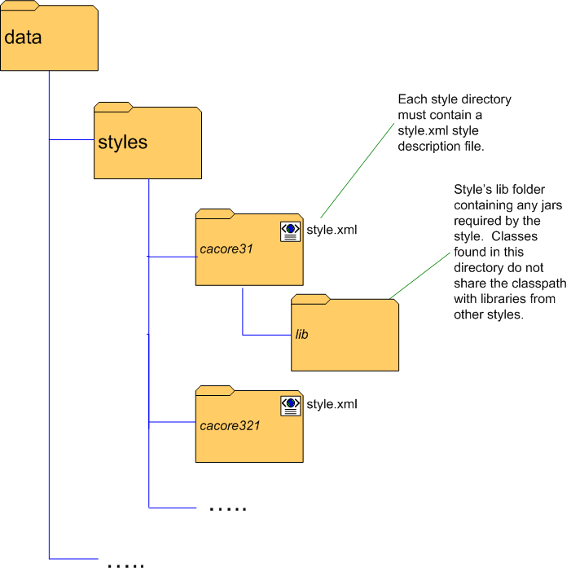
Figure 6-33 Data Service styles directory structure

Functionality Extended by Styles
Data Service styles may add functionality to any or all of the following areas of service development with the Introduce toolkit:
- Creation Wizard
  - The service style may supply a list of wizard panels to be displayed and chained together in a wizard-like fashion to break the setup process for the service style into a series of steps. These panels will be shown in a wizard dialog when a service style is selected at service creation time.
- Post-creation processing
  - Just as Introduce extensions may add functionality to the service creation process, data service styles may add processing capabilities to this step.
- Modification User Interface
  - The style may supply a graphical panel which will be added to the data service tab in the Introduce service modification viewer. This tab can be used to configure any style-specific options in the service.
- Post-code generation processing
  - The style may add functionality to the code generation process of service modification. This processing will be invoked each time the service is modified and saved in Introduce.

Federated Query Processor Usage Overview
The caGrid Federated Query Infrastructure provides a mechanism to perform basic distributed aggregations and joins of queries over multiple data services. As caGrid data services all use a uniform query language, CQL, the Federated Query Infrastructure can be used to express queries over any combination of caGrid data services. Federated queries are expressed with a query language, DCQL, which is an extension to CQL to express such concepts as joins, aggregations, and target services. The infrastructure is composed of a core engine and grid services which provide access to and management of the use of the core engine.

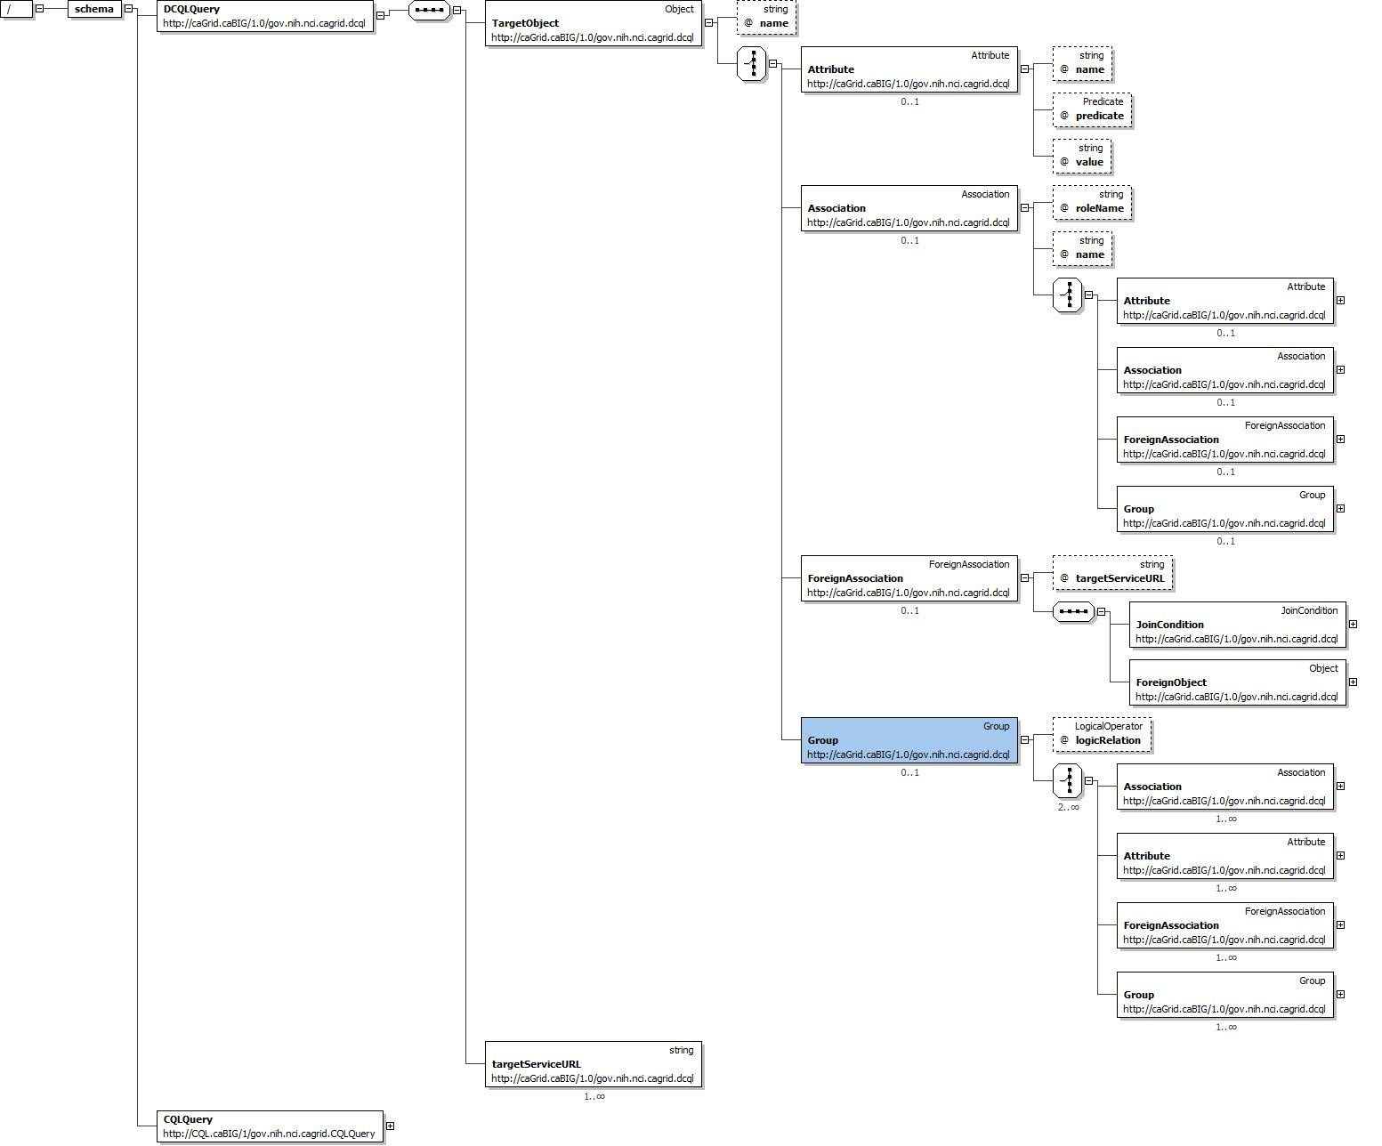
Figure 34 DCQL Schema

DCQL, the language used to express federated queries, is an extension to CQL, the language used to express single data service queries. The DCQL schema is shown in Figure 34. Both CQL and DCQL use a declarative approach to describe the desired data by identifying the nature of the instance data with respect to its containing UML information model. That is, a query can be seen as identifying a class in a UML model, and restricting its instances to those which meet criteria defined over that class’s UML attributes and UML associations.
The primary additions to CQL, which DCQL provides, are the introduction of the ability to specify multiple target services (aggregations), and the ability to specify object restrictions through relationships to objects on remote data services (joins). The other primary difference between the languages is that CQL is context dependent, meaning the language must be interpreted against the service receiving the query, and DCQL itself specifies the context of the queries (by identifying the target services). As such, services accepting DCQL (such as the FQP service), generally do not expose any local data. Details on DCQL can be found in the Federated Query Processor design document.

An example DCQL query, represented in XML, is shown below in Figure 6-35. In this fictitious example, a PersonRegistry Data Service is joined with a StudyRegistry Data Service. The query specifies Persons in the PersonRegistry should be returned when they have a “ssn” that is equal to that of a Participant’s “patientSSN” and the Participant should have an “age” greater than 18. The specification of the target service can be seen on line 18 in the example (in this case only one service is targeted, though may could have been listed). Additionally, the “join” is specified starting on line 6, wherein the second target service is identified, and the join condition is defined. The join condition creates a link between the containing Object (in this case, Person), and an Object (in this case Participant, as defined on line 10) in the second target service. The condition specifies a predicate to be evaluated against an attribute in each of the two linked Objects (in this case Person.ssn and Participant.patientSSN). It is worth noting that as DCQL is a recursive language, the ForeignObject defined on line 10 could have also specified a join to a third Data Service, or other more complex criteria.
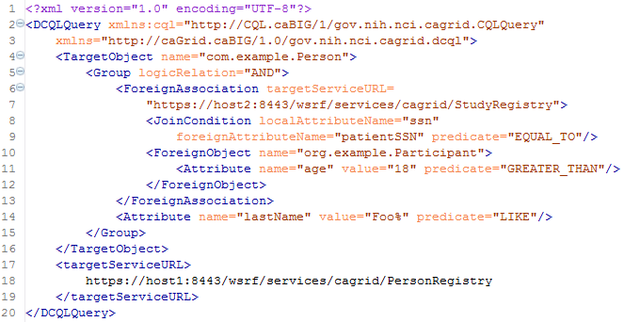
Figure 6-35 Example DCQL Query
The Federated Query Engine is a simple but powerful design. The main functionality of the engine is to process a DCQL query by converting it into regular CQL queries to the targeted data services, appropriately aggregating results. As such, all of the actual “joining” of data is offloaded to the remote data services. This allows the engine to be reused as a client API as no databases or complex service infrastructure is needed; it is simply a client-side querying tool. The engine requires no special support from data services. Each service which is contacted to satisfy the distributed query is only sent one or more standard, but potentially complex, CQL queries. It is possible to construct a DCQL query which is essentially a standard CQL query, with the addition of specifying one or more target data services. In this case, the engine simply “forwards” that query on to the targeted services, and aggregates their results. Details on the implementation and query processing logic of the engine can be found in the Federated Query Processor design document.
The Federated Query Processing Infrastructure contains three main client-facing components: an API implementing the business logic of federated query support, a grid service providing remote access to that engine, and a grid service for managing status and results for queries that were invoked asynchronously using the query service.

Federated Query Engine
For clients not wishing to use the grid service, the FederatedQueryEngine is the client-facing entry point to the engine. It provides two methods which accept DCQL queries, and return the results. Each of the two methods provides a different variant on how results are represented. The first method is the executeAndAggregateResults method, which returns the standard CQLQueryResults (the same result type returned by data services’ query method). Each CQLResult obtained from each targeted data service is merged into an aggregate list, and a master CQLQueryResults object is constructed which contains them all. The information about which result came from which data service is lost in this scenario, but this provides the ability to reuse existing data service tooling and APIs when that information is not relevant.
In cases where it is important to know from which data service a given result came, the second query method called execute can be used. This method returns a new type called DCQLQueryResultsCollection. The DCQLQueryResultsCollection contains a list of DCQLResult, wherein each DCQLResult specifies a CQLQueryResults object, and the data service URL from which it came. That is, the result type is a collection of tuples containing the standard data service results, and that service’s URL.
Both query methods will throw a RemoteDataServiceException in the event a queried data service returns invalid results (such as the wrong target class type), or if a data service itself throws an exception when being queried, or if there is any problem querying the data service. Additionally, a FederatedQueryProcessingException, which is the parent class of RemoteDataServiceException, may be thrown if there is a problem processing the query itself.

Federated Query Processor Service
The Federated Query Processor service is the main service interface to the federated query engine. It provides three query execution operations. The first two are: execute which takes a DCQL query and returns a DCQLQueryResultsCollection, and executeAndAggregateResults which returns a CQLQueryResults. These are both simple grid service wrappers for the corresponding methods in the FederatedQueryEngine API. The third operation, executeAsynchronously, provides asynchronous, non-blocking, access to the execute method, and returns a FederatedQueryResultsReference. The FederatedQueryResultsReference is a typed container for an EPR to the Federated Query Results service. The Federated Query Results service client API can be used to subsequently retrieve the DCQLQueryResultsCollection.

Federated Query Results Service
The Federated Query Results service is the service responsible for providing access to query results and processing status for asynchronously executed queries. The service can only be contacted with a resource-qualified EPR, provided by the Federated Query Processor service. Whenever the query processor service is requested to execute an asynchronous query, a Resource is created and an EPR, which identifies that Resource in the results service, is returned. The Federated Query Results service’s only purpose is to expose information about, and management of, these Resource instances. This Resource contains the current status of the query it corresponds to, any exceptions which occurred during processing, and eventually the results of the query. It supports standard WSRF Resource Lifetime behavior. As such, it exposes, as Resource Properties, the current time (as believed by the local system), and the termination time of the Resource. Once created, the resource will be terminated/destroyed by the service once its termination time is past. This lifetime is initially controlled by a setting in the grid service. The client can also immediately destroy the resource with the Destroy operation, or change its termination time with the SetTerminationTime operation. Both of these operations are standardized operations for resources supporting Resource Lifetime and as such corresponding common Resource Lifetime clients may be used (though the Federated Query Results client API also makes these operations available).
In addition to the operations and resource properties necessary to support Resource Lifetime on the resource, the service also provides the getResults and isProcessingComplete operations. The isProcessingComplete operation returns a simple Boolean value, indicating whether or not the query processing has completed. Once the query processing has completed, the results can be accessed via the getResults operation, which returns a DCQLQueryResultsCollection. If the operation is invoked prior to the processing being complete, a ProcessingNotCompleteFault fault will be thrown. If the processing is complete, but an exception occurred, a FederatedQueryProcessingFault will be thrown, and its cause will be the exception that occurred during query processing.

Security Considerations
The Federated Query Processor services support two deployment scenarios. The first is an insecure deployment, wherein no security (authentication or authorization) is enforced by the container. In this scenario, no encryption is used and no protection of query results is enforced. That is, anonymous communication is used over an open channel, and it is possible for one client to manipulate the query resources of another, given it knows the EPR.
The recommended second scenario is when the services are deployed securely, such as with transport level security (https). Deployments using transport level security ensure integrity and privacy of the communication channel (and obviously the data traveling over it). In this scenario, no authorization is performed by the query service, but any query results created via asynchronous queries are protected such that only the issuer of the query can view or manipulate the results. In this scenario, clients should use credentials to ensure proper protection of query results.
The services do not make use of delegated credentials, and as such, remote data services are accessed either with an identification or anonymously, or with the Federated Query Processor’s credentials (depending on the deployment scenario and the settings of the remote data services). While future work may enable this feature, clients needing this capability (credentialed access of data services) now may leverage the federated query engine directly using the API.

API Details

gov.nih.nci.cagrid.fqp.client.FederatedQueryProcessorClient
The FederatedQueryProcessorClient is the main client interface to the federated query service (Figure 6-36).
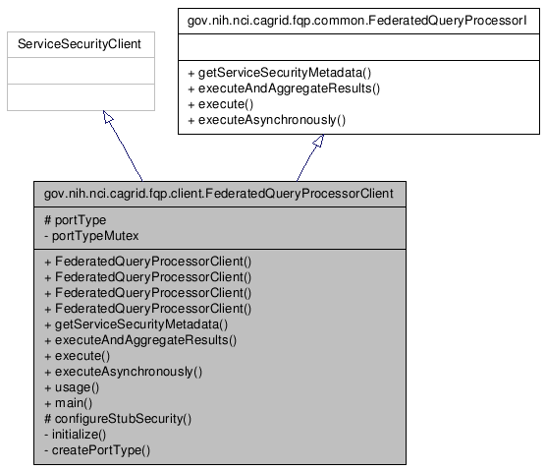
Figure 6-36 FederatedQueryProcessor Inheritance Model

Constructor Documentation
FederatedQueryProcessorClient (String url)
throws MalformedURIException, RemoteException
FederatedQueryProcessorClient (String url, GlobusCredential proxy)
throws MalformedURIException, RemoteException
FederatedQueryProcessorClient (EndpointReferenceType epr)
throws MalformedURIException, RemoteException
FederatedQueryProcessorClient (EndpointReferenceType epr, GlobusCredential proxy)
throws MalformedURIException, RemoteException

Member Function Documentation
Access to caGrid Service Security Metadata:
- gov.nih.nci.cagrid.metadata.security.ServiceSecurityMetadata getServiceSecurityMetadata ()
  - throws RemoteException
  - Description: Returns the caGrid service security metadata
Distributed Query Methods:
- gov.nih.nci.cagrid.cqlresultset.CQLQueryResults executeAndAggregateResults (gov.nih.nci.cagrid.dcql.DCQLQuery query)
  - throws RemoteException, gov.nih.nci.cagrid.fqp.stubs.types.FederatedQueryProcessingFault
  - Description: Executes the DCQL query, aggregating and returning them as standard data service results
- gov.nih.nci.cagrid.dcqlresult.DCQLQueryResultsCollection execute (gov.nih.nci.cagrid.dcql.DCQLQuery query)
  - throws RemoteException, gov.nih.nci.cagrid.fqp.stubs.types.FederatedQueryProcessingFault
  - Description: Executes the DCQL query, aggregating and returning them as standard data service results
- gov.nih.nci.cagrid.fqp.results.client.FederatedQueryResultsClient executeAsynchronously (gov.nih.nci.cagrid.dcql.DCQLQuery query)
  - throws RemoteException, org.apache.axis.types.URI.MalformedURIException
  - Description: Executes the DCQL query asynchronously, returning a results client which can be used to access the results

gov.nih.nci.cagrid.fqp.results.client.FederatedQueryResultsClient
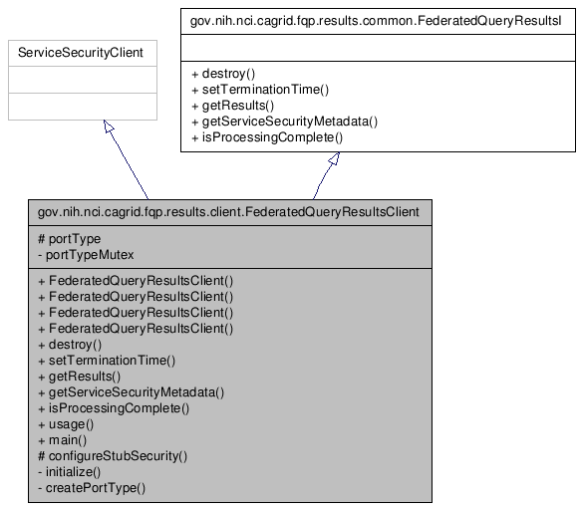
Figure 6-37 FederatedQueryResultsClient Inheritance Model

Constructor Documentation
FederatedQueryResultsClient (String url)
throws MalformedURIException, RemoteException
FederatedQueryResultsClient (String url, GlobusCredential proxy)
throws MalformedURIException, RemoteException
FederatedQueryResultsClient (EndpointReferenceType epr)
throws MalformedURIException, RemoteException
FederatedQueryResultsClient (EndpointReferenceType epr, GlobusCredential proxy)
throws MalformedURIException, RemoteException

Member Function Documentation
Access to caGrid Service Security Metadata:
- gov.nih.nci.cagrid.metadata.security.ServiceSecurityMetadata getServiceSecurityMetadata ()
  - throws RemoteException
  - Description: Not used.

Resource Lifetime Methods:
org.oasis.wsrf.lifetime.DestroyResponse destroy (org.oasis.wsrf.lifetime.Destroy params)
throws RemoteException
Description: Destroys the corresponding resource and query results.
org.oasis.wsrf.lifetime.SetTerminationTimeResponse setTerminationTime (org.oasis.wsrf.lifetime.SetTerminationTime params)
throws RemoteException
Description: Sets the time at which the resource and corresponding query results should be destroyed.

Query Results Methods:
gov.nih.nci.cagrid.dcqlresult.DCQLQueryResultsCollection getResults ()
throws RemoteException, gov.nih.nci.cagrid.fqp.results.stubs.types.ProcessingNotCompleteFault, gov.nih.nci.cagrid.fqp.stubs.types.FederatedQueryProcessingFault, gov.nih.nci.cagrid.fqp.stubs.types.InternalErrorFault
Description: Returns the query results, if processing is complete. If processing is not complete, throws ProcessingNotCompleteFault. If processing is complete, but threw an exception, that exception is then rethrown.
boolean isProcessingComplete ()
throws RemoteException
Description: Returns true if and only if processing of the query is complete.

gov.nih.nci.cagrid.fqp.processor.FederatedQueryEngine

Constructor Documentation

gov.nih.nci.cagrid.fqp.processor.FederatedQueryEngine.FederatedQueryEngine ()
Default constructor

Member Function Documentation

DCQLQueryResultsCollection gov.nih.nci.cagrid.fqp.processor.FederatedQueryEngine.execute (DCQLQuery dcqlQuery) throws FederatedQueryProcessingException
Call Federated Query Processor, and send the generated CQLQuery to each targeted service, placing each result into a single DCQLQueryResults object.

Parameters:
dcqlQuery

Returns:

Exceptions:
FederatedQueryProcessingException

CQLQueryResults gov.nih.nci.cagrid.fqp.processor.FederatedQueryEngine.executeAndAggregateResults (DCQLQuery dcqlQuery) throws FederatedQueryProcessingException
Call Federated Query Processor, and send the generated CQLQuery to each targeted service, aggregating the results into a single CQLQueryResults object.

Parameters:
dcqlQuery

Returns:

Exceptions:
FederatedQueryException

API Usage Examples
The examples below show various uses of the federated query infrastructure; both executing the grid services and the engine’s stand alone API. The exception handling is omitted from the examples for demonstration purposes. Additionally, the result processing shown is simplistic. The results returned from the federated query APIs, DCQLResultsCollection instances, are simple container objects for standard Data Service results, CQLQueryResults. A DCQLResult is just a CQLQueryResult and the address of the service which created the result. Additional details on how Data Service results can be processed can be found in the Data Service section of this document.

Executing a Blocking Query
The first example, shown below in Figure 6-38, demonstrates the simplest case of executing a query using the Federated Query Processor grid service, via the FederatedQueryProcessorClient. An instance of the client is constructed on lines 1 and 2, wherein the address of the service is provided. Next, a query document is created by loading it from a file (in this case the “exampleDCQL.xml” file) on the local file system. The caGrid common utilities are used to accomplish this on lines 4 and 5. Though not shown, DCQL queries can also be constructed programmatically, just as CQL queries can. On line 7, the service is requested to perform the query as described in the DCQLQuery; this operation will block until the processing is complete. The result of the invocation is a DCQLResultsCollection, which contains an array of DCQLResult. Lines 10-16 loop over these results, and then print out the URL of the service which yielded the result and the number of data instances it produced.
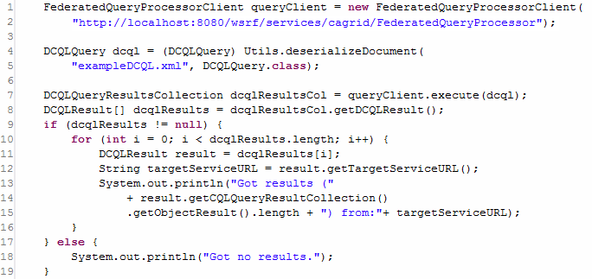
Figure 6-38 Executing a Distributed Query

Executing a Non-Blocking Query
The next example, shown in Figure 6-39, illustrates the capability of the federated query service infrastructure to execute queries in the background, and allow clients to process the results later (suitable for long running queries, or distributed processing of results). It begins to diverge from the example above when it invokes executeAsynchronously on line 8 (as opposed to execute, as shown in Figure 6-38). This operation returns a new instance of the FederatedQueryResultsClient, which can be used to access the results once they are completed. This instance is returned before the service actually starts processing the query. The FederatedQueryProcessorClient abstracts the details that an EPR was actually returned by the service, and it directly provides the caller the appropriate API to communicate with the stateful service container for the not yet populated query results. Lines 10-15 demonstrate checking the status of the processing and printing out a “.” to the screen each second until the processing is complete. Future versions of the service will support subscriptions and notifications of query status and completion. The isProcessingComplete operation will return false until the query results are available, or the processing is terminated by failure. Once processing is complete, the results can be accessed via the getResults operation, shown on line 17. This returns a DCQLQueryResultsCollection, just as execute did in Figure 6-38. At this point, in terms of result processing, there is no longer a difference between asynchronous (this example) and synchronous (the previous example) query logic. However, to further demonstrate how to process the results, the example below loops over each DCQLResult (as before), and prints out the service which yielded it (on line 23). It then, on line 24-27, accesses the standard Data Service query result type, and constructs a CQLQueryResultsIterator to iterate over each Object result. This iteration, shown on lines 29-33, prints the XML representation of each Object, as the iterator was constructed to use “xml only” by passing true to the second argument of its constructor on line 27.
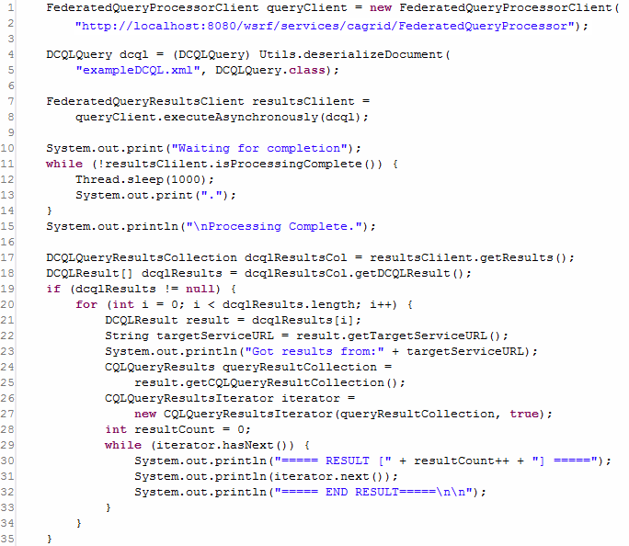
Figure 6-39 Executing a Non-Blocking Distributed Query

Removing Query Results
As mentioned above, the Federated Query Results grid service is a stateful WSRF service, and executing asynchronous queries with the Federated Query Processor service generates Resources on it. These resources house the query results for clients, and can be accessed multiple times. The example shown below in Figure 6-40, demonstrates how, after the client is done with the results, they should be removed from the service by invoking the destroy operation of the FederatedQueryResultsClient, shown on line 12. The results will eventually “expire” and be automatically removed after a service-specified lifetime, unless their lifetime is extended as shown in Figure 6-41,, but it is good practice to manually release unneeded resources.
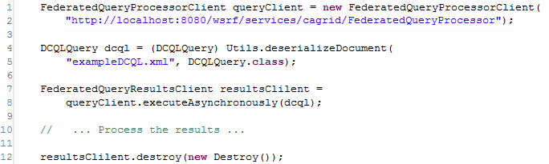
Figure 6-40 Destroying Query Results

Scheduling Removal of Query Results
As mentioned above, query results will expire after a service-configure default lifetime. However, this can be controlled by the client by specifying a new termination time for the resource. The example shown below in Figure 6-41, demonstrates how one client may request the service to perform a federated query, set the lifetime of the yet to be created results, and hand off an EPR to those results to some other processing thread or client. In this example, the query is executed asynchronously just as before (on lines 7-8). However, rather than waiting on completion of the results, the example uses, on line 13, the setTerminationTime operation of the results client to request the results live on the service for four hours. This is accomplished by creating a Resource Lifetime standard SetTerminationTime request, and providing it a Calendar instance configured to be four hours later than the current time, as shown on lines 11 and 12. The result of this operation is a Resource Lifetime standard SetTerminationTimeResponse, which indicates the current time, as believed by the service, and the time at which the resource will be destroyed. The example prints these out, as well as the value of the local Calendar instance, on lines 18-23. Finally, the code demonstrates, on line 25, how an EPR to the result Resource can be accessed from the client with the getEndPointReference method.
It should be noted that if the client’s system clock and the service’s system clock have significant differences in their belief of the current time, this example code could cause the resource to terminate either earlier or later than expected. In cases where this may be an issue for clients, the results service provides as a Resource Property, the current time as believed by the service. A client could access this resource property, and construct the Calendar instance from it, rather than using its local system clock.
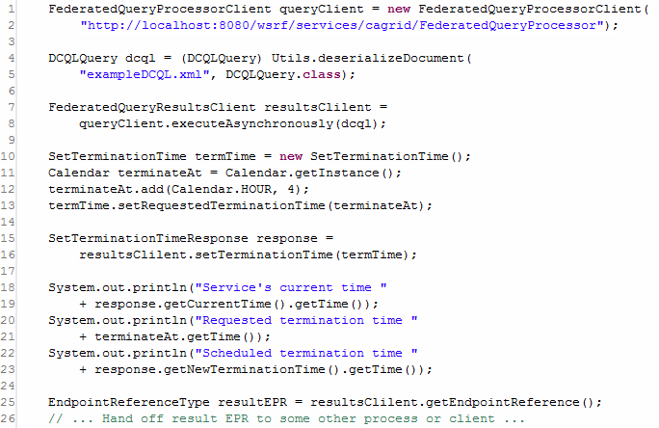
Figure 6-41 Scheduling the Destruction of Query Results

Using the Engine Directly to Access Protected Data Services
The final example, shown below in Figure 6-42, demonstrates how the federated query infrastructure can be used to locally execute federated queries (as opposed to requesting the service to execute them). While most clients will opt to use the service interfaces, there are many reasons why a client may wish to invoke the engine locally, such as minimizing data movement. The most common reason to use the engine locally is if the Data Services being targeted requires authorization to access the data of interest. The federated query processor service infrastructure does not currently have the capability to assume the identity of the client requesting the query; it queries Data Services either anonymously, or with its own credentials (depending on deployment scenarios). When executing the engine locally, the client has the ability to use credentials when it queries data services. When executing locally, the engine will make use of the “default” Globus credentials if the Data Service being accessed does not allow anonymous access. Consult the caGrid security documentation on how to get and set default Globus credentials.
Using the engine locally is similar to using the processor service. The engine can be constructed, as shown on line 1, by instantiating a FederatedQueryEngine. This has the same query execution methods as the grid service, except it does not provide asynchronous execution (as this is easily done locally). The example below (Figure 6-42) shows the ability of the engine to aggregate DCQL results and return them as standard Data Service Results, shown on line 4. It then uses the CQLQueryResultsIterator to print the XML representation of the results, just as in Figure 6-39.

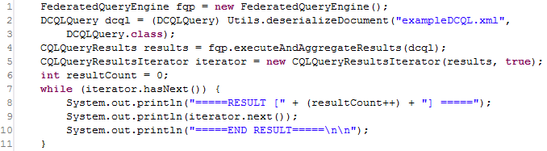
Figure 6-42 Invoking the FederatedQueryEngine Locally

WS-Enumeration

This chapter describes the client-side APIs for enumerations.
Topics in this chapter include:
- Overview on this page
- Client API on this page

Overview
An overview of WS-enumeration is beyond the scope of this document. For more information, see the following websites:
Specification:
http://www.w3.org/Submission/WS-Enumeration/
Schema:
http://schemas.xmlsoap.org/ws/2004/09/enumeration/enumeration.xsd
WSDL:
http://schemas.xmlsoap.org/ws/2004/09/enumeration/enumeration.wsdl

Client API
There are two main client-side APIs for enumerations. The ClientEnumeration API provides basic functions for managing enumeration lifetime and retrieving its data. The ClientEnumIterator API provides java.util.Iterator abstraction for retrieving enumeration data and supports automatic data deserialization.

ClientEnumeration
The ClientEnumeration API provides basic functions for managing enumeration lifetime and retrieving its data. ClientEnumeration must be initialized with a javax.xml.rpc.Stub instance that is a Stub for the service that implements the WS-Enumeration operations and with an EnumerationContextType object returned by the enumerate operation of the service or any other operation that initiates an enumeration.
The javax.xml.rpc.Stub instance must define all of the WS-Enumeration operations except the enumerate operation. Also, the Stub instance must be properly configured with the security properties if calling a secure service.

IterationResult pull(IterationConstraints constraints)
Retrieves the next set of elements of the enumeration. The input parameter defines the constraints for the operation such as the maximum number of elements to retrieve, the maximum number of characters that the consumer can accept, and the maximum amount of time in which the data needs to be returned. The return parameter contains the results of the iteration and an end of sequence flag to indicate if there is more data to be returned. The results of the iteration are of the javax.xml.soap.SOAPElement type.
This method calls the WS-Enumeration pull operation on the data service.

IterationResult pull()
Same as pull(IterationConstraints) function but uses default constraints (maximum number of elements set to 1, no maximum characters limit and no time limit).

void release()
Explicitly releases the enumeration. In general, the enumeration context is automatically released when a client finishes retrieving all the enumeration data or the enumeration expires if it was configured with an expiration time or duration. In cases where no expiration time was set for the enumeration or when not enumerating over the entire data, the enumeration should be released explicitly.
This method calls the WS-Enumeration release operation on the data service.

EnumExpiration renew(EnumExpiration expiration)
Sets a new expiration time/duration of the enumeration. The input parameter can be null to configure the enumeration without an expiration time/duration (the enumeration will not expire). The expiration time/duration cannot be in the past (as according to the service clock). The service can choose to accept a different expiration time then specified. The return parameter can also be null to indicate that the enumeration does not have an expiration time/duration.
This method calls the WS-Enumeration renew operation on the data service

EnumExpiration getStatus()
Gets the current expiration time/duration of the enumeration. The return parameter can be null to indicate that the enumeration does not have an expiration time/duration.
This method calls the WS-Enumeration getStatus operation on the data service

ClientEnumIterator
The ClientEnumIterator API provides a simple-to-use API for enumerating over data using the WS-Enumeration operations. The ClientEnumIterator class implements the java.util.Iterator interface but the implementation of these functions does not follow the Iterator contract exactly because of the WS-Enumeration specification limitations. The ClientEnumIterator class uses the ClientEnumeration API underneath and in contrast to the ClientEnumeration API offers automatic data deserialization.
The ClientEnumIterator must be initialized with a javax.xml.rpc.Stub instance that is a Stub for the service that implements the WS-Enumeration operations and with an EnumerationContextType object returned by the enumerate operation of the service or any other operation that initiates an enumeration.
The javax.xml.rpc.Stub instance must define all of the WS-Enumeration operations except the enumerate operation. Also, the Stub instance must be property configured with the security properties if calling a secure service.
During iteration the ClientEnumIterator makes remote calls to the data service to retrieve the next set of items (calls the WS-Enumeration pull operation). The frequency of these remote calls is controlled by the maxElements setting of the IterationConstraints of the ClientEnumIterator. If that number is small the ClientEnumIterator will make a lot of remote calls but will use a small amount of memory (since it always keeps a few of the items in the memory). But if that number is big the ClientEnumIterator will make fewer remote calls but will use more memory (since it now keeps more items in the memory).

void setItemType(Class itemType)
Sets the type of the object returned by the next() operation. By default the objects returned by the next() operation will be of the javax.xml.soap.SOAPElement type. If the item type is set, the enumeration elements will be automatically deserialized into this type. This assumes the enumeration elements are all of the same type.

void setIterationConstraints (IterationConstraints constraints)
Sets iteration constraints for the iterator. By default the constraints are not set and defaults are assumed (maximum number of elements set to 1, no maximum characters limit and no time limit).

Object next()
Returns the next object in the enumeration. The returned object can be null. If item type is set (using the setItemType method) the current object will be automatically converted into that type and returned. Otherwise, an object of the javax.xml.soap.SOAPElement type is returned. If the enumeration has ended (hasNext() returns false) or has been released on the client, the NoSuchElementException is raised. Also, in certain cases the NoSuchElementException can also be raised even though hasNext() is returned as true. If deserialization is performed and it fails, a ConversionException is raised and the index of the iteration is not advanced (so that the user can specify another item type or disable deserialization).
This method calls the WS-Enumeration pull operation on the data service.

boolean hasNext()
Tests if there are more elements in the enumeration to be returned. If it returns false, there are no more elements to be returned. If true, there might be more elements to be returned. This method can return true even though the next() operation consistently returns null. Also, this method can return true even though the next() operation will throw NoSuchElementException.

Object convert(SOAPElement element)
Performs object conversion on the enumeration element. This function is called by the next() function every time the next() function is called. It can be used to deserialize the enumeration element into the appropriate Java object. This function is meant to be overwritten by the subclasses of the ClientEnumIterator to provide custom deserialization behavior. If deserialization fails, then a ConversionException is thrown.

void release()
Explicitly releases the enumeration context.
This method calls the WS-Enumeration release operation on the data service. hasNext() will return false and next() will throw NoSuchElementException after this method is called.

Examples

ClientEnumeration
The following example shows how to iterate over the data using the ClientEnumeration API (Figure 7-43).
import org.globus.ws.enumeration.ClientEnumeration;
import org.globus.ws.enumeration.IterationResult;
import org.globus.ws.enumeration.IterationConstraints;
…

EnumerationServiceAddressingLocator locator =
new EnumerationServiceAddressingLocator();

URL serviceURL =
new URL(“http://127.0.0.1:8080/wsrf/services/EnumerationService”);

EnumerationPortType port =
locator.getEnumerationPortTypePort(serviceURL);

// obtain the enumeration context from the service somehow
EnumerationContextType context = …

// create iteration constraints (return maximum of 10 elements)
IterationConstraints constraints =
new IterationConstraints(10, -1, null);

// create client enumeration
ClientEnumeration enumeration =
new ClientEnumeration((Stub)port, context);

// iterate over the data
IterationResult iterResult;
do {
// retrieve the enumeration data with given constraints
iterResult = enumeration.pull(constraints);
Object [] items = iterResult.getItems();
if (items != null) {
// display the enumeration data
for (int i=0; i < items.length; i++) {
System.out.println(items[i]);
}
}
} while (!iterResult.isEndOfSequence());
Figure 7-43 Client enumeration example

ClientEnumIterator
This example shows how to iterate over the data using the ClientEnumIterator API (Figure 7-44).
import org.globus.ws.enumeration.ClientEnumIterator;
import org.globus.ws.enumeration.IterationConstraints;

…

EnumerationServiceAddressingLocator locator =
new EnumerationServiceAddressingLocator();

URL serviceURL =
new URL(“http://127.0.0.1:8080/wsrf/services/EnumerationService”);

EnumerationPortType port =
locator.getEnumerationPortTypePort(serviceURL);

// obtain the enumeration context from the service somehow
EnumerationContextType context = …

// create iteration constraints (return maximum of 10 elements)
IterationConstraints constraints =
new IterationConstraints(10, -1, null);

// create the client iterator
ClientEnumIterator iterator =
new ClientEnumIterator((Stub)port, context);

iterator.setIterationConstraints(constraints);

// iterate over the data
try {
while(iterator.hasNext()) {
Object obj = iterator.next();
}
} catch (NoSuchElementException e) {
// next() can throw this exception even though
// hasNext() returned true
}

Figure 7-44 ClientEnumIterator example

Command Line Clients

ws-enumerate-start
Starts an enumeration. It calls the enumerate operation on the data service and prints out the enumeration context to the console. The enumeration context can then be passed to ws-enumerate or ws-enumerate-end clients.

ws-enumerate
Enumerates over the data. It calls the pull operation on the data service and prints out the retrieved data to the console. The client requires an argument that is a filename that contains the enumeration context (created either by ws-enumerate-start or by other means).
The –n, --maxElements option can be used to configure the maximum number of elements to retrieve from the data service at a time. The –r, --maxCharacters option can be used to configure the maximum number of characters the client can accept at a time. The –n, --maxTime option can be used to specify the maximum amount of time in which the enumeration data has to be assembled. Any combination of these options can be specified at the same time.

ws-enumerate-end
Releases an enumeration. It calls the release operation on the data service. The client requires an argument that is a filename that contains the enumeration context (created either by ws-enumerate-start or other means).

Service

Service WSDL
The service that wishes to support enumerations must define the WS-Enumeration operations in its WSDL. All operations except the enumerate operation must be defined in the service WSDL. The enumerate operation of the WS-Enumeration specification is an optional operation and therefore it is up to the service designer to decide if the service should define and implement this operation or if the service will provide some other operation that will initiate an enumeration. Any operation of the service can initiate an enumeration by returning an element of the wsen:EnumerationContextType type to the client.

Service Implementation
The service must implement the enumerate operation of the WS-Enumeration specification or provide some other operation that will initiate an enumeration and return an element of the wsen:EnumerationContextType type to the client.
For all other WS-Enumeration operations the service must be configured with the built-in enumeration operation provider (EnumProvider). Of course, the service can choose to provide its own implementation for the WS-Enumeration operations but will need to replicate a lot of the built-in functionality.
The EnumProvider is configured in the same way as any other operation provider in the service deployment description (WSDD) file. All the WS-Enumeration operations should have the same security settings.

Enumeration Implementation Details
Internally, enumerations are managed and implemented just like any other WS-Resources. That is, there are enumeration resources (EnumResource) which are managed by the enumeration resource home (EnumResourceHome). The enumeration resources contain lifetime information and have a reference to the iterator (EnumIterator) that provides the actual data iteration functionality.

Types
There are two types of enumerations: transient and persistent. The transient enumerations live only while the container is running and are not restored after a container restart. The persistent enumerations are restored after a container restart. The type of enumeration has no impact on how the data of the enumeration is stored or retrieved. For example, a transient enumeration can query a database, retrieve data from a file, or have all the data in memory. It is entirely up to the service developers to decide how the data is retrieved, if the data is static or dynamic, etc.
In general it is not recommended to keep the entire enumeration data in memory. If the data is static, it is recommended to store the data in a database or a file, etc. and retrieve it in an efficient way.

Visibility
The enumeration resources also contain visibility properties (VisibilityProperties) to restrict what service and/or resource can access the particular enumeration resource. In general, an enumeration created by service S is only accessible through service S. Similarly, an enumeration created by resource R is only accessible through resource R.

Security
The service or resource through which the enumeration data is accessed can be configured with a security descriptor to further control access to the data.

Example
This example shows how to create a transient enumeration on the server-side with the help of the built-in WS-Enumeration operation provider (Figure 7-45).
import org.globus.ws.enumeration.EnumResourceHome;
import org.globus.ws.enumeration.EnumIterator;
import org.globus.ws.enumeration.EnumResource;
import org.globus.ws.enumeration.EnumProvider;
…

// obtain enumeration resource home
EnumResourceHome enumHome = EnumResourceHome.getEnumResourceHome();

// create iterator for the data
EnumIterator iter = …;

// create transient enumeration resource for the iterator
// with visibility properties obtained from the context
EnumResource resource = enumHome.createEnumeration(iter, false);

// get resource key for the enumeration resource
ResourceKey key = enumHome.getKey(resource);

// create EnumerationContextType to be returned to the client
EnumerationContextType enumContext =
EnumProvider.createEnumerationContextType(key);

Figure 7-45 Example of creating a transient enumeration on the server-side

API

EnumIterator
This API is used by the service developers to write their own EnumIterator implementations in order the retrieve the enumeration data in a fast and efficient way.
A new EnumIterator instance must be created for each new enumeration. The implementations should assume a single thread access. Only one client is allowed to access a particular enumeration at a time. The implementation must keep track of the progress of the enumeration (for example, store the index of the last item retrieved).
For persistent enumerations, the EnumIterator implementation must be fully serializable using the Java serialization framework. That will enable the enumeration to be restored in case of a container restart or in other conditions. An application should not keep references to the EnumIterator objects it creates. Such references will prevent efficient memory management by the EnumResourceHome.

IterationResult next(IterationConstraints constraints)
Retrieves the next set of items of the enumeration. The IterationConstraints define constraints for this operation such as the maximum number of the items that can be returned, the maximum number of characters of the items, and timeout in which the items must be returned. The constraints can change between the calls. If the timeout value constraint is specified and the data is not collected in that time, a TimeoutException should be raised. If there are no more elements in the enumeration a NoSuchElementException is raised.
The IterationResult contains the result of the iteration that fulfills the specified constraints. It must always be non-null. The IterationResult itself contains a list of enumeration items of javax.xml.soap.SOAPElement type and a flag that indicates if an end of sequence has been reached.

void release()
Releases any resources associated with this enumeration. For example, close database connections, delete files, etc. This method is called when the enumeration is explicitly released, expires, or the user is finished enumerating through all the data.

SimpleEnumIterator
The SimpleEnumIterator is a concrete implementation of the EnumIterator interface. It is a very simple implementation that can enumerate over in-memory data passed either as an array of objects or a list (java.util.List). The enumeration contents can be of javax.xml.soap.SOAPElement type, simple types such as java.lang.Integer, etc. or Axis generated Java beans.
The SimpleEnumIterator can only be used with transient types of enumerations.

IndexedObjectFileEnumIterator
The IndexedObjectFileEnumIterator is another concrete implementation of the EnumIterator interface. It is a memory efficient implementation that can enumerate over data stored in an indexed file created by IndexedObjectFileWriter. The indexed file format is optimized for retrieving objects in a sequential and random manner. The IndexedObjectFileEnumIterator uses the IndexedObjectFileReader to read the indexed file and quickly locate and retrieve the next set of objects of the enumeration.
The IndexedObjectFileEnumIterator can be used with transient and persistent types of enumerations.

IndexedObjectFileWriter
The IndexedObjectFileWriter is used to create an indexed file. The objects stored in the file will be serialized using the Java serialization framework, therefore, only the objects that implement the java.io.Serializable interface can be used.

IndexedObjectFileReader
The IndexedObjectFileReader is used to read an indexed file created by the IndexedObjectFileWriter. The objects stored in the file will be deserialized using the Java serialization framework.

IndexedObjectFileUtils
The IndexedObjectFileUtils is a collection of utility functions that can be used to create indexed files with the given data.

Other Implementation Details

WS-Enumeration WSDL and schema changes
The following changes have been made to the WS-Enumeration WSDL and schema files:
- The WS-Addressing namespace used by the specification was changed to http://schemas.xmlsoap.org/ws/2004/03/addressing in order to work with the existing tooling.
- The EnumerationEndOp operation was commented out as it violates WS-I Basic Profile 1.1 and is not supported by the tooling. Therefore, this part of WS-Enumeration functionality is not supported by the current implementation.
- Since the EnumerateOp operation is an optional operation, it was moved into a separate port type called DataSourceStart. All other operations remain in the DataSource port type.
- The EnumerationContextType type was simplified to an equivalent form in order to be properly recognized by the tooling.

Other comments on the WS-Enumeration WSDL and schema files:
- The schema file uses the xsd:union type which makes it hard for the tooling to figure out which value was actually serialized. The xsd:choice type might be better for such cases.
- Currently there is no way to ask the data service if it has any more elements without actually retrieving some elements.
- The EndOfSequence element in the schema file should be defined with an xsd:boolean type. Currently it defaults to xsd:anyType.

Workflow Management Service
This chapter describes the architecture and APIs for interacting with caGrid workflow.
Topics in this chapter include:
- Overview on this page
- Workflow Architecture on this page
- WorkflowFactoryService API on page 134
- WorkflowServiceImpl API on page 137
- Security in WorkflowFactory and Context Services on page 140
- Service Selection on page 141
- Provenance Tracking on page 141
- WS-RF Resources in Workflows on page 141

Overview
caBIG aims to bring together disparate data and analytic resources into a “World Wide Web of cancer research”. This will be achieved through common standards and software frameworks for the federation of these resources into “grid” services. Many of the tasks in the collection and analysis of cancer-related data on the grid involve the use of workflow. Here, we define workflow as the connecting of services to solve a problem that each individual service could not solve. caGrid implements workflow by providing a grid service for submitting and running workflows that are composed of other grid services.

Workflow Architecture
The workflow component leverages the same infrastructure stack as the caGrid toolkit (GT4, Tomcat, Java, Ant, and Introduce) with the addition of the ActiveBPEL workflow engine. The WorkflowFactoryService is a standard Introduce-built grid service that allows a workflow to be created from a BPEL workflow document. An EPR is returned to a WorkflowImplService resource that can be used to start, stop, pause, resume, cancel, and destroy the created workflow. The WorkflowImplService is layered on top of the ActiveBPEL workflow engine, which provides the primary functionality for running the BPEL-defined workflow. See Figure 8-46 for an overview of this architecture.
- 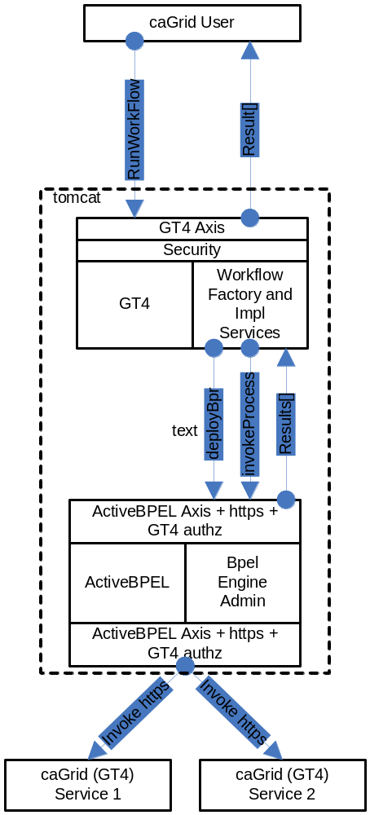
Figure 8-46 Overview of the architecture of the caGrid Workflow component
The following is a walk-through of a user’s interactions and the corresponding operations on the Workflow Services based on Figure 8-46:
- User creates a BPEL document that orchestrates one or more caGrid services.
- User configures (if it is not already configured), the workflow Submission GUI to contact the appropriate WorkflowFactory Service endpoint.
- User uses the WorkflowSubmission GUI to submit the BPEL document to a Workflow Factory service. The input BPEL document is parsed and an exception is thrown if it is not well-formed (with respect to schema compliance).
- The factory service implementation invokes PDDGenerator to generate the deployment descriptor for the workflow.
- The factory service implementation invokes BPRGenerator to generate the BPELArchive (called bpr hereafter) that is ready to be deployed.
- The workflow services are configured with the location of ActiveBPEL admin service location at deployment time.
- The factory service implementation invokes deployBpr operation on the ActiveBPEL Admin service, which is a vanilla Axis-based Web Service, to deploy the workflow archive that is created in the previous step.
- The admin service responds with a deployment summary reporting success if the workflow is deployed successfully along with a processId.
- The workflow factory service creates a Workflow Resource that consists of the BPEL document the user submitted. It constructs an EPR for the workflow resource using the processId returned by ActiveBPEL Admin Service and the endpoint url for WorkflowImpl Service that is used to manage the Workflow.
- Once the workflow is deployed successfully, it is deployed as a web service inside ActiveBPEL.
- The user provides the input to the workflow using the Workflow Submission GUI and invokes the start operation on the WorkflowImpl Service.
- The input arguments to the workflow are declared as an array of xsd:any. They are parsed and cast to the types that they are meant to be.
- To start the workflow, the WorkflowImpl Service sends a message to the receiving partnerLink in the workflow.
- After the workflow successfully executes, the results are returned to the client app/user by a call to getWorkflowOutput.
- The user can invoke the getStatus operation on the WorkflowImpl Service using the Workflow GUI to find out the status of the Workflow Execution. The workflow status is returned in one of the five possible states that a workflow can take (Submitted, Active, Finished, Failed, Suspended).
- If more detailed status is desired, getDetailedStatus operation can be invoked through the workflow gui which provides the user the node that is currently being executed in the workflow.

WorkflowFactoryService API
Workflows are created using the WorkflowFactoryService, which is a grid service that follows the resource pattern. The returned object holds an EPR to a WorkflowImplService, which can be used to manipulate the created workflow.
Public WorkflowFactoryOutputType createWorkflow(WorkflowDescriptionType wmsInputType) throws WorkflowException ()
Description:
This method creates a workflow resource from the BPEL document found in wmsInputType and returns an EPR of the created resource to the client. The BPEL resource, along with the most recent state, is persisted in a MySQL database and is recovered in the event of a container crash.
WorkflowDescriptionType:
This is the input to createWorkflow, and it consists of workflowName, a String bpelDoc, an Array of wsdlReferences, and an initial termination time for the workflow. If the termination time is not specified, the service defaults to 24 hours. Termination of the workflow invalidates the WorkflowManagementService EPR and any running workflow is stopped.
<xsd:complexType name="WorkflowDescriptionType">
<xsd:sequence>
<xsd:element name="workflowName" type="xsd:string" minOccurs="1" maxOccurs="1" />
<xsd:element name="bpelDoc" type="xsd:string" maxOccurs="1" />
<xsd:element name="wsdlReferences" type="tns:WSDLReferences" maxOccurs="unbounded" />
<xsd:element name=”InitialTerminationTime” type=”xsd:dateTime”/>
</xsd:sequence>
</xsd:complexType>

<xsd:complexType name="WSDLReferences">
<xsd:sequence>
<xsd:element name="wsdlNamespace" type="xsd:anyURI"/>
<xsd:element name="wsdlLocation" type="xsd:string"/>
<xsd:element name="serviceUrl" type="xsd:anyURI"/>
</xsd:sequence>
</xsd:complexType>

WorkflowFactoryOutputType:
This is the output of the createWorkflow method. An EPR is constructed by the factory and returned to the client. At this point the workflow document is deployed in the workflow engine and is also stored in a database, but it has not started. The EPR points to an instance of the WorkflowManagementService, which should be used to start the workflow.
<xsd:complexType name="WorkflowFactoryOutputType">
<xsd:annotation>
<xsd:documentation>This type represents the output from a workflow</xsd:documentation>
</xsd:annotation>
<xsd:sequence>
<xsd:element name="WorkflowEPR" type="wsa:EndpointReferenceType" />
</xsd:sequence>
</xsd:complexType>

Faults:
UnableToDeployWorkflowFault: This fault is thrown if the workflow is unable to be deployed (e.g. the BPEL document submitted fails pre-deployment validation).
InvalidBPELFault extends UnableToDeployWorkflowFault: This fault is thrown if the BPEL document submitted fails pre-deployment validation (e.g. not valid XML).
Factory ResourceProperties:
We intend to provide aggregate resource properties on the factory service in our next iteration. Following are some of the examples of those:
- Total number of workflows
- ListOfWorkflowsSubmitted

WorkflowServiceImpl API
This service is used to manage the workflow resources created by the WorkflowFactoryService (Figure 8-47). The service provides asynchronous execution of deployed workflows. The following are the operations the service provides in addition to the standard WS-RF operations such as destroy(), setTerminationTime(), etc.
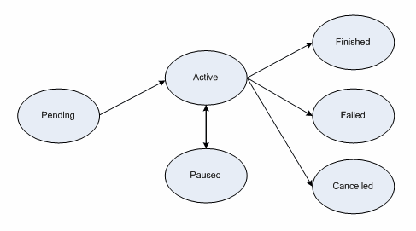
Figure 8-47 Workflow service state diagram
Public WorkflowStatusType start(StartInputType input) throws WorkflowException, StartCalledOnStartedWorkflowFault
Description:
This operation is used to start the workflow deployed using the factory with a set of input parameters. The input parameters are modeled as an array of xsd:any elements. The output is a void type.
<xsd:complexType name="StartInputType">
<xsd:sequence>
<xsd:element name="inputArgs" type="tns:WorkflowInputType" maxOccurs="1" />
</xsd:sequence>
</xsd:complexType>

<xsd:complexType name="WorkflowInputType">
<xsd:sequence>
<xsd:any maxOccurs="1" />
</xsd:sequence>
</xsd:complexType>

Faults:
StartCalledOnStartedWorkflowFault: This is thrown if start() is called on a workflow that is not in any one of the terminal states (i.e. Done, Failed, Cancelled).
WorkflowException: Every other fault results in the service throwing this with a message describing more details as to what went wrong.

Public WorkflowStatusType getStatus( ) throws WorkflowException
Description:
This operation is used to query for the status of the deployed workflow. WorkflowStatusType includes a fault.
<xsd:simpleType name="WorkflowStatusType">
<xsd:restriction base="xsd:string">
<xsd:enumeration value="Pending" />
<xsd:enumeration value="Active" />
<xsd:enumeration value="Done" />
<xsd:enumeration value="Failed" />
<xsd:enumeration value="Cancelled" />
</xsd:restriction>
</xsd:simpleType>

Public WorkflowStatusType pause() throws CannotPauseFault
Description:
This operation pauses the workflow until resume() or cancel() is invoked. This operation translates to invoking an equivalent operation provided in the ActiveBPEL Admin interface. When the pause operation is invoked, ActiveBPEL stops the execution of the workflow document which means that there would no further service invocations or other activities. However, this will not affect the invocations in progress when the pause() is invoked. This operation returns the new state of the workflow resource (which always should be Active).

Public WorkflowStatusType resume() throws CannotResumeFault
Description:
This operation resumes a paused workflow. It translates to invoking an equivalent operation provided in the ActiveBPEL Admin interface.

Public WorkflowOutputType getWorkflowOutput() throws WorkflowException
Description:
This operation is used to get the final output of a completed workflow. It will return a fault if the workflow is not yet completed. If ActiveBPEL allows for intermediate access of results, then this operation can potentially return the last result that the workflow engine has for this workflow. The output is modeled as an array of xsd:any elements.
<xsd:complexType name="WorkflowOutputType">
<xsd:sequence>
<xsd:any maxOccurs="1" />
</xsd:sequence>
</xsd:complexType>

Public void cancel() throws WorkflowException
Decription:
This operation terminates a workflow. It translates to invoking an equivalent operation provided in the ActiveBPEL Admin interface.

Public WorkflowStatusEventType[] getDetailedStatus() throws WorkflowException
Description:
This operation is used to get more detailed status of the Workflow that the user submitted. The main goal of this operation is to duplicate the information provided by the ActiveBPEL Admin webapp, which provides a detailed overview of the process states. Providing access to the ActiveBPEL admin webapp to the end-user is a security risk since a user can potentially stop/restart the workflow engine.
<xsd:complexType name="WorkflowStatusEventType">
<xsd:sequence>
<xsd:element name="timestamp" type="xsd:string"/>
<xsd:element name="state" type="tns:WorkflowStateType"/>
<xsd:element name="currentOperation" type="xsd:string"/>
</xsd:sequence>
</xsd:complexType>

Resource Properties:

WorkflowStatusRP:
The status of a workflow is exposed as a Resource Property so clients can subscribe to it and get notified when a state change happens. WorkflowStatusType is modeled as an Enum of Strings with the following valid values:
- Pending (Created but Start has not been called)
- Active
- Done
- Paused
- Failed
The status also includes the latest fault a workflow execution throws.
<xsd:simpleType name="WorkflowStatusType">
<xsd:restriction base="xsd:string">
<xsd:enumeration value="Pending" />
<xsd:enumeration value="Active" />
<xsd:enumeration value="Done" />
<xsd:enumeration value="Failed" />
<xsd:enumeration value="Cancelled" />
<xsd:enumeration value="Paused" />
</xsd:restriction>
</xsd:simpleType>

WorkflowStartTimeRP:
This property denotes the time when the start() operation is called on the resource.

WorkflowEndTimeRP:
This property denotes the time when the workflow status is set to Done/Failed/Cancelled.

Public void destroy()

Description:
This is a standard WS-RF operation but is mentioned here to clarify the semantics and what it means to a Workflow Resource. If called, this method will delete a Workflow resource from the database along with the intermediate results and subscriptions for notifications. This operation is called by the GT4 framework when the lifetime of a resource is expired. The lifetime is set in the initial create() call in the factory. Internally, destroy() removes all the database entries for a particular workflow resource, all the subscriptions for notifications, and other temporary resources both in memory and on the disk.

Security in WorkflowFactory and Context Services
Two types of deployment patterns for Workflow are needed in regards to security. One deployment scenario would have the factory and the context service running with grid security (using Transport level security and caGrid authorization) and would require a client to present grid credentials to submit and run workflows. Once a workflow resource is created by a user, programmatic GridMap authorization is used to limit access to the resource to the creator of the resource. Delegation of credentials is performed using the delegation service of the Globus Toolkit. This deployment is used to orchestrate workflows that require secure access to any services involved in the workflow. The other deployment does not have any security and is used to orchestrate workflow between unsecured grid services.

Service Selection
This feature is not implemented yet. A Custom invoke handler is written for ActiveBPEL that queries a pre-configured GT4 index service to get the list of services. The query would be based on input and output types of the service invocation. Once a list of service handles is obtained from the index service, the dynamic endpoint for the service invocation is replaced by the first endpoint in the list.

Provenance Tracking
This is out of scope for this component during this release. No provenance tracking is exposed via the workflow component.

WS-RF Resources in Workflows
A BPEL service can involve affecting the state of a WS-RF resource. It is outlined below how one can go about creating WS-RF resources and passing them in a BPEL workflow using a hypothetical factory and instance service.
The partner links define the different services that interact with the BPEL process. The <partnerLinks> section in the code listing below shows the two services that interact with the workflow.

<partnerLinks>

<partnerLink name="rft" partnerLinkType="RFTPortTypeLink" partnerRole="RFTPortTypeProvider"/>

<partnerLink name="RFTFactory" partnerLinkType="RFTFactoryPortTypeLink"
partnerRole="RFTFactoryPortTypeProvider"/>

</partnerLinks>

The partnerLinks here correspond to the RFT service (rft), as well as the factory for that service (RFTFactory). The partner link type and a role name in each partner link identifies the functionality that must be provided by the partner services. That is, the interface (portType) that the partners need to implement.
Variables
The code below shows some of the message variables used by the BPEL process. The variables are defined in terms of WSDL message types, XML Schema simple types, or XML Schema elements. These variables are used in messages exchanged with partner services.
<variables>
...
<variable messageType="ns4:CreateResourceRequest"
name="CreateResourceRequest"/>
<variable messageType="ns4:CreateResourceResponse"
name="CreateResourceResponse"/>
<variable messageType="ns2:StartTransfersRequest"
name="gsuRequest"/>
<variable messageType="ns2:StartTransfersResponse"
name="rftResponse"/>
<!-- some variables RFT service & factory -->
<variable messageType="ns5:GetResourcePropertyRequest"
name="GetResourcePropertyRequest"/>
<variable messageType="ns5:GetResourcePropertyResponse"
name="GetResourcePropertyResponse"/>
<!-- variable for endpoint reference -->
<variable element="wsa:EndpointReference"
name="DynamicEndpointRef"/>
</variables>

Creating a Web Service Instance
Creating a new Web service resource instance involves making a call to the createResource operation of a designated factory service. This is achieved by using BPEL's service invocation mechanism. The <invoke> construct allows a BPEL process to invoke a one-way or request-response operation on a portType (interface) ordered by a partner service. The code listing below shows the invocation to the createResource operation of the RFT factory service.
<invoke
name="InvokeRFTFactory"
partnerLink="RFTFactory"
portType="RFTFactoryPortType">
operation="createResource"
inputVariable="CreateResourceRequest"
outputVariable="CreateResourceResponse"
</invoke>

The invoke activity which makes a synchronous call to the factory service, contains the portType of the operation as well as the inputVariable and outputVariable variables. If the invocation is successful, the outputVariable will contain the endpoint reference of the created instance. Below is an example SOAP message returned after a successful invocation to the factory service.
<soapenv:Envelope>
...
<soapenv:Body>
<createResourceResponse xmlns="...">
<wsa:EndpointReference>
<wsa:Address>
http://.../wsrf/services/RFTService
</wsa:Address>
<wsa:ReferenceProperties>
<ns1:RFTResourceKey xmlns:ns1="...">
8807d620-acb3-11db-9abe-b9e88f054119
</ns1:RFTQueryResourceKey>
</wsa:ReferenceProperties>
...
</wsa:EndpointReference>
</createResourceResponse>
</soapenv:Body>
</soapenv:Envelope>

The EndpointReference element can be seen in this message, which contains the Address and resource key (RFTResourceKey) to the created service instance.

Invoking the Web Service Instance
Since the identifier of a WS-Resource instance is obtained at runtime, any message to this instance must contain the resource identifier in its SOAP header. Note that although the instance of the service is only known at runtime, the service would have been declared as a partner at development time. The BPEL specification allows for the actual service endpoint of a partner to be dynamically defined within the process. The specification, however, does not make provisions for how dynamically obtained information such as resource identifiers can be defined for those endpoints. This type of information needs to be mapped to the headers of the SOAP messages for the target endpoint. Because the BPEL specification is deficient in this regard, the method mapping desired information to SOAP headers depends on the specific implementation of the BPEL execution engine. The method described below is suited for the ActiveBPEL Engine.
To dynamically associate an endpoint reference to a service, the WS-Addressing endpoint reference is used to represent the dynamic data required to describe a partner service endpoint. To achieve the association of a partner with its service endpoint, an endpoint reference has to be assigned to the declared partner link within the process. As shown below, we use the copy operation of an assignment activity to copy literally an endpoint reference to a variable (DynamicEndpointRef).
<copy>
<from>
<wsa:EndpointReference xmlns:s="...">
<wsa:Address/>
<wsa:ServiceName PortName="RFTPortType">
s:RFTService
</wsa:ServiceName>
<wsa:ReferenceProperties>
<!--Elements to be mapped to the SOAP Header-->
<wsa:Action/>
<wsa:To/>
<wsa:From/>
<ns2:RFTResourceKey/>
</wsa:ReferenceProperties>
</wsa:EndpointReference>
</from>
<to variable="DynamicEndpointRef"/>
</copy>

This endpoint reference contains an Address element that will hold the service endpoint address. The ReferenceProperties of the endpoint reference contains some WS-Addressing message information header elements and a RFTResourceKey element.
The RFTResourceKey element will hold the resource identifier for the WS-Resource. Values for the endpoint reference will be assigned at run time. The message information header elements and the RFTResourceKey will be mapped by the BPEL engine to the invocation SOAP message for the partner Web service, which in this case is RFTService.
The WS-Resource identifier information required for the endpoint reference is copied from the reply message of their respective factory services. The copy operation below copies the service endpoint address from the factory response message (CreateResourceResponse) to the endpoint variable (DynamicEndpointRef).
The query attribute of the <from> and <to> clauses are XPath queries, which are used to select a field within a source or target variable part.
<copy>
<from variable="CreateResourceResponse"
part="response"
query="/ns4:createResourceResponse
/wsa:EndpointReference/wsa:Address"/>
<to variable="DynamicEndpointRef"
query="/wsa:EndpointReference
/wsa:ReferenceProperties/wsa:To"/>
</copy>

A similar mechanism is used to assign the service endpoint address to the <wsa:Address> property of the endpoint reference variable. The BPEL engine needs this address to determine the destination of the invocation message for the service. The <wsa:To> component of the message information header is used by the service to determine the endpoint of the required service instance. Here, the same address is returned by the factory because, for this application, the address of a service and its instance are the same.
<copy>
<from variable="CreateResourceResponse"
part="response"
query="/ns4:createResourceResponse
/wsa:EndpointReference/wsa:Address"/>
<to variable="DynamicEndpointRef"
query="/wsa:EndpointReference
/wsa:Address"/>
</copy>

The name of the operation to be invoked on the WS-Resource instance needs to be assigned to the Action part of the SOAP header. To achieve this, an XPath expression is used to write the name as a string to the endpoint reference variable. An XPath expression, which is specified in an expression attribute in the <from> clause, is used to indicate a value to be stored in a variable. The string that represents the operation is in the form of a URI that includes the target namespace of the WSDL document for the WS-Resource and the associated portType. Thus in the listing below, http://RFTService instance is the namespace, RFTPortType is the portType, and startTransfers is the operation.
<copy>
<from expression="string('
http://RFTService_instance
/RFTPortType/startTransfers)"/>
<to variable="DynamicEndpointRef"
query="/wsa:EndpointReference
/wsa:ReferenceProperties/wsa:Action" />
</copy>

The listing below shows how the copy operation is used and how XPath queries to copy the resource instance key (RFTResourceKey) from the factory response message to the endpoint reference variable.
<copy>
<from variable="CreateResourceResponse" part="response"
query="/ns4:createResourceResponse
/wsa:EndpointReference/wsa:ReferenceProperties
/ns2:RFTResourceKey"/>
<to variable="DynamicEndpointRef"
query="/wsa:EndpointReference/wsa:ReferenceProperties
/ns2:RFTResourceKey"/>
</copy>

The <wsa:From> property of the message information header identifies the source of the message. This property can be set with the WS-Addressing "anonymous" endpoint URI, which can be used because the invocation to the resource instance is synchronous in this case and the underlying message layer takes care of delivering replies to the source.
<copy>
<from>
<From xmlns="...">
<Address>
http://schemas.xmlsoap.org/ws/2004/03
/addressing/role/anonymous
</Address>
</From>
</from>
<to variable="DynamicEndpointRef"
query="/wsa:EndpointReference
/wsa:ReferenceProperties/wsa:From"/>
</copy>

After assigning values to all the necessary parts of the endpoint reference variable, an association is now made with this variable and the desired partnerlink. As shown below, a copy operation is used to copy the endpoint reference variable (DynamicEndpointRef) to the predefined partner link. An invocation can now be made to the Web service (WS-Resource) partner (RFT service).
The information carried in the SOAP message header of the invocation is used to identify the appropriate instance of this service.
<copy>
<from variable="DynamicEndpointRef"/>
<to partnerLink="rft"/>
</copy>

Accessing resource properties
The WS-ResourceProperties specification includes a set of port types for querying and modifying the state of a WS-Resource. The RFT service implements the GetResourceProperty port type of this specification. We use this port type and its operation (also called GetResourceProperty) to access the result from the RFT Service. Prior to invoking the GetResourceProperty operation, some initialization needs to be made to the variable of its input message. This initialization includes the name of the resource property to which we want to retrieve the value. In our case, this resource property is called result.
The listing below shows how the GetResourcePropertyRequest is initialized in the BPEL process. The <from> clause includes (as attributes) the target namespace of the WSDL documents that contain the definitions for the GetResourceProperty port type and the result resource property.
<copy>
<from>
<GetResourceProperty
xmlns="http://docs.oasis-open.org/wsrf/2004/06
/wsrf-WS-ResourceProperties-1.2-draft-01.xsd"
xmlns:ns3="http://RFTService_instance">
ns3:result
</GetResourceProperty>
</from>
<to variable="GetResourcePropertyRequest"
part="GetResourcePropertyRequest"/>
</copy>

The WS-ResourceProperties specification also includes the GetMultipleResourceProperty port type for retrieving the values of multiple resource properties. To invoke the operation of this port type, the variable message initialization must include the list of all the resources properties, each encapsulated within a </ResourceProperty> element.
<copy>
<from>
<GetMultipleResourceProperty
xmlns="http://docs.oasis-open.org/wsrf/2004/06
/wsrf-WS-ResourceProperties-1.2-draft-01.xsd">
<ResourceProperty
xmlns:ns3="http://RFTService_instance">
ns3:result
</ResourceProperty>
<ResourceProperty xmlns:ns1="...">
...
</ResourceProperty>
</GetMultipleResourceProperty>
</from>
<to .../>
</copy>

Because an attempt is being made to try and access the resource properties of a WS-Resource instance, assignments need to be made to all parts of the message header necessary for identifying the instance. The way to do this is previously described. The only difference in this example is in the URI that specifies the verb of the invocation message.
<copy>
<from expression="string('http://docs.oasis-open.org
/wsrf/2004/06/wsrf-WS-ResourceProperties
/GetResourceProperty')"/>
<to variable="DynamicEndpointRef"
query="/wsa:EndpointReference
/wsa:ReferenceProperties/wsa:Action"/>
</copy>

API Sample for WorkflowFactory and WorkflowImpl Services:

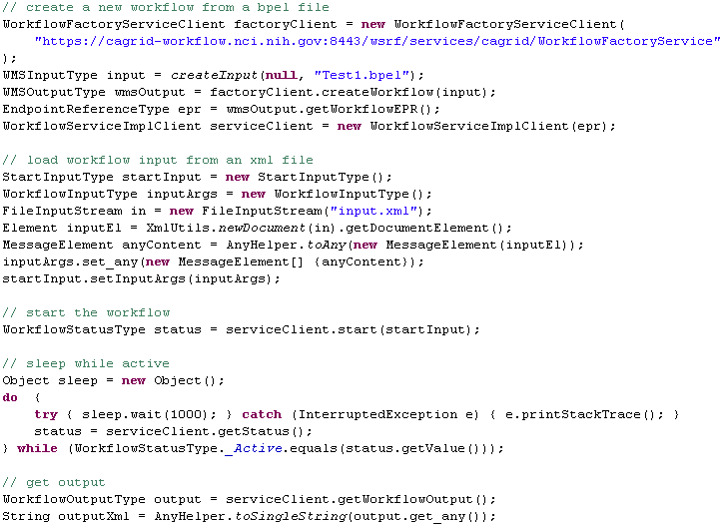

caGrid Global Model Exchange
This chapter describes the caGrid Global Model Exchange.
Topics in this chapter include:
- Overview on this page
- GME Client on page 155

Overview
The caGrid Global Model Exchange (GME) is dependent on several software packages/systems that must be installed prior to installing and deploying the GME. The GME requires all of the required software packages of the caGrid core (Table 9-2).
Software | Version | Description
Java SDK | jsdk1.5 or higher | GME is written in Java therefore it requires the Java SDK. After installing you will have to set up an environmental variable pointing to the Java SDK directory and name it JAVA_HOME.
Mysql | Mysql 4.x or higher | For persistence and cache of models, GME uses the mysql database. Mysql can be downloaded from http://www.mysql.com/products/mysql/. The GME requires mysql version 4.X.
Ant | Ant 1.6.5 | GME along with the Globus Toolkit in which GME is built on, uses Jakarta Ant for building and deploying.
Globus | Globus 4.0.3 | GME is built on top of the Globus Toolkit. GME requires the ws-core installation of the Globus Toolkit.
Tomcat  (Only required if deploying to Tomcat) | Tomcat 5.0.30 | GME can be optionally deployed as a Grid Service to a Tomcat deployed Globus Toolkit.
Table 9-2 Software prerequisites for GME

Building the GME
GME is built when caGrid core is built. To build caGrid, the following environment variables are required:
GLOBUS_LOCATION - The location of your globus 4.0.X installation.
CATALINA_HOME - The location of your Tomcat installation. (optional container)
If you have checked out caGrid core from CVS, installed the required software packages, and set the required environment variables, begin building caGrid core by going into the caGrid core checkout directory and entering ant all.

Configuring and Deploying the GME

Configuration
GME requires two configuration files for configuring the service. One configuration file is for configuring the Mobius GME and the other is for configuring the GME security preferences.
Each addresses a different GME set-up: connecting GME to other services, etc. The file gme-globus-config.xml contains a basic setup for a GME server to run on the local machine and provides an example of how the configuration files are structured. See http://projectmobius.org/docs/mobiusconfig.php for information on the elements in the top resource block of the configuration files.
The localhost config files should never be used for more than single GME testing purposes. If you are running multiple GMEs, customize the config files by assigning unique service identifiers and making any other changes necessary to specify the service as unique. When other services connect to a GME started as localhost, the GME identifies itself as "localhost" to the connecting service. This can cause problems with service name resolution.
The GME server contains a single resource block that provides certain functionality and information to other GME components. The resources defined in the block are instantiated by the GME server at startup and are configured by the config file. The resource for the GME is: GME Configuration <resource name="gmeConfig"... >. Each configuration element is listed here, along with its children. Below this list, the purpose of the elements are described.
- policies
- performance-caching
- notification-policy
- root-database
<policies>
This element establishes parameters for how long the GME should keep old data and what other hosts it should notify of its existence.
<performance-caching>
The <namespace-caching> and <schema-caching> sub-elements of this element tell the GME how much namespace and schema data it should cache and for how long it should maintain the cache.
<notification-policy>
This element contains a <notification-list> sub-element that specifies which running GMEs it should notify upon instantiation.
<root-database>
This element configures the MySQL root database information. The children of this element configure the database. Its "id" attribute is the base name of the MySQL databases that will be created and used by the GME. If you configure multiple GMEs to use a single MySQL installation, be sure to give a unique value to the "id" for each GME or there will be problems with name collision in MySQL.
<name>
This element specifies the name of the database. For MySQL's root database, this should be nothing.
<driver>
The driver class for accessing the MySQL database.
<urlPrefix>
The URL prefix for accessing the database.
<host>
The host the database lives on. Usually, this will be localhost.
<port>
The port from which the database can be accessed.
<username>
The username to log into the database with. This username must have privileges to create and delete databases and tables.
<password>
The password to authenticate the username.
<pool>
This element determines how many connections to the database will be made initially. When the GME needs to communicate with the database, it will get a connection and when it’s done, it releases it. Should the Database Manager run out of available connections, it will make a new one, but this causes a slight delay. Set the pool value in anticipation of how many concurrent database operations will be needed.

Deployment
The GME_LOCATION/deploy.properties file allows the configuration of deployment time properties of the service. The properties file contains two variables for configuring the service name and the service path, as well as information needed to identify the service. These variables are defaulted during skeleton creation time.
service.name=GlobalModelExchange
service.deployment.path=cagrid/GlobalModelExchange
service.deployment.host.default=localhost
service.deployment.port.default=8080
service.deployment.protocol.default=http
Once GME is configured, it can be deployed to Globus running in Tomcat by entering ant deployTomcat or ant deployGlobus from the GME_LOCATION directory. These targets will prompt for the host, port, and protocol which the GME will be running with, and can be changed from the defaults set above in the deploy.properties.
Note: For proper functioning of the GME, these values must be set according to the deployment environment in use
Once deployed starting or restarting the container starts up the GME.

GME Backup and Restore
GME installations should run a backup script to make sure the integrity of the database can be restored if there are any failures. A general purpose script for this is provided in the tools/backup directory. There is one script for backup and one for restore. Each script has a short description inside describing the usage of the script and what variables might need to be configured. This script can be executed from a crontab and maintains five rolling backup caches of the GME databases.

GME Move
If the GME is started up with a different service URL or a move if required to another machine, the GME database will need to be updated. Scripts are provided in the tools/move directory for exporting and importing a GME database. Scripts are also provided for updating the service URL in the database if the service has a new URL resulting from either moving or changing the address of the machine etc. In order to move a GME, the following steps are required.
- Export the database:
  - Use the gmeExportDB.sh script to create an archive of the database data
    - ./gmeExportDB.sh [databaseprefix] [optional database password]
- Import the database:
  - First make sure that you have started up the container on the new machine with the gme service deployed to it. This will create the database and its required tables.
  - Use the gmeImportDB.sh script to import the archived data created from the export step.
    - ./gmeImportDB.sh [databaseprefix] [data file] [optional database password]
- Update the service URL in the database:
  - Use the gmeChangeURL.sh script to modify the databases service url entries with the new service URL.
    - ./gmeChageURL.sh [databaseprefix] [old service url] [new service url] [optional database password]

Important Notes
The default GME configuration is set to connect to a MySQL database on the localhost with no password and username root. If you need to change this be sure to edit the gme config file in the etc directory. The GME also dynamically creates its databases and tables. Make sure that the database privileges are set correctly to enable this.

GME Client

GME Client API
The GME client API is a simple java based API that enables simple access to remote GMEs in order to publish, retrieve, and discover models as well as manage GMEs. The client API comes from the Mobius project and is included in the caGrid release. The communication factories required to use the GME in the caGrid environment are built into the caGrid release jar and deployed into the skeleton. Below is a code example of how to get a handle to a GME and request a schema, and all its referenced schemas, to be retrieved and written to a place on the file system.

GridServiceResolver.getInstance().setDefaultFactory(new GlobusGMEXMLDataModelServiceFactory());
List writtenNamespaces = null;
File directory = new File(CACHE_LOCATION);
try {
XMLDataModelService handle = (XMLDataModelService) GridServiceResolver.getInstance()
.getGridService(“http://dc04.bmi.ohio-state.edu:8080/ogsa/services/cagrid/gme”);
writtenNamespaces = handle.cacheSchema(cagrid.nci.nih.gov/1/Gene,directory);
} catch (MobiusException e1) {
e1.printStackTrace();
}

For more information on other methods the GME API provides, refer to http://projectmobius.org/docs/gmeapi.php or browse the Mobius GME source code, which is freely available at www.projectmobius.org.

GME Viewer
To launch the GME Viewer, run ant gmeViewer from the GME_LOCATION. This launches the Mobius GME Viewer GUI configured to use Globus for communication. Once this tool is launched, follow the Mobius GUI Documentation for using the GUI (http://projectmobius.org/docs/gmeqs.php ).
A simplified GUI for communicating with the GME is also provided as an Introduce extension, under the “Browse Data Types” menu.

- References

Scientific Publications

Technical Manuals/Articles
National Cancer Institute. "caCORE 3.1 Technical Guide", ftp://ftp1.nci.nih.gov/pub/cacore/caCORE3.1_Tech_Guide.pdf
Java Bean Specification: http://java.sun.com/products/javabeans/docs/spec.html
Foundations of Object-Relational Mapping: http://www.chimu.com/publications/objectRelational/
Object-Relational Mapping articles and products:
http://www.service-architecture.com/object-relational-mapping/
Hibernate Reference Documentation: http://www.hibernate.org/hib_docs/reference/en/html/
Basic O/R Mapping: http://www.hibernate.org/hib_docs/reference/en/html/mapping.html
Java Programming: http://java.sun.com/learning/new2java/index.html
Javadoc tool: http://java.sun.com/j2se/javadoc/
JUnit: http://junit.sourceforge.net/
Extensible Markup Language: http://www.w3.org/TR/REC-xml/
XML Metadata Interchange: http://www.omg.org/technology/documents/formal/xmi.htm
Global Grid Forum: http://www.gridforum.org
Globus: http://www.globus.org
Mobius: http://www.projectmobius.org
W3C: http://www.w3c.org
OGSA-DAI: http://www.ogsadai.org
Apache: http://www.apache.org
Globus Toolkit 3 Programmer's Tutorial:
http://gdp.globus.org/gt3-tutorial/singlehtml/progtutorial_0.4.3.html
XPath tutorial: http://www.w3schools.com/xpath/xpath_syntax.asp
Globus Security Overview:
http://www.ogsadai.org.uk/docs/OtherDocs/SECURITY-FOR-DUMMIES.pdf
High level Overview of Grid:
http://gridcafe.web.cern.ch/gridcafe/index.html
Overview of Globus Toolkit 3 and the OGSI architecture :
http://www-128.ibm.com/developerworks/grid/library/gr-gt3/

caBIG Material
caBIG: http://cabig.nci.nih.gov/
caBIG Compatibility Guidelines: http://cabig.nci.nih.gov/guidelines_documentation

caCORE Material
caCORE: http://ncicb.nci.nih.gov/NCICB/infrastructure
caBIO: http://ncicb.nci.nih.gov/NCICB/infrastructure/cacore_overview/caBIO
caDSR: http://ncicb.nci.nih.gov/NCICB/infrastructure/cacore_overview/cadsr
EVS: http://ncicb.nci.nih.gov/NCICB/infrastructure/cacore_overview/vocabulary
CSM: http://ncicb.nci.nih.gov/NCICB/infrastructure/cacore_overview/csm

Glossary
Term | Definition
{jboss-home} | The base directory where JBoss is installed on the server
API | Application Programming Interface
caArray | cancer Array Informatics
caBIG | cancer Biomedical Informatics Grid
caBIO | Cancer Bioinformatics Infrastructure Objects
caCORE | cancer Common Ontologic Representation Environment
caDSR | Cancer Data Standards Repository
caMOD | Cancer Models Database
cardinality | Cardinality describes the minimum and maximum number of associated objects within a set
CDE | Common Data Element
CGAP | Cancer Genome Anatomy Project
CMAP | Cancer Molecular Analysis Project
CN | Common Name
CS | Classification Scheme
CSI | Classification Scheme Item
CSM | Common Security Module
CTEP | Cancer Therapy Evaluation Program
CUI | Concept Unique Identifier
CVS | Concurrent Versions System
DAIS | Data Access and Integration Services
DAML | DARPA Agent Markup Language
DAO | Data Access Objects
DARPA | Defense Advanced Research Projects Agency
DAS | Distributed Annotation System
DL | Description Logic
EA | Enterprise Architect
EBI | European Bioinformatics Institute
EVS | Enterprise Vocabulary Services
GAI | CGAP Genetic Annotation Initiative
GEDP | Gene Expression Data Portal
GGF | Global Grid Forum
GME | Mobius Global Model Exchange - DNS-like service for the universal creation, versioning, and sharing of data descriptions
Grid Service | Basically a Web Services with improved characteristics and standard services like stateful and potentially transient services, Service Data, Notifications, Service Groups, portType extension, and Lifecycle management.
GSH | Grid Service Handle
GSI | Grid Security Infrastructure - represents the latest evolution of the Grid Security Infrastructure. GSI in GT3 builds off of the functionality present in early GT2 toolkit releases - X.509 certificates, TLS/SSL for authentication and message protection, X.509 Proxy Certificates for delegation and single sign-on.
HTTP | Hypertext Transfer Protocol
ISO | International Organization for Standardization
JAAS | Java Authentication and Authorization Service
JAR | Java Archive
Javadoc | Tool for generating API documentation in HTML format from doc comments in source code (http://java.sun.com/j2se/javadoc/)
JDBC | Java Database Connectivity
JET | Java Emitter Templates
JMI | Java Metadata Interface
JSP | JavaServer Pages
JUnit | A simple framework to write repeatable tests (http://junit.sourceforge.net/)
LDAP | Lightweight Directory Access Protocol
LLT | Lowest Level Term
LOINC | Logical Observation Identifier Names and Codes
MAGE | MicroArray and Gene Expression
MAGE-OM | MicroArray Gene Expression - Object Model
MDA | Model Driven Architecture
MedDRA | Medical Dictionary for Regulatory Activities
metadata | Definitional data that provides information about or documentation of other data.
MGED | Microarray Gene Expression Data
Mobius | An array of tools and middleware components to coherently share and manage data and metadata in a Grid and/or distributed computing environment.
multiplicity | Multiplicity of an association end indicates the number of objects of the class on that end may be associated with a single object of the class on the other end
NCI | National Cancer Institute
NCICB | National Cancer Institute Center for Bioinformatics
OGSA | Open Grid Services Architecture - developed by the Global Grid Forum, aims to define a common, standard, and open architecture for grid-based applications.
OGSI | Open Grid Services Infrastructure -gives a formal and technical specification of what a Grid Service is. In other words, for a high-level architectural view of what Grid Services are, and how they fit into the next generation of grid applications
OIL | Ontology Inference Layer
OilEd | Ontology editor allowing you to build ontologies using DAML+OIL
OLLT | Obsolete Lower Level Terms
OMG | Object Management Group
ORM | Object Relational Mapping
PT | Preferred Term
RDBMS | Relational Database Management System
SDE | Service Data Element
SDK | Software Development Kit
Semantic connector | A development kit to link model elements to NCICB EVS concepts.
SOA | Service Oriented Architecture: A discipline for building reliable distributed systems that deliver application functionality as services with the additional emphasis on loose coupling between interacting services.
SOA | Service Oriented Architecture
SOAP | Simple Object Access Protocol
SOC | System Organ Class
SPORE | Specialized Programs of Research
SQL | Structured Query Language
SSC | Special Search Categories
UI | User Interface
UID | User Identification
UML | Unified Modeling Language
UML | Unified Modeling Language
UMLS | Unified Medical Language System
UPT | User Provisioning Tool
URL | Uniform Resource Locators
VD | Value Domain
Virtualization | Make a computational or data resource available to caBIG community - some people call "Gridification"
VO | Virtual Organization
WAR | Web Application Archive
Web Service | Application to application communication using web based service interfaces as describe by the Web Services 1.0 or 2.0 specification.
WSDD | Web Service Deployment Descriptor
WSDL | Web Services Description Language
WSDL | Web Services Description Language
WSRF | Web Services Resource Framework
XMI | XML Metadata Interchange (http://www.omg.org/technology/documents/formal/xmi.htm) - The main purpose of XMI is to enable easy interchange of metadata between modeling tools (based on the OMG-UML) and metadata repositories (OMG-MOF) in distributed heterogeneous environments
XML | Extensible Markup Language (http://www.w3.org/TR/REC-xml/) - XML is a subset of Standard Generalized Markup Language (SGML). Its goal is to enable generic SGML to be served, received, and processed on the Web in the way that is now possible with HTML. XML has been designed for ease of implementation and for interoperability with both SGML and HTML
XML | Extensible Markup Language
XPath | XML query/traversal language adhering to the XPath specification set forth by the W3C.
XQuery | XML query/transformation language adhering to the XQuery specification set forth by the W3C.

Index

addNonNullPredicate
gov::nih::nci::cagrid::discovery::client::DiscoveryClient, 49
annotateServiceMetadata, 56
API
caDSR grid service usage, 25, 55
caDSR Grid Service usage examples, 63
caDSR Grid Services details, 59
Discovery API details, 36
Discovery usage examples, 51
Discovery usage overview, 34
EVS usage overview, 67
federated query processor details, 102
federated query processor examples, 106
GME client, 145
metadata details, 28
metadata usage examples, 31
WS-enumeration client, 113
WS-enumeration usage examples, 116
BPEL, 127
buildDataUMLClassPredicate
gov::nih::nci::cagrid::discovery::client::DiscoveryClient, 48
buildPOCPredicate
gov::nih::nci::cagrid::discovery::client::DiscoveryClient, 48
buildUMLClassPredicate
gov::nih::nci::cagrid::discovery::client::DiscoveryClient, 48
caBIG
references, 151
caCORE
references, 151
caDSR Grid Service
overview, 25, 55
security considerations, 59
caDSR Grid Services
API details, 59
API usage examples, 63
examining project information model, 63
generating data service metadata, 64
caDSRServiceClient, 59
caGrid
security overview, 75
caGrid document, 2
CQL syntax validation, 94
CQLQueryResults, 90
creating, 91
createConceptPredicatedUMLClass
gov::nih::nci::cagrid::discovery::client::DiscoveryClient, 44
createPermissibleValuePredicatedUMLClass
gov::nih::nci::cagrid::discovery::client::DiscoveryClient, 44
Data Services
CQL query results, 90
CQL query syntax, 93
domain model conformance, 94
results validation, 94
utility classes, 91
DataServiceConstants, 88
deserializeDomainModel, 33
gov::nih::nci::cagrid::metadata::MetadataUtils, 30
deserializeServiceMetadata, 33
gov::nih::nci::cagrid::metadata::MetadataUtils, 29
discoverByFilter
gov::nih::nci::cagrid::discovery::client::DiscoveryClient, 49
discoverDataServicesByAssociationsWithClass
gov::nih::nci::cagrid::discovery::client::DiscoveryClient, 47
discoverDataServicesByDomainModel, 53
gov::nih::nci::cagrid::discovery::client::DiscoveryClient, 45
discoverDataServicesByExposedClass
gov::nih::nci::cagrid::discovery::client::DiscoveryClient, 46
discoverDataServicesByModelConceptCode
gov::nih::nci::cagrid::discovery::client::DiscoveryClient, 45
discoverDataServicesByPermissibleValue
gov::nih::nci::cagrid::discovery::client::DiscoveryClient, 46
discoverServiceByOperationInput, 55
discoverServicesByConceptCode, 54
gov::nih::nci::cagrid::discovery::client::DiscoveryClient, 39
discoverServicesByDataConceptCode
gov::nih::nci::cagrid::discovery::client::DiscoveryClient, 43
discoverServicesByName
gov::nih::nci::cagrid::discovery::client::DiscoveryClient, 39
discoverServicesByOperationClass
gov::nih::nci::cagrid::discovery::client::DiscoveryClient, 41
discoverServicesByOperationConceptCode, 54
gov::nih::nci::cagrid::discovery::client::DiscoveryClient, 42
discoverServicesByOperationInput
gov::nih::nci::cagrid::discovery::client::DiscoveryClient, 40
discoverServicesByOperationName, 53
gov::nih::nci::cagrid::discovery::client::DiscoveryClient, 40
discoverServicesByOperationOutput
gov::nih::nci::cagrid::discovery::client::DiscoveryClient, 41
discoverServicesByPermissibleValue
gov::nih::nci::cagrid::discovery::client::DiscoveryClient, 43
discoverServicesByPointOfContact
gov::nih::nci::cagrid::discovery::client::DiscoveryClient, 38
discoverServicesByResearchCenter, 53
gov::nih::nci::cagrid::discovery::client::DiscoveryClient, 38
discoverServicesBySearchString, 53
gov::nih::nci::cagrid::discovery::client::DiscoveryClient, 37
Discovery API
configuring index service, 51
details, 36
discovering services, 52
usage examples, 51
DiscoveryClient
definition, 34
gov::nih::nci::cagrid::discovery::client::DiscoveryClient, 36
Disovery API
overview, 34
Document conventions, technical guide, 2
domain model, 92
Domain Model, 94
EVS API
getHistoryRecords, 70
getMetaSources, 67
getVocabularyNames, 68
searchDescLogicConcept, 68
searchMetaThesaurus, 71
searchSourceByCode, 73
usage overview, 67
execute
gov::nih::nci::cagrid::fqp::processor::FederatedQueryEngine, 105
executeAndAggregateResults
gov::nih::nci::cagrid::fqp::processor::FederatedQueryEngine, 105
FederatedQueryEngine
gov::nih::nci::cagrid::fqp::processor::FederatedQueryEngine, 105
FileReader, 33
FileWriter, 33
generateDomainModelForClasses, 56
generateDomainModelForClassesWithExcludes, 56
generateDomainModelForPackage, 56
generateDomainModelForProject, 56, 65
getAllDataServices
gov::nih::nci::cagrid::discovery::client::DiscoveryClient, 44
getAllServices
gov::nih::nci::cagrid::discovery::client::DiscoveryClient, 36
getDomainModel
gov::nih::nci::cagrid::metadata::MetadataUtils, 29
getIndexEPR
gov::nih::nci::cagrid::discovery::client::DiscoveryClient, 50
getServiceMetadata
gov::nih::nci::cagrid::metadata::MetadataUtils, 28
Getting help, 1
Global Model Exchange. See GME
GME
building, 141
client API, 145
configuring, 141
deploying, 143
software prerequisites, 141
viewer, 145
GME XE "Global Model Exchange" \t "See GME" XE "GME:software prerequisites"
overview, 141
gov::nih::nci::cagrid::discovery::client::DiscoveryClient
addNonNullPredicate, 49
buildDataUMLClassPredicate, 48
buildPOCPredicate, 48
buildUMLClassPredicate, 48
createConceptPredicatedUMLClass, 44
createPermissibleValuePredicatedUMLClass, 44
discoverByFilter, 49
discoverDataServicesByAssociationsWithClass, 47
discoverDataServicesByDomainModel, 45
discoverDataServicesByExposedClass, 46
discoverDataServicesByModelConceptCode, 45
discoverDataServicesByPermissibleValue, 46
discoverServicesByConceptCode, 39
discoverServicesByDataConceptCode, 43
discoverServicesByName, 39
discoverServicesByOperationClass, 41
discoverServicesByOperationConceptCode, 42
discoverServicesByOperationInput, 40
discoverServicesByOperationName, 40
discoverServicesByOperationOutput, 41
discoverServicesByPermissibleValue, 43
discoverServicesByPointOfContact, 38
discoverServicesByResearchCenter, 38
discoverServicesBySearchString, 37
DiscoveryClient, 36
getAllDataServices, 44
getAllServices, 36
getIndexEPR, 50
main, 50
setIndexEPR, 50
translateXPath, 50
gov::nih::nci::cagrid::discovery::XPathUtils
translateXPath, 51
gov::nih::nci::cagrid::fqp::processor::FederatedQueryEngine
execute, 105
executeAndAggregateResults, 105
FederatedQueryEngine, 105
gov::nih::nci::cagrid::metadata::MetadataUtils
deserializeDomainModel, 30
deserializeServiceMetadata, 29
getDomainModel, 29
getServiceMetadata, 28
serializeDomainModel, 30
serializeServiceMetadata, 29
Grid Grouper
overview, 79
InternalRuntimeException, 28, 34
InvalidProjectException, 56
InvalidResourcePropertyException, 28, 35
main
gov::nih::nci::cagrid::discovery::client::DiscoveryClient, 50
Malformed query, 96
Metadata
accessing from service, 31
API details, 28
API usage examples, 31
processing as XML, 32
PointOfContact, 54
processQuery() method, 96
properties, 96
optional, 96
QName, 88
QueryInvalidException, 28, 35
Reader, 33
References
caBIG, 151
caBIG materials, 151
caCORE, 151
caCORE material, 151
scientific publications, 147
technical manuals, guides, 150
RemoteResourcePropertyRetrievalException, 28, 35
ResourcePropertyHelper, 27
ResourcePropertyRetrievalException, 28, 34, 35
serializeDomainModel, 33
gov::nih::nci::cagrid::metadata::MetadataUtils, 30
serializeServiceMetadata, 33
gov::nih::nci::cagrid::metadata::MetadataUtils, 29
ServiceMetadata, 33, 56
setIndexEPR
gov::nih::nci::cagrid::discovery::client::DiscoveryClient, 50
sourceClassName, 56
sourceRoleName, 56
target data types, 94
targetClassName, 56
targetRoleName, 56
Text conventions, technical guide, 2
thread, 88
translateXPath
gov::nih::nci::cagrid::discovery::client::DiscoveryClient, 50
gov::nih::nci::cagrid::discovery::XPathUtils, 51
UMLAssocation, 58
UMLAssociationExclude, 58
UMLAssociationExcludes, 56
UMLAssociationMetadata, 58
UMLClass, 54
URL, 88
Workflow
architecture description, 125
overview, 125
security contexts, 132
WorkflowFactoryService API, 127
WorkflowManagementService API, 129
Writer, 33
wsdd parameters, 93
WS-Enumeration
client API, 113
command line clients, 119
overview, 113

