caGrid
Authorization Framework

Design and Architecture

caBIG™ is an initiative of the National Cancer Institute, NIH, DHHS

Copyright and License page

Insert Names of Development Team(s) here
Development | Programmer’s guide |  | Program Management
Names of developers | Names of technical writers and reviewers |  | Names of program managers
¹ Footnote contributing companies/ contractors/ divisions |  | ³ company
² department or division

Contacts and Support
Enter training contact | name (email address)
Enter customer support contact | Web hyperlink  Telephone: 111-222-3456  Toll free: 888-234-1234

LISTSERV Facilities Pertinent to software teams
LISTSERV | URL | Name
caBIO_Users | https://list.nih.gov/archives/cabio_users.html | caBIO Users Discussion Forum
caBIO_Developers | https://list.nih.gov/archives/cabio_developers.html | caBIO Developers Discussion Forum
caDSR_Users | https://list.nih.gov/archives/cadsr_users.html | Cancer Data Standards Repository
NCIEVS-L Listserv | https://list.nih.gov/archives/ncievs-l.html | NCI Vocabulary Services Information
caArray_Users
Add appropriate listservs and or websites here

Table of Contents

Chapter 1 Introduction 7
Chapter 2 caGrid Authorization Framework 9
Globus Authorization Framework 9
Policy Decision Points (PDPs) 11
caGrid Application Authorization Framework 14
Chapter 3 SAML/CSM Authorization Service 17
Chapter 4 Integrating SDK Applications 18
Chapter 5 Grid Virtual Organization Service 20

Introduction
Authorization is the process of determining who is allowed to perform what actions. The goal of the caGrid 1.0 authorization framework is to empower service providers and data owners to make authorization decisions. One of the major focuses of the caGrid 1.0 authorization framework is extensibility, allowing service providers to leverage their authorization mechanism of choice for enforcing access control policies. It is not the mission of the caGrid team to advocate one authorization mechanism over another but to facilitate the integration of authorization mechanisms required by applications for meeting authorization policies. To facilitate the integration the caGrid team will provide integration points within the grid infrastructure.
Another focus of the caGrid 1.0 authorization framework is to provide higher level services to facilitate authorization at the grid level. These services will be made available to service providers and will be developed based on community demand. In this document we will refer to these higher level services as extension points. Extension points are implementations of higher level community services that will be accessed through the integration points within the grid infrastructure. The purpose of this document is to design and present the architecture for the authorization integration points in the caGrid 1.0 . This document will also present the design and architecture of higher level authorization services or extension points. As new higher level services are made available their design and architecture will be maintained in this document. Please note this document assumes that the reader has a firm understanding of grid security, for a good overview of grid security please consult the following:
http://www.globus.org/toolkit/docs/4.0/security/GT4-GSI-Overview.pdf

caGrid Authorization Framework
Authorization can be performed at the grid service level, at the method level of a grid service, or at an application level. For example take a data service with a query method. Authorization can be used to restrict access to the entire data service. Authorization can also be used to restrict access to individual methods on the data service, such as the query method. In this example authorization can also be used to restrict access to individual data instances, such as the data the query interacts with; we refer to this as application level authorization. Both grid service level authorization and method level authorization are generally handled by the grid service infrastructure, since enforcing it is straight forward. Application level authorization is generally not enforced by the grid infrastructure since application level authorization depends on application business logic. We mentioned earlier, one of the major focuses of the caGrid 1.0 authorization framework is extensibility, allowing service providers to leverage their authorization mechanism of choice for enforcing access control policies. It is not the mission of the caGrid team to advocate one authorization mechanism over another but to facilitate the integration of authorization mechanisms required by applications for meeting authorization policies. To facilitate the integration the caGrid team will provide integration points within the grid infrastructure. The Globus Toolkit provides several integration points in their authorization framework for enforcing service level and method level authorization on grid services. caGrid will leverage this framework for providing service level and method level authorization on grid services. For providing application level security, caGrid will extend the Globus authorization framework to provide integration points for caGrid services to make callbacks that enforce application level security. In this manner grid services can enforce application level security by asking the underlying authorization layer whether a specific user has can perform a specific action on a specific resource, where the action and resource are defined by the application.
In this chapter we will define the caGrid Authorization Framework consisting of the Globus Authorization Framework and the caGrid extensions. In the remainder of this document we will define extensions to this framework that will provide higher level services to service providers for making authorization decisions.

Globus Authorization Framework

The Globus authorization framework enforces authorization policy configured and services. The framework allows developers to configure a chain of authorization mechanisms either programmatically or declaratively using security descriptors. It also allows for plugging in new authorization schemes (in addition to using those that are provided with the framework). Moreover, the framework allows for this configuration to be done at resource, service or container level, each taking precedence in the order specified and scoped as the name.
The Globus Authorization framework is based on the OASIS XACML and SAML standards . The architecture of the framework uses the XACML authorization model that is shown in Figure 1.
PEP
PDP
PAP
PIP
Obligation Service
Subject
Resource
Environment
1.Access Request
2.Request
7.Response
3.Policy
4.Attribute Query
5a.Subject Attributes
5b.Resource Attributes
5c.Environment Attributes
6.Attribute
8.Obligations

Figure 1 XACML Authorization Model
The XACML authorization model mainly consists of Policy Enforcement Points (PEP) , Policy Decision Points (PDP), Policy Information Points (PIP), and Policy Administration Points (PAP). The PEP intercepts the access requests from users and sends the requests to the PDP. The PDP makes access decisions according to the security policy or policy set written by PAP and, using attributes of the subjects, the resource, and the environment obtained by querying the PIP. The access decision given by the PDP is sent to the PEP. The PEP fulfills the obligations and either permits or denies the access request according to the decision of PDP.
The GT4 authorization framework uses the XACML model (PEP, PDPs, and PIPs), as shown in Figure 2. In the framework a PDP is constructed for evaluating each authorization policy. The Master PDP had the responsibility of coordinating and invoking the PDPs to render and authorization decision. The framework provides different kind of PIPs. Bootstrap PIPs, collect information only about the request, such as the peer subject, the requested action, and the resource. An example of one such PIP, is the X509BootstrapPIP, which extracts the subject DN of the peer from the X509 certificate. The framework can be configured to leverage other PIPs, such as Shibboleth for obtaining user attributes that may be required by a PDP for making an authorization decision.
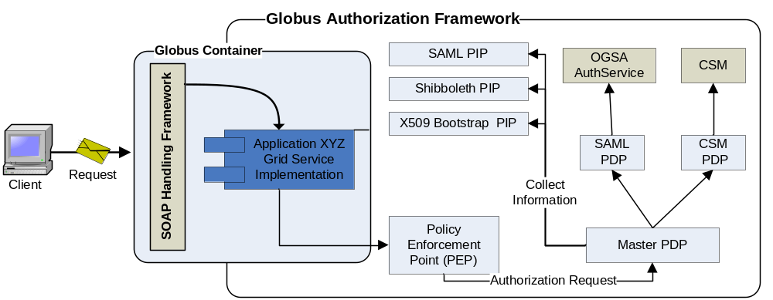
Figure 2 Globus Authorization Framework
The PEP intercepts service requests and asks the master PDP to make and authorization decision. The master PDP acquires information from the Bootstrap PIPs and any other configured PIPs. The information is then used to make an authorization decision or invoke other PDPs, the master PDP combines the decisions f the other PDPs to issue a final decision back to the PEP.

Policy Decision Points (PDPs)

The PDP is the cornerstone of the Globus authorization framework, PDPs can be used to integrate and leverage any authorization mechanism. Since PDPs can be chained the Globus authorization framework supports the deployment of multiple PDPs allowing service to provide access control based on integrating with multiple authorization mechanisms. To integrate an authorization mechanism one needs to implement a PDP for it. In this manner a PDP is merely an adapter mapping authorization decision requests into the authorization mechanism being integrated with. A PDP can be implemented by implementing Globus’s Java PDP interface (org.globus.wsrf.security.authorization.PDP). Once implemented the PDP can be configured and used in the Globus Authorization Framework. For more information on implementing PDPs please consult the following: http://www-128.ibm.com/developerworks/grid/library/gr-gt4auth/
Globus includes several PDPs in its release, in the remainder this section we will document these PDPs. There are also many other PDPs developed by the grid community that can be leveraged as well, for example PDPs exist for Permis, VOMS, and Shibboleth.

Self PDP (org.globus.wsrf.impl.security.authorization.SelfAuthorization)

The Self PDP enforces that the Invoker of the service is the same as the owner of the service.

Grid Map PDP (org.globus.wsrf.impl.security.authorization.GridMapAuthorization)

The GridMap PDP enforces the identity of the invoker of the service is listed in a grid map file. A grid map file is a list of grid users identities and their mapping to a local identity that will be given access to a service or resource.

Identity PDP (org.globus.wsrf.impl.security.authorization.IdentityAuthorization)

The Identity PDP enforces the identity of the invoker to be equal to an identity specified by the service.

Host PDP (org.globus.wsrf.impl.security.authorization.HostAuthorization)

The Host PDP enforces the identity of the invoker to be equal to a hostname specified by the service.

SAML Callout PDP (org.globus.wsrf.impl.security.authorization.SAMLAuthorizationCallout)

The SAML Callout PDP makes a request to an OGSA Authz compliant authorization service for an authorization decision. The OGSA Authz authorization service defines a standard service interface for making authorization decisions, creating an abstraction layer between the grid and authorization systems, providing a uniform access pattern to all authorization systems. An implementation of the OGSA Authz authorization service would consist of layering an existing authorization system (such as the CSM or PERMIS) behind the standard interface defined. The OGSA Authz authorization service uses the Security Assertion Markup Language (SAML) for requesting and expressing authorization assertions and decisions from an OGSA authorization service and allow for the communication of authorization decisions from such a service to a service fielding a request from a client. For more information on an OGSA Authz compliant authorization service, please consult: https://forge.gridforum.org/projects/ogsa-authz

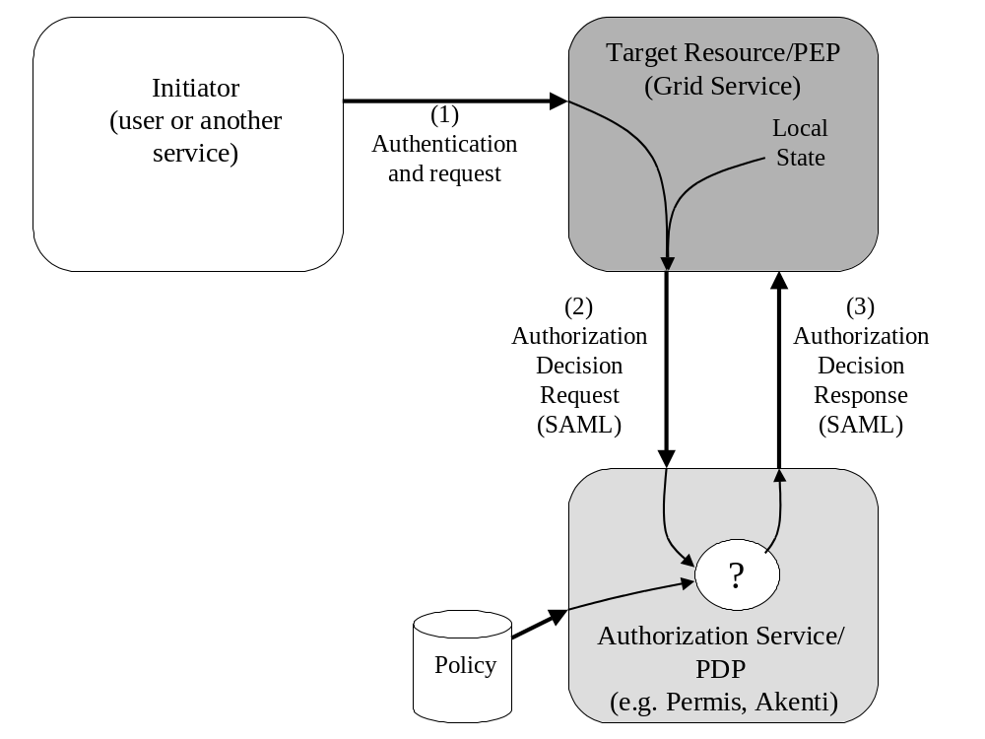
Figure 3 OGSA Authz Authorization Service (Taken from OGSA Authz Specification)

caGrid Application Authorization Framework

Application level authorization is generally not enforced by the grid infrastructure since application level authorization depends on application business logic. The Globus Authorization Framework provides and extensible solution for service level authentication but does not provide facilities for application level security, this is generally left up to the application developers. For providing application level security, caGrid will extend the Globus authorization framework to provide integration points for caGrid services to make callbacks that enforce application level security. In this manner grid services can enforce application level security by asking the underlying authorization layer whether a specific user has can perform a specific action on a specific resource, where the action and resource are defined by the application. The current Globus Authorization Framework’s (4.0.2) PDP model is very low level and does not lend itself well to application level authorization. The PDP interfaces make authorization decisions based on web service contexts, which are generally not available at the application level. For that reason we will be required to create an application level XACML model, we refer to this as the caGrid Authorization Framework (caGridAppAuthz). The main difference between the Globus XACML model and the Application XACML model will be the component interfaces. For example the Globus PDP interface is as follows:
public boolean isPermitted(Subject subject, MessageContext context, QName operation)
You will notice that the input to the isPermitted method is based on the current context in web services, which is not applicable to the application domain. The input (User Identity, Action, Resource) for the application PDP will apply more to the application:
public boolean isPermitted(String userIdentity, String action, String resource)

caGridAppAuthz will be configurable and deployable with caGrid services. Access to the framework will be made available to caGrid services. Application developers may leverage the framework to protect access to specific data or specific areas in the application. caGridAppAuthz provides an abstraction between the application and the authorization system, making the application agnostic to the underlying authorization system.

An example instantiation of the caGridAppAuthz is illustrated in Figure 4. When application wishes to provide access control on data or within an area of the application, the application makes an authorization request to the authorization framework. Prior to making a decision the authorization framework collection information about the target user, that will be used by the PDPs to make a decision. In the framework a PDP is constructed for evaluating each authorization policy. The Master PDP had the responsibility of coordinating and invoking the PDPs to render and authorization decision. The decision is then returned to the application.
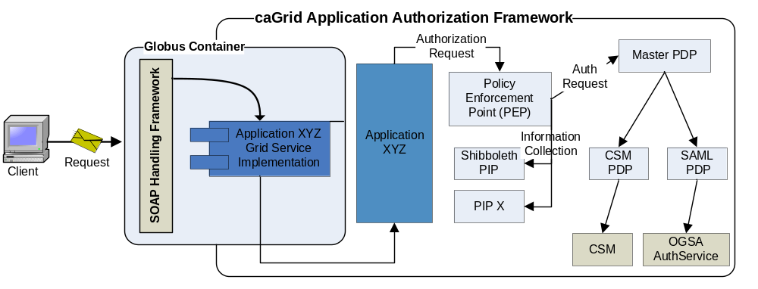Figure 4 caGrid Application Authorization Framework

Like the Globus Authorization Framework the PDP is the cornerstone of caGridAppAuthz, PDPs can be used to integrate and leverage any authorization mechanism. caGridAppAuthz will provide PDP implementations for relevant PDPs that Globus already supports, for example the SAML callout PDP.

SAML/CSM Authorization Service
The NCICB's Common Security Module (CSM) was chartered to provide a comprehensive solution to common security objectives so not all development teams would have to create their own security methodology. The CSM provides a authorization solution for application developers and is used widely within NCICB applications. Given the successful adoption and usefulness of CSM within the NCICB, it was determined that CSM could bring a lot of value to the Grid as an authorization service. The OGSA Authz authorization service defines a standard service interface for making authorization decisions, creating an abstraction layer between the grid and authorization systems, providing a uniform access pattern to all authorization systems. caGrid will provide an implementation of the OGSA Authz authorization service for CSM. This will bring CSM to grid allowing it to be leveraged to provide access control on grid services and grid applications. Enabling grid service and applications to leverage CSM will be turn key, they simply will need to be configured to use the SAML callout PDP for making authorization decisions. Figure 5 illustrates the CSM OGSA Authorization Service, integrating CSM requires the implementation of a simple adapter which calls into the CSM for making authorization decisions based on the SAML callout request.
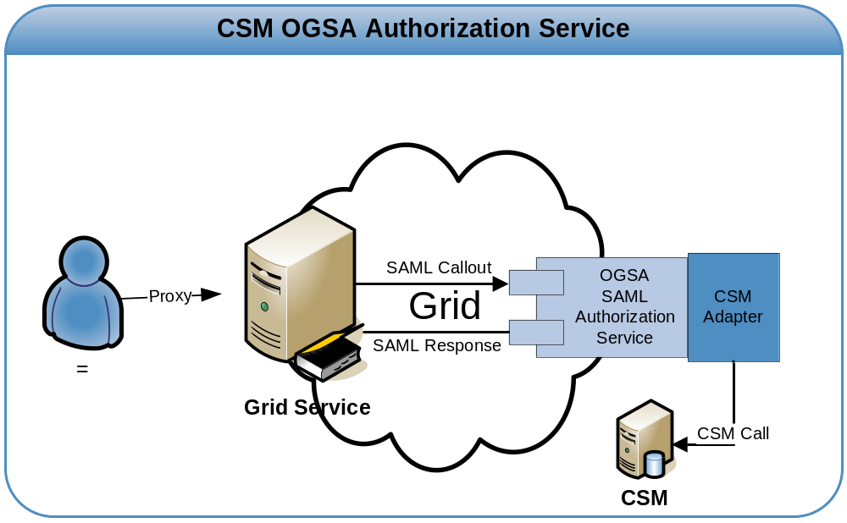
Figure 5 CSM OGSA Authorization Service

Integrating SDK Applications
The caCORE SDK The NCICB caCORE Software Development Kit (SDK) is a set of tools designed to aid in the design and creation of a “caCORE-like” software system. This system is “semantically integrated” -- all exposed API elements have runtime accessible metadata that defines the meaning of the elements using controlled terminology.
To achieve this integration, “caCORE-like” systems follow certain design practices:
- UML Modeling
- n-tier architecture with Open APIs
- Controlled Vocabularies
- Registered metadata
The caCORE SDK helps developers to develop the caCORE like systems fast and effectively. As such caCORE SDK does not have its own security infrastructure. To enable security in caCORE SDK generated system, CSM has been integrated with SDK. The generated system is configurable to make security off or on. If the security is on, then a client has to authenticate itself before making call to the system.
The following design discussion is for secured system where security is on. Typically a user establishes a session with server by authenticating itself only once. This avoids the user to authenticate itself again and again with every call.
CSM integration with SDK provides object level security. Present release of caCORE SDK does not support object instance level security. To leverage the existing application level security, the user context (user id ) has to be passed to the application service layer.
When a user presents its proxy to a grid service, the user id will be extracted based on the proxy presented. This user id will then be used by CSM for authorization. When a API call has to be made to the caCORE SDK generated system APIs, the user has to authenticate itself. But in a grid service scenario, we will only have access to the user id and not the password. To facilitate and leverage the existing security, the authentication process has to be bypassed. For future reference purposes, we will call it proxy authentication.
The CSM authentication mechanism uses the concept of an ApplicationContext, which contains the name of a system. CSM uses the ApplicationContext object to identify the required login module and access control policy repository. Essentially, CSM instantiates the AuthenticationManager and AuthorizationManager based on the ApplicationContext object. Details pertaining to the ApplicationContext are specified in securityconfig.xml, which is a xml configuration file for CSM.
To integrate SDK generated applications, a custom login module will be implemented. The login module will check if the user id exist but will not check for user id / password combination. The login module will simply return true if the user id is found in the access control repository. This will establish the user session for the user in the question. Any API call from here will automatically kick in the authorization check using CSM.
The complete integration scenario can be comprehended using the following diagram
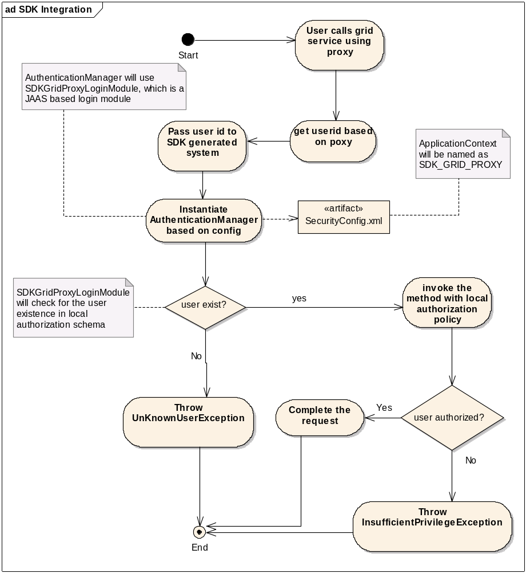

Grid Virtual Organization Service
Suppose we have a Patient Provider service, that provides patient information about an institution’s Patients, and that any user classified as a Doctor can access the patient information provided by the Patient Provider service. The deployment scenario shown in Figure X contains three Patient Provider service one at Duke, one at Georgetown, and one at the Ohio State University. The Duke Patient Provider Service allows access to users that are classified as Doctors by Duke (represented by the Duke Doctors group). The Georgetown Patient Provider Service allows access to users that are classified as Doctors by Georgetown (represented by the Georgetown Doctors group). The Ohio State University Patient Provider Service allows access to users that are classified as Doctors by caBIG, where a user is classified as a caBIG Doctor if they are classified as a Doctor by a caBIG affiliated institution. In current scenario caBIG Doctors are all the users classified by Duke as Doctors and all the users classified by Georgetown as Doctors. The access control or authorization mechanism demonstrated in this example is often referred to as group/role based authorization. Under group/role based authorization users are organized into groups and assigned a roles based on membership in a group. In the scenario just demonstrated the users are group based on whether or not they are Doctors. If a user is in the “Doctor’s Group”, they have the role of being Doctor, the Patient Provider Service grants access based on membership to the “Doctor’s Group” or based on having the role of Doctor.
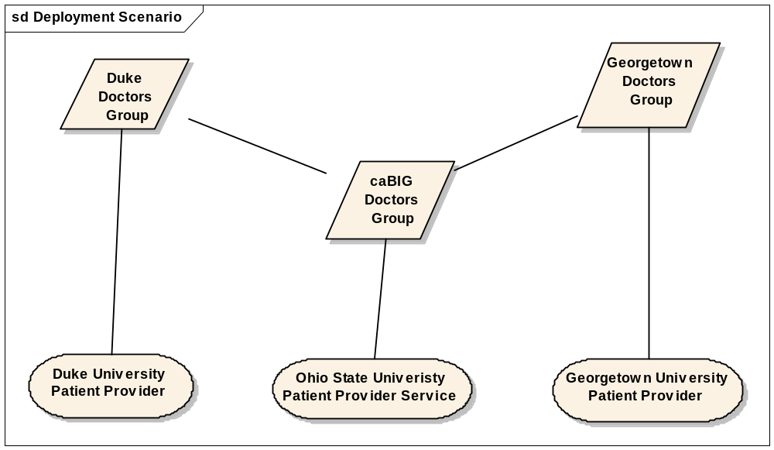
Group/Role authorization is a commonly used for meeting access control requirements in many of today’s applications. In for the group/role model to scale and be manageable in a multi-institution grid environment, groups must be maintained and federated at the grid level. For example imagine trying to manage the caBIG Doctors Group locally, every time a Doctor is added or removed from either of the two sub groups (Georgetown, Duke) the caBIG Doctors group needs to be updated. In this trivial example one can see how difficult it is to provision group membership across related groups, this difficulty will increase exponentially as the relationships between groups become more an more complex. This problem can be solved by maintaining all the groups in a centralized location behind the grid such as the SAML/CSM Authorization service described earlier. Another solution is to build grid infrastructure for provisioning and federating groups at the grid level. The Grid Virtual Organization Service (GVOS) defines and manages a set of virtual organizations at the grid level, where a virtual organization is compromised as a set of users and set of other virtual organizations, which may be defined on another GVOS.
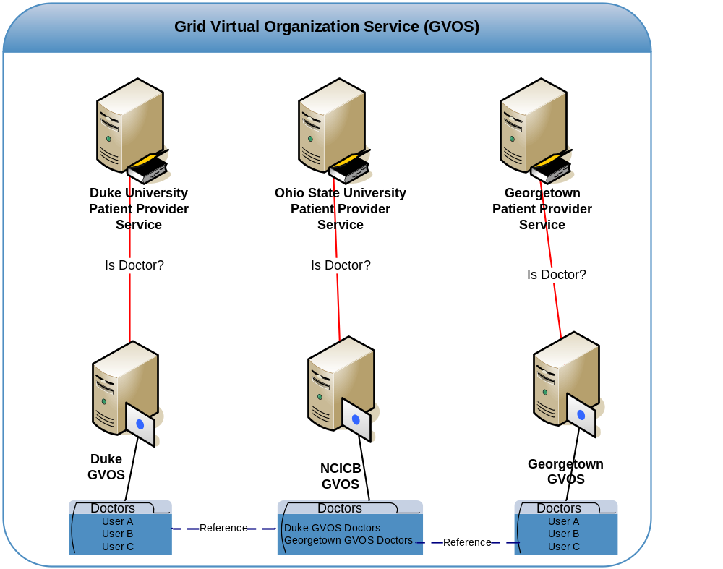
Figure XX demonstrates how GVOS address the scenario defined earlier. Georgetown and Duke each maintain a GVOS service that manages a Doctor VO, consisting of a list of all the Doctors within their respective institution. Both the Georgetown and Duke Patient Provider Service authorize users based on membership in the Doctor VO maintained at the GVOS of their respective institution. The NCICB maintains a GVOS services that contains a Doctors VO consisting of two sub Doctor VOs, the one defined in the GVOS at Duke and the one defined in the GVOS at Georgetown. The Ohio State Patient Provider allows access to users if they are a member of the NCICB Doctors VO or more specifically are a member of the Duke Doctors VO o the Georgetown Doctors VO.

Attribute based authorization
Use Case Scenario:
We propose to evaluate the technical implementation approaches in the light of the use case scenario presented below:
Actors: User A belonging to OSU
User B belonging to NCI
Environment: caTissue data service at UPMC ( access control using CSM)
caTissue data service at WASU ( access control using CSM)
FireBird application running at NCI ( access control using some other framework)
Use Case: User A and User B access data from these three services.
What is expected when invoking the services: User A or User B logs in and sends request to all the three services, User should be able to access the permitted data irrespective of its existence at local site.
Place the figure here

Immediate concern: The data services control the access to the data using CSM. As CSM control the access to the data based on the user Id, every user who wishes to have access to the data, need to exist in the CSM authorization schema. This problem is not specific to CSM but applies to mostly all the application which uses some local authorization scheme like CSM.
When these applications are brought to grid as grid services, the access to these services should not be limited to the users existing locally within application else the whole point of bringing these applications to the grid is useless.
So facilitate the usage of these services to grid users, the access control should be based not only local user identities but also on other user attributes. There are various approaches ( VOMS, Authz, and attribute based authorization) to address this issue.
In the following sections the approaches and their pros and cons will be discussed.
Attribute based authorization: When a user logs in the grid then a grid id is granted, for the access control to work for that user, somehow the grid id should be mapped to local account. But this approach has lot of scalability and maintenance problems.
So rather than providing low level access, the approach should be towards higher level access. To that end, a user should have some other qualifying attributes. For example, all the members belonging caGrid developers list can check in the code. This leads to higher level access. So rather than listing all the users in the policy repository or authorization schema, we can just say that any one belonging to this list can write a file to CVS. The higher level access can be achieved by attributes of the user and not the user identity.
Attributes can be as minimum as a group which a user belongs to. A PDP can make a authorization decision based on the attributes. But what is important in this protocol is the presentation of attributes. The attributes can be made be available to PDP by PSUH or PULL model. In PUSH model, user will present its attribute with request, whereas in PULL model, the attributes will be retrieved from an attribute server on the behalf of the user. These attributes server may exist at institution level or VO level.
It is very important to establish the trust between attribute server and the resource provider. This is called trust management policy. This is crucial in environments where the same attributes could be provided by different authorities. It is the responsibility of the resource provider to decide who to trust for specific attributes.
The concern of authorization dependency on user identity is also very subjective. The user identity may be propagated to different layer before it may be delegated to local authorization schema. The user identity may be used to pull the user’s attributes and not for authorization purpose.
The agreed upon solution at F2F is somewhat agreement and a step towards attribute based approach ‘cause of its extensible nature. There are various concern as far as the adoption and implementation of attribute based authorization is concerned. At present the participating institutes are not ready with the infrastructure for full blown attribute based authorization. The cons can be listed as follows:
- User attribute assignment and provisioning
Maintaining every the possible user attributes at this point is a big task. It is big administrative overhead at this point of time.
- Attribute integrity
From security perspective, it is important to know, who asserted the attribute. The trust between the attribute asserter and the service can’t be compromised.
- Attribute standardization
Absence of the standard set of attributes leads to lot of challenges in attribute provisioning. It will be very easy if the community agree upon the standard set of the attributes. Applications are not mature enough to agree upon common set of attributes.

