caBIG® Platform Independent Model and Service Specification

caGrid Identifiers Framework

1.0

03/25/2010

Authors | Calixto Melean
Editor | Calixto Melean
Reviewers | TBD
Architecture Inception Team | Scott Oster

Version Number | Date | Contributor | Description

TABLE OF CONTENTS

1 Introduction 6
1.1 Overview 6
1.2 Relationship to Standards 6
1.3 Relation to the caGrid Identifiers Framework Conceptual Functional Service Specification 7
1.3.1 Conformance and Compliance 7
2 Platform Independent Model and Service Specification 8
2.1 Overview and Architecture 8
2.2 Implementation Considerations 9
2.2.1 Assumptions 9
2.2.2 Deployment Considerations 9
2.2.3 Jurisdictional Domains 10
2.3 Information Model 10
2.3.1 MaintainerNamingAuthority Type 10
2.3.2 MaintainerNamingAuthority State Model 10
2.3.3 Identifiers Implementation model 11
2.3.4 Error Implementation Model 17
2.4 Control Data Type Definitions 17
2.4.1 Status/Return Values/Exceptions 17
2.4.2 Error Codes 18
2.4.3 Query Parameters 19
3 Interfaces 19
3.1 UML Model of Interfaces 19
3.2 Operations (Enumeration) 19
3.3 Operation Behavior Descriptions 20
3.3.1 NamingAuthority Interface 20
3.3.2 MaintainerNamingAuthority 23
4 Dynamic Model 27
5 Profiles 30
5.1 Functional Profiles 30
5.2 Semantic Profiles 31
6 Relationship with other services 31
7 Conformance Statements 31
8 Appendix A – References 32
9 Appendix B – Glossary 32
10 Appendix C - Cross Reference Tables 32
10.1 Interface to Profile Mapping 32
10.2 Interface Operations to Profile Operations 32

Introduction

Overview
The functionality provided by caGrid’s Identifier Services Framework is related to having “identifiers” for individual data-objects. The identifier is essentially a forever globally unique name for the data-object such that it can be unambiguously used to refer to the data from different application contexts.
In order to create, modify, delete the name-object bindings, facilities and services have to be defined and provided. Furthermore, in order to find the data-object when only the identifier is known, global resolution services have to be defined to resolve the name to the object.

Relationship to Standards
The identifiers framework conforms with existing web standards and protocols, providing a natural approach to identifier adoption and resolution.

- RFC 3305: Uniform Resource Identifier (URI)
- RFC 2616: Hypertext Transfer Protocol (HTTP)
- W3C XML 1.1: Extensible Markup Language (XML)

Relation to the caGrid Identifiers Framework Conceptual Functional Service Specification

Conceptual Functional Service Specification Name | Conceptual Functional Service Specification Version | Description & Link to the Conceptual Functional Service Specification
caGrid Identifiers Framework Conceptual Functional Service Specification | 1.0

Deviation from the Conceptual Functional Service Specification | Reason for Deviation
None

Conformance and Compliance

Conformance Profile No. | NA-CP1
Conformance Profile Name | Naming Authority Resolution Conformance Profile
Functional Profiles
  Functional Profile No. | Functional Profile Name
  NA-FP1 | NA Resolution
Semantic Profiles
  Semantic Profile No. | Semantic Profile Name
  NA-SP1 | NA v1.0 Resolution

Conformance Profile No. | NA-CP2
Conformance Profile Name | Naming Authority Full Administration Profile
Functional Profiles
  Functional Profile No. | Functional Profile Name
  NA-FP2 | NA Administration
Semantic Profiles
  Semantic Profile No. | Semantic Profile Name
  NA-SP2 | NA v1.0 Administration

Platform Independent Model and Service Specification

Overview and Architecture
The framework architecture consists of a Naming Authority component, a Prefix Authority component, a Grid Service component, and a Client Toolkit component.

The Naming Authority (NA) is the entity that issues and manages identifiers and their metadata. This is the mapping between identifiers and data objects. A naming authority is identified by a prefix URI, which is part of the identifier as explained later. It is the authority for identifiers created within its prefix.

The Prefix Authority binds an identifier domain/prefix to a Naming Authority. In the figure below, the Prefix Authority “na.cagrid.org” binds the “foo” domain to the Naming Authority running at http://foo.osumc.edu. In other words, it binds the identifier prefix http://na.cagrid.org/foo to http://foo.osumc.edu.
The Prefix Authority could maintain prefix binding for multiple naming authorities (e.g. a “bar” domain could be mapped to a naming authority running at http://bar.osumc.edu).

The Naming Authority Grid Service provides a grid interface for administration and identifier resolution purposes.

The Client Toolkit is a convenience package to aid in identifier resolution and data retrieval.

Implementation Considerations

Some of the framework components are optional. The Naming Authority is the only required component, which provides, at minimum, resolution services for identifiers via HTTP.

Assumptions
None

Deployment Considerations

The only required component in any deployment is the naming authority.

Deployment Consideration | Impact
No Prefix Authority | Deployments with no prefix authority are impacted by losing federated capabilities. There is no controlled way to coordinate more than one naming authority.  Identifiers tend to lack “permanence”. They are highly dependent on the naming authority location.
No Grid Service | No management interface to create/update identifiers. A resolution interface is enough to satisfy the requirements of such deployments.

Jurisdictional Domains
None

Information Model

MaintainerNamingAuthority Type
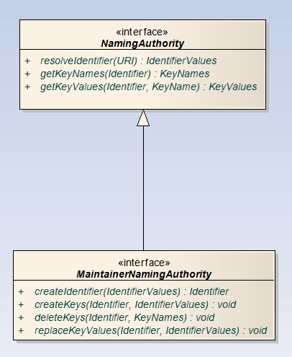

Naming authorities wishing to provide a full management interface implement the MaintainerNamingAuthority interface. At minimum, all naming authorities must implement the NamingAuthority interface.

MaintainerNamingAuthority State Model
The naming authority has one and only one state: RUNNING. All operations are available in the RUNNING state.

Identifiers Implementation model
The identifiers framework software architecture consists of the following components or layers with clearly defined interfaces. In the picture, each layer depends on the interfaces defined by the component immediately below it.
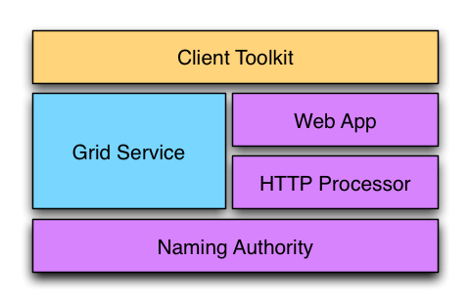

The Naming Authority is the core component. At minimum, it declares an interface to resolve identifiers. This is, accepting an identifier as input, and producing identifier metadata as output. A naming authority could optionally implement interfaces to support creation and maintenance of identifiers and their metadata.

The HTTP Processor component defines an interface to process HTTP requests. It is responsible for handling the HTTP protocol aspects of the resolution process. It understands the components of the identifier URI and responds accordingly. It uses the naming authority’s interface to respond to identifier resolution requests.

The Web App layer provides a component meant to be deployed to an application container (i.e. Tomcat). It wraps and stands up the HTTP processor implementation.

The Grid Service component provides a standard grid (web) service interface to grid clients. The interface availability here depends on the underlying naming authority being used.

The Client Toolkit provides a client library useful to resolve identifiers using the web interface as well as the grid interface. It also provides a framework that can be extended to support data object retrieval from a variety of sources once identifier resolution is complete.

The Naming Authority, HTTP Processor, and Web App are required components and exist in all deployments. They provide basic resolution services for the framework.
The Grid Service is an optional component. However, this is expected to provide the “write” interface to create/update identifiers in deployments where this functionality is supported. The Web App is a resolution-only interface.

The Client Toolkit is a convenience library that clients may use or not.

The identifiers framework provides a default implementation for its interfaces and components. This is expected to meet the needs of most adopters and deployment scenarios.

The framework, however, has been designed to make certain pieces or components replaceable or extended, in order to accommodate different deployment needs. This is accomplished by the use of a powerful configuration system based on the Spring Framework.

The framework is composed of three sub-projects within caGrid: identifiers-namingauthority, identifiers-namingauthority-gridsvc, and identifiers-client.

The rest of this chapter discusses in detail the framework components as well as the default implementation.

Identifiers-NamingAuthority
This project provides the three required framework components, the Naming Authority, the HTTP Processor, and the Web App.

Interfaces and protocols that must be followed by all naming authority deployments/implementations are established here.

This project also provides a default implementation for these interfaces as explained later in this chapter.

The Naming Authority
At minimum, a naming authority is capable of resolving identifiers. This is, given an identifier (URI), return the metadata (IdentifierValues) associated with it.

public interface NamingAuthority {
IdentifierValues resolveIdentifier(URI identifier);
}

A naming authority could also provide identifier creation and maintenance capabilities.

public interface MaintainerNamingAuthority extends NamingAuthority {
URI createIdentifier(IdentifierValues values);
}

The createIdentifier interface is expected to accept identifier values (metadata), generate a new identifier URI and return it to the client.

The HTTP Processor

public interface HttpProcessor {
void process(HttpServletRequest, HttpServletResponse);
}

HTTP processor responds to identifier resolution requests via HTTP GET. Identifiers are functional HTTP URIs that lead a client to the naming authority that owns them.

For example, assuming a naming authority with a prefix URI of http://foo.osumc.edu:8080/; a local identifier ABC can be resolved by navigating to http://foo.osumc.edu:8080/ABC

Resolution Response
A naming authority responds to a HTTP resolution request (such as GET http://foo.osumc.edu:8080/ABC) by returning the set of identifier values associated with the identifier URI.

The format of the response is either HTML or XML. A client specifies the type of response desired by setting the HTTP ACCEPT request header appropriately.
The ACCEPT header typically contains a list of response formats that are acceptable by the client.

For a naming authority, HTML is the dominant format. That is, in order to request XML, the ACCEPT header must contain application/xml, and must not include text/html. The presence of text/html or */* anywhere in the list would result in HTML.

HTML is also the default format. Therefore, an empty ACCEPT header would also result in HTML being returned.

HTML Response
This response is intended to be consumed by humans, such as those using a web browser for resolution purposes. Therefore, this specification does not require any particular styling or presentation layout. The response should simply present identifier values in a valid HTML document.

XML Response
The XML response is a serialized view of the IdentifierValues object. It’s a XML document that conforms to a well-known XML schema. As example:

<?xml version="1.0" encoding="UTF-8"?>
<na:IdentifierValues
xmlns:na="http://na.cagrid.org/1.0/NamingAuthority"
xmlns:xsi="http://www.w3.org/2001/XMLSchema-instance"
xsi:schemaLocation="http://na.cagrid.org/1.0/NamingAuthority http://foo.osumc.edu:8080/namingauthority/org.cagrid.identifiers.namingauthority.xsd">
<na:KeyValues>
<na:key>EPR</na:key>
<na:value>end point reference 1</na:value>
<na:value>end point reference 2</na:value>
</na:KeyValues>
<na:KeyValues>
<na:key>URL</na:key>
<na:value>http://www.google.com</na:value>
</na:KeyValues>
</na:IdentifierValues>

Identifiers-Client
This project provides a toolkit for clients to easily interface with a naming authority for resolution services and with data owners for object retrieval. A client would typically use the Resolver class to obtain the identifier metadata (IdentifierValues) and then use a built-in or custom Retriever object to retrieve the data object from the owner’s space.

The Resolver Class
This class provides two methods for identifier resolution:

IdentifierValues resolveGrid( URI identifier )
IdentifierValues resolveHttp( URI identifier )

resolveGrid resolves the identifier using the naming authority’s grid service (if available). The grid service end point URL is discovered by querying the configuration object from the naming authority.

resolveHTTP resolves the identifier by using the naming authority’s HTTP services as previously described. The identifier is simply followed using HTTP GET. IdentifierValues are received from the naming authority as an XML document which is then automatically de-serialized into a java object (IdentifierValues).

URI identifier = new URI("http://foo.osumc.edu:8080/ABC");
IdentifierValues ivs = new Resolver().resolveHttp(identifier);
System.out.println(ivs.toString());

By default, Resolver loads spring configuration for identifier-client-context.xml. A different resource can be provided by using the Resolver(String[]) constructor. Currently, the only configuration required from this resource is the castor XML context necessary to de-serialize responses from the naming authority.

The Retriever Interface
This interface declares a single operation, retrieve; whose purpose is to retrieve a data object from the owner’s space.

public interface Retriever {
public Object retrieve(IdentifierValues ivs) throws Exception;
}

The framework has a built-in retriever (CQLRetriever) that allows a client to query a grid data service.

public class CQLRetriever extends RetrieverImpl {

public Object retrieve( IdentifierValues ivs ){
CQLQueryResults results = new CQLQueryResults();
return results;
}

The RetrieverFactory Interface
A RetrieverFactory “owns” a collection of Retriever objects uniquely identified by their name. A retriever instance can be calling the getRetriever method, which takes either a name, that uniquely identifies the retriever class; or the identifier’s metadata.

public interface RetrieverFactory {
public Retriever getRetriever( String retrieverName );
public Retriever getRetriever( IdentifierValues ivs );
}

The framework provides a default factory, DefaultRetrieverFactory. It maintains a map of RetrieverImpl objects keyed by retriever name.

The getRetriever by IdentifierValues chooses the retriever instance whose ALL required keys (RetrieverImpl.getRequiredKeys()) exist in the identifier’s metadata (IdentifierValues). If multiple retrievers meet this criteria, the one with the largest number of keys is chosen. If multiple retrievers have the same number of keys, an exception is thrown.

Identifier adopters are free to provide different factory implementations with different retriever selection criteria. All factories must implement the RetrieverFactory interface.

The RetrieverService Class
This class loads a RetrieverFactory from spring framework configuration file(s). The default constructor loads the default retriever factory name and configuration files. The specialized constructor can be used to specify a different factory name and/or configuration files.

Using Identifiers-Client to Resolve and Retrieve a Data Object
// Resolution
IdentifierValues ivs = new Resolver().resolveHttp( identifierStr );

// Data Retrieval
RetrieverFactory factory = new RetrieverService().getFactory();
Retriever retriever = factory.getRetriever( CQLRetriever );
CQLQueryResults results = (CQLQueryResults) retriever.retrieve( ivs );

Or, a simplified way:
// Resolution
IdentifierValues ivs = new Resolver().resolveHttp( identifierStr );

// Data Retrieval
CQLQueryResults results =
(CQLQueryResults) new RetrieverService().retrieve( CQLRetriever, ivs );

In both cases, the first step is to resolve the identifier. That is, retrieve the identifier values (metadata).

The second overall step is to instantiate a Retriever object from the RetrieverFactory. The RetrieverService class loads a factory using the default spring configuration file identifiers-client-context.xml. Other spring files can be used by using the specialized RetrieverService constructor.

Identifiers-NamingAuthority-GridSvc
The framework implements a standard analytical grid service that runs the naming authority implementation described above. Even though deployment of this grid service is not required by the framework, it adds value to the naming authority web application:

- It provides the “update” interface necessary to manage/administer identifiers.
- It provides a fined-grained read interface.

Error Implementation Model
Refer to section 2.4.2

Control Data Type Definitions

Status/Return Values/Exceptions

Return | Operation | Exceptions
String[] | getKeyNames | NamingAuthorityConfigurationException  InvalidIdentifierException  NamingAuthoritySecurityException
KeyData | getKeyData | InvalidIdentifierException  InvalidIdentifierValuesException  NamingAuthoritySecurityException  NamingAuthorityConfigurationException
IdentifierData | resolveIdentifier | InvalidIdentifierException  NamingAuthorityConfigurationException  NamingAuthoritySecurityException
URI | createIdentifier | NamingAuthorityConfigurationException  InvalidIdentifierValuesException  InvalidIdentifierException  NamingAuthoritySecurityException
void | deleteKeys | NamingAuthorityConfigurationException  InvalidIdentifierValuesException  InvalidIdentifierException  NamingAuthoritySecurityException
void | createKeys | NamingAuthorityConfigurationExceptio  InvalidIdentifierValuesException  InvalidIdentifierException  NamingAuthoritySecurityException
void | replaceKeyValues | NamingAuthorityConfigurationException  InvalidIdentifierValuesException  InvalidIdentifierException  NamingAuthoritySecurityException

As covered in previous sections, the resolution interface over HTTP returns a XML-serialized version of IdentifierData, and a response status of 202 (HTTP SUCCESS).

Error Codes

Error Code | Error/Exception Description
HTTP 403 | HTTP request to resolve identifier has been denied (user is not authorized).
NamingAuthorityConfigurationException | A configuration error has been detected by the naming authority while serving a request.
NamingAuthoritySecurityException | Request denied due to authorization error.
InvalidIdentifierException | The identifier provided is invalid or does not exist.
InvalidIdentifierValuesException | The identifier metadata provided is invalid.

Query Parameters

Operation | Parameters
getKeyNames | URI Identifier
getKeyData | URI Identifier, String KeyName
resolveIdentifier | URI Identifier

Interfaces

UML Model of Interfaces

Interface No | Interface Name | Interface Description
NA-INF1 | NamingAuthority | Provides functionality to query and retrieve identifiers metadata.
NA-INF2 | MaintainerNamingAuthority | Provides functionality to administer naming authority identifiers.

Operations (Enumeration)

Operation No. | Operation Name | Interface Name | Operation Description
NA-INF1-OP1 | getKeyNames | NamingAuthority | Returns the metadata key names associated with a given identifier.
NA-INF1-OP2 | getKeyData | NamingAuthority | Returns the metadata associated with a specific key within an identifier.
NA-INF1-OP3 | resolveIdentifier | NamingAuthority | Returns all the metadata associated with the given identifier.
NA-INF2-OP1 | createIdentifier | MaintainerNamingAuthority | Generates a new identifier and associates the input metadata to it.
NA-INF2-OP2 | deleteKeys | MaintainerNamingAuthority | Deletes the provided keys (and data) from an existing identifier.
NA-INF2-OP3 | createKeys | MaintainerNamingAuthority | Adds new keys to an existing identifier.
NA-INF2-OP4 | replaceKeyValues | MaintainerNamingAuthority | Replaces the values associated with current keys in an existing identifier.

Operation Behavior Descriptions

NamingAuthority Interface

resolveIdentifier

Behavior Description | This operation returns the metadata associated with the given identifier.
Pre-Conditions | The identifier must exist and the requesting user must be authorized to resolve it.
Security Conditions | A user can read a key from an identifier if any one of the below conditions are met:  (a) User is identifier's administrator  (b) User is listed as reader by the key’s policy identifier  (c) Key has no policy identifier and user is listed as reader or the identifier  (d) Key has no policy identifier and identifier has no security settings  Only the keys that the user is authorized to read are returned.  A security exception is thrown if the user can’t read any of the keys associated with the identifier.
Inputs | Identifier (Required)
Outputs | Identifier Metadata (keys and values)
Post-Conditions
Exception Conditions | InvalidIdentifierException  NamingAuthorityConfigurationException  NamingAuthoritySecurityException
Additional Implementation Details
Notes

getKeyNames
Behavior Description | This operation returns the key names associated with a given identifier.
Pre-Conditions | The identifier must exist and the requesting user must be authorized to resolve it.
Security Conditions | A user can read a key from an identifier if any one of the below conditions are met:  (a) User is identifier's administrator  (b) User is listed as reader by the key’s policy identifier  (c) Key has no policy identifier and user is listed as reader or the identifier  (d) Key has no policy identifier and identifier has no security settings  Only the keys that the user is authorized to read are returned.  A security exception is thrown if the user can’t read any of the keys associated with the identifier.
Inputs | Identifier (Required)
Outputs | Key Names
Post-Conditions
Exception Conditions | InvalidIdentifierException  NamingAuthorityConfigurationException  NamingAuthoritySecurityException
Additional Implementation Details
Notes

getKeyData
Behavior Description | This operation returns the values associated with the provided key in an existing identifier.
Pre-Conditions | The identifier must exist and contain the provided key name. The user must be authorized to read the provided key.
Security Conditions | A user can read a key from an identifier if any one of the below conditions are met:  (a) User is identifier's administrator  (b) User is listed as reader by the key’s policy identifier  (c) Key has no policy identifier and user is listed as reader or the identifier  (d) Key has no policy identifier and identifier has no security settings  A security exception is thrown if the user can’t read the requested key.
Inputs | Identifier (Required)  KeyName (Required)
Outputs | Key Values
Post-Conditions
Exception Conditions | InvalidIdentifierException  InvalidIdentifierValuesException (e.g. the key does not exist)  NamingAuthorityConfigurationException  NamingAuthoritySecurityException
Additional Implementation Details
Notes

MaintainerNamingAuthority

createIdentifier
Behavior Description | This operation generates a new identifier and associates the provided metadata to it.
Pre-Conditions
Security Conditions | A user can create identifiers if any one of the below  conditions are met:  (a) The system has been configured to allow anyone to create identifiers.  (b) The user has been given explicit authorization to create identifiers.
Inputs | Identifier Metadata(Optional)
Outputs | Identifier
Post-Conditions
Exception Conditions | NamingAuthorityConfigurationException  InvalidIdentifierValuesException  InvalidIdentifierException  NamingAuthoritySecurityException
Additional Implementation Details
Notes

deleteKeys
Behavior Description | This operation deletes the specified keys from an existing identifier.
Pre-Conditions | The identifier must exist and contain all keys in the request. User must be an authorized to modify the identifier.
Security Conditions | Administrative keys can only be deleted by identifier administrators.  Non-administrators can delete non-administrative keys if they are listed as writers by the identifier, or if no write settings have been specified by the identifier.
Inputs | Identifier (Required)  Key Names (Required)
Outputs
Post-Conditions
Exception Conditions | NamingAuthorityConfigurationException  InvalidIdentifierValuesException (e.g., key(s) do not exist)  InvalidIdentifierException  NamingAuthoritySecurityException
Additional Implementation Details
Notes

createKeys
Behavior Description | This operation adds new keys to an existing identifier.
Pre-Conditions | The identifier must exist and the requesting user must be authorized.
Security Conditions | Administrative keys can only be added by identifier administrators.  Non-administrative keys can be added administrators, and by non-administrators given they are listed as writers by the identifier, or if no write settings have been specified for the identifier.
Inputs | Identifier (Required)  Keys and Values (Required)
Outputs
Post-Conditions
Exception Conditions | NamingAuthorityConfigurationExceptio  InvalidIdentifierValuesException (e.g., key(s) already exist)  InvalidIdentifierException  NamingAuthoritySecurityException
Additional Implementation Details
Notes

replaceKeyValues
Behavior Description | This operation replaces the values of existing keys in the given identifier.
Pre-Conditions | The identifier must exist and the requesting user must be authorized.
Security Conditions | Administrative keys can only be replaced by identifier administrators.  Non-administrators can replace non-administrative keys if any of the following is met:  a) User is listed a writer by the key’s policy identifier  b) The key has no policy identifier and the user is listed as writer by the identifier.  c) The key has no policy identifier and no security settings have been defined at the identifier level.
Inputs | Identifier (Required)  Keys and New Values (Required)
Outputs
Post-Conditions
Exception Conditions | NamingAuthorityConfigurationException  InvalidIdentifierValuesException (e.g., key(s) does not exist)  InvalidIdentifierException  NamingAuthoritySecurityException
Additional Implementation Details
Notes

Dynamic Model
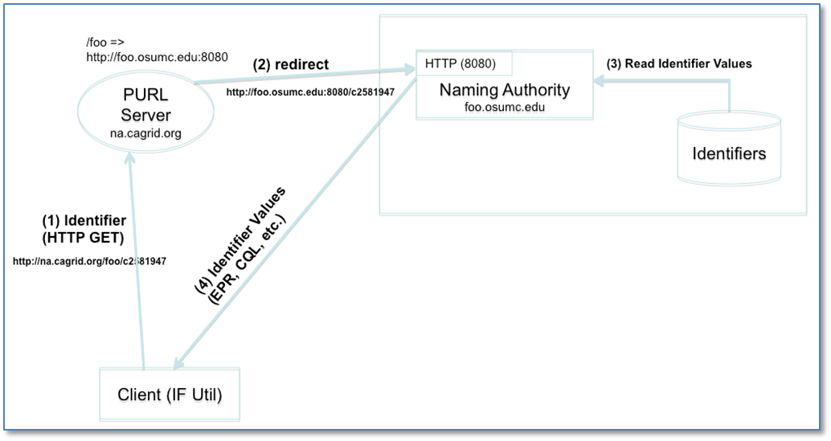

The figure above shows a resolution scenario using HTTP GET. When the identifier (URL) is followed, the PURL server redirects the request to the location (NA) that has been mapped. The NA extracts the local identifier name from the URL (c2581947), looks up the values from the identifiers table, and returns them to the client.

A client could also use the framework’s grid service to resolve an identifier. As shown next.

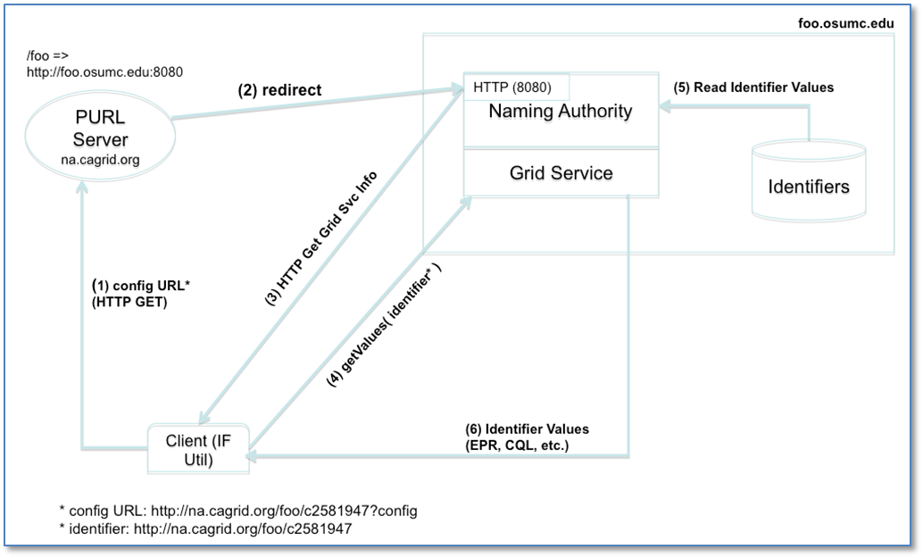

The framework’s client retrieves the naming authority configuration by simply adding ?config to the identifier URL and following it. The NA configuration is needed in this case in order to determine the grid service end point.
For example:
- A user wishes to resolve identifier http://na.cagrid.org/foo/c2581947 using the grid service.

- Client toolkit appends an extra parameter (?config) to the query string, and issues an HTTP GET on http://na.cagrid.org/foo/c2581947?config

- PURL servers redirects to http://foo.osumc.edu:8080/c2581947?config

- NA recognizes that configuration is being requested and returns the information as XML. The response contains the location where the naming authority grid service is running, for example, http://foo.osumc.edu/wsrf/services/cagrid/IdentifiersNAService

- Client now acts as a grid service client and executes the getValues operation on the grid service located at the URL retrieved in the previous step.
In this way, the web (HTTP) is used resolve the identifier to its naming authority, and after the naming authority provides the information about its grid service, the grid is used to actually retrieve the identifier’s metadata.

The flow shows a use case for identifier creation.
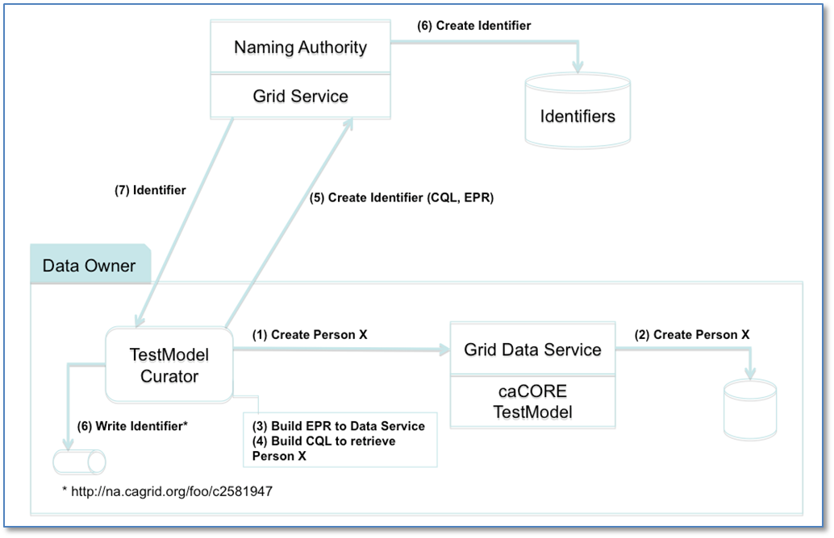

The data owner (also acting as identifier curator) creates identifiers for Person objects that exist in a database application. The data owner provides access to these objects via a grid data service.

A component in the data owner space (TestModel Curator) builds end point references (EPR) to the data service, and serialized CQL queries. This information is sent in the request to create an identifier to the naming authority. The naming authority creates the identifier and persists the EPR and CQL in the identifiers table as metadata. The identifier is returned to the client.

A data retrieval use case is shown below.
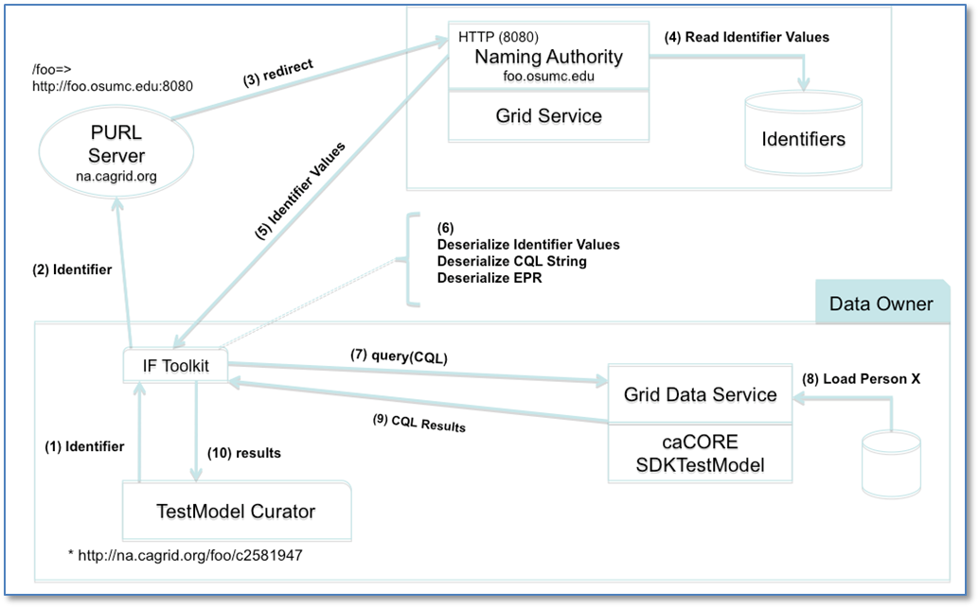

The identifier previously created is used to retrieve a person object. Steps 1 through 5 correspond to the Resolution process as described earlier. In step 6, the retriever class (CQLRetriever.java) de-serializes the CQL and EPR strings, and use the resulting java objects to make the call to the grid data service. The retriever interface returns the CQL result set to the TestModel Curator, where it can be further processed by “casting it” to the expected Person object.

Profiles

Functional Profiles

Profile No. | Profile Name | Profile Description
NA-FP1 | NA Resolution | Contains functionality for identifier resolution.
NA-FP2 | NA Administration | Contains functionality to administrate identifiers and their data.

Interface Operation No. | Interface Operation Name | Profile No. | Profile Name
NA-INF1-OP1 | resolveIdentifier | NA-FP1 | NA Resolution
NA-INF1-OP2 | getKeyNames | NA-FP1 | NA Resolution
NA-INF1-OP3 | getKeyData | NA-FP1 | NA Resolution
NA-INF2-OP1 | createIdentifier | NA-FP2 | NA Administration
NA-INF2-OP2 | deleteKeys | NA-FP2 | NA Administration
NA-INF2-OP3 | createKeys | NA-FP2 | NA Administration
NA-INF2-OP4 | replaceKeyValues | NA-FP2 | NA Administration

Semantic Profiles

Semantic Profile No. | Semantic Profile Name | Semantic Profile Description
NA-SP1 | NA v1.0 Resolution | This profile includes identifier resolution services.
NA-SP2 | NA v1.0 Administration | This profile includes identifier administration services.

Relationship with other services
None

Conformance Statements
The identifiers framework conceptual model conforms with existing web standards and protocols, providing a natural approach to identifier adoption and resolution.

- RFC 3305: Uniform Resource Identifier (URI)
- RFC 2616: Hypertext Transfer Protocol (HTTP)
- W3C XML 1.1: Extensible Markup Language (XML)

Appendix A – References
Description | Location
caGrid Identifiers Framework Design Document v1.0  Scott Oster  Calixto Melean | https://ncisvn.nci.nih.gov/svn/cagrid/trunk/cagrid/Documentation/core/Identifiers/caBIG_IdentifierSvcFramework_Design.docx
caIdentifiers Framework Conceptual Functional Service Specification v1.0 | https://ncisvn.nci.nih.gov/svn/cagrid/trunk/cagrid/Documentation/core/Identifiers/caBIG_Conceptual_Functional_Service_Specification.doc

Appendix B – Glossary
Term | Description
NA | Identifiers Naming Authority

Appendix C - Cross Reference Tables

Interface to Profile Mapping

Interface No. | Interface | Profile No. | Profile
NA-INF1 | NamingAuthority | NA-FP1 | NA Resolution
NA-INF2 | MaintainerNamingAuthority | NA-FP2 | NA Administration

Interface Operations to Profile Operations
Operation No. | Operation Name | Capability No. | Profile Capability
NA-INF1-OP1 | resolveIdentifier | NA-FP1-C1 | Resolve Identifier
NA-INF1-OP2 | getKeyNames | NA-FP1-C2 | Retrieve Key Names
NA-INF1-OP3 | getKeyData | NA-FP1-C3 | Retrieve Data
NA-INF2-OP1 | createIdentifier | NA-FP2-C1 | Create Identifier
NA-INF2-OP2 | deleteKeys | NA-FP2-C2 | Delete Keys
NA-INF2-OP3 | createKeys | NA-FP2-C3 | Create Keys
NA-INF2-OP4 | replaceKeyValues | NA-FP2-C4 | Replace Key Values

http://www.springsource.org

