Grid Grouping Architecture
(GroupG)

Architecture Document

caBIG™ is an initiative of the National Cancer Institute, NIH, DHHS

Copyright and License page

Insert Names of Development Team(s) here
Development | Programmer’s guide |  | Program Management
Names of developers | Names of technical writers and reviewers |  | Names of program managers
Stephen Langella | Stephen Langella
¹ Footnote contributing companies/ contractors/ divisions |  | ³ company
² department or division

Contacts and Support
Enter training contact | name (email address)
Enter customer support contact | Web hyperlink  Telephone: 111-222-3456  Toll free: 888-234-1234

LISTSERV Facilities Pertinent to software teams
LISTSERV | URL | Name
caGrid_Developers | https://list.nih.gov/archives/cagrid_developers.html | caGrid Developers Discussion

Table of Contents
Chapter 1 Introduction 2
Chapter 2 Use Case Scenario 3
Chapter 3 Grid Grouping Architecture 4
Addressing the Use Case 5
Chapter 4 Group Management Service (GMS) 6
Grid Management Service API 6
GMS Public API 6
GMS Administrative API 7
Outstanding Issues 8
Chapter 5 Group Management UI 9

List of Figures
Figure 1 Patient Provider Use Case Scenario 3
Figure 2 Grid Grouping Architecture 4
Figure 3 Addressing the Use Case 5

- Introduction
Authorization is the process of determining who is allowed to perform what actions on a given resource. The goal of the caGrid 1.0 authorization framework is to empower service providers and data owners to make authorization decisions. One of the major focuses of the caGrid 1.0 authorization framework is extensibility, allowing service providers to leverage their authorization mechanism of choice for enforcing access control policies. It is not the mission of the caGrid team to advocate one authorization mechanism over another but to facilitate the integration of authorization mechanisms required by applications for meeting authorization policies. To facilitate the integration the caGrid team will provide integration points within the grid infrastructure. Another focus of the caGrid 1.0 authorization framework is to provide higher level services to facilitate authorization at the grid level. These services will be made available to service providers and will be developed based on community demand. The purpose of this document it to define a grid service for instantiating and managing groups of users in a grid. Given such a service, access to resources can be restricted based on membership to groups.

- Use Case Scenario
Suppose we have a Patient Provider service, that provides patient information about an institution’s Patients, and that any user classified as a Doctor can access the patient information provided by the Patient Provider service. The deployment scenario shown in Figure 1contains three Patient Provider services one at Duke, one at Georgetown, and one at the Ohio State University. The Duke Patient Provider Service allows access to users that are classified as Doctors by Duke (represented by the Duke Doctors group). The Georgetown Patient Provider Service allows access to users that are classified as Doctors by Georgetown (represented by the Georgetown Doctors group). The Ohio State University Patient Provider Service allows access to users that are classified as Doctors by caBIG, where a user is classified as a caBIG Doctor if they are classified as a Doctor by a caBIG affiliated institution. In current scenario caBIG Doctors are all the users classified by Duke as Doctors and all the users classified by Georgetown as Doctors.

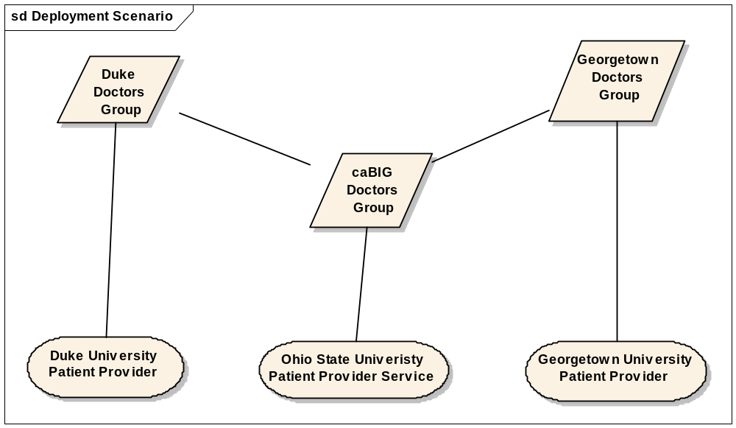
Figure 1 Patient Provider Use Case Scenario
In order to be able to efficiently manage and scale access control policy it is critical that policy is based on “groups or users” or “attributes of users”. In this simple use case access to the Ohio State Patient Provider service is based on membership to the caBIG Doctors group. It is important to note that as users are added and removed to that group, the authorization policy is not changed.

- Grid Grouping Architecture
The Grid Grouping Architecture (GroupG) provides a group based authorization solution for caGrid, where grid services and applications built on top of them can enforce authorization policy based on membership to groups defined and managed at the grid level. The Grid Grouping Architecture (Figure 2) is composed of several core components and several external components. The core components include the Group Management Service (GMS), the Group Management GUI, the Group Provisioning Service (GPS), and Policy Enforcement Service (PES). The Group Management Service (GMS), is a grid service for creating and managing groups at the grid level. In this environment caGrid Services and Applications can create access control policies based on membership in groups defined in the GMS. These policies can be enforced by leveraging the GMS to determine whether or not a user is a member of a particular group. The Group Management GUI provides a graphical interface for administrators to create and administer groups within Group Management Service(s). The Group Provisioning Service (GPS) is a grid service that provides a mechanism for autonomously managing groups within Group Management Service(s). For example an instance of a Group Provisioning Service may use attributes defined in federation for adding and removing users from groups maintained by a Group Management Service(s). The Policy Enforcement Service (PES) is an grid service that enables registration and enforcement of policies across applications. The PES provides an alternative solution to caGrid Services and Applications managing their policies and enforcing them locally. Applications using PES would register their access control policies to the PES and simply ask the PES whether a user is allowed to access a given resource. Access control policies defined in a PES would be based on membership to groups existing in a GMS and would be enforced based on asking a GMS whether a user is a member of a particular group.
The Grid Grouping Architecture is also compromised of external components, highlighted with a blue background in Figure 2. The external components, the Identifier Framework and the Index service are provided by the caGrid Infrastructure. The Identifier Framework is used for obtaining and assigning unique identifiers to groups within the grid. The Index Service is used for registration a discovery of services within the grid grouping architecture.
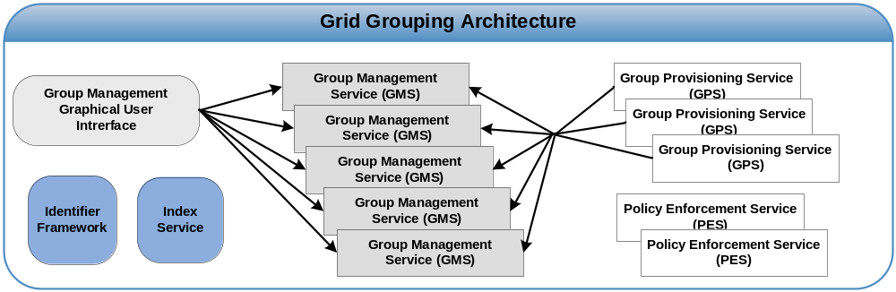
Figure 2 Grid Grouping Architecture
The implementation of the Grid Grouping Architecture will be iterative with the components required in satisfying the caBIG use cases getting the highest priority. The components in Figure 2 with a gray background are targeted to be implemented for caGrid 1.0. These components include the Group Management Service (GMS) and the Group Management GUI.

Addressing the Use Case

Figure 3 demonstrates how Grid Management Service (GMS) component of GroupG addresses the use case scenario defined earlier. Georgetown and Duke each maintain a GMS service that manages a Doctor Group, consisting of a list of all the Doctors within their respective institution. Both the Georgetown and Duke Patient Provider Service authorize users based on membership in the Doctor Group maintained at the GMS of their respective institution. The NCICB maintains a GMS that contains a Doctors Group consisting of two sub Doctor Groups, the one defined in the GMS at Duke and the one defined in the GMS at Georgetown. The Ohio State Patient Provider allows access to users if they are a member of the NCICB Doctors Group or more specifically are a member of the Duke Doctors Group or the Georgetown Doctors Group.
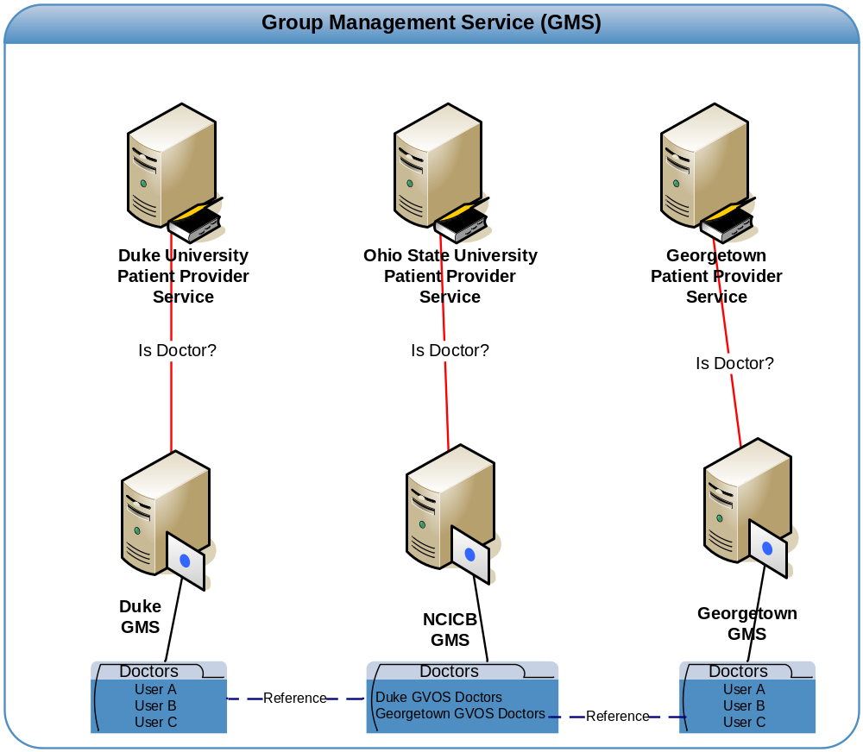
Figure 3 Addressing the Use Case

- Group Management Service (GMS)
The Group Management Service (GMS), is a grid service for creating and managing groups at the grid level. In this environment caGrid Services and Applications can create access control policies based on membership in groups defined in the GMS. These policies can be enforced by leveraging the GMS to determine whether or not a user is a member of a particular group. The GMS defines a group as a set of members, set of member groups, a set of metadata, and a set of permissions that are given to both member and member groups for administering the group. A member of a group can be a grid user or a grid service or any entity that has been issued grid credentials. Members are added to the group based on the grid identity assigned in their credentials. Member Groups provide the ability to add existing groups defined in any GMS to a group. For example if group B is added as a member group to group A, all the member in group b will also be members of group A. Support for adding existing groups as members to a group enables the ability to create and manage federated groups across the grid. Each group in the GMS can be assigned metadata describing the group, this will provide administrators and services like the Group Provisioning Service (GPS) the ability to distinguish between groups as well as provide the ability to discover groups. As mentioned above each member of member group of a group can be assigned permissions within the group. These permission would dictate at what level they may administrate the group. The GMS will also provide the ability to assign permissions to users for creating groups.

Grid Management Service API

In this section we will present the public API and administrative API for the GMS service. The GMS public API will be used by caGrid services, applications, and by the Policy Enforcement Service (PES) to determine group membership such that they may enforce access control policy. The administrative API will be used by administrative applications such as the Group Management UI to administer groups defined in the GMS. Since this document is a high level design document, the level of support in the APIs may changed based on the following in order of priority: (1) requirements dictated by the caBIG community (2) limitations that any middleware we may choose to leverage may have. Operations highlighted in bold back text are least likely to change, where as operation highlighted in gray bold text are more likely to change or may not be supported.

GMS Public API
        - isMemberOf()- This operation will allow a client to ask whether a given grid user is a member of a given group.
        - findGroups() – This operation will allow a client to find a group(s), this search will most likely be based on the groups metadata.
        - getMembers() – This operation will allow a client to get all the members for a specified group. (This operation is highlighted in gray because we are not yet sure if we would want to make this public)
        - getProxy() – If the invoking user is a member, this operation will allow a user to create a proxy such that they may invoke service with sole context of the group.

GMS Administrative API
        - createGroup()- This operation will facilitate the creation of a group.
        - removeGroup() – This operation will facilitate the removal of a group.
        - updateGroup() – This operation will allow a client to update the definition of a group. (This operation is highlighted in gray because we are not sure that this will be needed.)
        - addMember()- This operation will facilitate adding a member to a group.
        - removeMember()- This operation will facilitate removing a member from a group.
        - getMembers()-This operation will allow a client to get all the members for a specified group.
        - getMembers(SearchCriteria)-This operation will allow a client to get all the members for a specified group based on a SearchCriteria. For example this method could allow getting all the members in group at a specified period of time or for some specified time range.
        - addMemberGroup()- This operation will facilitate adding a member group to a group.
        - removeMemberGroup()-This operation will facilitate the removal of a member group from a group.
        - getMembersGroups()-This operation will allow a client to get all the members groups for a specified group.
        - getMembersGroups(SearchCriteria)-This operation will allow a client to get all the member groups for a specified group based on a SearchCriteria. For example this method could allow getting all the member groups in group at a specified period of time or for some specified time range.
        - addServicePermission()- This operation will facilitate adding a service level permission to the GMS. A service level permission would enable users to create and remove groups.
        - removeServicePermission()- This operation will facilitate removing a service level permission from the GMS. A service level permission would enable users to create and remove groups.
        - getServicePermissions()- This operation will facilitate obtaining a list of all the service level permissions for a GMS. A service level permission would enable users to create and remove groups.
        - addMemberPermission()- This operation facilitates adding a member permission. A member permission applies to a user’s membership to a group, specifying what a user can do in context of managing the group. For example a member permission could be used for giving a member of a group permission to add and remove members.
        - removeMemberPermission()-This operation facilitates removing a member permission. A member permission applies to a user’s membership to a group, specifying what a user can do in context of managing the group. For example a member permission could be used for giving a member of a group permission to add and remove members.
        - getMemberPermissions()- This operation will facilitate obtaining a list of all the member permissions for a given member of the group. A member permission applies to a user’s membership to a group, specifying what a user can do in context of managing the group. For example a member permission could be used for giving a member of a group permission to add and remove members.

Outstanding Issues

In this section we will list any outstanding issues that would need to be resolved in order to provide a detailed design.

- It is a requirement to be able to get a list of members in a group based on a specified time period? Do we need to track group membership overtime? This may be valuable in auditing.

- Group Management UI
The Grid Grouping Architecture will provide an Group Management UI that will provide a graphical user interface for compete administration of the Group Management Service (GMS). The type of interface (web, swing app, etc.) will be dependent on the technologies we choose for implementing the GMS. For example if we leverage a technology that already provides a GUI, we will try to adapt their GUI for our use. If we are not able to leverage an existing GUI, we will use the swing portal framework code base already in caGrid to build such a GUI. The Introduce toolkit as well as the Dorian and GTS administrative UI’s are already built on this code base. The GMS will provide a client object model on which GUIS can be built, making it easy to develop GUIs, also making it easy to embed GMS functionality into applications.

