Grid Trust Service
caGrid 1.0 Beta

Technical Guide

caBIG™ is an initiative of the National Cancer Institute, NIH, DHHS

Copyright and License page

Insert Names of Development Team(s) here
Development | Programmer’s guide |  | Program Management
Names of developers | Names of technical writers and reviewers |  | Names of program managers
Stephen Langella | Stephen Langella
¹ Footnote contributing companies/ contractors/ divisions |  | ³ company
² department or division

Contacts and Support
Enter training contact | name (email address)
Enter customer support contact | Web hyperlink  Telephone: 111-222-3456  Toll free: 888-234-1234

LISTSERV Facilities Pertinent to software teams
LISTSERV | URL | Name
caGrid_Developers | https://list.nih.gov/archives/cagrid_developers.html | caGrid Developers Discussion

Table of Contents
Chapter 1 Introduction 3
Abstract 3
Introduction 3
Motivation 4
Background 5
Chapter 2 Grid Trust Service 7
Levels of Trust 9
Operations 11
Managing Trusted Certificate Authorities 12
Operations 13
Federation 14
Operations 16
Discovery 17
Operation 18
Validation 18
Operation 18
Managing Administrators 19
Operations 19
Chapter 3 SyncGTS 20
Appendix A References 22
Technical Manuals/Articles 22
Scientific Publications 22
caBIG Material 22
caCORE Material 23
Appendix B GTS WSDL 24
Appendix C GTS Schema 42
Appendix D SyncGTS Schema 46
Appendix E Glossary 49

List of Figures
Figure 1 Grid Trust Service (GTS) RRLV Profile 8
Figure 2 Grid Trust Service (GTS) RSRV Profile 9
Figure 3 GTS Admin GUI - Trust Level Management 10
Figure 4 GTS Admin GUI - Managing Trusted Certificate Authorities 12
Figure 5 Federated Trust Fabric 15
Figure 6 GTS Admin GUI - Managing Authority GTSs 15
Figure 7 GTS Admin GUI – Discovery 17
Figure 8 SyncGTS 21

- Introduction

Abstract

In order to authenticate users and other services, grid services need to maintain a list of certificate authorities that they trust as a source for issuing credentials. Grids inherently span multiple institutional administration boundaries and aim to provide support for the sharing of applications, data, and computational resources in a collaborative environment. In this environment there may exist hundreds of certificate authorities, each issuing hundreds if not thousands of certificates. In such a dynamic multi-intuitional environment with tens of thousands of users, credentials will be issued and revoked fairly frequently. One underlying problem in this arrangement is how to provide a grid-wide mechanism for maintaining and provisioning trusted certificate authorities, such that grid services may make authentication decisions against the most up to date information. In this paper we will present the design and implementation of the Grid Trust Service (GTS), a federated framework for the creation and management of a grid trust fabric, enabling the provisioning of certificate authorities.

Introduction

As Grid technologies gain acceptance and adoption, the transition from highly specialized Grids with only a few institutional participants to more general purpose Grids with dozens to hundreds of institutions is becoming a reality. Security is of primary importance in such environments, in particular in settings where sensitive data (e.g., patient medical information) needs to be accessed and exchanged. Mechanisms are needed for such functions as secure communication, authentication, and authorization. This paper is concerned with provisioning and management of a grid trust fabric.
The establishment, provisioning, and management of trust fabrics are critical to the scalability, maintenance and security of the grid and other web service environments. Many components of the grid rely on having trust agreements in place. For example in assigning identifiers to data objects, the authorities assigning the identifiers need to be trusted. When an identifier is assigned by an authority it is generally signed by the authority. Consumers of the identifiers use the authority’s certificate to validate the signature. In a dynamic multi-institutional grid environment there may be a frequently changing list trusted of identifier authorities. Consumers of identifiers will need to be able to validate the integrity of a given identifier at run time against the most up to date set of identifier authorities.
In a grid environment, clients and services authenticate with one another using X509 identity certificates. Authentication decisions are made based on whether or not the certificate presented is signed by a trusted certificate authority. Authentication in grids requires a trust agreement between the consumers of X509 identity certificates and the certificate authorities that issue them. The certificate authority’s certificate is used to validate whether or not it issued a given X509 Identity certificate. In a large grid there may exist hundreds of certificate authorities, each issuing hundreds if not thousands of certificates. To make matter worse, credentials will be created and revoked fairly frequently; therefore certificate authorities will frequently be publishing updated Certificate Revocation List (CRLS). Performing authentication against the most up to date set of trusted and certificate authorities and their corresponding CRLS is critical to the security and integrity of the grid.
The Grid Trust Service (GTS) is a WSRF compliant federated framework enabling the provisioning and management of a grid trust fabric. The GTS provides a complete grid enabled federated solution for registering and managing certificate authority certificates and CRLS, making them accessible to consumers so they can create and enforce trust agreements against the latest trust fabric. The GTS allows the definition and management of trust levels, such that certificate authorities may be grouped and discovered by the level of trust that is acceptable to the consumer. The GTS can also perform validation for a client, allowing a client to submit a certificate and trust requirements in exchange for a validation decision.

Motivation

Our work is driven mainly by use cases and requirements gathered from the Cancer Biomedical Informatics Grid (caBIGTM). The caBIGTM Security Technology Evaluation White Paper serves as one of the motivating influences for the GTS work.
The caBIGTM program funded by the National Cancer Institute (NCI) was launched to meet the need for a more coordinated approach to informatics resource development, management and dissemination for cancer research. The goal is to speed the delivery of innovative approaches for the prevention and treatment of cancer by facilitating discovery, integration, and analysis of distributed information and sharing of results from multiple institutions.
Given the sensitivity of the medically related data and the number of institutions involved, security has quickly become a high priority issue in caBIGTM. A key security challenge in caBIGTM is to be able to implement an effective mechanism of authenticating users to caBIGTM services, such that access to resources can be restricted to individual users or a group of users. This is a challenging issue because of the scale of caBIGTM. Although the caBIGTM effort is a relatively recent, it is expected that the caBIGTM community will grow to consist of hundreds of organizations and thousands of cancer-research participants from geographically dispersed medical centers, universities, government agencies, and commercial companies.
The Grid software infrastructure of caBIGTM, called caGrid [2] is based on a service-oriented architecture and provides the implementation of the core services, toolkits and wizards for the development and deployment of community provided services. One of the primary design principles of caGrid is the leveraging of open Grid standards [3, 4]. The caGrid infrastructure is built on top of the Globus Toolkit [5], the most widely used reference implementation of the grid standards. The Globus Toolkit implements support for security via its Grid Security Infrastructure (GSI). GSI utilizes X509 Identity Certificates for identifying a user. An X509 Certificate with its corresponding private key forms a unique credential or so-called “grid credential” within the Grid. These grid credentials are used to authenticate both users and services. Under the current Globus release (4.0.2) services authenticate clients by ensuring that the X509 Identity provided by the client was issued by a trusted certificate authority. Trusted certificate authorities and their CRLS are maintained locally on the file system per Globus installation. When a client authenticates with a service, Globus locates the root CA and CRL of the client’s Identity Certificate on the local file system. Once located, Globus validates the Identity Certificate against the CA certificate and CRL that was located. Although this approach is effective it is difficult to provision CA certificates and CRLs in a large multi-institutional environment in caBIG, as each must be copied to every installation. Given the sensitivity of the data in caBIG, it is critical that services authenticate clients against the most up to date list of CA certificates and CRLs, this requirement is one of the primary motivations behind the design and development of the Grid Trust Service (GTS).

Background

The XML Key Management Specification (XKMS) specifies models and protocols for distributing and managing public keys. XKMS specifies a tiered service model allowing applications to leverage the precise level of functionality for meeting their requirements. In designing the GTS, we leveraged the XKMS tiered service model for defining the level of service that the GTS will provide. For the purpose of this paper we will describe the relevant tiers of the XKMS tiered service model in terms of the locations of CA certificates and location of certificate validation.
Tier 0 or as we refer to it, the Locally Stored, Locally Validated Profile (LSLV), specifies that CA certificates are stored and accessed locally; certificate validation is done locally against the locally stored CA certificates. Although little infrastructure is needed for the deployment and maintenance of the LSLV profile, the usage of such a profile in a large dynamic grid could pose a potential serious security risk. The LSLV profile allows users to maintain their own trust fabric, thus putting the trust fabric in the hands of the user. A simple user error could easily introduce an undetectable security hole in the grid. The LSLV profile makes it virtually impossible to provision CA certificates and their corresponding CRLS. Under LSLV, every local environment existing in the grid will be required to update their local trust store each time a new CA certificate becomes available or each time a CA publishes a new CRL.
Tier 1 or as we refer to it, the Remotely Retrieved, Locally Validated Profile (RRLV), specifies that CA certificates are retrieved remotely from a Trust Service; certificate validation is done locally against the remotely retrieved CA certificates. From a large grid perspective the RRLV profile significantly improves upon the LSLV profile. Retrieving the latest CA certificates and corresponding CRLS remotely allows grid services to perform validation against the latest trust fabric. It also moves the management of the trust fabric from the hands of the users to the hands of administrators that have expertise in managing trust. Performing the validation locally also allows services / applications to enforce local validation policies which may go above and beyond those specified in X509 certificate validation. At the same time local validation can be a potential security risk, if the local validation process is not effectively enforced.
Tier 2 or as we refer to it, the Remotely Stored, Remotely Validated Profile (RSRV), specifies that CA certificates are stored remotely; certificate validation is done remotely against the remotely stored CA certificates. The RRLV profile and the RSRV profile are similar in that validation is done against the latest trust fabric. They differ in where the validation is done. Under the RSRV profile validation is done remotely. Remote validation removes validation from the hands of the local providers minimizing potential security risks that might have occurred if validation was not strongly enforced. At the same time it prevents local providers from enforcing local validation policies in addition to the commonly accepted ones. It also introduces a potential performance problem in that a local service is required to contact a remote validation service every time validation is required.
- Grid Trust Service
The Grid Trust Service (GTS) is a WSRF compliant grid service framework for the creation, management, and provisioning of a federated grid trust fabric. Establishing trust in the grid is essentially a problem of determining whether or not to trust a given certificate authority. Through its service interface, the GTS provides the ability to register and manage certificate authorities. Grid entities establish trust by leveraging the GTS to discover trusted certificate authorities. The GTS supports Remotely Retrieved, Locally Validated (RRLV) and Remotely Stored, Remotely Validated (RSRV) profiles for accessing the trust fabric.
The Globus Toolkit facilitates the authentication of clients against a trust fabric; this consists of validating the client’s certificate to ensure that it was issued and signed by a trusted certificate authority. The Globus 4.0.2 release does not provide a means of supporting remote validation of credentials; rather validation must be done against a locally maintained trust fabric. To enable Globus to authenticate users by validating their credentials against the trust fabric maintained in the GTS, we employ the Remotely Retrieved Locally Validated (RRLV) profile. Figure 1 illustrates how authentication is performed in caGrid. In caGrid users obtain grid credentials using Dorian [11]. Dorian is a grid service infrastructure that enables users to obtain grid credentials using their locally provided authentication mechanism, allowing users to authenticate to the grid using their locally provided credentials. This is illustrated in Figure 1, where an OSU user, authenticates to the Ohio State University authentication system, using their local user name and password. Upon successfully authenticating, the user is given a signed assertion which can be given to Dorian in exchange for a grid proxy or grid credentials¹. The grid proxy is used to authenticate to grid services. When a grid service is invoked, Globus authenticates the client by validating that the grid proxy provided is signed by a trusted certificate authority. As mentioned earlier, Globus does certificate validation against a local store. To allow Globus to perform validation against the current trust fabric maintained in the GTS, the GTS provides a framework called SyncGTS which imbeds itself into Globus to automatically synchronize the local trust certificate store with the latest trust fabric maintained in the GTS. In the example in Figure 1, the Dorian certificate authority has been registered with the GTS as a trusted certificate authority and Globus has been configured to synchronize its local trusted certificate store with the GTS. Thus when the OSU user invokes a grid service using their proxy, they will be successfully authenticated by Globus.
Our usecases for enabling trust between identifier providers and consumers of identifiers and between attribute authorities and consumers of attributes call for the use of Remotely Stored Remotely Validated (RSRV) profile. It is also anticipated that future releases of Globus will support callouts to remote validation services. The GTS supports the RSRV profile by providing a validation operation through its service interface. In this manner, the GTS is a validation service allowing clients to submit validation criteria and an X509 certificate chain for validation. Figure 2 illustrates how future versions of Globus may leverage the GTS as a validation service. In this example the user still obtains their grid proxy from Dorian and authenticates to the grid service using a grid proxy. The main difference is instead of Globus validating the proxy against its local store it makes a call to the GTS asking it to validate the proxy against the latest trust fabric.
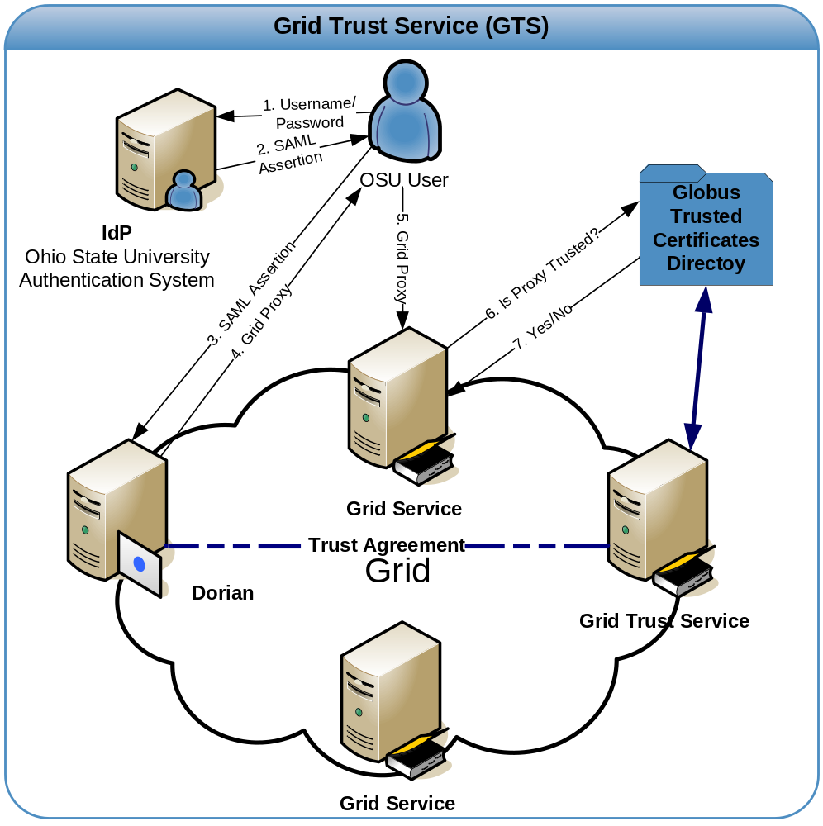
Figure 1 Grid Trust Service (GTS) RRLV Profile

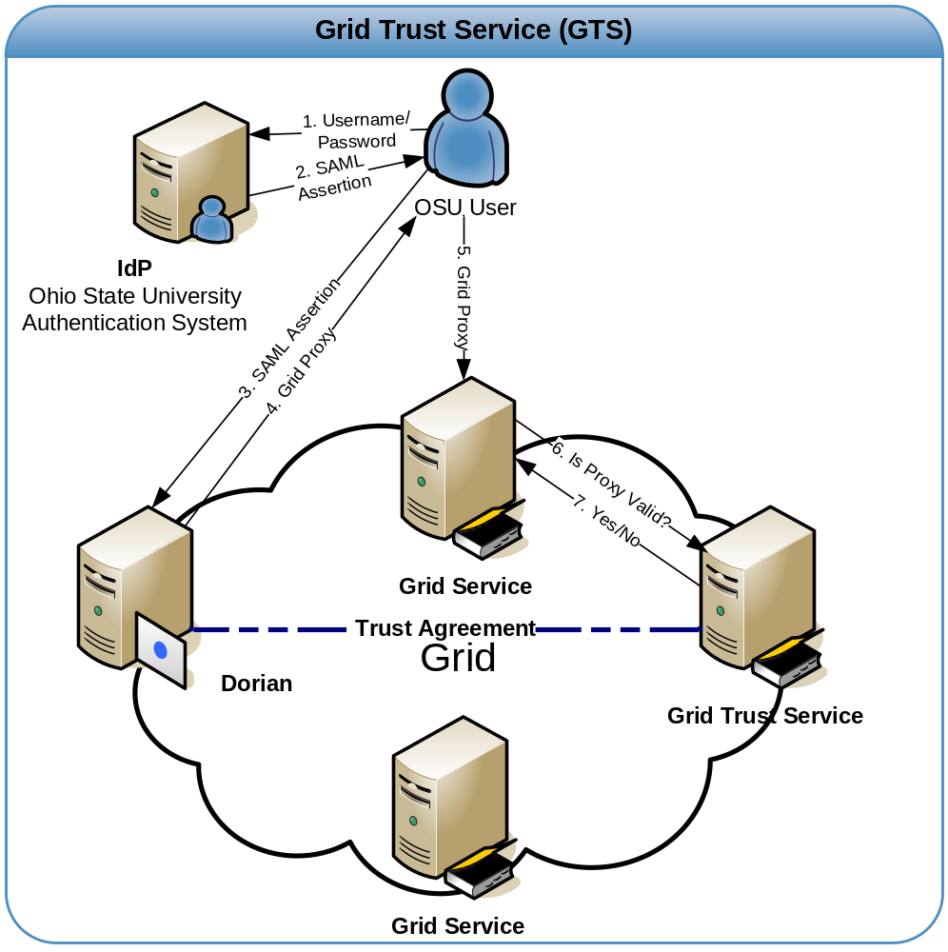
Figure 2 Grid Trust Service (GTS) RSRV Profile

Levels of Trust

It would be impractical to assume that in a heterogeneous environment such as the grid, that all certificate authorities would be implicitly trusted with the same level confidence. In a grid there will be many different certificate authorities that will be used for asserting many different things. For example, some certificate authorities will be used to assert identity and others might be used to digitally signed documents. Even certificate authorities asserting the same thing may have differing levels of trust associated with them, as they may employ different issuing policies. A certificate authority that has a very strict policy for asserting user identification should be trusted more than a certificate authority that has a looser policy for asserting identification. To model levels of trust in the trust fabric, the GTS provides a mechanism for its administrators to define and manage trust levels. When certificate authorities are registered into the trust fabric they are assigned a trust level. Clients can specify the level of trust that they require when discovering trusted CAs or when requesting validation. Trust levels in the GTS each consist of a unique name and description. The unique name is used to implicitly bind a certificate authority to a trust level. The description is used as a human readable method of understanding what a specific trust level represents. Through its grid service interface, the GTS provides several operations for accessing and administrating trust levels. The getTrustLevels() operation is a publicly accessible operation which provides a list of all the trust levels existing in a GTS. The addTrustLevel(), updateTrustLevel(), and removeTrustLevel() operations are accessible to GTS administrators, providing them with a method of administering trust levels. Figure 3 illustrates the trust level management interface in the GTS graphical administration portal.

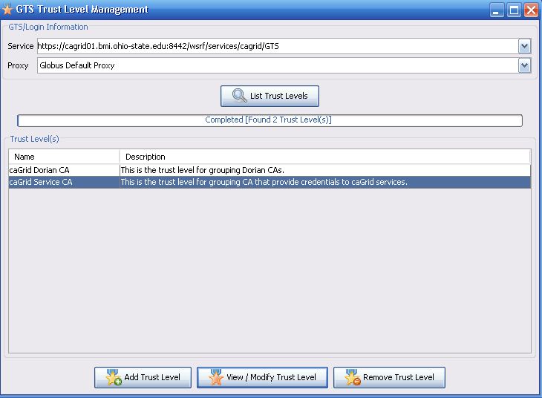

Figure 3 GTS Admin GUI - Trust Level Management

Operations

getTrustLevels() – This operation obtains a list of the trust levels acknowledged by a GTS.
Inputs
None
Outputs
1) Namespace: http://cagrid.nci.nih.gov/8/gts Name: TrustLevel[]

addTrustLevel() – This operation allows administrators to define a level of trust within a GTS.
Inputs
1) Namespace: http://cagrid.nci.nih.gov/8/gts Name: TrustLevel
Outputs
None

updateTrustLevel() – This operation allows administrators to update a trust level.
Inputs
1) Namespace: http://cagrid.nci.nih.gov/8/gts Name: TrustLevel
Outputs
None

removeTrustLevel() – This operation allows administrators to remove a trust level.
Inputs
1) Namespace: http://www.w3.org/2001/XMLSchema Name: string
Outputs
None

Managing Trusted Certificate Authorities

The GTS service interface provides several operations for registering and managing trusted certificate authorities. Registration of certificate authority requires the specification of the CA’s root certificate, a trust level, a status, and an optional CRL. The CA’s root certificate is required for validating certificates. The trust level specifies the level of confidence or how much a given certificate authority is trusted in the fabric in which it is deployed. The status specifies the current state of the certificate authority; the status can be set to “trusted” or “suspended”. Setting the status of a certificate authority allows it to be temporarily added and removed, respectively, from the trust fabric. For each trusted certificate authority, the GTS maintains a Certificate Revocation List (CRL). The CRL contains a list of certificates that have been revoked by the CA. The GTS makes several operations available to administrators for managing trusted certificate authorities, these include addTrustedAuthority(), updateTrustedAuthority(), removeTrustedAuthority(), and updateCRL(). The updateCRL() operation provides a mechanism for certificate authorities to publish their CRL immediately after it is locally updated. For example, Dorian revokes a user’s certificate and adds an entry to its CRL, every time a user’s account is suspended. Upon updating its CRL, Dorian immediate publishes it to the GTS. The updateCRL() operation can be invoked by GTS administrators and individual trusted certificate authority administrators. The GTS provides a mechanism of assigning and maintaining individual trusted certificate authority administrators.
Figure 4 illustrates the trusted certificate authority management interface in the GTS admin portal.
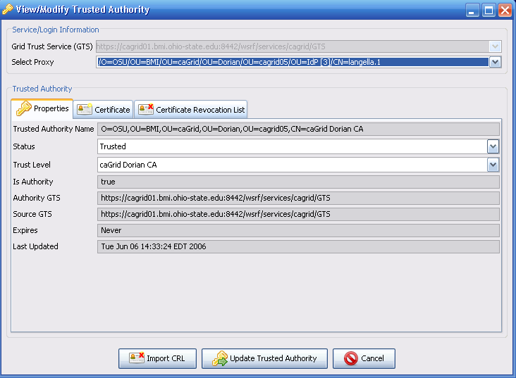
Figure 4 GTS Admin GUI - Managing Trusted Certificate Authorities

Operations
addTrustedAuthority() – This operation provides a mechanism for registering certificate authorities to the GTS.
Inputs
1) Namespace: http://cagrid.nci.nih.gov/8/gts Name: TrustedAuthority
Outputs
1) Namespace: http://cagrid.nci.nih.gov/8/gts Name: TrustedAuthority

updateTrustedAuthority() – This operation provides a mechanism for updating a trusted certificate authority.
Inputs
1) Namespace: http://cagrid.nci.nih.gov/8/gts Name: TrustedAuthority
Outputs
None

removeTrustedAuthority() – This operation allows administrators to remove a trusted authority from a GTS.
Inputs
1) Namespace: http://www.w3.org/2001/XMLSchema Name: string
Outputs
None

updateCRL() – This operation provides a mechanism for updating a trusted certificate authority’s CRL.
Inputs
1) Namespace: http://www.w3.org/2001/XMLSchema Name: string (Trusted Authority name)
2) Namespace: http://cagrid.nci.nih.gov/8/gts Name: X509CRL
Outputs
None

Federation

Establishing a federated trust fabric is critical for redundancy, scalability, and for the integration of multiple trust fabrics. There will be serious performance implications if all entities in the grid are discovering and performing validation against a trust fabric maintained in a central GTS. To enable a federated trust fabric, each GTS can be administered to synchronize with a set of authority GTSs. GTSs can inherit both trust levels and trusted certificate authorities from its authority GTSs. Registering an authority GTS requires the specification of the following properties: service URI, priority, whether or not to synchronize the trust levels, time to live, whether or not to perform authorization, and the authority service’s identity if authorization is required. The priority property is used for resolving conflicts between authority GTSs, for example if two authority GTSs have a listing for the same certificate authority, the authority GTS with the highest priority will be used for obtaining that certificate authority, and its corresponding information. If contact to an authority GTS is lost for a significant amount of time, the trust fabric within the subordinate GTS may become significantly out of date; this could be a potential security risk. The time to live property specifies how long certificate authorities obtained from authority GTSs will be valid for in the subordinate GTS. The time to live on a given certificate authority record is reset after each synchronization with the authority GTS. If contact is with and authority GTS is lost, the time to live will expire and the certificate authority will be removed from the trust fabric.
Figure 5 illustrates an example of how multiple GTSs can be deployed to create and manage a federated trust fabric. In the example there are five GTSs: caGrid GTS, TeraGrid GTS, OSU GTS, caGrid/TeraGrid GTS, and UT GTS. The caGrid GTS has no authority GTSs, it manages the certificate authorities A and S. The TeraGrid GTS has no authority GTSs, it manages the certificate authorities X and S. The OSU GTS has one authority GTS, the caGrid GTS. The OSU GTS inherits the certificate authorities A and S from its authority the caGrid GTS. The OSU GTS manages an additional certificate authority B. The OSU GTS is an example of how the global trust fabric can be extended to include local trusted certificate authorities, in this case and additional certificate authority trusted by OSU. The caGrid/TeraGrid GTS has two authority GTSs, the caGrid GTS and the TeraGrid GTS. The TeraGrid GTS inherits CA A from the caGrid GTS and CA X from the TeraGrid GTS, since the caGrid GTS has a higher priority then the TeraGrid GTS, it inherits CA S from the caGrid GTS. The caGrid/TeraGrid GTS is an example of how two existing trust fabrics from two different grids can be joined together. Finally the UT GTS has one authority GTS, the TeraGrid GTS. The UT GTS inherits CA X and CA S from the TeraGrid GTS. The UT GTS is an example of standing up a GTS for better redundancy and scalability.
Supporting a federated trust fabric across GTSs introduces additional metadata to be associated with trust levels and certificate authorities. This metadata includes the “Source GTS”, “Authority GTS”, and “Time to Live”. The “Source GTS” specifies the service URI of the GTS in which the trust level or certificate authority was inherited from. The “Authority GTS” specifies the service URI of the GTS that is the authority of trust level or certificate authority. “Time to Live” specifies the date in which the certificate authority entry is valid until.
The GTS provides administrative operations through its service interface for managing the federation. Management of the trust fabric is accomplished by specifying authority GTSs for a given GTS. To support this, the GTS service interface provides the following operations: addAuthority(), updateAuthority(), removeAuthority(), and updateAuthorityPriorities().
Figure 6 illustrates the authority GTS management interface in the GTS admin portal.

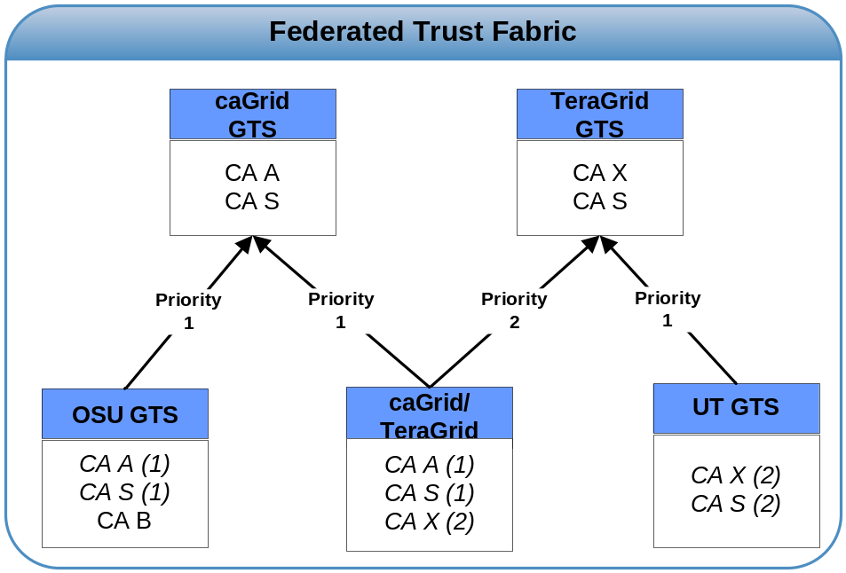
Figure 5 Federated Trust Fabric
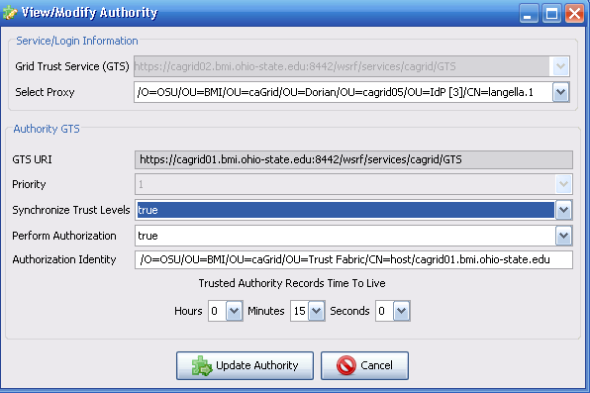
Figure 6 GTS Admin GUI - Managing Authority GTSs

Operations
getAuthorities() – This operation provides a mechanism for obtaining the list of authority GTSs for a GTS.
Inputs
None
Outputs
1) Namespace: http://cagrid.nci.nih.gov/8/gts Name: AuthorityGTS[]

addAuthority() – This operation provides a mechanism for adding an authority GTS to a GTS
Inputs
1) Namespace: http://cagrid.nci.nih.gov/8/gts Name: AuthorityGTS
Outputs
None

updateAuthority() – This operation provides a mechanism for updating and Authority GTS.
Inputs
1) Namespace: http://cagrid.nci.nih.gov/8/gts Name: AuthorityGTS
Outputs
None

removeAuthority() – This operation provides a mechanism for removing an authority GTS from a GTS’s list of authorities.
Inputs
1) Namespace: http://www.w3.org/2001/XMLSchema Name: string (URI of authority GTS)
Outputs
None

updateAuthorityPriorities() – Each authority GTS is assigned a priority, the priority is used in resolving conflict between authorities. When a conflict arises the information received from the GTS with the highest priority will be used. This method provides a mechanism for updating the priority of the authority GTSs.
Inputs
1) Namespace: http://cagrid.nci.nih.gov/8/gts Name: AuthorityPriorityUpdate
Outputs
None

Discovery

To support the Remotely Retrieved, Locally Validated Profile (RRLV), local validators will need a method of remotely discovering and obtaining certificate authorities to perform validation against. Discovery of trusted certificate authorities is critical for supporting the RRLV profile and for facilitating the administration of the trust fabric. In order to support discovery, the GTS provides a publicly available operation, findTrustedAuthorities() through its service interface. In discovering trusted certificate authorities the GTS allows the specification of search criteria. The search criteria include the name of the certificate authority, the trust level, the status, the lifetime, the source GTS, and the authority GTS. Using this operation, validators implementing the RRLV profile can discover a list of trusted certificate authorities based on trust level. Trust fabric administrators may leverage this operation for discovering the trust fabric such that they administer it.
Figure 7 illustrates the discovery interface in the GTS admin portal.

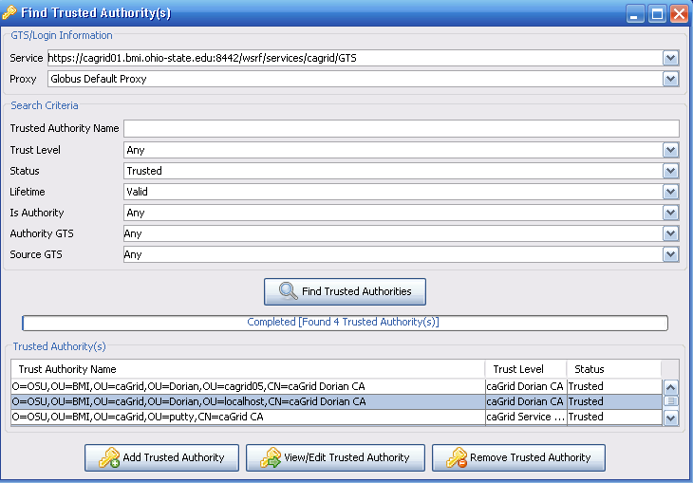
Figure 7 GTS Admin GUI – Discovery

Operation
findTrustedAuthorities() – This operation provides a mechanism for querying for a list of trusted certificate Authorities
Inputs
1) Namespace: http://cagrid.nci.nih.gov/8/gts Name: TrustedAuthorityFilter
Outputs
1) Namespace: http://cagrid.nci.nih.gov/8/gts Name: TrustedAuthority[]

Validation

To support the Remotely Stored, Remotely Validated (RSRV) model, the GTS takes on the role of a validation service. The GTS validate() operation enables clients to submit, for validation, a certificate chain and validation criteria. The GTS uses the validation criteria to identify a set of certificate authorities to validate the specified certificate chain against. The GTS uses the X509 validation specifications for validating the certificate chain. Additionally is will enforce the X509 Proxy extensions for validating the certificate chain if an X509 proxy certificate exists in the chain. The validation criteria are similar to the discovery criteria, allowing the set of certificate authorities to validate against to be limited based on the following: the name of the certificate authority, the trust level, the status, the lifetime, the source GTS, and the authority GTS.

Operation
validate() – This operation validates a X509 certificate chain against the trust fabric. Specification of a TrustedAuthorityFilter allows the caller to limit the set of trusted certificate authorities to perform the validation against.
Inputs
1) Namespace: http://cagrid.nci.nih.gov/8/gts Name: X509Certificate[]
2) Namespace: http://cagrid.nci.nih.gov/8/gts Name: TrustedAuthorityFilter

Outputs
1) Namespace: http://cagrid.nci.nih.gov/8/gts Name: TrustedAuthority[]

Managing Administrators

Many of the operations provided by the GTS provide a means of administrating the trust fabric and are therefore are restricted to GTS administrators. The GTS provides the following operations for managing the assignment of administrative roles to users: addPermission(), revokePermssion(), and findPermissions(). These operations are, themselves, obviously restricted to GTS administrators.

Operations
findPermissions() – This operation provides a mechanism for obtaining the list of administrative permissions assigned in a GTS.
Inputs
None
Outputs
1) Namespace: http://cagrid.nci.nih.gov/8/gts Name: Permission

addPermission() – This operation provides a mechanism for adding an administrative permission to a GTS.
Inputs
1) Namespace: http://cagrid.nci.nih.gov/8/gts Name: Permission
Outputs
None
revokePermission() – This operation provides a mechanism for revoking an administrative permission from a GTS.
Inputs
1) Namespace: http://cagrid.nci.nih.gov/8/gts Name: Permission
Outputs
None
- SyncGTS
As previously mentioned, the current Globus release (4.0.2) supports the Locally Stored, Locally Validated Profile (LSLV) model for certificate validation. To meet the security requirements of caBIG, we needed to ensure that certificate validation is performed against the latest trust fabric. To facilitate this without having to modify the Globus Toolkit we created SyncGTS. SyncGTS is a plugin for the Globus Toolkit enabling it to support the Remotely Retrieved, Locally Validated (RRLV) certificate validation model. Globus performs authentication or certificate validation against a trusted certificates directory on the local file system. SyncGTS (Figure 8) maintains the local trusted certificates directory for Globus. When SyncGTS synchronizes with a set of GTSs, it copies the CA certificates and CRLS obtained to the local trusted certificates directory, purging all certificate and CRLS that existed from previous synchronizations. SyncGTS is configured with a synchronization description, which describes the synchronization criteria. Each synchronization criterion specifies a GTS to synchronize with and a set of search criteria for enforcing restrictions (trust level, etc.) on the certificate authority set returned. When SyncGTS is executed, it connects to all the GTSs specified in the synchronization description and obtains a list of trusted certificate authorities matching the specified search criteria. The synchronization description is defined in the SyncDescription element for the SyncGTS schema (Appendix D).
For auditing purposes SyncGTS maintains a reporting model, SyncReport, describing each synchronization. A SyncReport is written to the local file system each time SyncGTS synchronizes with a set of GTSs. The SyncReport describes when the synchronization occurred, the synchronization description executed, and the outcome of the synchronization. The outcome details which GTS it obtained a certificate authority and CRL from, where on the file system they were written, as well as describing any certificate authorities and CRLS that were removed because they were a remnants of a previous synchronization. SyncReport is defined in the SyncGTS schema (Appendix D).
SyncGTS can support several deployment options. It can be embedded directly into a Globus container as a grid service, enabling all services running in that container to perform authentication against the GTS maintained trust fabric. SyncGTS can also be embedded directly in client-side applications by leveraging the SyncGTS Java API. SyncGTS also provides command line utilities, which can be leveraged on both the client- and service- sides.

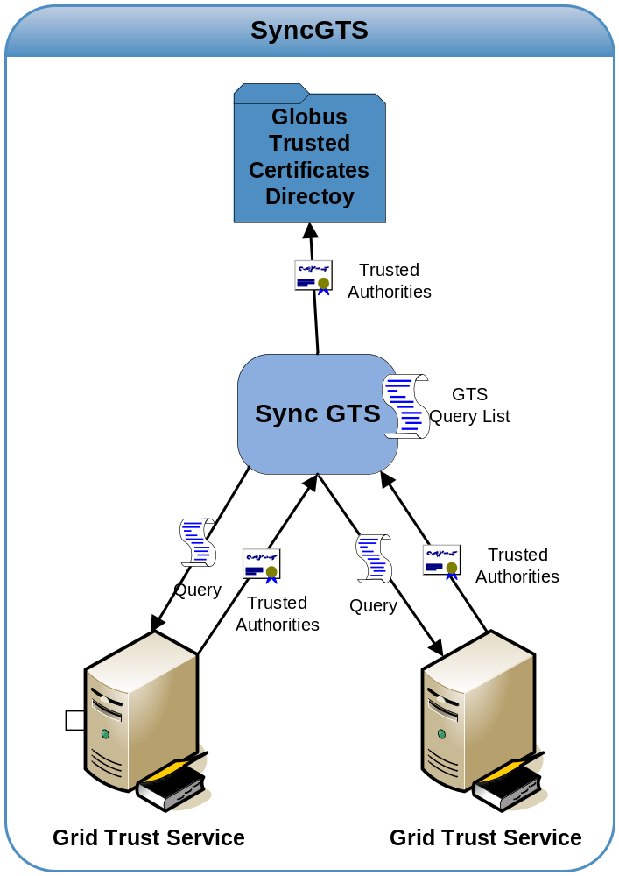
Figure 8 SyncGTS
hg

- References

Technical Manuals/Articles
- I. Foster, C. Kesselman, S. Tuecke., “The Anatomy of the Grid: Enabling Scalable Virtual Organizations”, International J. Supercomputer Applications, 15(3), 2001.
- I. Foster, C. Kesselman, J. Nick, S. Tuecke, “The Physiology of the Grid: An Open Grid Services Architecture for Distributed Systems Integration”, 2002.
- The Globus Toolkit, http://www.globus.org
- V. Welch, F. Siebenlist, I. Foster, J. Bresnahan, K. Czajkowski, J. Gawor, C. Kesselman, S. Meder, L. Pearlman, S. Tuecke, “Security for Grid Services”, Twelfth International Symposium on High Performance Distributed Computing (HPDC-12), IEEE Press, to appear June 2003.
- I. Foster, C. Kesselman, S. Tuecke, J. Volmer, V. Welch, R. Butler, D. Engert, “A National-Scale Authentication Infrastructure.”, IEEE Computer, 33(12):60-66, 2000.
- S. Langella, S. Oster, S. Hastings, T. Kurc, J. Saltz, “caGrid 0.5 Security Infrastructure”. July 2005.
- OASIS Security Services (SAML) TC, http://www.oasisopen.org/committees/tc_home.php?wg_abbrev=security
- Ken Lin, Gary Daemer, “caBIG™ Security Technology Evaluation White Paper”. January 2006.
- Web Services Resource Framework (WSRF), http://www.oasis-open.org/committees/tc_home.php?wg_abbrev=wsrf
- S. Tuecke, V. Welch, D. Engert, L. Pearlman, M. Thompson, Internet X.509 Public Key Infrastructure (PKI) Proxy Certificate Profile
- XML Key Management Specification (XKMS) http://www.w3.org/TR/xkms/
- S. Langella, S. Oster, S. Hastings, F. Siebenlist, T. Kurc, and J. Saltz, "Dorian: Grid Service Infrastructure for Identity Management and Federation," presented at The 19th IEEE Symposium on Computer-Based Medical Systems, Special Track: Grids for Biomedical Informatics, Salt Lake City, Utah., 2006.

Scientific Publications

caBIG Material
- Cancer Biomedical Informatics Grid (caBIGTM), https://cabig.nci.nih.gov.
- Cancer Biomedical Informatics Grid (caBIGTM), https://cabig.nci.nih.gov/workspaces/Architecture/caGrid/

caCORE Material
- caCORE: http://ncicb.nci.nih.gov/core
- caBIO: http://ncicb.nci.nih.gov/core/caBIO
- caDSR: http://ncicb.nci.nih.gov/core/caDSR
- EVS: http://ncicb.nci.nih.gov/core/EVS
- CSM: http://ncicb.nci.nih.gov/core/CSM

- GTS WSDL
<?xml version="1.0" encoding="UTF-8"?>
<definitions name="GTS" targetNamespace="http://cagrid.nci.nih.gov/GTS"
xmlns:tns="http://cagrid.nci.nih.gov/GTS"
xmlns:wsrp="http://docs.oasis-open.org/wsrf/2004/06/wsrf-WS-ResourceProperties-1.2-draft-01.xsd"
xmlns:wsrlw="http://docs.oasis-open.org/wsrf/2004/06/wsrf-WS-ResourceLifetime-1.2-draft-01.wsdl"
xmlns:wsdlpp="http://www.globus.org/namespaces/2004/10/WSDLPreprocessor"
xmlns:gtwsdl1="http://docs.oasis-open.org/wsrf/2004/06/wsrf-WS-ServiceGroup-1.2-draft-01.wsdl"
xmlns:wsa="http://schemas.xmlsoap.org/ws/2004/03/addressing"
xmlns:wsntw="http://docs.oasis-open.org/wsn/2004/06/wsn-WS-BaseNotification-1.2-draft-01.wsdl"
xmlns:wsrbfw="http://docs.oasis-open.org/wsrf/2004/06/wsrf-WS-BaseFaults-1.2-draft-01.wsdl"
xmlns:wsrpw="http://docs.oasis-open.org/wsrf/2004/06/wsrf-WS-ResourceProperties-1.2-draft-01.wsdl" xmlns="http://schemas.xmlsoap.org/wsdl/">

<import
namespace="http://docs.oasis-open.org/wsrf/2004/06/wsrf-WS-ResourceProperties-1.2-draft-01.wsdl"
location="../wsrf/properties/WS-ResourceProperties.wsdl"/>
<import namespace="http://docs.oasis-open.org/wsrf/2004/06/wsrf-WS-BaseFaults-1.2-draft-01.wsdl"
location="../wsrf/faults/WS-BaseFaults.wsdl"/>
<!--============================================================

T Y P E S

============================================================-->
<types>
<schema targetNamespace="http://cagrid.nci.nih.gov/GTS"
xmlns:tns="http://cagrid.nci.nih.gov/GTS"
xmlns:ns1="gme://caGrid.caBIG/1.0/gov.nih.nci.cagrid.metadata"

xmlns:ns0="http://cagrid.nci.nih.gov/8/gts"

xmlns:xs="http://www.w3.org/2001/XMLSchema" xmlns="http://www.w3.org/2001/XMLSchema" xmlns:wsrbf="http://docs.oasis-open.org/wsrf/2004/06/wsrf-WS-BaseFaults-1.2-draft-01.xsd" elementFormDefault="qualified" attributeFormDefault="unqualified">
<import namespace="http://docs.oasis-open.org/wsrf/2004/06/wsrf-WS-BaseFaults-1.2-draft-01.xsd" schemaLocation="../wsrf/faults/WS-BaseFaults.xsd"/>
<import namespace="gme://caGrid.caBIG/1.0/gov.nih.nci.cagrid.metadata" schemaLocation="./xsd/cagrid/types/caGridMetadata.xsd"/>

<import namespace="http://cagrid.nci.nih.gov/8/gts" schemaLocation="./gts.xsd"/>

<element name="AddTrustedAuthorityRequest">
<complexType>
<sequence>
<element name="ta">
<complexType>
<sequence>
<element ref="ns0:TrustedAuthority" minOccurs="1" maxOccurs="1" />
</sequence>
</complexType>
</element>
</sequence>
</complexType>
</element>

<element name="AddTrustedAuthorityResponse">
<complexType>
<sequence>

<element ref="ns0:TrustedAuthority" minOccurs="1" maxOccurs="1" />

</sequence>
</complexType>
</element>

<element name="FindTrustedAuthoritiesRequest">
<complexType>
<sequence>
<element name="filter">
<complexType>
<sequence>
<element ref="ns0:TrustedAuthorityFilter" minOccurs="1" maxOccurs="1" />
</sequence>
</complexType>
</element>
</sequence>
</complexType>
</element>

<element name="FindTrustedAuthoritiesResponse">
<complexType>
<sequence>

<element ref="ns0:TrustedAuthority" minOccurs="1" maxOccurs="unbounded" />

</sequence>
</complexType>
</element>

<element name="RemoveTrustedAuthorityRequest">
<complexType>
<sequence>
<element name="trustedAuthorityName" type="xs:string" minOccurs="1" maxOccurs="1" /></sequence>
</complexType>
</element>

<element name="RemoveTrustedAuthorityResponse">
<complexType>
<sequence>

</sequence>
</complexType>
</element>

<element name="AddPermissionRequest">
<complexType>
<sequence>
<element name="permission">
<complexType>
<sequence>
<element ref="ns0:Permission" minOccurs="1" maxOccurs="1" />
</sequence>
</complexType>
</element>
</sequence>
</complexType>
</element>

<element name="AddPermissionResponse">
<complexType>
<sequence>

</sequence>
</complexType>
</element>

<element name="FindPermissionsRequest">
<complexType>
<sequence>
<element name="filter">
<complexType>
<sequence>
<element ref="ns0:PermissionFilter" minOccurs="1" maxOccurs="1" />
</sequence>
</complexType>
</element>
</sequence>
</complexType>
</element>

<element name="FindPermissionsResponse">
<complexType>
<sequence>

<element ref="ns0:Permission" minOccurs="1" maxOccurs="unbounded" />

</sequence>
</complexType>
</element>

<element name="RevokePermissionRequest">
<complexType>
<sequence>
<element name="permission">
<complexType>
<sequence>
<element ref="ns0:Permission" minOccurs="1" maxOccurs="1" />
</sequence>
</complexType>
</element>
</sequence>
</complexType>
</element>

<element name="RevokePermissionResponse">
<complexType>
<sequence>

</sequence>
</complexType>
</element>

<element name="UpdateTrustedAuthorityRequest">
<complexType>
<sequence>
<element name="ta">
<complexType>
<sequence>
<element ref="ns0:TrustedAuthority" minOccurs="1" maxOccurs="1" />
</sequence>
</complexType>
</element>
</sequence>
</complexType>
</element>

<element name="UpdateTrustedAuthorityResponse">
<complexType>
<sequence>

</sequence>
</complexType>
</element>

<element name="AddTrustLevelRequest">
<complexType>
<sequence>
<element name="trustLevel">
<complexType>
<sequence>
<element ref="ns0:TrustLevel" minOccurs="1" maxOccurs="1" />
</sequence>
</complexType>
</element>
</sequence>
</complexType>
</element>

<element name="AddTrustLevelResponse">
<complexType>
<sequence>

</sequence>
</complexType>
</element>

<element name="UpdateTrustLevelRequest">
<complexType>
<sequence>
<element name="trustLevel">
<complexType>
<sequence>
<element ref="ns0:TrustLevel" minOccurs="1" maxOccurs="1" />
</sequence>
</complexType>
</element>
</sequence>
</complexType>
</element>

<element name="UpdateTrustLevelResponse">
<complexType>
<sequence>

</sequence>
</complexType>
</element>

<element name="GetTrustLevelsRequest">
<complexType>
<sequence>
</sequence>
</complexType>
</element>

<element name="GetTrustLevelsResponse">
<complexType>
<sequence>

<element ref="ns0:TrustLevel" minOccurs="1" maxOccurs="unbounded" />

</sequence>
</complexType>
</element>

<element name="RemoveTrustLevelRequest">
<complexType>
<sequence>
<element name="trustLevelName" type="xs:string" minOccurs="1" maxOccurs="1" /></sequence>
</complexType>
</element>

<element name="RemoveTrustLevelResponse">
<complexType>
<sequence>

</sequence>
</complexType>
</element>

<element name="AddAuthorityRequest">
<complexType>
<sequence>
<element name="authorityGTS">
<complexType>
<sequence>
<element ref="ns0:AuthorityGTS" minOccurs="1" maxOccurs="1" />
</sequence>
</complexType>
</element>
</sequence>
</complexType>
</element>

<element name="AddAuthorityResponse">
<complexType>
<sequence>

</sequence>
</complexType>
</element>

<element name="UpdateAuthorityRequest">
<complexType>
<sequence>
<element name="authorityGTS">
<complexType>
<sequence>
<element ref="ns0:AuthorityGTS" minOccurs="1" maxOccurs="1" />
</sequence>
</complexType>
</element>
</sequence>
</complexType>
</element>

<element name="UpdateAuthorityResponse">
<complexType>
<sequence>

</sequence>
</complexType>
</element>

<element name="UpdateAuthorityPrioritiesRequest">
<complexType>
<sequence>
<element name="authorityPriorityUpdate">
<complexType>
<sequence>
<element ref="ns0:AuthorityPriorityUpdate" minOccurs="1" maxOccurs="1" />
</sequence>
</complexType>
</element>
</sequence>
</complexType>
</element>

<element name="UpdateAuthorityPrioritiesResponse">
<complexType>
<sequence>

</sequence>
</complexType>
</element>

<element name="GetAuthoritiesRequest">
<complexType>
<sequence>
</sequence>
</complexType>
</element>

<element name="GetAuthoritiesResponse">
<complexType>
<sequence>

<element ref="ns0:AuthorityGTS" minOccurs="1" maxOccurs="unbounded" />

</sequence>
</complexType>
</element>

<element name="RemoveAuthorityRequest">
<complexType>
<sequence>
<element name="serviceURI" type="xs:string" minOccurs="1" maxOccurs="1" /></sequence>
</complexType>
</element>

<element name="RemoveAuthorityResponse">
<complexType>
<sequence>

</sequence>
</complexType>
</element>

<element name="UpdateCRLRequest">
<complexType>
<sequence>
<element name="trustedAuthorityName" type="xs:string" minOccurs="1" maxOccurs="1" /><element name="crl">
<complexType>
<sequence>
<element ref="ns0:X509CRL" minOccurs="1" maxOccurs="1" />
</sequence>
</complexType>
</element>
</sequence>
</complexType>
</element>

<element name="UpdateCRLResponse">
<complexType>
<sequence>

</sequence>
</complexType>
</element>

<element name="ValidateRequest">
<complexType>
<sequence>
<element name="chain">
<complexType>
<sequence>
<element ref="ns0:X509Certificate" minOccurs="1" maxOccurs="unbounded" />
</sequence>
</complexType>
</element>
<element name="filter">
<complexType>
<sequence>
<element ref="ns0:TrustedAuthorityFilter" minOccurs="1" maxOccurs="1" />
</sequence>
</complexType>
</element>
</sequence>
</complexType>
</element>

<element name="ValidateResponse">
<complexType>
<sequence>

<element name="response" type="xs:boolean" minOccurs="1" maxOccurs="1" />

</sequence>
</complexType>
</element>

<element name="GTSInternalFault" >
<complexType>
<complexContent>
<extension base="wsrbf:BaseFaultType"/>
</complexContent>
</complexType>
</element>

<element name="IllegalTrustedAuthorityFault" >
<complexType>
<complexContent>
<extension base="wsrbf:BaseFaultType"/>
</complexContent>
</complexType>
</element>

<element name="PermissionDeniedFault" >
<complexType>
<complexContent>
<extension base="wsrbf:BaseFaultType"/>
</complexContent>
</complexType>
</element>

<element name="InvalidTrustedAuthorityFault" >
<complexType>
<complexContent>
<extension base="wsrbf:BaseFaultType"/>
</complexContent>
</complexType>
</element>

<element name="IllegalPermissionFault" >
<complexType>
<complexContent>
<extension base="wsrbf:BaseFaultType"/>
</complexContent>
</complexType>
</element>

<element name="InvalidPermissionFault" >
<complexType>
<complexContent>
<extension base="wsrbf:BaseFaultType"/>
</complexContent>
</complexType>
</element>

<element name="IllegalTrustLevelFault" >
<complexType>
<complexContent>
<extension base="wsrbf:BaseFaultType"/>
</complexContent>
</complexType>
</element>

<element name="InvalidTrustLevelFault" >
<complexType>
<complexContent>
<extension base="wsrbf:BaseFaultType"/>
</complexContent>
</complexType>
</element>

<element name="IllegalAuthorityFault" >
<complexType>
<complexContent>
<extension base="wsrbf:BaseFaultType"/>
</complexContent>
</complexType>
</element>

<element name="InvalidAuthorityFault" >
<complexType>
<complexContent>
<extension base="wsrbf:BaseFaultType"/>
</complexContent>
</complexType>
</element>

<element name="CertificateValidationFault" >
<complexType>
<complexContent>
<extension base="wsrbf:BaseFaultType"/>
</complexContent>
</complexType>
</element>

<element name="GTSResourceProperties">
<complexType>
<sequence><element ref="ns1:ServiceMetadata"/></sequence>
</complexType>
</element>
</schema>
</types>

<!-- place service messages here -->
<message name="AddTrustedAuthorityRequest">
<part name="parameters" element="tns:AddTrustedAuthorityRequest"/>
</message>

<message name="AddTrustedAuthorityResponse">
<part name="parameters" element="tns:AddTrustedAuthorityResponse"/>
</message>
<message name="FindTrustedAuthoritiesRequest">
<part name="parameters" element="tns:FindTrustedAuthoritiesRequest"/>
</message>

<message name="FindTrustedAuthoritiesResponse">
<part name="parameters" element="tns:FindTrustedAuthoritiesResponse"/>
</message>
<message name="RemoveTrustedAuthorityRequest">
<part name="parameters" element="tns:RemoveTrustedAuthorityRequest"/>
</message>

<message name="RemoveTrustedAuthorityResponse">
<part name="parameters" element="tns:RemoveTrustedAuthorityResponse"/>
</message>
<message name="AddPermissionRequest">
<part name="parameters" element="tns:AddPermissionRequest"/>
</message>

<message name="AddPermissionResponse">
<part name="parameters" element="tns:AddPermissionResponse"/>
</message>
<message name="FindPermissionsRequest">
<part name="parameters" element="tns:FindPermissionsRequest"/>
</message>

<message name="FindPermissionsResponse">
<part name="parameters" element="tns:FindPermissionsResponse"/>
</message>
<message name="RevokePermissionRequest">
<part name="parameters" element="tns:RevokePermissionRequest"/>
</message>

<message name="RevokePermissionResponse">
<part name="parameters" element="tns:RevokePermissionResponse"/>
</message>
<message name="UpdateTrustedAuthorityRequest">
<part name="parameters" element="tns:UpdateTrustedAuthorityRequest"/>
</message>

<message name="UpdateTrustedAuthorityResponse">
<part name="parameters" element="tns:UpdateTrustedAuthorityResponse"/>
</message>
<message name="AddTrustLevelRequest">
<part name="parameters" element="tns:AddTrustLevelRequest"/>
</message>

<message name="AddTrustLevelResponse">
<part name="parameters" element="tns:AddTrustLevelResponse"/>
</message>
<message name="UpdateTrustLevelRequest">
<part name="parameters" element="tns:UpdateTrustLevelRequest"/>
</message>

<message name="UpdateTrustLevelResponse">
<part name="parameters" element="tns:UpdateTrustLevelResponse"/>
</message>
<message name="GetTrustLevelsRequest">
<part name="parameters" element="tns:GetTrustLevelsRequest"/>
</message>

<message name="GetTrustLevelsResponse">
<part name="parameters" element="tns:GetTrustLevelsResponse"/>
</message>
<message name="RemoveTrustLevelRequest">
<part name="parameters" element="tns:RemoveTrustLevelRequest"/>
</message>

<message name="RemoveTrustLevelResponse">
<part name="parameters" element="tns:RemoveTrustLevelResponse"/>
</message>
<message name="AddAuthorityRequest">
<part name="parameters" element="tns:AddAuthorityRequest"/>
</message>

<message name="AddAuthorityResponse">
<part name="parameters" element="tns:AddAuthorityResponse"/>
</message>
<message name="UpdateAuthorityRequest">
<part name="parameters" element="tns:UpdateAuthorityRequest"/>
</message>

<message name="UpdateAuthorityResponse">
<part name="parameters" element="tns:UpdateAuthorityResponse"/>
</message>
<message name="UpdateAuthorityPrioritiesRequest">
<part name="parameters" element="tns:UpdateAuthorityPrioritiesRequest"/>
</message>

<message name="UpdateAuthorityPrioritiesResponse">
<part name="parameters" element="tns:UpdateAuthorityPrioritiesResponse"/>
</message>
<message name="GetAuthoritiesRequest">
<part name="parameters" element="tns:GetAuthoritiesRequest"/>
</message>

<message name="GetAuthoritiesResponse">
<part name="parameters" element="tns:GetAuthoritiesResponse"/>
</message>
<message name="RemoveAuthorityRequest">
<part name="parameters" element="tns:RemoveAuthorityRequest"/>
</message>

<message name="RemoveAuthorityResponse">
<part name="parameters" element="tns:RemoveAuthorityResponse"/>
</message>
<message name="UpdateCRLRequest">
<part name="parameters" element="tns:UpdateCRLRequest"/>
</message>

<message name="UpdateCRLResponse">
<part name="parameters" element="tns:UpdateCRLResponse"/>
</message>
<message name="ValidateRequest">
<part name="parameters" element="tns:ValidateRequest"/>
</message>

<message name="ValidateResponse">
<part name="parameters" element="tns:ValidateResponse"/>
</message>
<message name="GTSInternalFaultFaultMessage">
<part name="fault" element="tns:GTSInternalFault"/>
</message>
<message name="IllegalTrustedAuthorityFaultFaultMessage">
<part name="fault" element="tns:IllegalTrustedAuthorityFault"/>
</message>
<message name="PermissionDeniedFaultFaultMessage">
<part name="fault" element="tns:PermissionDeniedFault"/>
</message>
<message name="InvalidTrustedAuthorityFaultFaultMessage">
<part name="fault" element="tns:InvalidTrustedAuthorityFault"/>
</message>
<message name="IllegalPermissionFaultFaultMessage">
<part name="fault" element="tns:IllegalPermissionFault"/>
</message>
<message name="InvalidPermissionFaultFaultMessage">
<part name="fault" element="tns:InvalidPermissionFault"/>
</message>
<message name="IllegalTrustLevelFaultFaultMessage">
<part name="fault" element="tns:IllegalTrustLevelFault"/>
</message>
<message name="InvalidTrustLevelFaultFaultMessage">
<part name="fault" element="tns:InvalidTrustLevelFault"/>
</message>
<message name="IllegalAuthorityFaultFaultMessage">
<part name="fault" element="tns:IllegalAuthorityFault"/>
</message>
<message name="InvalidAuthorityFaultFaultMessage">
<part name="fault" element="tns:InvalidAuthorityFault"/>
</message>
<message name="CertificateValidationFaultFaultMessage">
<part name="fault" element="tns:CertificateValidationFault"/>
</message>

<!--============================================================

P O R T T Y P E

============================================================-->
<portType name="GTSPortType" wsrp:ResourceProperties="tns:GTSResourceProperties">
<operation name="addTrustedAuthority">
<input message="tns:AddTrustedAuthorityRequest"/>
<output message="tns:AddTrustedAuthorityResponse"/>
<fault name="GTSInternalFault" message="tns:GTSInternalFaultFaultMessage"/>

<fault name="IllegalTrustedAuthorityFault" message="tns:IllegalTrustedAuthorityFaultFaultMessage"/>

<fault name="PermissionDeniedFault" message="tns:PermissionDeniedFaultFaultMessage"/>

</operation>
<operation name="findTrustedAuthorities">
<input message="tns:FindTrustedAuthoritiesRequest"/>
<output message="tns:FindTrustedAuthoritiesResponse"/>
</operation>
<operation name="removeTrustedAuthority">
<input message="tns:RemoveTrustedAuthorityRequest"/>
<output message="tns:RemoveTrustedAuthorityResponse"/>
<fault name="GTSInternalFault" message="tns:GTSInternalFaultFaultMessage"/>

<fault name="InvalidTrustedAuthorityFault" message="tns:InvalidTrustedAuthorityFaultFaultMessage"/>

<fault name="PermissionDeniedFault" message="tns:PermissionDeniedFaultFaultMessage"/>

</operation>
<operation name="addPermission">
<input message="tns:AddPermissionRequest"/>
<output message="tns:AddPermissionResponse"/>
<fault name="GTSInternalFault" message="tns:GTSInternalFaultFaultMessage"/>

<fault name="IllegalPermissionFault" message="tns:IllegalPermissionFaultFaultMessage"/>

<fault name="PermissionDeniedFault" message="tns:PermissionDeniedFaultFaultMessage"/>

</operation>
<operation name="findPermissions">
<input message="tns:FindPermissionsRequest"/>
<output message="tns:FindPermissionsResponse"/>
<fault name="GTSInternalFault" message="tns:GTSInternalFaultFaultMessage"/>

<fault name="PermissionDeniedFault" message="tns:PermissionDeniedFaultFaultMessage"/>

</operation>
<operation name="revokePermission">
<input message="tns:RevokePermissionRequest"/>
<output message="tns:RevokePermissionResponse"/>
<fault name="GTSInternalFault" message="tns:GTSInternalFaultFaultMessage"/>

<fault name="InvalidPermissionFault" message="tns:InvalidPermissionFaultFaultMessage"/>

<fault name="PermissionDeniedFault" message="tns:PermissionDeniedFaultFaultMessage"/>

</operation>
<operation name="updateTrustedAuthority">
<input message="tns:UpdateTrustedAuthorityRequest"/>
<output message="tns:UpdateTrustedAuthorityResponse"/>
<fault name="GTSInternalFault" message="tns:GTSInternalFaultFaultMessage"/>

<fault name="IllegalTrustedAuthorityFault" message="tns:IllegalTrustedAuthorityFaultFaultMessage"/>

<fault name="InvalidTrustedAuthorityFault" message="tns:InvalidTrustedAuthorityFaultFaultMessage"/>

<fault name="PermissionDeniedFault" message="tns:PermissionDeniedFaultFaultMessage"/>

</operation>
<operation name="addTrustLevel">
<input message="tns:AddTrustLevelRequest"/>
<output message="tns:AddTrustLevelResponse"/>
<fault name="GTSInternalFault" message="tns:GTSInternalFaultFaultMessage"/>

<fault name="IllegalTrustLevelFault" message="tns:IllegalTrustLevelFaultFaultMessage"/>

<fault name="PermissionDeniedFault" message="tns:PermissionDeniedFaultFaultMessage"/>

</operation>
<operation name="updateTrustLevel">
<input message="tns:UpdateTrustLevelRequest"/>
<output message="tns:UpdateTrustLevelResponse"/>
<fault name="GTSInternalFault" message="tns:GTSInternalFaultFaultMessage"/>

<fault name="InvalidTrustLevelFault" message="tns:InvalidTrustLevelFaultFaultMessage"/>

<fault name="IllegalTrustLevelFault" message="tns:IllegalTrustLevelFaultFaultMessage"/>

<fault name="PermissionDeniedFault" message="tns:PermissionDeniedFaultFaultMessage"/>

</operation>
<operation name="getTrustLevels">
<input message="tns:GetTrustLevelsRequest"/>
<output message="tns:GetTrustLevelsResponse"/>
<fault name="GTSInternalFault" message="tns:GTSInternalFaultFaultMessage"/>

</operation>
<operation name="removeTrustLevel">
<input message="tns:RemoveTrustLevelRequest"/>
<output message="tns:RemoveTrustLevelResponse"/>
<fault name="GTSInternalFault" message="tns:GTSInternalFaultFaultMessage"/>

<fault name="InvalidTrustLevelFault" message="tns:InvalidTrustLevelFaultFaultMessage"/>

<fault name="IllegalTrustLevelFault" message="tns:IllegalTrustLevelFaultFaultMessage"/>

<fault name="PermissionDeniedFault" message="tns:PermissionDeniedFaultFaultMessage"/>

</operation>
<operation name="addAuthority">
<input message="tns:AddAuthorityRequest"/>
<output message="tns:AddAuthorityResponse"/>
<fault name="GTSInternalFault" message="tns:GTSInternalFaultFaultMessage"/>

<fault name="IllegalAuthorityFault" message="tns:IllegalAuthorityFaultFaultMessage"/>

<fault name="PermissionDeniedFault" message="tns:PermissionDeniedFaultFaultMessage"/>

</operation>
<operation name="updateAuthority">
<input message="tns:UpdateAuthorityRequest"/>
<output message="tns:UpdateAuthorityResponse"/>
<fault name="GTSInternalFault" message="tns:GTSInternalFaultFaultMessage"/>

<fault name="IllegalAuthorityFault" message="tns:IllegalAuthorityFaultFaultMessage"/>

<fault name="InvalidAuthorityFault" message="tns:InvalidAuthorityFaultFaultMessage"/>

<fault name="PermissionDeniedFault" message="tns:PermissionDeniedFaultFaultMessage"/>

</operation>
<operation name="updateAuthorityPriorities">
<input message="tns:UpdateAuthorityPrioritiesRequest"/>
<output message="tns:UpdateAuthorityPrioritiesResponse"/>
<fault name="GTSInternalFault" message="tns:GTSInternalFaultFaultMessage"/>

<fault name="IllegalAuthorityFault" message="tns:IllegalAuthorityFaultFaultMessage"/>

<fault name="PermissionDeniedFault" message="tns:PermissionDeniedFaultFaultMessage"/>

</operation>
<operation name="getAuthorities">
<input message="tns:GetAuthoritiesRequest"/>
<output message="tns:GetAuthoritiesResponse"/>
<fault name="GTSInternalFault" message="tns:GTSInternalFaultFaultMessage"/>

</operation>
<operation name="removeAuthority">
<input message="tns:RemoveAuthorityRequest"/>
<output message="tns:RemoveAuthorityResponse"/>
<fault name="GTSInternalFault" message="tns:GTSInternalFaultFaultMessage"/>

<fault name="InvalidAuthorityFault" message="tns:InvalidAuthorityFaultFaultMessage"/>

<fault name="PermissionDeniedFault" message="tns:PermissionDeniedFaultFaultMessage"/>

</operation>
<operation name="updateCRL">
<input message="tns:UpdateCRLRequest"/>
<output message="tns:UpdateCRLResponse"/>
<fault name="GTSInternalFault" message="tns:GTSInternalFaultFaultMessage"/>

<fault name="IllegalTrustedAuthorityFault" message="tns:IllegalTrustedAuthorityFaultFaultMessage"/>

<fault name="InvalidTrustedAuthorityFault" message="tns:InvalidTrustedAuthorityFaultFaultMessage"/>

<fault name="PermissionDeniedFault" message="tns:PermissionDeniedFaultFaultMessage"/>

</operation>
<operation name="validate">
<input message="tns:ValidateRequest"/>
<output message="tns:ValidateResponse"/>
<fault name="GTSInternalFault" message="tns:GTSInternalFaultFaultMessage"/>

<fault name="CertificateValidationFault" message="tns:CertificateValidationFaultFaultMessage"/>

</operation>
<operation name="GetResourceProperty">
<input name="GetResourcePropertyRequest" message="wsrpw:GetResourcePropertyRequest"
wsa:Action="http://docs.oasis-open.org/wsrf/2004/06/wsrf-WS-ResourceProperties/GetResourceProperty"/>
<output name="GetResourcePropertyResponse" message="wsrpw:GetResourcePropertyResponse"
wsa:Action="http://docs.oasis-open.org/wsrf/2004/06/wsrf-WS-ResourceProperties/GetResourcePropertyResponse"/>
<fault name="InvalidResourcePropertyQNameFault"
message="wsrpw:InvalidResourcePropertyQNameFault"/>
<fault name="ResourceUnknownFault" message="wsrpw:ResourceUnknownFault"/>
</operation>
<operation name="GetMultipleResourceProperties">
<input name="GetMultipleResourcePropertiesRequest"
message="wsrpw:GetMultipleResourcePropertiesRequest"
wsa:Action="http://docs.oasis-open.org/wsrf/2004/06/wsrf-WS-ResourceProperties/GetMultipleResourceProperties"/>
<output name="GetMultipleResourcePropertiesResponse"
message="wsrpw:GetMultipleResourcePropertiesResponse"
wsa:Action="http://docs.oasis-open.org/wsrf/2004/06/wsrf-WS-ResourceProperties/GetMultipleResourceProperties"/>
<fault name="InvalidResourcePropertyQNameFault"
message="wsrpw:InvalidResourcePropertyQNameFault"/>
<fault name="ResourceUnknownFault" message="wsrpw:ResourceUnknownFault"/>
</operation>
<operation name="QueryResourceProperties">
<input name="QueryResourcePropertiesRequest"
message="wsrpw:QueryResourcePropertiesRequest"
wsa:Action="http://docs.oasis-open.org/wsrf/2004/06/wsrf-WS-ResourceProperties/QueryResourceProperties"/>
<output name="QueryResourcePropertiesResponse"
message="wsrpw:QueryResourcePropertiesResponse"
wsa:Action="http://docs.oasis-open.org/wsrf/2004/06/wsrf-WS-ResourceProperties/QueryResourcePropertiesResponse"/>
<fault name="ResourceUnknownFault" message="wsrpw:ResourceUnknownFault"/>
<fault name="InvalidResourcePropertyQNameFault"
message="wsrpw:InvalidResourcePropertyQNameFault"/>
<fault name="UnknownQueryExpressionDialectFault"
message="wsrpw:UnknownQueryExpressionDialectFault"/>
<fault name="InvalidQueryExpressionFault" message="wsrpw:InvalidQueryExpressionFault"/>
<fault name="QueryEvaluationErrorFault" message="wsrpw:QueryEvaluationErrorFault"/>
</operation>
</portType>
</definitions>
- GTS Schema
<xsd:schema targetNamespace="http://cagrid.nci.nih.gov/8/gts"
attributeFormDefault="qualified"
elementFormDefault="qualified"
xmlns:xsd="http://www.w3.org/2001/XMLSchema"
xmlns:gts="http://cagrid.nci.nih.gov/8/gts">

<xsd:element name="Permission" minOccurs="0" maxOccurs="1" type="gts:Permission"/>

<xsd:complexType name="Permission">
<xsd:sequence>
<xsd:element name="GridIdentity" minOccurs="1" maxOccurs="1" type="xsd:string"/>
<xsd:element name="Role" minOccurs="1" maxOccurs="1" type="gts:Role"/>
<xsd:element name="TrustedAuthorityName" minOccurs="0" maxOccurs="1" type="xsd:string"/>
</xsd:sequence>
</xsd:complexType>

<xsd:element name="AuthorityGTS" minOccurs="0" maxOccurs="1" type="gts:AuthorityGTS"/>

<xsd:complexType name="AuthorityGTS">
<xsd:sequence>
<xsd:element name="ServiceURI" minOccurs="1" maxOccurs="1" type="xsd:string"/>
<xsd:element name="Priority" minOccurs="1" maxOccurs="1" type="xsd:int"/>
<xsd:element name="SyncTrustLevels" minOccurs="1" maxOccurs="1" type="xsd:boolean"/>
<xsd:element name="TimeToLive" minOccurs="1" maxOccurs="1" type="gts:TimeToLive"/>
<xsd:element name="PerformAuthorization" minOccurs="1" maxOccurs="1" type="xsd:boolean"/>
<xsd:element name="ServiceIdentity" minOccurs="0" maxOccurs="1" type="xsd:string"/>
</xsd:sequence>
</xsd:complexType>

<xsd:element name="AuthorityPriorityUpdate" minOccurs="0" maxOccurs="1" type="gts:AuthorityPriorityUpdate"/>

<xsd:complexType name="AuthorityPriorityUpdate">
<xsd:sequence>
<xsd:element name="AuthorityPrioritySpecification" minOccurs="1" maxOccurs="unbounded" type="gts:AuthorityPrioritySpecification"/>
</xsd:sequence>
</xsd:complexType>

<xsd:complexType name="AuthorityPrioritySpecification">
<xsd:sequence>
<xsd:element name="ServiceURI" minOccurs="1" maxOccurs="1" type="xsd:string"/>
<xsd:element name="Priority" minOccurs="1" maxOccurs="1" type="xsd:int"/>
</xsd:sequence>
</xsd:complexType>

<xsd:complexType name="TimeToLive">
<xsd:sequence>
<xsd:element name="hours" type="xsd:int"/>
<xsd:element name="minutes" type="xsd:int"/>
<xsd:element name="seconds" type="xsd:int"/>
</xsd:sequence>
</xsd:complexType>

<xsd:element name="PermissionFilter" minOccurs="0" maxOccurs="1" type="gts:PermissionFilter"/>

<xsd:complexType name="PermissionFilter">
<xsd:sequence>
<xsd:element name="GridIdentity" minOccurs="0" maxOccurs="1" type="xsd:string"/>
<xsd:element name="Role" minOccurs="0" maxOccurs="1" type="gts:Role"/>
<xsd:element name="TrustedAuthorityName" minOccurs="0" maxOccurs="1" type="xsd:string"/>
</xsd:sequence>
</xsd:complexType>

<xsd:element name="TrustedAuthorityFilter" minOccurs="0" maxOccurs="1" type="gts:TrustedAuthorityFilter"/>

<xsd:complexType name="TrustedAuthorityFilter">
<xsd:sequence>
<xsd:element name="Name" minOccurs="0" maxOccurs="1" type="xsd:string"/>
<xsd:element name="CertificateDN" minOccurs="0" maxOccurs="1" type="xsd:string"/>
<xsd:element name="TrustLevel" minOccurs="0" maxOccurs="1" type="xsd:string"/>
<xsd:element name="Lifetime" minOccurs="0" maxOccurs="1" type="gts:Lifetime"/>
<xsd:element name="Status" minOccurs="0" maxOccurs="1" type="gts:Status"/>
<xsd:element name="IsAuthority" minOccurs="0" maxOccurs="1" type="xsd:boolean"/>
<xsd:element name="AuthorityGTS" minOccurs="0" maxOccurs="1" type="xsd:string"/>
<xsd:element name="SourceGTS" minOccurs="0" maxOccurs="1" type="xsd:string"/>
</xsd:sequence>
</xsd:complexType>

<xsd:element name="TrustedAuthority" minOccurs="0" maxOccurs="1" type="gts:TrustedAuthority"/>

<xsd:complexType name="TrustedAuthority">
<xsd:sequence>
<xsd:element name="Name" minOccurs="1" maxOccurs="1" type="xsd:string"/>
<xsd:element name="TrustLevel" minOccurs="1" maxOccurs="1" type="xsd:string"/>
<xsd:element name="Status" minOccurs="1" maxOccurs="1" type="gts:Status"/>
<xsd:element name="IsAuthority" minOccurs="0" maxOccurs="1" type="xsd:boolean"/>
<xsd:element name="AuthorityGTS" minOccurs="0" maxOccurs="1" type="xsd:string"/>
<xsd:element name="SourceGTS" minOccurs="0" maxOccurs="1" type="xsd:string"/>
<xsd:element name="Expires" minOccurs="1" maxOccurs="1" type="xsd:long"/>
<xsd:element name="LastUpdated" minOccurs="1" maxOccurs="1" type="xsd:long"/>
<xsd:element name="Certificate" minOccurs="1" maxOccurs="1" type="gts:X509Certificate"/>
<xsd:element name="CRL" minOccurs="0" maxOccurs="1" type="gts:X509CRL"/>
</xsd:sequence>
</xsd:complexType>

<xsd:simpleType name="Role">
<xsd:restriction base="xsd:string">
<xsd:enumeration value="TrustServiceAdmin"/>
<xsd:enumeration value="TrustAuthorityManager"/>
<xsd:enumeration value="User"/>
</xsd:restriction>
</xsd:simpleType>

<xsd:simpleType name="Status">
<xsd:restriction base="xsd:string">
<xsd:enumeration value="Trusted"/>
<xsd:enumeration value="Suspended"/>
</xsd:restriction>
</xsd:simpleType>

<xsd:simpleType name="Lifetime">
<xsd:restriction base="xsd:string">
<xsd:enumeration value="Valid"/>
<xsd:enumeration value="Expired"/>
</xsd:restriction>
</xsd:simpleType>

<xsd:element name="TrustLevel" minOccurs="0" maxOccurs="1" type="gts:TrustLevel"/>

<xsd:complexType name="TrustLevel">
<xsd:sequence>
<xsd:element name="name" minOccurs="1" maxOccurs="1" type="xsd:string"/>
<xsd:element name="description" minOccurs="1" maxOccurs="1" type="xsd:string"/>
<xsd:element name="IsAuthority" minOccurs="0" maxOccurs="1" type="xsd:boolean"/>
<xsd:element name="AuthorityGTS" minOccurs="0" maxOccurs="1" type="xsd:string"/>
<xsd:element name="SourceGTS" minOccurs="0" maxOccurs="1" type="xsd:string"/>
<xsd:element name="LastUpdated" minOccurs="1" maxOccurs="1" type="xsd:long"/>
</xsd:sequence>
</xsd:complexType>

<xsd:element name="X509Certificate" minOccurs="0" maxOccurs="1" type="gts:X509Certificate"/>

<xsd:complexType name="X509Certificate">
<xsd:sequence>
<xsd:element name="certificateEncodedString" minOccurs="1" maxOccurs="1" type="xsd:string"/>
</xsd:sequence>
</xsd:complexType>

<xsd:element name="X509CRL" minOccurs="0" maxOccurs="1" type="gts:X509CRL"/>

<xsd:complexType name="X509CRL">
<xsd:sequence>
<xsd:element name="crlEncodedString" minOccurs="1" maxOccurs="1" type="xsd:string"/>
</xsd:sequence>
</xsd:complexType>

</xsd:schema>
- SyncGTS Schema
<xsd:schema targetNamespace="http://cagrid.nci.nih.gov/12/SyncGTS"
attributeFormDefault="qualified"
elementFormDefault="qualified"
xmlns:xsd="http://www.w3.org/2001/XMLSchema"
xmlns:sync="http://cagrid.nci.nih.gov/12/SyncGTS"
xmlns:gts="http://cagrid.nci.nih.gov/8/gts">

<xsd:element name="SyncDescription" minOccurs="0" maxOccurs="1" type="sync:SyncDescription"/>

<xsd:complexType name="SyncDescription">
<xsd:sequence>
<xsd:element name="SyncDescriptor" minOccurs="0" maxOccurs="unbounded" type="sync:SyncDescriptor"/>
<xsd:element name="DeleteInvalidFiles" minOccurs="1" maxOccurs="1" type="xsd:boolean"/>
<xsd:element name="DeleteExistingTrustedRoots" minOccurs="1" maxOccurs="1" type="xsd:boolean"/>
<xsd:element name="FilePrefix" minOccurs="1" maxOccurs="1" type="xsd:string"/>
<xsd:element name="NextSync" minOccurs="1" maxOccurs="1" type="xsd:integer"/>
<xsd:element name="PerformAuthorization" minOccurs="1" maxOccurs="1" type="xsd:boolean"/>
<xsd:element name="HostIdentity" minOccurs="0" maxOccurs="1" type="xsd:string"/>
</xsd:sequence>
</xsd:complexType>

<xsd:complexType name="SyncDescriptor">
<xsd:sequence>
<xsd:element name="gtsServiceURI" minOccurs="1" maxOccurs="1" type="xsd:string"/>
<xsd:element name="TrustedAuthorityFilter" minOccurs="0" maxOccurs="unbounded" type="gts:TrustedAuthorityFilter"/>
</xsd:sequence>
</xsd:complexType>

<xsd:element name="SyncReport" minOccurs="0" maxOccurs="1" type="sync:SyncReport"/>

<xsd:complexType name="SyncReport">
<xsd:sequence>
<xsd:element name="Timestamp" minOccurs="1" maxOccurs="1" type="xsd:string"/>
<xsd:element ref="sync:SyncDescription" minOccurs="1" maxOccurs="1"/>
<xsd:element name="AddedTrustedCAs" minOccurs="0" maxOccurs="1" type="sync:AddedTrustedCAs"/>
<xsd:element name="RemovedTrustedCAs" minOccurs="0" maxOccurs="1" type="sync:RemovedTrustedCAs"/>
<xsd:element name="Messages" minOccurs="0" maxOccurs="1" type="sync:Messages"/>
</xsd:sequence>
</xsd:complexType>

<xsd:element name="TrustedCA" minOccurs="0" maxOccurs="1" type="sync:TrustedCA"/>

<xsd:complexType name="TrustedCA">
<xsd:sequence>
<xsd:element name="name" minOccurs="1" maxOccurs="1" type="xsd:string"/>
<xsd:element name="gts" minOccurs="0" maxOccurs="1" type="xsd:string"/>
<xsd:element name="CertificateFile" minOccurs="1" maxOccurs="1" type="xsd:string"/>
<xsd:element name="CRLFile" minOccurs="0" maxOccurs="1" type="xsd:string"/>
<xsd:element name="SigningPolicyFile" minOccurs="0" maxOccurs="1" type="xsd:string"/>
</xsd:sequence>
</xsd:complexType>

<xsd:complexType name="AddedTrustedCAs">
<xsd:sequence>
<xsd:element ref="sync:TrustedCA" minOccurs="0" maxOccurs="unbounded"/>
</xsd:sequence>
</xsd:complexType>

<xsd:complexType name="RemovedTrustedCAs">
<xsd:sequence>
<xsd:element ref="sync:TrustedCA" minOccurs="0" maxOccurs="unbounded"/>
</xsd:sequence>
</xsd:complexType>

<xsd:complexType name="Messages">
<xsd:sequence>
<xsd:element name="Message" minOccurs="0" maxOccurs="unbounded" type="sync:Message"/>
</xsd:sequence>
</xsd:complexType>

<xsd:complexType name="Message">
<xsd:sequence>
<xsd:element name="type" minOccurs="1" maxOccurs="1" type="sync:MessageType"/>
<xsd:element name="value" minOccurs="1" maxOccurs="1" type="xsd:string"/>
</xsd:sequence>
</xsd:complexType>

<xsd:simpleType name="MessageType">
<xsd:restriction base="xsd:string">
<xsd:enumeration value="Fatal"/>
<xsd:enumeration value="Error"/>
<xsd:enumeration value="Warning"/>
<xsd:enumeration value="Info"/>
</xsd:restriction>
</xsd:simpleType>

<xsd:element name="DateFilter" minOccurs="0" maxOccurs="1" type="sync:DateFilter"/>

<xsd:complexType name="DateFilter">
<xsd:sequence>
<xsd:element name="year" type="xsd:int"/>
<xsd:element name="month" type="xsd:int"/>
<xsd:element name="day" type="xsd:int"/>
</xsd:sequence>
</xsd:complexType>
</xsd:schema>

- Glossary
Following is an example list of terms and their definitions.
Term | Definition
{jboss-home} | The base directory where JBoss is installed on the server
API | Application Programming Interface
caArray | cancer Array Informatics
caBIG | cancer Biomedical Informatics Grid
caBIO | Cancer Bioinformatics Infrastructure Objects
caCORE | cancer Common Ontologic Representation Environment
caDSR | Cancer Data Standards Repository
caMOD | Cancer Models Database
cardinality | Cardinality describes the minimum and maximum number of associated objects within a set
CDE | Common Data Element
CGAP | Cancer Genome Anatomy Project
CMAP | Cancer Molecular Analysis Project
CN | Common Name
CS | Classification Scheme
CSI | Classification Scheme Item
CSM | Common Security Module
CTEP | Cancer Therapy Evaluation Program
CUI | Concept Unique Identifier
CVS | Concurrent Versions System
DAML | DARPA Agent Markup Language
DAO | Data Access Objects
DARPA | Defense Advanced Research Projects Agency
DAS | Distributed Annotation System
DL | Description Logic
EA | Enterprise Architect
EBI | European Bioinformatics Institute
EVS | Enterprise Vocabulary Services
GAI | CGAP Genetic Annotation Initiative
GEDP | Gene Expression Data Portal
HIPPA | Health Insurance Portability and Accountability Act
HLGT | High Level Group Term
HLT | High Level Term
HTTP | Hypertext Transfer Protocol
ISO | International Organization for Standardization
JAAS | Java Authentication and Authorization Service
JAR | Java Archive
Javadoc | Tool for generating API documentation in HTML format from doc comments in source code (http://java.sun.com/j2se/javadoc/)
JDBC | Java Database Connectivity
JET | Java Emitter Templates
JMI | Java Metadata Interface
JSP | JavaServer Pages
JUnit | A simple framework to write repeatable tests (http://junit.sourceforge.net/)
LDAP | Lightweight Directory Access Protocol
LLT | Lowest Level Term
LOINC | Logical Observation Identifier Names and Codes
MAGE | MicroArray and Gene Expression
MAGE-OM | MicroArray Gene Expression - Object Model
MedDRA | Medical Dictionary for Regulatory Activities
metadata | Definitional data that provides information about or documentation of other data.
MGED | Microarray Gene Expression Data
MMHCC | Mouse Models of Human Cancers Consortium
MO | MGED Ontology
multiplicity | Multiplicity of an association end indicates the number of objects of the class on that end may be associated with a single object of the class on the other end
NCI | National Cancer Institute
NCICB | National Cancer Institute Center for Bioinformatics
OIL | Ontology Inference Layer
OilEd | Ontology editor allowing you to build ontologies using DAML+OIL
OLLT | Obsolete Lower Level Terms
OMG | Object Management Group
ORM | Object Relational Mapping
PT | Preferred Term
RDBMS | Relational Database Management System
SDK | Software Development Kit
Semantic connector | A development kit to link model elements to NCICB EVS concepts.
SOC | System Organ Class
SPORE | Specialized Programs of Research
SQL | Structured Query Language
SSC | Special Search Categories
UI | User Interface
UID | User Identification
UML | Unified Modeling Language
UMLS | Unified Medical Language System
UPT | User Provisioning Tool
URL | Uniform Resource Locators
VD | Value Domain
WAR | Web Application Archive
WSDL | Web Services Description Language
XMI | XML Metadata Interchange (http://www.omg.org/technology/documents/formal/xmi.htm) - The main purpose of XMI is to enable easy interchange of metadata between modeling tools (based on the OMG-UML) and metadata repositories (OMG-MOF) in distributed heterogeneous environments
XML | Extensible Markup Language (http://www.w3.org/TR/REC-xml/) - XML is a subset of Standard Generalized Markup Language (SGML). Its goal is to enable generic SGML to be served, received, and processed on the Web in the way that is now possible with HTML. XML has been designed for ease of implementation and for interoperability with both SGML and HTML

This process is simplified here for clarity.

