caGWAS 1.1.0

Title of Publication

Local Installation Guide for LSD 1.2.0

This is a U.S. Government work.

Table of Contents

Introduction 1
caGWAS 1.1.0 Software and Technology Requirements 1
Java SDK Installation 2
Apache Ant Installation 3
Apache Ant Environment Variables 3
Installing caGWAS 1.1.0 Application and Services 8
Downloading caGWAS 1.1.0 files 9
Installing a New caGWAS 9
Running GUI installer in Headless Environment 10
Command-Line Installation 26
caGWAS Port Usage 26
JBoss Errors During Installation 26
Configuring JBoss 26
Configuring JBoss to Run as a Service 27
Running JBoss as a Service 28
Contacting Application Support 28

Introduction
This caGWAS 1.1.0 installation Guide provides you with the instructions to install and configure the caGWAS 1.1.0 application in your environment. The caGWAS (Cancer Genome-Wide Association Scan) installation installs and configures the JBoss application servers.

NOTE  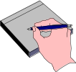 | Published caGWAS documentation can be found on the caGWAS section of the LSD GForge site:  https://gforge.nci.nih.gov/frs/?group_id=450

Overview of caGWAS Installation | The process for installing caGWAS includes the following tasks described in this document:  - Downloading and installing required software  - Setting environment variables  - Downloading caGWAS 1.1.0 distribution files  - Installing caGWAS  - Configuring JBoss

Before You Proceed | - Please contact us directly with any questions:  E-mail: ncicb@pop.nci.nih.gov  Telephone: 301-451-4384  Toll free: 888-478-4423  - Directions are given in this document for both Linux and Windows operating systems.

caGWAS 1.1.0 Software and Technology Requirements

Tested Environment | The caGWAS 1.1.0 installation has been tested on Linux Red Hat Enterprise Linux AS 4 64/32-bit (for AMD chipset) and the Windows XP/2003 environments. While the installation may work in other Linux and Windows environments, it has only been tested in these environments.

Required Software—Not Included in caGWAS | Many of the servers and services that make up caGWAS 1.1.0 are automatically installed as part of this installation. However, certain tools that you must manually install and configure are listed in Table 1. The software name, version, description, and URL hyperlinks (for download) are indicated in the table.

Prior to the caGWAS 1.1.0 installation, you must download and install the following tools and recommended versions in the order they are listed. Complete the directions for installing each, as directed on the corresponding website.

Required Software Name  Version | Description
Java 2 Platform Standard Edition 5.0 Update 10 (J2SE 5.0)  http://java.sun.com/products/archive/j2se/5.0_10/.  Be sure to download the correct Java SDK for your operating environment. For example, for Linux AMD 64, you would download jdk-1_5_0_10-linux-amd64-rpm.bin. For Windows, you might download jdk-1_5_0_10-windows-i586-p.exe. | The J2SE Development Kit (JDK) supports creating J2SE applications.
Apache Ant, 1.7.0  https://gforge.nci.nih.gov/svnroot/lsd/trunk/tools/apache-ant-1.7.0-bin.zip | Apache Ant is a Java-based build tool.
MySQL, 5.0.45  http://downloads.mysql.com/archives.php?p=mysql-5.0&v=5.0.45 | MySQL is an open-source database software application.
Table 1 Required Software

IMPORTANT | As you install each application, record the installation directory path, and the hostname of your MySQL DB server, and the DB admin username/password.  Also, if you plan to install caGWAS locally, do these installs first and record the hostname, application port, and grid port for each.

Java SDK Installation
When you install the Java SDK, you will be prompted to select the installation directory. Record the path, as this directory will be used when you set the environment variables.

Apache Ant Installation

Unzip the Apache Ant distribution files using a command line unzip tool or a zip utility, such as WinZip.

After extracting the zip, you must set the environment variables, described in the following section, so that Ant is available in the system PATH.

Apache Ant Environment Variables

NOTE | The purpose of setting operating system environment variables is so that the Java SDK and Ant build tool are available to run from anywhere in the system.

Linux
To set the environmental variables in Linux, follow these steps:

NOTE | The JAVA_HOME, ANT_HOME and PATH environment variables are set in /etc/profile. You may need to create the variables, or modify them if they already exist.

Step | Action
1 | As the root user (or sudo w/ privileges), enter the following in the /etc/profile file. A PATH variable should already be created in this file, so be sure to define the JAVA_HOME and ANT_HOME export before the PATH export. Replace <installation_directory> with the directory where you have installed the Java SDK and Ant.  (The location example in the Apache Ant installation is /usr/java.)  export JAVA_HOME=<installation_directory>/jdk1.5.0_10  export ANT_HOME=<installation_directory>/apache-ant-1.7.0  export PATH=$JAVA_HOME/bin:$ANT_HOME/bin:$PATH
2 | Log out and log back in so that the system recognizes your changes.

Verifying the Environment Variables in Linux
To verify that environment variables have been set correctly, follow these steps:

Step | Action
1 | From the command line, enter:  echo $JAVA_HOME  echo $ANT_HOME  Both of these commands should return the location where you installed these tools.
2 | To verify your Java SDK installation, enter java –version from a command prompt. You should see java version "1.5.0_10".
3 | To verify your Ant installation, enter: ant –version from a command prompt. You should see: Apache Ant version 1.7.0 compiled on December 13 2006.

Windows
To set the environmental variables in Windows, follow these steps:

NOTE | The JAVA_HOME, ANT_HOME and PATH environment variables are set in the Systems Properties.

Step | Action
1 | In Windows, select Control Panel, then select the Systems application. In the Systems window, select the Advanced tab.
2 | On the Advanced tab, click the Environment Variables button. To add a new system variable, select the New button.  - In the Variable name text box, enter JAVA_HOME.  - In the Variable value text box, enter the location of your Java installation.
3 | Click the New button again.  - In the Variable name text box, enter ANT_HOME.  - In the Variable value text box, enter the location of your Ant installation.
4 | Select the PATH system environment variable, and select the Edit button. This opens the Edit System Variable dialog box, displayed here as an example.  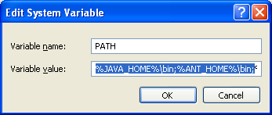
5 | In the Variable value text box, prepend the following text in front of the text that already exists in the Variable Value field.  %JAVA_HOME%\bin;%ANT_HOME%\bin;  Click OK.

Verifying the Environment Variables in Windows
To verify the environment variables have been set correctly, follow these steps:

Step | Action
1 | From the command line, enter:  echo %JAVA_HOME%  echo %ANT_HOME%  Both of these commands should return the location where you installed these tools.
2 | To verify your Java SDK installation, enter java –version from a command prompt. You should see java version "1.5.0_10".
3 | To verify your Ant installation, enter ant –version from a command prompt.  You should see: Apache Ant version 1.7.0 compiled on December 13 2006.

NOTES | Environment variables for caGWAS will be modified and set in those sections of this document: Installing a New caGWAS on page 9.

MySQL Installation and Configuration
A MySQL 5.0.45 server must be downloaded, installed and running in order for the caGWAS installation to work successfully.

To download and install MySQL, follow the steps outlined on the MySQL website: http://downloads.mysql.com/archives.php?p=mysql-5.0&v=5.0.45

TIP | You should consult the following three links to successfully set up secure and well-performing MySQL servers, in preparation for installing CAGWAS:  - MySQL Security Guide - http://dev.mysql.com/doc/refman/5.0/en/security-guidelines.html  - Performance –  - General performance tuning - http://dev.mysql.com/books/hpmysql-excerpts/ch06.html  - InnoDB engine performance tuning - http://dev.mysql.com/doc/refman/5.0/en/innodb-tuning.html

MORE TIPS | - Record the MySQL root username/password chosen during the MySQL installation process, as you will need to use this as your database.system.user/ database.system.password later in the CAGWAS installation process.  - Note the MySQL port chosen during the MySQL installation process, as you will need to use this as your database.port later in the installation process.  - As part of the installation process, the default character set is set to latin1 for the CAGWAS MySQL database.

Once installed, you must configure My-SQL for CAGWAS (only for Linux).

Linux
Configure MySQL in Linux using the following steps:

Step | Action
1 | Lowercase Table Names in MySQL  Edit the /etc/init.d/mysqld (or mysql) file as follows:  - Locate the start() section and modify the mysqld_safe command (do not include the ellipses):  /usr/bin/mysqld_safe --lower_case_table_names=1 ...  - Restart the MySQL service for the changes to take effect:  Restart /etc/init.d/mysqld

Downloading and Installing UPT (Optional)
If you do not already have a User Provisioning Tool (UPT) installed, and you wish to manage user accounts for your caGWAS application, you must install UPT.

Overview of UPT | UPT is used to provision users in the caGWAS application. Each application installs with its own Common Security Module (CSM) schema that has sample/default users and a role/permissions structure. To add additional users you must provision the caGWAS application in the UPT. Then you can assign users to caGWAS.

You can download UPT 4.2 through the following link:

https://gforge.nci.nih.gov/frs/download.php/7244/CSM_UPT_42_Release.zip

For instructions on how to install UPT 4.2, refer to the chapter, UPT Installation and Deployment, in the following document:

https://gforge.nci.nih.gov/docman/view.php/12/18945/caCORE_CSM_v42_ProgrammersGuide.pdf

Installing caGWAS 1.1.0 Application and Services
To install the caGWAS 1.1.0 application and services, follow the steps in this section:
- Downloading caGWAS 1.1.0 files from GForge
- Installing a New caGWAS
- Configuring JBoss to Run as a Service

IMPORTANT | Before running the installers, be sure your Database Administrator has created an empty database (if installing the software for the first time) and a database user with full access to this database. Once the database has been created and permissions granted, you will need the following information before beginning the install:  - Database Name  - Database User  - Database Password  - Port where MySQL is installed

Downloading caGWAS 1.1.0 files
To download the caGWAS 1.1.0 files, follow this step:

Step | Action
1 | The installation file for caGWAS 1.1.0 is over 100MB.  - For a new installation, from the https://gforge.nci.nih.gov/frs/?group_id=450 directory in GForge, download the cagwas_gui_distribution_1_1_0.jar file.  Remember the download location as you will be using this file to run the installation in the steps that follow.

Server Components in caGWAS 1.1.0 | These server components are installed and configured as part of the caGWAS 1.1.0 installation. You do not need to do anything further to download or install these components.  - JBoss 4.0.5 (hosts the caGWAS application)

Installing a New caGWAS
For performing a new installation of caGWAS, v. 1.1.0, follow these steps:

Step | Action
1 | From the directory where you downloaded the cagwas_gui_distribution_1_0_1.jar from Downloading caGWAS 1.1.0 files, open a command prompt and type:  java –jar cagwas_gui_distribution_1_0_1.jar
2 | A graphic user interface (GUI) wizard-based installer will prompt you for information. Follow the instructions. If you need detailed information on the property values you will enter during the installation process, see
3 | Configuring property values is an important step in the installation process. For detailed information on the property values you will enter during the installation process, see https://wiki.nci.nih.gov/x/Caml

The GUI installer generates installation files into the ${user.home} directory. (For example, in Windows, this might be something like C:\Documents and Settings\nate.greene\.installer-cagwas). In particular, the installer generates a file called antlog_installer.txt in this directory that can be useful when troubleshooting.

For performing an installation using the GUI Installer, follow these steps:

Step | Action
1 | Open a command prompt in the directory where you downloaded the cagwas_gui_distribution_1_1_0.jar. Enter this command to Invoke the GUI installer : java –jar cagwas_gui_distribution_1_1_0.jar.
2 | The Installation Wizard opens to facilitate the installation process. Click Next to proceed through the pages of the wizard, beginning with progressing past the Welcome page.
3 | Review the release notes.
4 | You must accept the license agreement.
5 | Select Install installation type. For a new installation, select Install.  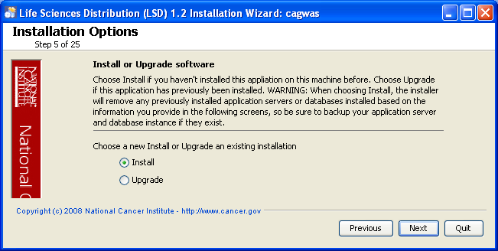
6 | Navigate to the directory where you would like to install caGWAS 1.1.0.  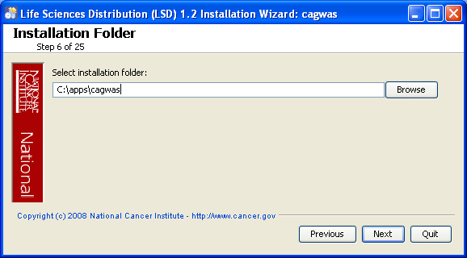  If the folder does not yet exist, click OK in the dialog box to indicate that you want the folder to be created.
7  7 | Select “Everything” if this is a new installation and you would like to install both the Jboss server and the database.  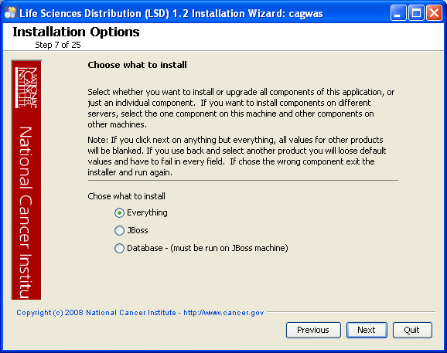
8 | Configure caGWAS JBoss server on the next two pages of the installation wizard. The screen shots show example values. The port values which are specified are the defaults and can be used unless you want to reconfigure the values because of values already in use.  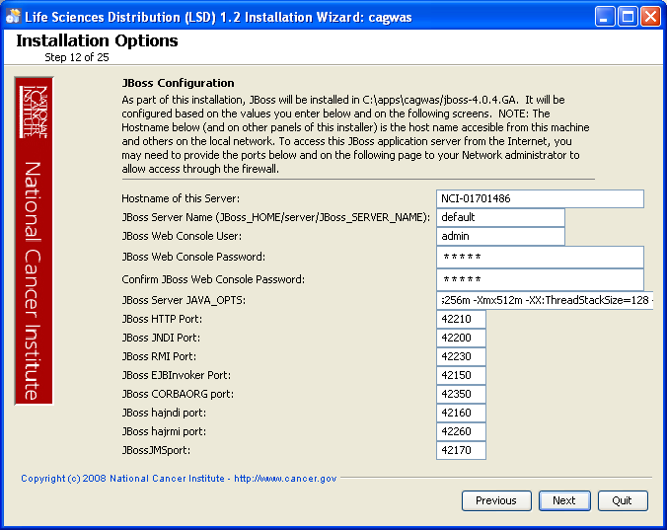
9 | 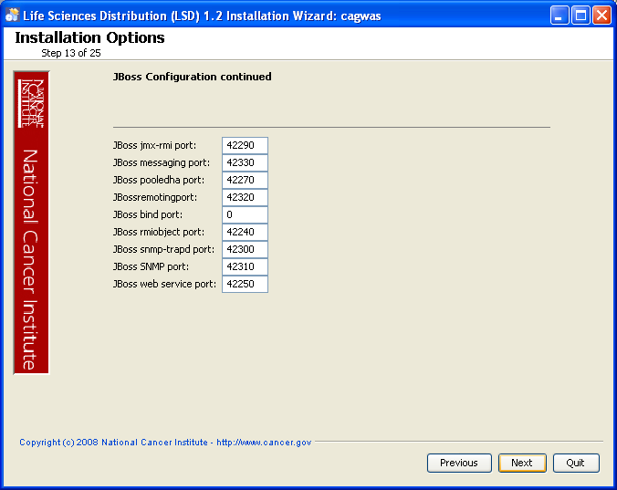
10 | For JBoss SSL and Secure Grid configuration requires that you have requested and retrieved certificates already. See https://wiki.nci.nih.gov/x/7xWy for details on SSL, caGWAS does not have a caGrid service.  If you are not configuring caGWAS as an SSL, then select Next  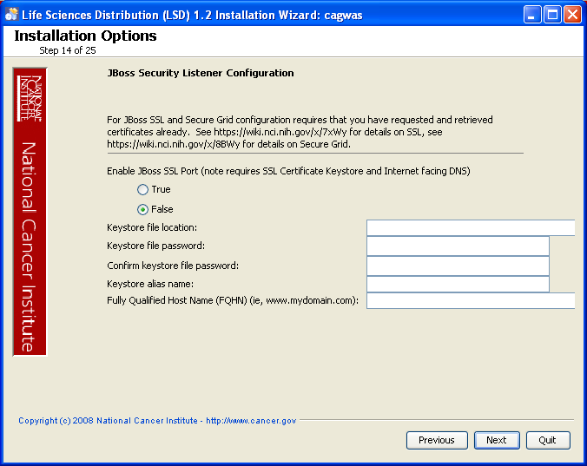
For JBoss External Hostname configurations see https://wiki.nci.nih.gov/x/8hWy, Values are not required if not externally accessible, just select Next
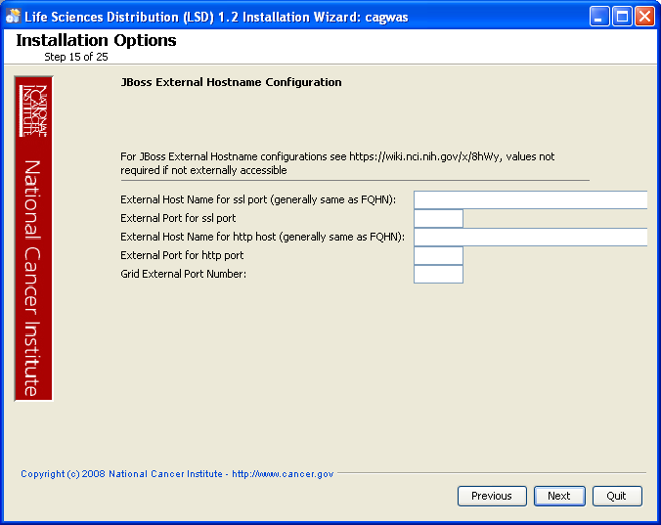
9 | Specify the authentication type that caGWAS should use. Database is the most likely choice if you aren’t sure what to select here.  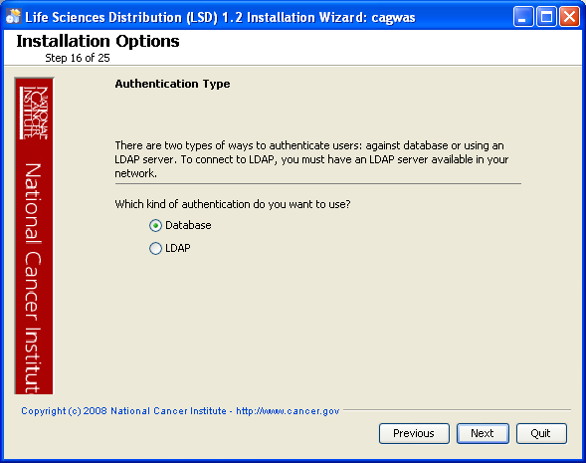
44  10 | If LDAP was selected in the previous step, enter the appropriate configuration information for LDAP.  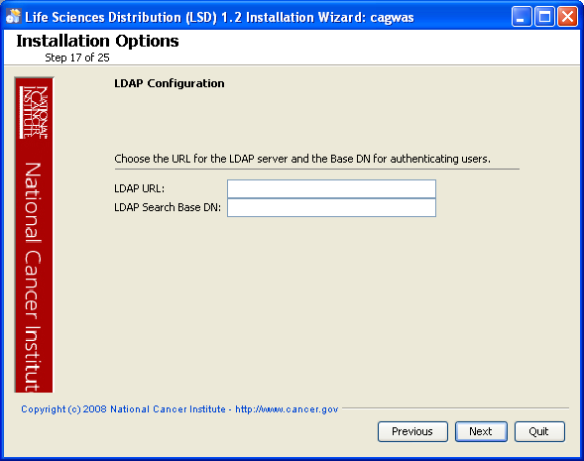
11 | If the authentication type is database:  Specify the database connection information, including the name of the pre-existing database where the caGWAS schema will be installed, and the pre-existing user which will be used by caGWAS to connect to its database.  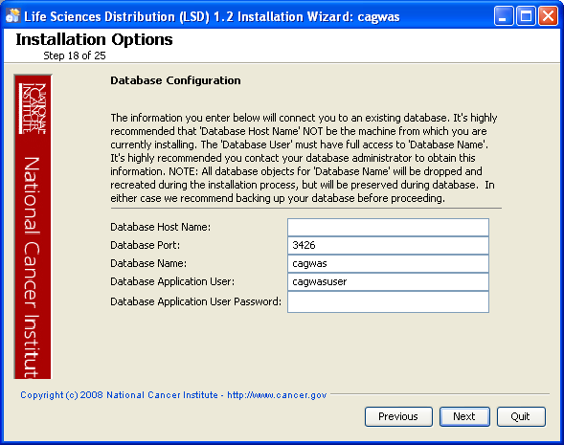  Error messages inform you if the following occurs:  - If the specified database host cannot be reached, or the field is blank.  If the specified database does not already exist, or the caGWAS DB user’s credentials are wrong.
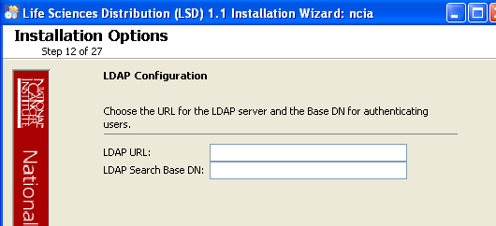  12 | Specify SMTP mail server connection info so that caGWAS can send emails from users with new account requests.  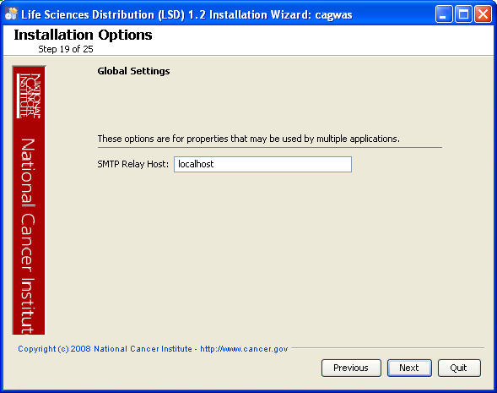
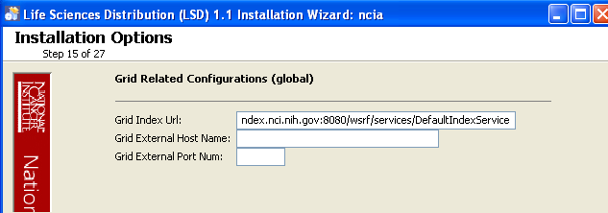  13 | This page allows you to use your own java keystore to sign the jars or to have a self-signed one generated for you. If you have an existing one put the full path to the file, the alias and password.  Otherwise, just select Next  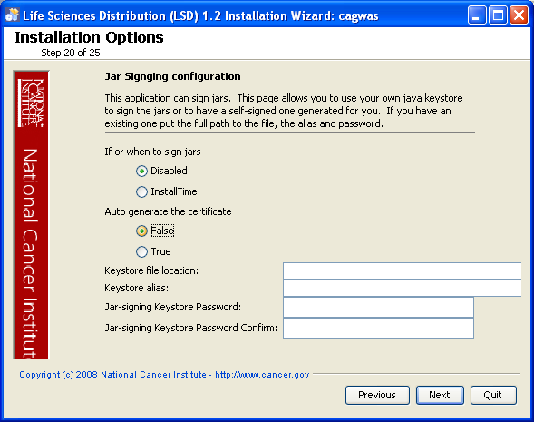
14 | Specify the caGWAS Settings.  For detailed descriptions on each of the properties below, see the Application Settings section at https://wiki.nci.nih.gov/x/Caml 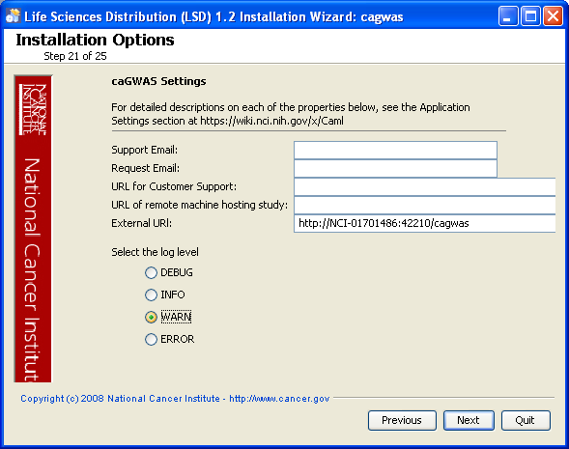  An error message opens informing you of required fields you may have missed.
15 | Review the summary of the information you entered and if everything appears fine, Select Next  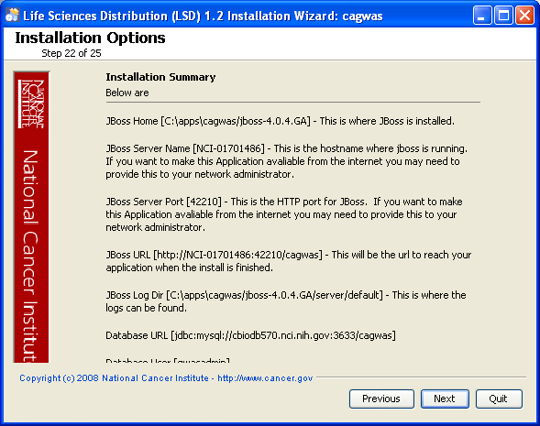
11  16 | Review the selected install type.  After you click Next from reviewing the installation destination, the installer runs. The installation wizard displays the installation progress and completion.  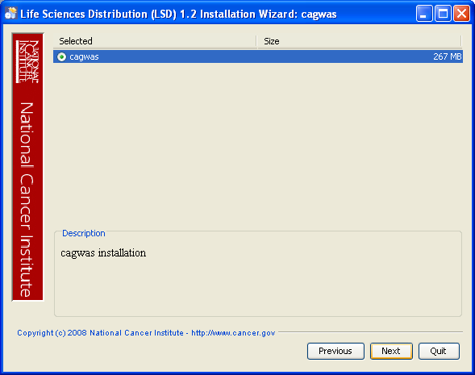
17  12 | When you are informed that the process is finished, click Done in the lower right corner of the wizard to close the installer.  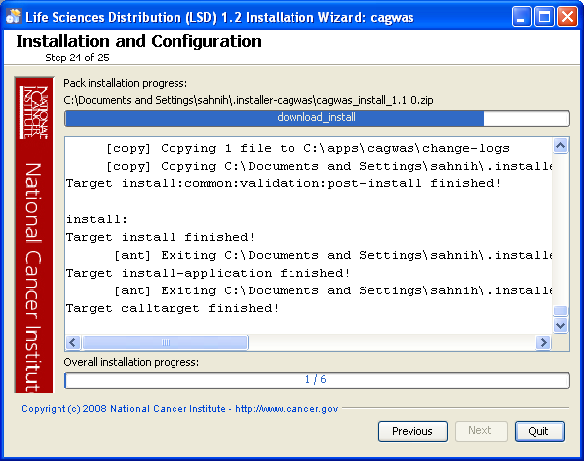

18 | To verify caGWAS installation:  - open your web browser to http://<jboss.server.hostname>.<jboss.server.port>/cagwas  - Refer to the <installtion folder>/cagwas/change-logs/install.properties-DDMMYYXXXX file for the correct values.  - Such as C:\apps\cagwas\change-logs\  - Enter cagwas_user as the user and cagwas_user as the password.
19 | After successfully installing caGWAS, make a backup of the <installtion folder>/cagwas/change-logs/install.properties-DDMMYYXXXX file in a different directory for future reference.

Running GUI installer in Headless Environment

NOTE | If you are attempting to use the GUI installers in an environment that has no GUI (such as a headless Linux operating system), you can install a tool on your Windows workstation to install in a remote headless environment. See https://wiki.nci.nih.gov/x/gq6l for more information.

Command-Line Installation
NOTE | An alternative to using the GUI-based installer is to install caGWAS via the command line. See https://wiki.nci.nih.gov/x/r6ql for detailed instructions on installing from the command line.

caGWAS Port Usage
NOTE | Verify that default port values, as provided by the installer are not in use on your system by running netstat –a from the command line. The default ports for caGWAS are in the 42000 series. If the ports are in use prior to installation, you will likely experience problems with your installation.

JBoss Errors During Installation
NOTE | You may receive an error such as Exception in thread "main" java.lang.NoClassDefFoundError: org/jboss/Shutdown. This should not be a problem, as the installer attempts to remove previously installed servers to prevent problems during the installation. If this is your first time installing caGWAS, you may receive and disregard this error message.

Configuring JBoss

NOTE | For optimal performance, you must modify your JBoss 4.0.5 configuration to increase the amount of available memory for the caGWAS application. Directions for doing this in Windows are in the following step 1.

To configure JBoss in Windows, follow these steps:

Step | Action
1 | Add the following entry to the JBoss run.bat file which is located will be located at <application_root_directory>/jboss-4.0.5.GA/bin/run.bat. Add the text right after the line ”rem Add -server to the JVM options, if supported”.  -server –Xms1024m –Xmx1024m -XX:ThreadStackSize=128 -XX:SurvivorRatio=10 -XX:PermSize=128m -XX:MaxPermSize=128m -Dsun.rmi.dgc.client.gcInterval=3600000 -Dsun.rmi.dgc.server.gcInterval=3600000 -Djava.awt.headless=true  Warning: Be careful when copying and pasting from this document, whether PDF or MS Word. No spaces must come before and after the columns. A safe way to ensure that the text has no unwanted space and unwanted characters is to copy the text into a blank Notepad first. Correct the spacing, then copy and paste back into the run.bat file.
2 | Restart your JBoss 4.0.5 server for the changes to take effect. The method of doing this may depend on the start/stop/restart scripts you created after the installation. Most commonly, you can execute shutdown.bat and then run.bat under $JBOSS_HOME/bin. Refer to the publicly available JBoss user’s guide at www.jboss.org for more information.

Configuring JBoss to Run as a Service

NOTE | The JBoss server that runs caGWAS must run continually as a service. The instructions in this section covers this scenario. For caGWAS 1.1.0, there are is a single server:  - JBoss 4.0.5 (for caGWAS application)

NOTE | The default caGWAS installation runs JBoss as a command line process using the user currently logged on. Therefore, when you log out as this user, JBoss will no longer be available for caGWAS. For that reason, it is recommended that you configure your JBoss servers to run as a Linux or Windows service. The instructions are contained in this section.

Running JBoss as a Service

To run JBoss as a service, follow these steps:

Step | Action
1 | Linux  See http://wiki.jboss.org/wiki/Wiki.jsp?page=StartJBossOnBootWithLinux.
2 | Windows  To run an existing JBoss command line installation as a service, follow the directions for creating a user-defined service at http://support.microsoft.com/kb/137890/EN-US/  Note: You need to have access to the Windows Resource Kit.

Contacting Application Support
NCICB Application Support | http://ncicb.nci.nih.gov/NCICB/support  Telephone: 301-451-4384  Toll free: 888-478-4423

