caMOD/caIMAGE EVS Implementation

Software Design Description

Version 1.0

January 13, 2006

Document Change Record
Version Number | Date | Description
1.0 | 01/13/06 | Initial document
1.1 | 01/19/06 | Revision 1
1.2 | 01/25/06 | Revision 2
1.3 | 04/13/06 | Revision 3

TABLE OF CONTENTS
1. Introduction 1
1.1 PROJECT BACKGROUND 1
1.2 System Overview 1
1.2.1 User Client Software 3
1.2.2 Back End 3
1.2.3 Hibernate 3 Data Access 3
1.2.4 JBoss Application Server 3
1.2.5 Database 4
1.2.6 Java 4
1.3 Requirement Traceability 4
2. USE CasEs 8
3. components 9
3.1 EVS Javascript modification (requirement id 1) 9
3.2 Caching the EVS tree on The client side (perfomace) 11
3.3 Database Modification (Requirement ID 9) 12
3.4 Client JavaScript modifications (requiremnt id 12) 12
3.5 RePort For added termS ( Requirement id 4) 13
3.6 Display name (requirement Id 3) 13
3.7 Synonym search (requirement ID 2) 13
3.8 skin change (requirement ID 5) 13
3.9 Stain vocabulary and dropdown population (requirement id 8) 15
3.10 Xenograph submission (requirement iD 7) 15
4. Notes 17
Appendix A – acronym List 18

Introduction
The purpose of this document is to describe the Software Design Description (SDD) for the integration of caMOD/caIMAGE with EVS using a caBIO API. This enhancement will allow the user to use the any vocabulary or any tree. It will cache certain tree configurations upon startup for performance reasons. Implementing the new caBIO API will move the caIMAGE application to new NCI Thesaurus codes, which is using the old CTRM codes.

PROJECT BACKGROUND
caMOD utilizes vocabularies provided via read-only access by the NCI Thesaurus. NCI Thesaurus is a product of the NCI’s Enterprise Vocabulary System (EVS). The objects returned by the EVS API’s are used to display vocabularies in tree-like structures in the caMOD application. Currently, vocabularies for mouse anatomy and diseases in mice are used. The caMOD application is queried based upon the returned concept id from the tree. This minimizes display or entry errors. The vocabulary trees can be cached locally or accessed at runtime using the caBIO API’s of the caMOD application.
caIMAGE, which is part of the caMOD application, uses the mouse and human anatomy vocabularies as well as disease vocabularies provided by the CTRM vocabulary browser. In the near future, the CTRM vocabulary will no longer be supported. Therefore, caIMAGE needs to move from the CTRM code to NCI Thesaurus code.

System Overview
The purpose of this section is to give an overview of the caMOD/caIMAGE, EVS, caBIO API. The following diagrams show the overall architecture and sequence of events of the use of EVS system.
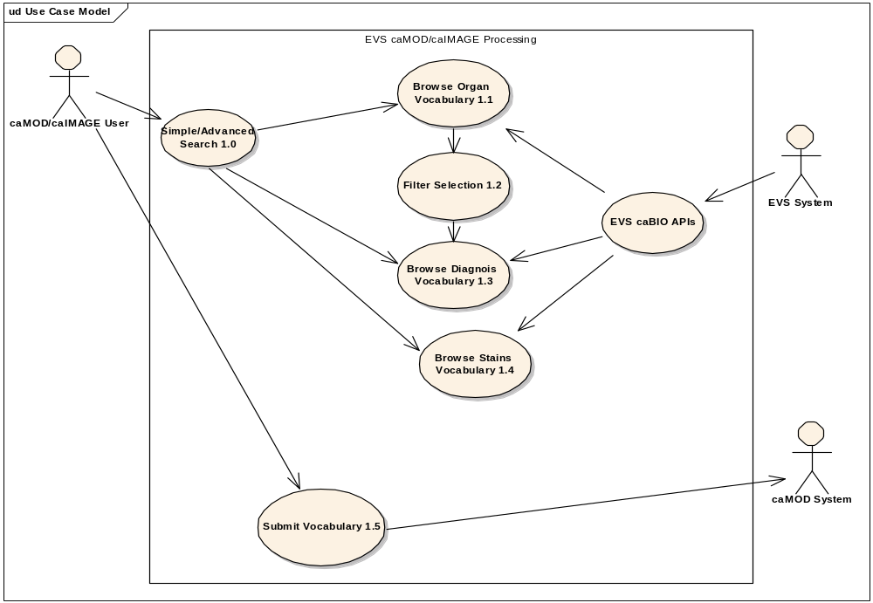

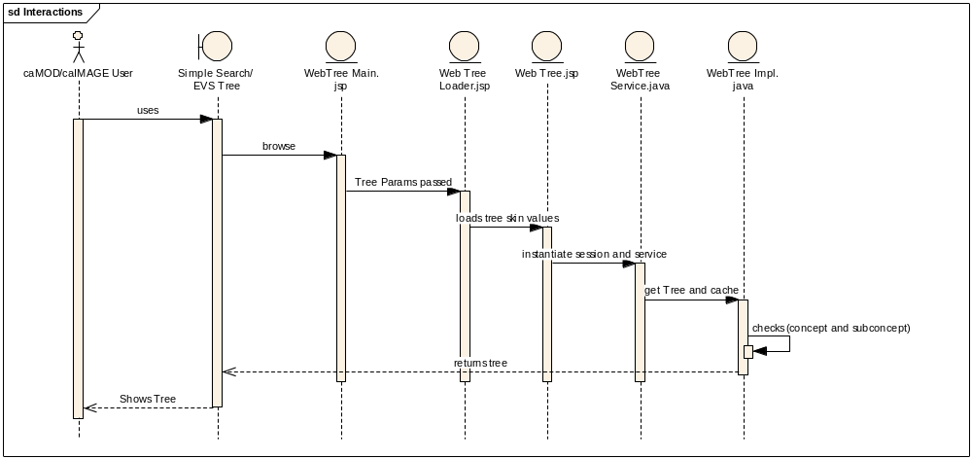

User Client Software

EVS, caMOD and caIMAGE is web based user interface is implemented as HTML, JSP and JavaScript. The use of JavaScript is limited to improving usability only.

Java Server Pages (JSPs) are used to generate dynamic HTML based on user actions. JSPs are combinations of HTML, Java Code, and custom JSP tags that get compiled into servlet classes.

Back End

The caMOD back end components provide access to persistence services for retrieving and storing data in the database. Hibernate, an open source tool, is used as the Object Relational Mapping (ORM) software.

Hibernate 3 Data Access
The caMOD uses Hibernate version 3. Hibernate is used for read, write access. It provides the insert, update and delete capability to the caMOD application thru the domain classes.

JBoss Application Server

The user interface, middle tier, and backend components are run with in jBoss Java2 Enterprise Edition (J2EE) application server. JBoss is an open source application server that provides a servlet container, an EJB container, the full range of J2EE 1.4 features as well as extended enterprise services including clustering, caching and persistence. caIMAGE application will be migrated to run on jBoss 4.0.2 instead of Tomcat 4.1.18. JBoss 4.0.2 conforms to the latest technology stack. It will be consistent with most other applications.

Database

Oracle Relation Database Management System (RDBMS) software is used as the persistent store for caMOD and caIMAGE application data. Java classes access the database using the Java Database Connectivity (JDBC) API.

Java
The new version of Java1.5 (Java tool kit version jdk1.5.0_04) is used for compilation. Since EVSTree, which has the dependency on the client.jar file has been up upgraded to Java 1.5. in the latest caBIO version (cacoretoolkit 3.1). Therefore all the code in caMOD and caIMAGE had been compiled using the JDK 1.5 version. This will conform to the latest technology stack currently used by NCI.

Requirement Traceability
Table 2.1-1: EVS NCI Thesaurus Requirements
Req ID | Requirement Description
1 | EVS Tree - restore the association between organ and diagnosis  The vocabulary tree prior to caMOD 2.0 supported the association between organ and diagnosis. The user selected an organ and the diagnosis tree opens only the diagnoses that could occur in the selected organ. This functionality no longer exists in the new tree. NCI Thesaurus still provides the association between organ and diagnosis (EO_Disease_Has_Associated_EO _Anatomy), but the software does not utilize this information. User shall be able to select sub tree or entire tree or both using the role name.  For search side organ and diagnosis shall be independent of each other i.e. user shall be able to use the diagnosis tree without selecting the organ tree first.  For submission side the user has to first select the organ tree and then the associated diagnosis tree.  The use of associations is also required for building a human anatomy vocabulary as well as connecting the human anatomy to the disease vocabulary.  The actor needs to be able to access all diagnoses for all organs. This feature was provided via a link on the right side of the tree window on the EVS pop up window.
2 | (EVS Tree - the search for synonyms returns all kinds of results)  The vocabulary tree supports a search for synonyms. The search returns results not matching results. The search for "throat" in the mouse anatomy vocabulary should return "pharynx". This function works correctly, but the search also suggests "alternate search terms" and the list of these terms includes diagnoses. This is not correct. If querying for an anatomical structure the alternate search terms should be limited to anatomical terms. The same is true when querying for a diagnostic term.  Example shows "alternate search terms" returned for "throat"  Pharyngeal Hemorrhage / Pharyngeal haemorrhage / Hemorrhage from throat / [D]Throat hemorrhage / Bleeding of pharynx / [D]Throat hemorrhage / [D]Throat hemorrhage (context-dependent category) / Bleeding of pharynx (finding) / Pharyngeal hemorrhage (disorder) / Hemorrhage from throat (disorder) / Observation of bleeding of pharynx / Hemorrhage from pharynx / Hemorrhage from pharynx / PHARYNGEAL BLEED / hemorrhage; throat / Pharynx / Head and Neck, Pharynx / Pharynxes / Pharyngeal structure / Pharyngeal structure (body structure) / THRT / Head, Ears, Eyes, Nose and Throat / HEENT / Acute Pharyngitis / Acute pharyngitis NOS (disorder) / Acute pharyngitis, unspecified / Acute sore throat NOS / Pharyngitis / Throat infection / Pharyngeal pain / Pharyngitis (disorder) / Pharyngeal pain (finding) / Irritation of the throat / Sore throat / Throat soreness / inflammation; throat / inflammation; pharynx / Throat Cancer / Throat Carcinoma.  This functionality was not supported in previous caBIO release. We shall check and test the new functionality in the new release 3.0.1. Implement this functionality if caBIO API has been modified (official release in March).
3 | EVS Tree - use display name instead of concept name  The vocabulary tree used to support the use of the display name instead of concept name. The concept name contains underscore(s) and the letters MMHCC.  Example: concept name: Esophagus_MMHCC  Display name: Esophagus  This functionality was not supported in previous caBIO release. We shall check and test the new functionality in the new release 3.1. We shall try to get the concept name and concept id and make sure that display name is not shown. Implement this functionality after caBIO API has been modified (official release in March).
4 | EVS Tree - develop procedure to inform/email EVS team about newly entered diagnostic terms  We need to develop a procedure how to handle the manual submissions (free text entry) for organ, diagnosis stain etc. A periodic report for the new terms will be provided to the EVS team manually or automatically.
5 | EVS Tree - change skin to match caMOD application  The vocabulary tree should match the layout and color schema of current caMOD application. Look at he options including style sheet in caMOD.
6 | EVS Tree - remove the word "Done" from the tree  After performing a search the word "done" appears at the lower left corner of the tree browser window. This looks like a programming artifact.
7 | EVS Tree - show species specific anatomy vocabularies  The xenograft submission page contains a field where the users indicate from what species and strain the graft was taken. Only the mouse anatomy is available at this point and users who selected another species than mouse are not prevented from selecting an organ from the mouse anatomy tree.  We need to  - Research if anatomy vocabularies are available from EVS.  - Add anatomy vocabularies.  - Show anatomy vocabulary depending on what species was selected  - If no anatomy vocabulary is available offer text input fields.  There are few case like histopathology, cell lines, associated expressions where user default to mouse model but has to be referenced to whatever the species user can pick from species selection (like zebra, fish etc.).
8 | EVS Tree - utilize the staining vocabulary  The image submission page should utilize the staining method vocabulary provided by NCI Thesaurus.  Path: Clinical or Research Activity → Procedure→ Laboratory Procedure → Histological Technique → Staining Method  Drop down to populated by using the EVS vocabulary.
9 | caIMAGE still uses the vocabularies stored on the CTRM browser. The EVS team would like to retire this service. We need to take the following steps to make this possible:  1. Identify in NCI Thesaurus what vocabulary should be used as human anatomical vocabulary  2. Identify in NCI Thesaurus what vocabulary should be used as human disease vocabulary  3. Get these vocabularies to work (structure is more complicated than for mouse)  4. Map the existing CTRM concept codes in caIMAGE to NCI Thesaurus concept codes; use existing spreadsheet; if terms cannot be found ask Sherri DeCoronado or somebody else from the EVS team for help  5. Replace the CTRM concept codes in caIMAGE with NCI Thesaurus concept codes
10  Deleted | Deleted as it is application specific to caMOD and shall be handled with in the application.
11  Deleted | Deleted as it is application specific to caMOD and shall be handled with in the application.
12 | Make the EVSTree generic- Currently the EVS tree GUI is designed around organ and disease. It expects certain fields on the form being passed in, and when an organ is selected it blanks out the disease fields. What we really need is an interface, which allows this behavior to be configurable. We need to be able to configure the following behavior:  - Which fields to be set. Do not hard code the names.  - What fields need to be already populated before a selection can be made.  - What fields need to be blanked out when a selection is made?  - What tree to display  - What relationship to use to display the tree. I.e. if an organ is selected we want to use an EVS relationship to restrict the displayed tree. We should be able to use any tree and any relationship.

USE CasEs
Use cases requirements are documented in details in Use Cases Document. Please refer to Use Cases Document.

components

EVS Javascript modification (requirement id 1)
Previously the tree, in CTRM EVS System, was passed in the form name and parameters, which was hard coded in the Java Script. In order to make it more generic we have to pass in parameters which we going to set on the forms( like oot node, descendents, depth level and role type).
Var form = document.forms[0]
This function will null out the values when user has selected the organ and then selects the diagnosis. In case user goes back to organ again then organ value for the form shall be null out.
function showTissueTree(form, inConceptCode, inConceptName, inDisplayName, leafNode)

{

var rootNode = 'Murine_Tissue_Type';
var roleType= 'Anatomic_Structure_is_Physical_Part_of, Anatomic_Structure_Has_Location, part_of';
var sementicType = 'T023';
var title = 'Tissue Select';
var params = ["true", "true", "4", "3"];

showTree(form, inConceptCode, inConceptName, inDisplayName, rootNode, roleType, sementicType, skin, params, leafNode, title, fieldToBlank)
}
function showDiagnosisTree(form, inConceptCode, inConceptName, inDisplayName, leafNode, rootNode)
{
var roleType= 'EO_Disease_Has_Associated_EO_Anatomy';
var sementicType = 'T047,T191';
var title = 'Diagnosis Select';
var params = ["true", "true", "4", "3"];

showTree(form, inConceptCode, inConceptName, inDisplayName, rootNode, roleType, sementicType, skin, params, leafNode, title, fieldToBlank)

}
function showTssueTree( form, inConceptCode, inCconceptName, leafParams, fieldToBlank)
{
var rootNode = 'Murine_Tissue_Type';
var roleType= 'Anatomic_Structure_is_Physical_Part_of, Anatomic_Structure_Has_Location, part_of';
var sementicType = 'T023';
var title = 'Tissue Select';
var params = ["true", "true", "4", "3"];

showTree(form, inConceptCode, inConceptName, inDisplayName, rootNode, roleType, sementicType, skin, params, leafNode, title, fieldToBlank)
}
In JavaScript.js after the confirmation the passed in fields will be blanked.
function confirmSelection(formName, conceptName, value, code, conceptCode, displayName, formDisplayName, fieldToBlank){

for (j=0;fieldToBlank.length; j++){
if (document.getElementById(fieldToBlank[j])==null){
for (i=0; i<document.forms[0].elements.length; i++){
if (document.forms[0].elements[i].type=="text" ){
if(document.forms[0].elements[i].value = fieldToBlank[j]){
document.forms[0].elements[i].value = ‘’;
}
}
}
}//if
}//for
}//for

}
In the above case we will assume the descendants= true, depthLevel=4, attribute=3, and Boolean = true for isa and part_of relationship.

This change will provide the to start the tree at any given nodes and view the tree depth and descendent based upon the role name.
Also we have added the parameters in the configure file so that the tree with the known root can be cached at the server start up time. More than one tree can be cached at the start up time. The evsconfig.properties file example is shown as below.
There are following parameters, which need to get set:
- VocabularyName:- This can be NCI _Thesaurus or any other known vocabulary type.
- Descendents:- This is a Boolean true/ false value to traverse the tree down.
- Depth: - This is to access the depth at each level of the tree. e.g. # ALL for all the available levels. 1 or 2 or 3 for each level of depth desired. In our applications we will use “ALL” for the vocabulary tree.
- isaFlag: - This is a Boolean tree to show the two kind of relationship i.e. isa or part of relationship.
- attributes: - This is a int value which can be set for an AttributeSetDescriptor instance for examples:
set 0 for WITH_NO_ATTRIBUTES
set 1 for WITH_ALL_ATTRIBUTES
set 2 for WITH_ALL_ROLES
set 3 for WITH_ALL_PROPERTIES
- root node:- This is a node for the start node of the tree for examples: Murine_Tissue_Type (for Mouse), Organ_System (Human). This is a concept name not the preferred name.
- rolecollection:- One or more roles can be applied separated by comma.

The example to configure the property file is provided below.
vocabularyname = NCI_Thesaurus
descendants = true
depthlevel = 6
isaFlag = false
attributes = 3
rootnode = Murine_Tissue_Type
symentictype1=T023
rolecollection = Anatomic_Structure_is_Physical_Part_of

Caching the EVS tree on The client side (perfomace)

New method to cache the tree on the client side is added in WebTreeImpl.java class. Given the tree root node or organ tree the diagnosis tree can be cached locally via SDK API. This is for example only. roleType = "EO_Disease_Has_Associated_EO_Anatomy" will be read from the property file, which is shown hard coded in the example.
public void loadSubConcepts( DefaultMutableTreeNode tree , String rootNode, String vocabularyName, boolean isaFlag, String depthLevel, int attributes, boolean direction ){
String key = null;

for (Enumeration e = tree.children() ; e.hasMoreElements() ;) {
try{
DefaultMutableTreeNode myChildNode = DefaultMutableTreeNode)e.nextElement();

DescLogicConcept childObj = (DescLogicConcept) myChildNode.getUserObject();
if (childObj != null)
{
String myId = childObj.getCode();
String myName = childObj.getName();

if (rootNode!=null){

key = vocabularyName+"$"+myName+"$"+direction+"$"+isaFlag+"$"+depthLevel+"$"+roleType;
tree = getTree(vocabularyName, myName, direction, isaFlag, attributes, depthLevel, rolesdig);
}
allTrees.put(key,tree);
}
} catch (Exception ex){
ex.printStackTrace();
}
}//for
}

Database Modification (Requirement ID 9)

ctrm_nci_code_mapping_final_no_c3.csv or txt file is provided which has the mapping of CTRM code to the NCI_ Thesaurus codes. This is the format of the file.
CTRM  code | NCI  code | CTRM  Name | NCI  Name
98 | 443 | Biphosphonates | Biphosphonates

Here is the script which can be run to update the codes for the CTRM to the NCI Thesaurus codes.

update IMAGE_ORGAN a
set a.ORGAN = (select NCI_CODE from CTRM_NCI_CODE_MAPPINGS GP where GP.CTRM_CODE = a.organ)
where a.organ in (select CTRM_CODE from GP)

Simillarly the Image_Diagnosis table in database can be updated as
update IMAGE_DIAGNOSIS a
set a.DIAGNOSIS = (select NCI_CODE from CTRM_NCI_CODE_MAPPINGS where CTRM_NCI_CODE_MAPPINGS.CTRM_CODE = a.DIAGNOSIS )
where a.DIAGNOSIS in (select CTRM_CODE from CTRM_NCI_CODE_MAPPINGS)

Client JavaScript modifications (requiremnt id 12)
Applications access the tissue and diagnosis in the following manner using the “scripts/EVSTreeScripts.js”. The form name and the input field are required. Input field can be further parsed using the following parameters such as vocabularyname, descendants, depthlevel, isaFlag, attributes, rootnode, rolecollection. These are defined in section 3.1.

This will be changed generic way to:

function showTree(form, conceptCode, conceptName, displayName, rootNode, roleType, sementicType, skin, params, leafNode, title, fieldToBlank)

{

var now = new Date();
var glob = now.getHours()+now.getSeconds()+now.getMilliseconds();
var targetURL;
var descendants;
var isaFlag;
var depthLevel;
var attribute;
for (j=0;j < params.length; j++){
descendants = params[0];
isaFlag = params[1];
depthLevel = params[2];
attribute = params[3];
}

targetURL = '/EVSTree/webtree/WebTreeMain.jsp?treeParams=rootNode='+rootNode+';conceptName='+conceptName+';conceptCode='+conceptCode+';displayName='+displayName+';descendants='+descendants+';isaFlag='+isaFlag+';depthLevel='+depthLevel+';attributes='+attribute+';onlyLeaf='+leafNode+';roleType='+roleType+’fieldsToBlank=’+fieldsToBlank+';sementicType='+sementicType+';formName='+form+';&skin='+skin+'&windowTitle='+title+'&rand='+glob;

// open target window
windowOpen(targetURL, 810, 500, title);
}
Here root node and form name are both variables . This way there is no dependencies on the hard coded values.

RePort For Controlled vocabulary termS ( Requirement id 4)
A report of the controlled vocabulary terms for organ, diagnosis or stain will be provided to EVS team periodically. Report can be manually or automatically generated.

Display name (requirement Id 3)
The vocabulary tree supports the use of display name in 3.1. caMOD and caIMAGE application will use the display name instead of preferred name. Where display name is not available vocabulary tree will use preferred name. This will solve the concept name that contains underscore(s) and the letter MMHCC. We will test the caBIO 3.1 API. and try to get the concept name and concept id and make sure display name is shown appropriately.

Synonym search (requirement ID 2)
Te vocabulary tree supports a search for synonyms. The search returns not matching the synonyms. Currently this functionality is not working in caMOD application. We shall use DescLogicConcept which has an attribute called property. “Synonym” is a name of a property. If you want to find a search term that has a specific role associated to it can use the searchDescLogicConcept method. Search can be performed based on a search tern and property or role value.
Following is the snippet of the code.
String vocabularyName = "NCI_Thesaurus";
EVSQuery evsQuery = new EVSQueryImpl();
List evsResults = (List)appService.evsSearch(evsQuery);

if(evsResults.size()>0){
for(int i=0; i< evsResults.size(); i++){
MetaThesaurusConcept mtc = (MetaThesaurusConcept)evsResults.get(i);
List synonymList = mtc.getSynonymCollection();
for(int p=0; p<synonymList.size(); p++){

List semanticTypeList = mtc.getSemanticTypeCollection();
for(int q=0; q<semanticTypeList.size(); q++){

SemanticType st = (SemanticType)semanticTypeList.get(q);

if(sementicType !=null){
sementicType.size());
String semantic = null;
for(int r=0; r<sementicType.size(); r++)
{
semantic = ((String)sementicType.get(r)).trim();

if ( semantic.equals(st.getId()) ) {
synonymVector.add(synonymList.get(p));
}//if

}//for
}//if

}//for
}//for
}//for
}//if

skin change (requirement ID 5)
The vocabulary tee shall match the layout and color schema of current caMOD/caIMAGE application. Currently the EVS trees are configurable. Only by applying changes of the skin from “evs” to “evs1” will configure the change using the WebTreeMain.jsp as shown below. Most importantly the TopHeader.html will be changed to match the caMOD application header file. The others files may need appropriate changes/additons for the caMOD logo images, style sheet, HTML and JavaScript. The following changes are planned
- Header change to caMOD application header.
- Font type and size changes to match the caMOD application font using style sheet.
- Background change to match the caMOD application.
From:-
http://156.40.129.119:8080/EVSTree/webtree/WebTreeMain.jsp?treeParams=rootNode=Heart;descendants=true;isaFlag=false;depthLevel=6;roleType=Anatomic_Structure_is_Physical_Part_of;formName=exampleForm;type=tissue;&skin=evs&windowTitle=NCI%20Center%20for%20Bioinformatics&rand=100
To:
http://156.40.129.119:8080/EVSTree/webtree/WebTreeMain.jsp?treeParams=rootNode=Heart;descendants=true;isaFlag=false;depthLevel=6;roleType=Anatomic_Structure_is_Physical_Part_of;formName=exampleForm;type=tissue;&skin=evsMouse&windowTitle=NCI%20Center%20for%20Bioinformatics&rand=100

Stain vocabulary and dropdown population (requirement id 8)
CaMOD/caIMAGE application will utilize the staining method vocabulary provided by NCI Thesaurus. Root node or super concept “Staining_Methods” will be used for finding all the sub concepts. This will be added to the list or vector object. This list/vector will be returned to the caMOD/caIMAGE application. This list can be used to populate the drop down in the appropriate application. This method will be added in EVSTreeUtil.Java class under the gov,nih.nci.util package of caMOD application. Dropdown Utility in caMOD application will call this method and populate the dropdowns from the list.
public List loadStainConcepts(DefaultMutableTreeNode tree , String rootNode, String vocabularyName, boolean isaFlag, String depthLevel, int attributes, boolean direction ){
String key = null;
List stainvector = new ArrayList();

for (Enumeration e = tree.children() ; e.hasMoreElements() ;) {
try{
DefaultMutableTreeNode myChildNode = (DefaultMutableTreeNode)e.nextElement();

DescLogicConcept childObj = (DescLogicConcept) myChildNode.getUserObject();
if (childObj != null)
{
//String myId = childObj.getCode();
String stainName = childObj.getName();
stainvector.add(stainName);

}
} catch (Exception ex){
ex.printStackTrace();
}

}//for
List<String> stainlist = new ArrayList<String>(stainvector);

return stainlist;

}

Xenograph submission (requirement iD 7)
In this caMOD application case the user selects another species other than mouse where the vocabulary is not available. The tree has to be disabled and text field shall be available for the entry of organ and diagnosis. This can be accomplished using the custom tags which is a feature of Struts frame work in the following manner.
- Modify the XenograftPopulateAction.setStrainDropdown to set variables to indicate whether or not the vocabularies are in EVS. This determination should either be controlled by a configuration file or by a dynamic query of the EVS system.

Set hasEVSVocab and rootNode, and noEVSCode for the JSP to use (noEVSCode will be equal to C000000)

- Modify the jsp to do something like the following after the initial TD block is setup for the organ. Do the same thing for disease:
<c:choose>
<c:when test = "${hasEVSVocab == 1}">
<a href="javascript:showTissueTree(<new api> <c:out value="${rootNode}"/> )">
<IMG src="images\selectUP.gif" align=middle border=0></a>
</td>
<td class="formField">
<html:hidden property="organTissueCode"/>
<input type="hidden" name="organTissueName" />
<html:text styleClass="formFieldSized" disabled="true" property="organ" size="30" />
</td>
</c:when>
<c:otherwise>
</td>
<td class="formField">
<html:hidden property="organTissueCode" value=”<c:out value="${noEVSCode}"/>” />
<input type="hidden" name="organTissueName" />
<html:text styleClass="formFieldSized" disabled="false" property="organ" size="30" />
</td>
</c:otherwise>
</c:choose>

Notes

Appendix A – acronym List
Acronym | Description
caIMAGE | The web based application to access the histological images and related data. It uses the EVS tree thru caBIO API to retrieve the concept name and concept id.
caMOD | The web based application to retrieve and submit the data to Cancer Models database for models. Retrieve information about the making of models, their genetic description, histopathology, derived cell lines, associated images, carcinogenic agents, and therapeutic trials.
EVS | The Enterprise Vocabulary Service is an API, which allows access to NCI’s controlled vocabularies.

