caIntegrator 2
Use-Case Specification: Browse Study Data

Version 0.3
April 24, 2008

Document Approvals
The list contains the name and contact information for the core project team and any key stakeholders who have an interest in the success of the project. An “S” identifies persons responsible for approval from the stakeholder groups. Sign off of the document would be required when a decision is made not to take action for defined gaps.

S | Name | Role | S | Name | Role
S | Anand Basu | NCICB Engineering Manager | S | Subha Madhavan | Product Manager
 | Shine Jacobs | Project Manager

Revision History
Date | Version | Description | Author
3/26/2008 | 0.1 | Initial revision | Eric Tavela
4/14/2008 | 0.2 | Completed draft for Inception | Eric Tavela
4/15/2008 | 0.3 | Incorporated review feedback | Eric Tavela

Table of Contents
1. Brief Description 4
2. Basic Flow of Events 4
3. Alternative Flows 4
3.1 Browse Clinical Data 4
3.2 Browse Imaging Data 4
3.3 Browse Genomic Data 5
3.4 View Gene Annotation 5
3.5 View Reporter Annotation 5
4. Key Scenarios 5
5. Preconditions 5
6. Postconditions 5
7. Extension Points 5
8. Special Requirements 5
8.1 Results Set Display 5
9. Additional Information 5
9.1 Open Issues 5

Use-Case Specification: Browse Study Data

Brief Description
In this use case, a Research Investigator reviews the available data in a study via simple search and browse tools.
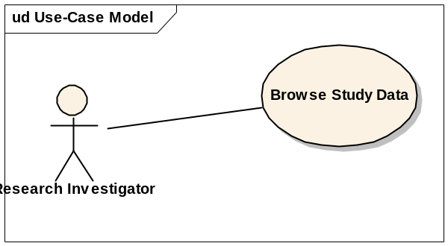

Basic Flow of Events
The Research Investigator chooses which study to browse and which type of data to browse. See the various Alternative Flows for details.

Alternative Flows

Browse Clinical Data
The system displays a basic search interface (the fields are defined at study deployment time) and a results set. Initially, the entire list of study subjects will be displayed. The research investigator may view complete details for a single subject. Details shown for the subject include:
- All clinical fields that the Research Investigator is permitted to see.
- All samples associated to the subject that the Research Investigator is permitted to see. Selecting a sample will display the detail information described below in Browse Genomic Data.
- All images associated to the subject organized by series. Selecting an image will display the detail information described below in Browse Imaging Data.

Browse Imaging Data
The system displays a basic search interface and a result set of images and the image features selected as study definition time for inclusion in the image browsing screen. Initially, the entire list of study images will be displayed. The research investigator may view complete details for an image. Details shown for the image:
- All image details (name, size, etc.)
- The series that the image belongs to
- All image feature attributes
- The subject ID. Clicking the subject ID will display the detail information described above in Browse Clinical Data.

Browse Genomic Data
The system displays a basic search interface and a result set of samples and array data files. The result set will display the subject id (linked to the subject detail display), the sample identifier, the time point (if any), the array platform and the data file name.

View Gene Annotation
The annotation for a gene will show basic information about the gene that has been imported into the system as well as links to external annotation resource database entries related to the gene.

View Reporter Annotation
The annotation for a single array reporter will indicate any vendor supplied information for the reporter and a link to view the annotation for the gene associated with the reporter.

Key Scenarios

Preconditions
None

Postconditions
None

Extension Points
None

Special Requirements

Results Set Display
The same special requirements given for displaying results sets in the Manage Queries use case apply to the display of Browse Study Data results. Conceptually, Browse Study Data is a simple case of query with preconfigured criteria. All functionality such as sorting, named list creation and pagination that apply to search results apply to the result sets from this use case.

Additional Information

Open Issues
We need to add detail for how images may be viewed and downloaded.
- Work with Anand to define imaging requirements.
We need to establish how samples and data files will be displayed together (or split apart).
  - Display like a simple SDRF: patient ID, sample ID, array data
  - There should be annotations on samples as well as images, subjects.
We need to refine the details on genomic data displayed on the details page. This will probably include an interface to view values for specific genes and reporters queried for (linking to view gene / view reporter annotation).
- Work with Subha on straw man for browse genomic.
It was pointed out that researchers might prefer a simple free-form search field (similar to Google) that will search across multiple fields. The typical use will be for a gene name or synonym.
  - Will promote this to a requirement, may require 2 fields (one genomic, one clinical), requires further discussion
Desire for a Gene Summary Page – everything about a gene across all studies.

