caIntegrator 2
Use-Case Specification: Curate Shared Annotation

Version 0.1
April 24, 2008

Document Approvals
The list contains the name and contact information for the core project team and any key stakeholders who have an interest in the success of the project. An “S” identifies persons responsible for approval from the stakeholder groups. Sign off of the document would be required when a decision is made not to take action for defined gaps.

S | Name | Role | S | Name | Role
S | Anand Basu | NCICB Engineering Manager | S | Subha Madhavan | Product Manager
 | Shine Jacobs | Project Manager

Revision History
Date | Version | Description | Author
4/15/2008 | 0.1 | Initial revision | Eric Tavela

Table of Contents
1. Brief Description 4
2. Basic Flow of Events 4
3. Alternative Flows 4
4. Key Scenarios 4
5. Preconditions 4
6. Postconditions 4
7. Extension Points 4
8. Special Requirements 4
9. Additional Information 4

Use-Case Specification: Curate Shared Annotation

Brief Description
In this use case, the TrWorkbench Administrator loads or updates annotation for entities that are shared between studies including genomic and array reporter annotation.
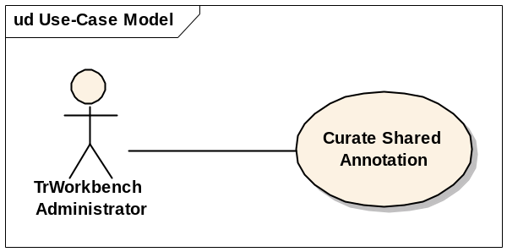

Basic Flow of Events
- <Step 1>
- <Step 2>

Alternative Flows

Key Scenarios

Preconditions

Postconditions

Extension Points

Special Requirements

Additional Information

Open Issues

Integration with caBIO for Gene and Reporter Annotation
We will need to investigate whether and how to integration with caBIO to import or reference its gene and microarray annotation elements.

